Airtime subscription

https://preprod-nigeria.api.mtn.com/v2/customers/2348031011125/subscriptions

Authorization

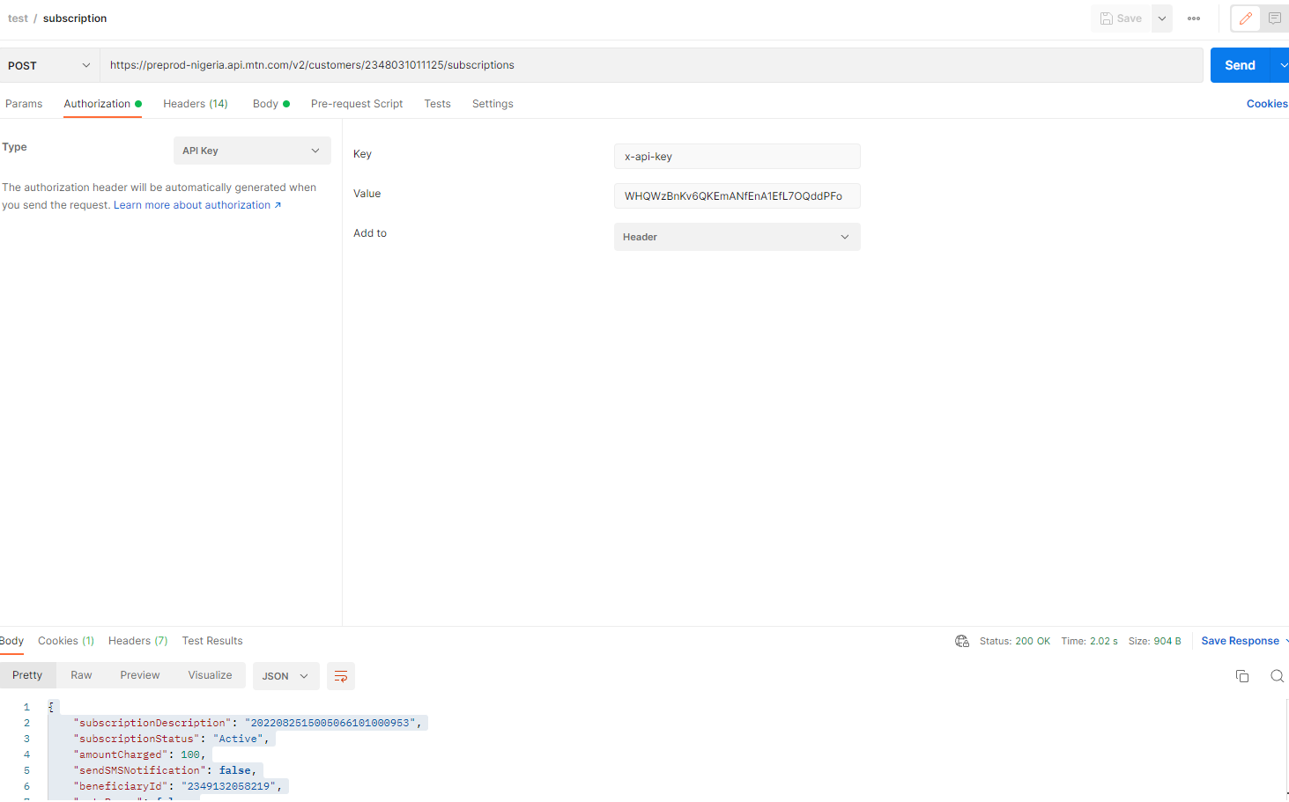

header

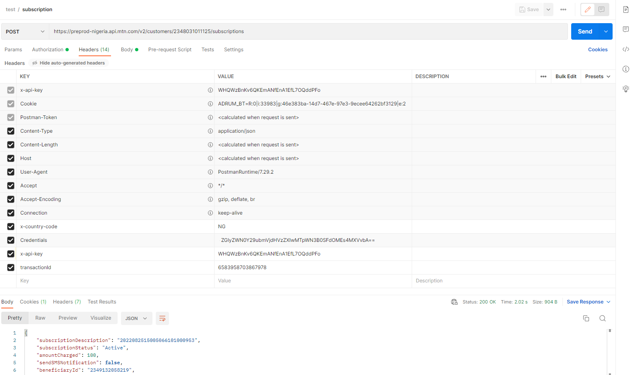

{

"subscriptionId":"1",

"beneficiaryId":"2349132058219",

"amountCharged":"100",

"subscriptionProviderId":"ERS",

"correlationId":"6583958703867978"

}

Resoponse:

{

    "subscriptionDescription": "2022082515005066101000953",

    "subscriptionStatus": "Active",

    "amountCharged": 100,

    "sendSMSNotification": **false**,

    "beneficiaryId": "2349132058219",

    "autoRenew": **false**,

    "amountBefore": 0.0,

    "amountAfter": 0.0,

    "correlationId": "6583958703867978",

    "links": [],

    "statusCode": "0000",

    "statusMessage": "Successful",

    "transactionId": "6583958703867978",

    "isCVMoffer": **false**

}

DATA

https://preprod-nigeria.api.mtn.com/v2/customers/2348031011125/subscriptions

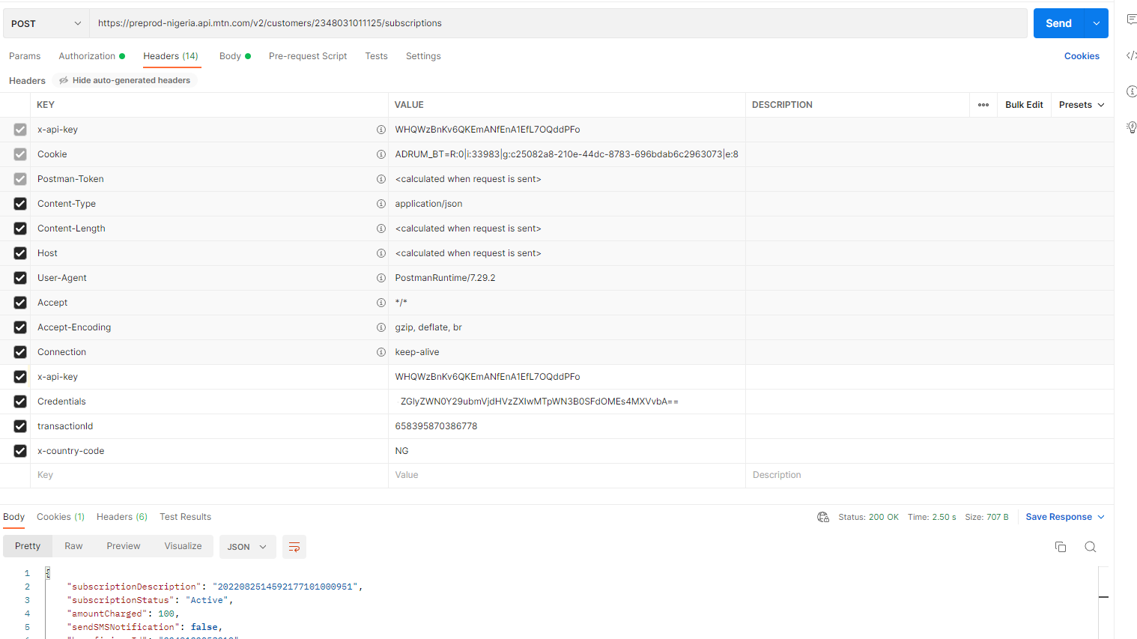

Request:

{

"subscriptionId":"9",

"beneficiaryId":"2349132058219",

"amountCharged":"100",

"subscriptionProviderId":"ERS",

"correlationId":"658395870386778"

}

Response:

{

    "subscriptionDescription": "2022082514592177101000951",

    "subscriptionStatus": "Active",

    "amountCharged": 100,

    "sendSMSNotification": **false**,

    "beneficiaryId": "2349132058219",

    "autoRenew": **false**,

    "amountBefore": 0.0,

    "amountAfter": 0.0,

    "correlationId": "658395870386778",

    "links": [],

    "statusCode": "0000",

    "statusMessage": "Successful",

    "transactionId": "658395870386778",

    "isCVMoffer": **false**

}

Query:

[https://preprod-nigeria.api.mtn.com/v2/customers/subscriptions/2348031011125/status/1228933?customerId=2348031011125&queryType=SEQUENCE](https://preprod-nigeria.api.mtn.com/v2/customers/subscriptions/2348031011125/status/1228933?customerId=2348031011125&queryType=SEQUENCE&subscriptionProviderId=ERS)[&subscriptionProviderId=ERS](https://preprod-nigeria.api.mtn.com/v2/customers/subscriptions/2348031011125/status/1228933?customerId=2348031011125&queryType=SEQUENCE&subscriptionProviderId=ERS)

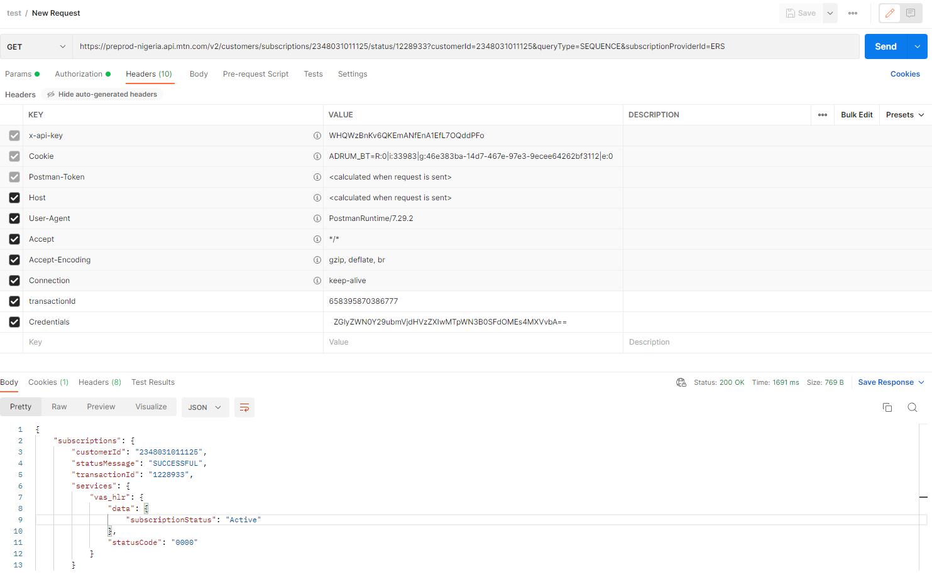

Response:

{

    "subscriptions": {

        "customerId": "2348031011125",

        "statusMessage": "SUCCESSFUL",

        "transactionId": "1228933",

        "services": {

            "vas_hlr": {

                "data": {

                    "subscriptionStatus": "Active"

                },

                "statusCode": "0000"

            }

        }

    },

    "links": []

}

LOOK UP

https://preprod-nigeria.api.mtn.com/v2/customers/2348031011125/subscriptions

{

    "correlationId":658395870386778,

    "subscriptionId":1,

    "beneficiaryId":"2348130373718",

    "amountCharged":"10",

    "subscriptionProviderId":"ERS",

    "subscriptionName": "LOOKUP"

}

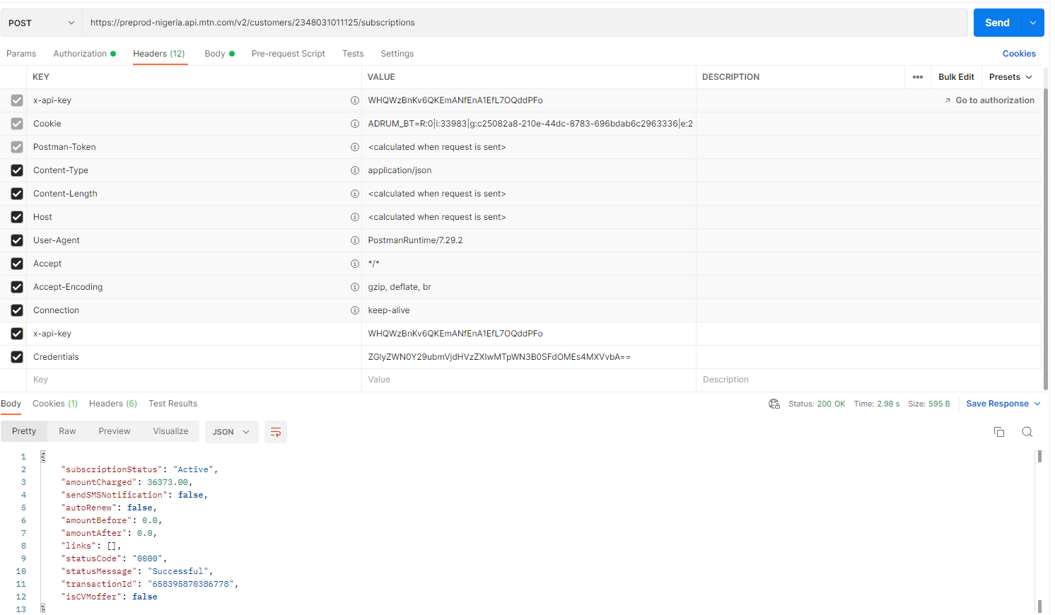

{

    "subscriptionStatus": "Active",

    "amountCharged": 36373.00,

    "sendSMSNotification": **false**,

    "autoRenew": **false**,

    "amountBefore": 0.0,

    "amountAfter": 0.0,

    "links": [],

    "statusCode": "0000",

    "statusMessage": "Successful",

    "transactionId": "658395870386778",

    "isCVMoffer": **false**

}

QUERY

https://preprod-nigeria.api.mtn.com/v2/customers/subscriptions/2348031011125/status/1228933?customerId=2348031011125&queryType=SEQUENCE&subscriptionProviderId=ERS

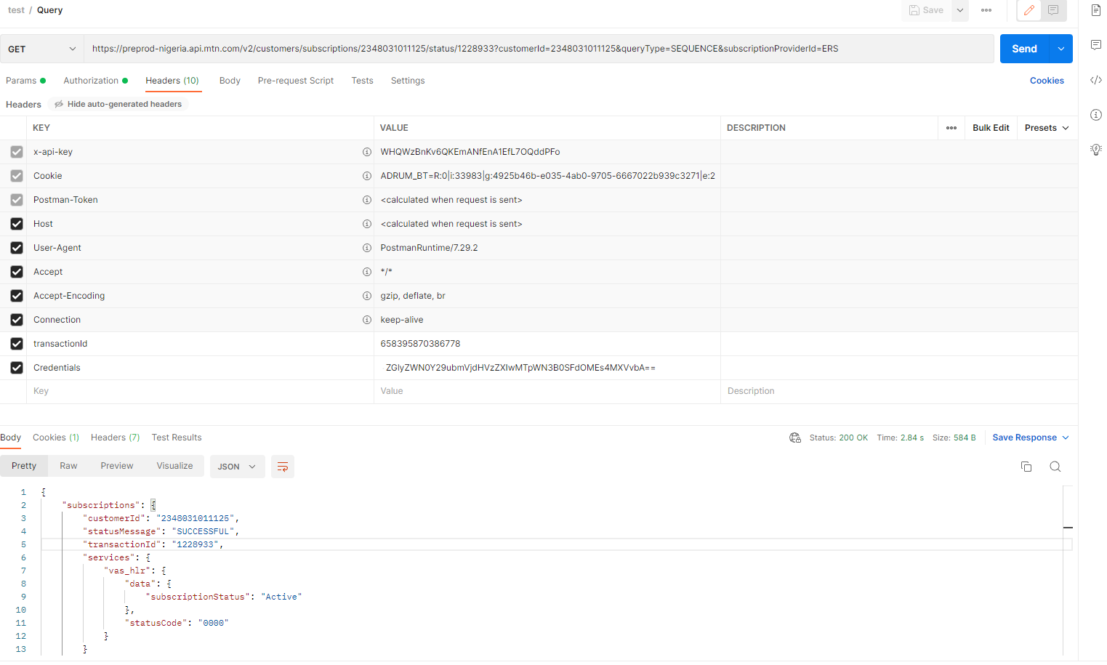

GET products

<https://preprod-nigeria.api.mtn.com/v3/products?nodeId=EVD>

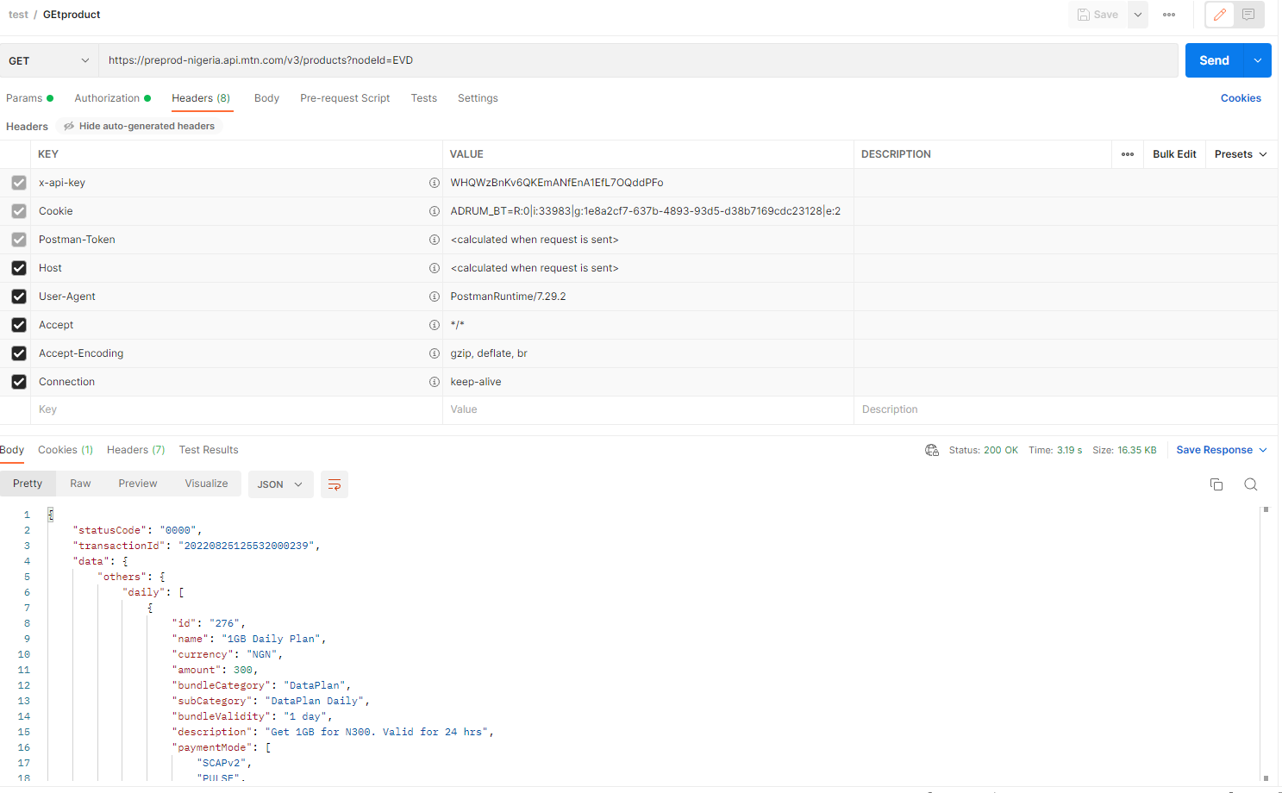

{

    "statusCode": "0000",

    "transactionId": "20220825125532000239",

    "data": {

        "others": {

            "daily": [

                {

                    "id": "276",

                    "name": "1GB Daily Plan",

                    "currency": "NGN",

                    "amount": 300,

                    "bundleCategory": "DataPlan",

                    "subCategory": "DataPlan Daily",

                    "bundleValidity": "1 day",

                    "description": "Get 1GB for N300. Valid for 24 hrs",

                    "paymentMode": [

                        "SCAPv2",

                        "PULSE",

                        "pulseAirtime"

                    ],

                    "buyForOthers": **true**,

                    "promotionApplicable": **true**,

                    "actions": [

                        "Opt-In:276",

                        "Opt-Out:276",

                        "Subscription:RACT_NG_Data_276"

                    ],

                    "renewal": **true**,

                    "activationId": "18"

                },

                {

                    "id": "307",

                    "name": "100MB Daily Plan",

                    "currency": "NGN",

                    "amount": 100,

                    "bundleCategory": "DataPlan",

                    "subCategory": "DataPlan Daily",

                    "bundleValidity": "1 day",

                    "description": "Get 100MB for N100. Valid for 24 hrs",

                    "paymentMode": [

                        "SCAPv2"

                    ],

                    "buyForOthers": **true**,

                    "promotionApplicable": **true**,

                    "actions": [

                        "Subscription:RACT_NG_Data_307"

                    ],

                    "renewal": **true**,

                    "activationId": "9"

                }

            ],

            "weekend": [],

            "weekly": [

                {

                    "id": "73",

                    "name": "Xtratalk 300 Weekly Bundle",

                    "currency": "NGN",

                    "amount": 300,

                    "bundleCategory": "Data and Voice",

                    "subCategory": "XTRATALK",

                    "bundleValidity": "7 days",

                    "description": "Gives N1500 Talk Time and 50MB Data, valid for 7 Days",

                    "paymentMode": [

                        "SCAPv2"

                    ],

                    "buyForOthers": **false**,

                    "promotionApplicable": **false**,

                    "actions": [

                        "Subscription:RACT_NG_Combo_73",

                        "Opt-In:73",

                        "Opt-Out:73"

                    ],

                    "renewal": **true**,

                    "activationId": "24"

                },

                {

                    "id": "83",

                    "name": "Xtratalk 500 Weekly Bundle",

                    "currency": "NGN",

                    "amount": 500,

                    "bundleCategory": "Data and Voice",

                    "subCategory": "XTRATALK",

                    "bundleValidity": "7 days",

                    "description": "Gives N2,500 Talk Time and 100MB Data, valid for 7 Days",

                    "paymentMode": [

                        "SCAPv2"

                    ],

                    "buyForOthers": **false**,

                    "promotionApplicable": **false**,

                    "actions": [

                        "Subscription:RACT_NG_Combo_83",

                        "Opt-In:83",

                        "Opt-Out:83"

                    ],

                    "renewal": **true**,

                    "activationId": "24"

                },

                {

                    "id": "90",

                    "name": "Xtradata 300 Weekly Bundle",

                    "currency": "NGN",

                    "amount": 300,

                    "bundleCategory": "Data and Voice",

                    "subCategory": "XTRADATA",

                    "bundleValidity": "7 days",

                    "description": "Gives 350MB Data and N300 Talk Time, valid for 7 Days",

                    "paymentMode": [

                        "SCAPv2"

                    ],

                    "buyForOthers": **false**,

                    "promotionApplicable": **false**,

                    "actions": [

                        "Subscription:RACT_NG_Combo_90",

                        "Opt-In:90",

                        "Opt-Out:90"

                    ],

                    "renewal": **true**,

                    "activationId": "25"

                },

                {

                    "id": "152",

                    "name": "350MB Weekly data plan",

                    "currency": "NGN",

                    "amount": 300,

                    "bundleCategory": "DataPlan",

                    "subCategory": "DataPlan Weekly",

                    "bundleValidity": "7 days",

                    "description": "Get 350MB for N300. Valid for 7 days.",

                    "paymentMode": [

                        "SCAPv2",

                        "PULSE"

                    ],

                    "buyForOthers": **true**,

                    "promotionApplicable": **true**,

                    "actions": [

                        "Subscription:RACT_NG_Data_152"

                    ],

                    "renewal": **true**,

                    "activationId": "9"

                },

                {

                    "id": "742",

                    "name": "1GB Weekly Plan",

                    "currency": "NGN",

                    "amount": 500,

                    "bundleCategory": "DataPlan",

                    "subCategory": "DataPlan Weekly",

                    "bundleValidity": "7 days",

                    "description": "Get 1GB for N500. Valid for 7days",

                    "paymentMode": [

                        "SCAPv2",

                        "PULSE"

                    ],

                    "buyForOthers": **true**,

                    "promotionApplicable": **true**,

                    "actions": [

                        "Subscription:RACT_NG_Data_742"

                    ],

                    "renewal": **true**,

                    "activationId": "19"

                },

                {

                    "id": "743",

                    "name": "6GB Weekly Plan",

                    "currency": "NGN",

                    "amount": 1500,

                    "bundleCategory": "DataPlan",

                    "subCategory": "DataPlan Weekly",

                    "bundleValidity": "7 days",

                    "description": "Get 6GB for N1,500. Valid for 7days",

                    "paymentMode": [

                        "SCAPv2",

                        "PULSE"

                    ],

                    "buyForOthers": **true**,

                    "promotionApplicable": **true**,

                    "actions": [

                        "Subscription:RACT_NG_Data_743"

                    ],

                    "renewal": **true**,

                    "activationId": "9"

                }

            ],

            "monthly": [

                {

                    "id": "84",

                    "name": "Xtratalk 1000 Monthly Bundle",

                    "currency": "NGN",

                    "amount": 1000,

                    "bundleCategory": "Data and Voice",

                    "subCategory": "XTRATALK",

                    "bundleValidity": "30 days",

                    "description": "Gives N5,000 Talk Time and 300MB Data, valid for 30 Days",

                    "paymentMode": [

                        "SCAPv2"

                    ],

                    "buyForOthers": **false**,

                    "promotionApplicable": **false**,

                    "actions": [

                        "Opt-In:84",

                        "Opt-Out:84",

                        "Subscription:RACT_NG_Combo_84"

                    ],

                    "renewal": **true**,

                    "activationId": "24"

                },

                {

                    "id": "85",

                    "name": "Xtratalk 2000 Monthly Bundle",

                    "currency": "NGN",

                    "amount": 2000,

                    "bundleCategory": "Data and Voice",

                    "subCategory": "XTRATALK",

                    "bundleValidity": "30 days",

                    "description": "Gives N10,000 Talk Time and 650MB Data, valid for 30 Days",

                    "paymentMode": [

                        "SCAPv2"

                    ],

                    "buyForOthers": **false**,

                    "promotionApplicable": **false**,

                    "actions": [

                        "Opt-In:85",

                        "Opt-Out:85",

                        "Subscription:RACT_NG_Combo_85"

                    ],

                    "renewal": **true**,

                    "activationId": "24"

                },

                {

                    "id": "86",

                    "name": "Xtratalk 5000 Monthly Bundle",

                    "currency": "NGN",

                    "amount": 5000,

                    "bundleCategory": "Data and Voice",

                    "subCategory": "XTRATALK",

                    "bundleValidity": "30 days",

                    "description": "Gives N25,000 Talk Time and 1.5GB Data, valid for 30 Days",

                    "paymentMode": [

                        "SCAPv2"

                    ],

                    "buyForOthers": **false**,

                    "promotionApplicable": **false**,

                    "actions": [

                        "Subscription:RACT_NG_Combo_86",

                        "Opt-In:86",

                        "Opt-Out:86"

                    ],

                    "renewal": **true**,

                    "activationId": "24"

                },

                {

                    "id": "87",

                    "name": "Xtratalk 10000 Monthly Bundle",

                    "currency": "NGN",

                    "amount": 10000,

                    "bundleCategory": "Data and Voice",

                    "subCategory": "XTRATALK",

                    "bundleValidity": "30 days",

                    "description": "Gives N50,000 Talk Time and 2.5GB Data, valid for 30 Days",

                    "paymentMode": [

                        "SCAPv2"

                    ],

                    "buyForOthers": **false**,

                    "promotionApplicable": **false**,

                    "actions": [

                        "Subscription:RACT_NG_Combo_87",

                        "Opt-In:87",

                        "Opt-Out:87"

                    ],

                    "renewal": **true**,

                    "activationId": "24"

                },

                {

                    "id": "88",

                    "name": "Xtratalk 15000 Monthly Bundle",

                    "currency": "NGN",

                    "amount": 15000,

                    "bundleCategory": "Data and Voice",

                    "subCategory": "XTRATALK",

                    "bundleValidity": "30 days",

                    "description": "Gives N75,000 Talk Time and 3.5GB Data, valid for 30 Days",

                    "paymentMode": [

                        "SCAPv2"

                    ],

                    "buyForOthers": **false**,

                    "promotionApplicable": **false**,

                    "actions": [

                        "Subscription:RACT_NG_Combo_88",

                        "Opt-In:88",

                        "Opt-Out:88"

                    ],

                    "renewal": **true**,

                    "activationId": "24"

                },

                {

                    "id": "89",

                    "name": "Xtratalk 20000 Monthly Bundle",

                    "currency": "NGN",

                    "amount": 20000,

                    "bundleCategory": "Data and Voice",

                    "subCategory": "XTRATALK",

                    "bundleValidity": "30 days",

                    "description": "Gives N100,000 Talk Time and 4.5GB Data, valid for 30 Days",

                    "paymentMode": [

                        "SCAPv2"

                    ],

                    "buyForOthers": **false**,

                    "promotionApplicable": **false**,

                    "actions": [

                        "Subscription:RACT_NG_Combo_89",

                        "Opt-In:89",

                        "Opt-Out:89"

                    ],

                    "renewal": **true**,

                    "activationId": "24"

                },

                {

                    "id": "92",

                    "name": "Xtradata 1000 Monthly Bundle",

                    "currency": "NGN",

                    "amount": 1000,

                    "bundleCategory": "Data and Voice",

                    "subCategory": "XTRADATA",

                    "bundleValidity": "30 days",

                    "description": "Gives 3GB Data and N1,000 Talk Time, valid for 30 Days",

                    "paymentMode": [

                        "SCAPv2"

                    ],

                    "buyForOthers": **false**,

                    "promotionApplicable": **false**,

                    "actions": [

                        "Subscription:RACT_NG_Combo_92",

                        "Opt-In:92",

                        "Opt-Out:92"

                    ],

                    "renewal": **true**,

                    "activationId": "25"

                },

                {

                    "id": "93",

                    "name": "Xtradata 2000 Monthly Bundle",

                    "currency": "NGN",

                    "amount": 2000,

                    "bundleCategory": "Data and Voice",

                    "subCategory": "XTRADATA",

                    "bundleValidity": "30 days",

                    "description": "Gives 9GB Data and N2,000 Talk Time, valid for 30 Days",

                    "paymentMode": [

                        "SCAPv2"

                    ],

                    "buyForOthers": **false**,

                    "promotionApplicable": **false**,

                    "actions": [

                        "Subscription:RACT_NG_Combo_93",

                        "Opt-In:93",

                        "Opt-Out:93"

                    ],

                    "renewal": **true**,

                    "activationId": "25"

                },

                {

                    "id": "94",

                    "name": "Xtradata 5000 Monthly Bundle",

                    "currency": "NGN",

                    "amount": 5000,

                    "bundleCategory": "Data and Voice",

                    "subCategory": "XTRADATA",

                    "bundleValidity": "30 days",

                    "description": "Gives 30GB Data and N5,000 Talk Time, valid for 30 Days",

                    "paymentMode": [

                        "SCAPv2"

                    ],

                    "buyForOthers": **false**,

                    "promotionApplicable": **false**,

                    "actions": [

                        "Subscription:RACT_NG_Combo_94",

                        "Opt-In:94",

                        "Opt-Out:94"

                    ],

                    "renewal": **true**,

                    "activationId": "25"

                },

                {

                    "id": "95",

                    "name": "Xtradata 10000 Monthly Bundle",

                    "currency": "NGN",

                    "amount": 10000,

                    "bundleCategory": "Data and Voice",

                    "subCategory": "XTRADATA",

                    "bundleValidity": "30 days",

                    "description": "Gives 60GB Data and N10,000 Talk Time, valid for 30 Days",

                    "paymentMode": [

                        "SCAPv2"

                    ],

                    "buyForOthers": **false**,

                    "promotionApplicable": **false**,

                    "actions": [

                        "Subscription:RACT_NG_Combo_95",

                        "Opt-In:95",

                        "Opt-Out:95"

                    ],

                    "renewal": **true**,

                    "activationId": "25"

                },

                {

                    "id": "96",

                    "name": "Xtradata 15000 Monthly Bundle",

                    "currency": "NGN",

                    "amount": 15000,

                    "bundleCategory": "Data and Voice",

                    "subCategory": "XTRADATA",

                    "bundleValidity": "30 days",

                    "description": "Gives 100GB Data and N15,000 Talk Time, valid for 30 Days",

                    "paymentMode": [

                        "SCAPv2"

                    ],

                    "buyForOthers": **false**,

                    "promotionApplicable": **false**,

                    "actions": [

                        "Subscription:RACT_NG_Combo_96",

                        "Opt-In:96",

                        "Opt-Out:96"

                    ],

                    "renewal": **true**,

                    "activationId": "25"

                },

                {

                    "id": "97",

                    "name": "Xtradata 20000 Monthly Bundle",

                    "currency": "NGN",

                    "amount": 20000,

                    "bundleCategory": "Data and Voice",

                    "subCategory": "XTRADATA",

                    "bundleValidity": "30 days",

                    "description": "Gives 140GB Data and N20,000 Talk Time, valid for 30 Days",

                    "paymentMode": [

                        "SCAPv2"

                    ],

                    "buyForOthers": **false**,

                    "promotionApplicable": **false**,

                    "actions": [

                        "Subscription:RACT_NG_Combo_97",

                        "Opt-In:97",

                        "Opt-Out:97"

                    ],

                    "renewal": **true**,

                    "activationId": "25"

                },

                {

                    "id": "153",

                    "name": "2GB Monthly Plan",

                    "currency": "NGN",

                    "amount": 1200,

                    "bundleCategory": "DataPlan",

                    "subCategory": "DataPlan Monthly",

                    "bundleValidity": "30 days",

                    "description": "2GB Monthly Plan Plus FREE 4GB for YouTube once in 30 days.",

                    "paymentMode": [

                        "SCAPv2",

                        "PULSE"

                    ],

                    "buyForOthers": **true**,

                    "promotionApplicable": **true**,

                    "actions": [

                        "Subscription:RACT_NG_Data_153"

                    ],

                    "renewal": **true**,

                    "activationId": "9"

                },

                {

                    "id": "194",

                    "name": "1.5GB Monthly Data plan",

                    "currency": "NGN",

                    "amount": 1000,

                    "bundleCategory": "DataPlan",

                    "subCategory": "DataPlan Monthly",

                    "bundleValidity": "30 days",

                    "description": "Get 1.5GB for N1,000. Valid for 30 days",

                    "paymentMode": [

                        "SCAPv2",

                        "PULSE"

                    ],

                    "buyForOthers": **true**,

                    "promotionApplicable": **true**,

                    "actions": [

                        "Subscription:RACT_NG_Data_194"

                    ],

                    "renewal": **true**,

                    "activationId": "9"

                },

                {

                    "id": "195",

                    "name": "4.5GB Monthly Plan",

                    "currency": "NGN",

                    "amount": 2000,

                    "bundleCategory": "DataPlan",

                    "subCategory": "DataPlan Monthly",

                    "bundleValidity": "30 days",

                    "description": "4.5GB Monthly Plan Plus FREE 4GB for YouTube once in 30 days.",

                    "paymentMode": [

                        "SCAPv2",

                        "PULSE"

                    ],

                    "buyForOthers": **true**,

                    "promotionApplicable": **true**,

                    "actions": [

                        "Subscription:RACT_NG_Data_195"

                    ],

                    "renewal": **true**,

                    "activationId": "9"

                },

                {

                    "id": "196",

                    "name": "12GB Monthly Plan",

                    "currency": "NGN",

                    "amount": 3500,

                    "bundleCategory": "DataPlan",

                    "subCategory": "DataPlan Monthly",

                    "bundleValidity": "30 days",

                    "description": "12GB Monthly Plan Plus FREE 4GB for YouTube once in 30 days.",

                    "paymentMode": [

                        "SCAPv2",

                        "PULSE"

                    ],

                    "buyForOthers": **true**,

                    "promotionApplicable": **true**,

                    "actions": [

                        "Subscription:RACT_NG_Data_196"

                    ],

                    "renewal": **true**,

                    "activationId": "9"

                },

                {

                    "id": "197",

                    "name": "20GB Monthly Plan",

                    "currency": "NGN",

                    "amount": 5000,

                    "bundleCategory": "DataPlan",

                    "subCategory": "DataPlan Monthly",

                    "bundleValidity": "30 days",

                    "description": "20GB Monthly Plan Plus FREE 4GB for YouTube once in 30 days.",

                    "paymentMode": [

                        "SCAPv2",

                        "PULSE"

                    ],

                    "buyForOthers": **true**,

                    "promotionApplicable": **true**,

                    "actions": [

                        "Subscription:RACT_NG_Data_197"

                    ],

                    "renewal": **true**,

                    "activationId": "9"

                },

                {

                    "id": "198",

                    "name": "40GB Monthly Plan",

                    "currency": "NGN",

                    "amount": 10000,

                    "bundleCategory": "DataPlan",

                    "subCategory": "DataPlan Monthly",

                    "bundleValidity": "30 days",

                    "description": "Get 40GB for N10,000. Valid for 30 days.",

                    "paymentMode": [

                        "SCAPv2",

                        "PULSE"

                    ],

                    "buyForOthers": **true**,

                    "promotionApplicable": **true**,

                    "actions": [

                        "Subscription:RACT_NG_Data_198"

                    ],

                    "renewal": **true**,

                    "activationId": "9"

                },

                {

                    "id": "211",

                    "name": "3GB Monthly Plan",

                    "currency": "NGN",

                    "amount": 1500,

                    "bundleCategory": "DataPlan",

                    "subCategory": "DataPlan Monthly",

                    "bundleValidity": "30 days",

                    "description": "3GB Monthly Plan Plus FREE 4GB for YouTube once in 30 days.",

                    "paymentMode": [

                        "SCAPv2",

                        "PULSE"

                    ],

                    "buyForOthers": **true**,

                    "promotionApplicable": **true**,

                    "actions": [

                        "Subscription:RACT_NG_Data_211"

                    ],

                    "renewal": **true**,

                    "activationId": "36"

                },

                {

                    "id": "212",

                    "name": "25GB Monthly Plan",

                    "currency": "NGN",

                    "amount": 6000,

                    "bundleCategory": "DataPlan",

                    "subCategory": "DataPlan Monthly",

                    "bundleValidity": "30 days",

                    "description": "Get 25GB for N6,000. Valid for 30 days.",

                    "paymentMode": [

                        "SCAPv2"

                    ],

                    "buyForOthers": **true**,

                    "promotionApplicable": **true**,

                    "actions": [

                        "Subscription:RACT_NG_Data_212"

                    ],

                    "renewal": **true**,

                    "activationId": "36"

                },

                {

                    "id": "278",

                    "name": "75GB Monthly Plan",

                    "currency": "NGN",

                    "amount": 15000,

                    "bundleCategory": "DataPlan",

                    "subCategory": "DataPlan Monthly",

                    "bundleValidity": "30 days",

                    "description": "N15,000 for 75GB. Valid for 30 days.",

                    "paymentMode": [

                        "SCAPv2",

                        "PULSE"

                    ],

                    "buyForOthers": **true**,

                    "promotionApplicable": **true**,

                    "actions": [

                        "Opt-In:278",

                        "Opt-Out:278",

                        "Subscription:RACT_NG_Data_278"

                    ],

                    "renewal": **true**,

                    "activationId": "9"

                },

                {

                    "id": "744",

                    "name": "6GB Monthly Plan",

                    "currency": "NGN",

                    "amount": 2500,

                    "bundleCategory": "DataPlan",

                    "subCategory": "DataPlan Monthly",

                    "bundleValidity": "30 days",

                    "description": "6GB Monthly Plan Plus FREE 4GB for YouTube once in 30 days.",

                    "paymentMode": [

                        "SCAPv2",

                        "PULSE"

                    ],

                    "buyForOthers": **true**,

                    "promotionApplicable": **true**,

                    "actions": [

                        "Subscription:RACT_NG_Data_744"

                    ],

                    "renewal": **true**,

                    "activationId": "9"

                },

                {

                    "id": "745",

                    "name": "10GB Monthly Plan",

                    "currency": "NGN",

                    "amount": 3000,

                    "bundleCategory": "DataPlan",

                    "subCategory": "DataPlan Monthly",

                    "bundleValidity": "30 days",

                    "description": "10GB Monthly Plan Plus FREE 4GB for YouTube once in 30 days.",

                    "paymentMode": [

                        "SCAPv2",

                        "PULSE"

                    ],

                    "buyForOthers": **true**,

                    "promotionApplicable": **true**,

                    "actions": [

                        "Subscription:RACT_NG_Data_745"

                    ],

                    "renewal": **true**,

                    "activationId": "9"

                },

                {

                    "id": "746",

                    "name": "120GB Monthly Plan",

                    "currency": "NGN",

                    "amount": 20000,

                    "bundleCategory": "DataPlan",

                    "subCategory": "DataPlan Monthly",

                    "bundleValidity": "30 days",

                    "description": "Get 120GB for N20,000. Valid for 30days",

                    "paymentMode": [

                        "SCAPv2"

                    ],

                    "buyForOthers": **true**,

                    "promotionApplicable": **true**,

                    "actions": [

                        "Subscription:RACT_NG_Data_746"

                    ],

                    "renewal": **true**,

                    "activationId": "36"

                }

            ],

            "days": [

                {

                    "id": "91",

                    "name": "Xtradata 500 Weekly Bundle",

                    "currency": "NGN",

                    "amount": 500,

                    "bundleCategory": "Data and Voice",

                    "subCategory": "XTRADATA",

                    "bundleValidity": "14 days",

                    "description": "Gives 1.47GB Data and N500 Talk Time, valid for 14 Days",

                    "paymentMode": [

                        "SCAPv2"

                    ],

                    "buyForOthers": **false**,

                    "promotionApplicable": **false**,

                    "actions": [

                        "Subscription:RACT_NG_Combo_91",

                        "Opt-In:91",

                        "Opt-Out:91"

                    ],

                    "renewal": **true**,

                    "activationId": "25"

                },

                {

                    "id": "192",

                    "name": "200MB 3-Day Plan",

                    "currency": "NGN",

                    "amount": 200,

                    "bundleCategory": "DataPlan",

                    "subCategory": "DataPlan Daily",

                    "bundleValidity": "3 days",

                    "description": "Get 200MB for N200. Valid for 3 days",

                    "paymentMode": [

                        "SCAPv2",

                        "PULSE"

                    ],

                    "buyForOthers": **true**,

                    "promotionApplicable": **true**,

                    "actions": [

                        "Subscription:RACT_NG_Data_192"

                    ],

                    "renewal": **true**,

                    "activationId": "9"

                },

                {

                    "id": "193",

                    "name": "750MB 2-Week Plan",

                    "currency": "NGN",

                    "amount": 500,

                    "bundleCategory": "DataPlan",

                    "subCategory": "DataPlan Weekly",

                    "bundleValidity": "14 days",

                    "description": "Get 750MB for N500. Valid for 14 days",

                    "paymentMode": [

                        "SCAPv2",

                        "PULSE"

                    ],

                    "buyForOthers": **true**,

                    "promotionApplicable": **true**,

                    "actions": [

                        "Subscription:RACT_NG_Data_193"

                    ],

                    "renewal": **true**,

                    "activationId": "9"

                },

                {

                    "id": "199",

                    "name": "100GB 2-Month Plan",

                    "currency": "NGN",

                    "amount": 20000,

                    "bundleCategory": "DataPlan",

                    "subCategory": "DataPlan 60Days",

                    "bundleValidity": "60 days",

                    "description": "Get 100GB for N20,000. Valid for 60 days.",

                    "paymentMode": [

                        "SCAPv2"

                    ],

                    "buyForOthers": **true**,

                    "promotionApplicable": **true**,

                    "actions": [

                        "Subscription:RACT_NG_Data_199"

                    ],

                    "renewal": **true**,

                    "activationId": "9"

                },

                {

                    "id": "200",

                    "name": "400GB 3-Month Plan",

                    "currency": "NGN",

                    "amount": 50000,

                    "bundleCategory": "DataPlan",

                    "subCategory": "DataPlan 90Days",

                    "bundleValidity": "90 days",

                    "description": "Get 400GB for N50,000. Valid for 90 days.",

                    "paymentMode": [

                        "SCAPv2"

                    ],

                    "buyForOthers": **true**,

                    "promotionApplicable": **true**,

                    "actions": [

                        "Subscription:RACT_NG_Data_200"

                    ],

                    "renewal": **true**,

                    "activationId": "9"

                },

                {

                    "id": "201",

                    "name": "600GB 3-Month Plan",

                    "currency": "NGN",

                    "amount": 75000,

                    "bundleCategory": "DataPlan",

                    "subCategory": "DataPlan 90Days",

                    "bundleValidity": "90 days",

                    "description": "Get 600GB for N75,000. Valid for 90 days.",

                    "paymentMode": [

                        "SCAPv2"

                    ],

                    "buyForOthers": **true**,

                    "promotionApplicable": **true**,

                    "actions": [

                        "Subscription:RACT_NG_Data_201"

                    ],

                    "renewal": **true**,

                    "activationId": "9"

                },

                {

                    "id": "202",

                    "name": "1TB Yearly Plan",

                    "currency": "NGN",

                    "amount": 100000,

                    "bundleCategory": "DataPlan",

                    "subCategory": "DataPlan Yearly",

                    "bundleValidity": "365 days",

                    "description": "Get 1TB for N100,000. Valid for 365 days.",

                    "paymentMode": [

                        "SCAPv2"

                    ],

                    "buyForOthers": **true**,

                    "promotionApplicable": **true**,

                    "actions": [

                        "Subscription:RACT_NG_Data_202"

                    ],

                    "renewal": **true**,

                    "activationId": "9"

                },

                {

                    "id": "210",

                    "name": "160GB 2-Month Plan",

                    "currency": "NGN",

                    "amount": 30000,

                    "bundleCategory": "DataPlan",

                    "subCategory": "DataPlan 60Days",

                    "bundleValidity": "60 days",

                    "description": "Get 160GB for N30,000. Valid for 60 days.",

                    "paymentMode": [

                        "SCAPv2"

                    ],

                    "buyForOthers": **true**,

                    "promotionApplicable": **true**,

                    "actions": [

                        "Subscription:RACT_NG_Data_210"

                    ],

                    "renewal": **true**,

                    "activationId": "9"

                },

                {

                    "id": "754",

                    "name": "2.5GB 2-Day Plan",

                    "currency": "NGN",

                    "amount": 500,

                    "bundleCategory": "DataPlan",

                    "subCategory": "DataPlan Daily",

                    "bundleValidity": "2 days",

                    "description": "Get 2.5GB for N500. Valid for 2 days",

                    "paymentMode": [

                        "SCAPv2",

                        "PULSE"

                    ],

                    "buyForOthers": **true**,

                    "promotionApplicable": **true**,

                    "actions": [

                        "Subscription:RACT_NG_Data_754"

                    ],

                    "renewal": **true**,

                    "activationId": "20"

                }

            ],

            "links": []

        }

    },

    "links": [

        {

            "rel": "self",

            "href": "null/products?nodeId=EVD&transactionId=20220825125532000239"

        }

    ]

}