**Impact Of Covid-19 pandemic on Nigeria Economic Sector**

**Awolusi Oluwabukola Olajumoke**

**October 14, 2024**



**Impact Of Covid-19 pandemic on Nigeria Economic Sector**

**Introduction**

The COVID-19 pandemic has severely impacted Nigeria, affecting its economy, healthcare system, and population.The early part of the COVID-19 crisis ushered in Nigeria deepest recession since the 1980s, with services and industry hit especially hard. The COVID-19 pandemic and aftermath have had a huge effect on Nigeria’s socioeconomic growth, affecting many parts of the country’s economy and society. One of the biggest problems has been the disruption of the economy, which has caused people to lose their jobs and see big differences in their incomes. Due to lockdowns, many companies, especially small and medium-sized ones, had to close or cut back on their hours, which hurt people’s ability to make a living and made poverty worse. This analysis aims to provide insights into the spread of COVID-19 in Nigeria, identifying high-risk states, and assessing the impact of lockdown phases on confirmed cases.

**Research Objectives**

- Analyze the spread of COVID-19 in Nigeria

- Identify high-risk states

- Analyze the impact of the pandemic on the country’s GDP

- Determine the death rate and community infection rate

- Assess the impact of lockdown phases on confirmed cases

**Problem Statement**

The rapid spread of COVID-19 in Nigeria poses significant challenges to the country's healthcare system and economy. Nigeria’s healthcare infrastructure was already weak, but the pandemic made it even weaker, making it harder to respond effectively to the health problem. The stress on healthcare systems has not only caused more deaths linked to COVID-19, but it has also taken resources away from other health problems, which has made the overall effect on public health worse. The virus has exerted a significant influence on several industries and macroeconomic indicators, resulting in a substantial burden on Nigeria’s economy. The COVID-19 pandemic has had an adverse effect on Nigeria’s economic growth trajectory, leading to a decline in gross domestic product (GDP) and significant disruptions in various key businesses. According to the World Bank, Nigeria saw a decline of 1.8% in its real gross domestic product (GDP) in the year 2020.This data highlights the significant impact that the COVID-19 epidemic had on the country’s economic performance. Understanding the dynamics of the pandemic is crucial for effective policy-making and resource allocation.

**Methodology**

This analysis utilized datasets from the Nigeria Centre for Disease Control (NCDC), John Hopkins Data Repository, and external datasets on budget and GDP. Data cleaning, visualization, and statistical analysis were performed using Python libraries (Pandas, NumPy, Matplotlib, and Seaborn).

**Data Collection**

* Ncdc data was collected using the ncdc data provided and read using pd.read()
* confirmed cases of covid-19, death cases and recovered cases were also collected from the john Hopkins repository and saved in a variable
* External data such as cov-external data, budge and real gross domestic product (GDP) data were also collected and saved to a data frame
* Basic information were also obtained from the data using .head() and .info() to check the data type if they are in the proper format for analysis

**Data cleaning and preparation processes**

* from the global confirmed, recovered and death covid-19 cases dataset, .index() was used to locate the index that contained each cases for Nigeria,
* after extracting information from the global dataset, data were passed into a list and dictionary, then used to create a new table containing covid-19 death, confirmed and recovered cases for Nigeria

**Converting data to appropriate data type for smooth analysis**

* All data set collected were checked and commas were removed from numerical data type using .replace(‘,’,’’), and converted to the appropriate data type, e.g numeric data in string format was converted to float/integer for smooth analysis, date was also converted to date time.

**Analysis and visualization**

### Top 10 states in terms of Confirmed Covid cases by Laboratory test was determined using .sort_values with Lagos state accounting for the top state with covid confirmed cases followed by FCT Abuja. Visualization was displayed on a bar chart with Lagos state having over 25,000 laboratory confirmed covid cases.

### Top ten states in terms of discharged cases, death and confirmed cases were determined using the .sort_values(), Lagos state ranked number one in terms of discharged cases, discharging over 24,000 covid-infected patient

### Visualization was done using the matplotlib.pyplot, xticks was set at a rotation of 50 for a better visibility

### Lagos state also accounted for the highest death of covid cases

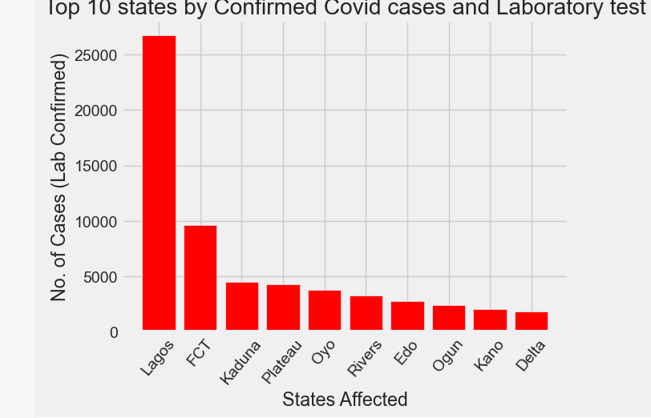

Fig1: Top 10 states in terms of Confirmed Covid cases by Laboratory test

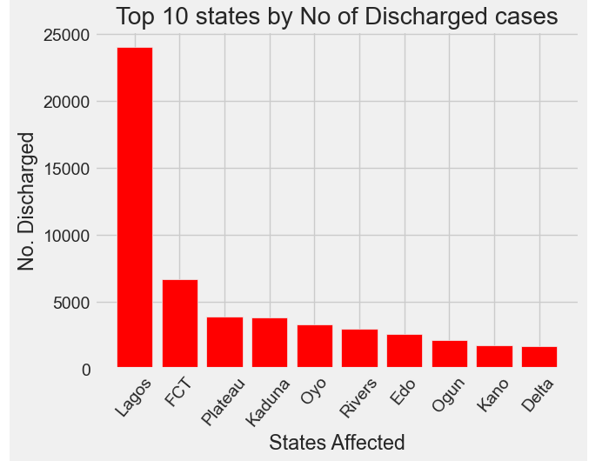

Fig2: Top ten states in terms of discharged cases

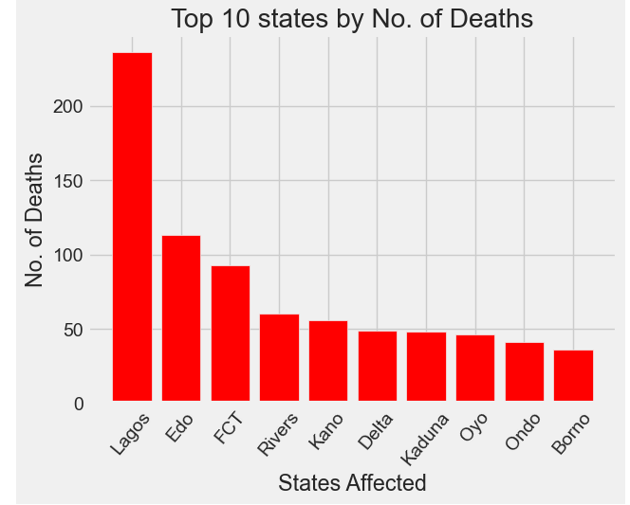

Fig3: Top ten states by death cases

### Daily infection rate

### Daily infection rate was plotted using the .diff() function, this was plotted against date to determine the date with the highest infection rate using the .max() function

* .idxmax() was used to determine the date with the highest infection rate , this occurred
* 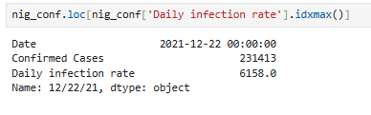

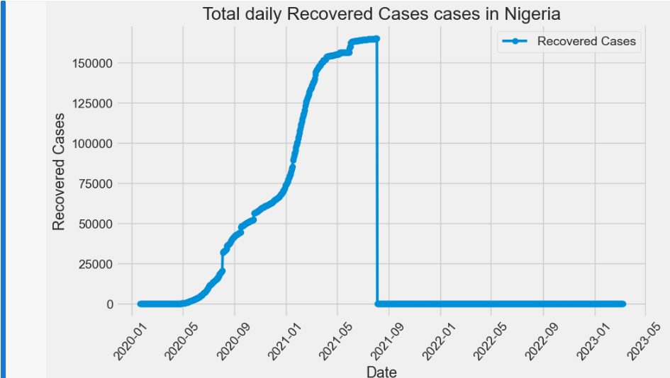

Fig4: Total daily recovered cases

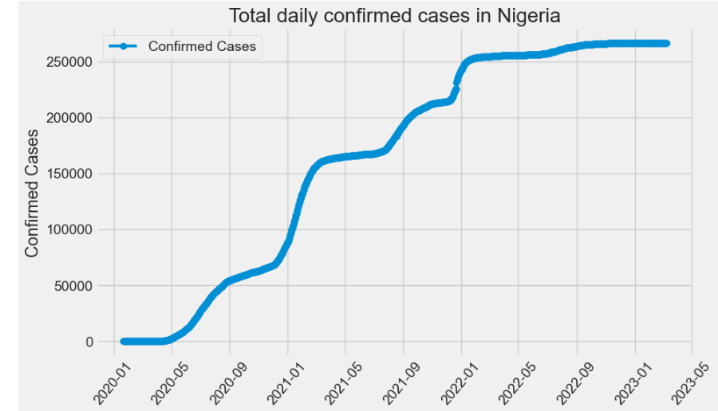

Fig5: Total daily confirmed cases

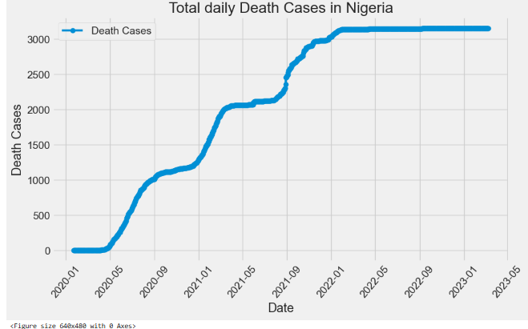

Fig6: Total daily Death cases

### Relationship between external dataset and ncdc covid-19 dataset

### To determine the relationship between ncdc and covid data set, the ncdc column was renamed to create a common column for the two data as states affected was renamed usind pd.rename(columns = {‘States Affected’: ‘states’}) to states, the dataset were then combined using the pd.merge() method on state column which is the common column for the two dataset

### The combined data set were then sorted in ascending order to arrange the top 10 covid confirmed confirmed cases

### Relationship between confirmed cases and Overall CCVI Index was determined and plotted using the axis1.plot, axis2=axis1.twinx()

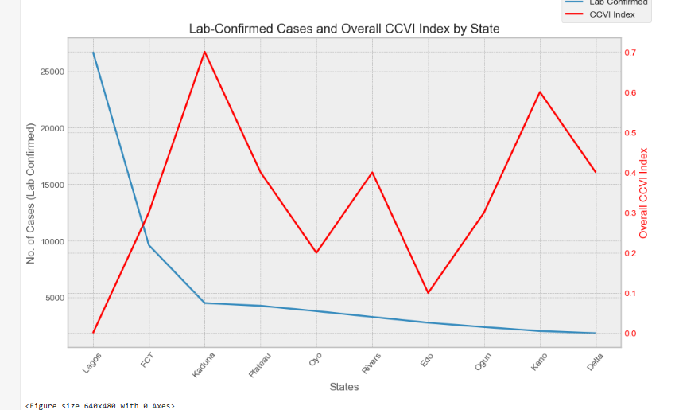

Fig7: Lab confirmed cases and overall ccvi Index state

### Observation

* Kaduna has the highest COVID-19 Community Vulnerability Index of 0.7,
* followed by Kano state with a ccvi of 0.6
* while Lagos state has the least ccvi

### Regression plot

### This was determined using the sns.regplot() between population density and confirmed cases

### x.corr(y), reg 0.5 was seen.

### Regression between number of death and confirmed cases was very high giving 0.9258264780306408 using x.corr(y)

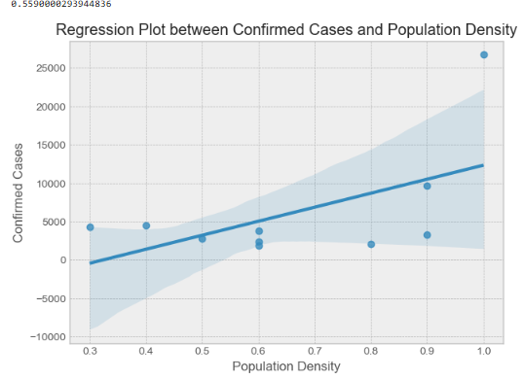

Fig8: Regression plot between confirmed and population density

## observation

* Correlation exist between confirmed cases and population density
* correlation is 0.5590000293944836

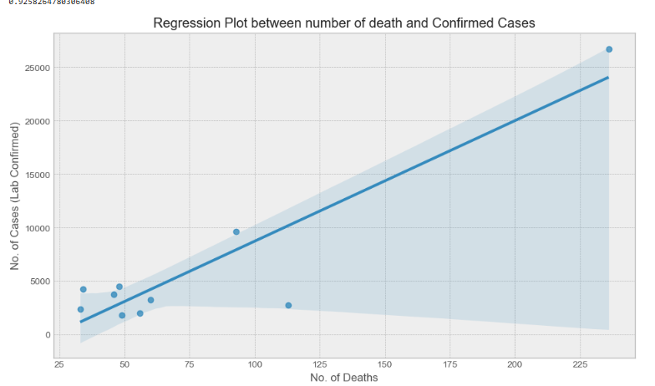

Fig9: Regression plot between number of death and confirmed cases

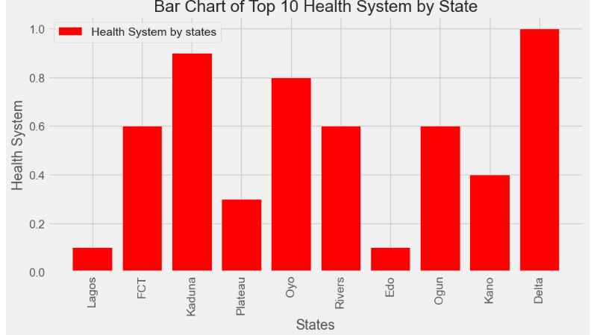

Fig10: Top 10 Health system by state

## **Observation**

Access to healthcare systems, and Healthcare system performance is:

* High in Lagos, Edo, and lowest in delta state and Borno state due to the high health system score
* This means that access to health system amongst covid confimed cases is higher in Lagos, and lowest in Borno and Delta state

### Effect of the Pandemic on the economy

### Real GDP value Pre-COVID-19 versus Real GDP in 2020 (COVID-19 Period, Q2 2020)

### Pandas.melt() was used to create the plot dataframe ,  quarter legend was to lower left.

### Using the axhline, a horizontal line was drawn through the graph at the value of Q2 2020

### Data was plotted using a barchart, figure size was set to (10,6) for a clearer view

### Axhline was set to colour red to highlight across the second quarter of the year.

* Real gdp was seen to be increasing across all quarters from 2014 till first quarter of 2020
* Due to the pandemic, a decline was observed in the second and the third quarter of 2020 compared to others years before the pandemic

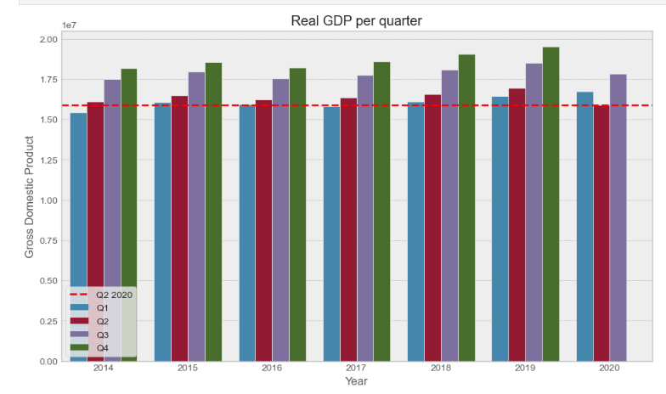

Fig11: Real GDP vs year

# Observation

* Real GDP was seen to be increasing across all quarters from 2014 till first quarter of 2020

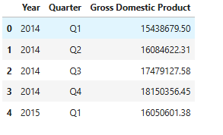

* Due to the pandemic, a decline was observed in the second and the third quarter of 2020 compared to others years before the pandemic, while the fourth quarter has a GDP value of 0.0 as shown below

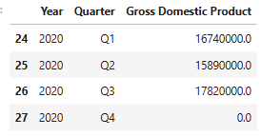

Budget analysis (initial vs revised)

* Barh chart() was used to visualize states with the highest revised and initial budget

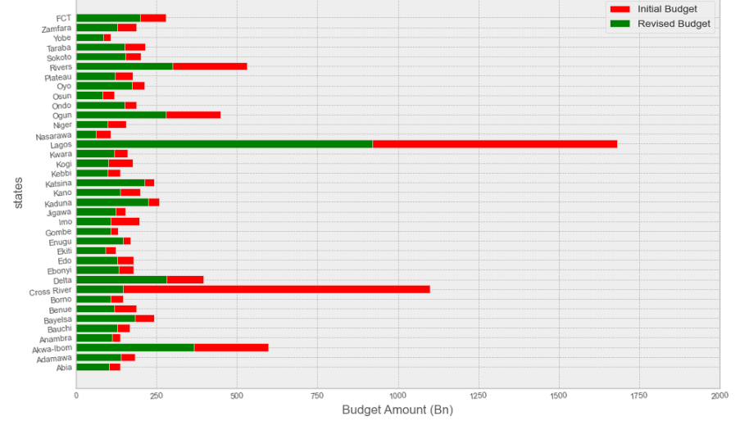

Fig12: Budget by states

# Observation

* Revised budget increased for most states except cross River state with a higher initial budget than the revised budget

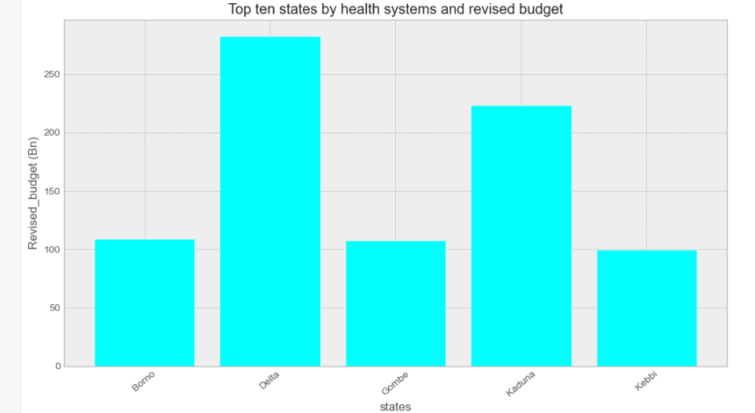

Fig13: Top states by health systems and revised budget

This was used to group the data by health system and top states

comcovid = covid_ext.nlargest(10,'Health System',keep='all').head()

Budcov = pd.merge(comcovid, Budget, on = 'states', how='inner')

# observation

Top states by health systems and revised budget

* Delta state has the highest health systems and revised budget,
* which means that access to and performance of health system is weak, but the state has a higher revised budget,
* followed by Borno state, having same health system value as delta state with second highest revised budged followed by Delta state.

Using this method, Convert date ranges to datetime

date_ranges = [(pd.to_datetime(start), pd.to_datetime(end)) for start, end in values]

# Create bins and labels

values = [

('2020-01-22', '2020-03-10'), pre-lockdown

('2020-03-11', '2020-07-04'), lockdown

('2020-07-05', '2020-12-30'), post-lockdown

]

Bins= pd.date_range(start='2020-01-22', end='2020-12-30', periods=5)

labels = ['Pre-Lockdown', 'Lockdown', 'Phase1','Phase2'], data were grouped into phases showing the prelockdown, lockdown and postlockdown , 'Phase1','Phase2', to compare confirmed cases and death cases due to the continuous spread of the infection.

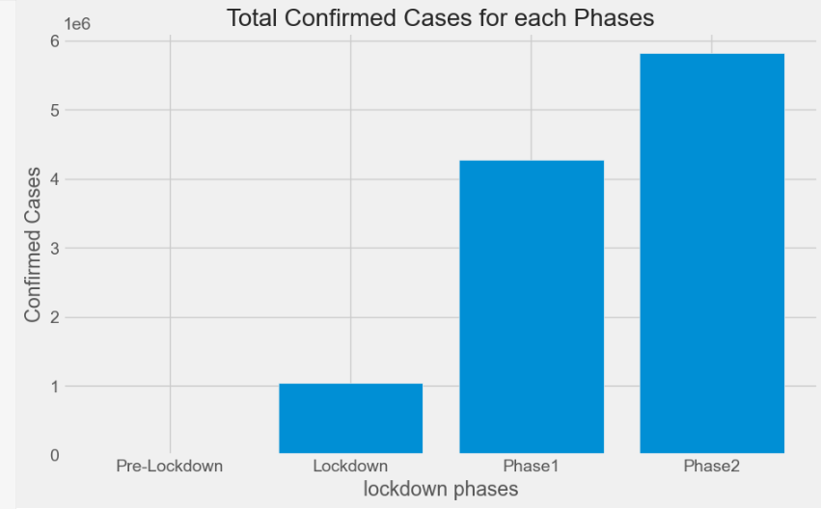

Fig14: Total confirmed cases for each phases

# observation

* Confirmed cases increased during the lock down phase down to phase2

Lockdown Phase Analysis

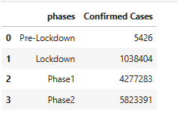

* - Pre-lock-down: Low confirmed cases
* - Lockdown, Phase1, Phase2: A very high confirmed cases were recorded as shown above
* Death cases during each phases;
* 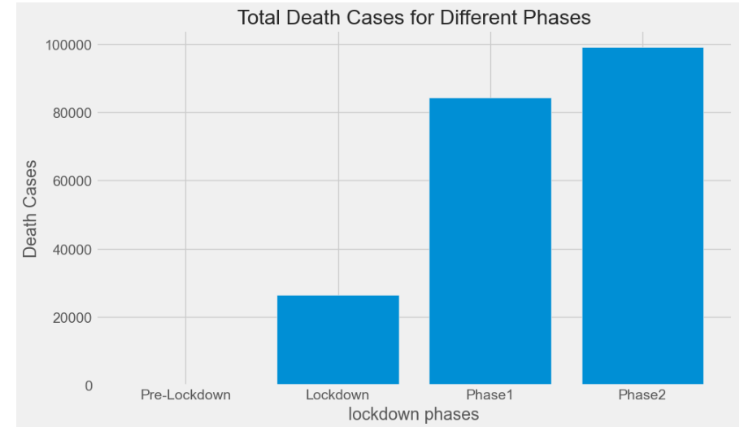

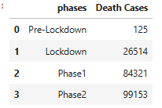

**Key Findings**

- High-Risk States: Lagos, Abuja, and Delta states have the highest confirmed cases

- Vulnerable States: Kaduna and Kano states have high COVID-19 Community Vulnerability Index scores

- Correlation Analysis: Moderate correlation (0.559) between confirmed cases and population density; High correlation (0.9258) between death cases and confirmed cases

- Healthcare Access: Lagos and Edo have high access to healthcare, while Delta and Borno states have low access

- Economic Impact: Real GDP declined in Q2 and Q3 2020 due to the pandemic; Revised budget increased for most states, except Cross River

**Research objectives**

- Analyze the spread of COVID-19 in Nigeria

- Identify high-risk states: Lagos, Abuja, and Delta states have the highest confirmed cases

- Analyze the impact of the pandemic on the country’s GDP: Real GDP was seen to be increasing across all quarters from 2014 till first quarter of 2020 when a decline was observed

- Determine the death rate and community infection rate: from the bar chart of the top ten states by death cases and confirmed cases, Lagos state was top on the list with over 25,000 confirmed cases and 236 death cases

- Assess the impact of lockdown phases on confirmed cases: prelockdown (Jan- Mar, 2020): Moderate confirmed cases

Based on the analysis performed, we’ve been able to answer the research objectives questions.

**Conclusion**

This analysis highlights the need for targeted interventions in high-risk states, increased healthcare funding, and continued monitoring of COVID-19 cases and economic impact. The findings inform policy decisions to mitigate the pandemic's effects and promote economic recovery in Nigeria.

**Recommendations**

- Targeted Interventions: High-risk states (Kaduna, Kano)

- Increased Healthcare Funding: States with low access (Delta, Borno)

- Continued Monitoring: COVID-19 cases and economic impact

- Data-Driven Policy-Making: Effective resource allocation

**Potential future work**

Conduct a comparative analysis with other African countries, develop predictive models to forecast COVID-19 cases, hospitalizations, and deaths, develop machine learning models to predict COVID-19 transmission dynamics.

**Analysis of the Economy**

Before the pandemic, Nigeria's economy was already facing challenges. The pandemic exacerbated these issues, leading to a decline in real GDP and increased poverty. Understanding the economic impact of the pandemic is crucial for effective policy-making.

**What This Subject Adds to the Body of Knowledge**

This analysis contributes to the understanding of COVID-19 dynamics in Nigeria, providing insights into high-risk states, healthcare access, and economic impact. It informs policy decisions and promotes data-driven decision-making.

**References**

1. Usman, S. О., Esоmchі, О. S., Nasiru, I. M., & Daniel, A. V. (2024). An assessment of COVID-19 and its impact on Nigeria’s socio-economic development. *Cogent Social Sciences*, *10*(1). <https://doi.org/10.1080/23311886.2024.2306700>

2. Nigerian National Bureau of Statistics (NBS). (2021). Nigerian Gross Domestic Product Report: Q1 2021. Abuja: Nigerian National Bureau of Statistics. Retrieved from https:// nigerianstat.gov.ng/download/1241027