Factors Associated With Hypertension Among Adults
A Biostatistical Analysis Using NHANES 2017–2018 Data
Academic Research Report
Public-health data-analysis project
Data source: NHANES 2017–2018

Abstract
This project examines factors associated with a project-defined high-blood-pressure classification among adults using public-use NHANES 2017–2018 data. Demographic, blood-pressure examination, body-measurement, and questionnaire files were linked using SEQN, and the demographic data were restricted to adults aged 18 years and older. The outcome was classified as 1 when the mean of available first-three systolic readings was at least 140 mmHg OR the mean of available first-three diastolic readings was at least 90 mmHg, and 0 otherwise. This operational definition is not a clinical diagnosis. A survey-weighted logistic regression model included age, sex, and BMI, using the examination weight, strata, and primary sampling unit variables. Age (OR 1.0617, 95% CI 1.0541–1.0693) and BMI (OR 1.0376, 95% CI 1.0257–1.0496) were positively associated with the outcome. The adjusted association for male sex was not statistically significant at the 5% level (OR 1.2358, 95% CI 0.9338–1.6354). Five-fold mean AUC was 0.7575 (SD 0.0128), and held-out test AUC was 0.75. Predictive metrics were sample-based and unweighted. Findings are associations, not proof of causation.

Contents
- 1. Introduction
- 2. Data and Methods
- 3. Results
- 4. Discussion
- 5. Limitations
- 6. Conclusion and Recommendations
- 7. Reproducibility and Portfolio
- References

1. Introduction

Background
Hypertension is an important public-health concern because persistently elevated blood pressure is associated with cardiovascular and kidney complications. Understanding how blood pressure varies with age and body-size characteristics can help describe population patterns and generate hypotheses for further research.

Research problem and aim
This project examines associations between age, sex, BMI, and a project-defined measured high-blood-pressure outcome among adults in NHANES 2017–2018. It also evaluates the discrimination and classification performance of a logistic regression model.

Objectives
- Describe the adult sample and blood-pressure/BMI patterns.
- Examine unadjusted outcome patterns by age, sex, and BMI.
- Fit a survey-weighted logistic regression adjusted for age, sex, and BMI.
- Report adjusted odds ratios and 95% confidence intervals.
- Evaluate predictive performance using cross-validation and a held-out test set.

Research questions
- How is age associated with the odds of meeting the outcome threshold?
- Is sex associated with the outcome after adjustment for age and BMI?
- How is BMI associated with the outcome after adjustment for age and sex?
- How well does the model distinguish outcome-positive from outcome-negative participants?

2. Data and Methods

Data source
The analysis used public-use NHANES 2017–2018 Demographics (DEMO_J), Blood Pressure Examination (BPX_J), Blood Pressure Questionnaire (BPQ_J), and Body Measures (BMX_J) files, linked using SEQN. NHANES uses a complex, multistage probability sampling design.

Study population
The demographic file contained 9,254 records. Restricting to adults aged 18 years or older yielded 5,856 records. A total of 5,247 adults had at least one available reading among the first three systolic and diastolic measurements; 609 had no available readings for the derived mean outcome.

Outcome definition
Mean systolic and diastolic pressures were calculated from available readings 1–3. The outcome was 1 if mean systolic pressure was ≥140 mmHg OR mean diastolic pressure was ≥90 mmHg, 0 otherwise, and missing if either derived mean was unavailable. Counts were 1,239 outcome-positive, 4,008 outcome-negative, and 609 missing. The fourth reading was not automatically included because it is an additional reading when necessary. This outcome is a project-defined classification, not a clinical diagnosis.

Predictors
- Age: RIDAGEYR, in years.
- Sex: RIAGENDR recoded as Male/Female, with Female as reference.
- BMI: BMXBMI, in kg/m².

Survey-weighted regression
The final association model used survey::svyglm with a quasibinomial family: measured_high_bp ~ RIDAGEYR + sex + BMXBMI. The survey design included SDMVPSU (primary sampling unit), SDMVSTRA (stratum), and WTMEC2YR (examination weight). Odds ratios were obtained by exponentiating coefficients; 95% confidence intervals were obtained by exponentiating coefficient confidence limits.

Prediction evaluation
Recorded five-fold AUC values were 0.7442, 0.7523, 0.7602, 0.7526, and 0.7781 (mean 0.7575; SD 0.0128). Held-out test AUC was 0.75. At threshold 0.1835941, the confusion matrix contained 498 true negatives, 308 false positives, 50 false negatives, and 180 true positives. The resulting classification metrics were unweighted sample metrics.

3. Results

Exploratory findings
- Adult sample size was 5,856; median age was 51 years and mean age was about 49.89 years.
- Among participants with observed outcomes, 1,239 met the threshold and 4,008 did not.
- Unweighted proportions meeting the threshold were 23.37% for females and 23.87% for males; unweighted chi-square p = 0.6933.
- The observed proportions by age group were 5.67% (18–39), 23.62% (40–59), 36.75% (60–79), and 54.0% (age 80; 350 participants with observed outcomes). Unweighted age-group chi-square p < 0.001.
- Mean BMI was 29.34 in the outcome-negative group and 30.76 in the outcome-positive group; unweighted Welch t-test p ≈ 2.54 × 10⁻⁸. BMI–mean systolic correlation was 0.153.

Table 1. Survey-weighted adjusted odds ratios
Predictor | Adjusted OR | 95% CI
Age (per year) | 1.0617 | 1.0541–1.0693
Male vs female | 1.2358 | 0.9338–1.6354
BMI (per unit) | 1.0376 | 1.0257–1.0496

Predictive performance
- Five-fold mean AUC: 0.7575 (SD 0.0128).
- Held-out test AUC: 0.75.
- Accuracy: 65.44%; sensitivity: 78.26%; specificity: 61.79%.
- Positive predictive value: 36.89%; negative predictive value: 90.88%; F1 score: 0.5014.

Table 2. Test-set confusion matrix
Actual class | Predicted 0 | Predicted 1
0 (not high BP) | 498 | 308
1 (high BP) | 50 | 180

4. Discussion

Main findings
Age and BMI were positively associated with the project-defined outcome after adjustment for the other model variables. The estimated association for male sex was not statistically significant at the 5% level. The prediction model showed moderate discrimination, with test AUC 0.75.

Interpreting metrics
Sensitivity of 78.3% means that about 78% of test-set outcome-positive participants were identified. Specificity of 61.8% means that about 62% of outcome-negative participants were correctly classified. PPV was 36.9%, while NPV was 90.9%; these values depend on outcome prevalence and the selected threshold.

Causality
This is an observational, cross-sectional analysis. Results cannot establish that age or BMI causes high blood pressure.

5. Limitations

Limitations
- The outcome is based on a single examination session and is not a clinical diagnosis or evidence of persistent hypertension.
- Some derived means used fewer than three readings; missing BP and BMI data reduced the analytic sample.
- Exploratory comparisons and predictive metrics reported here are unweighted and should not be described as nationally representative estimates.
- The classification threshold of 0.1835941 should be documented with its selection method and selected without using test outcomes.
- Cross-validation should be reviewed to ensure that data splitting and survey-design handling are appropriate.
- The model includes only age, sex, and BMI; nonlinear effects, interactions, calibration, sensitivity analyses, and external validation could be considered.

6. Conclusion and Recommendations

Conclusion
In NHANES 2017–2018 adults, age and BMI were positively associated with the project-defined measured high-BP outcome in the survey-weighted model. Sex was not statistically significant at the 5% level. The prediction model had moderate discrimination (test AUC 0.75), with sensitivity higher than specificity at the selected threshold.

Recommendations
- Clearly distinguish the project-defined outcome from clinical hypertension diagnosis.
- Use survey-weighted estimates for population-level descriptive claims and label unweighted predictive metrics appropriately.
- Document threshold selection and keep it separate from final test-set evaluation.
- Assess model calibration and consider alternative predictors and sensitivity analyses.
- Do not use this model as a clinical decision tool.

7. Reproducibility and Portfolio

Suggested repository contents
- README.md — project overview and findings.
- analysis.R — clean, commented analysis script.
- hypertension_logistic_regression_results.csv — odds-ratio table.
- Academic and portfolio report PDFs.
- figures/ — saved visualisations.

Reproducibility note
Before public release, rerun the full R script from a clean session and verify sample counts, outcome definition, threshold selection, and all reported metrics.

References

NHANES overview
National Center for Health Statistics. NHANES continuous survey overview, 2017–2018. https://wwwn.cdc.gov/nchs/nhanes/continuousnhanes/overview.aspx?BeginYear=2017

BP examination documentation
National Center for Health Statistics. NHANES 2017–2018 Blood Pressure (BPX_J) Data Documentation. https://wwwn.cdc.gov/Nchs/Data/Nhanes/Public/2017/DataFiles/BPX_J.htm

BP questionnaire documentation
National Center for Health Statistics. NHANES 2017–2018 Blood Pressure Questionnaire (BPQ_J) Data Documentation. https://wwwn.cdc.gov/Nchs/Data/Nhanes/Public/2017/DataFiles/BPQ_J.htm

Visual Results
The figures below complement the statistical results. The blood-pressure outcome is a project-defined classification based on measurements from one examination session, not a clinical diagnosis. Unless otherwise stated, exploratory plots and predictive evaluation are unweighted sample-based results.
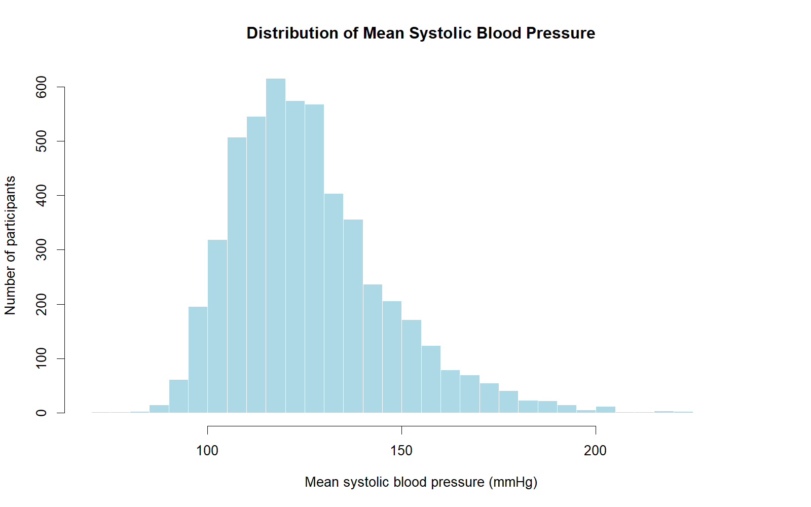
Figure 1. Distribution of mean systolic blood pressure
The distribution is concentrated around the lower-to-middle range, with a right tail showing fewer participants at higher mean systolic readings.
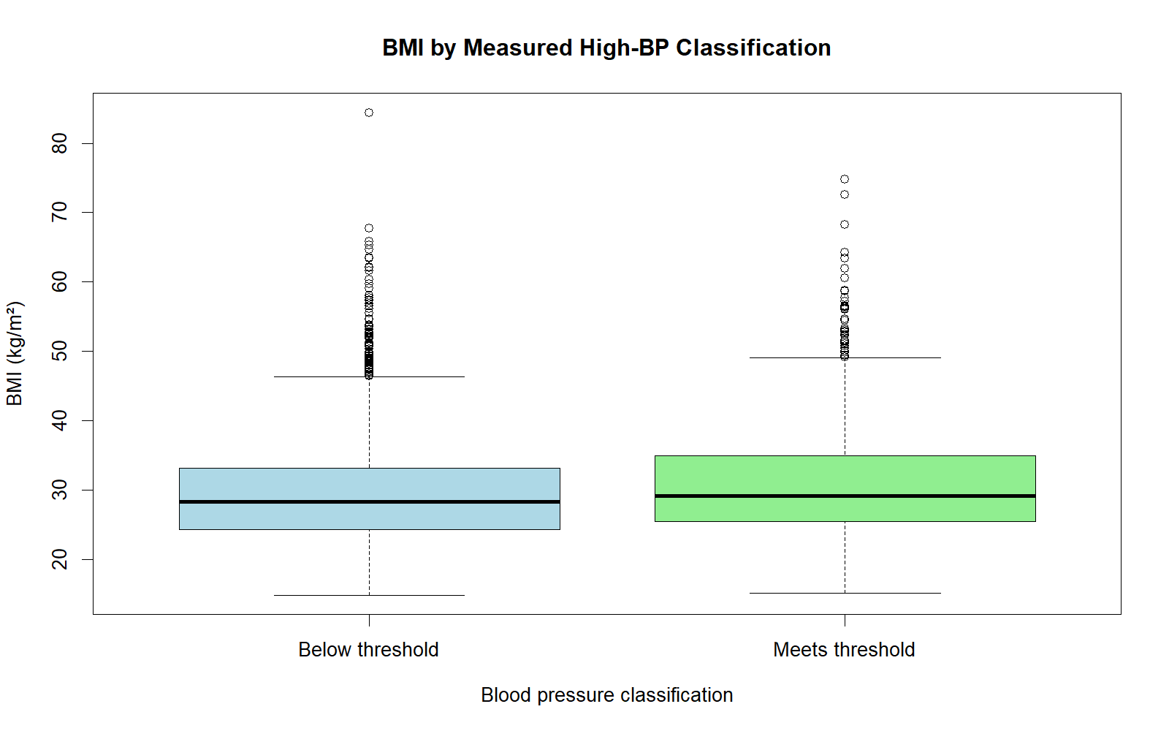
Figure 2. BMI by project-defined measured high-BP classification
The outcome-positive group has a somewhat higher median BMI. The distributions overlap substantially, so BMI alone does not distinguish the groups.
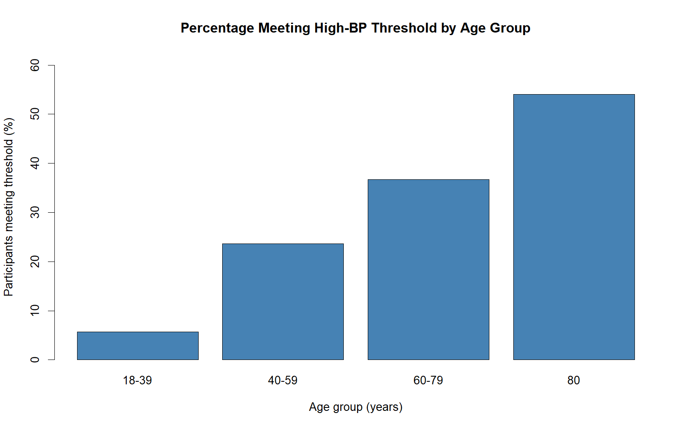
Figure 3. Percentage meeting the project-defined high-BP threshold by age group
The observed percentage increases across age groups in this unweighted sample. The age-80 group has a smaller sample and missing outcomes should be kept in mind.
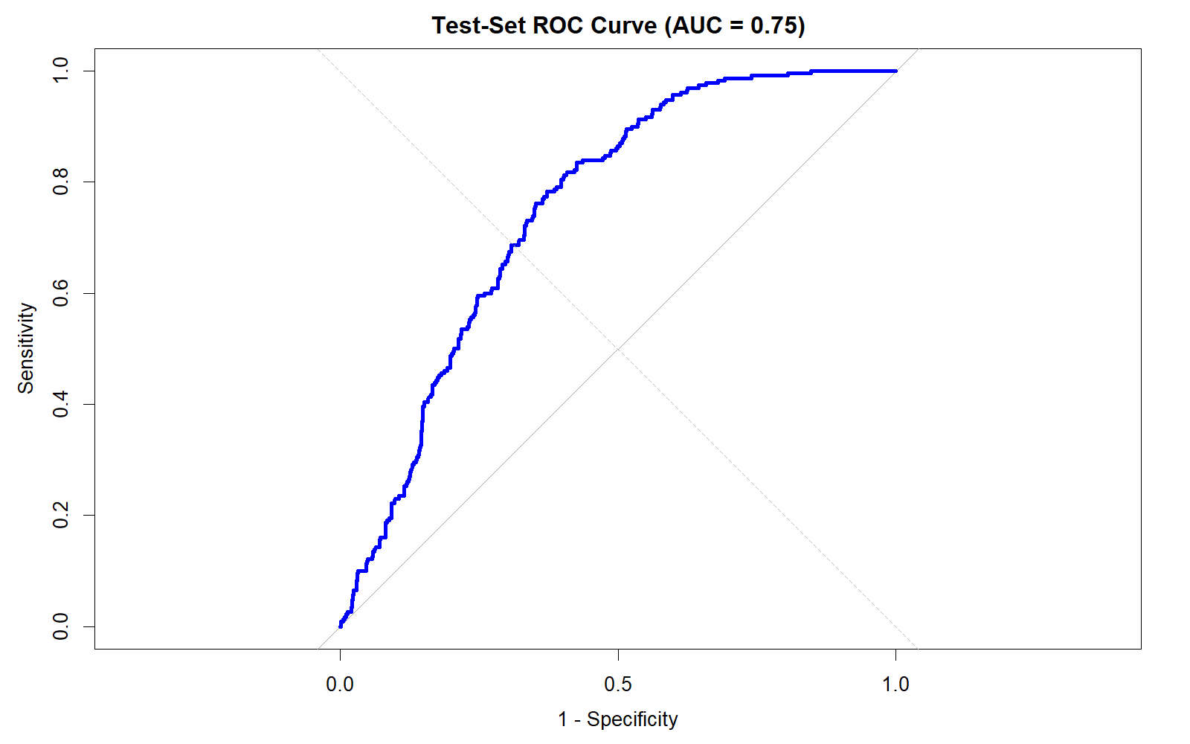
Figure 4. ROC curve for the held-out test set
The test-set AUC is 0.75, indicating moderate discrimination in this sample. These predictive metrics are unweighted.
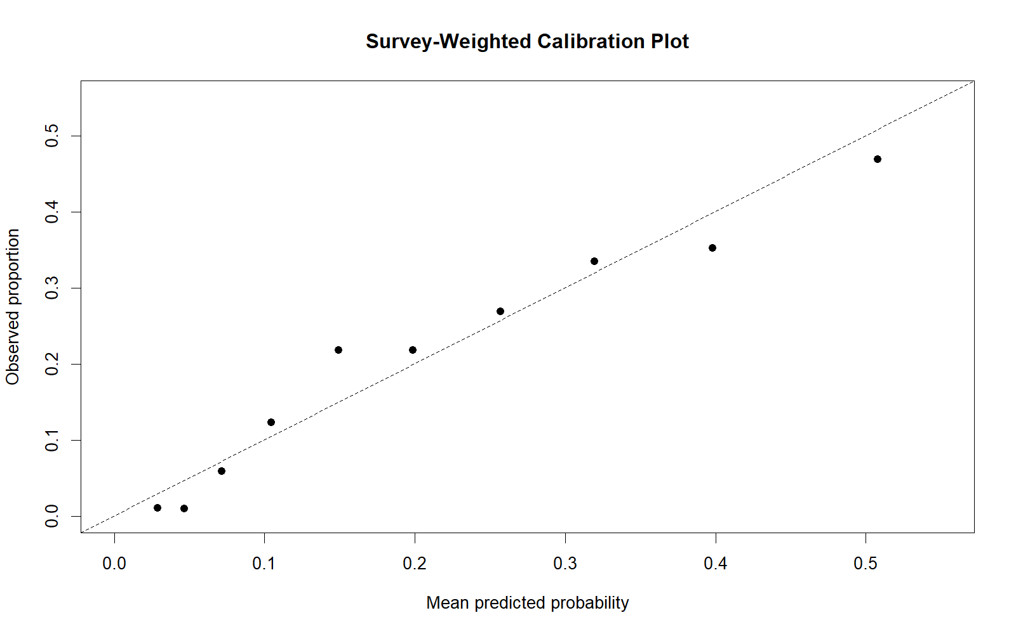
Figure 5. Calibration plot
Points nearer the diagonal indicate closer agreement between predicted and observed proportions. The plot should be interpreted in light of the calibration grouping and weighting procedure used.

