Factors Associated With Hypertension Among Adults
A Biostatistical Analysis Using NHANES 2017–2018 Data
Professional Portfolio Brief

Project overview
This project uses NHANES 2017–2018 public-use data to examine how age, sex, and BMI relate to a project-defined high-blood-pressure classification among adults.

Methods
Demographics, blood-pressure examination, body-measurement, and questionnaire files were linked by SEQN. The outcome was defined as mean available first-three systolic pressure ≥140 mmHg OR mean available first-three diastolic pressure ≥90 mmHg. Survey-weighted logistic regression used age, sex, BMI, examination weights, strata, and primary sampling units. Prediction was evaluated separately.

Key findings
- Age: adjusted OR 1.0617 (95% CI 1.0541–1.0693).
- BMI: adjusted OR 1.0376 (95% CI 1.0257–1.0496).
- Male vs female: adjusted OR 1.2358 (95% CI 0.9338–1.6354); not statistically significant at 5%.
- Mean five-fold AUC 0.7575 (SD 0.0128); test AUC 0.75.
- At the selected threshold, accuracy 65.4%, sensitivity 78.3%, specificity 61.8%, and F1 0.501.

Skills demonstrated
R programming, data import and joins, data cleaning, descriptive statistics, exploratory analysis, survey-weighted logistic regression, odds-ratio interpretation, cross-validation, ROC/AUC, confusion-matrix metrics, and research reporting.

Limitations
The outcome is an operational study definition, not a clinical diagnosis. Predictive metrics are sample-based and unweighted. The study is observational, so associations do not establish causation. Threshold selection and cross-validation procedures should be verified before publication.

Conclusion
Age and BMI were positively associated with the project's high-BP outcome after adjustment. The model showed moderate discrimination. The project demonstrates a public-health data-analysis workflow while distinguishing population inference from predictive evaluation.

Adjusted odds ratios
Predictor | Adjusted OR | 95% CI
Age (per year) | 1.0617 | 1.0541–1.0693
Male vs female | 1.2358 | 0.9338–1.6354
BMI (per unit) | 1.0376 | 1.0257–1.0496

Data documentation
NHANES overview: https://wwwn.cdc.gov/nchs/nhanes/continuousnhanes/overview.aspx?BeginYear=2017
BPX_J documentation: https://wwwn.cdc.gov/Nchs/Data/Nhanes/Public/2017/DataFiles/BPX_J.htm
BPQ_J documentation: https://wwwn.cdc.gov/Nchs/Data/Nhanes/Public/2017/DataFiles/BPQ_J.htm

Project Visualisations
The figures below complement the statistical results. The blood-pressure outcome is a project-defined classification based on measurements from one examination session, not a clinical diagnosis. Unless otherwise stated, exploratory plots and predictive evaluation are unweighted sample-based results.
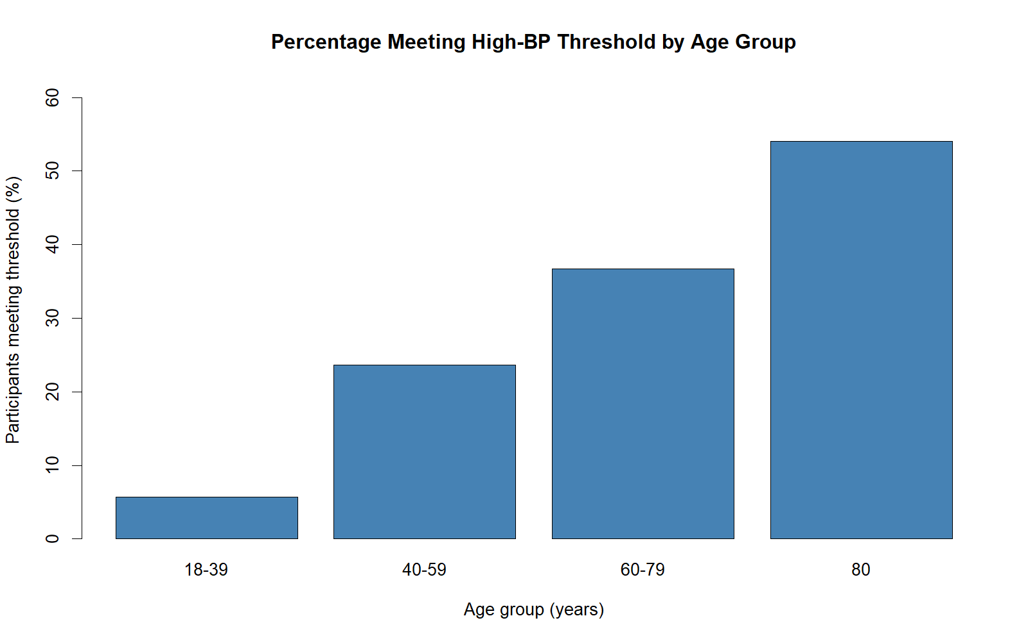
Figure 3. Percentage meeting the project-defined high-BP threshold by age group
The observed percentage increases across age groups in this unweighted sample. The age-80 group has a smaller sample and missing outcomes should be kept in mind.
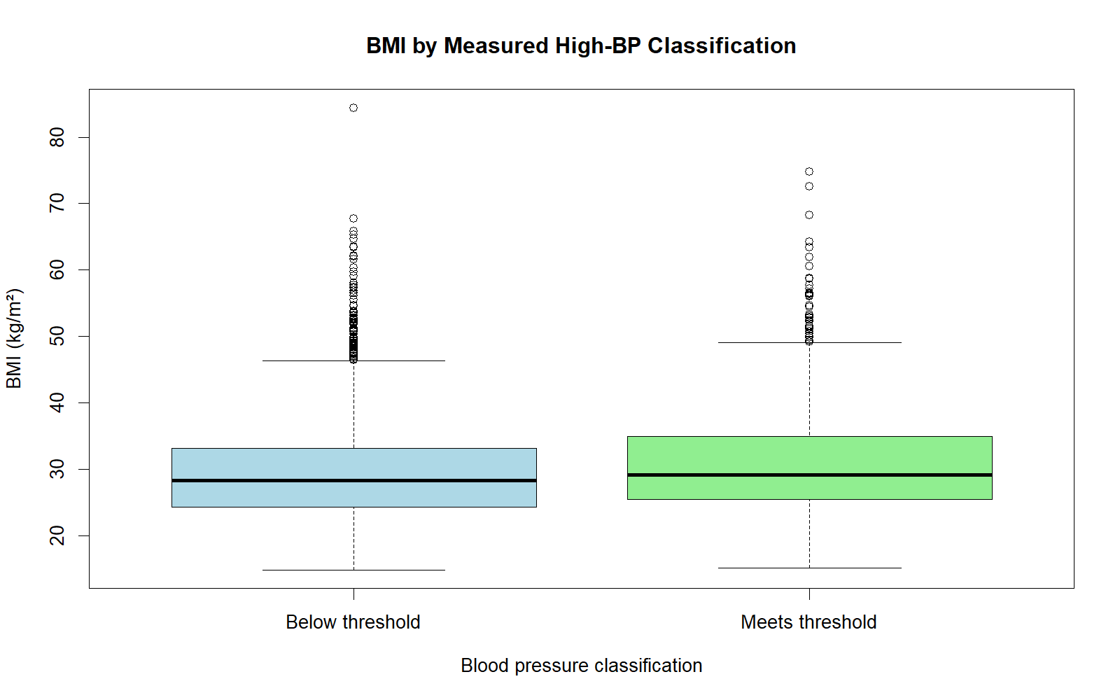
Figure 2. BMI by project-defined measured high-BP classification
The outcome-positive group has a somewhat higher median BMI. The distributions overlap substantially, so BMI alone does not distinguish the groups.
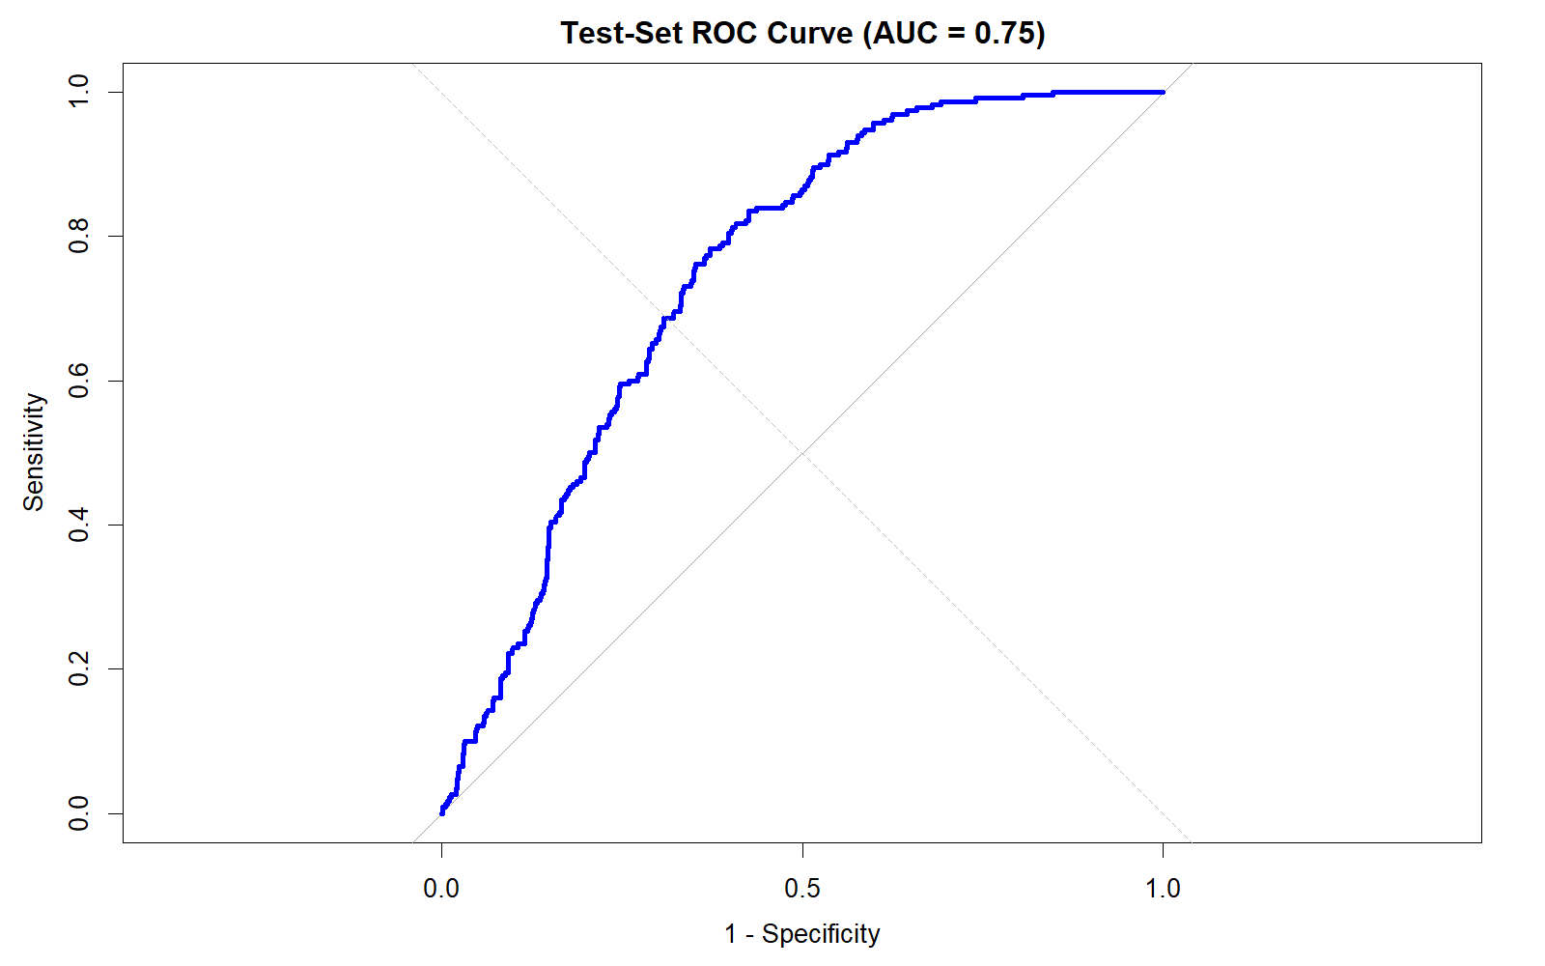
Figure 4. ROC curve for the held-out test set
The test-set AUC is 0.75, indicating moderate discrimination in this sample. These predictive metrics are unweighted.
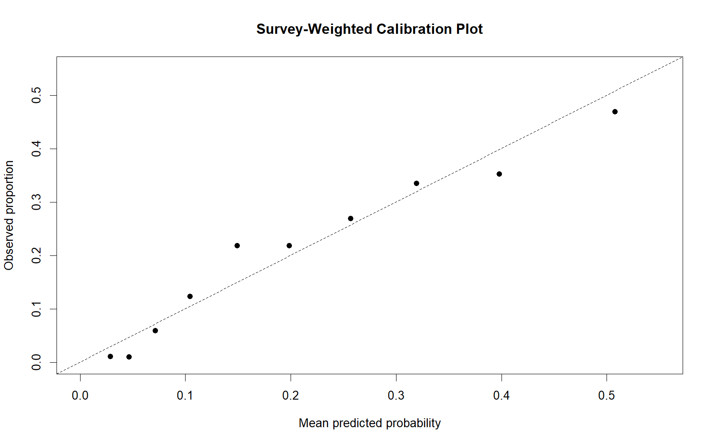
Figure 5. Calibration plot
Points nearer the diagonal indicate closer agreement between predicted and observed proportions. The plot should be interpreted in light of the calibration grouping and weighting procedure used.

