FACTORS ASSOCIATED WITH A PROJECT-DEFINED HIGH BLOOD-PRESSURE CLASSIFICATION AMONG ADULTS
A Biostatistical Analysis of NHANES 2017–2018 Data
Akinwale Oluwaferanmi Emmanuel
Academic Research Report
Data source: NHANES 2017–2018

Abstract
This study examined associations between age, sex, body mass index (BMI), and a project-defined high blood-pressure classification among adults using public-use National Health and Nutrition Examination Survey (NHANES) 2017–2018 data. The DEMO_J, BPX_J, BMX_J, and BPQ_J files were linked using participant identifier SEQN. Adults aged 18 years or older were included. Mean systolic and diastolic blood pressure were derived from available readings among the first three measurements. The outcome was positive when mean systolic pressure was ≥140 mmHg or mean diastolic pressure was ≥90 mmHg. This operational outcome is not a clinical diagnosis.
A survey-weighted logistic regression model included age, sex, and BMI and incorporated the examination weight, strata, and primary sampling units. Age was positively associated with the outcome (adjusted odds ratio [aOR] 1.0617, 95% confidence interval [CI] 1.0541–1.0693), as was BMI (aOR 1.0376, 95% CI 1.0257–1.0496). The adjusted association for male sex compared with female sex was not statistically significant at the 5% level (aOR 1.2358, 95% CI 0.9338–1.6354). The held-out test-set area under the receiver operating characteristic curve (AUC) was 0.75. Predictive metrics were unweighted and should not be interpreted as nationally representative. The cross-sectional analysis identifies associations rather than causal effects.

1. Introduction
Hypertension is an important public-health concern because persistently elevated blood pressure is associated with cardiovascular and renal complications. Population-based data can describe patterns in measured blood pressure and help investigate demographic and anthropometric factors associated with elevated readings.
Aim and objectives. The aim was to examine associations between age, sex, BMI, and a project-defined high blood-pressure classification among adults in NHANES 2017–2018. Objectives were to describe the adult sample; examine unadjusted patterns by age, sex, and BMI; estimate adjusted associations using survey-weighted logistic regression; and assess discrimination of a logistic-regression prediction model.
Research questions. Are age, sex, and BMI associated with the project-defined outcome after adjustment for the other included variables? How well does the prediction model distinguish participants classified as outcome-positive from those classified as outcome-negative?

2. Materials and Methods
Study design and data source. This was a cross-sectional secondary analysis of publicly available NHANES 2017–2018 data. NHANES uses a complex, multistage probability sampling design. The analysis used the DEMO_J demographic, BPX_J blood-pressure examination, BMX_J body-measures, and BPQ_J blood-pressure questionnaire files. Records were linked using SEQN.
Study population. The demographic file contained 9,254 records. Restricting the data to adults aged 18 years or older yielded 5,856 records. Blood-pressure outcome data were available for 5,247 adults; 609 had no available readings for the derived mean outcome. Complete-case analysis for the adjusted model included 5,176 participants with non-missing outcome and model predictors.
Outcome definition. Mean systolic and diastolic blood pressure were calculated from available readings among the first three examination readings. The outcome was coded as 1 when mean systolic pressure was ≥140 mmHg or mean diastolic pressure was ≥90 mmHg, and 0 otherwise. The outcome was missing when the required derived mean values were unavailable. Among adults, 1,239 were outcome-positive, 4,008 were outcome-negative, and 609 had a missing outcome. This is a project-defined analytical classification based on one examination session, not a diagnosis of persistent hypertension.
Predictors. Age was measured in years using RIDAGEYR. Sex was recoded from RIAGENDR as male or female, with female as the reference category. BMI was measured in kg/m² using BMXBMI.
Statistical analysis. Descriptive summaries and unadjusted comparisons characterised the sample. The main association model was survey-weighted logistic regression fitted in R using the survey package and a quasibinomial family. The model included age, sex, and BMI. The survey design incorporated WTMEC2YR as the examination weight, SDMVSTRA as the stratum identifier, and SDMVPSU as the primary sampling unit identifier. Adjusted odds ratios were obtained by exponentiating model coefficients; 95% confidence intervals were obtained by exponentiating coefficient confidence limits. Statistical significance was assessed at the 5% level.
Prediction assessment. Recorded five-fold cross-validation AUC values were 0.7442, 0.7523, 0.7602, 0.7526, and 0.7781 (mean 0.7575; standard deviation 0.0128). The held-out test-set AUC was 0.75. At the recorded classification threshold of 0.1835941, the test-set confusion matrix contained 498 true negatives, 308 false positives, 50 false negatives, and 180 true positives. Predictive metrics were unweighted sample metrics. The threshold-selection method and survey-aware handling of resampling require further documentation before predictive results are used for operational purposes.
Ethical considerations. The study used de-identified, publicly available NHANES data and involved no direct participant contact or collection of new personal data. Users should follow the data-use guidance published by the National Center for Health Statistics.

3. Results
Descriptive and unadjusted findings. The adult sample included 5,856 participants, with a mean age of approximately 49.89 years and a median age of 51 years. Of participants with an observed outcome, 1,239 met the project-defined threshold and 4,008 did not. The unweighted proportion classified as outcome-positive was 23.37% among females and 23.87% among males; the unweighted chi-square test did not indicate evidence of a difference by sex (p = 0.6933).
The unweighted outcome-positive proportions increased across age groups: 5.67% for ages 18–39, 23.62% for ages 40–59, 36.75% for ages 60–79, and 54.0% among participants recorded as age 80 with observed outcomes. NHANES top-codes age at 80 for participants aged 80 years or older; this category should not be interpreted as one exact age. The unweighted age-group comparison had p < 0.001. Mean BMI was 29.34 kg/m² in the outcome-negative group and 30.76 kg/m² in the outcome-positive group (unweighted Welch test p ≈ 2.54 × 10⁻⁸). The correlation between BMI and mean systolic pressure was 0.153.
Survey-weighted multivariable model. After adjustment for age, sex, and BMI, age and BMI were positively associated with the project-defined outcome. The adjusted association for male sex was not statistically significant at the 5% level.

Table 1. Survey-weighted adjusted odds ratios
Predictor | Adjusted OR | 95% CI | p-value
Age (per year) | 1.0617 | 1.0541–1.0693 | 5.37 × 10⁻¹⁰
Male vs female | 1.2358 | 0.9338–1.6354 | ≈ 0.10
BMI (per kg/m²) | 1.0376 | 1.0257–1.0496 | 3.03 × 10⁻⁵
Note. Predictive metrics are unweighted sample estimates and depend on the classification threshold.

Table 2. Held-out test-set classification results
Metric | Estimate
AUC | 0.75
Accuracy | 65.44%
Sensitivity | 78.26%
Specificity | 61.79%
Positive predictive value | 36.89%
Negative predictive value | 90.88%
F1 score | 0.5014
Note. Predictive metrics are unweighted sample estimates and depend on the classification threshold.

Figures
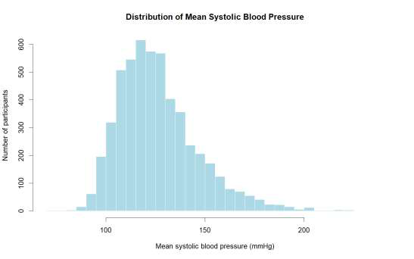
Figure 1. Distribution of mean systolic blood pressure among adult participants with available measurements.
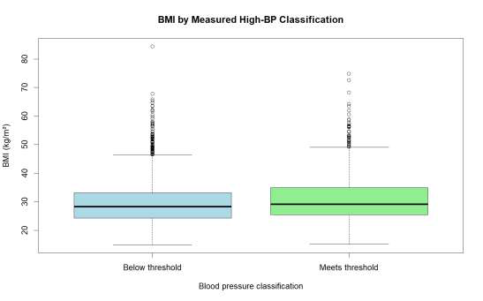
Figure 2. Body mass index by project-defined blood-pressure outcome group.
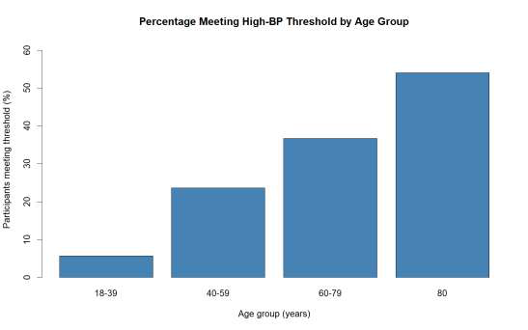
Figure 3. Observed proportion meeting the project-defined blood-pressure threshold by age group. The age-80 category is top-coded in NHANES.
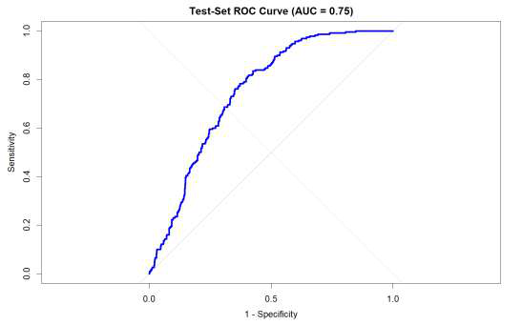
Figure 4. Receiver operating characteristic curve for the held-out test set; AUC = 0.75.
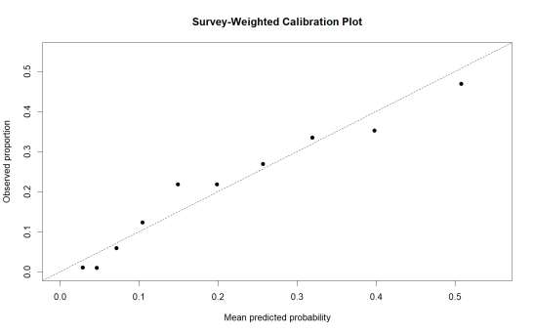
Figure 5. Exploratory calibration plot. Calibration results are not treated as definitive because the grouping and weighting procedure has not been fully verified.

4. Discussion
The survey-weighted model indicated higher odds of meeting the project-defined blood-pressure threshold with increasing age and BMI, conditional on the other variables in the model. The age odds ratio of 1.0617 corresponds to approximately 6.2% higher adjusted odds per additional year of age. The BMI odds ratio of 1.0376 corresponds to approximately 3.8% higher adjusted odds per one-unit increase in BMI (kg/m²). These are odds comparisons, not percentage-point increases in probability, and they do not establish causation.
The adjusted estimate for male sex was above one, but its confidence interval included one and the association was not statistically significant at the 5% level. The prediction model showed moderate discrimination in the held-out test set, with an AUC of 0.75. At the recorded threshold, sensitivity was 78.26% and specificity was 61.79%; positive predictive value was 36.89%, while negative predictive value was 90.88%. These measures depend on sample composition and the chosen threshold. They are unweighted sample metrics and should not be interpreted as population-representative estimates.

5. Limitations
The outcome is a project-defined threshold based on measurements from one examination session, not a clinical diagnosis. Some blood-pressure values were missing, and the number of available readings could vary by participant. Descriptive comparisons and prediction metrics reported here are unweighted and should not be used for nationally representative claims.
The prediction threshold was recorded as 0.1835941, but its selection method must be documented and confirmed to have been determined without using held-out test outcomes. The cross-validation workflow should be reviewed for appropriate separation of training and test data and for handling of the survey design. The calibration plot is exploratory because its grouping and weighting procedure has not been fully verified. External validation was not established. Finally, the model included only age, sex, and BMI, so other relevant factors may not be accounted for.

6. Conclusion
In this analysis of NHANES 2017–2018 adults, age and BMI were positively associated with a project-defined high blood-pressure classification in a survey-weighted logistic regression model adjusted for sex and the other included predictor. The adjusted association for male sex was not statistically significant at the 5% level. The prediction model achieved a held-out test AUC of 0.75, although the reported classification metrics were unweighted and aspects of threshold selection and resampling require further documentation. These findings describe associations in cross-sectional survey data and should not be used as a clinical decision tool.

References
Centers for Disease Control and Prevention, National Center for Health Statistics. National Health and Nutrition Examination Survey (NHANES): 2017–2018 Survey Data and Documentation. https://wwwn.cdc.gov/nchs/nhanes/continuousnhanes/overview.aspx?BeginYear=2017
Centers for Disease Control and Prevention, National Center for Health Statistics. NHANES 2017–2018 Blood Pressure Examination Data (BPX_J). https://wwwn.cdc.gov/Nchs/Data/Nhanes/Public/2017/DataFiles/BPX_J.htm
Centers for Disease Control and Prevention, National Center for Health Statistics. NHANES 2017–2018 Blood Pressure Questionnaire Data (BPQ_J). https://wwwn.cdc.gov/Nchs/Data/Nhanes/Public/2017/DataFiles/BPQ_J.htm
Centers for Disease Control and Prevention, National Center for Health Statistics. NHANES 2017–2018 Demographics Data (DEMO_J) and Body Measures Data (BMX_J). Available through the NHANES 2017–2018 survey documentation portal: https://wwwn.cdc.gov/nchs/nhanes/continuousnhanes/overview.aspx?BeginYear=2017

