**SIWES 2023 2020/32557 OLALEYE KAZEEM DOLAPO**

**REPORT OF STUDENT INDUSTRIAL WORK EXPERIENCE SCHEME UNDERTAKEN AT FLORIN TECH**



**BY**

**OLALEYE KAZEEM DOLAPO**

**2020/32557**



**SUBMITTED TO THE DEPARTMENT OF COMPUTER SCIENCE**

**FACULTY OF COMPUTING AND INFORMATION TECHNOLOGY (FOCIT)**

**(MARCH 2023 - AUGUST 2023)**

**SUBMISSION LETTER**

Osun State University ,

Faculty of Communication

Information and Technology,

Department of Computer Science,

Osogbo, Osun State,

December 2023.

The Director,

Industrial Training Co-ordinator unit,

Osun State University,

P.M.B 4494, Osogbo,

Osun State.

**LETTER OF SUBMISSION**

I hereby submit the six months technical report of my Student Industrial

Work Experience Scheme which was undertaken at FLORIN TECH from the

month of March to August, 2023.

Thank you.

Yours Faithfully,

OLALEYE KAZEEM

**CERTIFICATION**

This is to show that the technical report on student's industrial work

experience scheme at Florin Tech, No 25 Olutimilehin street Ejigbo, Lagos

State is prepared, compiled and submitted by Olaleye Kazeem D to the

department of Computer Science having been accepted on meeting part of

the requirement for the award of B.SC Computer Science.

................................................................

**Industrial Based Supervisor.**

**(Head of Department)**

**DEDICATION**

This report is dedicated to my parents MR & MRS OLALEYE for all their

support throughout my education, and lecturers for impacting

knowledge into me and lastly my friends.

**ACKNOWLEDGEMENTS**

All praise, adoration and thanks goes to my creator, for the life in me, divine health, guidance and protection throughout my life and this program. I would like to acknowledge my parents and all staffs i met at my IT placement for making my experience an interesting and life changing one.

Finally, I will like to acknowledge everybody that contributed positively in one way or another during the course of my training.

**ABSTRACT**

Florin tech is a monotechnic running a 2year diploma in computer Engineering, Digital Multimedia Marketing and Computer Hardware Engineering.

Florin Tech Academy Limited is in the industry of ICT training and Consultancy. Florin Technology Academy Limited was started in 2021.

This Industrial Training was aimed at getting oneself acquitted with the work environment, getting to see the practical aspect of what we study in the classroom and also preparing us for the future ahead.

In the course of my training, I had various responsibilities like doing various projects under graphic designs, photoshop and Corel draw for Florin Tech and many more.

My Industrial Training gave me a proper exposure especially in the area of providing solution as its solely based on IT. My Industrial Training has also changed my method of thinking whenever problem occurs, my training has given me ability to keep calm and think whenever am faced with a problem. Inside this report, contains full details of the organization where the student industrial training scheme took place, the working principles of equipment’s and tools used in various departments of the organization and the knowledge gained.

Contents

**CHAPTER 1** 5

**STUDENTS INDUSTRIAL WORK EXPERIENCE SCHEME** 5

**INTRODUCTION** 5

**1.1 OBJECTIVES** 6

**1.2 BODIES INVOLVED IN THE MANAGEMENT OF SIWES AND THEIR ROLES** 6

**CHAPTER 2** 7

BRIEF INTRODUCTION ABOUT FLORIN TECH ACADEMY 7

**Works & Service** 8

**COMPANY’S ORGANIZATIONAL STRUCTURE** 8

**CHAPTER 3** 9

**EXPERIENCE OBTAINED DURING TRAINING** 10

**CHAPTER 4** 10

**Corel Draw** 10

**ADOBE PHOTOSHOP** 13

**CHAPTER 5** 25

**RECOMMENDATION/CONCLUSION:** 25

**CHALLENGES FACED BY STUDENT** 25

**CONTRIBUTIONS** 25

**CONCLUSION** 25

# **CHAPTER 1**

# **STUDENTS INDUSTRIAL WORK EXPERIENCE SCHEME**

# **INTRODUCTION**

In earlier years of science and technology education system in Nigeria, students were graduating from their respective institutions without acquiring any technical knowledge or work experience, which enables then to be exposed to the work force of the society. It was with this view that students undergo science and technology related courses in different institutions were required to partake in the SIWES program, designed to expose and prepare students of universities and other tertiary institution for the industrial work situation they are likely to face after graduation. The student industrial work experience scheme (SIWES) was established by the industrial trust fund (ITF) in 1973 with the aim of exposing students to machines and ways to safeguarding the work areas and workers in the industries, offices, laboratories, hospitals and other organization. The main reason behind the embackment of students in SIWES was to expose them to the industrial environment and enable them to develop occupational competencies so that they can readily contribute their quota to national economic and technological development after graduation. The major benefit to students who partake in the SIWES are the skills and competencies acquired. The relevant production skills remain a part of the recipients of industrial training as life-long assets which cannot be taken away from them. This is because the knowledge and skills acquired through training are internalized and become relevant when required to perform jobs.

# **1.1 OBJECTIVES**

The Industrial training funds policy of 1973 which established SIWES outlined the objectives of the scheme.

The objectives are to:

I. Provide students with an opportunity to apply their theoretical knowledge in real work situation, thereby bridging the gap between university work and actual practice.

II. Prepare students for work situations they are likely to face after graduation.

III. Enables students to work methods and techniques in handling equipment and machinery that may not be available in the university.

IV. Provides an avenue for students in higher institutions of learning to acquire industrial skills and experience during their course of study.

V. Make transition from university to the world of work easier and thus enhance contest for later job placement.

# **1.2 BODIES INVOLVED IN THE MANAGEMENT OF SIWES AND THEIR ROLES**

The Federal Government, the industrial training fund (ITF), the supervising agency, National Universities Commission (NUC),Employers of labor and institution has specific roles to play in the management of SIWES.

The roles are:

I. The federal government: * To provide adequate funds to the ITF through the federal ministry of industrial for the scheme

* To make it mandatory for all ministries and companies to offer places to students in accordance with the provisions of decree No. 47 of 1971 as amended in 1990

* Formulate policies to guide the running of the scheme nationally

II. The Industrial Trust Funds (ITF): * Formulate policies and guidelines on SIWES for distribution to all the SIWES participating bodies and provide logistic materials needed to administer the scheme

* Organize orientation programs for students prior to attachment and provide information on companies for attachment and assist in industrial placement of students.

* Supervise students on industrial attachment and accept and process Master and Placement lists from institutions and supervising agencies

* Vet and process students logbooks and ITF Form 8

III. The Supervisory Agency (NUC,NABTEB, etc.)

* To ensure the establishment and accreditation of SIWES unit/directorate in institutions under their jurisdiction

* To vet and approve Master & placement lists of students from participating institution and forward same to ITF

* Fund SIWES directorate in participating institutions and to direct for the appointment of full-time SIWES coordinator/Director.

* Review programs qualified from SIWES regularly and participate in the biennial SIWES Conferences and seminars in conjunction with ITF.

Therefore, the success of SIWES depends on the efficiency of the

Ministry, ITF, Institution, Employers of labor and general public

involved in articulation and management of the program. Thus the

evaluation of SIWES in tertiary institution in meeting up with the

needs for the establishment of program is necessary.

# **CHAPTER 2**

# BRIEF INTRODUCTION ABOUT FLORIN TECH ACADEMY

Florin tech is a monotechnic running a 2year diploma in computer Engineering, Digital Multimedia Marketing and Computer Hardware Engineering.

Florin Tech Academy Limited is in the industry of ICT training and Consultancy. Florin Technology Academy Limited was started in 2021.

Mission Statement

The mission statement of the school is to provide opportunities for learning by creating enabling environment that help young people harness their full potentials and develop them into useful member of the society.

School History

Florin High school was founded in September, 2003 by Mr. & Mrs. Idowu Bode (the proprietor & proprietress) the school started with 100 students on the 15th of September, 2003 with a vision to provide qualitative and standard education for the young people who are our tomorrow's leaders.

Future Plans for the School

Continuously promote academic excellence and extend it further away from out immediate environment. To go international, have boarding facilities and school bus, and to go for an excursion to Britain, England. To expand the population of the school and to build future Ambassadors of the nation

## **Works & Service**

* ICT Training and Consultancy
* Multi-Media Marketing
* Computer Hardware Engineering
* School

## **COMPANY’S ORGANIZATIONAL STRUCTURE**

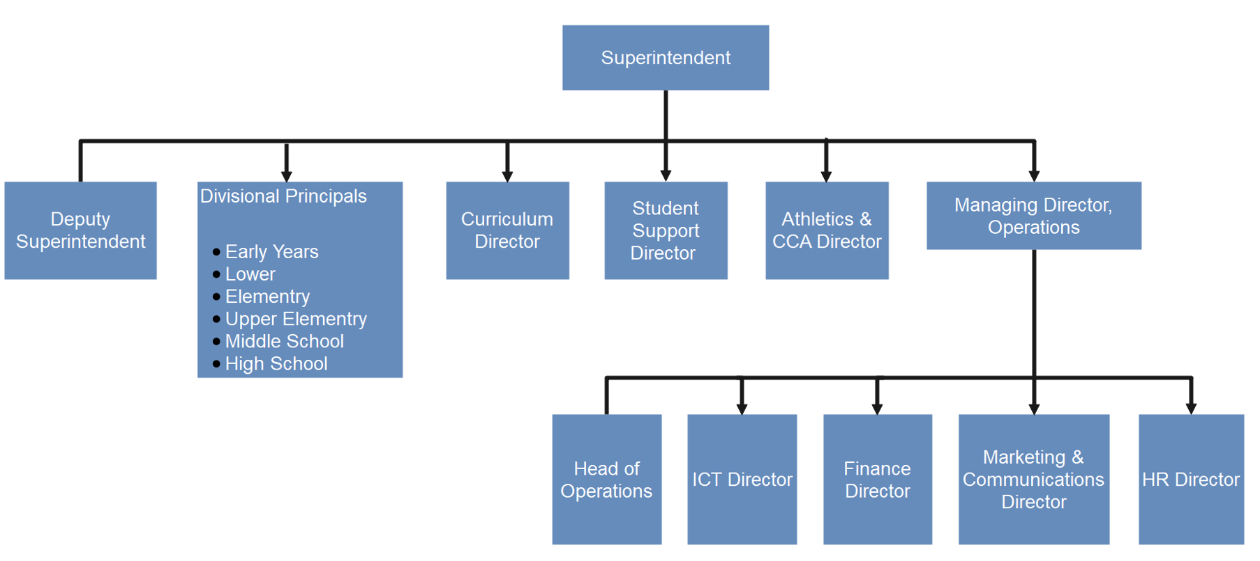

# **CHAPTER 3**

# **EXPERIENCE OBTAINED DURING TRAINING**

* Corel Draw **(Chapter 4).**
* Photoshop**(Chapter 4).**

# **CHAPTER 4**

# **Corel Draw**

CorelDRAW is a popular vector graphics editor developed and marketed by Corel Corporation. It has been a prominent tool in the graphic design industry for many years, offering a wide range of features and capabilities. Here's a brief description of CorelDRAW:

Vector Graphics Editor:

CorelDRAW is primarily used for creating vector graphics. Unlike raster graphics, which are composed of pixels, vector graphics are based on mathematical equations, allowing for scalability without loss of quality. This makes CorelDRAW suitable for various design projects, including logos, illustrations, and print materials.

User-Friendly Interface:

The software boasts an intuitive and user-friendly interface, making it accessible to both beginners and experienced designers. The workspace is customizable, allowing users to arrange tools and panels based on their preferences.

Versatile Tools:

CorelDRAW provides a comprehensive set of tools for drawing, shaping, and editing vector objects. It includes tools for creating lines, curves, shapes, text, and more. Users can manipulate objects with precision, applying various transformations and effects.

Typography Features:

Typography is a strong suit of CorelDRAW, offering a variety of text-related features. Users can work with a wide range of fonts, apply formatting, adjust spacing, and even convert text to curves for further customization.

Advanced Color Management:

The software supports advanced color management, allowing designers to work with a diverse color palette. Users can create and manage color swatches, apply gradients, and work in various color modes, including RGB and CMYK.

Compatibility:

CorelDRAW supports a variety of file formats, ensuring compatibility with other design software. It can import and export files in formats such as AI, PSD, PDF, and more. This facilitates collaboration and seamless integration into different workflows.

Design for Print and Web:

CorelDRAW is versatile enough to cater to both print and web design needs. Designers can create layouts for brochures, business cards, posters, websites, and other multimedia projects.

Regular Updates:

Corel Corporation regularly releases updates and new versions of CorelDRAW, introducing enhancements, bug fixes, and additional features to keep the software current and competitive.

Overall, CorelDRAW is a powerful and versatile graphic design tool that has become a staple in the toolkit of many designers and illustrators around the world

CorelDRAW provides a diverse set of tools to facilitate graphic design, illustration, and layout creation. Here's an overview of some of the key tools commonly used in CorelDRAW:

Pick Tool:

The Pick Tool is a fundamental tool for selecting, moving, and transforming objects. It allows users to resize, rotate, and skew objects with precision.

Shape Tool:

The Shape Tool is used for manipulating the nodes and control handles of vector objects. It enables users to customize the shape of objects by adjusting their curves and angles.

Text Tool:

The Text Tool is essential for adding and editing text in a design. It provides options for formatting, aligning, and styling text. Users can also convert text to curves for further customization.

Rectangle/Ellipse Tool:

These tools are used for creating basic shapes like rectangles and ellipses. Users can draw these shapes directly or create custom shapes by combining and modifying them.

Pen Tool:

The Pen Tool is crucial for creating precise and custom vector paths. Designers can draw freehand lines or create complex shapes by placing anchor points and adjusting curves.

Knife Tool:

The Knife Tool allows users to cut objects along freehand or straight paths. This is useful for dividing shapes into separate pieces or creating intricate designs.

Zoom Tool:

The Zoom Tool helps users navigate and focus on specific areas of their design. It allows for easy zooming in and out of the workspace.

Eyedropper Tool:

The Eyedropper Tool is used to sample colors from existing objects in the design. This makes it easy to maintain a consistent color scheme throughout the project.

Fill and Outline Tools:

These tools are used to apply fill colors and outlines to objects. Users can choose from a variety of fill types, gradients, and outline styles.

Interactive Tools (Blend, Contour, Distortion, etc.):

CorelDRAW includes a set of interactive tools that enable users to apply dynamic effects to objects. For example, the Blend Tool can create smooth transitions between objects, while the Contour Tool can add a contour or offset to shapes.

Mesh Fill Tool:

The Mesh Fill Tool allows users to create gradient-like fills with multiple color nodes, providing a realistic shading effect.

Transparency Tool:

The Transparency Tool is used to adjust the transparency level of objects, allowing for creative layering and blending effects.

These are just a few examples of the extensive toolkit available in CorelDRAW. The combination of these tools provides designers with the flexibility to create a wide range of professional-quality graphics and designs.

# **ADOBE PHOTOSHOP**

Adobe Photoshop is a powerful raster graphics editor widely used for image editing, graphic design, and digital art creation. The software comes equipped with a variety of tools that cater to the needs of photographers, designers, and artists. Here's an overview of some key tools and features in Photoshop:

1. Move Tool:

The Move Tool allows users to select and move objects within an image. It is fundamental for rearranging and repositioning elements.

2. Marquee Tools (Rectangular, Elliptical):

Used for making selections in rectangular or elliptical shapes. Useful for isolating specific areas of an image.

3. Lasso Tools (Lasso, Polygonal Lasso, Magnetic Lasso):

These tools enable freehand or controlled selection of irregular shapes. The Magnetic Lasso snaps to the edges of contrasting elements.

4. Magic Wand Tool:

Selects areas of similar color with a single click, making it efficient for quick selections based on color similarity.

5. Crop Tool:

Allows users to trim or resize the canvas of an image, helping to focus on specific areas.

6. Brush Tool:

Essential for digital painting and adding details. Users can choose from various brush shapes, sizes, and hardness levels.

7. Clone Stamp Tool:

Clones parts of an image, allowing users to duplicate or remove elements seamlessly.

8. Eraser Tool:

Erases parts of an image or layer. The background becomes transparent when erasing on a layer with transparency.

9. Gradient Tool:

Creates smooth transitions between colors. Useful for creating gradients in backgrounds or adding subtle effects.

10. Pen Tool:

- Creates precise paths and shapes. Useful for creating complex selections and vector shapes.

11. Text Tool:

- Adds and edits text in an image. Users can customize fonts, sizes, colors, and other text attributes.

12. Eyedropper Tool:

- Samples colors from the image, allowing users to match or pick colors for painting and editing.

13. Hand Tool:

- Navigates around the image, especially useful when zoomed in.

14. Zoom Tool:

- Zooms in and out of the image for detailed editing.

15. Layers Panel:

- Manages layers, allowing users to organize and control the stacking order of elements.

16. Adjustment Layers:

- Non-destructive adjustments for color, brightness, contrast, and more.

17. Filters:

- A wide range of filters for various effects, such as blurring, sharpening, and distorting.

18. Selection and Masking Tools:

- Tools like Quick Selection, Refine Edge, and Masking options help create precise selections.

19. 3D Tools (in Photoshop Extended version):

- Tools for working with 3D models and creating 3D text and objects.

Adobe Photoshop is continually updated, and new features are introduced regularly to meet the evolving needs of its user base. Its versatility and extensive toolset make it a go-to software for a wide range of creative projects.

SOME OF THE PROJECTS BUILT WITH MY EXPERIENCE GAINED:



BANNER FOR A WORDPRESS DEVELOPER TO EXPLAIN SERVICE

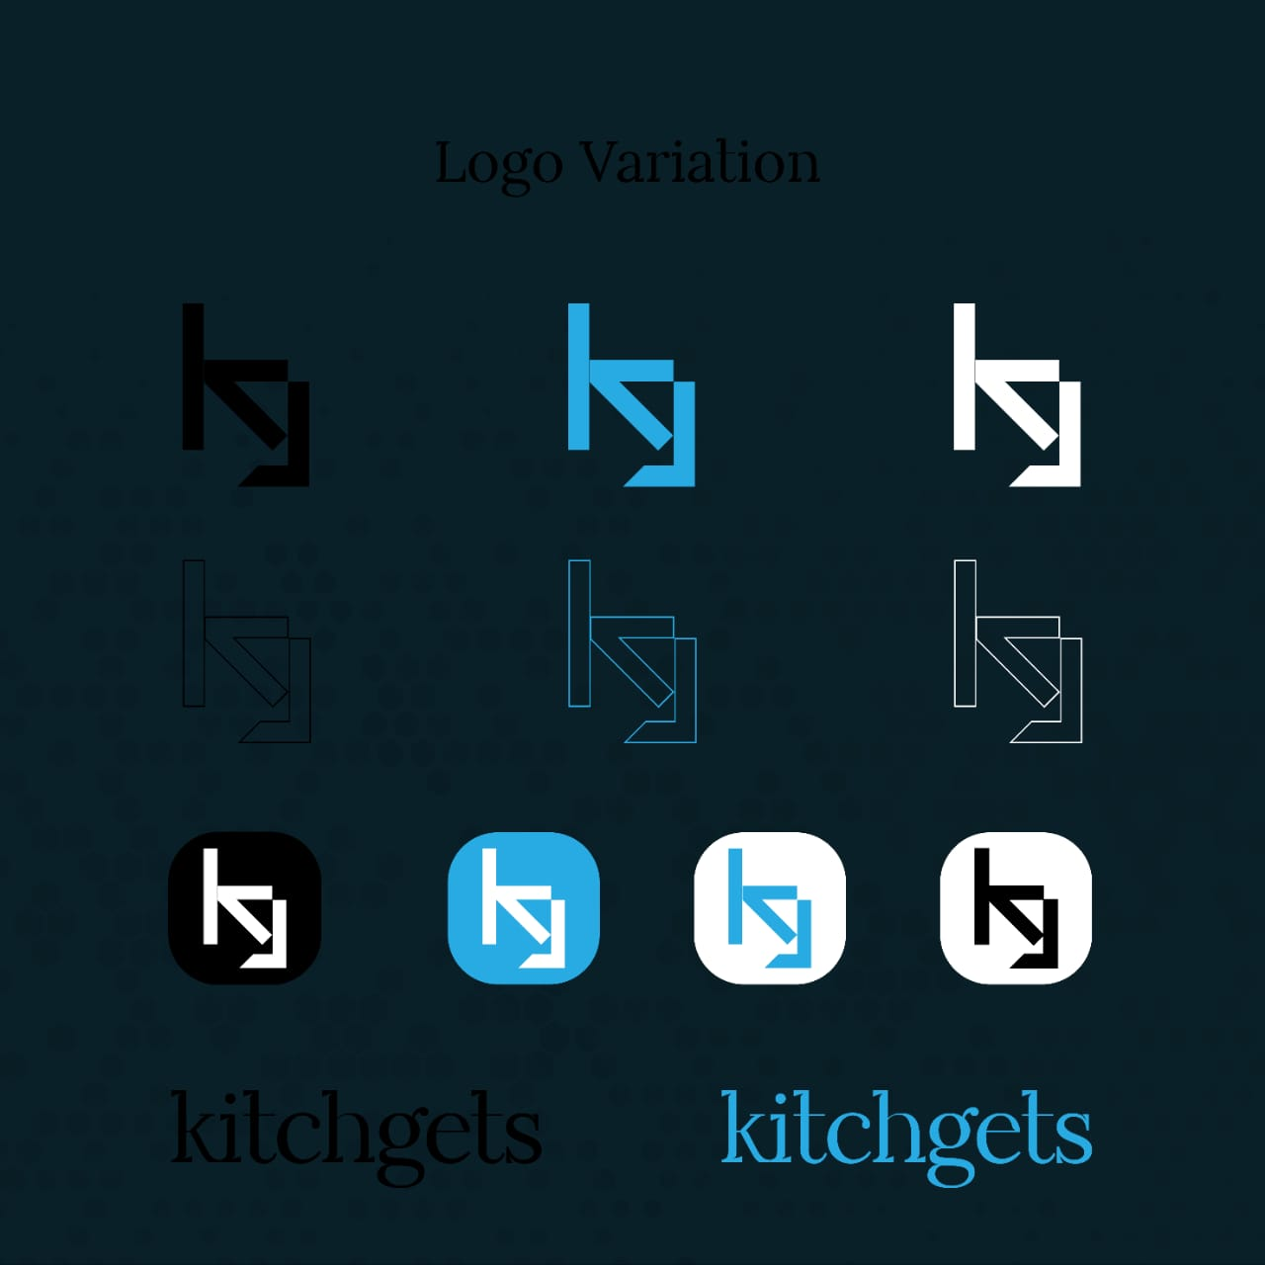

BRAND LOGO WITH VARIATIONS

BRAND LOGO



BRAND LOGO



BRAND LOGO

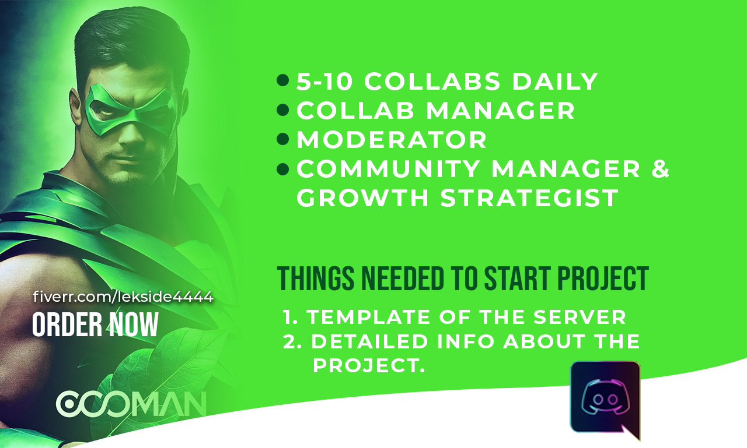

BANNER

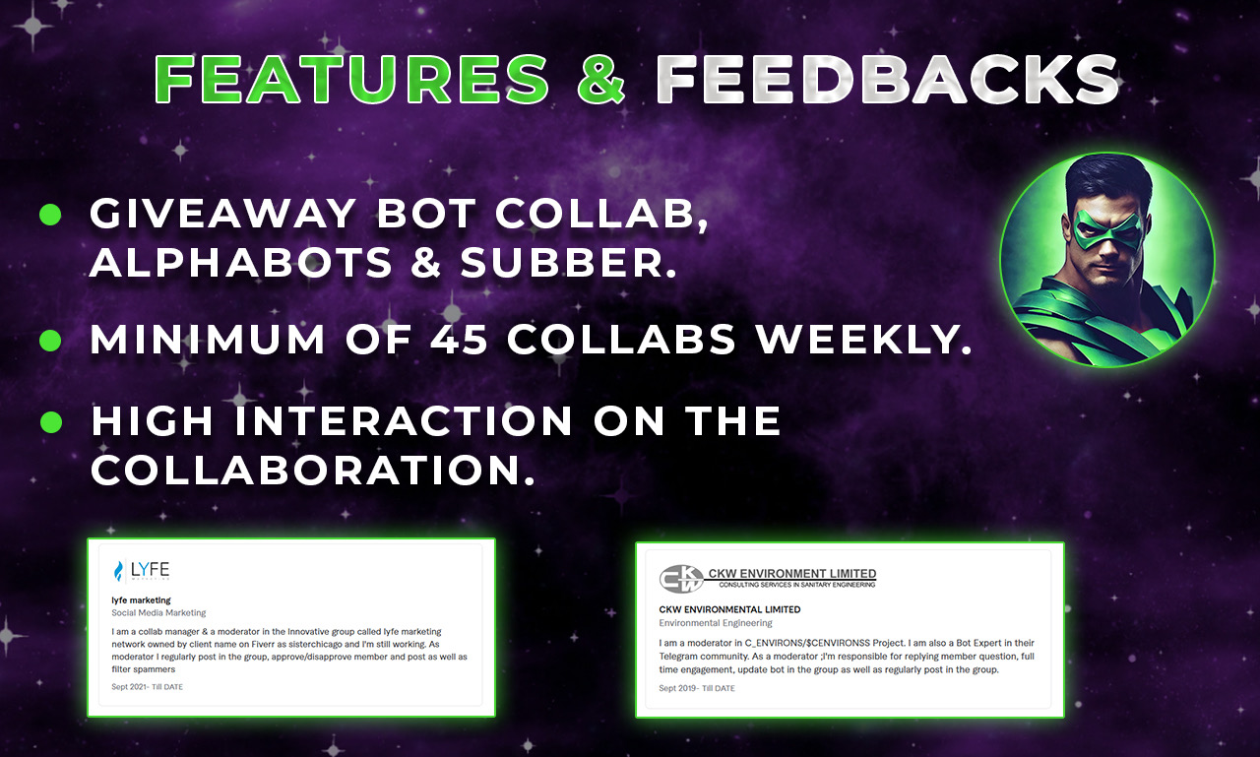

BANNER



BANNER



# 

# **CHAPTER 5**

# **RECOMMENDATION/CONCLUSION:**

This section discusses about the various challenge i faced as an intern, the various observations and contributions I made and also conclusion about my internship on a whole.

# **CHALLENGES FACED BY STUDENT**

ADJUSTING TO A COMPLETELY NEW ENVIRONMENT - The

most challenging part of my job was adjusting to a completely new environment. When I first arrived, I was excited to jump in and start doing meaningful work. However, the reality was that I had never been in an industrial environment before and I knew very little or nothing about the process. I discovered that I had a lot to learn.

# **CONTRIBUTIONS**

In review this internship has been an excellent and rewarding experience. I have been able to meet and network with so many people that I am sure will be able to help me with opportunities in the future.

My SIWES experience has indeed served its purpose as the initial idea of SIWES program was to not only expose the student to the real life work environment but to enable us students to educate ourselves about work ethics and ethos, mannerism and how to conduct ourselves in the work environment.

The industrial training illustrates what life is really like after school. It has really exposed me to what I obtainable in the industrial settings and I believe the experience gained would be put to good use in the nearest future. The training made me realize that there is much knowledge out there waiting to be gained. The knowledge gained during the six months of SIWES program was highly significant in the pursuit of my aspiration to be an Entrepreneur.

# **CONCLUSION**

In review this internship has been an excellent and rewarding experience. I have been able to meet and network with so many people that i’m sure will be able to help me with opportunities in the future.

My SIWES experience has indeed served its purpose as the initial idea of SIWES program was to not only expose the student to the real life work environment but to enable us students to educate ourselves about work ethics and ethos, mannerism and how to conduct ourselves in the work environment.

The industrial training illustrates what life is really like after school. It has really exposed me to what is obtainable in the industrial settings and i believe the experience gained would be put to good use in the nearest future. The training made me realize that there is much knowledge out there waiting to be gained.