[[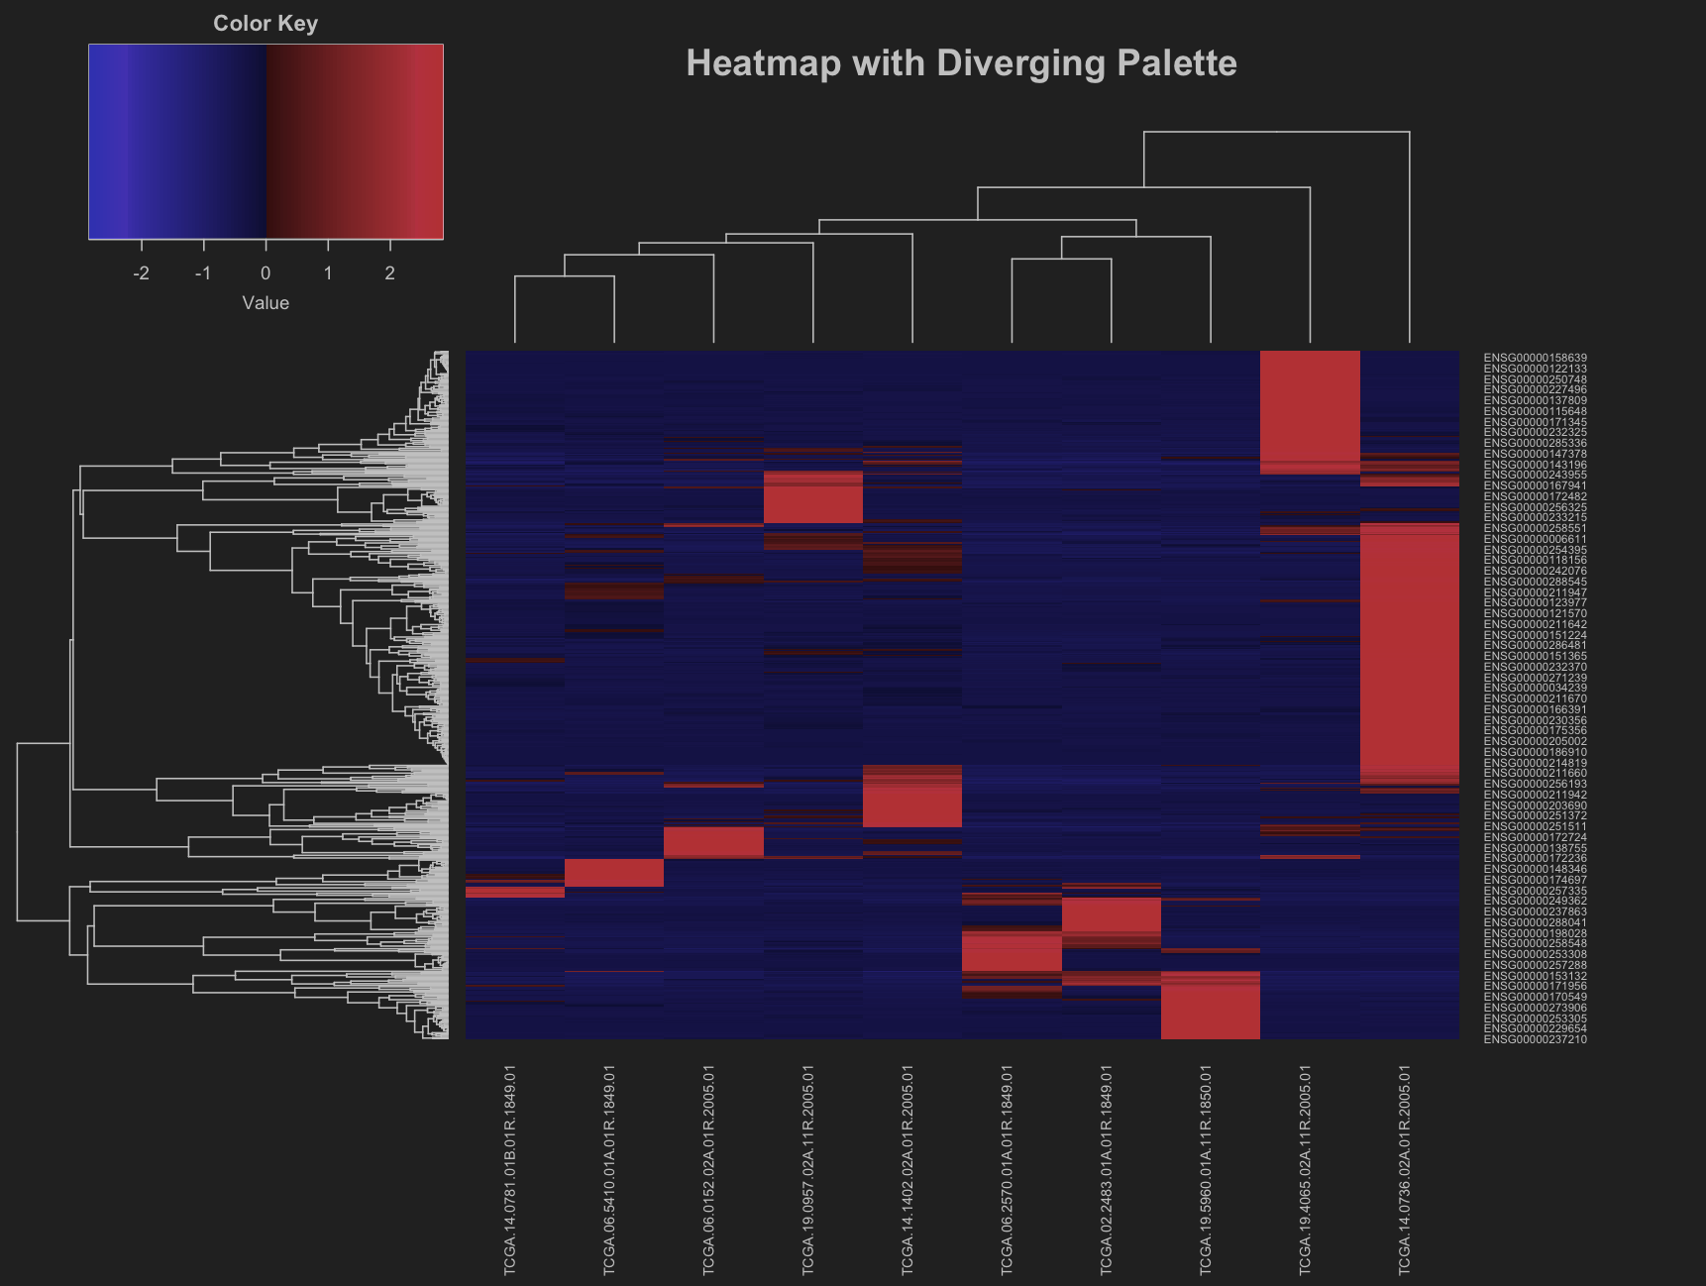](https://github.com/isongjosiah/hack-bio/blob/main/stage2/diverging-palette.png)](https://github.com/isongjosiah/hack-bio/blob/main/stage2/diverging-palette.png" \t "_blank) *Fig. 1: Heatmap with diverging color palette*

[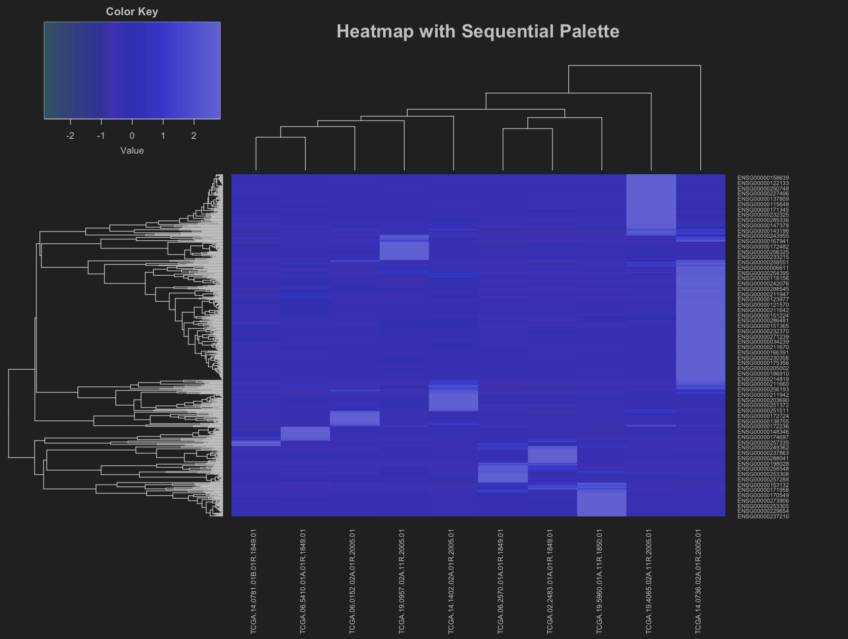](https://github.com/isongjosiah/hack-bio/blob/main/stage2/sequential-palette.png) *Fig. 2: Heatmap with sequential color palette*

[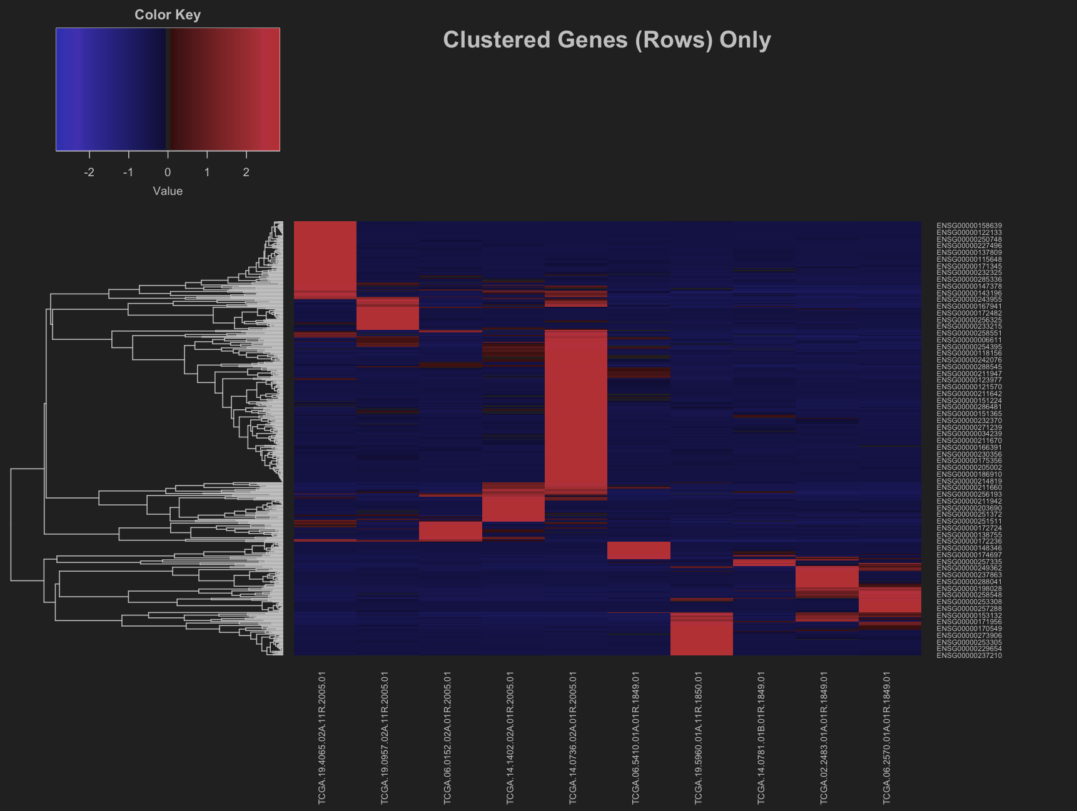](https://github.com/isongjosiah/hack-bio/blob/main/stage2/clustered-gene-rows.png) *Fig. 3: Heatmap clustered genes(rows) only*

[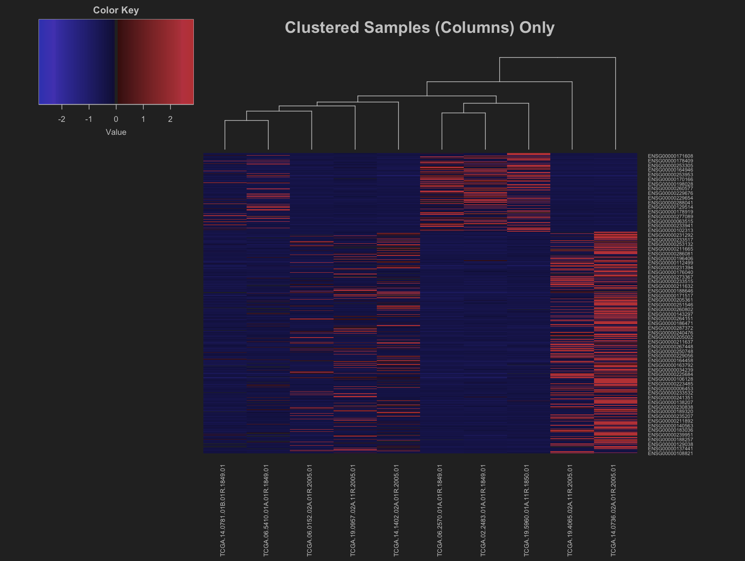](https://github.com/isongjosiah/hack-bio/blob/main/stage2/clustered-samples.png) *Fig. 4: Heatmap clustered samples(columns) only*

[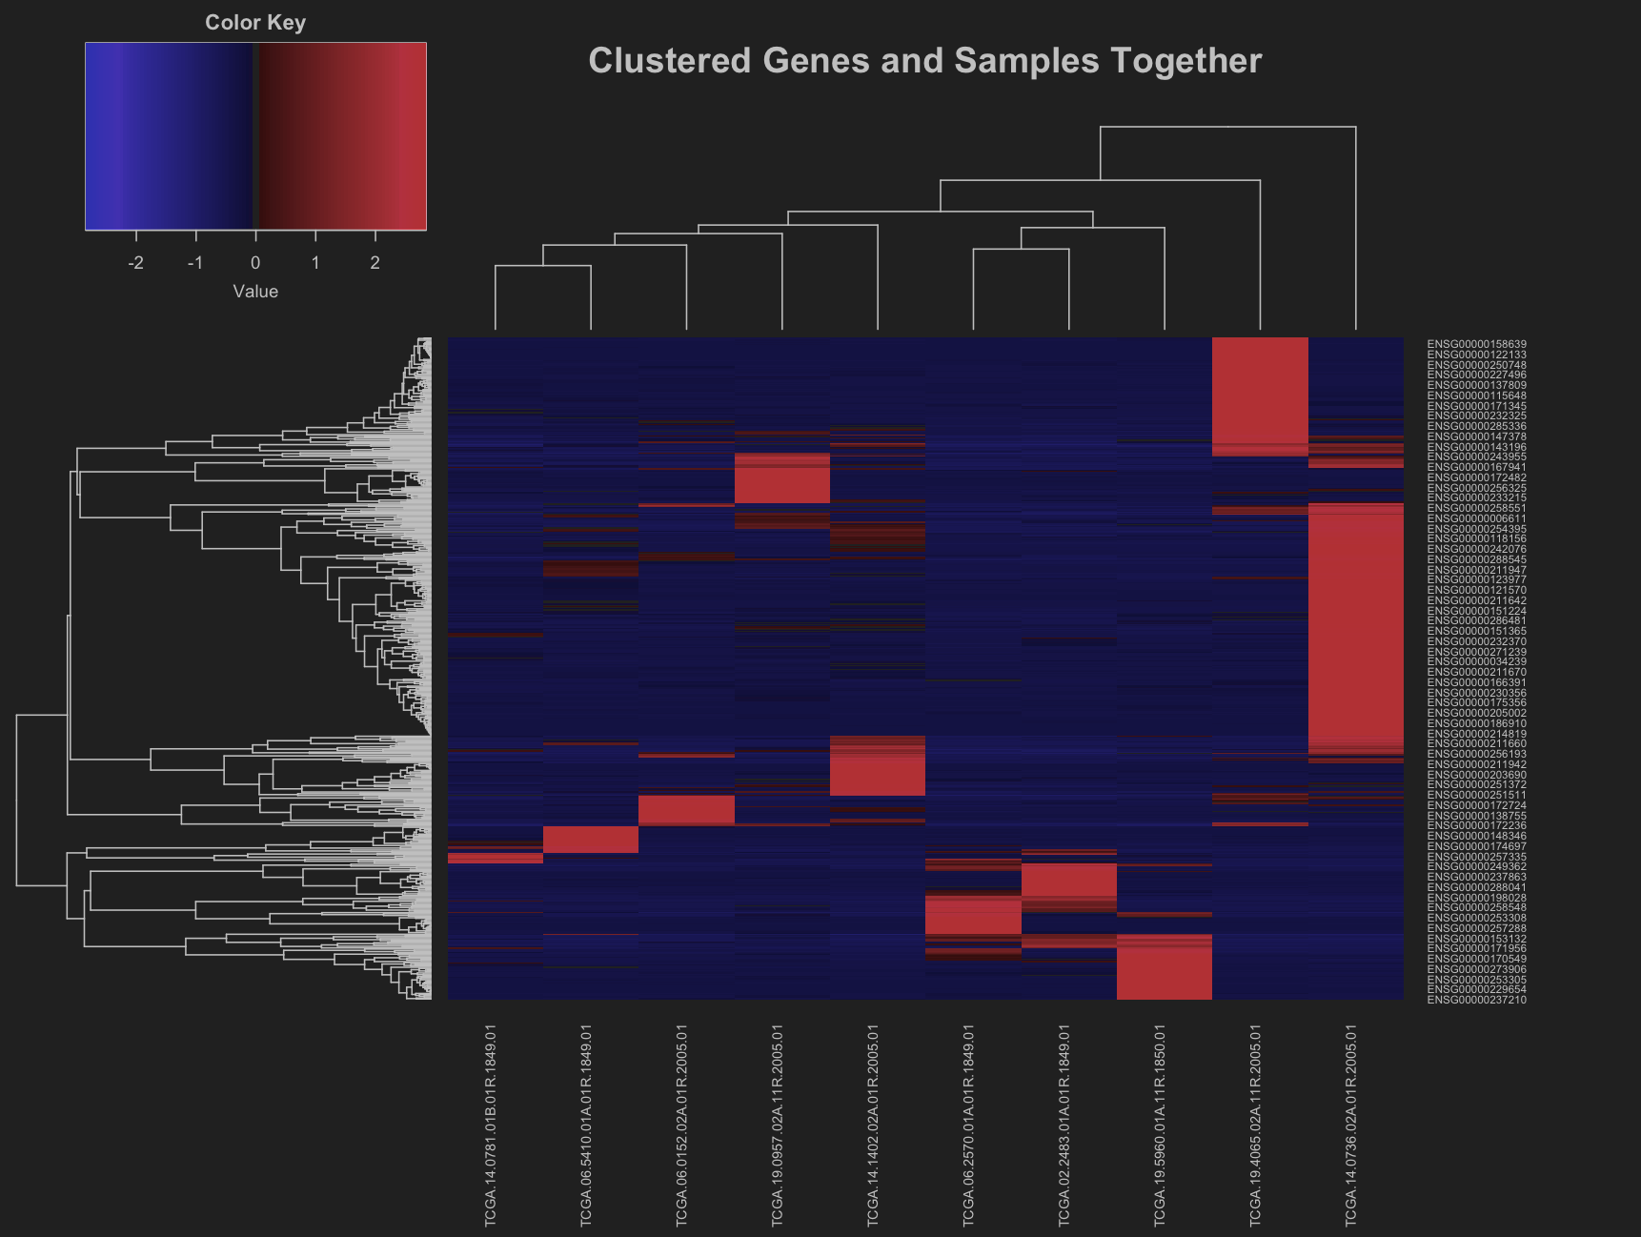](https://github.com/isongjosiah/hack-bio/blob/main/stage2/clustered-gene-and-samples.png) *Fig. 5: Heatmap clustered genes and samples together*

***Fig. 6: Downregulated genes and fold enrichments***

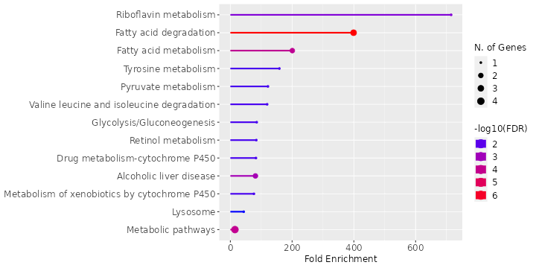

*Fig. 7: Upregulated genes and fold enrichments*

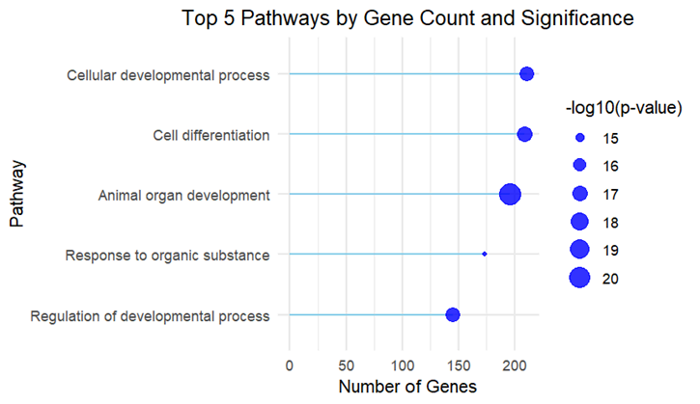

*Fig. 8: Top 5 pathways by gene count and significance. The length of ech stem represents the number of genes associated with each pathway, and the size of each point reflects the significance of the pathway (scaled by the negative log10 of the p-value)*