**Keywords Password Reset**

Description How to reset user's password

***Instructions Introduction***

This solution needs to be applied in case user experience following issues and errors

User cannot logon. Incorrect username and password

User cannot logon. error password has expired

User cannot logon, error too many attempts

***Instructions***

Q: How To Request for SAP GUI Password

A: Please provide your user id

Please provide your email address

Which of the Client is it P10 (Production System) or A10 (Acceptance System)

Use the following temporary password to logon

Please find the Password as requested to login to P10.

User:

Initial Password:

Please logon with your User ID and above initial password.

Password Guidelines (Application dependent)

* Initial password to be changed upon first time login
* Password to be changed every 30 days
* Minimum password length is 8 characters
* Password must have combination of: Uppercase, lowercase, number and special character
* Not possible to re-use last password
* Account will be locked upon 3 invalid log-on attempts.

The system will automatically LOCK your account if not logged on within 15 days and delete if unused for 30 days from date of creation.

Inactive accounts are locked in 90 days and deleted in 120 days, please endeavour to change password every 30 days

**Keywords Agreement, Legacy, contract**

Q: Description How do I retrieve agreement number from legacy contract number in SAP

A: Instructions

How to get agreement number from legacy contract number.

Log on to SAP GUI with your user id and password

In the Transaction Search window/ Type Tcode ME33K - Display Contract

Click on the in Agreement click on Radio Button

Choose Purchasing Document per legacy contract/ input the legacy contract number/Start Search/The last number is the Agreement number

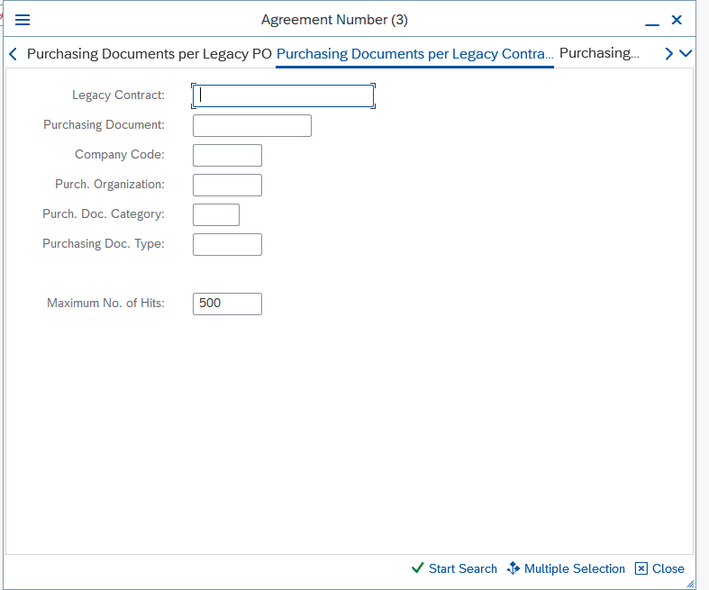

Purchase Requisition (PR)

Keywords PR, Purchase, Requisition, error, report

Description. How to run PR error Report

Instructions

Input ZCR_PR_ERROR in Tcode search window,

click on the green good  or press the Enter key on your keyboard

The page below displays

Then input Purchasing organization, vendor, purchasing group plant, execute.

MATERIAL NUMBER

Keywords Material number, Statement

Description How to know the plant and statement material number is on

Instruction

Launch SAP, in the Tcode search window

Input ME33K, click on the green good  or press the Enter key on your keyboard

PRINTING ISSUE IN SAP

Keywords Printer error, Device not found

Description How to activate printing option in SAP

Instruction

Launch SAP in the Tcode search window

Input SU3, click on the green good  or press the Enter key on your keyboard.

Click on Default, click on Decimal Notation choose 1,234,567.89 as circled Output Device LOCL

Personal Time Zone

Time Zone WAT or click on the radio button to choose country of your choice

Keywords Work order, number

Description How to check for work order number

Instruction

Launch SAP in the Tcode search window

Input iw33, click on the green good  or press the Enter key on your keyboard.

Input work order number and execute.

Assignment End Date

Keywords Assignment End Date, AED, Validity Start, Validity End

Description. How to get Contract end date

Launch SAP in the Tcode search window

Input ME33K, click on the green good  or press the Enter key on your keyboard

Click on the marked radio button

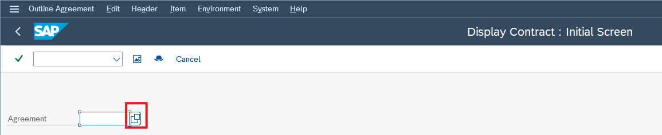

Choose Purchasing Documents per Legacy Contract, input the legacy contract number.

Click on start search, scroll down and double click on the last purchase document number.

Click on Header Details, it will display.