Untitled
2026-09-22

R Markdown
This is an R Markdown document. Markdown is a simple formatting syntax for authoring HTML, PDF, and MS Word documents. For more details on using R Markdown see http://rmarkdown.rstudio.com.
When you click the Knit button a document will be generated that includes both content as well as the output of any embedded R code chunks within the document. You can embed an R code chunk like this:
# Import the data
ships <- read.csv(
"ShipAccidents.csv",
na.strings = "NA"
)
# Create one construction-era variable
ships$construction_era <- with(
ships,
ifelse(
construction1 == 1, "Construction 1",
ifelse(
construction2 == 1, "Construction 2",
ifelse(
construction3 == 1, "Construction 3",
"Reference"
)
)
)
)
# Convert categorical variables to factors
ships$construction_era <- factor(
ships$construction_era,
levels = c(
"Reference",
"Construction 1",
"Construction 2",
"Construction 3"
)
)
ships$operational <- factor(ships$operational)
# Retain observations with nonmissing exposure
ships_analysis <- subset(
ships,
!is.na(exposure)
)
# Check dimensions and missing values
dim(ships)
## [1] 40 8
colSums(is.na(ships))
## accidents operational construction1 construction2
## 0 0 0 0
## construction3 exposure service_months construction_era
## 0 6 0 0
nrow(ships_analysis)
## [1] 34
# Select variables for descriptive statistics
variables <- ships_analysis[
c("accidents", "exposure", "service_months")
]
# Calculate descriptive statistics
descriptive_table <- data.frame(
Variable = names(variables),
Mean = sapply(variables, mean),
SD = sapply(variables, sd),
Median = sapply(variables, median),
Minimum = sapply(variables, min),
Maximum = sapply(variables, max),
row.names = NULL
)
# Round only the numeric columns
descriptive_table[-1] <- round(
descriptive_table[-1],
2
)
# Display the table
descriptive_table
## Variable Mean SD Median Minimum Maximum
## 1 accidents 10.47 15.73 4 0.00 58.00
## 2 exposure 7.05 1.72 7 3.81 10.71
## 3 service_months 4810.12 9643.39 1095 45.00 44882.00
# Import the data
ships <- read.csv(
"ShipAccidents.csv",
na.strings = "NA"
)
# Create construction-era variable
ships$construction_era <- with(
ships,
ifelse(construction1 == 1, "Construction 1",
ifelse(construction2 == 1, "Construction 2",
ifelse(construction3 == 1, "Construction 3",
"Reference")))
)
ships$construction_era <- factor(
ships$construction_era,
levels = c(
"Reference",
"Construction 1",
"Construction 2",
"Construction 3"
)
)
# Convert operational status to a factor
ships$operational <- factor(
ships$operational,
levels = c(0, 1),
labels = c("Category 0", "Category 1")
)
# Construct the binary outcome
# 1 = at least one accident; 0 = no accidents
ships$accident_event <- ifelse(ships$accidents > 0, 1, 0)
ships$accident_status <- factor(
ships$accident_event,
levels = c(0, 1),
labels = c("No accidents", "At least one accident")
)
# Examine sample size and missing values
dim(ships)
## [1] 40 10
colSums(is.na(ships))
## accidents operational construction1 construction2
## 0 0 0 0
## construction3 exposure service_months construction_era
## 0 6 0 0
## accident_event accident_status
## 0 0
# Retain observations with complete information
ships_analysis <- subset(
ships,
!is.na(exposure) &
!is.na(operational) &
!is.na(construction_era)
)
nrow(ships_analysis)
## [1] 34
# Frequency and proportion of binary outcome
outcome_frequency <- table(ships_analysis$accident_status)
outcome_frequency
##
## No accidents At least one accident
## 8 26
round(prop.table(outcome_frequency) * 100, 1)
##
## No accidents At least one accident
## 23.5 76.5
# Descriptive statistics for exposure
exposure_statistics <- data.frame(
Mean = mean(ships_analysis$exposure),
SD = sd(ships_analysis$exposure),
Median = median(ships_analysis$exposure),
Minimum = min(ships_analysis$exposure),
Maximum = max(ships_analysis$exposure)
)
round(exposure_statistics, 2)
## Mean SD Median Minimum Maximum
## 1 7.05 1.72 7 3.81 10.71
# Outcome by operational status
operational_table <- table(
ships_analysis$operational,
ships_analysis$accident_status
)
operational_table
##
## No accidents At least one accident
## Category 0 5 10
## Category 1 3 16
round(prop.table(operational_table, margin = 1) * 100, 1)
##
## No accidents At least one accident
## Category 0 33.3 66.7
## Category 1 15.8 84.2
# Outcome by construction era
construction_table <- table(
ships_analysis$construction_era,
ships_analysis$accident_status
)
construction_table
##
## No accidents At least one accident
## Reference 0 5
## Construction 1 5 4
## Construction 2 3 7
## Construction 3 0 10
round(prop.table(construction_table, margin = 1) * 100, 1)
##
## No accidents At least one accident
## Reference 0.0 100.0
## Construction 1 55.6 44.4
## Construction 2 30.0 70.0
## Construction 3 0.0 100.0
# Boxplot of exposure by accident outcome
boxplot(
exposure ~ accident_status,
data = ships_analysis,
xlab = "Accident Outcome",
ylab = "Exposure",
main = "Exposure by Accident Outcome",
col = c("lightgray", "lightblue")
)
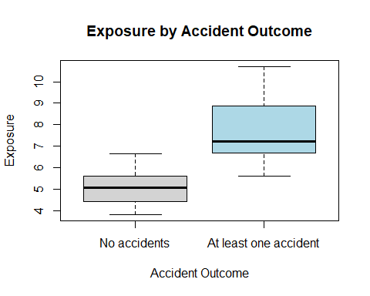
# Proportion with at least one accident by operational status
operational_proportion <- prop.table(
operational_table,
margin = 1
)[, "At least one accident"]
barplot(
operational_proportion,
ylim = c(0, 1),
ylab = "Proportion with at Least One Accident",
xlab = "Operational Status",
main = "Accident Occurrence by Operational Status",
col = "steelblue"
)
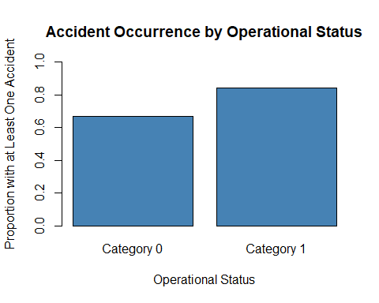
# Proportion with at least one accident by construction era
construction_proportion <- prop.table(
construction_table,
margin = 1
)[, "At least one accident"]
barplot(
construction_proportion,
ylim = c(0, 1),
ylab = "Proportion with at Least One Accident",
xlab = "Construction Era",
main = "Accident Occurrence by Construction Era",
col = "darkseagreen",
las = 2
)
