MatCH · Maternal, Adolescent and Child Health Institute
CHOMS
Community Health & Outreach Management System
Task 2 — System Development Report
From paper registers to a secure, offline-first, role-based health outreach platform: one Firebase cloud backend serving a public website, an installable Progressive Web App and a native Android application.

Module | Work Integrated Learning 3 — XADAD7112w
Qualification | Advanced Diploma in Application Development (ADAD113)
Client | Maternal, Adolescent and Child Health Institute (MatCH), Durban
Group members
GitHub repository
Firebase project | match-choms — Cloud Firestore in africa-south1 (Johannesburg)
Document version | 2.0 — October 2026

1. Executive Summary & Introduction
MatCH sends Community Health Workers (CHWs) into Durban communities every day to support mothers, children and adolescents affected by HIV/TB and other health risks. Until now, every client, home visit, referral and appointment lived in paper registers and disconnected spreadsheets. Task 1 showed what that costs: duplicate records, referrals that disappear between the clinic and the household, coordinators who only see fieldwork weeks later, and funder reports assembled by hand.
CHOMS replaces that paper trail with a single, secure, cloud-based system. A CHW records a visit on a phone in a household with no signal; the moment the phone reconnects, the visit appears on the administrator's dashboard, is counted in the funder report, and is written — together with who did it and when — into an audit trail that nobody can edit or delete.
CHOMS at a glance
One backend, three front ends: a public website, an installable offline-first Progressive Web App (PWA) and a native Android app — all on the same Firebase project.
Four account states, three working roles: new sign-ups are pending; an administrator approves them as CHW, Coordinator or Admin, and can deactivate or delete them later.
Zero unaudited writes: every create, update, delete, registration and approval is committed in the same atomic batch as its audit entry — the database rules reject anything else.
Verified, not assumed: 50 Jest unit tests, 21 Android JUnit tests and 76 automated Firestore security-rule tests, plus two GitHub Actions pipelines.

1.1 From paper registers to a connected platform
Before (paper & spreadsheets) | After (CHOMS)
Registers kept per CHW; duplicates are common | One beneficiary register with South African ID validation and duplicate-ID blocking
Referrals tracked on loose forms and phone calls | Referrals with urgency, status and mandatory outcome notes; urgent ones stay on the dashboard
Coordinators learn about fieldwork weeks later | Live dashboards: stat cards, work lists and completed visits per CHW chart
Funder reports compiled by hand | Reports for any date range, saved for approval, exported to CSV or printed to PDF
No reliable record of who changed what | Immutable auditLogs collection, enforced by server-side rules
Paper files on the move (POPIA risk) | Consent required by the server, IDs masked, CHWs only ever receive their own clients' data

1.2 What we delivered
- Website (web/index.html) — the public face of the programme with Create account and Sign in entry points.
- Web / desktop app (web/app/) — the full system as an installable PWA: service-worker app shell, localStorage cache and an offline outbox that synchronises automatically.
- Android app (android/) — a native Java application (MVVM + Repository) using the official Firebase Android SDKs against the same collections, rules and audit contract.
- Cloud backend — Firebase Authentication (email/password, enabled as code in firebase.json), Cloud Firestore in Johannesburg, versioned security rules and a ready-to-deploy deleteUser Cloud Function.
1.3 How the design evolved from Task 1
Task 1 proposed separate desktop and mobile clients behind a custom REST API. During development we kept every architectural idea — layering, the Repository pattern, cache-aside/outbox offline support and role-based access control — but moved the API's responsibilities into managed cloud services. Authorisation that would have lived in API controllers now lives in Firestore Security Rules, which run on Google's servers and cannot be bypassed by a modified client.
Task 1 design | Final system | Why
Custom REST API + EF Core | Firebase SDKs + Cloud Firestore | No servers to run; scales automatically; free tier for the pilot
RBAC in API controllers | RBAC in Firestore Security Rules (+ UI hints) | Enforced on the server for every client, including the Android app
Separate desktop and mobile apps | Responsive PWA + native Android app | One web codebase for all browsers; a native app where field staff prefer one
Audit table written by the API | Audit entry in the same atomic batch, checked by rules | Impossible to change data without leaving a trace

1.4 Requirements coverage
# | Requirement | How CHOMS delivers it
FR1 | Register beneficiaries | SA ID validation (13 digits, date, Luhn checksum) auto-fills date of birth and gender; duplicate IDs blocked; POPIA consent enforced by the server.
FR2 | Case files | Case file shows profile, visits, referrals and appointments; CHWs see only their own clients.
FR3 | Field visits offline-first | Web outbox stores the visit on the device and syncs on reconnect; status chip shows pending changes.
FR4 | Schedule / allocate visits | Admins schedule visits and appointments and assign beneficiaries, visits, appointments and referrals to a specific CHW.
FR5 | Referrals | Facility, reason, urgency, status and outcome; completion requires outcome notes.
FR6 | Appointments & reminders | Book, reschedule (status changes automatically), cancel; reminder channel and due time (24 h before) stored. Sending SMS is future work.
FR7 | Role-based access control | Admin, Coordinator, CHW (+ pending) in the UI and in server rules.
FR8 | Funder reports | Any date range; Coordinators save for approval; only Admins approve; CSV and Print/PDF.
FR9 | Searchable history | Live multi-term search and status filters on every list.
FR10 | Offline sync | Service worker + localStorage cache + outbox with automatic and manual sync.
FR11 | User management | Self sign-up (pending) → approve with a role → edit → deactivate/reactivate → delete.
FR12 | Audit trail | Every write paired with an immutable auditLogs entry, enforced server-side; admin-only, searchable, filterable by action.

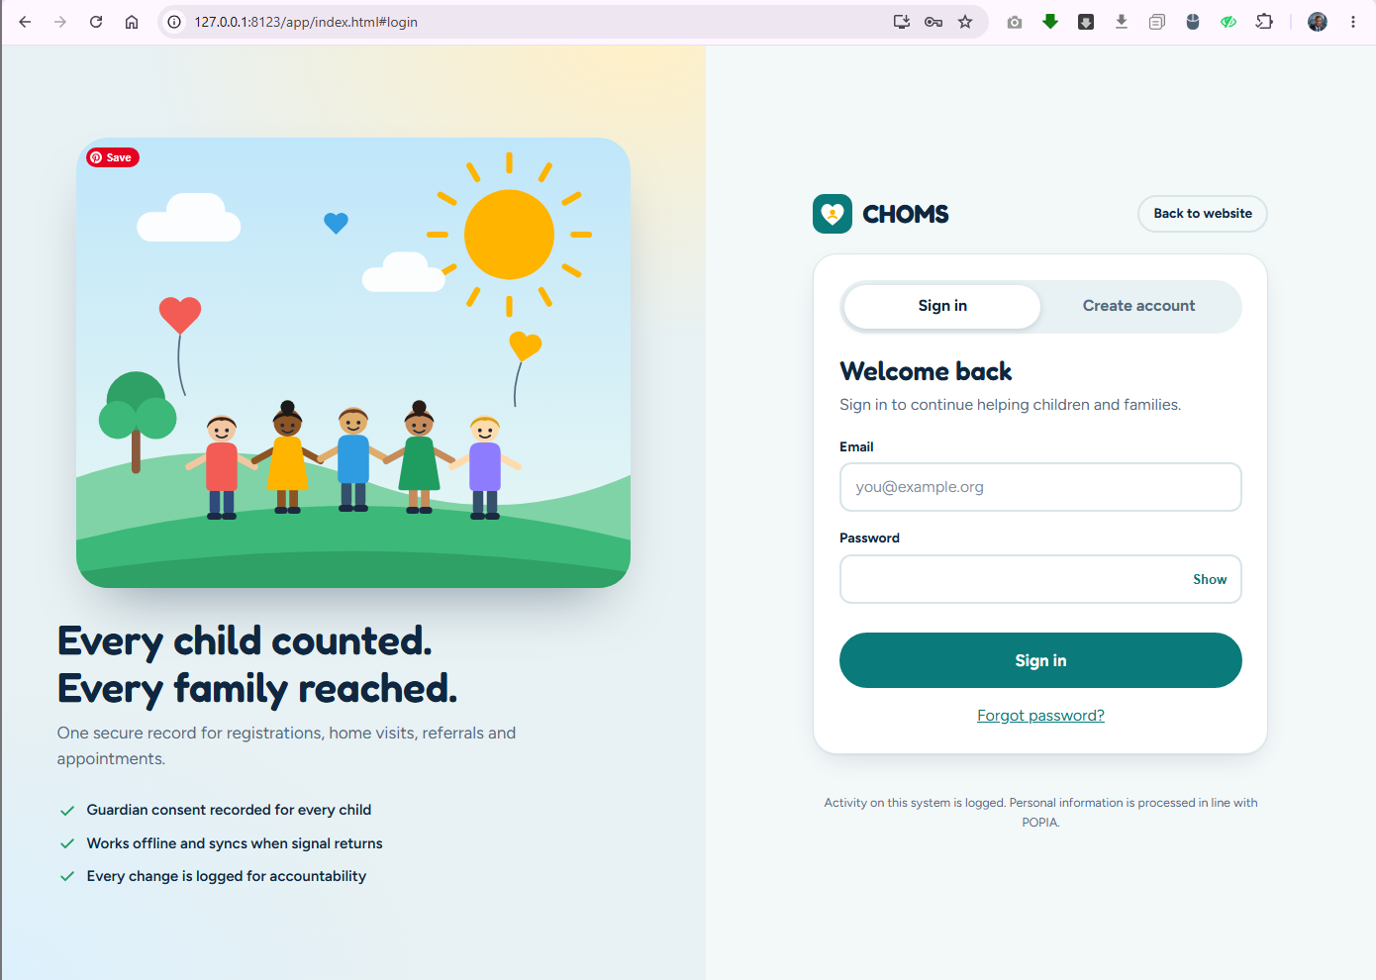
2. System Architecture
CHOMS follows a strict N-tier (layered) architecture. Each layer has one job and only talks to the layer beneath it, which keeps the code testable and lets us swap clients without touching the data rules.
+--------------------+ +-----------------------+ +---------------------+
| Public website | | Web app / PWA | | Android app (Java) |
| web/index.html | | web/app/ (ES mods) | | android/ (MVVM) |
+---------+----------+ +-----------+-----------+ +----------+----------+
| links to app | |
==========|==========================|==========================|===========
PRESENTATION app.js ui.js entities.js | Activities + XML layouts
---------------------------------------------+------------------------------
BUSINESS LOGIC utils.js (validators, can(),| ViewModels + util/Validators
report maths) - pure, tested| (LiveData, JUnit-tested)
---------------------------------------------+------------------------------
DATA ACCESS repo.js (Repository: | *Repository + BaseRepository
cache-aside, outbox, audit | (saveWithAudit / deleteWith-
batches) firebase.js | Audit batches)
=============================================+==============================
| HTTPS / WebChannel (TLS) | gRPC (TLS)
+---------v----------------------------------v---------------------------+
| CLOUD (Firebase project match-choms) |
| Authentication (email/password) Cloud Firestore (africa-south1) |
| Security Rules: roles + schema + users beneficiaries visits |
| enforced audit pairing referrals appointments reports |
| Cloud Function deleteUser (ready) auditLogs (append-only) |
+------------------------------------------------------------------------+
Figure A: CHOMS N-tier architecture — three clients, one rule-protected cloud backend.
2.1 The four layers
Layer | Web (PWA) | Android | Responsibility
Presentation | index.html, css/app.css, js/app.js, js/ui.js, js/entities.js | Activities, XML layouts, RowAdapter, Material 3 components | Screens, routing, forms, events — no business rules
Business logic | js/utils.js | viewmodel/*, util/Validators, util/DateUtils | Validation, permission matrix, date/ID logic, report calculations
Data access | js/repo.js, js/firebase.js | repository/* (BaseRepository) | Repository pattern: the only code that talks to Firebase
Cloud | Firebase Auth, Cloud Firestore, firebase/firestore.rules, functions/index.js | (same) | Identity, storage, server-side enforcement, privileged operations

2.2 Technology stack
Concern | Technology
Web front end | HTML5, CSS3 (custom design system, no framework), JavaScript ES modules — no build step; Firebase JS SDK 10.14 from Google's CDN
Android | Java 17, Android Gradle Plugin 8.7, compile SDK 35, ViewBinding, Material Components, Firebase BoM 33.5 (Auth, Firestore, Functions)
Identity | Firebase Authentication — email/password, enabled declaratively in firebase.json
Database | Cloud Firestore (Native mode), location africa-south1
Authorisation | Firestore Security Rules (rules_version = 2)
Privileged operations | Cloud Functions for Firebase v2 (Node.js 22) — deleteUser callable
Offline (web) | Service worker app-shell cache + localStorage data cache and outbox
Quality | Jest 29, JUnit 4, @firebase/rules-unit-testing + Firestore emulator
DevOps | Git, GitHub, GitHub Actions (web tests; Android tests + APK build), Firebase CLI

2.3 The Repository pattern in practice
Screens never call Firestore directly. repo.js exposes a small, intention-revealing API, and its Android twin (BaseRepository and one repository per collection) offers the same guarantees:
Operation | What it does
list(col) | Role-scoped query (a CHW only asks for their own records), caches the result per user, overlays pending local changes, and falls back to the cache when offline.
save(col, id, data) | Stamps createdAt/By, updatedAt/By, generates an auditId, and queues the write with its audit entry in the outbox.
remove(col, id) | Queues the delete with an audit entry whose ID is deterministic: delete-<collection>-<id>.
flush() | Replays the outbox in order; each item is committed as one atomic writeBatch (record + audit).
writeOnline() | Immediate, audited writes for user management (approve, edit, deactivate).
registerSelf() | Creates the locked pending profile and the register audit entry together.
removeUserProfile() | Admin fallback delete of a user profile when the Cloud Function is unavailable (Section 7).

2.4 Cloud data model
Collection | Purpose | Key fields
users | One profile per login (document ID = Auth UID) | name, email, phone, role (pending | chw | coordinator | admin), requestedRole, status (active | deactivated), createdAt, approvedBy/At, auditId
beneficiaries | Clients / case files | ref, names, idNumber, dob, gender, phone, address, area, programme, enrolmentDate, status, assignedChwId, consent
visits | Field visits | beneficiaryId, chwId, date, status, location, outcome, notes
referrals | Referrals to facilities | beneficiaryId, chwId, facility, reason, urgency, referralDate, status, outcomeNotes
appointments | Bookings and reminders | beneficiaryId, chwId, datetime, purpose, status, reminderChannel, reminderDue
reports | Saved funder reports | from, to, summaryJson, status (pending | approved), generatedBy, approvedBy
auditLogs | Immutable history | action, collection, docId, summary, userId, userName, role, at

Every record also carries createdAt, createdBy, updatedAt, updatedBy and auditId. Relationships are held by IDs (for example visits.beneficiaryId), the document-database equivalent of the foreign keys in the Task 1 ER diagram.
2.5 Offline-first synchronisation engine (web)
- Read (cache-aside). list() fetches from Firestore, stores the result under a per-user key, and serves the cached copy when the device is offline.
- Write (outbox). Each change is appended to a localStorage outbox and shown immediately. IDs are generated on the device, so records can be created with no signal.
- Synchronise. On the browser online event, every 60 seconds while changes are pending, or when the user taps Sync now, the outbox is replayed in order.
- Atomic audit. Each outbox item is committed as one batch — the record and its audit entry succeed or fail together.
- Reject safely. A permanent rejection (for example a record reassigned to another CHW while the phone was offline) is moved to a "failed" list and reported, so one bad item never blocks the queue.
- Protect privacy. On sign-out, if nothing is pending, cached client data is wiped from the device.
2.6 Project structure
choms-suite/
web/index.html public website
web/app/ PWA: index.html, sw.js, manifest.json, css/app.css
web/app/js/ app.js ui.js entities.js utils.js repo.js firebase.js
web/app/tests/utils.test.js Jest unit tests (50)
android/app/src/main/java/com/match/choms/{model,repository,viewmodel,ui,util}
android/app/src/test/... JUnit tests (21)
firebase/firestore.rules server-side security
firebase/tests/ Firestore rule tests (76, emulator)
functions/index.js deleteUser Cloud Function
tools/ admin scripts + this report generator
.github/workflows/ main.yml (Jest) android-apk.yml (JUnit + APK)
firebase.json .firebaserc auth provider, rules, functions, hosting, emulators
Figure B: Repository layout.
3. Security & Role-Based Access Control
Children's health information is among the most sensitive data a system can hold. CHOMS is designed on the principle that the server decides: the apps hide what a user may not do, but the Firestore Security Rules are what actually protect the data — including against a modified app or a hand-written script.
3.1 Account lifecycle
Sign up (website / PWA / Android) Admin: Users screen
chooses "CHW" or "Coordinator"
|
v Approve (pick role)
[ pending ] ---------------------------------------> [ chw | coordinator | admin ]
no data access status: active
"Waiting for approval" screen | ^
Deactivate | | Reactivate
v |
[ deactivated ] -- no access
|
Delete (Cloud Function, or
admin profile-delete fallback)
Figure C: From sign-up to approval, deactivation and deletion — every arrow is an audited write.
3.2 Permission matrix
Capability | CHW | Coordinator | Admin
Beneficiaries | Own clients: view, add, edit | View all | Full, incl. delete
Visits, referrals, appointments | Own: full CRUD | View all | Full
Assign work to a CHW / schedule for others | — | — | Yes (assignee must be an active CHW)
Team list (CHW names) | — | View | View + manage
Reports | — | Generate, save, delete unapproved | Generate, save, approve, delete
Users: approve, edit, deactivate, delete | — | — | Yes (never their own role/status)
Audit log | — | — | Read (search + action filter)

3.3 Defence in depth
- UI layer — can(role, action, collection) (web) and User.canEditRecords()/isStaff() (Android) hide buttons and menu items.
- Query layer — a CHW's queries always filter on their own UID (assignedChwId / chwId), mirroring the rules so legitimate reads succeed.
- Server layer (authoritative) — firestore.rules re-checks the caller's role and status from users/{uid} on every request.
What the rules enforce
- Default deny — any path not explicitly allowed is refused.
- Strict schemas — validator functions (isValidBeneficiary, isValidVisit, …) with hasOnly field lists, type checks and length limits on every string, in both create and update.
- Safe self-registration — a new user may only create their own profile, only as pending, only with their verified Auth email, and only asking to be chw or coordinator.
- No privilege escalation — only admins change roles; an admin cannot change their own role or deactivate themselves; email and createdAt are immutable.
- Ownership integrity — a CHW cannot create records for, or move records to, another CHW. When an admin assigns work, the rules read the assignee's profile and require an active CHW.
- Deactivation — status: deactivated removes all data access immediately, even if the person still has a valid sign-in session.
- POPIA consent — a beneficiary cannot be saved without consent == true, even by a modified client.
3.4 The immutable audit trail
Most systems write audit logs "on a best-effort basis". CHOMS makes the audit entry a precondition of the change itself:
- Every created or updated document carries an auditId.
- The rules require that this audit document did not exist before the request and will exist after it (!exists() + getAfter()), describing the same collection, document and signed-in user.
- Deletes write their entry under the deterministic ID delete-<collection>-<id>, which the rules check in the same way.
- Audit documents can never be updated or deleted by any client; only administrators can read them.
function audited(col, id, actions) {
let aid = request.resource.data.get('auditId', '');
return str(aid, 1, 128)
&& !exists(auditPath(aid)) // must be a NEW entry
&& getAfter(auditPath(aid)).data.collection == col
&& getAfter(auditPath(aid)).data.docId == id
&& getAfter(auditPath(aid)).data.userId == me() // logged as the real caller
&& getAfter(auditPath(aid)).data.action in actions;
}
Figure D: Excerpt from firebase/firestore.rules — a write is only valid together with its own audit entry.
Result
There is no code path — in the web app, the Android app or a hand-crafted request — that can change CHOMS data without leaving an attributable, tamper-proof record. The audit entry even records the writer's role, and the rules reject entries that lie about it.

3.5 Hardened sign-in
- Passwords are handled entirely by Firebase Authentication (salted hashes); CHOMS never stores them.
- After authentication the profile is read directly from the server (getDocFromServer), so a stale cached "pending" state can never override a fresh approval.
- Only approved, active profiles are cached for offline start-up; pending, deactivated or unknown profiles are never cached and any old copy is removed.
- Pending accounts see a dedicated Waiting for approval screen; deactivated or unknown accounts are signed out with a clear message.
- Five failed attempts trigger a 60-second lock (on top of Firebase throttling); the message never reveals whether an email exists.
- Passwords need 8+ characters with upper-case, lower-case and a number; reset by email is built in.
3.6 POPIA by design
- Data stored in Johannesburg (africa-south1) and encrypted in transit (TLS) and at rest (Google Cloud).
- Mandatory informed consent, enforced by the server; ID numbers masked in lists.
- Need-to-know access: CHWs only ever download their own clients; cached data is wiped on sign-out.
- Accountability: complete, immutable audit trail; deactivation preserves history instead of erasing it.
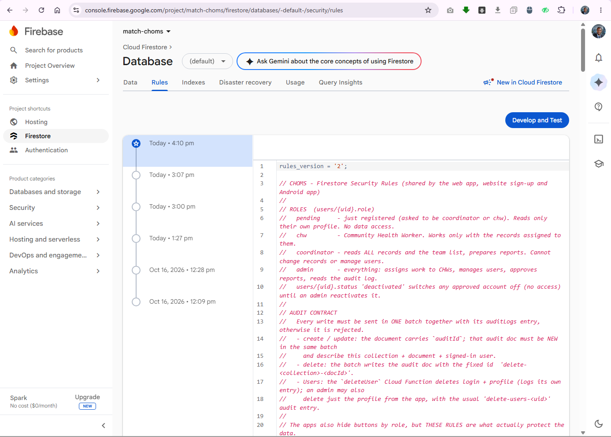
4. The Android App & the Progressive Web App
Field staff and office staff work very differently, so CHOMS meets them where they are: an installable PWA that runs in any modern browser and keeps working without signal, and a native Android application for staff who prefer a phone app. Both are first-class clients of the same backend: same collections, same rules, same audit contract — a visit captured on a phone appears in the web dashboard, and the reverse.
4.1 The Progressive Web App
- Installable — manifest.json lets Chrome/Edge install CHOMS to the home screen or desktop.
- Service worker (sw.js) — caches the app shell and the Firebase SDK, network-first, so updates arrive when online and the app still opens with no signal. Cache versions are rotated (choms-shell-v3) so users never get stuck on an old build.
- Offline data — localStorage cache and outbox (Section 2.5) with a visible Online / Offline · N pending chip and a Sync now button.
- Responsive — full-width sidebar layout on desktops; a bottom tab bar and stacked "card" tables on phones.
4.2 The native Android app
The Android client is a native Java application built with Android Studio and Gradle, not a wrapper around the website. It follows Google's recommended architecture:
Layer | Implementation
View | Activities with ViewBinding and Material components: sign in, create account, dashboard, beneficiaries, visits, referrals, appointments, reports, users
ViewModel | AuthViewModel, BeneficiaryViewModel, VisitViewModel, ReferralViewModel, AppointmentViewModel, DashboardViewModel, ApprovalsViewModel — LiveData state that survives rotation
Repository | AuthRepository, UserRepository, per-collection repositories and BaseRepository with saveWithAudit / deleteWithAudit batch helpers
Model | User, Beneficiary, Visit, Referral, Appointment mirroring the Firestore documents

- Same roles, same behaviour — CHWs see My Clients and My Visits; coordinators get read-only screens (no Add/Save) plus Reports; admins assign work through the CHW selector on each form and manage accounts on the Users screen (approve with a role, edit, deactivate/reactivate, delete).
- Same audit guarantee — every save and delete is a WriteBatch containing the record and its audit entry, exactly like the web app.
- Offline behaviour — the Firestore Android SDK keeps a local cache, so previously loaded data stays readable without signal, and writes made offline are held by the SDK and sent on reconnection. The screens wait for server confirmation, so the richest offline capture experience (instant save + visible outbox) is the PWA; an optimistic offline UI for Android is listed as future work.
4.3 Build and distribution
cd android
./gradlew testDebugUnitTest # 21 JUnit tests
./gradlew assembleDebug # builds the APK

Output: android/app/build/outputs/apk/debug/app-debug.apk

The real google-services.json for project match-choms (package com.match.choms) was downloaded with the Firebase CLI. In CI, the file can be supplied as the repository secret GOOGLE_SERVICES_JSON; the android-apk.yml workflow runs the unit tests, builds the APK and publishes it as a downloadable artifact.
 | PWA (web app) | Native Android
Runs on | Any modern browser; installable on desktop and phone | Android 7.0+ (minSdk 24)
Code | HTML, CSS, JavaScript ES modules | Java 17, XML layouts, Gradle
Firebase access | Firebase JS SDK | Firebase Android SDKs (BoM)
Offline | Service worker + localStorage outbox (instant offline saves) | Firestore SDK cache; offline writes synced by the SDK
Security | Same Firestore rules + audit batches | Same Firestore rules + audit batches

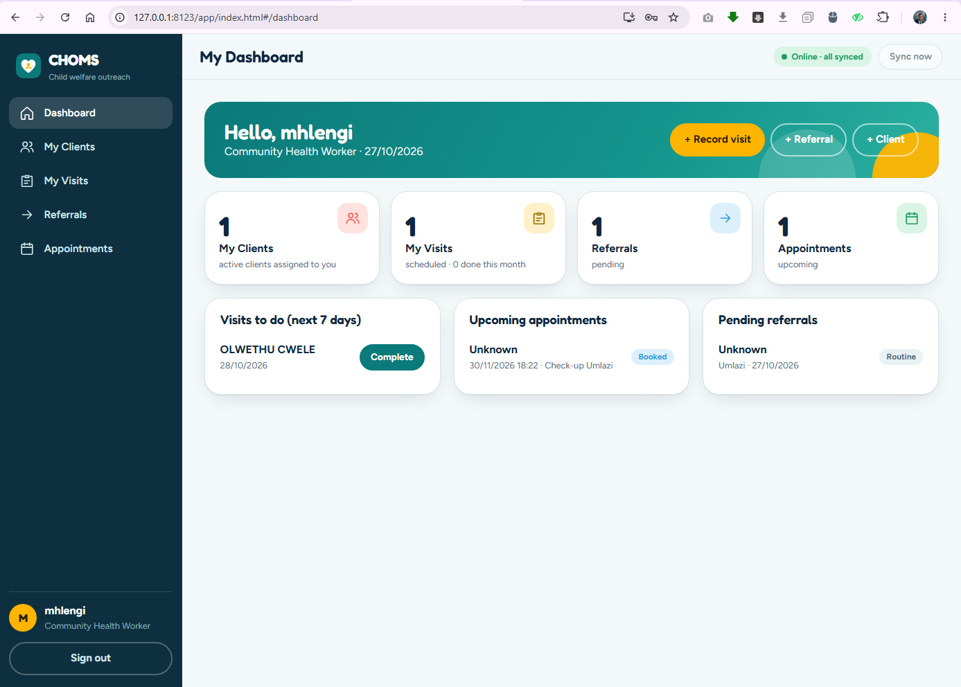
5. Key Features & UI/UX
The interface was designed to feel like a modern enterprise dashboard while staying simple enough for a CHW on a small phone: large touch targets, plain language, status badges that always carry text, and a layout that uses the full width of wide screens.
5.1 Navigation
Administrators see the complete sidebar — Dashboard, Beneficiaries, Visits, Referrals, Appointments, Reports, Users, Audit Log — with a live badge counting accounts waiting for approval. Coordinators see the fieldwork pages plus Reports. CHWs see Dashboard, My Clients, My Visits, Referrals, Appointments, and on phones the same items appear in a bottom tab bar.
5.2 Role-aware dashboards
- Admin / Coordinator — four stat cards (Active beneficiaries, Visits this month, Pending referrals, Upcoming appointments), work lists (visits due in the next 7 days, upcoming appointments, urgent referrals first) and a Completed visits per CHW bar chart for the current month.
- Admin extras — an Administration panel with accounts waiting for approval, team size, open work without an active CHW, reports awaiting approval, and shortcuts to Users, Assign work, Reports and Audit Log.
- CHW — My Clients, My Visits (scheduled and overdue), Referrals and Appointments, with one-tap Complete on scheduled visits.
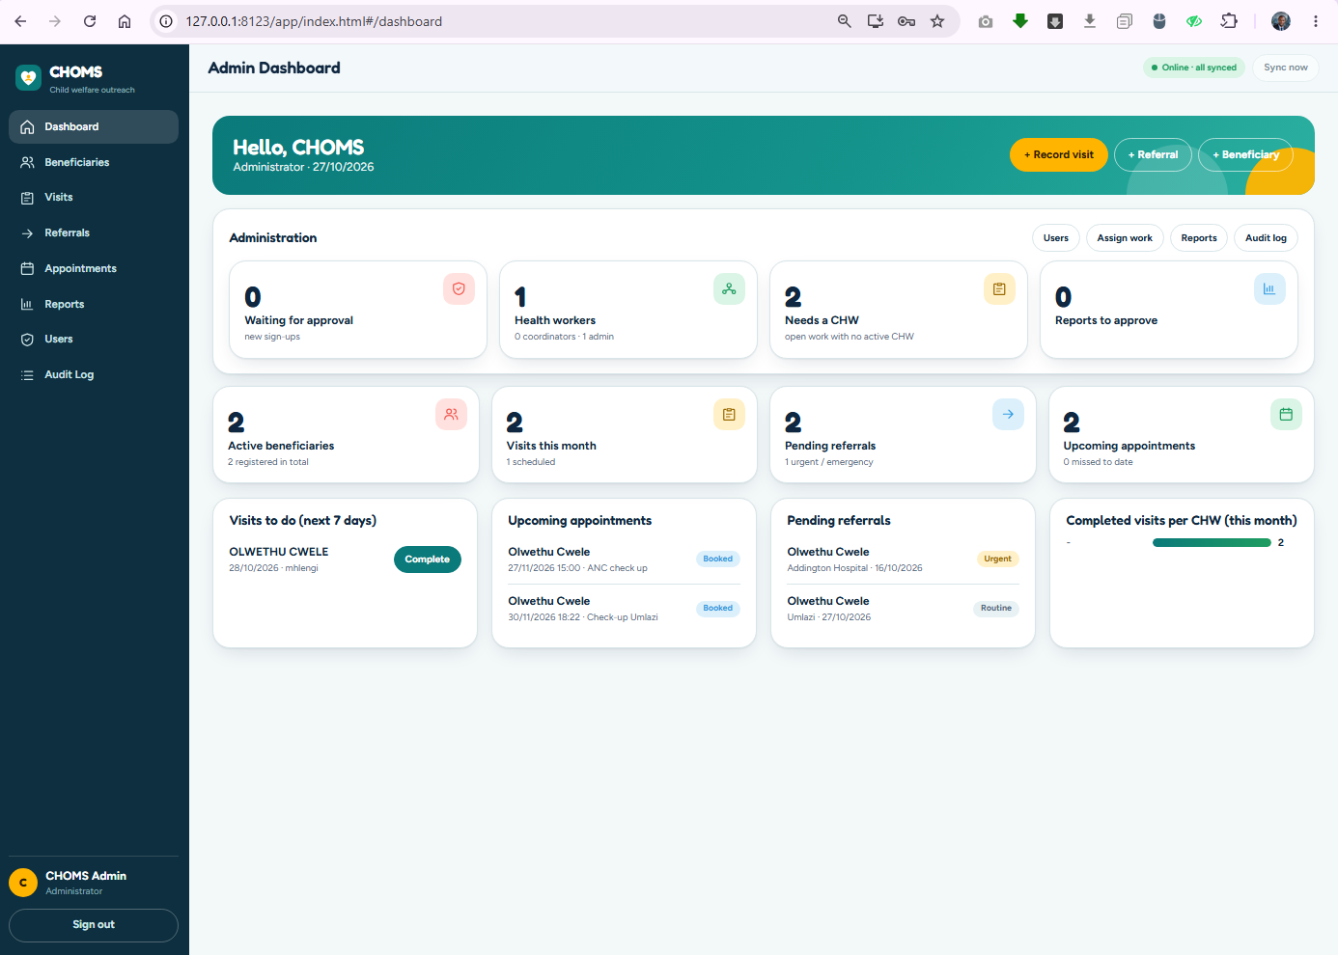
5.3 Fieldwork and assignment
- Beneficiary registration — SA ID number auto-fills date of birth and gender, duplicates are blocked, consent is mandatory; every client has a printable reference such as MCH-2026-AB12C.
- Case file — profile with masked ID plus the full visit, referral and appointment history on one screen.
- Assign — admins open Assign on any beneficiary, visit, appointment or referral and pick a CHW; reassigning a beneficiary can also move that client's scheduled visits and open appointments.
- Team & assignments — workload per CHW (clients, scheduled and overdue visits, appointments, visits done this month) and a list of open work without an active CHW.
- Appointments — changing the time automatically sets rescheduled; cancelling clears the reminder.
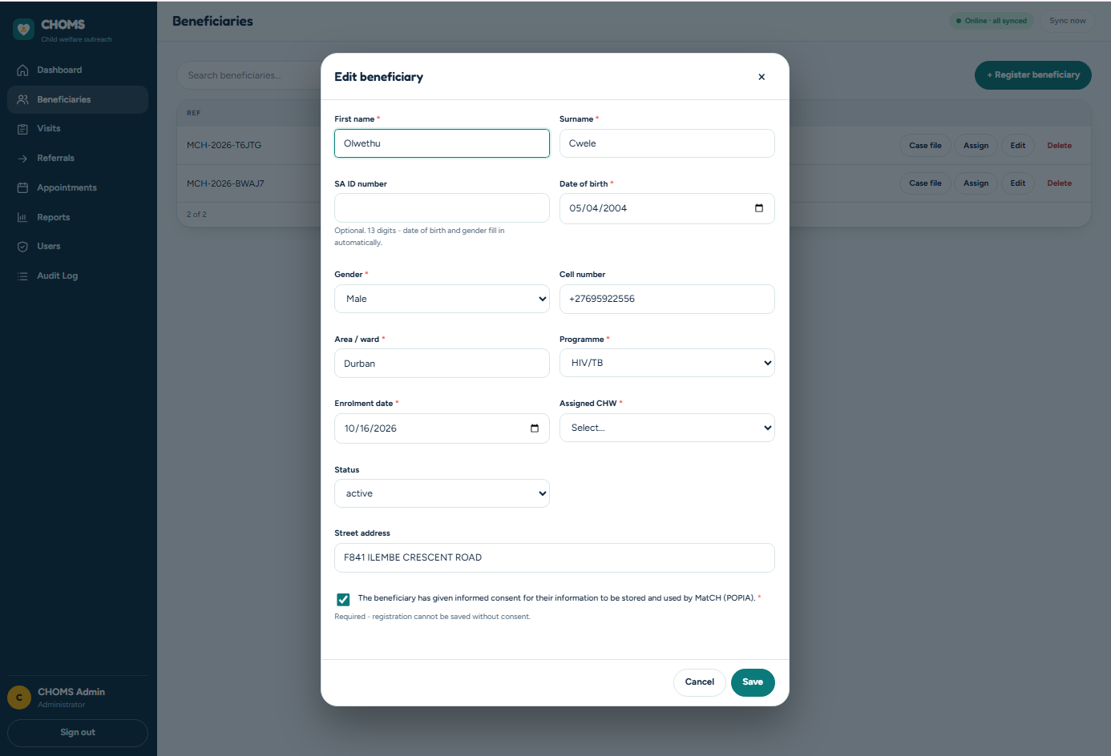
5.4 Reports
Admins and Coordinators generate a programme report for any date range: new beneficiaries by programme, visits and outcomes, completed visits per CHW, referral completion rate and appointment attendance rate. Reports can be exported to CSV (with spreadsheet formula-injection protection) or printed to PDF, and saved for approval — only an Admin can approve.
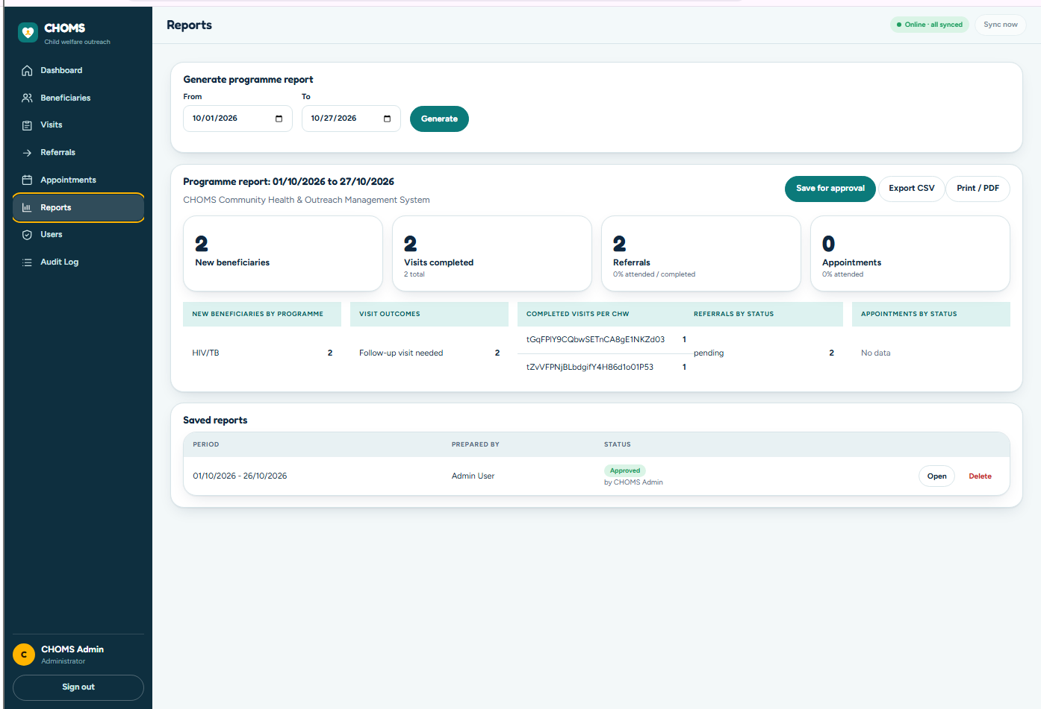
5.5 User management
The Users screen lists every account with Name, Email, Role, Status and Registered date, pending accounts first, with search and a role filter. Each row offers Approve (pending accounts, choosing CHW, Coordinator or Admin — the requested role is pre-selected), Edit (name, phone, role) and Deactivate / Reactivate. Permanent deletion sits inside the Edit dialog to prevent accidents.
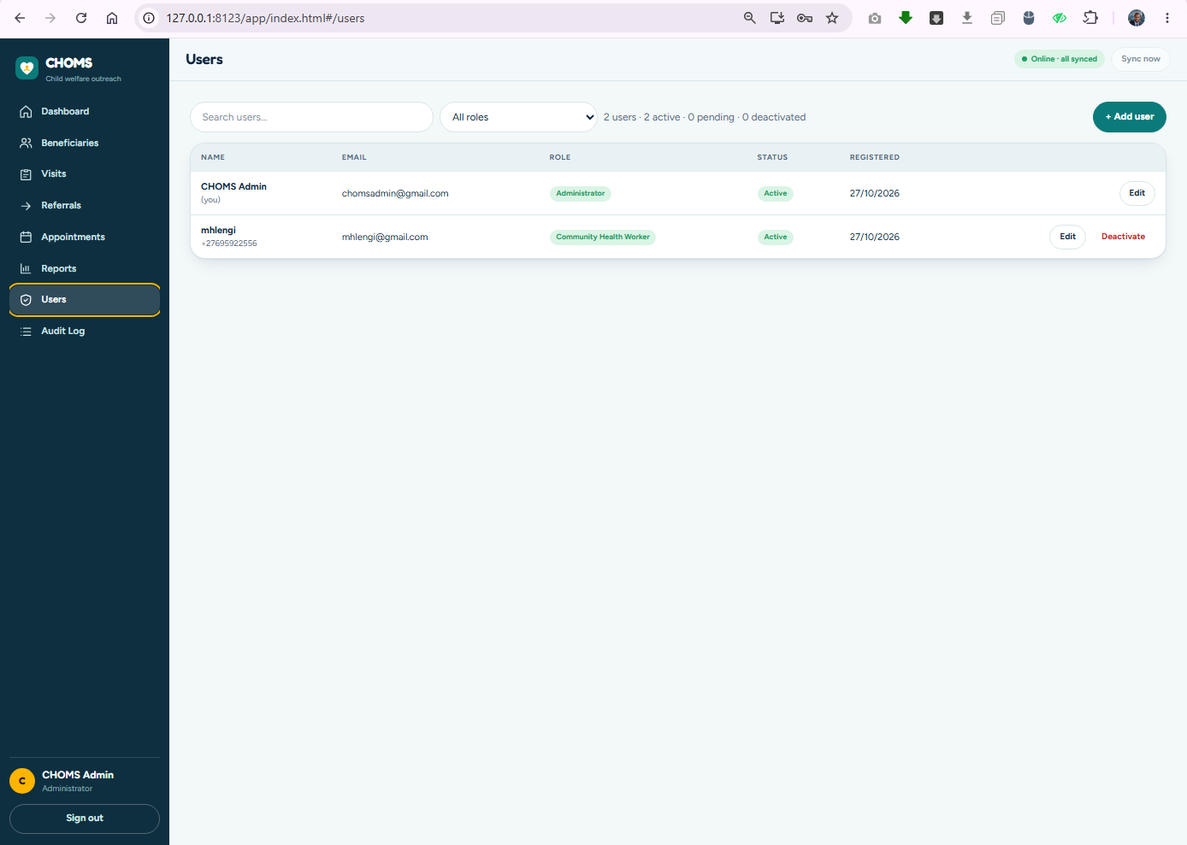
5.6 Friendly, resilient error handling
- friendlyError() translates technical codes (permission-denied, unavailable, auth/too-many-requests, Cloud Function errors) into plain sentences.
- Form errors appear beside the field, the first invalid field receives focus, and Save is disabled while saving.
- Refused sign-ins keep their explanation on screen (the message survives the automatic sign-out that follows).
- Network timeouts (10–12 s) stop the interface hanging on weak mobile connections; storage-full and blocked-storage cases are handled without crashing.
- Toasts confirm every success or failure; global handlers catch unexpected errors so nothing fails silently.
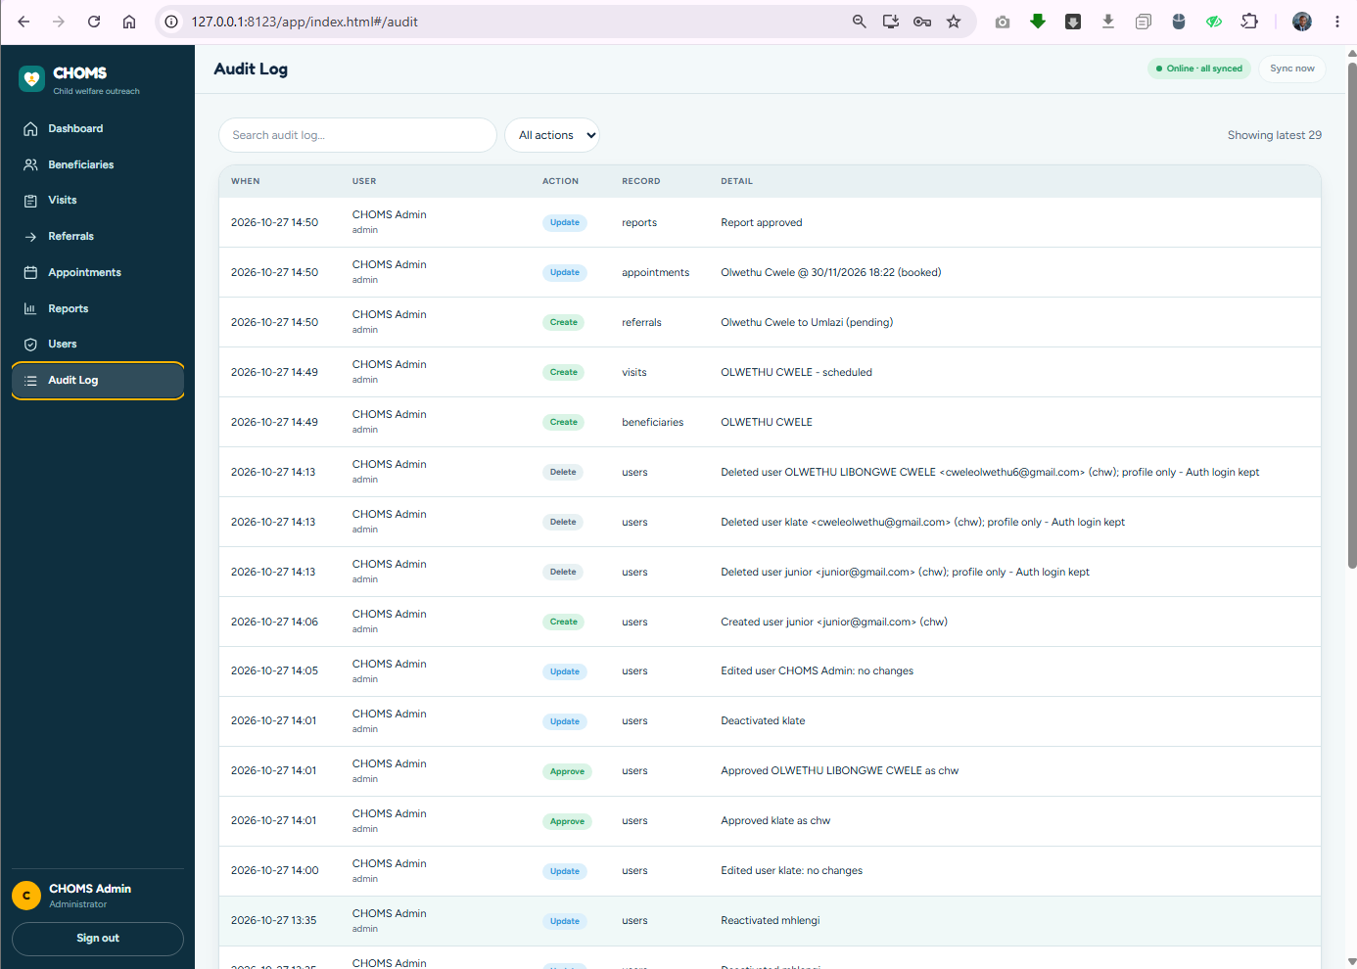
6. DevOps & Testing
6.1 Infrastructure as code
The Firebase project is described in version-controlled files: .firebaserc selects match-choms; firebase.json declares the email/password auth provider, the Firestore rules file and database location, the Cloud Functions codebase (Node.js 22), hosting headers and emulator ports. A single command (npx firebase-tools deploy) can rebuild the backend configuration.
6.2 Continuous integration
Pipeline | Trigger | Steps
main.yml — CHOMS CI | Every push and pull request | Checkout → Node.js 20 and 22 matrix → npm ci → Jest with coverage → upload coverage report
android-apk.yml — Build Android APK | Push to main touching android/**, or manual | Checkout → JDK 17 → inject google-services.json from a secret → JUnit tests → assembleDebug → upload APK artifact

6.3 Test strategy
Level | Tool | Count | What it proves
Business logic (web) | Jest | 50 | SA ID Luhn/DOB/gender, phone/email/password rules, all four entity validators, permission matrix for every role (incl. pending and invalid roles), report maths, CSV escaping, search
Business logic (Android) | JUnit | 21 | Same validation rules in Java, sign-up form (incl. role choice), appointment rules, role behaviour incl. deactivation
Security rules | Firestore emulator + rules-unit-testing | 76 | Real rules, real batch shapes: escalation attempts, ownership, schema pollution, audit pairing, deactivation, assignment validity, reports, admin profile delete
Live smoke checks | Firebase JS SDK against match-choms | — | Sign-up produced a pending profile + audit entry and was denied data; admin profile read path verified
Build verification | Gradle | — | Debug APK builds against the real Firebase configuration

Security rule scenarios (excerpt)
- A new user cannot register as admin, as an approved role, with extra fields or for someone else.
- A pending or deactivated account can read nothing but its own profile.
- Every create, update and delete without its audit entry is rejected; forged or edited audit entries are rejected.
- Admins cannot assign work to a coordinator, a pending account or a deactivated CHW.
- Coordinators can read everything and save reports, but cannot edit records, approve reports, manage users or read the audit log.
# web unit tests
cd web/app && npm install && npm test

# Firestore security-rule tests (from the project root)
cd firebase/tests && npm install && cd ../..
npx firebase-tools emulators:exec --only firestore --project demo-choms \
"node firebase/tests/rules.test.mjs firebase/firestore.rules"

# Android unit tests
cd android && ./gradlew testDebugUnitTest
Figure E: Reproducing the automated test runs.
6.4 Manual acceptance tests
ID | Scenario | Expected result
M1 | Register as CHW on the website | "Request sent"; profile role: pending, requestedRole: chw; register audit entry
M2 | Pending person signs in | Waiting for approval screen
M3 | Admin approves as CHW | Person signs in to My Dashboard; approve audit entry
M4 | Admin assigns a beneficiary to the CHW | Client appears under the CHW's My Clients on web and Android
M5 | CHW records a visit offline, then reconnects | Saved instantly with "1 pending"; synced and visible to the admin
M6 | Coordinator saves a report; admin approves | Coordinator has no Approve button; status changes to approved
M7 | Admin deactivates a user | User is refused at sign-in and loses data access
M8 | Admin deletes a user | User disappears from Users; delete audit entry recorded

7. Challenges & Solutions
Real systems are shaped by the problems they meet. These are the most significant ones we solved and the reasoning behind each solution.
7.1 Deleting users without a paid Cloud Function
Challenge | Removing another person's Firebase Authentication login requires the Admin SDK, which must run on a trusted server. Our deleteUser Cloud Function is written and tested, but deploying functions requires the Blaze (pay-as-you-go) plan, which was not active on match-choms.
Solution | A secure, admin-only fallback. The Delete button first calls the Cloud Function. If the function is not deployed, the app deletes the user's Firestore profile directly — but only through a dedicated rule: the caller must be an active admin, cannot delete themselves, and must write the delete-users-<uid> audit entry in the same batch.
Effect | The person immediately disappears from CHOMS, can no longer use it ("no CHOMS profile"), and the deletion is permanently recorded. Their sign-in login remains in Firebase Authentication until removed in the console.
Next step | Once the project is on Blaze, npx firebase-tools deploy --only functions activates full deletion (login + profile) with no app changes — the app automatically prefers the function.

7.2 Unused white space on wide screens
On large monitors every page stopped at 1,280 pixels, leaving an empty band on the right. The cause was a max-width on the content container (#view). We removed it, gave the container width: 100% with balanced 2rem padding, allowed the main column to shrink (min-width: 0) so wide tables scroll inside their own box instead of stretching the page, and made stat cards share the full width evenly. Phone and tablet layouts were left unchanged.
7.3 Offline synchronisation and conflicts
- Audit without breaking offline mode. Requiring an audit entry for every write could have made offline capture fragile. Instead, each outbox item carries its audit entry and is replayed as one atomic batch, so offline writes stay fully audited.
- Idempotent replay. Records are written with merge semantics and deletes use deterministic audit IDs, so retrying after a dropped connection cannot create duplicates.
- Changed permissions while offline. If an admin reassigns a client while a CHW is offline, the CHW's queued edit is no longer allowed. The server rejects it, the app moves it to a "failed" list and tells the user — the queue keeps flowing and no data is silently lost.
7.4 The sign-in loop
During testing, signing in sometimes appeared to "bounce" back to the login screen. Two causes combined: the refusal message (for a pending account) was being cleared by the automatic sign-out that followed, and a cached profile could in principle stand in for the server copy. We now read the profile from the server on every sign-in, cache only approved active profiles, show pending users a dedicated Waiting for approval screen, and keep refusal messages visible. Sign-in now routes each role straight to its own dashboard.
7.5 Evolving the role model safely
The client's role requirements changed several times during development. Because authorisation lives in one rules file covered by 76 automated scenarios, each change could be made with confidence: update the rules, rerun the emulator suite, then update both clients and their tests.
7.6 Summary
Challenge | Solution
Cloud Function needs a paid plan | Audited, admin-only profile-delete fallback; function ready to deploy
White space on wide screens | Full-width content container and fluid grids
Offline writes vs. mandatory auditing | Outbox items carry their audit entry; atomic batch replay
Permissions changing while offline | Server rejects, client parks and reports the failed item
Sign-in appearing to loop | Server-fresh profile reads, safe caching, persistent messages, waiting screen
Admins creating logins without being signed out | Temporary secondary Firebase app instance creates the account
Assigning work to the wrong person | Rules require the assignee to be an active CHW

8. Conclusion & Future Work
CHOMS turns MatCH's paper registers into a connected, secure and accountable platform. CHWs capture work where it happens — even without signal; coordinators see the whole programme in real time; administrators control who can do what; and every change is traceable. All twelve functional requirements from Task 1 are implemented, with one clearly stated limitation: appointment reminders are scheduled and stored, but sending SMS or email requires a server-side component.
Impact for MatCH
Fewer lost referrals — urgent referrals stay visible until an outcome is recorded.
Faster oversight — fieldwork appears on the dashboard as soon as a phone reconnects.
Reporting in minutes — funder reports for any date range, exported or printed in one click.
Trust and compliance — POPIA-aligned access control and an audit trail nobody can alter.

Future work
Enhancement | Approach
SMS and email reminders | A scheduled Cloud Function reads appointments.reminderDue and sends messages through the Twilio API (or a South African SMS gateway), logging each delivery.
Native iOS app | A SwiftUI client using the Firebase iOS SDK against the same rules and audit contract.
Full user deletion | Activate the Blaze plan and deploy the existing deleteUser function.
Offline-first Android UI | An optimistic local queue with a visible pending-changes indicator, matching the PWA.
Custom claims for roles | Mirror roles into Auth custom claims to reduce rule document reads and latency.
Push notifications | Firebase Cloud Messaging for overdue visits and urgent referrals.
App Check & field encryption | Firebase App Check to block non-genuine clients; encryption of cached offline data.
Health system integration | Export to DHIS2 / provincial health information systems.

10. References
Fowler, M. (2002) Patterns of Enterprise Application Architecture. Boston: Addison-Wesley.
Google (2026) Android Developers: Guide to app architecture. Available at: https://developer.android.com/topic/architecture
Google (2026) Firebase Authentication documentation. Available at: https://firebase.google.com/docs/auth
Google (2026) Cloud Firestore: Get started with Security Rules. Available at: https://firebase.google.com/docs/firestore/security/get-started
Google (2026) Test your Cloud Firestore Security Rules. Available at: https://firebase.google.com/docs/firestore/security/test-rules-emulator
Google (2026) Cloud Functions for Firebase. Available at: https://firebase.google.com/docs/functions
GitHub (2026) GitHub Actions documentation. Available at: https://docs.github.com/en/actions
Meta Open Source (2026) Jest documentation. Available at: https://jestjs.io/docs/getting-started
Mozilla (2026) Service Worker API. MDN Web Docs. Available at: https://developer.mozilla.org/en-US/docs/Web/API/ServiceWorkerAPI
Republic of South Africa (2013) Protection of Personal Information Act 4 of 2013. Pretoria: Government Gazette.
Twilio (2026) Programmable Messaging documentation. Available at: https://www.twilio.com/docs/messagingAppendix A: Key Files

