

Functional Specification
Shipwar

Version 1.0
Last modified 29 May 2018
Number of pages 5

Table of Contents
1. Introduction 3
1.1. Document Identifier 3
1.2. Scope 3
1.3. Definitions of Terms and Acronyms 3
2. Problem Statement 3
3. Platform Requirements 3
4. Overview of Solution 3
5. Black-box Description 4

Introduction

Document Identifier
This document describes functional specifications of “Shipwar” game.

Scope
// TODO

Definitions of Terms and Acronyms
Operating System - system software that manages computer hardware and software resources and provides common services for computer programs.
Terminal - A computer terminal is an electronic or electromechanical hardware device that is used for entering data into, and displaying or printing data from, a computer or a computing system.

Problem Statement
The product should provide following functionality
Generate the board with given height and length and given number of ships. By default the generated board should have 10x10 size, 6 small ships , 4 medium and 4 big ships.
The customer can decide to change any of this numbers as they wish.
Ships should be placed on random positions each time the board is generated.
User should not be able to see the generated board and know the placement of the ships.
User should know number of the ships that are placed on the board in the beginning of the game.
User should be able to check (shut) one square at a time for appearance of a ship or part of it if it is medium or big size.
User should be told if the square contained a ship, is the ship killed or it is still alive.
The game should end and exit when all ships are shut.

Platform Requirements
The executable should run on any platform that has Terminal/Bash/Shell.
- Supported OS:
  - Ubuntu
  - Windows
  - Mac

Overview of Solution
Board and ship generation. (Illustrations contain generated board, but they will not be present in the final project, this is just for checking).
A matrix should be created and ships placed on it randomly each time.

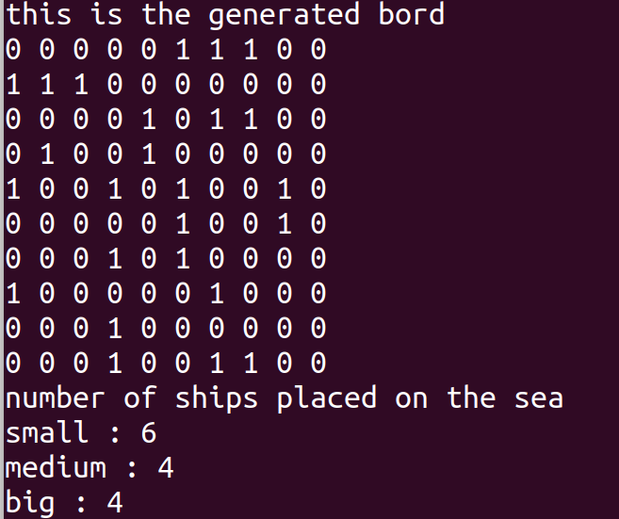
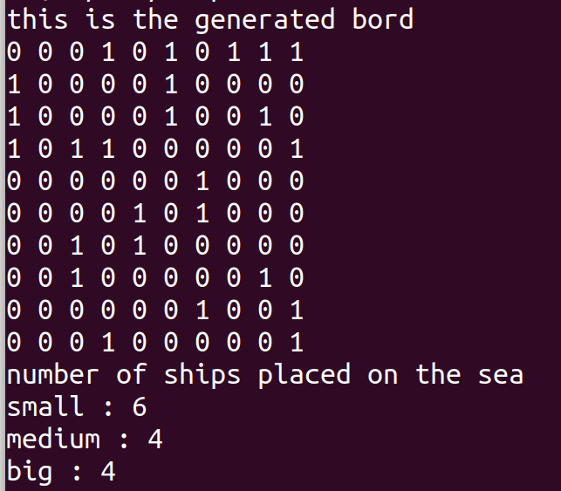

Shutting
User is prompted with a text asking to input coordinates.
User enters two separate numbers from 1 to 10 that represent row and column index of the square. User is told if there was a ship or it was a miss , if there was a ship is it killed or still alive.
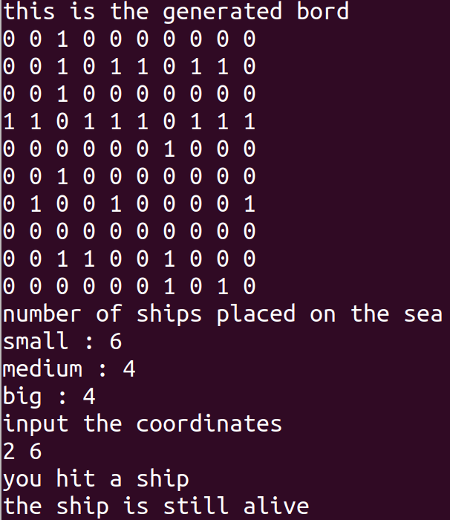
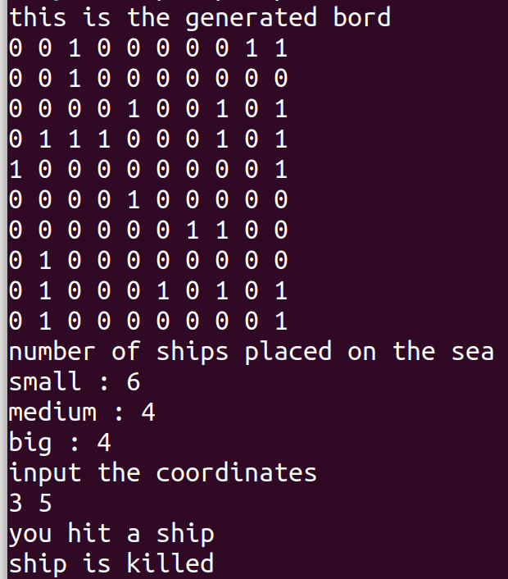
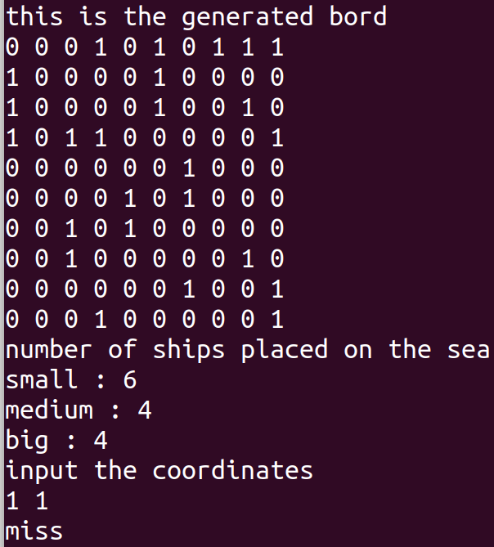

Black-box Description
As described in previous section user can just shut without seeing the board.
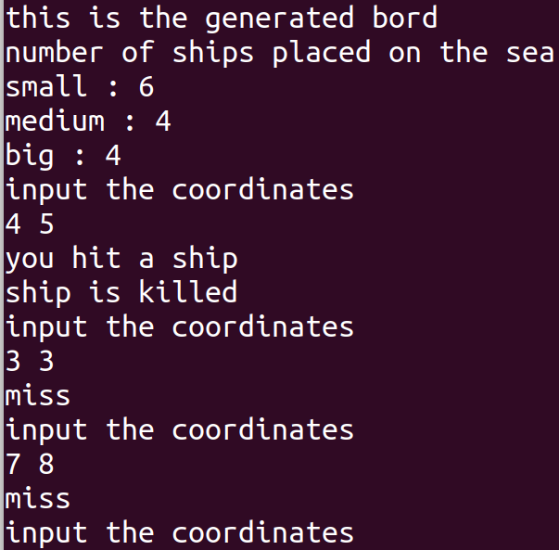

If the user tries to shut each place several times they will be told that the square has already been chacked.
