Vignette Title

Vignette Author

2017-03-29

Vignettes are long form documentation commonly included in packages. Because they are part of the distribution of the package, they need to be as compact as possible. The html_vignette output type provides a custom style sheet (and tweaks some options) to ensure that the resulting html is as small as possible. The html_vignette format:

* Never uses retina figures
* Has a smaller default figure size
* Uses a custom CSS stylesheet instead of the default Twitter Bootstrap style

## Vignette Info

Note the various macros within the vignette section of the metadata block above. These are required in order to instruct R how to build the vignette. Note that you should change the title field and the \VignetteIndexEntry to match the title of your vignette.

## Styles

The html_vignette template includes a basic CSS theme. To override this theme you can specify your own CSS in the document metadata as follows:

output:   
 rmarkdown::html_vignette:  
 css: mystyles.css

## Figures

The figure sizes have been customised so that you can easily put two images side-by-side.

plot(1:10)  
plot(10:1)

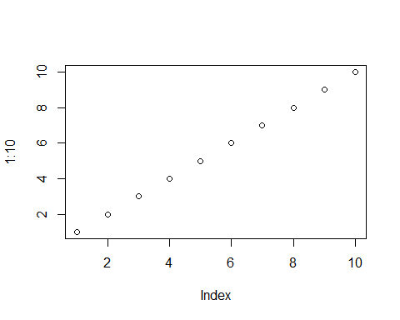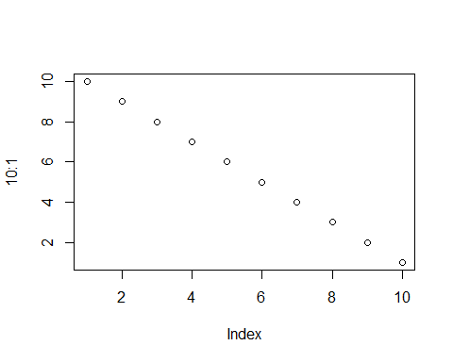

You can enable figure captions by fig_caption: yes in YAML:

output:  
 rmarkdown::html_vignette:  
 fig_caption: yes

Then you can use the chunk option fig.cap = "Your figure caption." in **knitr**.

## More Examples

You can write math expressions, e.g. $Y=Xβ+ϵ$, footnotes[1], and tables, e.g. using knitr::kable().

|  |  |  |  |  |  |  |  |  |  |  |  |
| --- | --- | --- | --- | --- | --- | --- | --- | --- | --- | --- | --- |
|  | mpg | cyl | disp | hp | drat | wt | qsec | vs | am | gear | carb |
| Mazda RX4 | 21.0 | 6 | 160.0 | 110 | 3.90 | 2.620 | 16.46 | 0 | 1 | 4 | 4 |
| Mazda RX4 Wag | 21.0 | 6 | 160.0 | 110 | 3.90 | 2.875 | 17.02 | 0 | 1 | 4 | 4 |
| Datsun 710 | 22.8 | 4 | 108.0 | 93 | 3.85 | 2.320 | 18.61 | 1 | 1 | 4 | 1 |
| Hornet 4 Drive | 21.4 | 6 | 258.0 | 110 | 3.08 | 3.215 | 19.44 | 1 | 0 | 3 | 1 |
| Hornet Sportabout | 18.7 | 8 | 360.0 | 175 | 3.15 | 3.440 | 17.02 | 0 | 0 | 3 | 2 |
| Valiant | 18.1 | 6 | 225.0 | 105 | 2.76 | 3.460 | 20.22 | 1 | 0 | 3 | 1 |
| Duster 360 | 14.3 | 8 | 360.0 | 245 | 3.21 | 3.570 | 15.84 | 0 | 0 | 3 | 4 |
| Merc 240D | 24.4 | 4 | 146.7 | 62 | 3.69 | 3.190 | 20.00 | 1 | 0 | 4 | 2 |
| Merc 230 | 22.8 | 4 | 140.8 | 95 | 3.92 | 3.150 | 22.90 | 1 | 0 | 4 | 2 |
| Merc 280 | 19.2 | 6 | 167.6 | 123 | 3.92 | 3.440 | 18.30 | 1 | 0 | 4 | 4 |

Also a quote using >:

"He who gives up [code] safety for [code] speed deserves neither." ([via](https://twitter.com/hadleywickham/status/504368538874703872))

1. A footnote here.