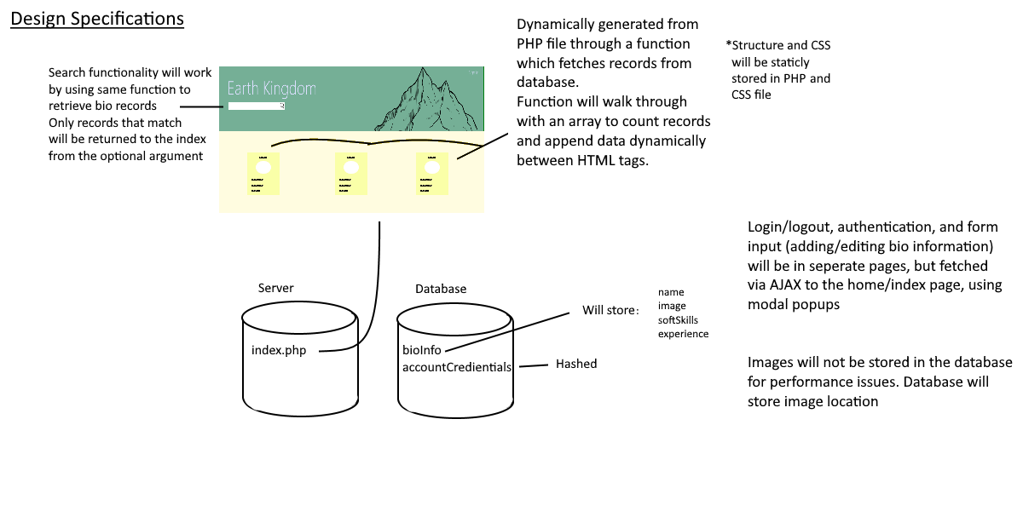

For our design considerations, we’re valuing our website to function with minimal overhead and dependencies. With the use of AJAX to fetch content for the home page, we encourage an all-in-one approach to our presentation, but with our backend focused on modularity of components. Having components ‘modularized’ means better maintainability and extensibility if things were to change. Using a front-end library (likely Bootstrap), will provide scalability and portability for our website’s presentation, regardless of how many personal profiles are on our home page.