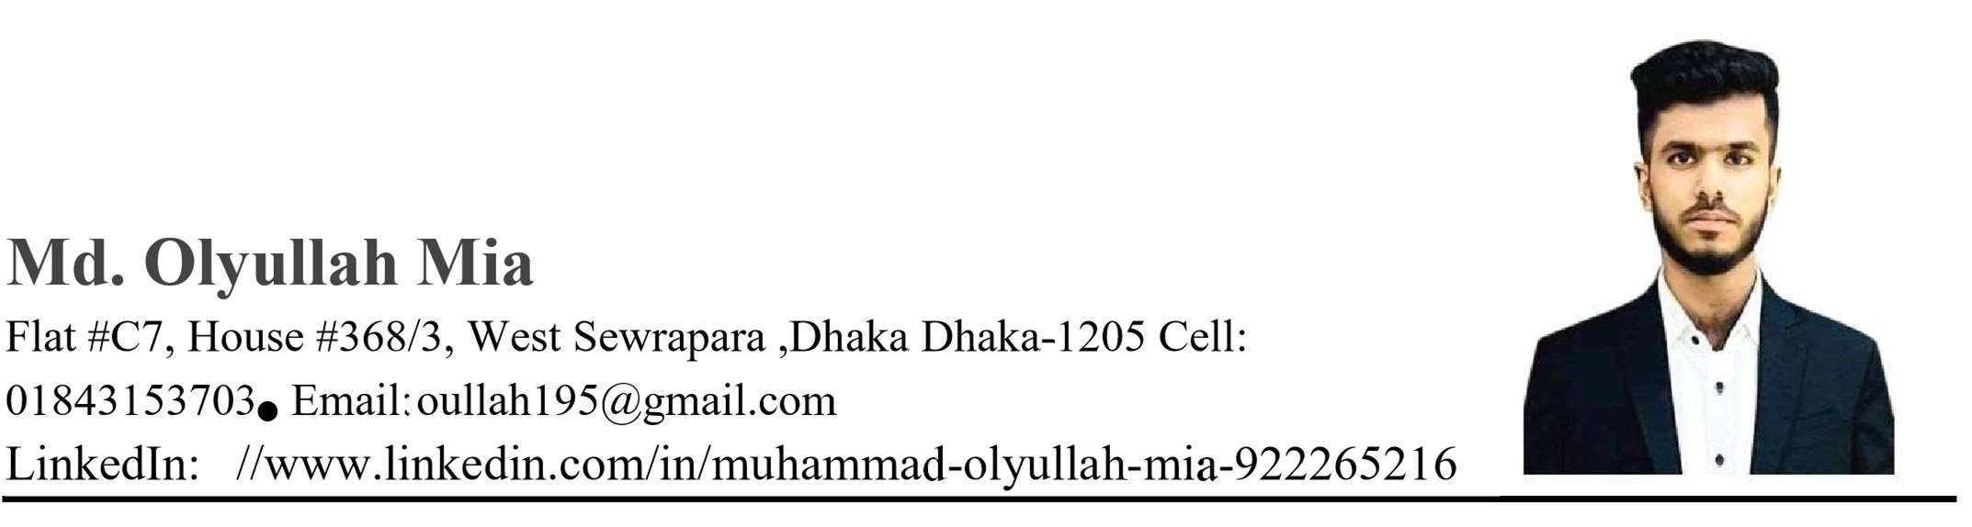
Career Objective: As a fresh graduate, I am looking forward to a job to build a career in growing, where I can get the opportunities to prove my abilities by accepting challenges. Always willing to listen and learn new concepts in various fields. Very dedicated and focused on achieving my goal and willing to work hard in the process.

Professional Training Summary
Cisco Certified Network Associate (CCNA)
Duration: November 2023 -March 2024
Institution- At Computer Solution Limited
• Switching, Routing, and Wireless Essentials • Enterprise Networking, Security and Automation.

Working Experience
1.Bets Consulting Service Ltd
GIS Assistant
Duration: August 2024 -Present
Accomplishments: Road Digitalization, GIS Database, Survey Database
2.North South University Power Station
Job Title: Engineering Internship
Duration: January2023 – June2023
3.Bangladesh Rural Electrification Board
Job Title: Engineering Internship
Duration: July2023-September2023

Education:
Bachelor of Science (BSC)  Passing Year: 2023  Concentration: Electrical and Electronic Engineering  Institution: North South University | CGPA:2.78/4.00
Higher Secondary Certificate (HSC)  Passing Year: 2018  Concentration: Science  Institution: Shaheed police smriti College Education  Board: Dhaka | GPA: 4.57/5.00
Secondary School Certificate (SSC)  Passing Year: 2016  Concentration: Science | GPA: 5.00/5.00
Institution: Monipur High School and Collage Education
Board: Dhaka

Skills
Operating system: Microsoft, Linux(Basic), MTCNA
Simulation Tool: Cisco packet tracer, Multisim, Logisim, Matlab, Autocad
Programming Languages: C, C+
Microsoft Office: Word, PowerPoint, Excel.
Interpersonal skills: Organizing, Teamwork, Critical thinking

Academic Projects
- Digital logic design
- Fire Alarm
- Water Level indicator
- Garbage Monitoring System (IOT) based
- Air Quality Index to Mosquito (IOT) based
- Electric Vehicles

Extra Curriculum
- Former member at IEEE NSU Branch.
- Former member at IEEE NSU PES Branch.
- Former member at NSU Earth Club
- • Former member at NSU Computer & Engineering Club.

Language Proficiency Proficiency in oral and written communication both in English & Bengali.

References:
Mr. Rifat Ahmed Hassan
Lectuter
SAC1179
Rifat.hassan02@northsouth.edu
+880255668200 Ext- 6204

