Uplift Modeling for Personalized Marketing in Telecommunications: Ranking Subscribers by the Incremental Effect of a Campaign

Abilkhay Askar and Kolzhabay Olzhas
Group Big Data Analysis 2406
Astana IT University
Applied Machine Learning
October 30, 2026
Abstract
Telecommunications operators usually target marketing offers at the customers who are most likely to convert, yet many of those customers would convert anyway, and some react negatively to being contacted. This study asks which subscribers should receive an offer so that the number of additional (incremental) conversions is maximized. We used the synthetic MegaFon Uplift Competition dataset, a randomized experiment with 600,000 subscribers, 50 anonymized features, a treatment flag and a binary conversion outcome. After confirming that treatment and control groups were balanced (maximum standardized mean difference 0.0046), we compared three uplift approaches built on histogram gradient-boosted trees, namely the S-learner, the T-learner and class transformation, with a linear T-learner, a conventional conversion classifier and random targeting. Base-learner settings were tuned by cross-validated Qini coefficient, and all models were evaluated on a 180,000-customer held-out test set and on five repeated splits. The T-learner performed best, with a test Qini coefficient of 0.245 (mean 0.244 over five splits) against 0.096 for the conversion classifier and approximately zero for random targeting. Contacting the top 30% of customers ranked by the T-learner produced an observed uplift of 22.4%, compared with 5.0% for the whole test set, which corresponds to about 4.5 times as many incremental conversions as random targeting. The results show that uplift models, not response models, should drive campaign targeting when the goal is incremental impact.
Keywords: uplift modeling, heterogeneous treatment effects, meta-learners, Qini coefficient, telecommunications marketing
Uplift Modeling for Personalized Marketing in Telecommunications
Introduction
Mobile operators run frequent marketing campaigns, such as discounted tariff upgrades, bundled data packages or loyalty bonuses. Each contact has a cost, and an operator with millions of subscribers can afford to reach only part of the base. The common way to choose whom to contact is to train a response (propensity) model that predicts the probability of conversion and to send the offer to the customers with the highest scores. This answers the question “Who is likely to convert?”, which is not the question the business needs to answer. A customer with a high propensity score may convert whether or not the offer arrives, so the campaign spends money without changing the outcome, and some customers are less likely to convert when contacted (Radcliffe, 2007; Ascarza, 2018).
Uplift modeling replaces the question with “Who is more likely to convert because of the offer?” In the potential-outcomes framework (Rubin, 1974), each customer with feature vector x has two outcomes: Y(1) if treated and Y(0) if not. The quantity of interest is the conditional average treatment effect, uplift(x) = E[Y(1) − Y(0) | X = x]. Only one potential outcome is ever observed, so uplift cannot be used as a training label. When treatment is assigned at random, however, uplift(x) equals P(Y = 1 | x, T = 1) − P(Y = 1 | x, T = 0) and can be estimated from the treatment and control groups (Gutierrez & Gérardy, 2017).
This distinction matters for telecommunications in particular. Operators run randomized holdout groups routinely, they have rich usage data for every subscriber, and their campaigns are large enough for small improvements in targeting to translate into thousands of extra conversions. Typical applications include selecting customers for upsell offers, deciding who should receive retention incentives, and avoiding “sleeping dogs”, customers whom a contact pushes away.
The research question of this project is therefore: Which subscribers should receive a marketing offer in order to maximize incremental conversions, and does an uplift model rank subscribers better than random targeting and better than a conventional conversion model? The objectives are to (a) check that the experimental data support causal estimation, (b) estimate individual uplift with at least two meta-learning approaches, (c) evaluate them with uplift-specific metrics on held-out data and across repeated splits, and (d) turn the best model into a ranked targeting list for a fixed contact budget.
Literature Review
Early uplift work came from direct marketing. Radcliffe (2007) argued that campaigns should be targeted on predicted lift rather than predicted response and introduced the Qini curve and Qini coefficient, which measure how many incremental responses a ranking captures compared with random selection. Radcliffe and Surry (2011) later proposed significance-based uplift trees that split on the difference in treatment effect between child nodes. Rzepakowski and Jaroszewicz (2012) built decision trees whose splitting criteria are divergences between the treatment and control outcome distributions, and Athey and Imbens (2016) developed honest recursive partitioning with valid confidence intervals for heterogeneous effects.
A second line of work reuses ordinary supervised learners. Künzel et al. (2019) formalized these meta-learners. The S-learner fits one model with the treatment flag as an extra feature, the T-learner fits separate models for treated and control units, and the X-learner combines the two with imputed effects. Jaskowski and Jaroszewicz (2012) proposed the class-transformation approach, which turns uplift estimation into a single binary classification problem when treatment is assigned with probability one half. Gutierrez and Gérardy (2017) and Devriendt et al. (2018) reviewed these families and concluded that no single method dominates; performance depends on the data, the strength of the treatment effect and the base learner. Ensemble learners such as gradient-boosted trees (Friedman, 2001; Ke et al., 2017) are attractive base models because they capture non-linear interactions between features and treatment.
Evaluation is a recognized difficulty because the true individual effect is never observed. The standard remedy is to rank customers and compare the observed treatment and control response rates within ranked groups, summarized by Qini and uplift curves (Radcliffe, 2007; Gutierrez & Gérardy, 2017). Large public benchmarks, such as the Criteo advertising dataset (Diemert et al., 2018) and the MegaFon Uplift Competition (MegaFon, 2021), have made such comparisons reproducible. In marketing research, Ascarza (2018) showed with field experiments that targeting the customers with the highest churn risk can be less effective than targeting those with the highest predicted response to the intervention.
Three gaps motivate this project. First, many applied studies still select and tune models by classification accuracy or ROC AUC, although these metrics say nothing about how well a model ranks customers by treatment effect. Second, published comparisons often report a single train/test split, which hides how stable the ranking is. Third, few studies translate uplift scores into an explicit budgeted targeting decision and compare it with the response model that practitioners actually use. This project addresses all three on a large telecommunications dataset.
Data
Source and Structure
The study uses the MegaFon Uplift Competition dataset (MegaFon, 2021), released by the Russian operator MegaFon on the Open Data Science platform and distributed through the scikit-uplift library (Shevchenko, n.d.). The data are synthetic: they were generated to imitate a telecommunications marketing experiment, so no real customer records are involved. The labelled file contains 600,000 rows. Each row has a treatment flag (“treatment” or “control”), 50 anonymized numeric features X_1 to X_50 whose business meaning is not published, and a binary conversion outcome. The distributed file contains no explicit subscriber identifier, so the row index was used as the customer id. A separate 900,000-row competition test file has no labels and was not used.
Table 1
Summary of the MegaFon Uplift Dataset
Property | Value
Labelled observations | 600,000
Features | 50 numeric (X_1 … X_50), anonymized
Treatment group | 300,368 (50.06%), conversion rate 22.89%
Control group | 299,632 (49.94%), conversion rate 17.94%
Average treatment effect | 0.0495 (95% CI 0.0475 to 0.0516)
Missing values / duplicate rows | 0 / 0
Maximum |SMD| between groups | 0.0046 (threshold 0.1)
Note. SMD = standardized mean difference. CI = confidence interval. Computed in the project notebook.
Validation and Balance
The data were checked for missing values, duplicate records and column types; none of the 50 features contained missing values and no row was duplicated. The offer raised the conversion rate from 17.94% to 22.89%, an average treatment effect of 4.95 percentage points (a relative lift of 27.6%). Because uplift estimation relies on random assignment, the distribution of every feature was compared between the two groups with the standardized mean difference SMD = (mean_T − mean_C) / √((var_T + var_C)/2). All 50 values were far below the common threshold of 0.1 (largest 0.0046), which is consistent with randomized assignment (Figure 1).
Figure 1
Absolute Standardized Mean Difference Between Treatment and Control for the 50 Features
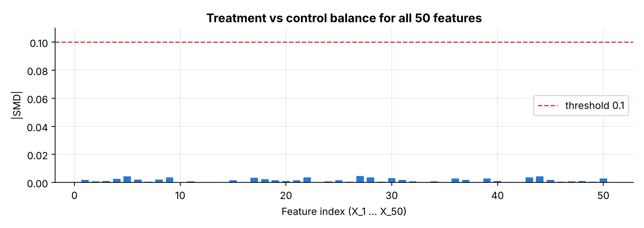
Note. The dashed line marks the 0.1 balance threshold. All features are below 0.005.
Preprocessing and Train/Test Split
No imputation was needed. Features were left unscaled for the tree-based learners, which are invariant to monotone transformations, and were standardized inside a pipeline for the logistic-regression baseline. The data were split into 70% training (420,000 rows) and 30% test (180,000 rows), stratified on the four combinations of treatment and conversion. The treatment share and conversion rate were identical to four decimals in the full, training and test sets. The test set was used only for final evaluation; hyper-parameter tuning used cross-validation inside the training set.
Methodology
Pipeline
Figure 2 shows the full pipeline, from loading the data to producing the targeting list. All steps run in one Python notebook with fixed random seeds.
Figure 2
Project Pipeline From Raw Data to Targeting Decision
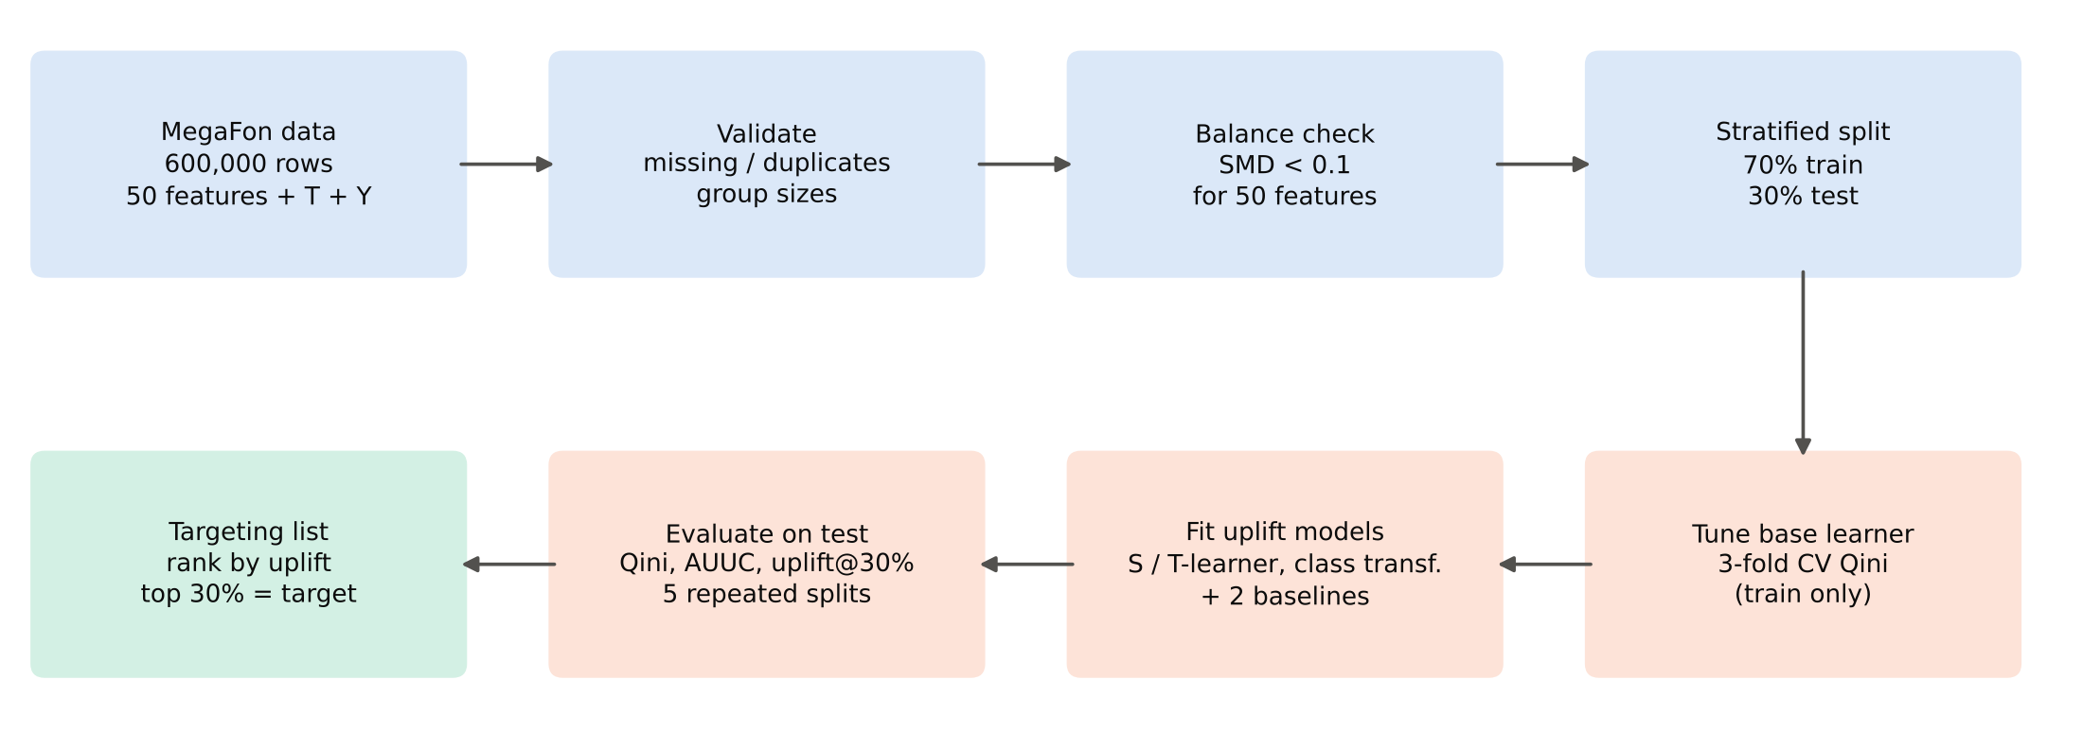
Uplift Models
Three uplift approaches were implemented with the scikit-uplift wrappers (Figure 3). The S-learner (SoloModel) trains a single classifier on [X, T] and estimates uplift as f(x, 1) − f(x, 0). The T-learner (TwoModels, vanilla mode) trains one classifier on treated customers and another on control customers and subtracts their predicted probabilities. Class transformation creates the label Z = 1 when (T = 1, Y = 1) or (T = 0, Y = 0); with a treatment probability of about 0.5, uplift(x) = 2P(Z = 1 | x) − 1 (Jaskowski & Jaroszewicz, 2012). A T-learner with standardized logistic regression was added as a linear reference.
Figure 3
Architectures of the Three Uplift Meta-Learners
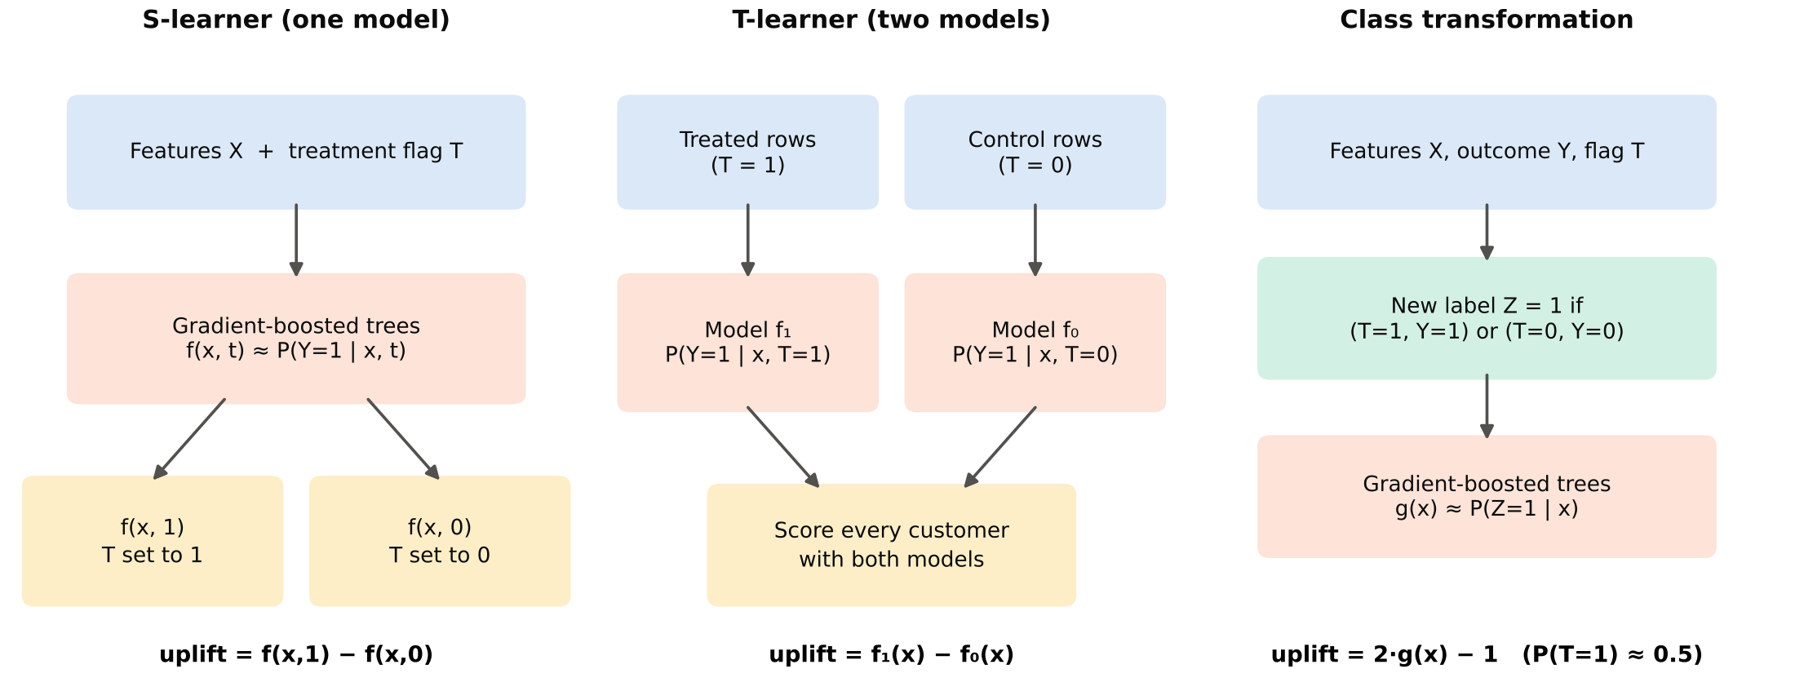
Two baselines represent current practice. Random targeting assigns each customer a random score. The conversion model is the same gradient-boosted classifier trained on X only (all training customers) and ranks customers by predicted conversion probability, which is how a response model is used in campaign selection.
Base Learner, Parameters and Training Procedure
All tree-based models use scikit-learn's HistGradientBoostingClassifier (Pedregosa et al., 2011), a histogram-based implementation of gradient-boosted decision trees (Friedman, 2001; Ke et al., 2017). Each model is an additive ensemble of shallow regression trees fitted sequentially to the gradient of the binary log-loss; tree models have no layers, activation functions, batches or epochs in the neural-network sense. Fixed settings were min_samples_leaf = 100, L2 regularization = 1.0, no early stopping and random_state = 42. The learning rate, the maximum number of leaves per tree and the number of boosting iterations were tuned over four configurations by the mean Qini coefficient in 3-fold stratified cross-validation on the training set (Table 2), as planned in the proposal, instead of by accuracy. The logistic-regression baseline used the L-BFGS optimizer with up to 1,000 iterations.
Table 2
Cross-Validated Qini Coefficient for Each Base-Learner Configuration
Model | Learning rate | Max leaves | Iterations | CV Qini M (SD)
S-learner | 0.10 | 31 | 200 | 0.2313 (0.0012)
S-learner | 0.05 | 31 | 300 | 0.2310 (0.0015)
S-learner | 0.10 | 15 | 200 | 0.2179 (0.0020)
S-learner | 0.10 | 63 | 150 | 0.2365 (0.0007)
T-learner | 0.10 | 31 | 200 | 0.2364 (0.0015)
T-learner | 0.05 | 31 | 300 | 0.2361 (0.0024)
T-learner | 0.10 | 15 | 200 | 0.2292 (0.0015)
T-learner | 0.10 | 63 | 150 | 0.2380 (0.0003)
Class transformation | 0.10 | 31 | 200 | 0.2184 (0.0025)
Class transformation | 0.05 | 31 | 300 | 0.2233 (0.0033)
Class transformation | 0.10 | 15 | 200 | 0.2177 (0.0021)
Class transformation | 0.10 | 63 | 150 | 0.2179 (0.0022)
Note. 3-fold stratified cross-validation on the 420,000 training rows. Selected configurations: 0.10/63/150 for the S- and T-learner, 0.05/31/300 for class transformation. The conversion model uses the S-learner setting.
Evaluation Metrics
Accuracy and ROC AUC were deliberately not used for model selection, because a model can predict conversion well and still rank customers poorly by treatment effect (Radcliffe, 2007). Three uplift metrics from scikit-uplift were computed on the test set. The Qini curve plots the cumulative number of incremental conversions, Yᵀ(k) − Yᶜ(k)·Nᵀ(k)/Nᶜ(k), when the top k customers by score are contacted. The Qini coefficient is the area between this curve and the random-targeting line, normalized by the area of a perfect model, so random targeting scores 0 and a perfect ranking scores 1; it is also the official metric of the MegaFon competition. AUUC applies the same normalization to the uplift curve. Uplift@30% is the treatment conversion rate minus the control conversion rate among the 30% of customers with the highest scores, which matches the planned contact budget. Stability was measured by retraining every approach on five stratified 70/30 splits (seeds 42, 7, 123, 2024 and 99), and the final model was the approach with the highest mean Qini coefficient over these splits.
Experiments and Results
Model Comparison on the Test Set
Table 3
Uplift Metrics on the 180,000-Customer Test Set and Across Five Repeated Splits
Model | Qini | AUUC | Uplift@30% | Qini, 5 splits M (SD) | Splits Qini > 0
T-learner | 0.2450 | 0.1695 | 0.2244 | 0.2438 (0.0026) | 5/5
S-learner | 0.2430 | 0.1679 | 0.2193 | 0.2407 (0.0046) | 5/5
Class transformation | 0.2315 | 0.1599 | 0.2165 | 0.2304 (0.0027) | 5/5
Conversion model | 0.0965 | 0.0666 | 0.1153 | 0.0958 (0.0026) | 5/5
T-learner (LogReg) | 0.0405 | 0.0282 | 0.0852 | 0.0356 (0.0030) | 5/5
Random | -0.0033 | -0.0023 | 0.0454 | -0.0021 (0.0034) | 1/5
Note. Observed uplift on the whole test set = 0.0495. Qini and AUUC are normalized (random = 0, perfect = 1). Higher is better for all columns.
Table 3 summarizes the comparison. The three gradient-boosted uplift models were close to each other and far ahead of both baselines. The T-learner achieved the highest test Qini coefficient (0.245), followed by the S-learner (0.243) and class transformation (0.231). The conversion model, which is what a response-based campaign would use, reached only 0.096, and random targeting scored -0.003, close to zero as expected. The ordering was the same on all five repeated splits: the T-learner had the highest mean Qini (0.244) and the smallest standard deviation (0.0026), so it was selected as the final model. Figure 4 shows the Qini curves.
Figure 4
Qini Curves of All Models on the Held-Out Test Set
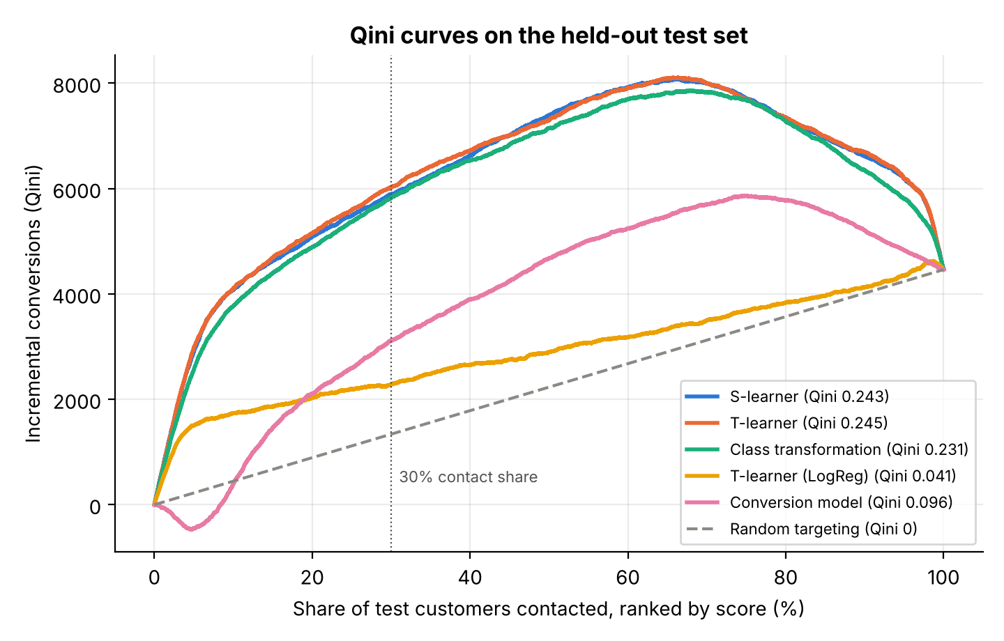
Note. Customers are contacted in order of decreasing score. The dashed line is random targeting; the dotted vertical line marks a 30% contact share.
The curves of the three boosted uplift models rise steeply over the first 10% to 20% of customers and then flatten. Beyond roughly 70% they decline, because the lowest-ranked customers convert less often when treated, so contacting them removes conversions. The conversion-model curve stays well below the uplift models: customers who are very likely to convert are not, in general, the ones whom the offer persuades.
Figure 5
Qini Coefficient on Five Repeated Train/Test Splits
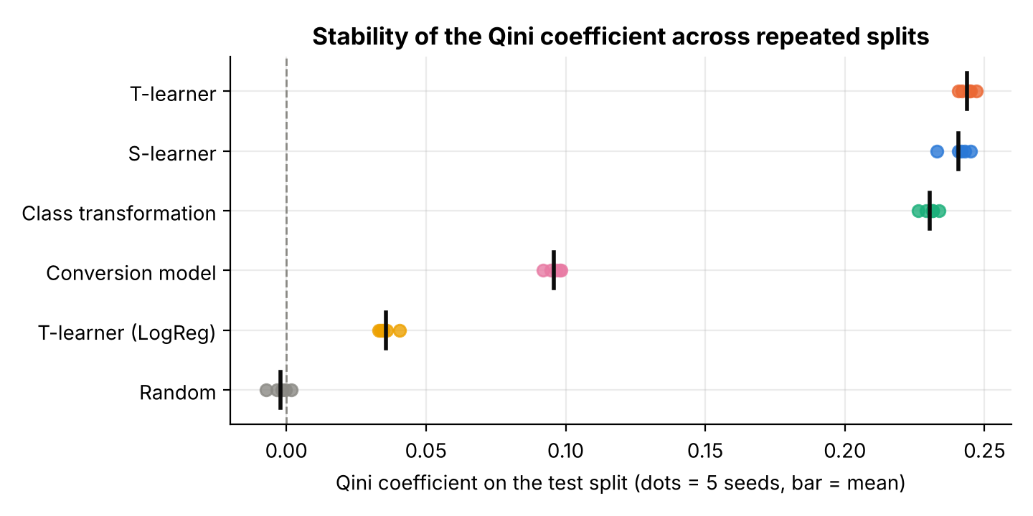
Note. Each dot is one split; the black bar is the mean over the five splits.
Why Some Models Performed Better
The T-learner's small advantage over the S-learner is consistent with the structure of the data. Because treatment and control groups are equally large (about 210,000 training customers each), each of the two models has ample data, and a separate model for each arm can represent completely different response surfaces. The S-learner must learn the treatment effect through splits on a single binary feature, and gradient boosting may use that feature in only part of its trees, which tends to shrink estimated effects toward zero (Künzel et al., 2019). Class transformation optimizes a related but noisier target: the transformed label mixes treatment and outcome information, and its variance grows with the base conversion rate, which explains its slightly lower Qini. Tuning confirmed that more complex trees (63 leaves) helped both the S- and T-learner, while class transformation preferred a lower learning rate and more iterations.
The linear T-learner reached a Qini coefficient of only 0.041. Its weakness shows that the treatment effect in this dataset depends on non-linear combinations of features that a linear decision boundary cannot represent. The conversion model ranked customers better than random but far worse than any boosted uplift model, which directly confirms the motivating argument of the project.
Uplift by Decile
Figure 6 and Table 4 show the observed treatment and control conversion rates within each decile of the T-learner's predicted uplift. Observed uplift falls almost monotonically from +0.460 in the top decile to -0.248 in the bottom decile. In the first decile, the offer raised conversion from 13.7% to 59.7%. In the last decile the pattern reversed: control customers converted at 54.1% but treated customers only at 29.3%. These are the customers that the uplift literature calls sleeping dogs; a response model would rank many of them highly because their baseline conversion rate is high.
Figure 6
Observed Conversion Rates by Decile of Predicted Uplift (T-Learner)
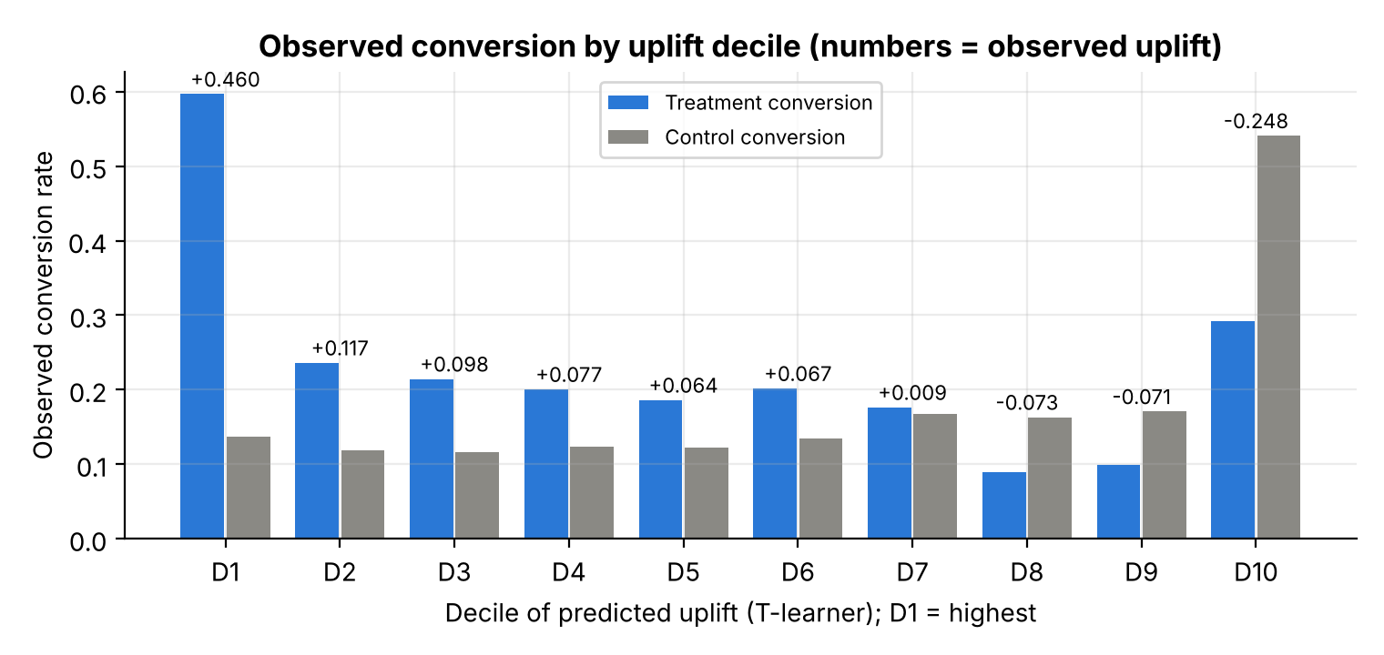
Note. D1 contains the 10% of test customers with the highest predicted uplift. Numbers above the bars are the observed uplift (treatment rate minus control rate).
Table 4
Observed Response Rates by Decile of T-Learner Predicted Uplift
Decile | n treatment | n control | Treatment rate | Control rate | Observed uplift
D1 | 8917 | 9083 | 59.7% | 13.7% | +0.460
D2 | 8946 | 9054 | 23.6% | 11.9% | +0.117
D3 | 8994 | 9006 | 21.4% | 11.7% | +0.098
D4 | 9059 | 8941 | 20.1% | 12.4% | +0.077
D5 | 8961 | 9039 | 18.6% | 12.2% | +0.064
D6 | 9130 | 8870 | 20.2% | 13.5% | +0.067
D7 | 9027 | 8973 | 17.6% | 16.7% | +0.009
D8 | 9038 | 8962 | 9.0% | 16.3% | -0.073
D9 | 9019 | 8981 | 9.9% | 17.1% | -0.071
D10 | 9019 | 8981 | 29.3% | 54.1% | -0.248

Campaign Efficiency and Targeting Decision
Uplift scores were turned into a budgeted decision. For a contact share k, the expected number of incremental conversions among the selected customers was estimated as the number contacted multiplied by their observed uplift; random targeting of the same number of customers yields that number multiplied by the overall test uplift (0.0495). At the planned 30% budget (54,000 of 180,000 test customers), the T-learner selection is associated with about 12,119 incremental conversions, compared with 6,224 for the conversion model and 2,674 for random targeting, a 4.5-fold gain (Table 5, Figure 7). The relative gain is largest for small budgets, because the most persuadable customers are concentrated at the top of the ranking.
Table 5
Estimated Incremental Conversions by Contact Share on the Test Set
Contact share | Customers | Random | Conversion model | T-learner | Gain vs. random
10% | 18,000 | 891 | 783 | 8,280 | 9.3×
20% | 36,000 | 1,783 | 4,204 | 10,379 | 5.8×
30% | 54,000 | 2,674 | 6,224 | 12,119 | 4.5×
40% | 72,000 | 3,566 | 7,799 | 13,477 | 3.8×
50% | 90,000 | 4,457 | 9,372 | 14,639 | 3.3×
Note. Incremental conversions = customers contacted × observed uplift in the selected group.
Figure 7
Estimated Incremental Conversions by Contact Share
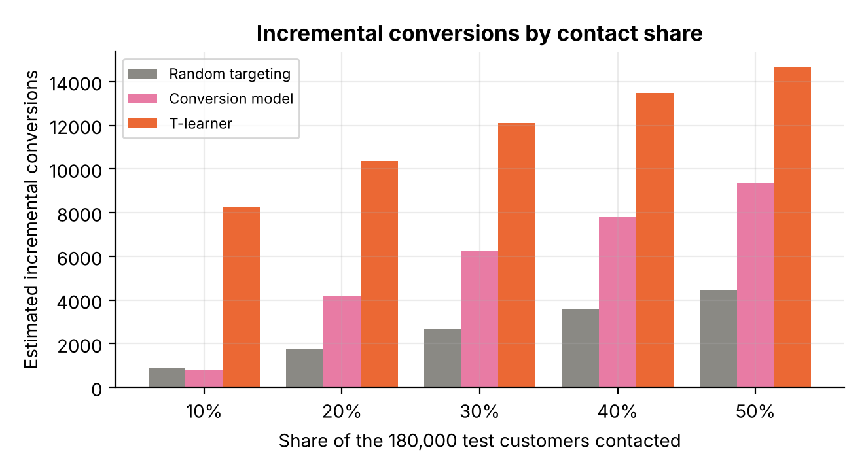
The final output of the system is a list of all 180,000 test customers sorted by predicted uplift, with the top 54,000 marked target. For each customer the list also gives the two potential-outcome probabilities. For example, the highest-ranked customer has an estimated conversion probability of 0.90 with the offer and 0.07 without it, whereas the lowest-ranked customer has 0.05 with the offer and 0.96 without it, so contacting them would be expected to cost a conversion.
Negative-Uplift Customers and Feature Influence
The T-learner predicted negative uplift for 35.2% of test customers. The prediction is supported by the observed data: in this group the treated conversion rate was 11.5 percentage points lower than the control rate, whereas in the remaining customers it was 13.8 points higher. The features that differ most between the two groups were X_4 (+0.104), X_42 (+0.065), X_33 (+0.049) in standardized mean difference. Because the features are anonymized, these differences are reported without business interpretation.
Feature influence was measured by permutation importance (Breiman, 2001) on the Qini coefficient: each feature was shuffled in a 60,000-customer test sample and the drop in the T-learner's Qini was recorded. Only 18 of the 50 features reduced the Qini by more than 0.005 when shuffled; the most influential were X_16, X_5, X_4, X_22 and X_40 (Figure 8). The treatment effect is therefore driven by a small subset of the anonymized features, while most features contribute little to the ranking.
Figure 8
Permutation Importance of the 15 Most Influential Features for the T-Learner Ranking
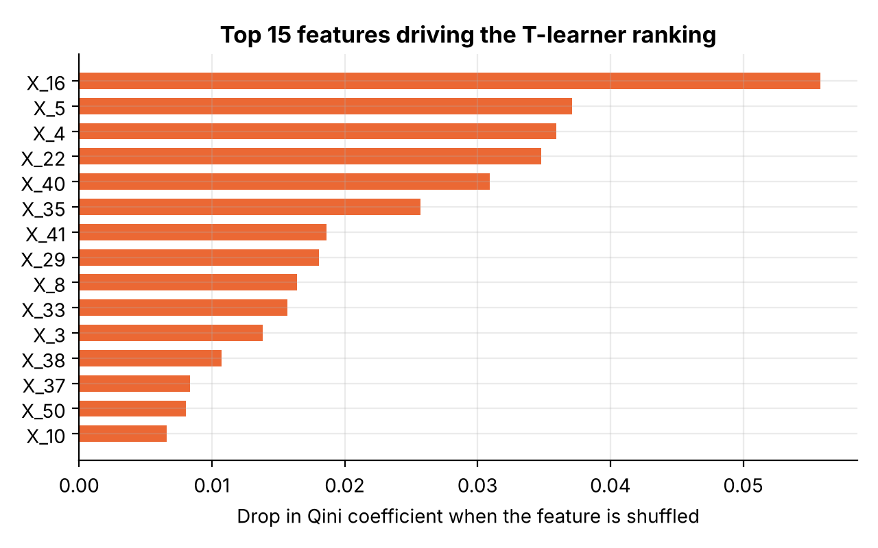
Note. Importance is the mean decrease in the Qini coefficient over two random permutations of each feature.
Success Criteria
Table 6
Proposal Success Criteria and Measured Results
Criterion | Measured value | Status
1 Data size | 600,000 rows used, 180,000 held out | Met
2 Group identification | 100% assigned; share deviation < 0.01 pp | Met
3 Group balance | max |SMD| = 0.0046 < 0.1 | Met
4 Coverage | 180,000 of 180,000 scores finite | Met
5 Better than random | Qini = 0.2450 > 0 | Met
6 Better than conversion model | 0.2450 vs. 0.0965 | Met
7 Stability | Qini > 0 in 5 of 5 splits | Met
8 Targeting value | uplift@30% 0.2244 vs. 0.0495 overall | Met
9 Reproducibility | 14 min end to end, fixed seeds | Met

All nine acceptance criteria defined in the proposal were met (Table 6), and all six optional requirements were completed: a third approach (class transformation), tuning by cross-validated Qini, AUUC and decile reporting, campaign-efficiency estimates for 10% to 50% contact shares, a profile of negative-uplift customers, and feature influence.
Challenges and Limitations
Several limitations qualify the results. The dataset is synthetic and its features are anonymized, so the absolute size of the effects (for example, the very large uplift in the top decile) may be stronger than in real campaigns, and the findings cannot be turned into business rules about specific customer attributes. Overfitting was controlled by tuning on training folds only, by the minimum leaf size and L2 penalty, and by checking stability on five independent splits, where the standard deviation of the Qini coefficient stayed below 0.005 for every boosted model; underfitting was evident only for the linear model. The campaign-efficiency figures use observed rates within the selected group and assume that costs per contact are equal and that no other campaign interferes. Finally, the analysis considers one treatment and one binary outcome; it does not model revenue, contact cost or multiple offers.
Future Work
Natural extensions are the X-learner and R-learner (Künzel et al., 2019), uplift random forests or causal forests (Athey & Imbens, 2016), cost-sensitive targeting that maximizes profit rather than conversions, multi-treatment models for choosing between several offers, and validation on a real operator's randomized campaign, ideally with a prospective test of the targeting list against random and response-based selection.
Conclusion
This project built and evaluated an uplift-modeling system that decides which telecommunications subscribers should receive a marketing offer. On the 600,000-customer MegaFon experiment, gradient-boosted meta-learners ranked customers by incremental effect far better than both random targeting and a conventional conversion model. The T-learner was the most accurate and the most stable approach, with a test Qini coefficient of 0.245 against 0.096 for the conversion model, and contacting its top 30% of customers produced an observed uplift of 22.4%, compared with 5.0% on average.
The practical implication is that campaign targeting should be based on predicted uplift, not predicted response. A response model wastes contacts on customers who would convert anyway and can even select customers whom the offer discourages; about 35.2% of customers in this dataset had negative predicted uplift. With a randomized holdout group, which most operators already maintain, the same pipeline can be applied to upsell, cross-sell and retention campaigns to raise incremental conversions for a fixed budget and to avoid contacting customers who react badly.
References
Ascarza, E. (2018). Retention futility: Targeting high-risk customers might be ineffective. Journal of Marketing Research, 55(1), 80–98. https://doi.org/10.1509/jmr.16.0163
Athey, S., & Imbens, G. (2016). Recursive partitioning for heterogeneous causal effects. Proceedings of the National Academy of Sciences, 113(27), 7353–7360. https://doi.org/10.1073/pnas.1510489113
Breiman, L. (2001). Random forests. Machine Learning, 45(1), 5–32. https://doi.org/10.1023/A:1010933404324
Devriendt, F., Moldovan, D., & Verbeke, W. (2018). A literature survey and experimental evaluation of the state-of-the-art in uplift modeling: A stepping stone toward the development of prescriptive analytics. Big Data, 6(1), 13–41. https://doi.org/10.1089/big.2017.0104
Diemert, E., Betlei, A., Renaudin, C., & Amini, M.-R. (2018). A large scale benchmark for uplift modeling. In Proceedings of the AdKDD and TargetAd Workshop, KDD 2018. ACM.
Friedman, J. H. (2001). Greedy function approximation: A gradient boosting machine. The Annals of Statistics, 29(5), 1189–1232. https://doi.org/10.1214/aos/1013203451
Gutierrez, P., & Gérardy, J.-Y. (2017). Causal inference and uplift modelling: A review of the literature. In Proceedings of the 3rd International Conference on Predictive Applications and APIs (Proceedings of Machine Learning Research, Vol. 67, pp. 1–13). PMLR.
Jaskowski, M., & Jaroszewicz, S. (2012). Uplift modeling for clinical trial data. In ICML 2012 Workshop on Clinical Data Analysis.
Ke, G., Meng, Q., Finley, T., Wang, T., Chen, W., Ma, W., Ye, Q., & Liu, T.-Y. (2017). LightGBM: A highly efficient gradient boosting decision tree. In Advances in Neural Information Processing Systems 30 (pp. 3146–3154).
Künzel, S. R., Sekhon, J. S., Bickel, P. J., & Yu, B. (2019). Metalearners for estimating heterogeneous treatment effects using machine learning. Proceedings of the National Academy of Sciences, 116(10), 4156–4165. https://doi.org/10.1073/pnas.1804597116
MegaFon. (2021). MegaFon Uplift Competition: Data [Data set]. Open Data Science (ODS.ai). https://ods.ai/tracks/df21-megafon/competitions/megafon-df21-comp/data
Pedregosa, F., Varoquaux, G., Gramfort, A., Michel, V., Thirion, B., Grisel, O., Blondel, M., Prettenhofer, P., Weiss, R., Dubourg, V., Vanderplas, J., Passos, A., Cournapeau, D., Brucher, M., Perrot, M., & Duchesnay, É. (2011). Scikit-learn: Machine learning in Python. Journal of Machine Learning Research, 12, 2825–2830.
Radcliffe, N. J. (2007). Using control groups to target on predicted lift: Building and assessing uplift models. Direct Marketing Analytics Journal, 14–21.
Radcliffe, N. J., & Surry, P. D. (2011). Real-world uplift modelling with significance-based uplift trees (Technical Report TR-2011-1). Stochastic Solutions.
Rubin, D. B. (1974). Estimating causal effects of treatments in randomized and nonrandomized studies. Journal of Educational Psychology, 66(5), 688–701. https://doi.org/10.1037/h0037350
Rzepakowski, P., & Jaroszewicz, S. (2012). Decision trees for uplift modeling with single and multiple treatments. Knowledge and Information Systems, 32(2), 303–327. https://doi.org/10.1007/s10115-011-0434-0
Shevchenko, M. (n.d.). scikit-uplift: Uplift modeling in scikit-learn style in Python (Version 0.5.1) [Computer software]. https://www.uplift-modeling.com

