**Jenkins**:

It is a Continous development tool which has the ability to perform process automation. Like scheduling a build(execution of complete project) in timely manner.

To download git :

<https://git-scm.com/downloads>

To Configure the Jenkins:

Download it from:

<https://www.jenkins.io/download/>

Step 1: java -jar jenkins.war

a. Go to the location of jenkins.war file in command prompt.

b. Run the command java -jar jenkins.war

c. complete the intialization process (username and password setup by going to the url http:\\localhost:8080)

In Jenkins the project that we create is called as Job.

Step 2: Plugin needs to install in jenkins

a. Go to manage jenkins:

b. click on manage pluggins.

c. Navigate to the available tab and install the following:

1. All the pluggins related to Maven.

2. TestNg

Step 3: Go to manage jenkins there we need to click on global tool configuration

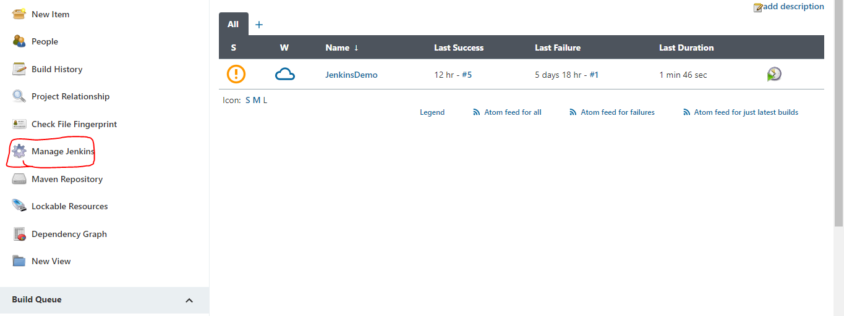

Step 2:Click on Global Tool Configuration.

Set JDK path:

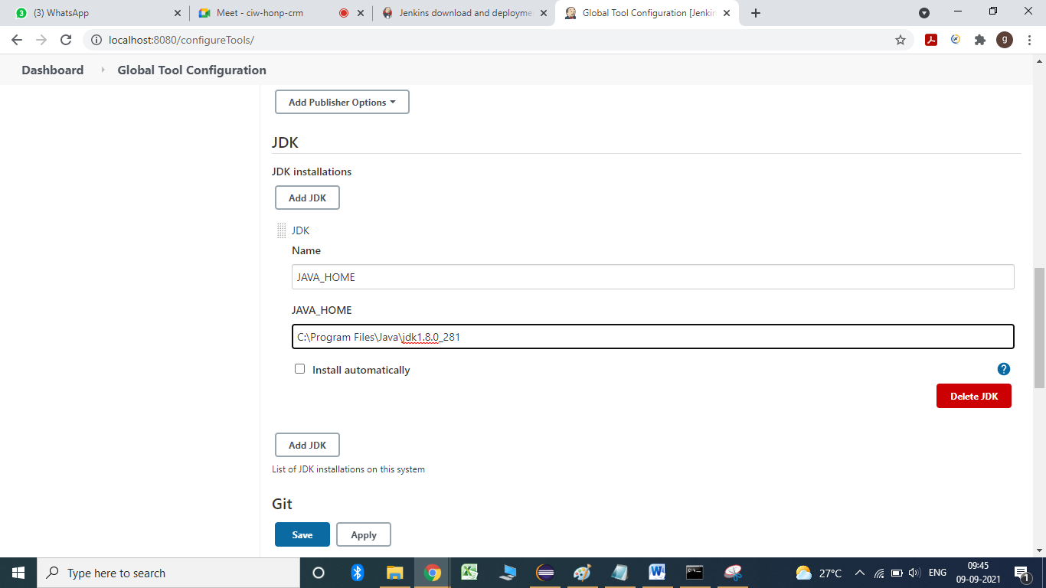

****************Global Tool Configuration************************

Step 3: Download git

<https://git-scm.com/downloads>

Step 4: set the path of git in the Jenkins:

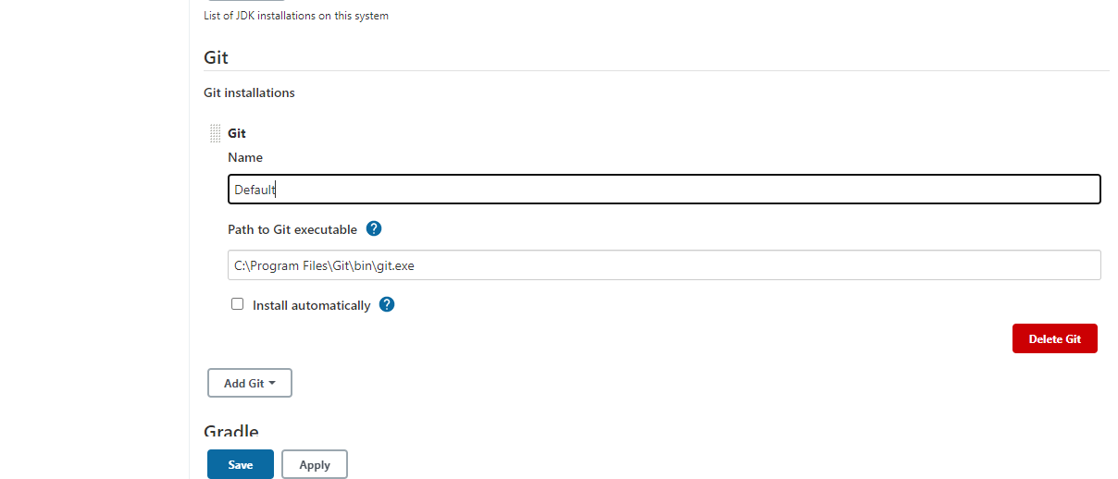

Step 4: provide the maven path:

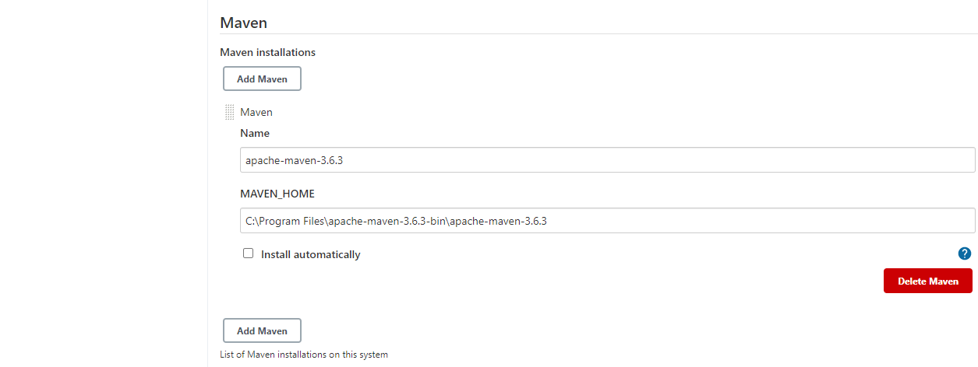

Step 5: Click on apply and then click on Save button.

************Creation and Configure Job(Project)*************************

step 1: go to the new item

step 2: Provide the name and select maven project.

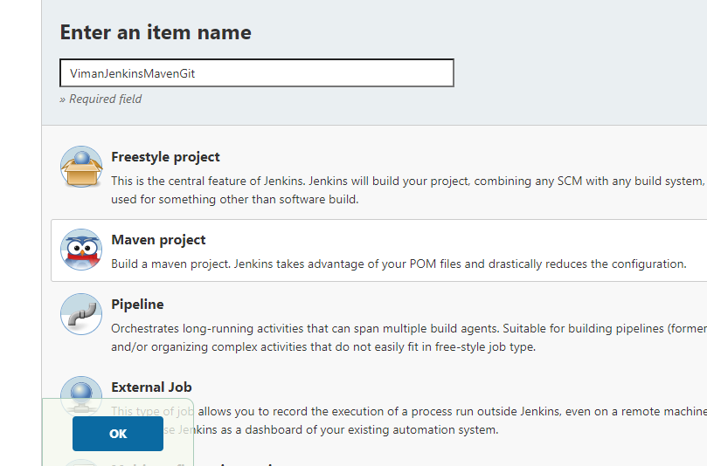

Step 3: Click on the project(Job) and say configure project.

Select git in the **Source Code Management and copy the giturl:**

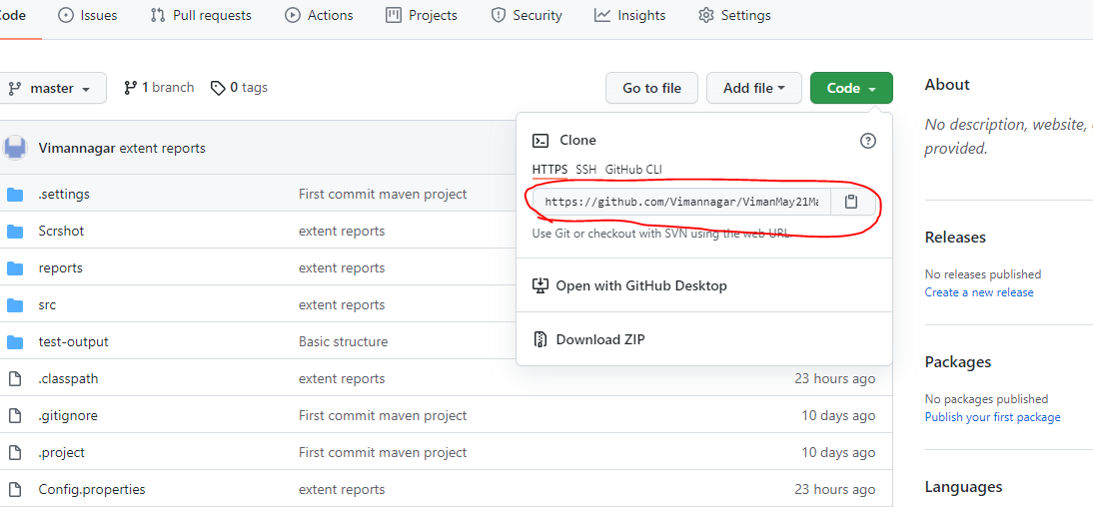

Add the credentials in Jenkins select those credentials dropown

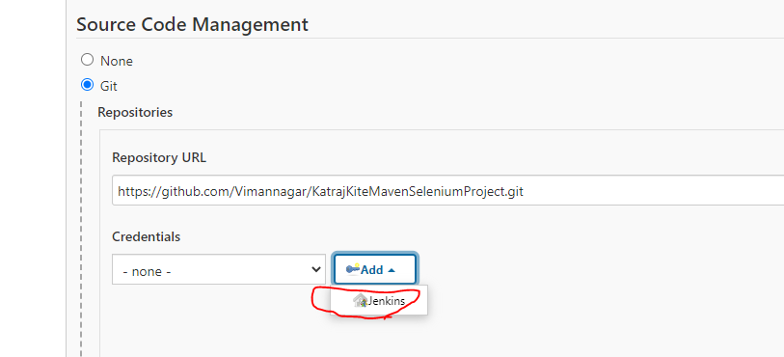

Add the password and username in the Jenkins

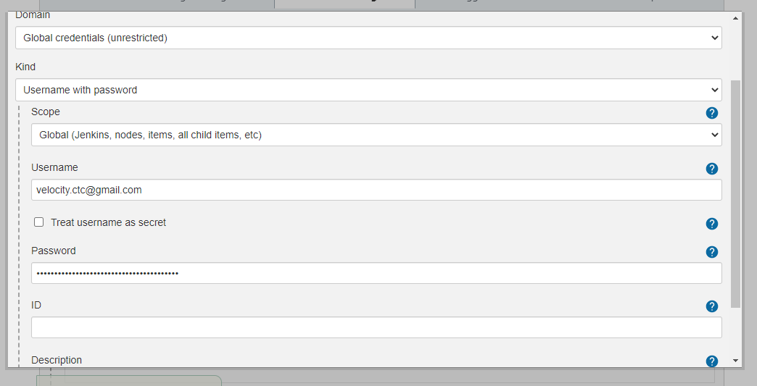

**Pre steps**

rootpom--> pom.xml

Goals and options : clean test

Click on Advanced

Check Resolve Dependencies during Pom parsing

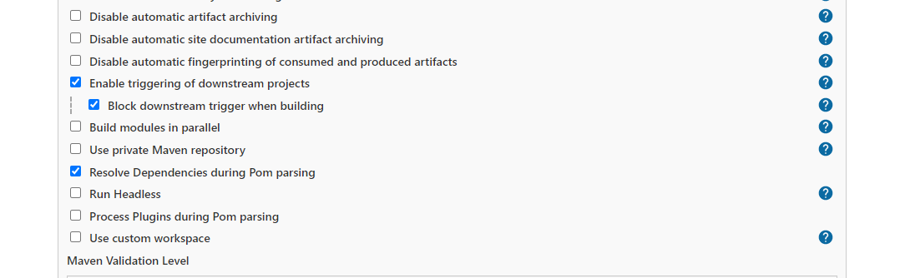

Click on apply and save

Through Jenkins:

1. We can schedule the build at particular time.

2. Through Jenkins we can see the reports of all the execution.

3. It execute all the process automatically.

**Scheduling a build :**

Jenkins uses expression, the different fields are :

MINUTES Minutesin one hour (0-59)

HOURS Hours in one day (0-23)

DAYMONTH Day in a month (1-31)

MONTH Month in a year (1-12)

DAYWEEK Day of the week (0-7) where 0 and 7 are Sunday

Check on build periodically:

Write the expression and click on apply and save.

5 number

*