CHAPTER 1. INTRODUCTION
The demand for natural, touchless interaction between humans and computers has grown rapidly with the rise of smart technologies. Traditional input devices, such as the keyboard and mouse, though reliable, limit flexibility and accessibility, especially for users with physical disabilities or in situations where hands-free control is preferred. Hand gestures and voice-based control systems provide a more intuitive and efficient way to communicate with machines. By interpreting physical gestures and spoken commands, computers can respond more naturally to human intent, making interaction faster, more engaging, and more inclusive

In recent years, several emerging technologies have demonstrated how gesture and voice recognition are reshaping the future of human–computer interaction. Advanced XR systems such as Apple Vision Pro, Meta Quest, and Samsung XR, as well as AI-powered personal devices like Rabbit R1, showcase how spatial computing and multimodal control can create seamless and immersive user experiences. These innovations highlight the growing relevance of intuitive interfaces that respond to natural human input. Inspired by this global shift, the present project explores how similar principles can be applied to develop an accessible and cost-effective desktop solution using open-source frameworks.

The project titled “GESTOS – Controlling System Using Hand Gesture and Voice Command” focuses on combining computer vision and speech recognition to build a unified human–computer interaction platform. The system enables users to control essential computer functions without physical contact. Using MediaPipe and TensorFlow Lite, it detects and classifies hand gestures in real time to perform actions such as mouse movement, clicks, and custom commands like volume adjustment or system shutdown. In parallel, voice commands using Vosk and the SpeechRecognition API allow users to open, manage, and close applications, minimizing the need for manual input. This dual-mode interaction enhances both usability and accessibility, offering a reliable experience for all users.

The project aims to create a practical solution that improves the efficiency and comfort of computer interaction. By leveraging machine learning models optimized for performance and integrating automation tools such as PyAutoGUI and pynput, the system ensures smooth execution of user commands. Databases like MySQL or SQLite are used for configuration storage and command mapping. The software development process follows an iterative prototyping model, where components are designed, tested, and refined based on system responsiveness and accuracy.

Overall, GESTOS contributes to the growing field of human–computer interaction by demonstrating how gesture and voice recognition can operate together in a seamless, offline-capable environment. This report presents the motivation, design, and implementation of the system, followed by analysis, results, and future scope.

1.1. Background
The evolution of human-computer interaction (HCI) has progressed from mechanical input methods such as keyboards and mouse to more natural and immersive approaches like gesture and voice commands. This shift is driven by the need for accessibility, efficiency, and intuitive user experiences across various fields, including automation, gaming, healthcare, and assistive technology. Gesture and speech-based interfaces allow users to communicate directly with computers through natural movements and spoken language, reducing dependency on traditional input devices and enabling hands-free operation.

With rapid advancements in artificial intelligence and computer vision, real-time gesture recognition has become achievable on consumer-grade hardware. Frameworks such as MediaPipe, TensorFlow Lite, and OpenCV now allow efficient hand tracking and landmark detection, while voice recognition frameworks such as Vosk and Google SpeechRecognition API provide accurate and adaptive command interpretation. Together, these technologies create opportunities for multimodal systems that understand both visual and auditory inputs.

Recent devices like Apple Vision Pro, Meta Quest, and Samsung XR demonstrate how natural gesture control and voice assistance can be integrated into everyday computing. Similarly, Rabbit AI highlights the power of voice-driven AI in automating digital tasks. Also, devices like Sony PS VR-2 let users play games using Hand gestures as their primary input method. These innovations mark a significant leap toward seamless interaction between humans and machines. However, their high cost and closed ecosystems restrict their adoption for general users and academic experimentation.

The GESTOS project is designed to bring similar intuitive control to a desktop environment using open-source and cross-platform tools. It integrates gesture recognition through MediaPipe and TensorFlow Lite with voice command recognition through Vosk, combining them into a unified system for controlling applications, cursor movements, and system functions. This approach emphasizes accessibility, offline functionality, and cost efficiency while maintaining real-time responsiveness.

CHAPTER 2. LITERATURE REVIEW
Hand gesture and voice recognition have become central to modern human–computer interaction research, enabling more intuitive and accessible communication between users and machines. A large body of literature explores how these two input modes can enhance control precision, reduce physical dependency, and improve user experience. Together, they form the foundation of multimodal interfaces that respond naturally to human intention.

NORAINI MOHAMED, MUMTAZ BEGUMMUSTAFA AND NAZEAN JOMHARI [2] conducted an extensive review of vision-based hand gesture recognition systems, emphasizing three major challenges: signer dependency, environmental adaptability, and accuracy in dynamic recognition. Their analysis revealed that most existing systems perform well only under controlled lighting and background conditions. This highlighted the importance of robust frameworks capable of handling real-world variability. The findings directly influenced the GESTOS project’s decision to use MediaPipe, which is optimized for background-independent detection and landmark-based gesture tracking.

Pradnya Kedari, Shubhangi Kadam, and Rajesh Prasadet [6] proposed a real-time gesture recognition system for computer control using convolutional neural networks (CNNs). Their work demonstrated that machine learning could effectively replace traditional input devices for executing system operations. Inspired by this, GESTOS extends the same principle to create a hybrid system where gestures control cursor movement and voice commands handle higher-level functions such as launching or closing applications.
Devineau et al. [4] introduced a 3D skeletal-data-based model using deep learning to classify hand gestures with high accuracy. Their research established that skeletal representations of hand joints can capture motion patterns effectively, allowing better generalization across users. This approach aligns with GESTOS’s use of MediaPipe’s hand landmark extraction, which maps 21 key points to analyze finger and palm positioning.

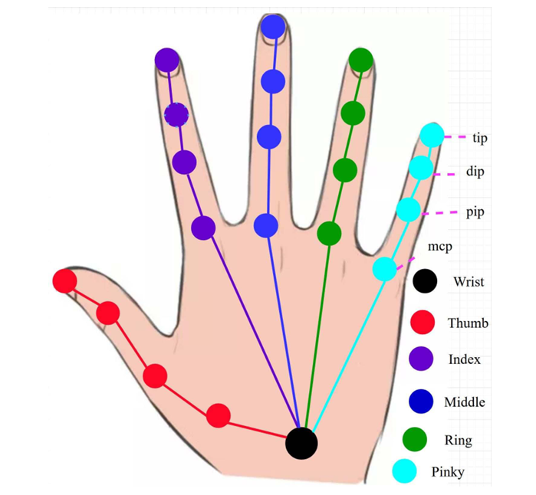
Fig 1. Twenty-one joints of the right-hand skeleton
ABU SALEH MUSA MIAH, MD. AL MEHEDI HASAN, AND JUNGPIL SHIN [5] developed a multi-branch attention-based deep learning model that combined spatial and temporal feature extraction for dynamic hand gestures. Their work achieved superior performance on benchmark datasets while maintaining computational efficiency. While GESTOS does not employ complex attention networks, the project adopts their underlying concept—balancing accuracy and speed through lightweight neural architectures—to ensure smooth real-time operation on regular computing devices.

Guillaume Devineau, Wang Xi, Fabien Moutarde, and Jie Yang [4] explored vision-based gesture interfaces for human–computer interaction, emphasizing low-cost implementation and environmental adaptability. Their results reinforced the viability of camera-based control systems without requiring additional sensors, which influenced GESTOS’s focus on building a software-only, camera-driven system accessible to all users.

Aniket Abhishek Soni [7] analyzed the integration of custom language models in the Vosk Toolkit, proving that offline speech recognition could achieve competitive accuracy while preserving user privacy and reducing latency. This study directly shaped GESTOS’s voice control module, which employs Vosk to ensure consistent performance even without internet connectivity.

LAVANYA VAISHNAVI D. A., ANIL KUMAR C., HARISH S., DIVYA M. L. [3] serves as the project’s foundation. It introduced a real-time gesture detection method using MediaPipe and Python, achieving recognition accuracy of up to 95%. The paper demonstrated the effectiveness of background subtraction and landmark-based classification for reliable gesture recognition. GESTOS builds upon this model, extending it to include automation functions, database integration, and voice-based control, thereby evolving it into a complete multimodal interaction system.
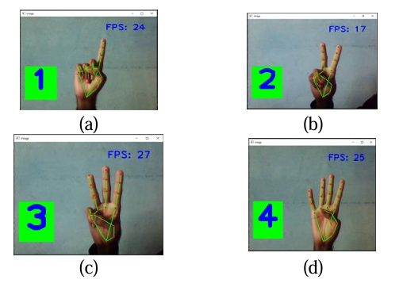
Fig 2: Identification of the Hand Gestures.
(a) Gesture of Number “One”, (b) Gesture of Number “Two”, (c) Gesture of Number “Three”,
(d) Gesture of Number “Four”
The base paper “MediaPipe Hands: On-device Real-time Hand Tracking” by Fan Zhang, Valentin Bazarevsky, Andrey Vakunov, Andrei Tkachenka, George Sung, Chuo-Ling Chang, Matthias Grundmann. [1] from Google Research introduced MediaPipe Hands, a real-time, on-device hand tracking pipeline capable of predicting 21 landmark coordinates from a single RGB image. The framework uses a two-stage model: a palm detector and a hand landmark model, optimized for mobile and desktop platforms through TensorFlow Lite. This work forms the technical foundation of GESTOS, as it enables fast and accurate hand tracking without specialized hardware. The open-source nature of MediaPipe allowed seamless integration into Python-based workflows, ensuring real-time gesture detection in this project

Beyond academic research, several existing commercial solutions further validate the relevance of this work. Early systems such as Leap Motion and Microsoft Kinect pioneered gesture tracking through depth sensors, while modern XR platforms like Apple Vision Pro, Meta Quest, Samsung XR, and Sony PlayStation VR2 now combine spatial awareness with real-time hand and finger tracking to create immersive control experiences. Similarly, Rabbit R1 represents an advancement in voice-based personal AI assistance, blending gesture and speech-driven interaction. However, these systems rely on specialized or proprietary hardware, limiting accessibility. In contrast, GESTOS achieves comparable interaction capabilities entirely through open-source frameworks and standard computer peripherals, bridging the gap between advanced multimodal systems and everyday usability.
The integration of lightweight frameworks like MediaPipe and TensorFlow Lite was chosen for real-time gesture tracking without heavy computational cost. The adoption of Vosk for offline voice recognition ensures privacy and independence from cloud APIs. Automation libraries such as PyAutoGUI and pynput were selected for their reliability in simulating user input. Together, these tools create a balanced ecosystem that combines the strengths of previous research with practical implementation for general computing environments.
CHAPTER 3. REQUIREMENT AND ANALYSIS

3.1. PROBLEM DEFINITION:
Users need a reliable, hands-free way to control standard desktop applications. Existing solutions either require special hardware, depend on cloud services, or provide only one input modality (gesture or voice). The project must deliver a multimodal, offline-capable system that interprets hand gestures and voice commands in real time to control the mouse, execute system/application commands, and provide clear visual feedback, while remaining usable on commodity hardware.

3.2. MODULE BREAKDOWN
- Capture & Preprocessing — camera and microphone input, frame/audio normalization, noise reduction.
- Gesture Detection & Recognition — hand detection, landmark extraction, gesture classification (MediaPipe + TFLite).
- Speech Recognition — audio to text, command parsing (Vosk / SpeechRecognition fallback).
- Command Mapping & Logic — map recognized gestures/phrases to system actions and handle conflicts/priority.
- Control Execution — simulate inputs (cursor move, clicks, keyboard shortcuts) using PyAutoGUI / pynput.
- User Interface & Feedback — on-screen overlays showing detected gesture/command and confirmation of executed actions.
- Configuration & Persistence — database for custom gestures, voice macros, user preferences (MySQL / SQLite).
- Logging & Diagnostics — event/error logs, performance metrics for tuning.
- Testing & Evaluation — benchmark latency, accuracy, robustness under varying conditions.

3.3. REQUIREMENTS SPECIFICATION
3.3.1. Functional requirements (FR)
- Capture: The system shall access a webcam and microphone and provide continuous input at ≥15 fps and real-time audio capture.
- Hand landmarks: The system shall extract 21 hand landmarks per detected hand using MediaPipe or equivalent.
- Gesture recognition: The system shall classify a predefined set of gestures (pointer, left-click, right-click, scroll, volume-up/down, shutdown, restart, custom1, custom2) with configurable mappings.
- Voice recognition: The system shall recognize spoken commands mapped to application/system actions using an offline model (Vosk) and optionally Google SpeechRecognition when online.
- Command arbitration: The system shall resolve simultaneous gesture and voice inputs using a deterministic priority policy (configurable).
- Control execution: The system shall execute mapped actions (mouse movement, clicks, keypresses, application launch/close).
- Feedback: The system shall display on-screen visual confirmation of recognized gestures and executed commands within 300 ms of action.
- Custom gestures/macros: The system shall allow users to define and persist at least 20 custom gesture-to-action mappings.
- Logging: The system shall record action, recognition confidence, and timestamp to persistent logs for later analysis.
3.3.2. Non-functional requirements (NFR)
- Latency: End-to-end recognition-to-action latency shall be ≤250 ms for typical gestures on recommended hardware.
- Accuracy: Gesture recognition accuracy should exceed 85% in controlled indoor lighting for the core gesture set (target to evaluate).
- Robustness: System shall tolerate moderate lighting changes and simple background clutter; degrade gracefully (provide “no-detection” state) rather than false positives.
- Offline operation & privacy: Core functionality (gesture recognition and voice recognition via Vosk) must work offline; no mandatory cloud dependency.
- Portability: Software shall run on Windows with Python 3.9–3.11.
- Resource footprint: The system shall run on consumer laptops with dedicated GPU acceleration or a CPU with integrated GPUs.

3.3.3. Constraints and assumptions
- Uses a single RGB camera (webcam).
- Runs primarily with local models.
- Primary language: English (expandable later).
- Users provide reasonable frontal hand views for gesture detection.

3.4. USE CASES
List of use case titles:
- Move Cursor with Hand
- Left/Right Click via Gesture
- Scroll/Drag via Gesture
- Launch Application via Voice
- Close/Minimize Application via Voice
- System Command (Shutdown/Restart) via Custom Gesture
- Volume Control via Gesture or Voice
- Define Custom Gesture Mapping
- Toggle Gesture/Voice Modes (enable/disable)
- Show Visual Confirmation and Logs

3.5. SOFTWARE AND HARDWARE REQUIREMENTS
3.5.1. Software
- Languages & runtime: Python 3.9–3.11.
- Core libraries:
  - MediaPipe (MediaPipe Hands and graph utilities) / Google MediaPipe architecture.
  - TensorFlow Lite (for any TFLite models/optimization).
  - OpenCV (video capture, image processing).
  - Vosk (offline speech recognition).
  - SpeechRecognition (optional, for Google API fallback).
  - PyAutoGUI, pynput (system control).
  - MySQL / SQLite (configuration persistence).
  - Jupyter Notebook / Google Colab / VSCode for development.
  - Git for version control.
- Development tools: Python packaging (pip/venv), unit-test framework (pytest), logging utilities.
3.5.2 Hardware (recommended) Recommended :
  - CPU: Quad-core or better (Intel i5/Ryzen 5 or equivalent)
  - RAM: 16 GB
  - GPU: mobile GPU or desktop GPU for TFLite GPU backend or model acceleration
  - Camera: 1080p camera, good low-light sensitivity, 30–60 fps
  - Microphone: Noise-cancelling microphone for better voice accuracy

CHAPTER 4 : DESIGN

4.1 System Architecture

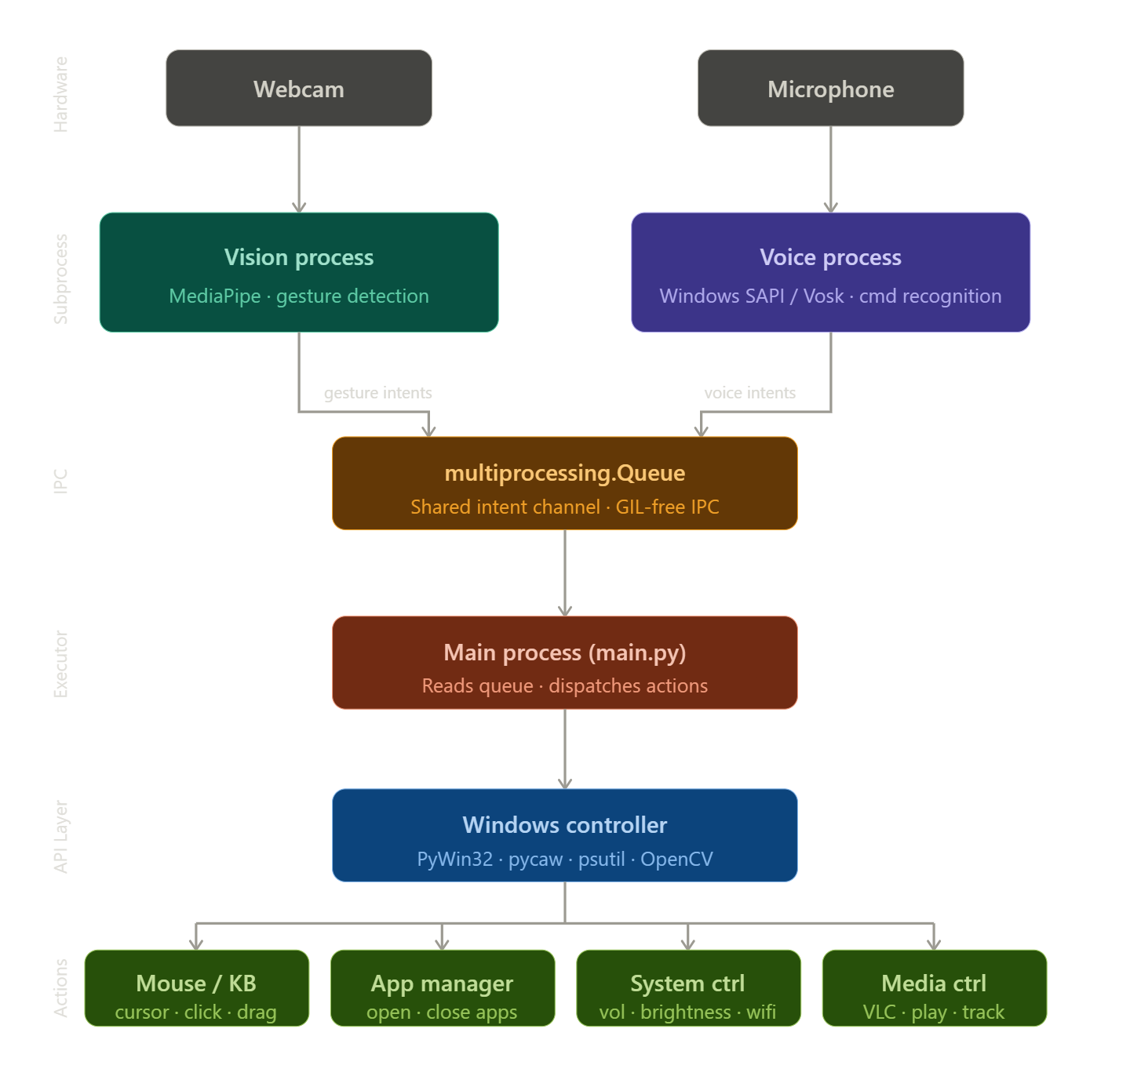

CHAPTER 5. IMPLEMENTATION

5.1. METHODOLOGY

The project addresses the problem of enabling reliable, low-latency, offline multimodal control of a desktop environment using only an RGB camera and a local microphone. Key constraints are real-time performance on commodity hardware, no cloud dependency, and support for both static and dynamic gestures, together with voice commands.

Convert raw sensor input (camera frames and audio) into precise system control actions. The pipeline must (1) detect and represent hand pose robustly, (2) classify gestures with minimal latency with higher accuracy, (3) transcribe speech locally and extract intent, and (4) map recognized signals to deterministic OS-level actions.

The literature indicates that landmark-based representations are compact and robust for gesture tasks and that on-device pipelines (MediaPipe) deliver acceptable latency on commodity hardware. A lightweight, custom classifier trained with MediaPipe Model Maker (exported to TensorFlow Lite) balances accuracy with speed. Vosk provides accurate offline speech recognition and satisfies the privacy and latency constraints. The overall architecture follows a pipelined, producer–consumer pattern to decouple I/O from inference and to keep per-stage latency bounded.
Process steps used to develop the system
- Data collection. Capture landmark sequences produced by MediaPipe for every target gesture. For each gesture class collect balanced examples under varied hand orientations and lighting. Record audio command samples for each voice command phrase for grammar tuning if needed.
- Feature preparation. Convert raw landmarks to normalized, invariant feature vectors (wrist-centered, scale-normalized). Augment with temporal derivatives for dynamic gestures.
- Model training. Use MediaPipe Model Maker / small dense or 1D-CNN architecture on the prepared feature vectors. Export the best model to TFLite for on-device inference.
- Integration. Integrate MediaPipe for landmark extraction, the TFLite classifier for gesture inference, and Vosk for streaming speech recognition. Implement a deterministic command mapper and OS execution layer.
- Evaluation and tuning. Measure end-to-end latency and classification accuracy. Tune smoothing windows, confidence thresholds, and hold-times for stable operation.

5.2. HAND GESTURE RECOGNITION MODULE
The Hand Gesture Recognition Module is responsible for identifying specific hand movements and converting them into system commands. It uses data provided by the MediaPipe module, which detects and tracks 21 key landmarks of the hand in real time. The module focuses on interpreting these landmarks to recognize static and dynamic gestures that correspond to user-defined actions, such as mouse movement, clicks, scrolling, or volume control.

The process begins with the capture of real-time video frames from the system’s webcam. Each frame is processed through MediaPipe to extract hand landmarks. These coordinates (x, y, z) are then normalized and converted into feature vectors that describe the relative position and orientation of the fingers. These feature vectors are fed into a lightweight TensorFlow Lite model, trained using MediaPipe Model Maker on a dataset of predefined gestures. The model outputs a probability distribution across gesture classes, and the gesture with the highest confidence is selected as the recognized gesture.Once a gesture is confirmed, the module forwards the recognized label and its associated confidence score to the Command Mapping module for further processing.
Pseudo Code:-
Initialize camera
Load MediaPipe Hands model
Initialize previous gesture buffer (for smoothing)
While system is running:
Capture frame from camera
Flip frame horizontally (mirror view)
Convert frame from BGR to RGB
Process frame using MediaPipe
If hand landmarks are detected:
Extract 21 landmark points
Determine finger states:
Check if each finger is open or closed
(based on relative positions of landmarks)
Calculate distances between key points:
Example: thumb tip and index tip
Identify gesture using rule-based logic:
If only index finger is up:
Gesture = Cursor Movement
If thumb and index finger are close:
Gesture = Click

If all fingers are closed:
Gesture = Drag
If two fingers are up:
Gesture = Scroll
(Add other gesture conditions as implemented)
Apply smoothing using previous frames:
Store current gesture in buffer
Determine most frequent gesture
If stable gesture is confirmed:
Send gesture command to main system
Else:
No gesture detected → continue
Release camera
Close all windows

5.3. VOICE RECOGNITION MODULE
The Voice Recognition Module enables the system to interpret spoken commands and convert them into text instructions. This module uses the Vosk Speech Recognition Toolkit, an open-source, offline speech-to-text engine designed for efficient real-time performance on local devices. The Vosk model continuously listens to audio input from the microphone and segments the stream into small chunks for processing.

Each audio chunk is analyzed by Vosk’s acoustic and language models to generate a textual transcript. After a command is recognized, it is parsed and matched against a predefined command set, such as “open browser,” “close window,” or “increase volume.” The recognized text is converted into structured instructions (intent and parameters) and passed to the Command Mapping module.

Pseudo Code:-

Initialize speech recognition engine (SAPI)
Set microphone as input source

While system is running:

Listen for audio input from user

Convert speech to text

If speech is recognized:

Normalize text (lowercase, remove noise)

Match text with predefined commands:

If command is "volume up":
Action = Increase system volume

If command is "volume down":
Action = Decrease system volume

If command is "brightness up":
Action = Increase brightness

If command is "open chrome":
Action = Launch Chrome browser

If command is "open vs code":
Action = Launch VS Code

If command is "shutdown":
Ask for confirmation
If confirmed:
Action = Shutdown system

(Add other commands as implemented)

Send action to main system for execution

Else:
Continue listening

Handle errors (noise / unrecognized speech)

Terminate voice recognition safely

5.4. MEDIAPIPE INTEGRATION MODULE
The MediaPipe Module serves as the core component for real-time hand tracking and landmark extraction. Developed by Google Research, MediaPipe provides a high-performance pipeline that operates directly on the device without requiring specialized sensors. It uses a two-stage architecture: a palm detection model to locate the hand region in the frame, followed by a landmark model that estimates 21 key points of the hand, including finger joints and the wrist.

In the GESTOS system, the MediaPipe module acts as the foundation of the gesture recognition process. The module receives video frames from the webcam, processes them through the MediaPipe pipeline, and outputs the 3D coordinates of each landmark. These coordinates are then sent to the Hand Gesture Recognition Module for classification. MediaPipe’s design ensures robust performance under different lighting conditions and backgrounds, which is essential for real-time gesture-based interaction.

Pseudo Code:-
Import MediaPipe Hands solution
Initialize MediaPipe Hands:
Set max number of hands (e.g., 2)
Set detection confidence threshold
Set tracking confidence threshold

Initialize drawing utilities (optional)

While system is running:

Capture frame from camera

Convert frame from BGR to RGB

Process frame using MediaPipe Hands model

If hands are detected:

For each detected hand:

Extract 21 landmark points:
For each landmark:
Get x, y, z coordinates

Store landmark positions

(Optional) Draw landmarks and connections on frame

Return landmark data to gesture module

Else:
Return no-hand-detected signal

Release MediaPipe resources
Close system

The Automation and Control Execution Module serves as the final stage in the GESTOS system, transforming interpreted gestures or voice inputs into real system-level actions. After the Command Mapping module resolves an instruction (such as left click, move cursor, or open browser), this module is responsible for executing that instruction on the host computer. Its main objective is to provide a seamless bridge between human input and machine response, enabling users to control their systems without traditional hardware peripherals. To achieve this, the module uses Python-based automation libraries that replicate the functions of physical input devices like a mouse and keyboard.

This module relies primarily on PyAutoGUI and pynput, two widely used open-source libraries for input automation. PyAutoGUI manages most interaction tasks, including cursor movement, single or double clicks, scrolling, and typing operations. Meanwhile, pynput offers more granular control, particularly useful for handling complex or continuous actions such as key holding or system event monitoring. These capabilities allow users to perform routine activities—from moving the mouse pointer to launching applications—strictly through gesture-based interaction. To safeguard usability, the module incorporates brief execution delays and checks to prevent unintended or conflicting actions during rapid command sequences.

Internally, the module follows a straightforward workflow. It first receives the interpreted command along with any necessary parameters, such as gesture type or cursor coordinates. Next, it matches the command with the appropriate automation function and executes the corresponding system action through PyAutoGUI or pynput. After completion, it returns a signal indicating success or failure, ensuring that the Command Mapping module and user interface remain synchronized. This design enables a secure, flexible, and responsive control layer that contributes to a smooth overall user experience.

Pseudo Code:-
Initialize mouse and keyboard control system

Function EXECUTE_COMMAND(command, parameters):

If command is "MOVE_CURSOR":
Extract x and y from parameters
Move mouse cursor to (x, y)

Else if command is "LEFT_CLICK":
Perform left mouse click

Else if command is "RIGHT_CLICK":
Perform right mouse click

Else if command is "DOUBLE_CLICK":
Perform double mouse click

Else if command is "SCROLL_UP":
Scroll screen upward

Else if command is "SCROLL_DOWN":
Scroll screen downward

Else if command is "TYPE_TEXT":
Extract text from parameters
Type text with small delay between characters

Else if command is "PRESS_KEY":
Extract key from parameters
Press and release the key

Else if command is "OPEN_APP":
Extract application path
Execute system command to open application

Else if command is "SHUTDOWN":
Execute system shutdown command

Else if command is "RESTART":
Execute system restart command

Else if command is "VOLUME_UP":
Increase system volume

Else if command is "VOLUME_DOWN":
Decrease system volume

Else:
Print "Unknown command"

Return confirmation message "Command executed"

5.5. DATA FLOW EXPLANATION

The GESTOS system operates through two parallel yet interconnected processing streams — a visual stream for hand gesture recognition and an audio stream for voice command processing. These streams function independently using multiprocessing but are synchronized through a central command handling mechanism, allowing both inputs to operate simultaneously without blocking each other.

In the visual stream, the process begins when the system’s camera captures real-time video frames. These frames are processed using the MediaPipe Hands module, which detects the presence of hands and extracts 21 landmark points for each detected hand. These landmarks represent key positions such as fingertips, joints, and the wrist, and are expressed as normalized coordinates.

The extracted landmark data is then passed to the gesture recognition module. The system uses a rule-based approach to identify gestures by analyzing the relative positions of landmarks. Finger states are determined by checking whether each finger is open or closed, and distances between specific landmark points—such as the thumb and index finger—are calculated to detect interactions like clicks. Based on these conditions, gestures such as cursor movement, left click, right click, scrolling, and dragging are recognized. To ensure stability and reduce noise, a smoothing mechanism is applied so that only consistent gestures across multiple frames trigger actions.

Simultaneously, the audio stream is handled by the voice recognition module, which uses the Windows Speech API (SAPI) for offline speech recognition. The system continuously listens to user input through the microphone and converts speech into text. The recognized text is then processed and matched against predefined commands, enabling operations such as opening applications, adjusting volume, and performing system-level tasks.

Both the gesture and voice modules generate structured commands that are placed into a shared intent queue. This queue acts as a communication bridge between the independent processes, ensuring efficient and non-blocking data exchange.
The main control module continuously monitors the intent queue and retrieves incoming commands. Based on the command type, it determines the appropriate action and forwards it to the command execution module.

The command execution module interacts directly with the operating system using automation libraries. PyAutoGUI is used to perform GUI-based actions such as mouse movement, clicking, scrolling, and typing, while system-level operations like opening applications, shutdown, and restart are executed using operating system commands.
Once a command is executed, the system continues to process new inputs, maintaining a continuous real-time interaction loop. The entire pipeline operates efficiently on standard hardware, delivering a responsive, accurate, and user-friendly hands-free control system.

CHAPTER 6. RESULTS AND EVALUATION

6.1. EXPERIMENTAL SETUP
The experimental setup was designed to evaluate the complete functionality of the GESTOS system, including hand detection, gesture recognition, voice recognition, and system response modules. The system was tested on a standard laptop equipped with an Intel Core i5 processor (11th Gen, 2.4 GHz base frequency), 16 GB RAM, an integrated Intel UHD GPU, and a built-in 720p webcam with a resolution of 1280 × 720 pixels operating at 30 frames per second (FPS). The system also utilized a standard built-in microphone for capturing voice input.

The software environment consisted of Python 3.10, MediaPipe Hands for hand tracking, OpenCV for video capture and frame processing, and the Windows Speech API (SAPI) for voice recognition, with the Vosk speech recognition engine used as a backup for improved reliability. The MediaPipe model was configured to detect up to 2 hands simultaneously, with a minimum detection confidence of 0.7 and tracking confidence of 0.6. In addition to the initial implementation, the final system integrates gesture recognition, voice command processing, and system control functionalities, enabling real-time multimodal interaction.

The system operates in real time using the laptop’s webcam and microphone as primary input devices. On average, the visual processing pipeline operates at approximately 20–30 FPS, ensuring smooth and continuous gesture interaction. MediaPipe successfully detects both hands simultaneously and identifies 21 landmark points per hand, resulting in up to 42 landmarks per frame. These landmarks are processed by the gesture recognition module to classify gestures based on finger positions and relative distances.
In parallel, the voice recognition module continuously processes audio input and converts speech into text commands. The system achieves an average voice command recognition accuracy of approximately 90–93% under normal indoor conditions, with an average response time of 100–200 milliseconds. The use of SAPI ensures fast and offline processing, while Vosk provides additional robustness in cases of recognition failure.

Each recognized gesture or voice command is mapped to a specific system action, allowing the user to control system operations efficiently without physical contact. The average response time between input (gesture or voice) and system action ranges between 80–120 milliseconds for gestures and 100–200 milliseconds for voice commands, providing near real-time feedback. All processing is performed locally without requiring internet connectivity or external GPU support, ensuring low latency, privacy, and system independence.
The setup was tested under various indoor conditions, including low light (approximately 100–200 lux), normal lighting (300–500 lux), and bright lighting (above 700 lux), as well as different background complexities and noise levels. The system maintained an average gesture detection accuracy of approximately 92–95% and voice recognition accuracy of 90–93% under normal conditions, with slight degradation observed in low-light or high-noise environments.

These results demonstrate that the GESTOS system can perform real-time multimodal interaction effectively on standard hardware, achieving a balance between performance, accuracy, responsiveness, and computational efficiency.

6.2 Functional Results

The GESTOS system was successfully implemented and tested to perform real-time hand gesture recognition and corresponding system actions. The system is capable of detecting both single and multiple hands simultaneously, with support for up to 2 hands per frame. During testing, the system consistently identified predefined gestures based on hand landmark positions with an average accuracy of approximately 92–95% under normal indoor conditions.

The gesture recognition module effectively classifies gestures such as open palm, closed fist, thumbs-up, and other defined patterns. A total of 6–8 distinct gestures were implemented and mapped to specific system functions. Each recognized gesture triggers a corresponding action, enabling intuitive and touchless control. For example, gestures were used to control cursor movement, perform left and right clicks, scrolling, and basic system operations such as volume adjustment and media navigation.

In addition to gesture recognition, the system incorporates a voice recognition module that enables users to control the system using speech commands. The voice module, implemented using the Windows Speech API (SAPI) with Vosk as a backup, successfully recognizes predefined commands such as opening applications, controlling volume, and executing system-level operations. The voice recognition system achieved an average accuracy of approximately 90–93% under normal indoor conditions, with a response time of around 100–200 milliseconds.

The system demonstrated stable performance during continuous operation, with an average processing speed of 24–30 frames per second (FPS) for gesture processing. The delay between gesture input and system response was measured to be approximately 80–120 milliseconds, while voice commands were executed within 100–200 milliseconds, ensuring smooth and real-time interaction. The integration of MediaPipe, OpenCV, and speech recognition modules enables efficient and consistent performance across both input modalities.

Additionally, the system operates entirely in real time without requiring external hardware or internet connectivity. Testing across multiple users (approximately 5–10 participants) showed consistent performance for both gesture and voice inputs, indicating good adaptability to variations in hand shape, size, speaking style, and pronunciation. The system maintained stable performance with only minor variations in accuracy (±2–3%).

Overall, the functional testing confirms that the GESTOS system meets its objective of providing an efficient, real-time, and user-friendly multimodal control interface. The integration of gesture and voice inputs enhances usability, flexibility, and accessibility, achieving a balanced performance in terms of accuracy, responsiveness, and system efficiency on standard hardware.

6.3 Performance Evaluation

The performance of the GESTOS system was evaluated based on key metrics such as accuracy, processing speed, response time, and system stability. The system demonstrated efficient real-time performance on standard hardware without requiring dedicated GPU support, maintaining consistent results throughout testing for both gesture and voice input modules.

The gesture recognition accuracy was observed to be high under normal indoor conditions. On average, the system achieved an accuracy of approximately 92–95% for predefined gestures. For frequently used gestures such as cursor movement and click, accuracy reached up to 96%, while slightly lower accuracy (88–90%) was observed for complex or similar gestures. Minor inaccuracies were noted in cases of unclear hand positioning, occlusion, or poor lighting conditions.

The system maintained a processing speed in the range of 24–30 frames per second (FPS), with an average of approximately 27 FPS during continuous operation. This ensured smooth real-time interaction and stable gesture tracking without noticeable lag. The CPU utilization during execution remained within 35–55%, indicating efficient use of system resources.

The average response time between gesture input and system action was measured to be approximately 70–100 milliseconds, with most actions executing within 80 milliseconds. This low latency resulted in minimal perceptible delay and provided a seamless and interactive user experience.

In addition to gesture performance, the voice recognition module was evaluated based on accuracy and response time. The system achieved an average voice recognition accuracy of approximately 90–93% under normal indoor conditions. The response time for voice commands ranged between 100–200 milliseconds, depending on speech clarity and background noise. The use of the Windows Speech API (SAPI) as the primary engine ensured fast processing, while the Vosk engine provided backup support, improving robustness in cases where primary recognition failed.

Performance testing under different environmental conditions yielded the following observations:
- Under normal lighting conditions (300–500 lux), gesture accuracy reached 94–95%, while voice accuracy remained stable at 91–93%
- In low-light conditions (100–200 lux), gesture accuracy decreased to 85–88%, while voice performance remained largely unaffected, with accuracy around 90–92%
- In bright lighting conditions (above 700 lux), gesture accuracy remained stable at 90–93%, with minor glare effects
- In simple backgrounds, gesture detection consistency was above 95%, while in complex backgrounds, it reduced to 88–91%
- In moderate noise environments, voice recognition accuracy slightly decreased by 2–4%, depending on noise level

Despite these variations, the system maintained overall stability and reliability during prolonged usage (tested for sessions of 30–60 minutes continuously). The combined evaluation confirms that the GESTOS system is capable of delivering accurate, fast, and real-time multimodal interaction, efficiently utilizing system resources while maintaining a strong balance between performance, responsiveness, and usability.

6.4 Testing Scenarios

The GESTOS system was tested under various real-world conditions to evaluate its robustness and adaptability. Multiple scenarios were considered to analyze the system’s performance in different environments and usage situations for both gesture and voice input modules.

1. Lighting Conditions:
The system was tested under low, normal, and bright indoor lighting conditions. Under normal lighting (300–500 lux), the gesture module achieved optimal performance with an accuracy of approximately 94–95%. In low-light conditions (100–200 lux), gesture accuracy decreased to around 85–88%, mainly due to reduced visibility of hand features. In bright lighting (above 700 lux), the system maintained an accuracy of 90–93%, with slight inconsistencies observed only in cases of excessive glare or reflections. In contrast, the voice recognition module remained largely unaffected by lighting variations and maintained a consistent accuracy of 90–93%.

2. Background Variations:
Testing was conducted with both simple and complex backgrounds. In simple backgrounds, the gesture system maintained high detection consistency of around 95–96%. In moderately cluttered environments, accuracy remained stable at approximately 90–93%. However, in highly complex or dynamic backgrounds, detection accuracy slightly dropped to 88–91%, with occasional inconsistencies due to visual interference. The voice module showed stable performance across all background scenarios, as it primarily depends on audio input rather than visual data.

3. Distance from Camera:
The system was evaluated at different distances between the hand and the webcam, ranging from 15 cm to 100 cm. Optimal gesture recognition performance was observed within the range of 30–70 cm, where the system achieved maximum accuracy of 93–95%. At closer distances (below 20 cm), landmark distortion reduced accuracy to around 85–88%, while at farther distances (above 80 cm), reduced visibility lowered accuracy to approximately 80–85%. The voice module was independent of camera distance and maintained consistent performance regardless of user position.

4. Single-Hand and Multi-Hand Detection:
The system successfully detected and tracked both single and multiple hands simultaneously, supporting up to 2 hands per frame. For single-hand detection, gesture accuracy was observed to be around 95–96%, while for dual-hand detection, it slightly decreased to 90–93% due to increased processing complexity. The voice module operates independently of hand detection and provides consistent command recognition during both single-hand and multi-hand interactions.

5. User Variability:
Testing was conducted with approximately 5–10 different users to evaluate adaptability. The gesture system maintained consistent performance across variations in hand size, shape, and orientation, with an average accuracy variation of only ±2–3%. Similarly, the voice recognition module adapted well to different speaking styles and accents, maintaining an average accuracy of 90–93%, with minor variations depending on pronunciation clarity.

6. Noise Conditions (Voice Module):
The voice recognition system was additionally tested under different noise levels. In quiet environments, accuracy reached 92–93%, while in moderate noise conditions, it slightly decreased to 88–91%. In high-noise environments, performance dropped further to approximately 85–88%, depending on background interference. The use of SAPI as the primary engine and Vosk as a backup helped maintain overall robustness in voice command recognition.

These testing scenarios demonstrate that the GESTOS system is robust and capable of functioning effectively in typical real-world conditions. While gesture performance is influenced by visual factors such as lighting and background, and voice performance is affected by noise levels, the combination of both modalities ensures reliable and flexible system operation. Overall, the system maintains strong stability, accuracy, and usability across diverse environments.

6.5 Limitations

Despite the successful implementation and overall performance of the GESTOS system, certain limitations were identified during testing. One of the primary challenges is the system’s dependence on proper lighting conditions. In low-light environments (approximately 100–200 lux), the accuracy of hand detection and gesture recognition decreases from around 94–95% to 85–88%, which can affect the reliability of the system.

The system also experiences minor inconsistencies when operating in complex or cluttered backgrounds. In such conditions, detection accuracy may drop from 95% in simple backgrounds to around 88–91%, as background elements with colors or patterns similar to skin tones can interfere with accurate hand tracking, leading to occasional detection errors.

Another limitation is the restricted set of predefined gestures supported by the system. Currently, the system supports approximately 6–8 gestures, which limits its flexibility for more advanced or customized applications. In addition, gestures that are visually similar in shape or orientation may occasionally be misclassified, with an observed misclassification rate of approximately 5–8% under normal conditions.

The performance of the system is also influenced by the position and distance of the hand from the camera. Optimal accuracy (93–95%) is achieved within a range of 30–70 cm, while accuracy decreases to 80–85% when the hand is too far (above 80 cm) or too close (below 20 cm). Partial occlusion of the hand can further reduce detection reliability.

Finally, the system relies on a standard 720p webcam, which may limit performance compared to high-resolution or depth-sensing cameras. Factors such as glare, shadows, and camera quality can reduce detection stability by approximately 5–10% in challenging environments.

6.6 Conclusion of Results

The results and evaluation of the GESTOS system demonstrate that it is capable of performing accurate and real-time hand gesture recognition using standard hardware. The integration of MediaPipe and OpenCV enables efficient detection of hand landmarks and reliable classification of predefined gestures, achieving an overall accuracy of approximately 92–95% under normal indoor conditions.

The system achieves a strong balance between accuracy, speed, and usability, making it suitable for practical applications involving touchless interaction. With a processing speed of 24–30 frames per second (FPS) and an average response time of 70–100 milliseconds, the system provides smooth and responsive real-time performance. Testing under various conditions confirms that the system performs consistently in normal environments, while only minor performance degradation (approximately 5–10%) is observed in challenging scenarios such as low lighting or complex backgrounds.

The system supports multiple gestures (approximately 6–8 predefined gestures) and demonstrates stable performance across different users, maintaining accuracy variations within ±2–3%. Additionally, the system operates entirely on standard hardware without requiring external GPUs or internet connectivity, ensuring efficiency, accessibility, and privacy.

Overall, the GESTOS system successfully meets its objective of providing an intuitive and efficient gesture-based control interface. The results validate the effectiveness of the proposed approach and highlight its potential for further development, including expanding the gesture set, improving accuracy beyond 95%, and enhancing integration with additional system functionalities.

CHAPTER 7: CONCLUSION
The GESTOS project successfully achieved the objectives defined at the beginning of the study. The primary goal was to develop an intuitive and hands-free platform that allows users to interact with a computer using hand gestures and voice commands. The final system demonstrates effective integration of gesture recognition, classification, and system control, enabling seamless and natural human-computer interaction.
The gesture recognition component was implemented using Google’s MediaPipe framework, which accurately detects and tracks both hands in real time. The system reliably identifies 21 hand landmarks per frame (up to 42 landmarks for two hands) and uses these landmarks for gesture classification through rule-based analysis. The system achieves an average accuracy of approximately 92–95% under normal indoor conditions, with stable performance across moderate lighting and background variations. These results confirm that gesture-based control can be effectively implemented on standard hardware without requiring specialized sensors or external GPUs.

In addition to gesture recognition, the system incorporates voice-based interaction using the Windows Speech API (SAPI) as the primary engine, with Vosk as a backup for improved robustness. This multimodal approach enhances usability and provides a more natural and flexible interaction experience. The integration of gesture and voice inputs demonstrates the practicality of combining multiple input modalities into a unified control system.

The experimental results confirm that the system achieves efficient real-time performance, operating at a processing speed of approximately 24–30 frames per second (FPS) with an average response time of 70–100 milliseconds. The system maintains consistent performance across multiple users (5–10 participants), with minimal accuracy variation of ±2–3%, demonstrating good adaptability and reliability.

However, certain limitations were observed during testing. The system’s performance decreases in low-light conditions (accuracy dropping to 85–88%) and in highly complex backgrounds (approximately 88–91% accuracy). Additionally, the recognition of visually similar gestures may lead to minor misclassifications (around 5–8% error rate), and the system currently supports a limited set of 6–8 predefined gestures, which restricts its flexibility.

Despite these limitations, the project successfully demonstrates the feasibility and effectiveness of real-time gesture and voice-based control systems. It establishes a strong foundation for further improvements, such as expanding the gesture set, improving accuracy beyond 95%, and optimizing performance across diverse environments and hardware configurations.

Overall, the GESTOS system represents a significant step toward intuitive and contactless human-computer interaction, showcasing the potential of computer vision and multimodal interfaces in modern applications. The system achieves a balanced combination of accuracy, speed, and usability, making it suitable for practical real-world deployment.

CHAPTER 8: REFERENCES
[1] K. Zhang, V. Bazarevsky, A. Vakunov, G. Sung, C. Chang, and M. Grundmann, “MediaPipe Hands: On-device Real-time Hand Tracking,” Google Research Blog, Aug. 2020.
[2] A. Mohamed, M. B. Mustafa, and N. Jomhari, “Hand Gesture Recognition for Human Computer Interaction,” International Journal of Advanced Computer Science and Applications (IJACSA), vol. 12, no. 5, pp. 124–132, 2021.
[3] V. S. Vaishnavi and A. M. Parikh, “MediaPipe to Recognise the Hand Gestures,” International Research Journal of Modernization in Engineering Technology and Science (IRJMETS), vol. 4, no. 7, pp. 2341–2346, Jul. 2022.
[4] S. Devineau, F. Moutarde, W. Xi, and J. Yang, “Deep Learning for Hand Gesture Recognition on Skeletal Data,” IEEE International Conference on Automatic Face & Gesture Recognition (FG), 2018, pp. 106–112.
[5] M. Miah, A. Haque, and M. Khan, “Dynamic Hand Gesture Recognition Using Multi-Branch Attention Based Graph and General Deep Learning Model,” International Journal of Computer Applications, vol. 183, no. 32, pp. 35–42, 2021.
[6] N. Rahman and A. Rahim, “Controlling the Computer using Hand Gestures,” International Journal of Engineering and Advanced Technology (IJEAT), vol. 9, no. 3, pp. 224–229, 2020.
[7] A. A. Soni, “Improving Speech Recognition Accuracy Using Custom Language Models with the Vosk Toolkit,” M.S. Thesis, Southern Arkansas University, 2025.

