

**NETWORKING SKILLS**

**Establishing a Professional Network with an Entrepreneur through LinkedIn**

**By Om Bhandwalkar (31231851)**

**2024-25**

**UNDER THE GUIDANCE OF**

# Dr. Pashmina Doshi

**Introduction**

* **Purpose and Objective:** The project aims to explore the entrepreneurial journey by interviewing a real estate entrepreneur who manages multiple rental properties. The focus is on understanding the challenges and strategies involved in managing rental properties and building a successful real estate business.
* **Why You Chose This Entrepreneur:** I chose this entrepreneur because of their experience in the real estate market and their approach to building a portfolio of rental properties. Their practical insights into property management, tenant relations, and business growth are valuable for understanding the real estate industry and entrepreneurship in general.

**Interview Scheduling**

Scheduling Process:

After finding the entrepreneur through a local business network, I reached out to them via email to request an interview. We agreed to conduct the interview in person at one of their properties, as it provided an opportunity to see their business operations firsthand.

We communicated through email and phone to arrange a convenient time, finalizing the interview details over a phone call.

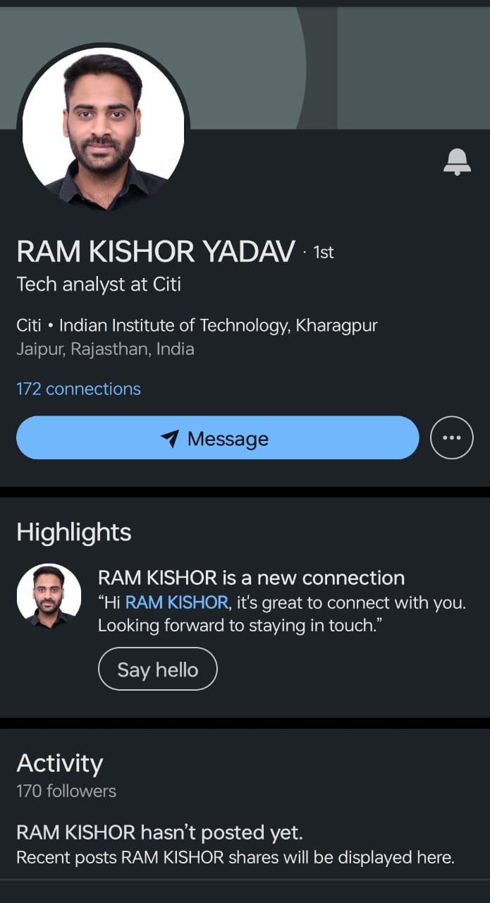

## Interview Questions

## List of Questions:

## What made you decide to start investing in rental properties?

## How did you finance your first rental property?

## What challenges did you face when you first started, and how did you overcome them?

## How do you determine the rental prices for your properties?

## What strategies do you use to find and keep reliable tenants?

## How do you manage the upkeep and repairs of your properties?

## Can you share a difficult experience with a tenant and how you handled it?

## What do you find most rewarding about being a property owner?

## How do you balance managing your rental properties with other commitments?

## What advice would you give to someone who wants to start their own rental property business?

## 

* **Rationale**:

These questions are designed to explore the entrepreneur’s journey, decision-making process, and strategies in the real estate rental business. Each question aims to uncover valuable insights into property management, tenant relations, and the challenges of growing a rental property portfolio.

## Key Insights

During the interview, the entrepreneur shared their reasons for entering the real estate market, primarily driven by a desire for financial independence and long-term investment security. They emphasized the importance of thorough market research before purchasing properties and understanding the local rental market dynamics.

They also discussed several challenges, such as dealing with non-paying tenants and maintaining properties, highlighting the importance of good communication skills and a proactive approach to property management. Despite the challenges, they found the business rewarding due to the steady income stream and the ability to build a valuable asset portfolio over time.

The entrepreneur stressed the significance of maintaining good tenant relationships, as satisfied tenants are more likely to stay longer, reducing turnover and associated costs. They also highlighted the importance of continuous learning and adapting to market changes to stay competitive.

## Unexpected Insights

## One surprising insight was the entrepreneur's approach to financing. Instead of taking large loans, they started small with a single property and gradually expanded their portfolio using rental income and savings, minimizing financial risk.

## Another unexpected takeaway was the emphasis on community involvement. The entrepreneur actively participates in local community events and networks with other property owners to share experiences and stay informed about market trends, which helps in maintaining a positive reputation and attracting reliable tenants.

## Important Takeaways

From the interview, I learned several key lessons about entrepreneurship in the real estate rental business:

Start Small and Grow Gradually: Starting with a smaller investment and scaling up allows for better management of risks and understanding the business before making larger commitments.

Know Your Market: Understanding local market trends and regulations is crucial for setting competitive rental prices and ensuring compliance with laws.

Build Strong Tenant Relationships: Good relationships with tenants can lead to longer leases and fewer vacancies, ultimately contributing to a more stable income stream.

Financial Prudence: Managing finances carefully and avoiding over-leveraging can help in maintaining financial stability and growth over the long term.

These insights are valuable not just for those interested in real estate but also for anyone looking to understand the broader principles of entrepreneurship, risk management, and strategic growth.

