Algorithm for file updates in Python

Project description
A health care organization needs me to regularly update a file of employees who can access restricted access level content. The file includes employee IP addresses that currently have access to personal patient records, and I have been given a list of IP addresses to remove. In this project, I create a Python algorithm that checks whether the allow list contains any of the IP addresses to remove, and remove them.

Open the file that contains the allow list
I first start by storing the allow_list.txt file path to a variable that I can use to open it.

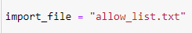

Then using the with open() as file syntax I open the file to read the currently allowed IP addresses listed in the file.
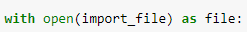

Read the file contents
With the file open, I can now read the contents with the .read() method which converts the contents of the file into a python string.

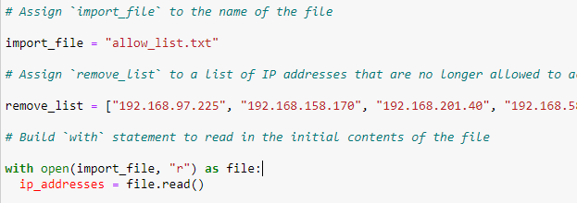

Convert the string into a list
Since I will need to iterate through the list of IP addresses to remove any unallowed IP addresses, I convert the file contents string into a Python list with .split().

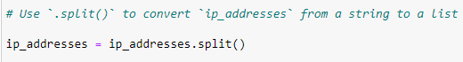

Iterate through the remove list
Now that all of the allowed IP addresses were easily available in a list, I iterated through all of the IP addresses I needed to remove so that I could check if they existed in the currently allowed IP addresses.

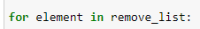

Remove IP addresses that are on the remove list
While iterating through the IP addresses to remove, I created a conditional to remove an IP address from the list of allowed IP addresses if it was currently allowed but should be removed.

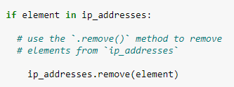

Update the file with the revised list of IP addresses
Now that I had the updated list of IP addresses, I needed to update the allow_list.txt file with the updated list. I first converted the Python list back to a string where each IP address is on its own line. Then I opened the allow_list.txt file with the “w” parameter to completely overwrite the file to avoid duplicate information. Finally, I wrote the updated string of allowed IP addresses to the file.

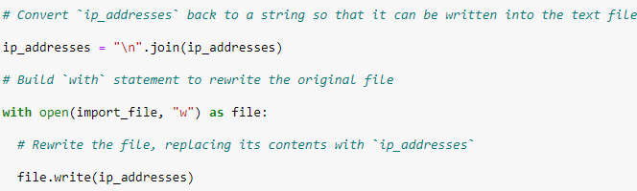

Summary
For this task, I created a Python algorithm that takes in a file of IP addresses and uses a list of IP addresses to remove to update the file. Using Python functionalities like with open, .read(), and .remove() I convert the file to a Python list and iterate through the list of IP addresses to remove and compare them to the IP addresses currently listed in the file. After removing the invalid IP addresses, I convert the list back to a string to then update the valid IP addresses file with the new list.

