Experiment No. 10
ChainTrack: A Blockchain-Based Supply Chain Tracker
Submitted in partial fulfillment of the requirements of
Mini Project
in
B.E. (Artificial Intelligence and Data Science)
By
Name | Roll Number
Veenus Patil | 08
Om Rajpure | 15
Omkar Gend | 74
Supervisor:
Prof. Shubhangi Katke

Department of Artificial Intelligence and Data Science
DATTA MEGHE COLLEGE OF ENGINEERING, AIROLI,
NAVI MUMBAI – 400 708.
University of Mumbai
(A.Y. 2026–27)

CERTIFICATE
This is to certify that the mini project entitled “ChainTrack: A Blockchain-Based Supply Chain Tracker” is a bonafide work carried out by Veenus Patil (08), Om Rajpure (15), and Omkar Gend (74) in partial fulfillment of the requirements for the award of the Degree of Bachelor of Engineering in Artificial Intelligence and Data Science from the University of Mumbai during the academic year 2026–27.
The work presented in this report is an original record of the investigation and implementation carried out by the students under my supervision, and has not been submitted elsewhere for any other degree or diploma.

Prof. Shubhangi Katke | Dr. [HOD NAME] | Dr. [PRINCIPAL NAME]
Project Guide | Head of Department  Dept. of AI & DS | Principal  DMCE, Airoli
ABSTRACT
Global multi-tier supply chains suffer from severe information fragmentation, opacity, and unauthorized record modification. Because stakeholders maintain siloed, private relational databases, records can be silently edited or disputed. Consequently, counterfeit products enter transit channels undetected, causing over $450 billion in annual economic losses globally and severely endangering public safety in pharmaceutical and consumer sectors.
To address these trust deficits, this project introduces ChainTrack, a full-stack, hybrid Web3 traceability platform. ChainTrack permanently anchors product digital identities, role-based custody transitions, and cryptographic metadata digests on an Ethereum smart contract (SupplyChain.sol) while storing rich descriptive metadata off-chain in PostgreSQL. Inventory mutations follow a strict two-step escrow handover protocol (Initiate &rarr; InTransit &rarr; Accept/Reject), preventing unilateral inventory assignment and enforcing non-repudiation. An autonomous background indexer ingests blockchain event logs, ensures idempotent synchronization, and maintains relational snapshots. For end consumers, ChainTrack enables instant, zero-login public verification: scanning a physical QR code dynamically recomputes a Keccak-256 hash over canonical database metadata and verifies it against the immutable on-chain proof. Verified across 87 automated tests (100% statement coverage), ChainTrack demonstrates a practical, tamper-evident architecture for enterprise supply chain integrity.

LIST OF FIGURES
Figure No. | Figure Caption | Page
Figure 1 | System architecture of ChainTrack (Dual-Pipeline Architecture) | 5
Figure 2 | ChainTrack product lifecycle and finite state machine | 5
Figure 3 | ChainTrack public landing page and instant verification portal | 6
Figure 4 | Enterprise manufacturer dashboard with inventory metrics | 7
Figure 5 | Product registration and canonical hash generation interface | 7
Figure 6 | Product digital identity view with QR code generation | 8
Figure 7 | Inbound custody transfer acceptance and rejection interface | 8
Figure 8 | Public product verification interface displaying AUTHENTIC verdict | 9
Figure 9 | Simulated metadata tampering resulting in DATA MISMATCH security alert | 9

LIST OF TABLES
Table No. | Table Title | Page
Table 1 | Technology stack components and selection rationale | 4
Table 2 | Participant roles and on-chain permissions in SupplyChain.sol | 5
Table 3 | Product lifecycle states and allowable state transitions | 5
Table 4 | Software and hardware operational environment specifications | 6
Table 5 | Automated testing results and verification observations | 10
Table 6 | Comparative evaluation between conventional systems and ChainTrack | 10

CONTENTS
Section | Topic Summary | Page
1. INTRODUCTION | Introduction, Literature Survey, Objectives, Tech Stack | 4
2. SYSTEM DESIGN | Architecture, Smart Contract, Environment Requirements | 5
3. IMPLEMENTATION & RESULTS | Modules 3.1.1–3.1.8, Testing Observations, Scope, Comparison | 6
4. CONCLUSION & FUTURE WORK | Conclusion, Planned Future Enhancements, References | 11

1. INTRODUCTION
1.1 Introduction
Modern commercial supply chains represent intricate ecosystems where products move through manufacturers, distributors, retailers, and end consumers. Despite ERP modernization, supply chain data remains siloed in private corporate databases where records can be silently edited, lost, or disputed. This opacity enables counterfeit products to enter transit channels undetected, causing massive financial losses and severe hazards in pharmaceutical and consumer markets. ChainTrack solves this trust deficit by implementing a hybrid blockchain architecture that permanently anchors custody handovers and metadata hashes on Ethereum while storing rich data in PostgreSQL.
1.2 Literature Survey
S. Nakamoto (2008) [1] established trustless decentralized transaction ledgers. G. Wood (2014) [2] and N. Szabo (1997) [3] formalized smart contract execution on the Ethereum Virtual Machine (EVM). E. Androulaki et al. (2018) [4] demonstrated that role-based access control and deterministic state execution are critical for multi-party supply chains. NIST FIPS PUB 180-4 [5] standardized cryptographic hashing (SHA-256/Keccak), enabling mathematical tamper detection. EIP-4361 (Sign-In with Ethereum) [6] established passwordless wallet authentication via ECDSA signatures.
1.3 Problem Statement & Objectives
Problem Statement: Problem Statement: Centralized supply chain records lack cross-organizational transparency, cryptographic non-repudiation, and independent consumer auditability, enabling unauthorized record manipulation and counterfeit product penetration.
Objectives: (1) Assign products a unique on-chain digital identity and Keccak-256 hash; (2) Record custody transitions immutably; (3) Enforce role-based access (Admin, Manufacturer, Distributor, Retailer); (4) Implement two-step escrow transfers (Initiate &rarr; Accept/Reject); (5) Enforce terminal Sold finality; (6) Enable zero-login QR verification; (7) Realize real-time mathematical tamper detection; (8) Index logs into PostgreSQL for sub-15ms queries; (9) Achieve 100% smart contract statement test coverage.
1.4 Technology Stack
Technology | Purpose in ChainTrack | Selection Rationale
Solidity (^0.8.24) | Smart contract logic | EVM standard; built-in overflow checks and custom errors.
Hardhat & Sepolia | Blockchain development & testnet | Local EVM node and official Ethereum testnet.
Next.js 14 & TypeScript | Full-stack web application | React Server Components with typed API route handlers.
PostgreSQL & Prisma | Relational off-chain database | ACID compliance, parameterized queries, and fast filtering.
ethers.js (v6) & SIWE | Web3 client & wallet authentication | Transaction signing and EIP-4361 passwordless sessions.
qrcode & html5-qrcode | QR generation and scanning | In-browser video parsing without external hardware.

2. SYSTEM DESIGN
2.1 Framework / System Architecture
ChainTrack implements a dual-pipeline architecture separating cryptographic proof from descriptive application metadata (Figure 1). Transactions are signed directly via MetaMask (EIP-1193) and broadcast to Ethereum, while off-chain metadata is persisted in PostgreSQL via Prisma. A background indexer daemon polls contract logs, mirrors events, and updates cache snapshots.
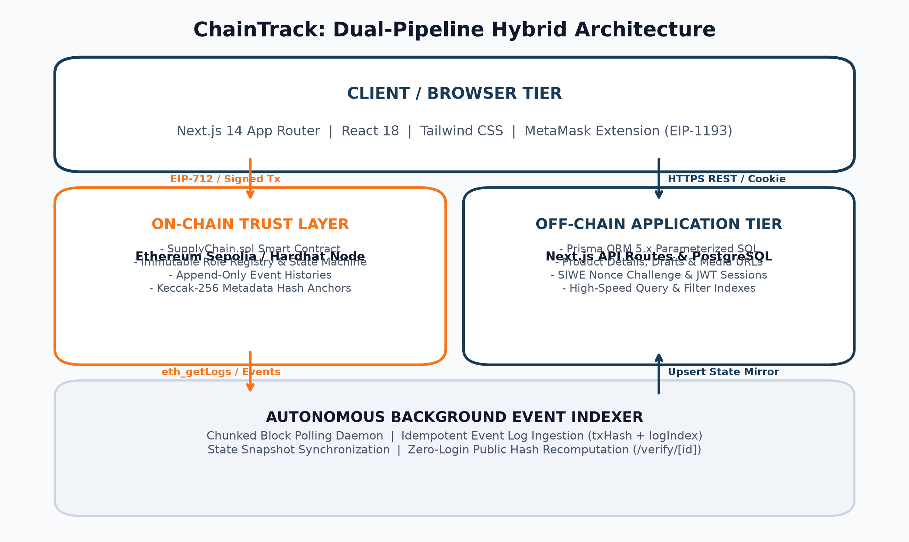
Figure 1: System architecture of ChainTrack (Dual-Pipeline Architecture)
2.2 Smart Contract / Blockchain Design
SupplyChain.sol manages participants, enforces the product lifecycle state machine (Figure 2), and maintains an append-only audit trail.
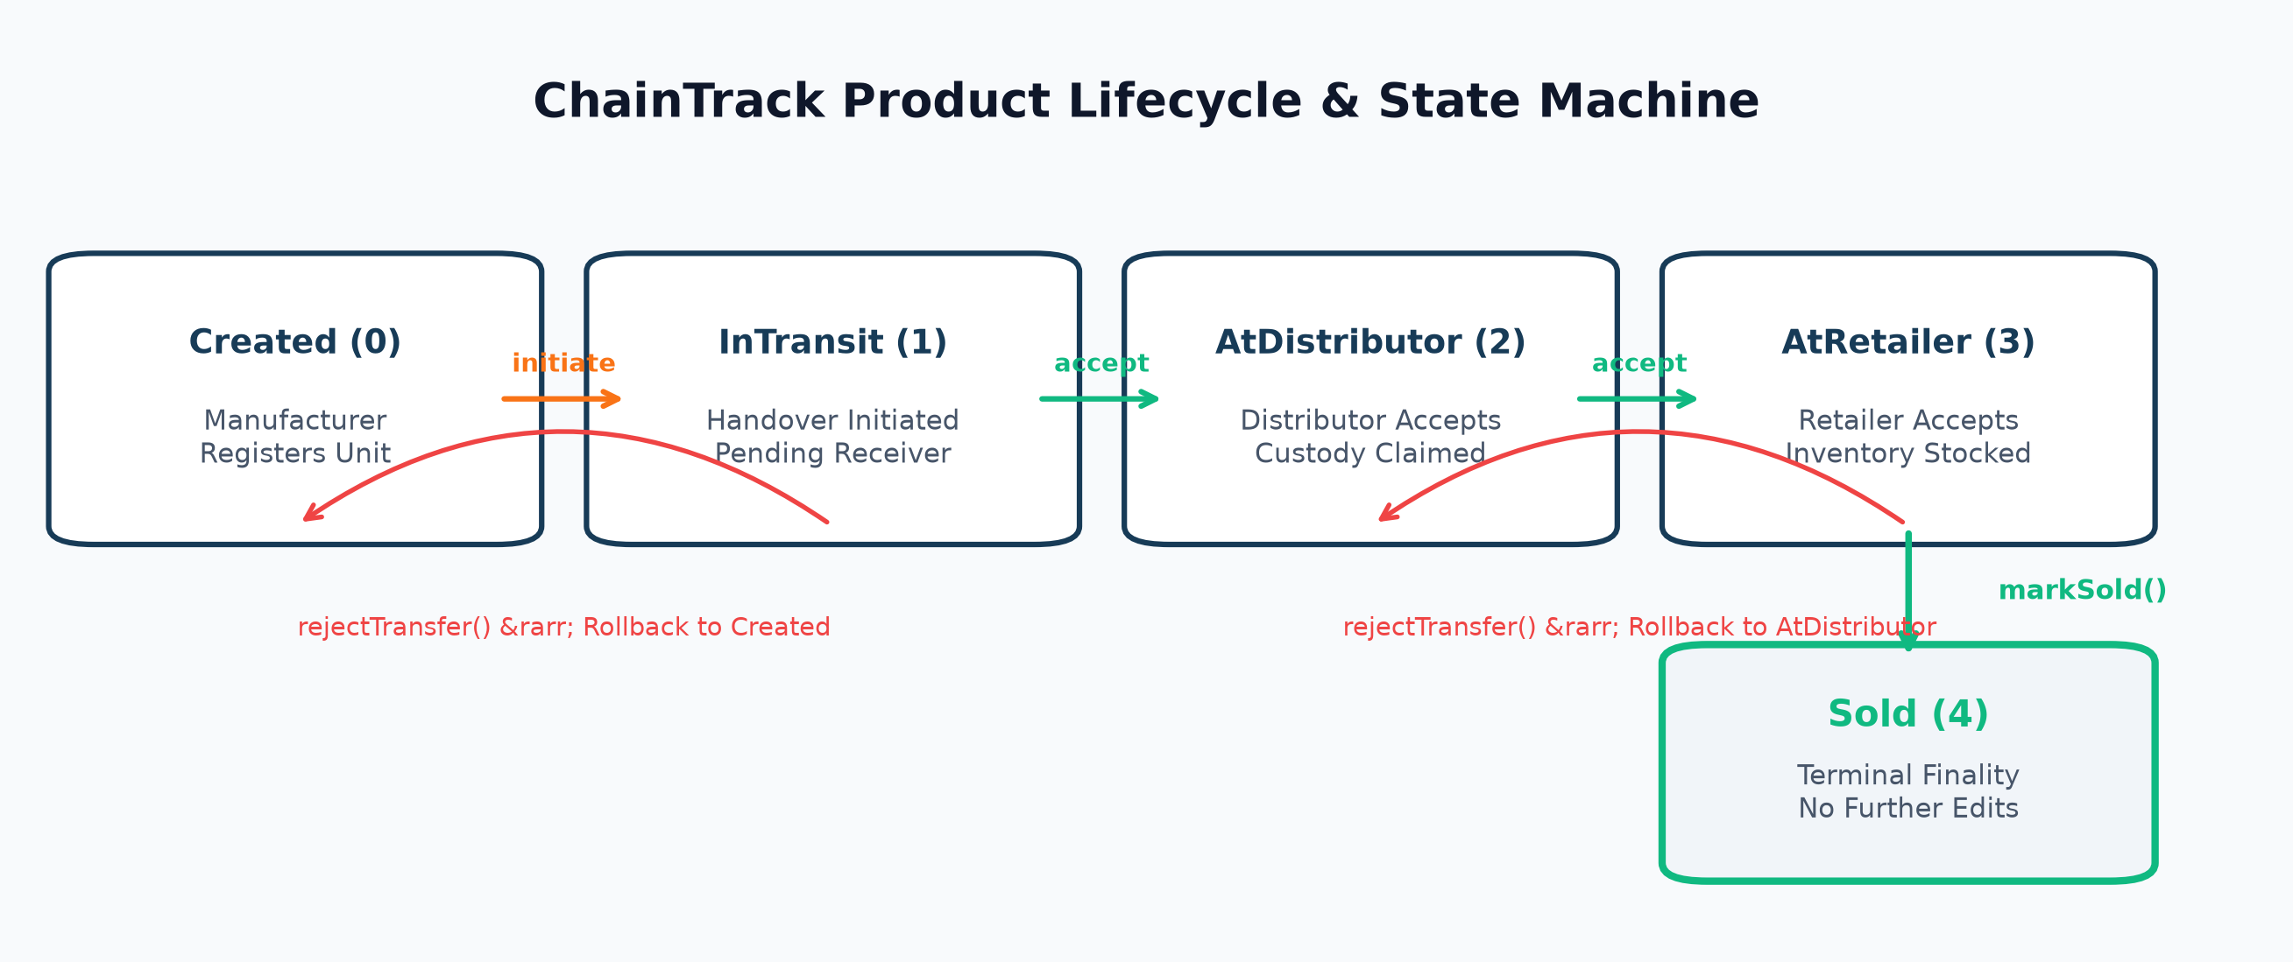
Figure 2: ChainTrack product lifecycle and finite state machine
Participant Role | Operational Responsibilities | Authorized Functions
Admin (0) | Contract deployer; registers and deactivates participant wallets. | registerParticipant, setParticipantActive
Manufacturer (1) | Mints products, anchors metadata hashes, initiates transfer. | registerProduct, initiateTransfer, addLocationUpdate
Distributor (2) | Receives wholesale inventory, logs checkpoints, ships onward. | acceptTransfer, rejectTransfer, initiateTransfer
Retailer (3) | Receives retail goods, logs store inventory, marks sold. | acceptTransfer, rejectTransfer, markSold
Customer / Public | Verifies product authenticity and views timeline without login. | getProduct, getHistory (Public view)

State Enum | Operational Meaning | Allowable Next Transitions
Created (0) | Registered by Manufacturer; held at factory floor. | initiateTransfer &rarr; InTransit (Distributor)
InTransit (1) | Custody transfer initiated; pending receiver acceptance. | acceptTransfer &rarr; AtDistributor/AtRetailer  rejectTransfer &rarr; Created/AtDistributor
AtDistributor (2) | Accepted and stocked by an active Distributor. | initiateTransfer &rarr; InTransit (Retailer)
AtRetailer (3) | Accepted and held in stock by an active Retailer. | markSold &rarr; Sold (Terminal Finality)
Sold (4) | Sold to end consumer; locked against all further edits. | None (Permanent finality)

2.3 Software & Hardware Requirements
Domain | Specification
Operating System | Windows 10/11, macOS, or Ubuntu Linux
Runtime & Tools | Node.js v20+ LTS, Solidity v0.8.24, Hardhat, Prisma v5.22
Database & Chain | PostgreSQL 16 (Docker/Native) & Ethereum Sepolia Testnet (11155111)
Client & Hardware | MetaMask Extension; CPU: 4 Cores 2.5 GHz+; RAM: 8 GB+; Disk: 10 GB SSD

3. IMPLEMENTATION AND RESULTS
3.1 System Implementation
ChainTrack is structured into modular frontend pages, REST API handlers, smart contracts, and background daemons. The public portal (Figure 3) enables zero-login search by numeric Product ID or QR scanning. Wallet authentication implements EIP-4361 Sign-In with Ethereum (SIWE): MetaMask signs a unique nonce, the server validates getParticipant() on-chain, and issues an httpOnly JWT session cookie.
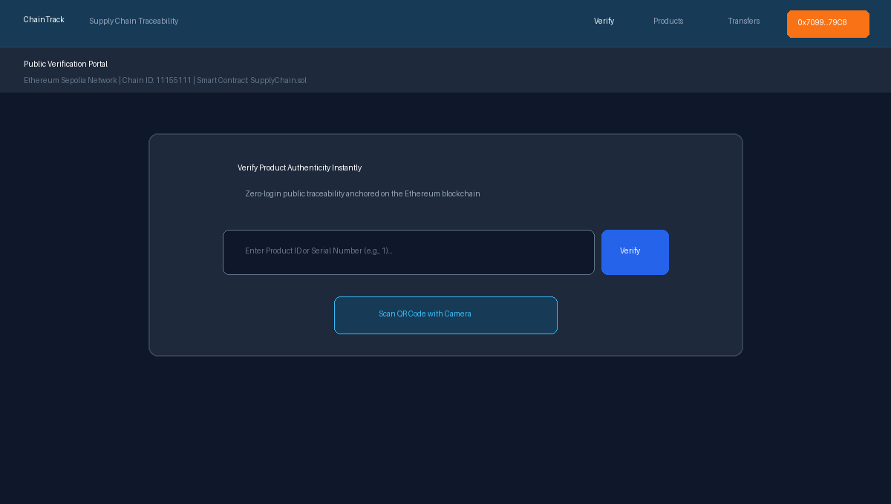
Figure 3: ChainTrack public landing page and instant verification portal
Upon authentication, the user lands on their role-specific dashboard (Figure 4), which aggregates inventory totals (Total Registered, In Transit, At Distributor, Sold) and provides instant status filters.

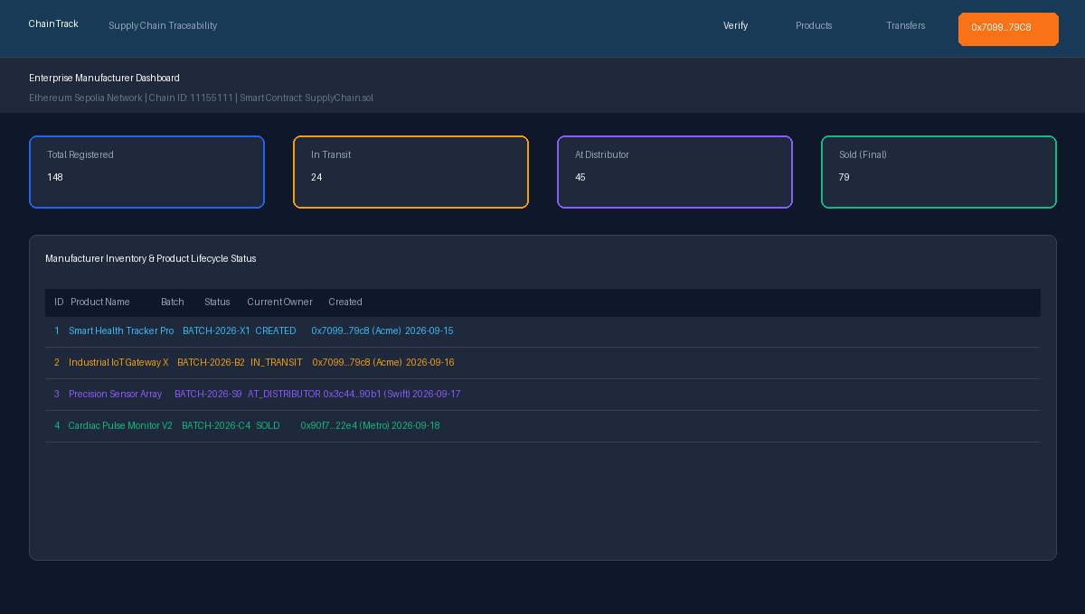
Figure 4: Enterprise manufacturer dashboard with inventory metrics
3.1.1 Product Registration & Canonical Hashing
Authorized Manufacturers register products through an intuitive interface (Figure 5). Upon submission, POST /api/products/draft creates a database draft and executes computeProductHash(), recursively sorting JSON keys alphabetically and computing a 32-byte Keccak-256 digest: DataHash = keccak256(CanonicalJSON). The frontend prompts MetaMask to call registerProduct(bytes32, string) on-chain. Once mined, POST /api/products/confirm binds the returned token ID to the confirmed database record.
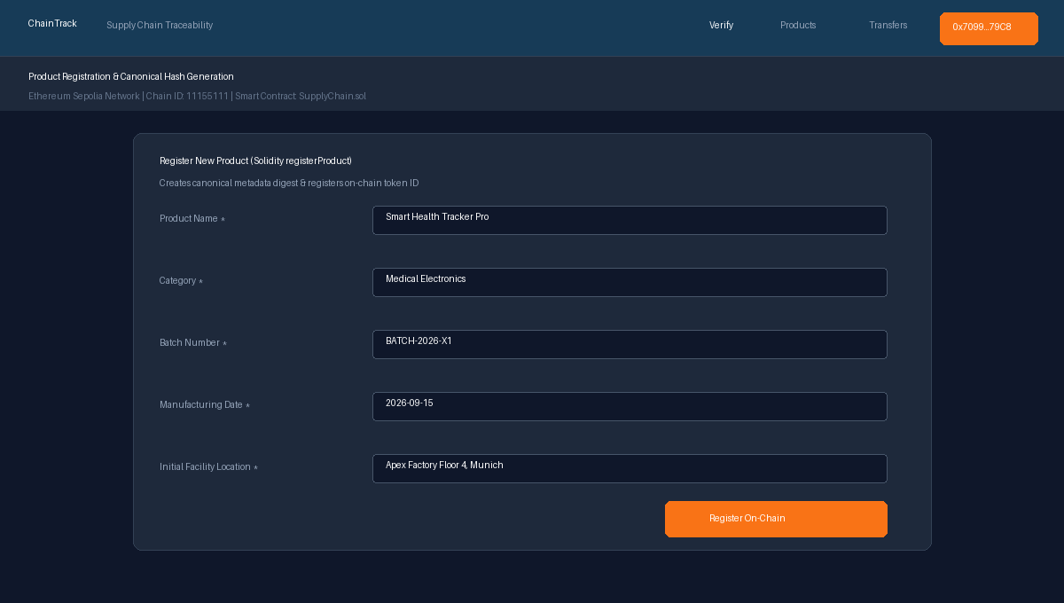
Figure 5: Product registration and canonical hash generation interface

3.1.2 Product Digital Identity & QR Tagging
The product details view (Figure 6) renders the verified serial number, on-chain hash, transaction receipt, and current owner. It dynamically generates a 512x512 PNG QR code encoding the public verification URL ({APP_BASE_URL}/verify/{id}) for direct printing onto physical packaging.
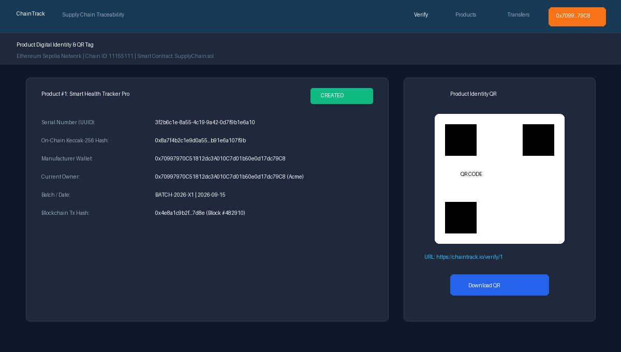
Figure 6: Product digital identity view with QR code generation
3.1.3 Two-Step Custody Handover Protocol
Custody transfer uses a two-step escrow protocol. The current owner executes initiateTransfer() on MetaMask, moving status to IN_TRANSIT. The designated receiver views incoming shipments (Figure 7) and can either accept custody via acceptTransfer() or decline via rejectTransfer() with an on-chain reason, rolling status back to the sender.
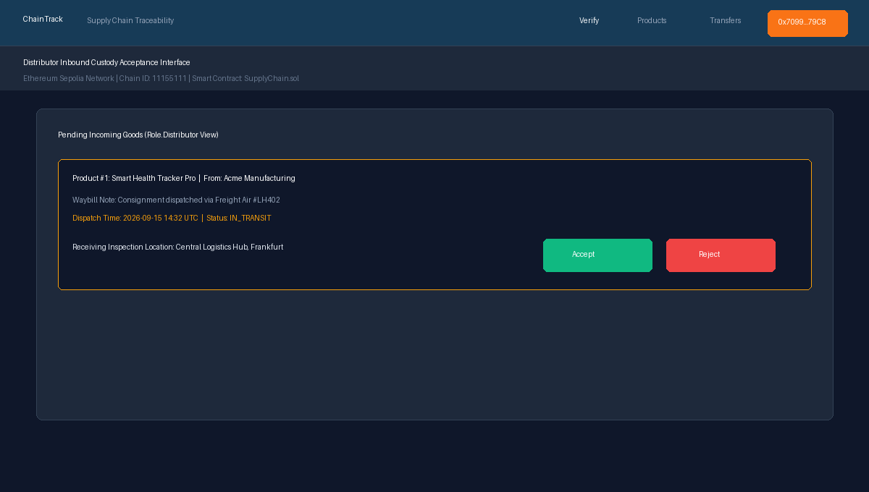
Figure 7: Inbound custody transfer acceptance and rejection interface

3.1.4 Public Verification & Cryptographic Tamper Detection
Scanning a product QR opens /verify/[id] (Figure 8) without login. The engine reads the on-chain status and hash directly from Ethereum RPC, fetches PostgreSQL metadata, and recalculates the Keccak-256 hash. If matching, an AUTHENTIC green banner is displayed alongside the verified chronological audit timeline.
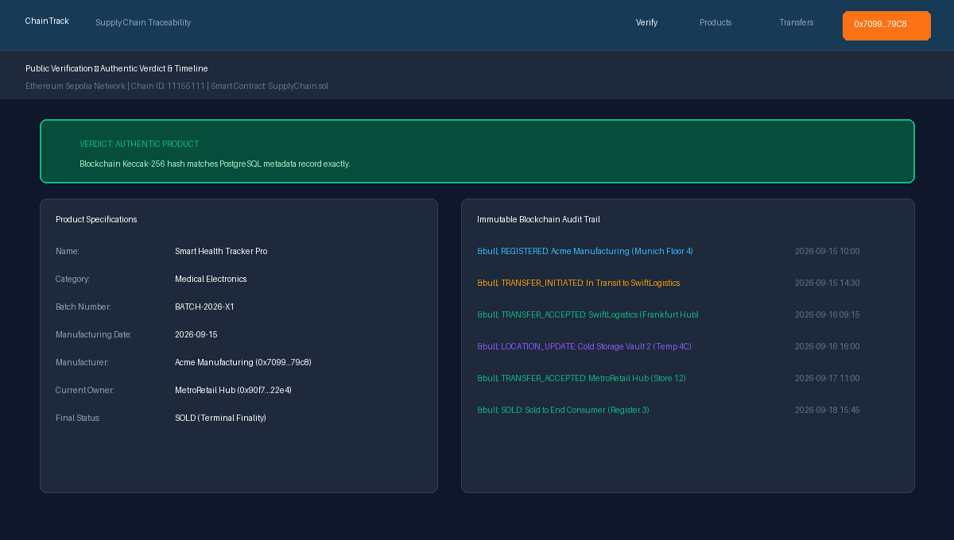
Figure 8: Public product verification interface displaying AUTHENTIC verdict
If an unauthorized actor alters off-chain database records (e.g., modifying batch numbers), the recalculated hash diverges from the on-chain digest. As shown in Figure 9, the engine instantly detects the discrepancy, displaying a prominent DATA MISMATCH security warning.
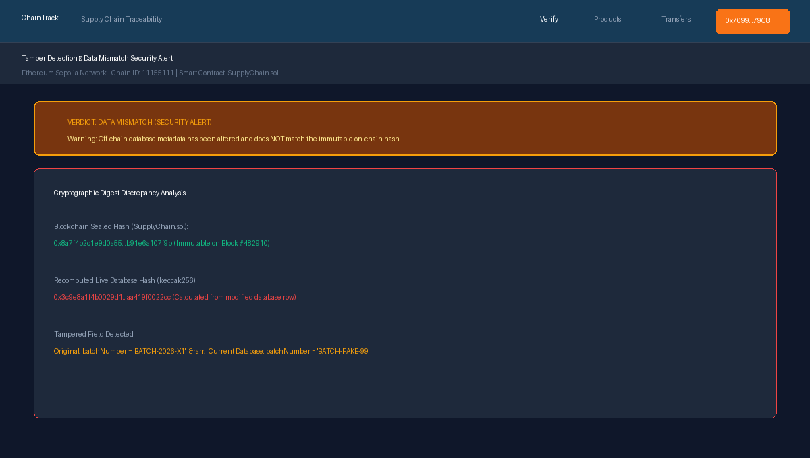
Figure 9: Simulated metadata tampering resulting in DATA MISMATCH security alert

3.2 Results and Observations
ChainTrack was verified across 87 automated tests: 43 smart contract tests (100% statement, function, and line coverage) and 44 backend integration tests, all passing with zero errors.
Test Domain | Scenario & Input Condition | Expected Architectural Behavior | Status
Admin Access Control | Non-admin calls registerParticipant() | Reverts with NotAdmin() | Passed (100%)
Product Registration | Manufacturer registers valid hash | Mints ID #1, emits ProductRegistered | Passed (100%)
Duplicate Hash Guard | Attempt to register duplicate hash | Reverts with DuplicateHash() | Passed (100%)
Transfer Handover | Distributor accepts incoming package | Ownership transferred, status AtDistributor | Passed (100%)
Transfer Rejection | Retailer rejects transfer with note | Ownership unchanged, status AtDistributor | Passed (100%)
Terminal Sale Finality | Retailer marks sold; write attempted | Status becomes Sold; write reverts | Passed (100%)
Tamper Detection | Modify batchNumber in database | Dynamic hash mismatch flags Warning | Passed (100%)
Zero-Login Verify | Access /verify/1 without wallet | Returns complete verified timeline | Passed (100%)

3.3 Scope and Limitations
Current limitations include: (1) Operation on Ethereum Sepolia testnet (production requires L2 rollups for low gas fees); (2) Physical oracle gap (standard 2D QR codes can be copied; enterprise requires cryptographic NFC tags); (3) Unresponsive receiver lock (inventory remains in transit if receiver never responds).
3.4 Comparison with Conventional Systems
Dimension | Conventional Supply Chain Database | ChainTrack Traceability Platform
Record Integrity | Centralized; database admin can alter or delete rows. | Cryptographically immutable; anchored on Ethereum.
Custody Handover | Manual paper waybills or isolated intra-company ERP logs. | Deterministic two-step cryptographic escrow.
Tamper Detection | Difficult; requires post-incident forensic database auditing. | Real-time mathematical detection via Keccak-256 comparison.
Consumer Verification | Usually impossible or relies on unverified static web pages. | Zero-login public portal reading directly from RPC.
Authentication | Vulnerable username/password databases prone to leaks. | Passwordless EIP-4361 cryptographic signatures (SIWE).

4. CONCLUSION
ChainTrack successfully demonstrates a robust, decentralized supply chain traceability platform. By separating immutable cryptographic proof on Ethereum from searchable application metadata in PostgreSQL, ChainTrack proves that blockchain can be deployed for enterprise logistics without sacrificing query performance. The two-step escrow handover enforces non-repudiation, canonical hashing detects database tampering in real time, and the zero-login public portal empowers consumers to verify product provenance effortlessly. With 100% test coverage across 87 automated tests, ChainTrack establishes an audit-ready foundation for trustworthy global supply chains.
FUTURE WORK
Future enhancements include: (1) Layer-2 Rollup Deployment (Arbitrum/Polygon zkEVM) for sub-cent gas fees; (2) ERC-1155 batch minting for high-volume palletized consignments; (3) Automated IoT sensor integration (GPS/temperature) for autonomous transit checkpoints; (4) Zero-knowledge proofs (zk-SNARKs) to verify provenance without exposing commercial wholesale pricing; (5) ERC-1967 transparent upgradeable proxies.
REFERENCES
[1] S. Nakamoto, “Bitcoin: A Peer-to-Peer Electronic Cash System,” 2008.
[2] G. Wood, “Ethereum: A Secure Decentralised Generalised Transaction Ledger,” Ethereum Project Yellow Paper, 2014.
[3] N. Szabo, “Formalizing and Securing Relationships on Public Networks,” First Monday, vol. 2, no. 9, 1997.
[4] E. Androulaki et al., “Hyperledger Fabric: A Distributed Operating System for Permissioned Blockchains,” EuroSys, 2018.
[5] NIST, “Secure Hash Standard (SHS),” FIPS PUB 180-4, U.S. Department of Commerce, 2015.
[6] W. Wayne et al., “EIP-4361: Sign-In with Ethereum,” Ethereum Improvement Proposals, no. 4361, 2022.
[7] Ethereum Foundation, “Solidity Documentation: v0.8.24,” docs.soliditylang.org, 2024.
[8] Nomic Foundation, “Hardhat: Ethereum Development Environment,” hardhat.org, 2024.
[9] R. Moore, “ethers.js: Compact Ethereum Library in TypeScript,” docs.ethers.org, 2024.
[10] Vercel Inc., “Next.js 14 App Router Architecture,” nextjs.org/docs, 2024.
[11] Prisma Data Inc., “Prisma ORM for PostgreSQL,” prisma.io/docs, 2024.
[12] ISO/IEC, “QR Code Bar Code Symbology Specification,” ISO/IEC 18004:2015 Standard, 2015.

