MAHA E-SEVA KENDRA • NERUL
Complete 32 Services Visual Catalogue & Card Reference
Shop No-15, Janta Market Bridge, Nerul East, Navi Mumbai 400706 | Phone: 099877 72424
――――――――――――――――――――――――――――――――――――――――――――――――
Service 01: Aadhaar Smart Card
Category: IDENTITY | Kendra Service Charge: ₹40
Assistance with PVC Aadhaar Smart Card printing, biometric updates, and address corrections.
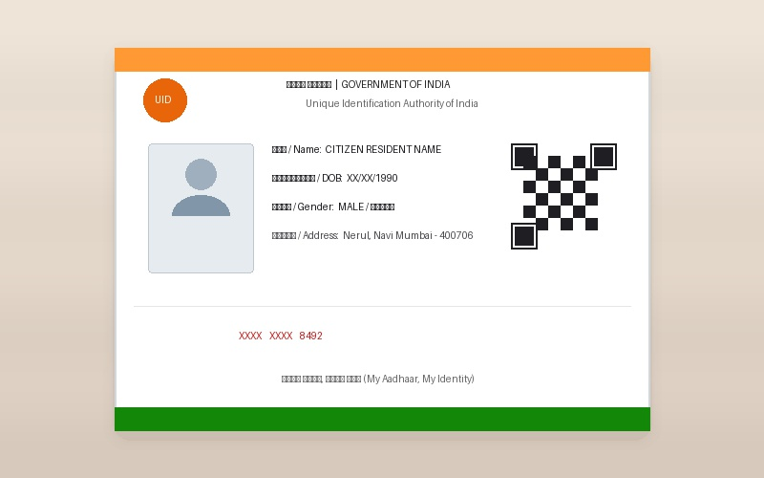
Figure 01: Real-life Aadhaar Smart Card Visual Representation (aadhaar-smart-card.jpg)

――――――――――――――――――――――――――――――――――――――――――――――――
Service 02: PAN Card
Category: IDENTITY | Kendra Service Charge: ₹150
New PAN card application, correction, reprint, and Aadhaar-PAN linking assistance.
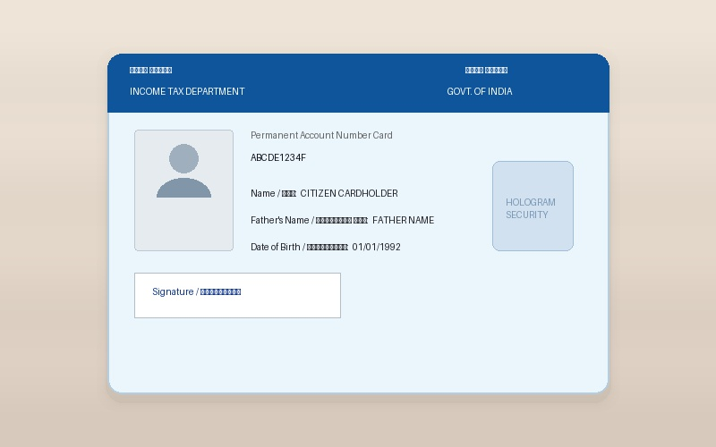
Figure 02: Real-life PAN Card Visual Representation (pan-card.jpg)

――――――――――――――――――――――――――――――――――――――――――――――――
Service 03: Voter ID
Category: IDENTITY | Kendra Service Charge: ₹100
New Voter ID registration (Form 6), address shift, corrections (Form 8), and e-EPIC download.
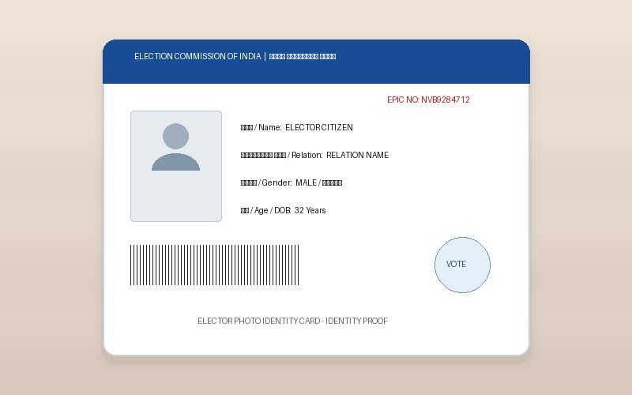
Figure 03: Real-life Voter ID Visual Representation (voter-id.jpg)

――――――――――――――――――――――――――――――――――――――――――――――――
Service 04: Passport Online Application
Category: TRAVEL-TRANSPORT | Kendra Service Charge: ₹300 (Centre Service Charge)
Fresh passport application, renewal, tatkaal guidance, document checklist, and PSK appointment booking.
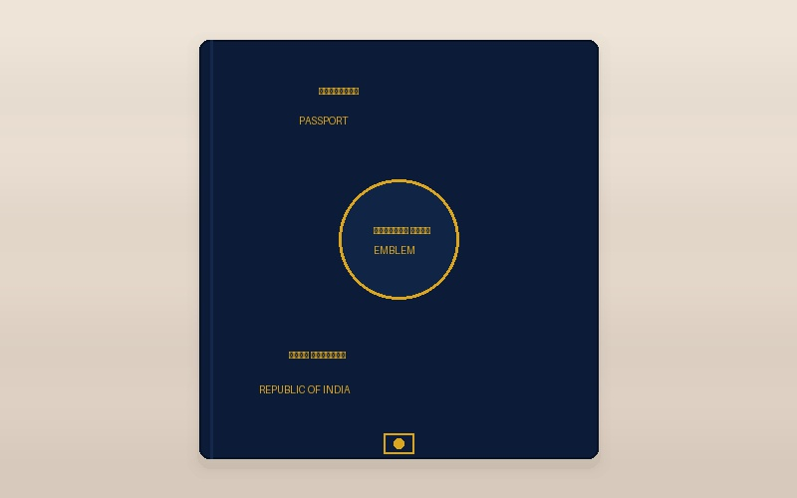
Figure 04: Real-life Passport Online Application Visual Representation (passport.jpg)

――――――――――――――――――――――――――――――――――――――――――――――――
Service 05: Driving Licence
Category: TRAVEL-TRANSPORT | Kendra Service Charge: ₹300
Learner licence test booking, permanent licence slot, renewal, and address change on Sarathi Parivahan.
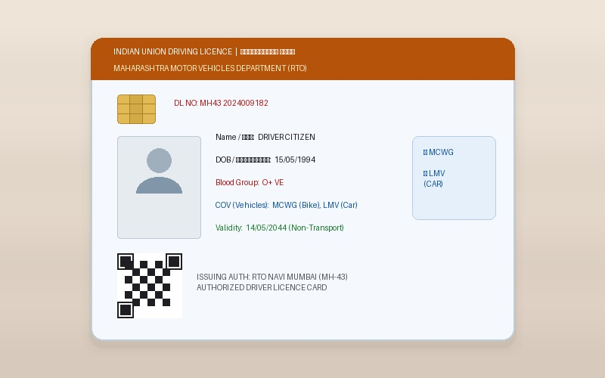
Figure 05: Real-life Driving Licence Visual Representation (driving-licence.jpg)

――――――――――――――――――――――――――――――――――――――――――――――――
Service 06: ABHA Health Card
Category: HEALTH-WELFARE | Kendra Service Charge: ₹50
Create your 14-digit Ayushman Bharat Health Account (ABHA) ID and get instant laminated card print.
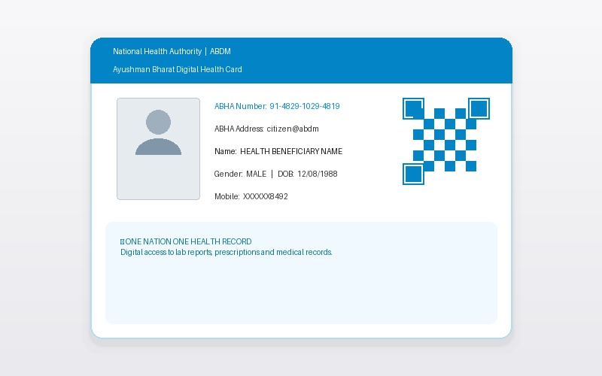
Figure 06: Real-life ABHA Health Card Visual Representation (abha-health-card.jpg)

――――――――――――――――――――――――――――――――――――――――――――――――
Service 07: Ayushman Bharat Card
Category: HEALTH-WELFARE | Kendra Service Charge: ₹50
PM-JAY Golden Card eligibility check, e-KYC verification, and ₹5 Lakh cashless health card print.
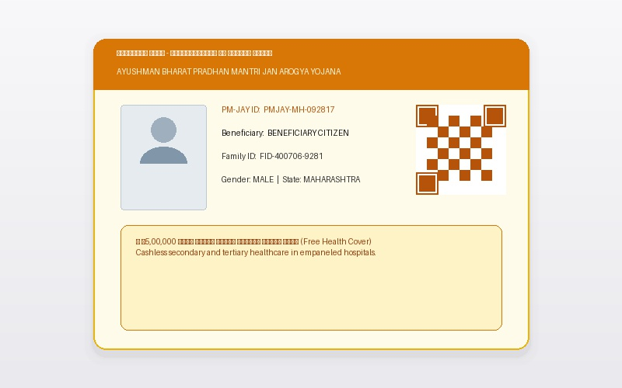
Figure 07: Real-life Ayushman Bharat Card Visual Representation (ayushman-bharat-card.jpg)

――――――――――――――――――――――――――――――――――――――――――――――――
Service 08: Senior Citizen Card
Category: HEALTH-WELFARE | Kendra Service Charge: ₹100
Official Maharashtra Senior Citizen Identity Card (Age 60+) for travel concessions and healthcare benefits.
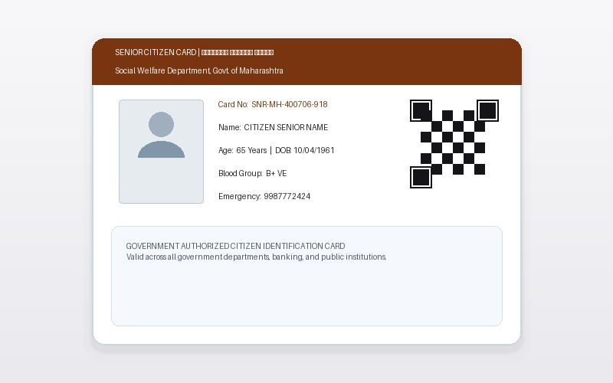
Figure 08: Real-life Senior Citizen Card Visual Representation (senior-citizen-card.jpg)

――――――――――――――――――――――――――――――――――――――――――――――――
Service 09: E-Shram Card
Category: EMPLOYMENT | Kendra Service Charge: ₹50
National Unorganised Workers Database registration with 12-digit UAN and ₹2 Lakh PMSBY insurance cover.
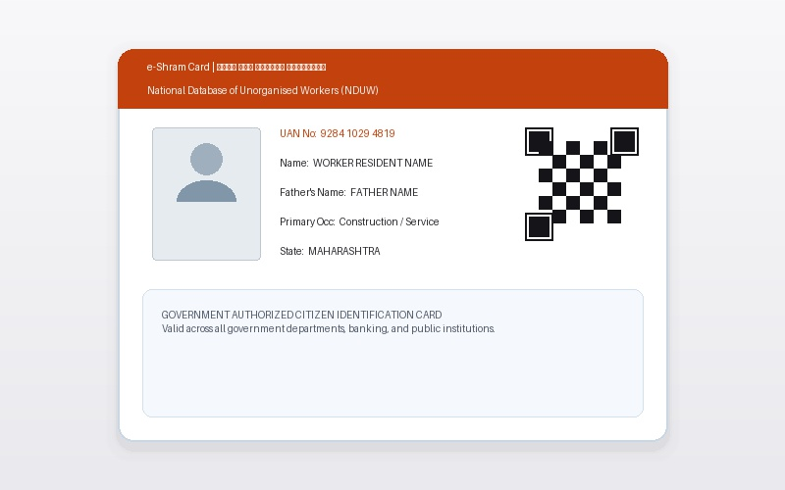
Figure 09: Real-life E-Shram Card Visual Representation (e-shram-card.jpg)

――――――――――――――――――――――――――――――――――――――――――――――――
Service 10: UAN / PF Card
Category: EMPLOYMENT | Kendra Service Charge: ₹100
EPFO UAN activation, PF passbook download, KYC update, and online PF withdrawal claim assistance.
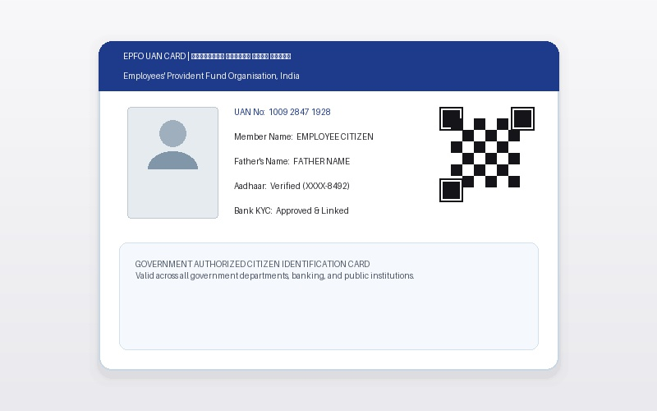
Figure 10: Real-life UAN / PF Card Visual Representation (uan-pf-card.jpg)

――――――――――――――――――――――――――――――――――――――――――――――――
Service 11: Domicile Certificate
Category: CERTIFICATES | Kendra Service Charge: ₹300
Age, Nationality & Domicile Certificate application on Aaple Sarkar portal for Maharashtra residence proof.
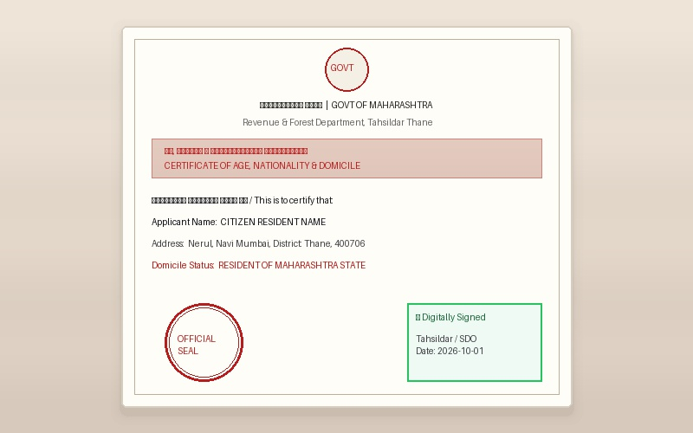
Figure 11: Real-life Domicile Certificate Visual Representation (domicile-certificate.jpg)

――――――――――――――――――――――――――――――――――――――――――――――――
Service 12: Income Certificate
Category: CERTIFICATES | Kendra Service Charge: ₹300
Annual Income Certificate (1 Year / 3 Years) from Tahsildar for scholarships, fee waivers & schemes.
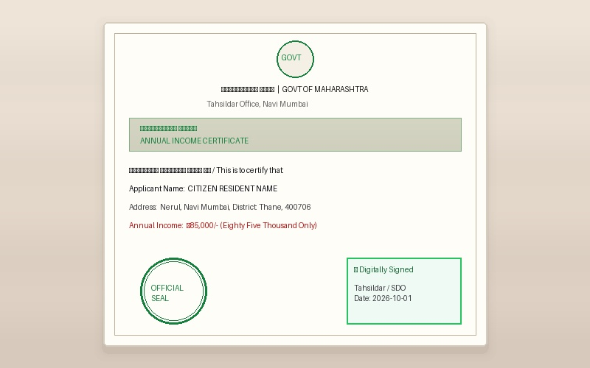
Figure 12: Real-life Income Certificate Visual Representation (income-certificate.jpg)

――――――――――――――――――――――――――――――――――――――――――――――――
Service 13: Residence Certificate
Category: CERTIFICATES | Kendra Service Charge: ₹300
Official proof of local residence (Rahivasi Dakhla) for school admissions, utilities & local verification.
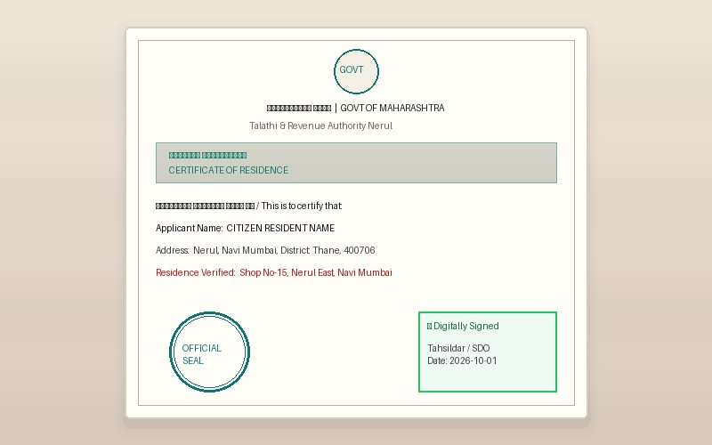
Figure 13: Real-life Residence Certificate Visual Representation (residence-certificate.jpg)

――――――――――――――――――――――――――――――――――――――――――――――――
Service 14: Non-Creamy Layer Certificate
Category: CERTIFICATES | Kendra Service Charge: ₹700
NCL Certificate for OBC, VJNT, and SBC category candidates to claim reservation benefits.
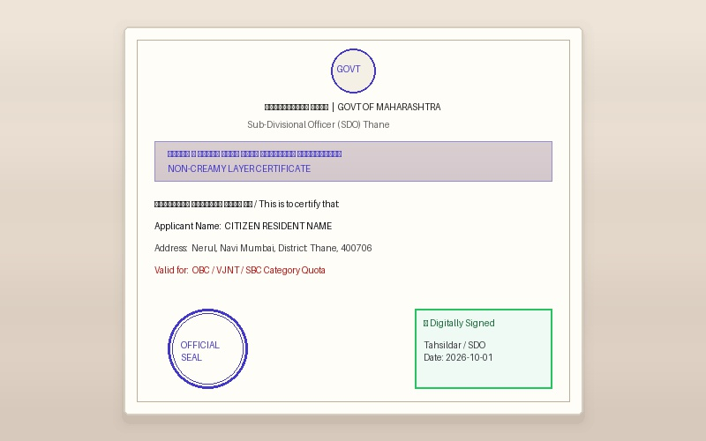
Figure 14: Real-life Non-Creamy Layer Certificate Visual Representation (non-creamy-layer.jpg)

――――――――――――――――――――――――――――――――――――――――――――――――
Service 15: Caste Certificate
Category: CERTIFICATES | Kendra Service Charge: ₹300
SC, ST, OBC, VJNT, and SBC Caste Certificate application on Aaple Sarkar portal.
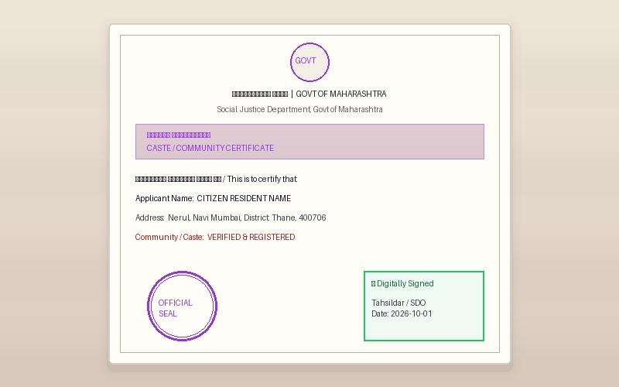
Figure 15: Real-life Caste Certificate Visual Representation (caste-certificate.jpg)

――――――――――――――――――――――――――――――――――――――――――――――――
Service 16: Police Verification
Category: OTHER | Kendra Service Charge: ₹500
Police Clearance Certificate (PCC) online application and tenant verification filing.
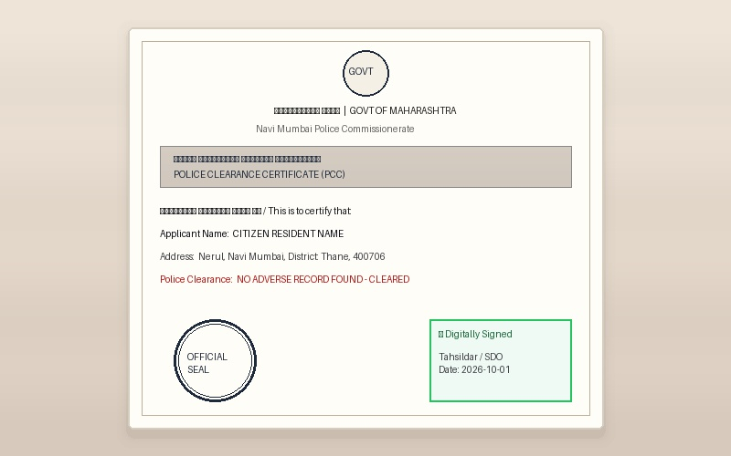
Figure 16: Real-life Police Verification Visual Representation (police-verification.jpg)

――――――――――――――――――――――――――――――――――――――――――――――――
Service 17: E-Registration Rent
Category: BUSINESS-REGISTRATION | Kendra Service Charge: ₹1,000
Government Registered Leave & License (Rent) Agreement with biometric e-signing at Kendra.
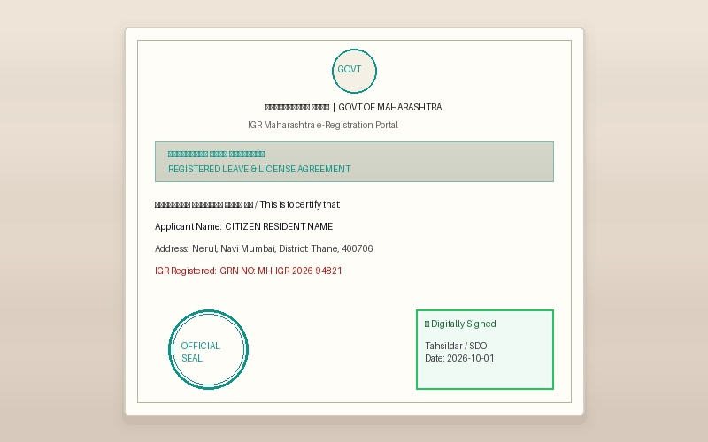
Figure 17: Real-life E-Registration Rent Visual Representation (e-registration-rent.jpg)

――――――――――――――――――――――――――――――――――――――――――――――――
Service 18: Lost Aadhaar / PAN Card
Category: IDENTITY | Kendra Service Charge: ₹100 / ₹200
Quick search, recovery, and duplicate reprint for lost Aadhaar and PAN cards.
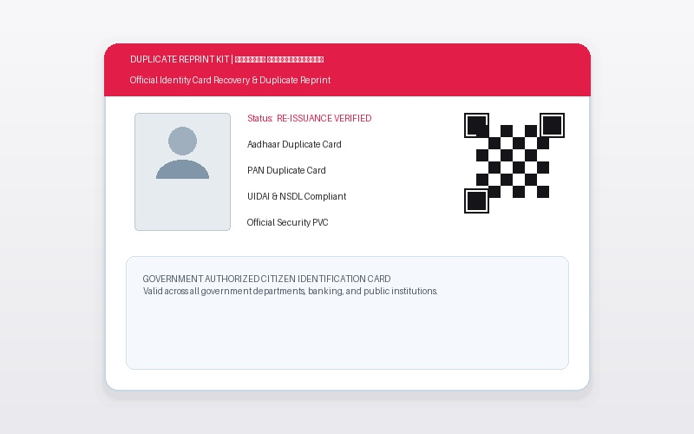
Figure 18: Real-life Lost Aadhaar / PAN Card Visual Representation (lost-aadhaar-pan.jpg)

――――――――――――――――――――――――――――――――――――――――――――――――
Service 19: Small Scale Business (MSME) Licence
Category: BUSINESS-REGISTRATION | Kendra Service Charge: ₹500
Udyam MSME Registration Certificate for small businesses, shops, startups, and traders.
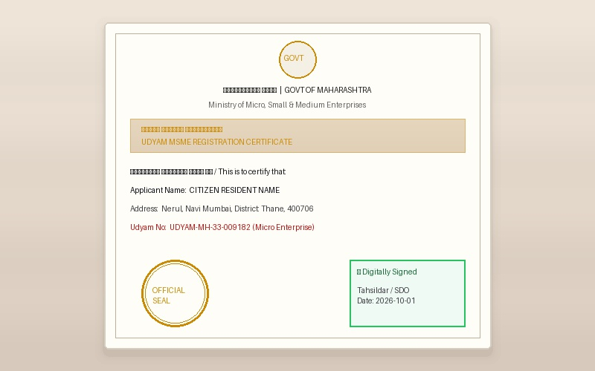
Figure 19: Real-life Small Scale Business (MSME) Licence Visual Representation (msme-registration.jpg)

――――――――――――――――――――――――――――――――――――――――――――――――
Service 20: Shop & Establishment Licence (Gumasta)
Category: BUSINESS-REGISTRATION | Kendra Service Charge: ₹500
Municipal Corporation Gumasta Licence (Intimation / Registration) for shops & commercial establishments.
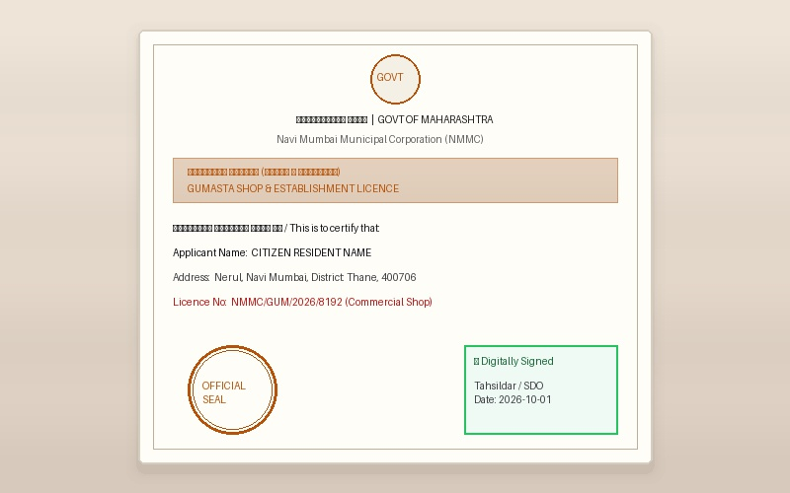
Figure 20: Real-life Shop & Establishment Licence (Gumasta) Visual Representation (gumasta-licence.jpg)

――――――――――――――――――――――――――――――――――――――――――――――――
Service 21: Name Change E-Gazette
Category: OTHER | Kendra Service Charge: ₹1,200
Official Maharashtra Government Gazette notification for name change, marriage & religion updates.
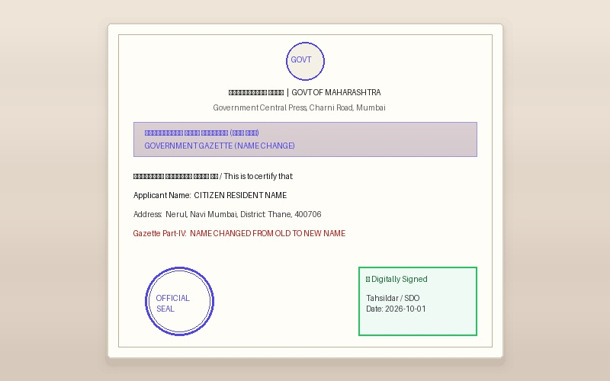
Figure 21: Real-life Name Change E-Gazette Visual Representation (name-change-gazette.jpg)

――――――――――――――――――――――――――――――――――――――――――――――――
Service 22: Banking Related Services
Category: BANKING | Kendra Service Charge: ₹100
Zero balance savings account opening, re-KYC update, DBT subsidy linking, and passbook print.
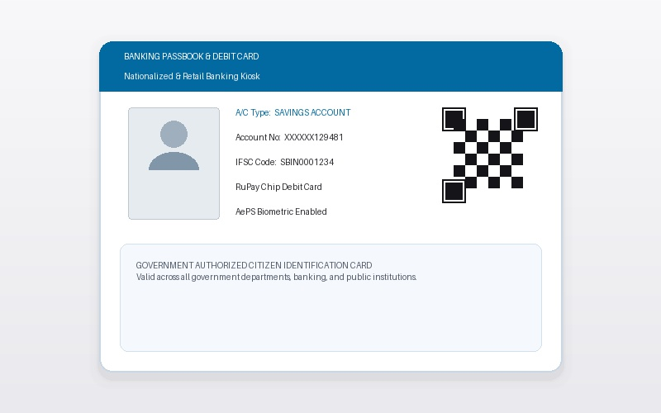
Figure 22: Real-life Banking Related Services Visual Representation (banking-services.jpg)

――――――――――――――――――――――――――――――――――――――――――――――――
Service 23: Health Insurance
Category: INSURANCE | Kendra Service Charge: ₹100
Compare family health insurance policies, calculate premium quotes, and instant policy renewal.
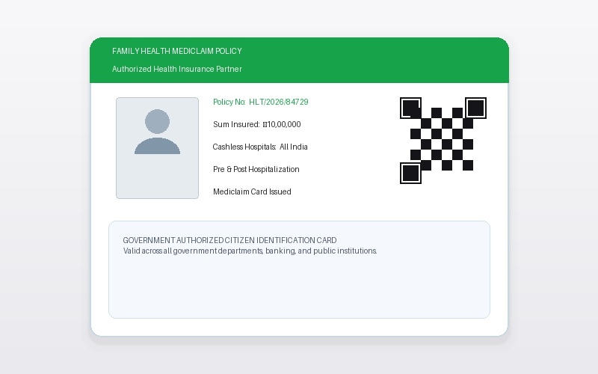
Figure 23: Real-life Health Insurance Visual Representation (health-insurance.jpg)

――――――――――――――――――――――――――――――――――――――――――――――――
Service 24: Motor Insurance
Category: INSURANCE | Kendra Service Charge: ₹100
Instant 2-wheeler, car, and commercial vehicle insurance policy renewal in 5 minutes.
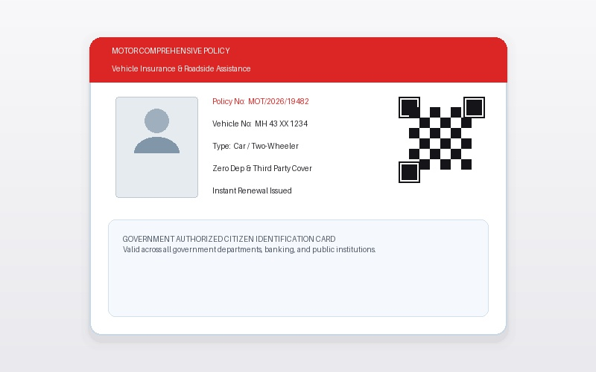
Figure 24: Real-life Motor Insurance Visual Representation (motor-insurance.jpg)

――――――――――――――――――――――――――――――――――――――――――――――――
Service 25: Digital Life Certificate for Pensioners
Category: HEALTH-WELFARE | Kendra Service Charge: ₹200
Jeevan Pramaan biometric digital life certificate generation for central & state government pensioners.
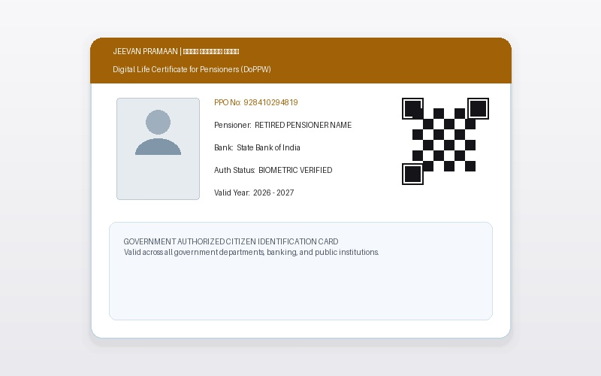
Figure 25: Real-life Digital Life Certificate for Pensioners Visual Representation (digital-life-certificate.jpg)

――――――――――――――――――――――――――――――――――――――――――――――――
Service 26: Passport Size Photo
Category: PHOTOGRAPHY-PRINTING | Kendra Service Charge: ₹100 / 30 photos
Instant studio-quality passport size color photos (30 copies for ₹100) printed in 5 minutes.
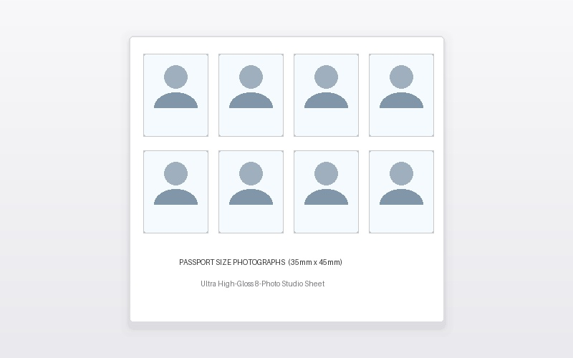
Figure 26: Real-life Passport Size Photo Visual Representation (passport-photo.jpg)

――――――――――――――――――――――――――――――――――――――――――――――――
Service 27: A4 & Card Lamination
Category: PHOTOGRAPHY-PRINTING | Kendra Service Charge: ₹10 / 5 units
Heavy-duty thermal pouch lamination for original certificates, marksheets, and smart ID cards.
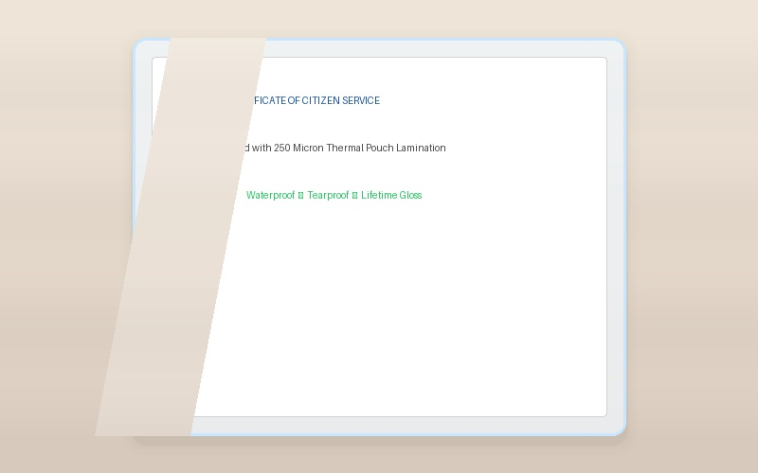
Figure 27: Real-life A4 & Card Lamination Visual Representation (lamination.jpg)

――――――――――――――――――――――――――――――――――――――――――――――――
Service 28: Money Transfer & Withdrawal
Category: BANKING | Kendra Service Charge: Contact for pricing
AePS Aadhaar fingerprint cash withdrawal, domestic money transfer (DMT), and mini-statement.
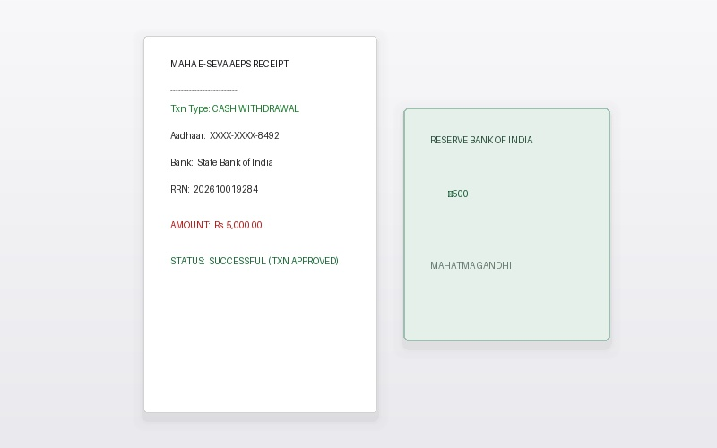
Figure 28: Real-life Money Transfer & Withdrawal Visual Representation (money-transfer.jpg)

――――――――――――――――――――――――――――――――――――――――――――――――
Service 29: Digital Album Photo Quality of Family Documents
Category: PHOTOGRAPHY-PRINTING | Kendra Service Charge: Contact for pricing
High-resolution 600 DPI scanning, color correction, and digital archival of family property & identity papers.
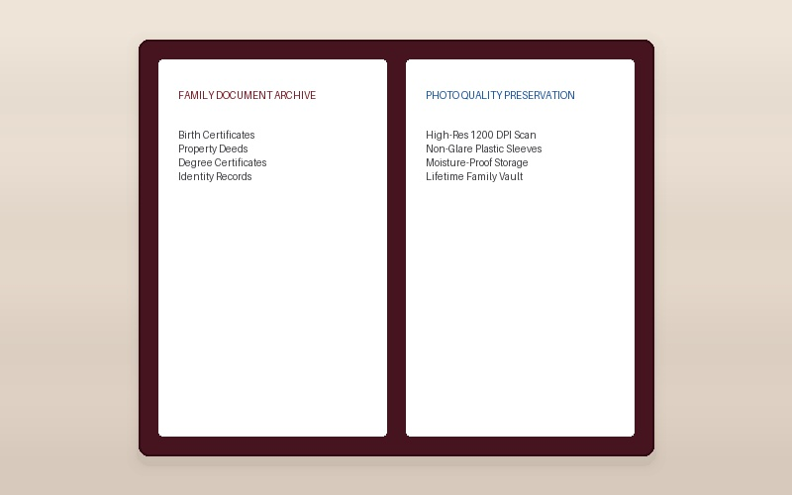
Figure 29: Real-life Digital Album Photo Quality of Family Documents Visual Representation (digital-document-album.jpg)

――――――――――――――――――――――――――――――――――――――――――――――――
Service 30: Government Job & Scheme Online Form Filling
Category: GOVERNMENT-FORMS | Kendra Service Charge: Contact for pricing
Error-free online application form filling for MPSC, UPSC, SSC, Railway, Police Bharti & welfare schemes.
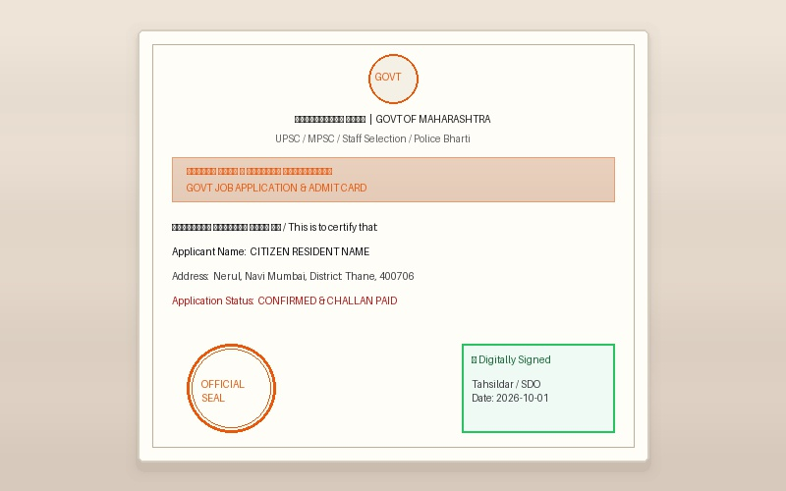
Figure 30: Real-life Government Job & Scheme Online Form Filling Visual Representation (govt-job-forms.jpg)

――――――――――――――――――――――――――――――――――――――――――――――――
Service 31: All Types of Bank Loan
Category: BANKING | Kendra Service Charge: Contact for pricing
Guidance and document dossier preparation for Home Loans, Mudra Business Loans & Personal Loans.
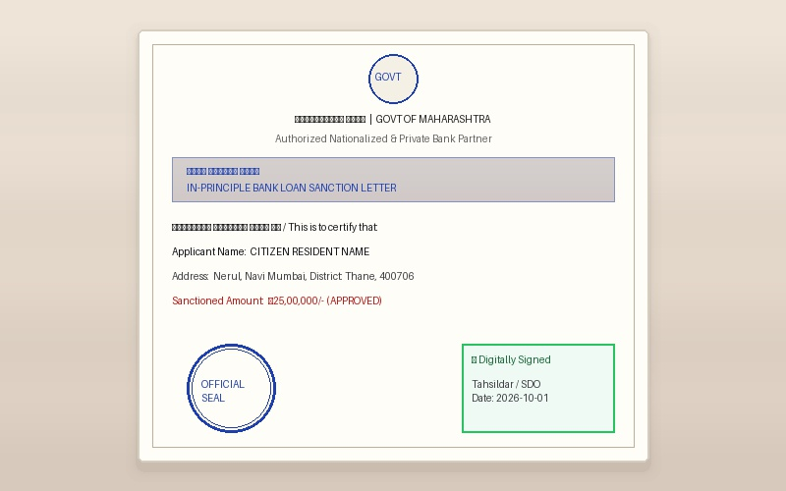
Figure 31: Real-life All Types of Bank Loan Visual Representation (bank-loan.jpg)

――――――――――――――――――――――――――――――――――――――――――――――――
Service 32: Insurance Services
Category: INSURANCE | Kendra Service Charge: Contact for pricing
Comprehensive insurance guidance covering Life, Health, Motor, Term, and Shop protection.
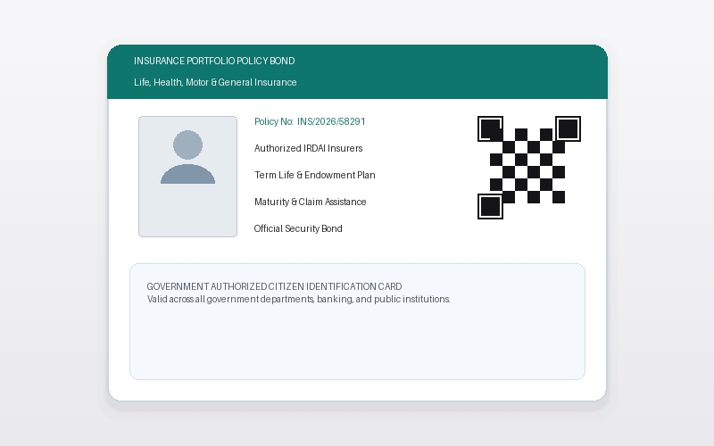
Figure 32: Real-life Insurance Services Visual Representation (insurance-services.jpg)

――――――――――――――――――――――――――――――――――――――――――――――――

