Assignment-Solution Week-01

# **Table of Contents**

|  |  |  |
| --- | --- | --- |
| No. | Assignment no. | Page no. |
| *1* | Assignment - 01 | 2 - 6 |
| *2* | Assignment - 02 | 7 - 12 |
| *3* | Assignment - 03 | 13 - 14 |
| *4* | Assignment - 04 | 15 - 21 |
| *5* | Assignment - 05 | 22 - 25 |

**Day 1/180 Introduction To Programming (Home work)**

* **Convert Decimal to Binary**

1. 37

Base Quotient Rem

2 37 1

2 18 0

2 9 1

2 4 0

2 2 0

2 1 1

2 0

**Ans = 100101**

1. 92

Base Quotient Rem

2 92 0

2 46 0

2 23 1

2 11 1

2 5 1

2 2 0

2 1 1

2 0

**Ans = 1011100**

1. 128

Base Quotient Rem

2 128 0

2 64 0

2 32 0

2 16 0

2 8 0

2 4 0

2 2 0

2 1 1

2 0

**Ans = 10000000**

1. 243

Base Quotient Rem

2 243 1

2 121 1

2 60 0

2 30 0

2 15 1

2 7 1

2 3 1

2 1 1

2 0

**Ans = 11110011**

* **Convert Binary to Decimal**

1. 1011

* 1*2^3 + 0*2^2 + 1*2^1 + 1*2^0
* 8 + 0 + 2 + 1
* **11**

1. 111001

* 1*2^5 + 1*2^4 + 1*2^3 + 0*2^2 + 0*2^1 + 1*2^0
* 32 + 16 + 8 + 0 + 0 + 1
* **57**

1. 10011011

* 1*2^7 + 0*2^6 + 0*2^5 + 1*2^4 + 1*2^3 + 0*2^2 + 1*2^1 + 1*2^0
* 128 + 0 + 0 + 16 + 8 + 0 + 2 + 1
* **155**

1. 10100100

* 1*2^7 + 0*2^6 + 1*2^5 + 0*2^4 + 0*2^3 + 1*2^2 + 0*2^1 + 0*2^0
* 128 + 0 + 32 + 0 + 0 + 4 + 0 + 0
* **164**
* **Convert Decimal to Octal**

1. 28

Base Quotient Rem

8 28 4

8 3 3

8 0

**Answer:- 34**

1. 47

Base Quotient Rem

8 47 7

8 5 5

8 0

**Answer:- 57**

1. 928

Base Quotient Rem

8 928 0

8 116 4

8 14 6

8 1 1

8 0

**Answer:- 1640**

1. 1243

Base Quotient Rem

8 1243 3

8 155 3

8 19 3

8 2 2

8 0

**Answer:- 2333**

* **Convert Octal to Decimal**

1. 41

* 4*8^1 + 1*8^0
* 32 + 1
* **33**

1. 207

* 2*8^2 + 0*8^1 + 7*8^0
* 128 + 0 + 7
* **135**

1. 124

* 1*8^2 + 2*8^1 + 4*8^0
* 64 + 16 + 4
* **84**

1. 311

* 3*8^2 + 1*8^1 + 1*8^0
* 192 + 8 + 1
* **201**
* **Convert Decimal to HexaDecimal**

1. 317

Base Quotient Rem

16 317 13=D

16 19 3

16 1 1

16 0

**Answer:- 13D**

1. 41

Base Quotient Rem

16 41 9

16 2 2

16 0

**Answer:- 29**

1. 14

Base Quotient Rem

16 14 E

16 0

**Answer:- E**

1. 845

Base Quotient Rem

16 845 13=D

16 52 4

16 3 3

16 0

**Answer:- 34D**

* **Convert HexaDecimal to Decimal**

1. A11

* 10*16^2 + 1*16^1 + 1*16^0
* 2560 + 16 + 1
* **2577**

1. 49

* 4*16^1 + 9*16^0
* 64 + 9
* **73**

1. AE2F

* 10*16^3 + 14*16^2 + 2*16^1 + 15*16^0
* 40960 + 3584 + 32 + 15
* **44591**

1. D97

* 13*16^2 + 9*16^1 + 7*16^0
* 3328 + 144 + 7
* **3479**

**Day 2/180 Flowchart and Pseudocode**

* **Create Flowchart and write pseudocode**

1. Two numbers are given, find their Product.

Pseudocode

1. Read a, b

2. Ans = a * b

3. Print Ans

Read a,b

ans=a*b

Print ans

1. Two numbers are given a and b, find a divided by b.

Pseudocode

1. Read a, b

2. Ans = a / b

3. Print Ans

Read a,b

ans=a/b

Print ans

1. Find the square of a number.

Pseudocode

1. Read num

2. Ans = num * num

3. Print Ans

Read n

ans=n*n

Print ans

1. Two numbers a and b are given, find which is greater, if both are equal print the same.

Pseudocode

1. Read a, b

2. if a>b

Print a

3. if a<b

Print b

4. if 2 or 3 not true

Print Same

Read a,b

If a>b

yes

Print a

No

If b>a

yes

Print b

No

Print Same

1. A number is given, find if it is positive or negative or zero.

Pseudocode

1. Read num

2. if num>0

Print Positive

3. if num<0

Print Negative

4. if 2 or 3 not true

Print Zero

Read n

If n>0

yes

Print Positive

No

If n<0

yes

Print Negative

No

Print Zero

1. Find the factorial of a given number.

Pseudocode

1. Read num
2. count=1, fact=1
3. while count <=num

fact = fact * count

count++

4. Print fact

Read n

Fact =1

Count=1

count++

count<=n

yes

fact=fact*count

No

Print fact

**Day 3/180 Introduction to c++**

* **Print number**

1. Two numbers are given, print their product

**Answer:-**

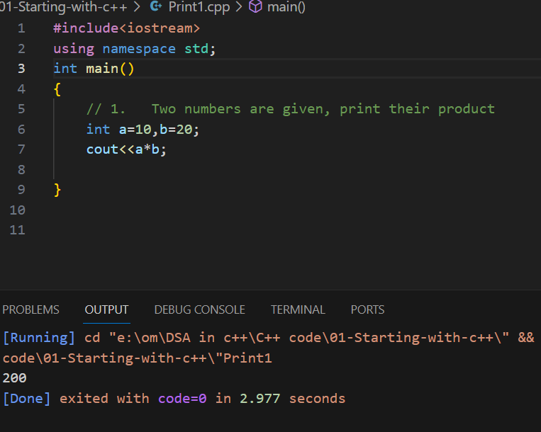

1. Two numbers are given a and b, print a-b

**Answer:-**

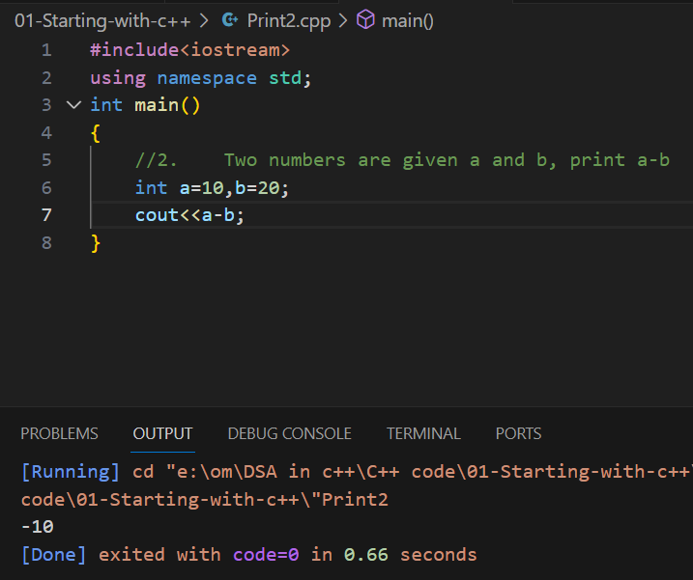

1. Print 6*3 in output, don’t print 18, just 6*3 should be in the output screen.

**Answer:-**

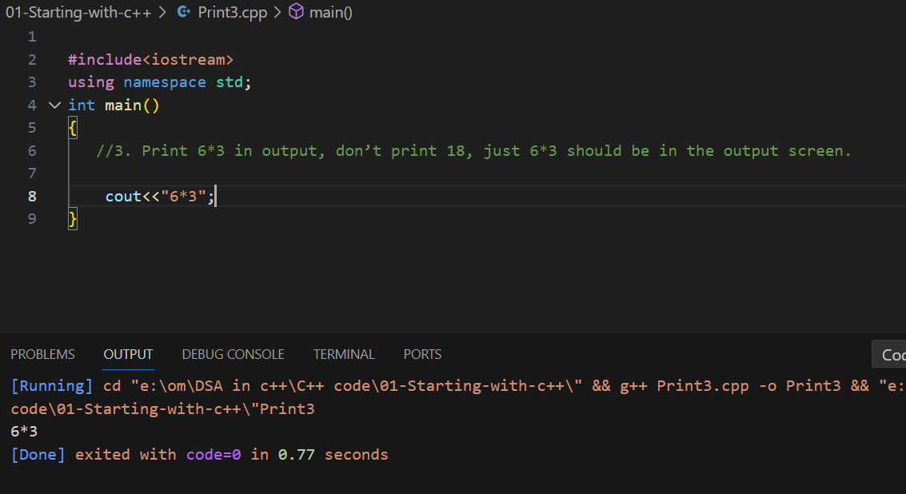

1. If we have only 4 bits, How 3 and -6 will be written in 4 bits.

**Answer:-**

**3 = 0011**

-6

6 = 0110

1’s complement = 1001

2’s complement = +1

**-6 = 1010**

1. If we have only 5 bits, How 13 and -16 will be written in 5 bits.

**Answer:-**

**13 = 01101**

-16

16 = 10000

1’s complement = 01111

2’s complement = +1

**-16 = 10000**

**Day 4/180 If-Else and For Loop**

* **If-else**

1. Two numbers are given, print the bigger number, It is given that both numbers can’t be the same.

**Solution:-**

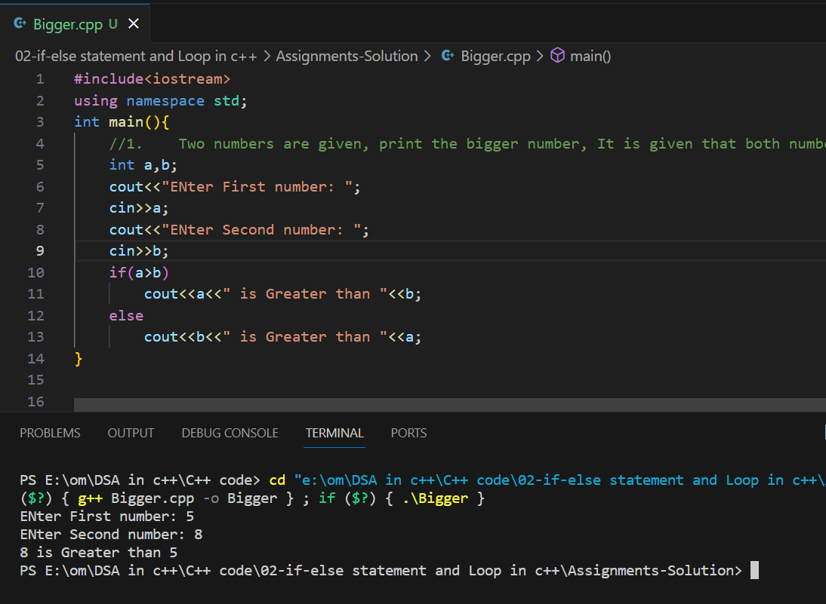

1. Age of a person is given, print Adult if his/her age is greater than 18, otherwise print Teenager.

**Solution:-**

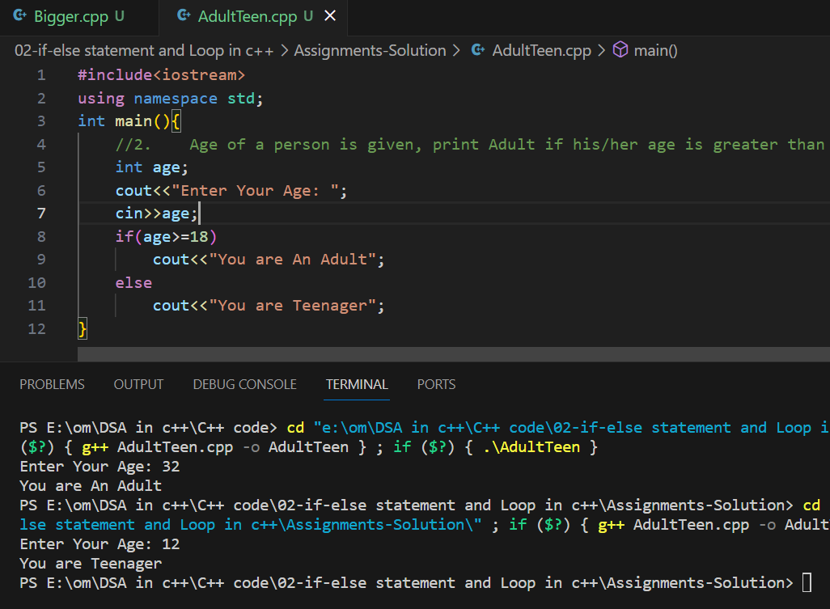

1. Take a number in input (ex n) and print the corresponding month to it. Ex: for n=1, print january, n=2, print feburary like this you need to give output. It is given that n will be greater than 0 and less than 13.

**Solution:-**

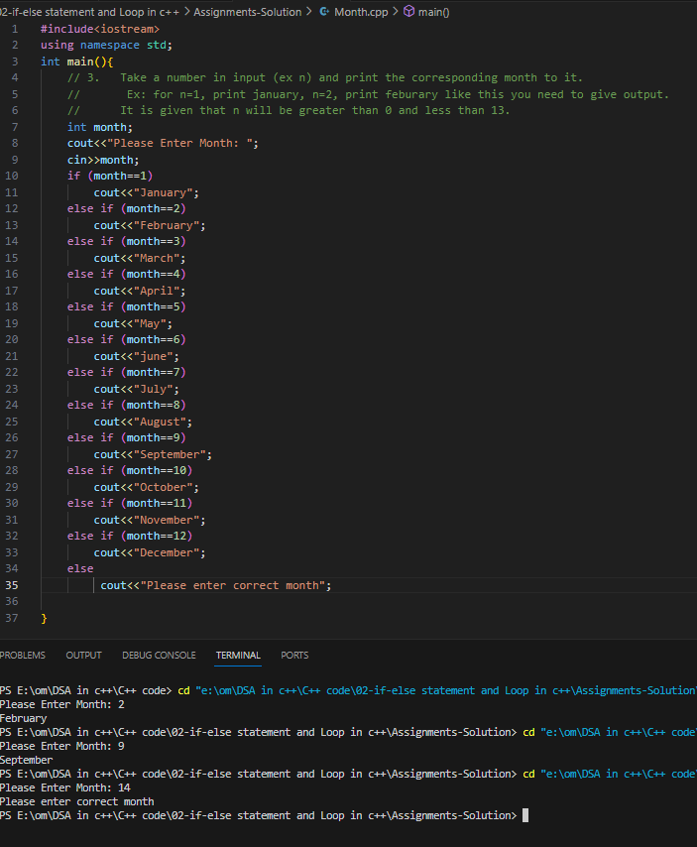

1. Ticket Price Calculator: Create a program that asks the user for their age and checks if they qualify for a discounted ticket price (e.g., under 12 and over 65 get discounts), If they are eligible print “YES” else “NO”.

**Solution:-**

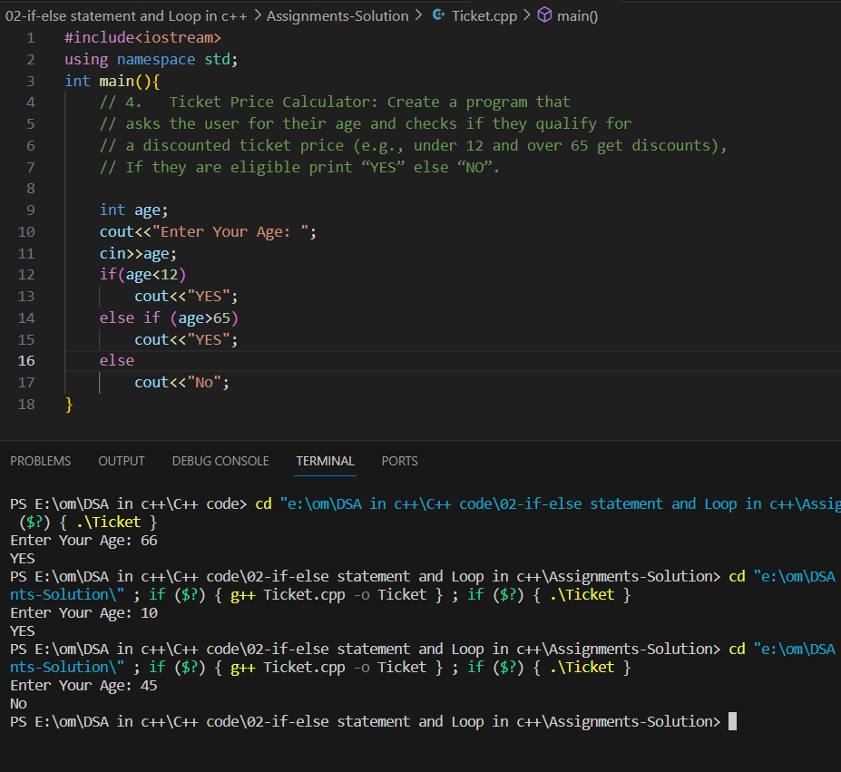

* **For Loop**

1. Print “India will win the World Cup 2023”, 20 times.

**Solution:-**

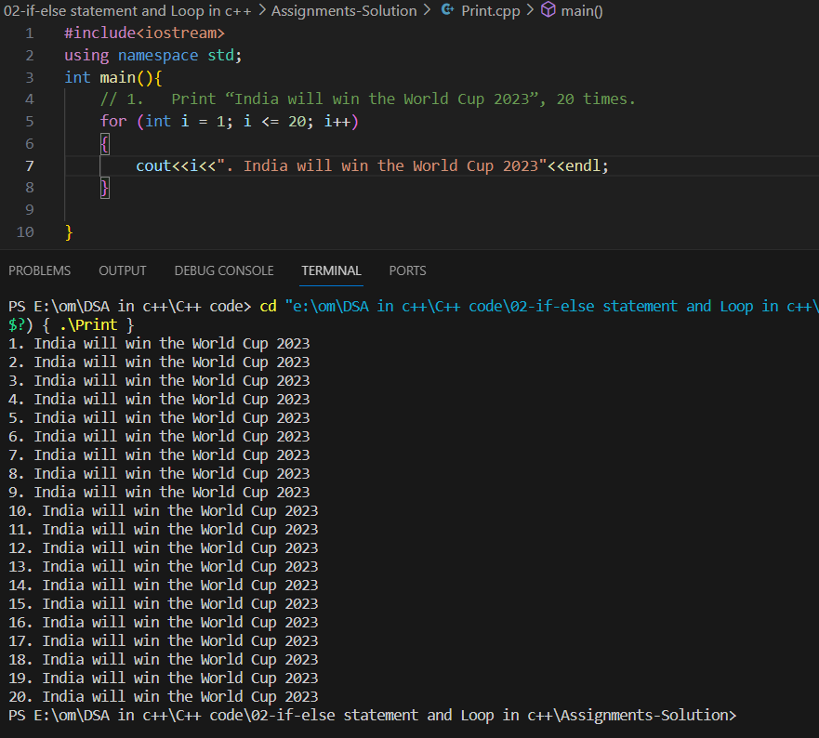

1. Print all Odd numbers from 1 to n, take n as an input from the user.

**Solution:-**

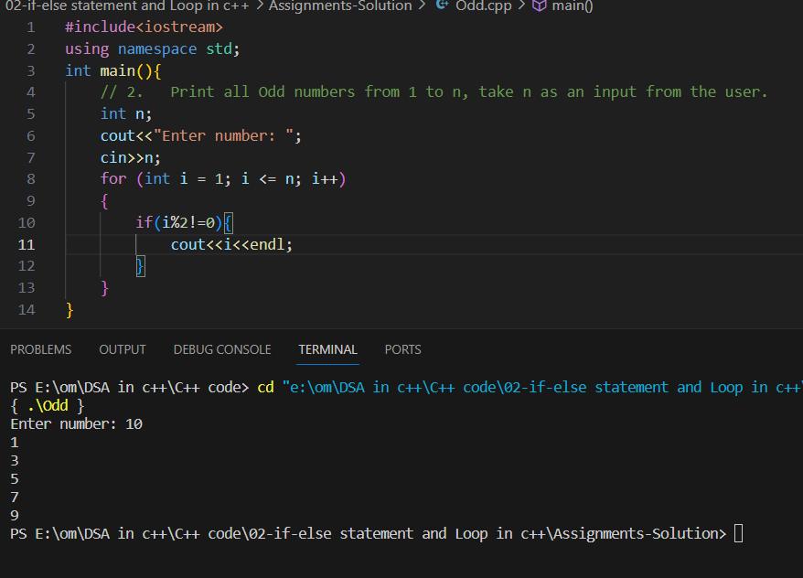

1. Print all numbers from 1 to n, which is divisible by 4. Take n as an input from the user. **Solution:-**

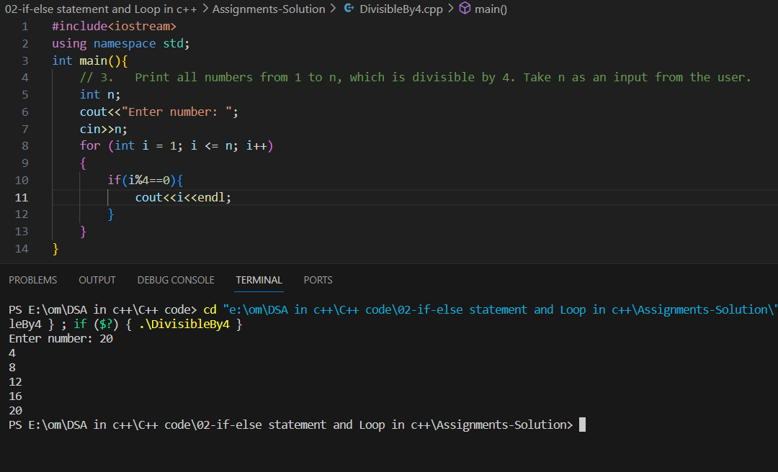

**Day 5/180: For Loop in advance**

1. Print number from 280 to 250 with the help of for loop.

**Solution:-**

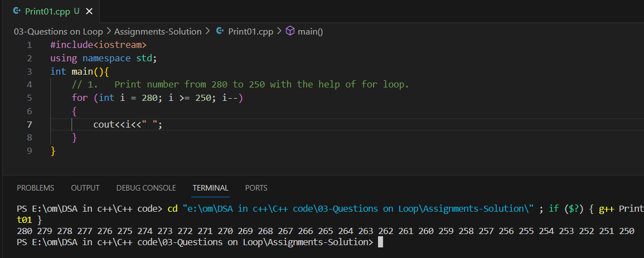

1. Print char from ‘A’ to ‘Z’ with the help of a for loop.

**Solution:-**

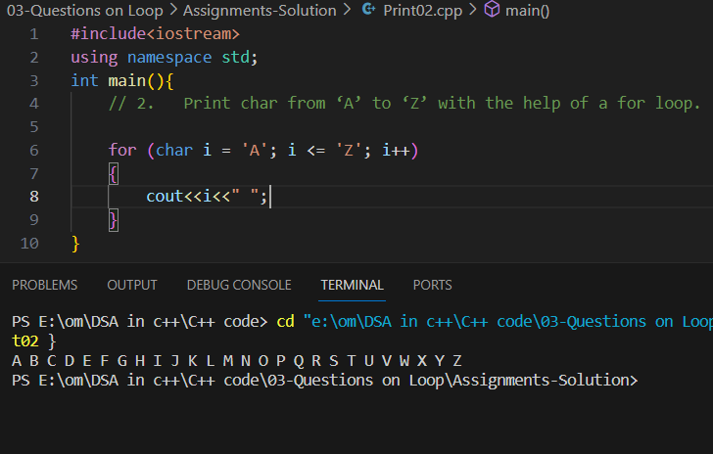

1. Print char from ‘Z’ to ‘A’ with the help of a for loop.

**Solution:-**

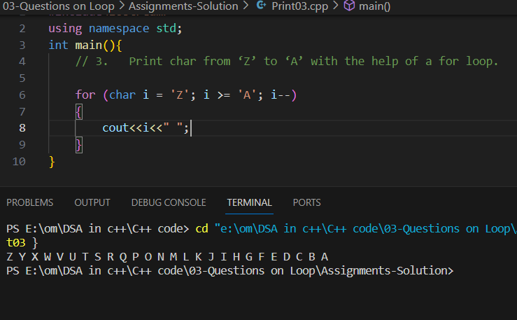

1. There is an Arithmetic Progression, First number is 220 and Common Difference is 7. So print all the numbers from 220 to 730 which follow the AP.

**Solution:-**

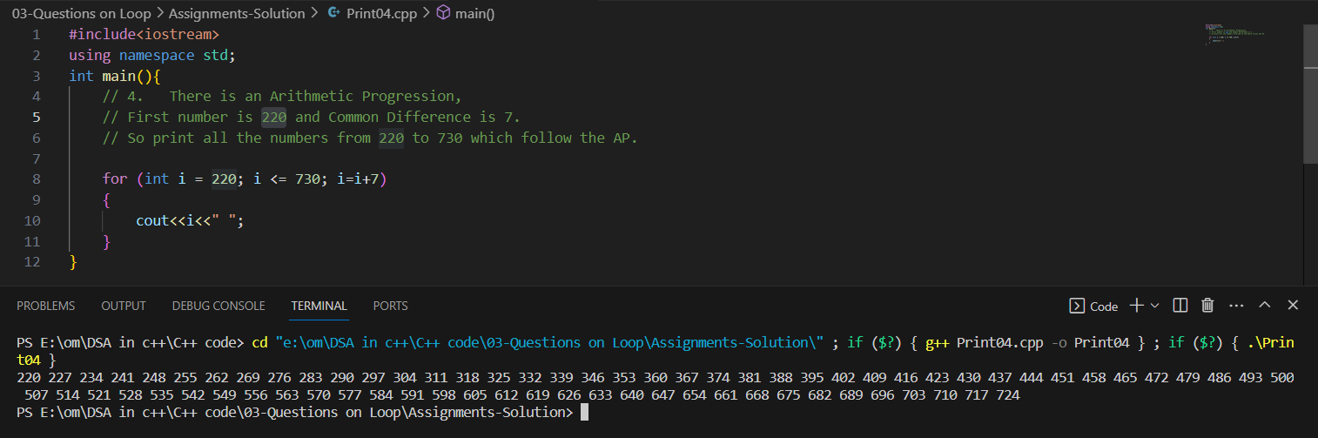

1. Print Sum of square of first n natural number.

**Solution:-**

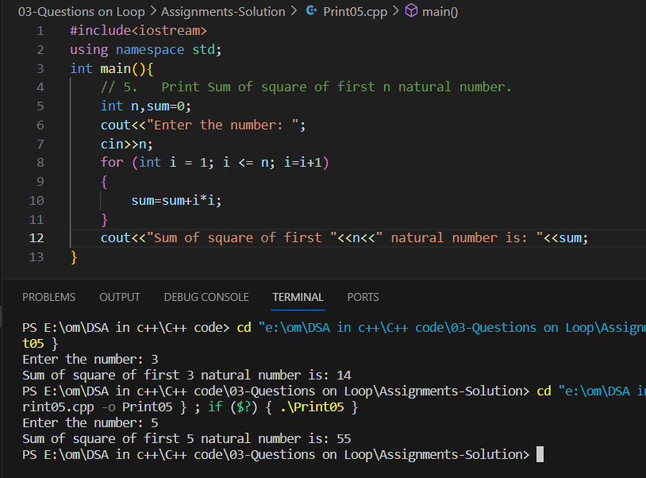

1. Print Sum of cube of first n natural number

**Solution:-**

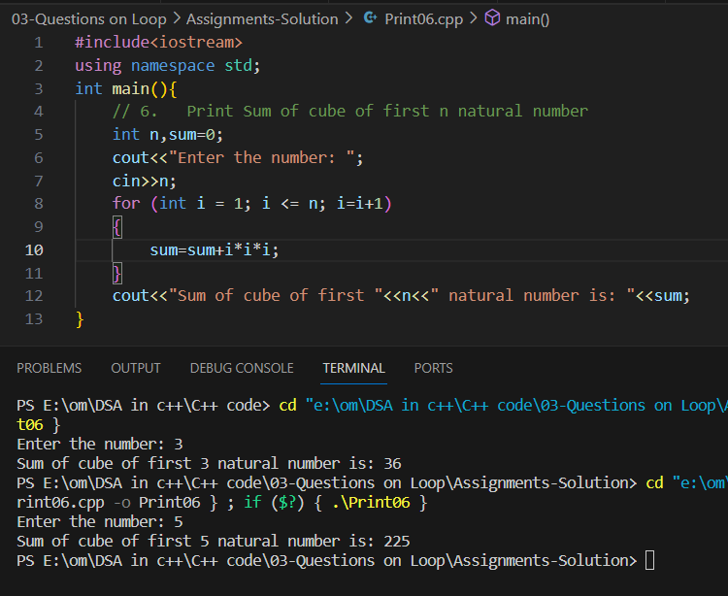

1. Print n’th Fibonacci number.

**Solution:-**

