**Batch: C4-1 Roll No.: 16010123217**

**Experiment / assignment / tutorial No. 1**

**Grade: AA / AB / BB / BC / CC / CD /DD**

**Signature of the Staff In-charge with date**

|  |
| --- |
| **TITLE:** Write a program for:  a. Program to find area and circumference of various Geometric shapes.  b. Program to calculate EMI (Equated Monthly Instalment) of loan amount if principal, rate of  interest and time in years is given by the user.  (E = (P.r.(1+r)n) / ((1+r)n – 1) |

**AIM:** Write a program for:

a. Program to find area and circumference of various Geometric shapes.

b. Program to calculate EMI (Equated Monthly Instalment) of loan amount if principal, rate of

interest and time in years is given by the user.

E = (P.r.(1+r)n) / ((1+r)n – 1)

**____________________________________________________________**

**Expected OUTCOME of Experiment:**

1. Find area and circumference of various Geometric shapes
2. To calculate EMI

**_____________________________________________________________________**

**Books/ Journals/ Websites referred:**

1. Programming in ANSI C, E. Balagurusamy, 7 th Edition, 2016, McGraw-Hill

Education, India.

1. Structured Programming Approach, Pradeep Dey and Manas Ghosh, 1 st

Edition, 2016, Oxford University Press, India.

1. Let Us C, Yashwant Kanetkar, 15th Edition, 2016, BPB Publications, India.

**_____________________________________________________________________**

**Problem Definition:**

**Problem 1:** Area and Circumference of any shape(will be given by instructor) (example Circle)

Ask the user to enter the value of the radius of a circle. Put the values in the formula for finding area of a circle and circumference of a circle and print the outcome for area of a circle and circumference of a circle

**Problem 2:** Calculating EMI Ask the user to enter the value of principal amount, rate of interest and time (in years).Store the value in E and print the final monthly instalment E as an outcome.

Formula to be used: (E = (P.r.(1+r)n) / ((1+r)n – 1)

**Flowchart: 1)**

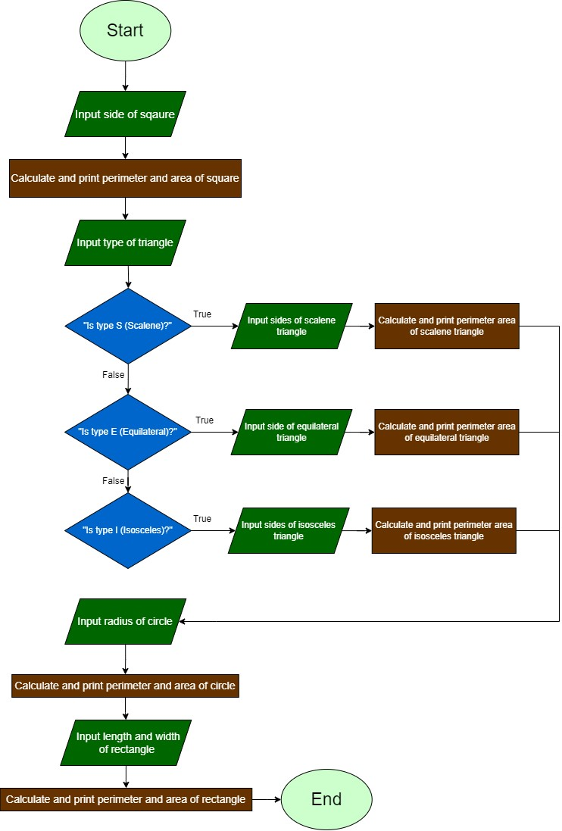

2)

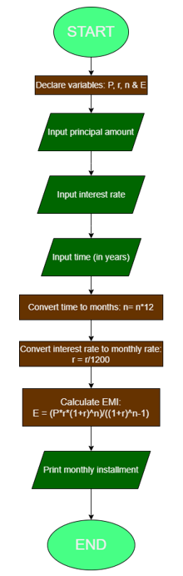

**Implementation details:**

1)

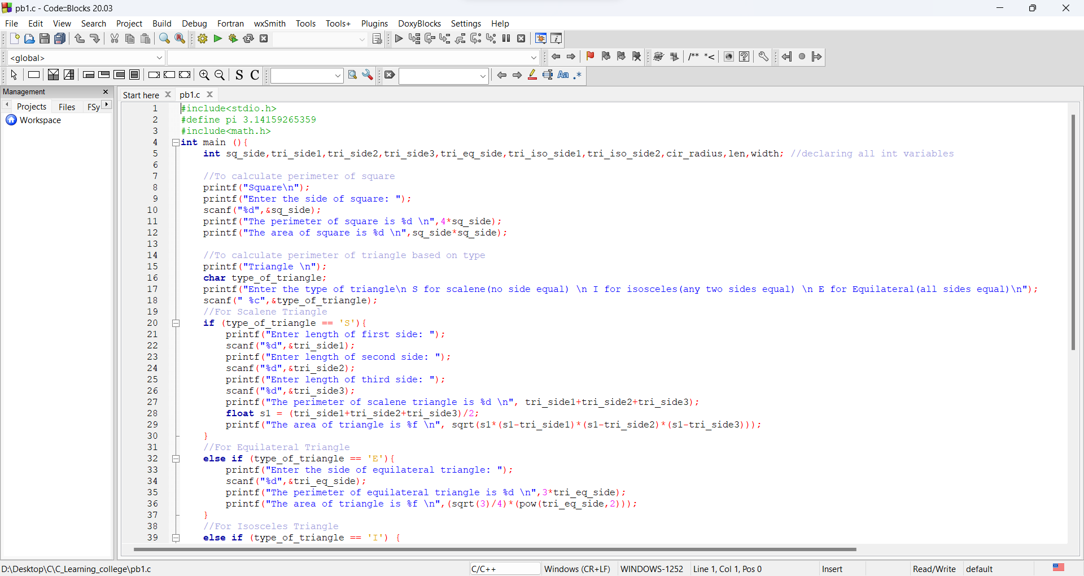

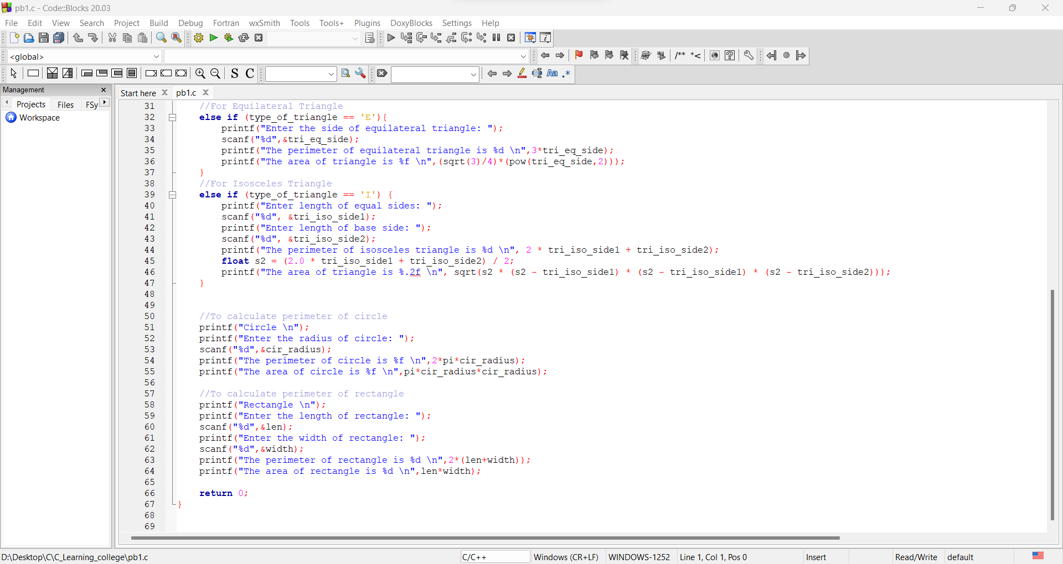

2)

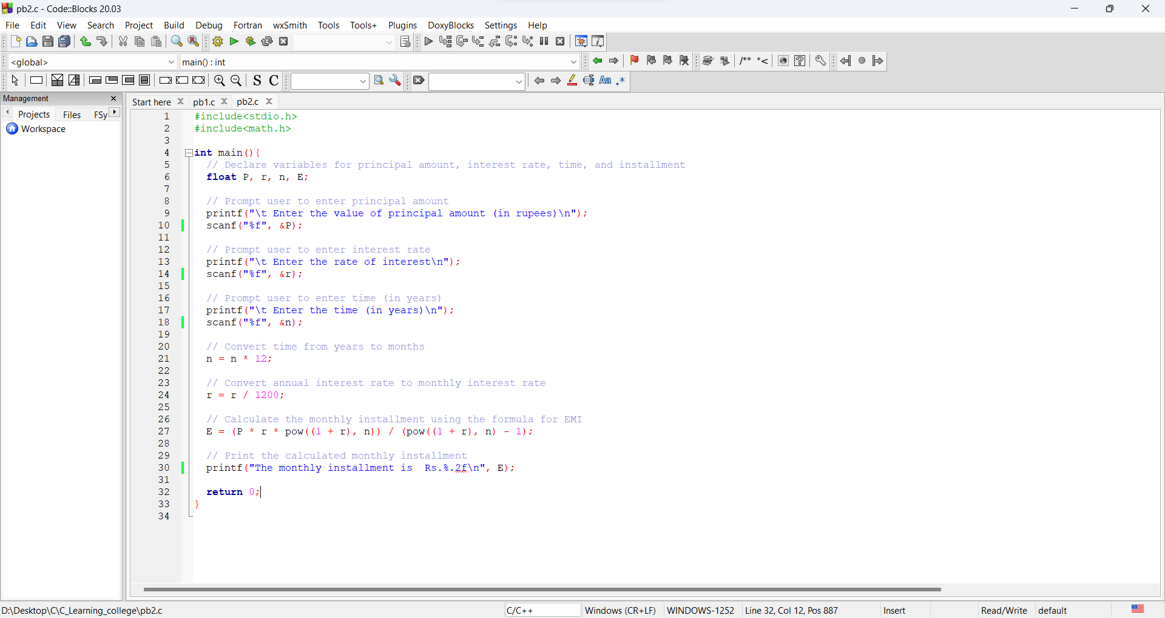

**Output(s):**

1)

Test 1 Test 2

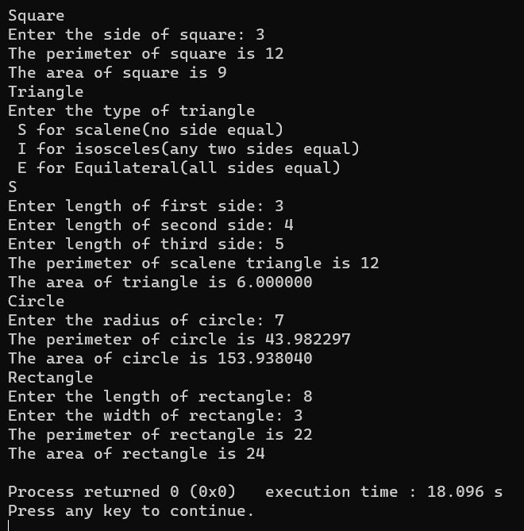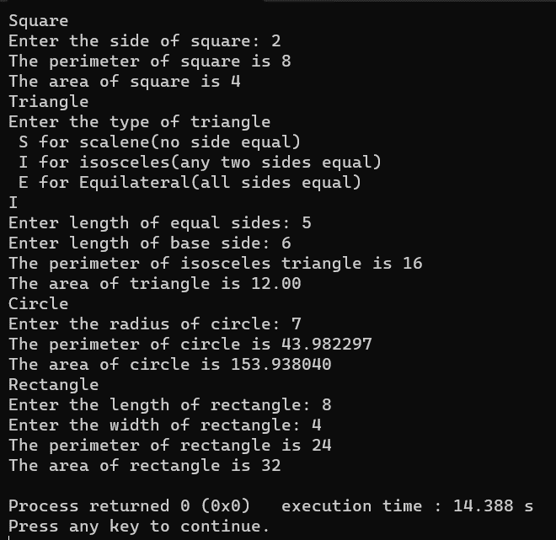

Test 3

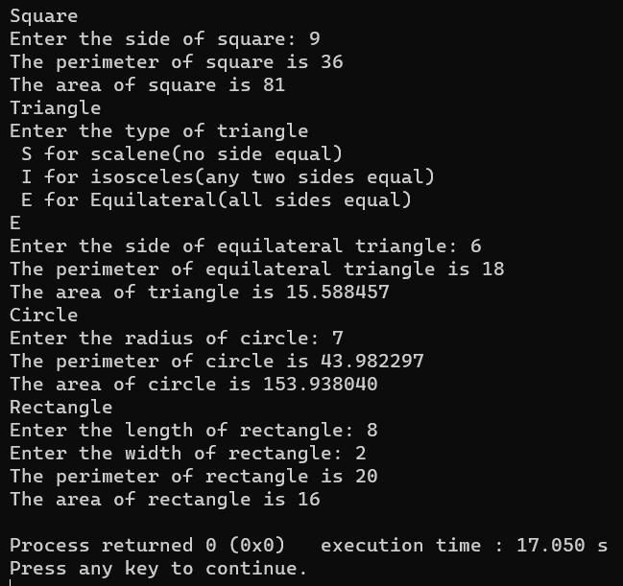

2)

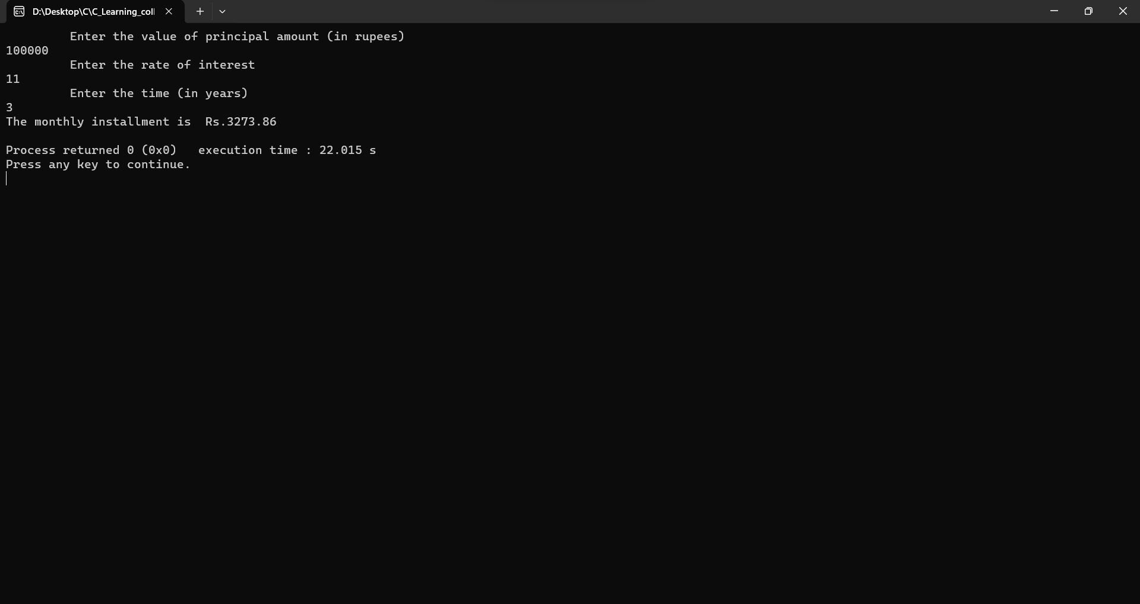

**Conclusion:**

This experiment successfully implemented C programming to calculate:

Area and circumference of various shapes: Demonstrating formula translation and real-world application.

Equated monthly installments for loans: Highlighting problem-solving and computational thinking skills.

**Post Lab Descriptive Questions**

1. **What are the basic data types in C?**

Ans. The basic data types in C are:

1. Integer Types:

char: Stores a single character (typically 1 byte).

int: Stores integers (typically 4 bytes).

short: Stores short integers (typically 2 bytes).

long: Stores long integers (typically 4 or 8 bytes).

signed: Can hold both positive and negative values (default for int, short, and long).

unsigned: Can only hold non-negative values (0 and positive numbers).

2. Floating-Point Types:

float: Single-precision floating-point numbers (typically 4 bytes).

double: Double-precision floating-point numbers (typically 8 bytes).

3. Void Type:

void: Represents the absence of type. It's often used to indicate that a function doesn't return a value.

4. Other Data Types:

_Bool: Stores Boolean values (true or false, typically 1 byte).

1. **Write a table for Operator Precedence and Associativity.**

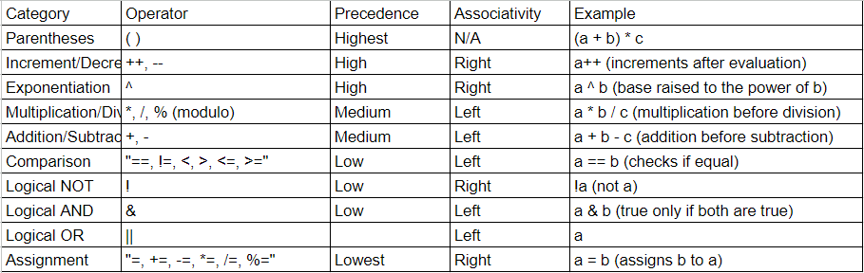

**Date: 9/1/24 Signature of faculty in-charge**