**Batch: C4-1 Roll No.: 16010123217**

**Experiment / assignment / tutorial No. 3**

**Grade: AA / AB / BB / BC / CC / CD /DD**

**Signature of the Staff In-charge with date**

|  |
| --- |
| **TITLE:**  Write a program in C to demonstrate use of looping control structures |

**AIM:** Write a menu driven program for following option

a.To find whether a number is palindrome or not. (e.g. 1221 is palindrome) using while loop

b. To calculate the sum of the Fibonacci series up to ‘n’ terms(use do-while loop only)

c. Write a program in C to make such a pattern like a right angle triangle with a number which will repeat a number in a row. [(Pattern is given below)](https://www.w3resource.com/c-programming-exercises/for-loop/index.php#editorr)

______**________________________________________________________________**

**Expected OUTCOME of Experiment:**

Apply basic concepts of C programming for problem solving.(CO1 and CO2).

**___________________________________________________________________**

**Books/ Journals/ Websites referred:**

1. Programming in C, second edition, Pradeep Dey and Manas Ghosh, Oxford University Press.
2. Programming in ANSI C, fifth edition, E Balagurusamy, Tata McGraw Hill.
3. Introduction to programming and problem solving , G. Michael Schneider ,Wiley India edition.

**_____________________________________________________________________**

**Problem Definition:**

The program accepts a choice from the user using a switch case statement and generates output accordingly.

**Choice a**: The program checks whether a given numbered by user is palindrome or not.If a number remains same, even if we reverse its digits then the number is known as palindrome number. For example, 12321 is a palindrome number because it remains same if we reverse its digits.

**Choice b:** Sum of Fibonacci series up to n terms will be generated. Fibonacci series is a series in which each number is the sum of the last two preceding numbers. The first two terms of a Fibonacci series are 0 and 1.(use while loop only)

**Example:**

Input: n = 5

Output: 7

Explanation: 0 + 1 + 1 + 2 + 3 = 7

Choice c: Write a program in C to make such a pattern like right angle triangle with a number which will repeat a number in a row.

The pattern like :

1

 22

 333

 4444

**Algorithm:**

1. Start

2. Display a menu with options:

a. Check Palindrome

b. Calculate Fibonacci Series and Sum

c. Print Right Angle Triangle Pattern

3. Prompt the user to enter their choice (a, b, or c).

4. Use a switch statement to handle the user's choice:

Case 'a' (Palindrome Check):

- Prompt the user to enter a number.

- Read the number.

- Reverse the number.

- Compare the original number with the reversed number.

- If they are equal, print "The number is a palindrome."

- Otherwise, print "The number is not a palindrome."

Case 'b' (Fibonacci Series and Sum):

- Prompt the user to enter the value of n (number of terms).

- Read the value of n.

- If n is invalid (less than or equal to 0), prompt again.

- Initialize variables for the Fibonacci series (a, b, c, sum, i).

- Print "The Fibonacci series is:"

- Use a do-while loop to generate and print the Fibonacci series up to n terms:

- Calculate the next term (c = a + b).

- Update variables for the next iteration (a = b, b = c).

- Add the current term to the sum.

- Print "The sum of the series is: " followed by the sum.

Case 'c' (Right Angle Triangle Pattern):

- Prompt the user to enter the number of rows for the pattern.

- Read the number of rows.

- Use nested for loops to print the pattern:

- The outer loop iterates through the rows.

- The inner loop iterates through the columns, printing the current row number.

Default (Invalid Choice):

- Print "Please enter a proper character."

- Go back to step 2 (display the menu again).

5. End

**Implementation details:**

**Code:**

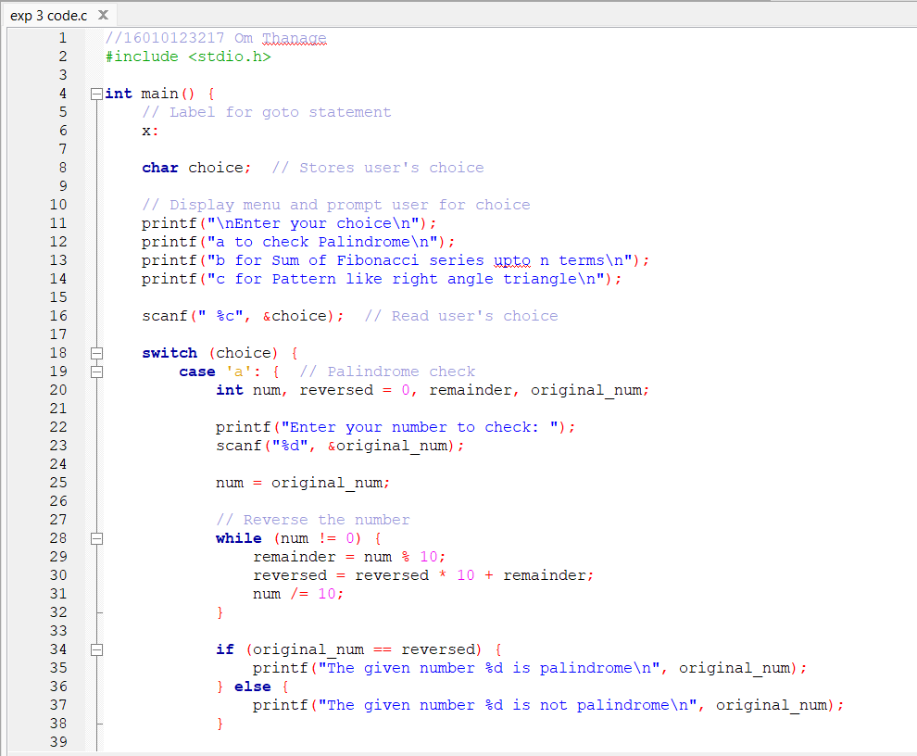

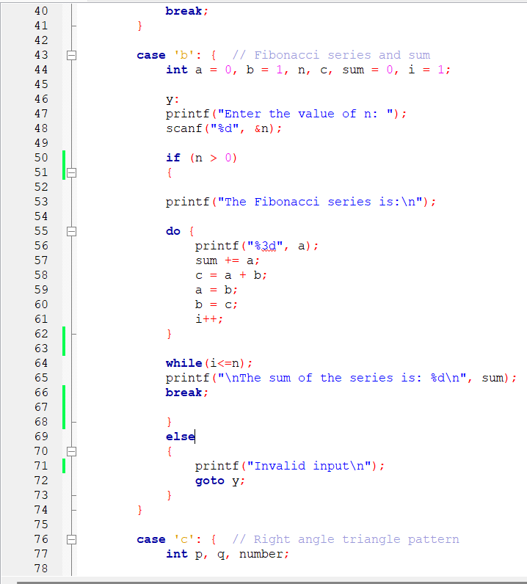

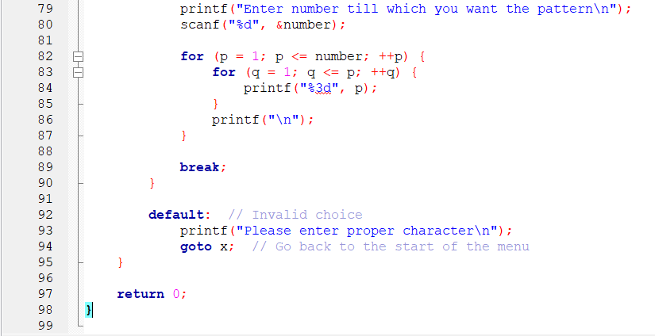

**Output(s):**

Test 1 : When user inputs choice a

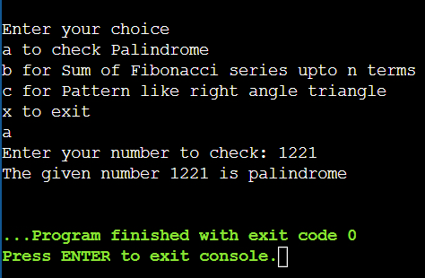

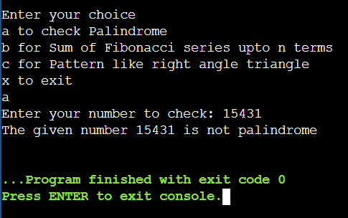

Test 2: When user inputs choice b

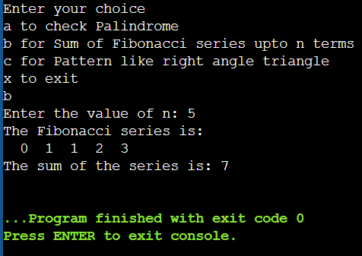

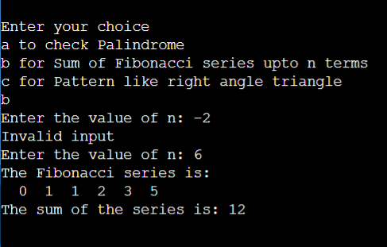

Test 3 : When user inputs choice c

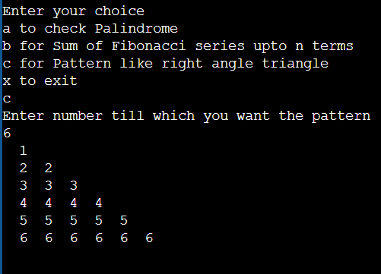

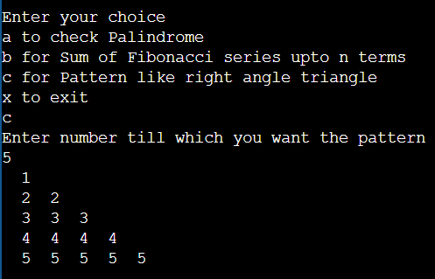

Test 4 : When user does not enter proper input

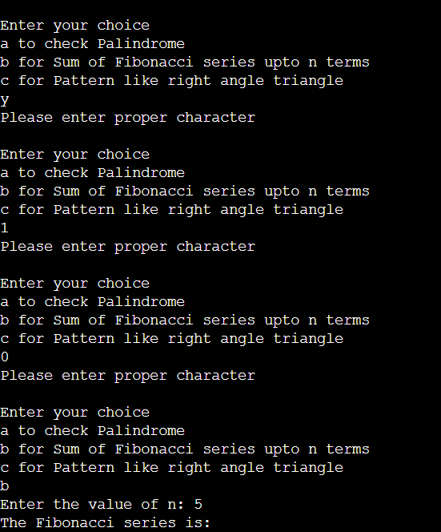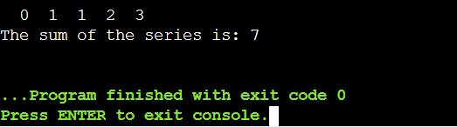

**Conclusion:** In this experiment, we learnt to use

While loop: Effectively used to reverse numbers and determine palindromes.

Do-while loop: To generate Fibonacci series and calculate their sum.

For loop: To create numerical patterns, showcasing control over iterations.

And using switch case statement to make a menu driven program.

**Post Lab Descriptive Questions**

* Write a program to enter numbers till the user wants. At the end it should display the count of positive, negative and zeros entered.

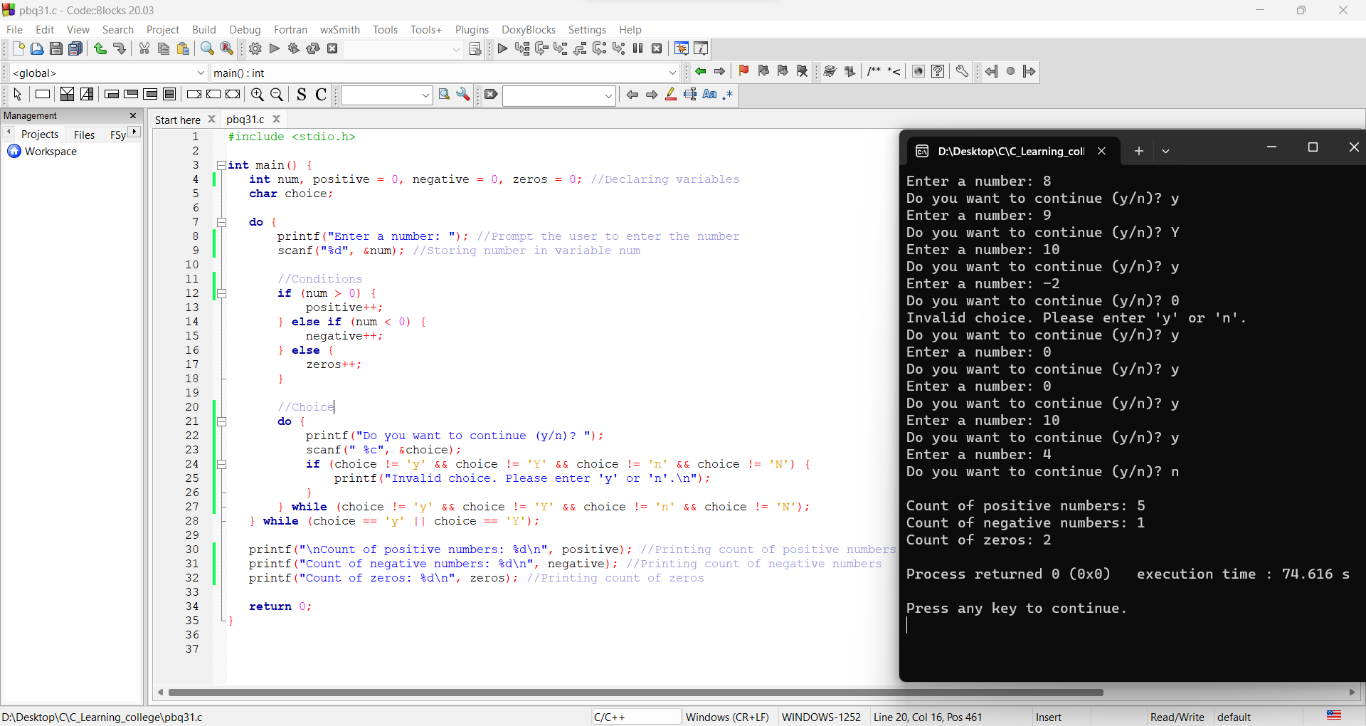

* Write a program to print all the ASCII values and their equivalent characters using a while loop. The ASCII values vary from 0 to 255.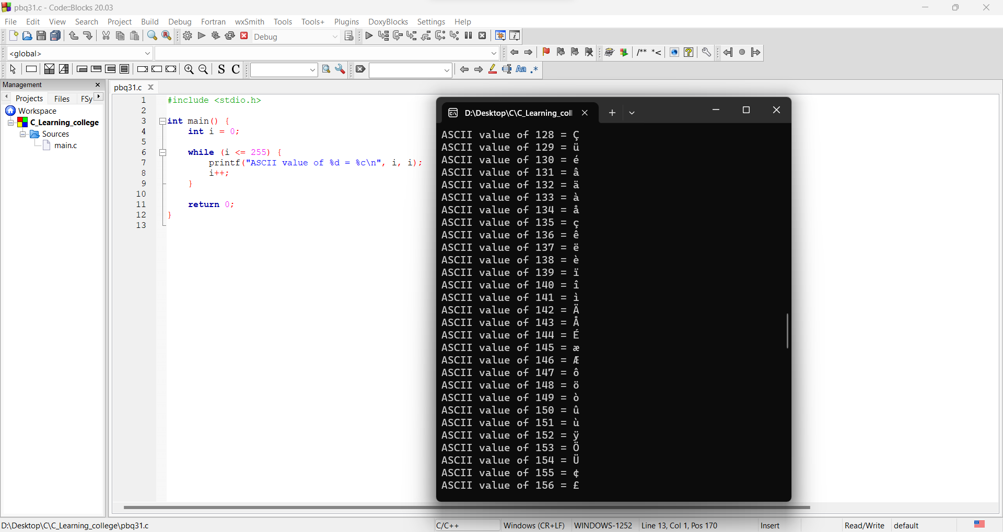

**Date: __30/01/24____ Signature of faculty in-charge**