Deep Learning Techniques for Crop Disease Detection and Classification
Group Name: CropPers
Names and Roll Numbers:
- Neelutpal Dutta (16010123211)
- Om Thanage (16010123217)
- Omkar Desai (16010123220)
- Rayan Kokate (16010123251)
Division: H2
Lab Batch: IDS6
Date of Submission: 21th April 2025
Faculty-in-Charge: Bhakti Palkar

Contents
Abstract 3
Introduction 4
Literature Review 5
Scope for Future Work 6
Conclusion 7
References 8
List of Figures 9
List of Tables 10

Abstract
Crop diseases and insect pests significantly threaten agricultural productivity, causing substantial yield and quality losses globally. Early and accurate detection is crucial for effective management, yet traditional methods relying on manual inspection are often time-consuming, subjective, and inefficient. Deep learning techniques have emerged as powerful tools, offering automated, rapid, and accurate identification of plant diseases and pests from images. This paper reviews recent advancements in applying deep learning, particularly Convolutional Neural Networks (CNNs) and transformer-based models like YOLO (You Only Look Once), for detecting and classifying crop diseases. We analyze four key studies focusing on different aspects: enhancing YOLO models for multi-scale pest detection (PestLite-YOLO), integrating deep learning with image processing for automated spray control based on disease severity, expanding detection beyond leaves using CNNs (AlexNet, MobileNet) on augmented datasets, and optimizing CNN structures (ResNet, InceptionV3, MobileNetV2) and training methods for improved accuracy. These studies demonstrate high accuracy levels (often exceeding 90%) and potential for real-world applications, such as targeted pesticide reduction and improved crop management. Future directions include enhancing image segmentation, incorporating hyper-spectral imaging, and expanding datasets to cover more plant parts and diseases.

Introduction
Agriculture forms the bedrock of global food systems, but its productivity is constantly challenged by plant diseases and pests. These biological stressors cause significant economic losses by reducing crop yield and quality. Therefore, the timely and accurate detection and identification of crop diseases are of paramount importance for ensuring food security, optimizing resource use, and promoting sustainable agricultural practices.
Traditionally, disease diagnosis in agriculture has heavily relied on manual inspection by farmers or agricultural experts. While valuable, these methods are inherently labor-intensive, time-consuming, and prone to subjectivity and human error. The sheer scale of modern agriculture makes comprehensive manual monitoring impractical. Furthermore, the visual symptoms of different diseases, or symptoms caused by nutrient deficiencies, can be similar, leading to misdiagnosis and inappropriate management strategies. Traditional image processing techniques have also been explored, but often require complex manual feature extraction and struggle with variations in illumination, background, and symptom presentation.
In recent years, the advent of deep learning, a subset of machine learning, has revolutionized computer vision tasks, including image-based disease detection. Deep learning models, particularly Convolutional Neural Networks (CNNs) and transformer-based architectures like YOLO, can automatically learn hierarchical features directly from image data, eliminating the need for manual feature engineering. These models have demonstrated remarkable success in identifying intricate patterns associated with various diseases across different crops. They offer the potential for automated, rapid, objective, and accurate disease detection systems that can operate in real-time or near-real-time. This capability enables early intervention, targeted treatment (like precise pesticide application), reduced resource wastage, and ultimately, improved crop yields and more sustainable farming. This paper explores recent deep learning techniques applied to crop disease and pest detection, reviewing specific methodologies, their performance, and future prospects in this rapidly evolving field.

Literature Review
Four important research studies examining the use of deep learning for crop disease and pest detection and classification are compiled in this section. Paper 4 is included per instruction because of its insights into model comparisons and optimization techniques, even though it was published before the 2023 cutoff.
Paper 1: Gao, J. (2024). Application of YOLO deep algorithm in detection of crop diseases and insect pests. 5th International Conference on Computer Information and Big Data Applications (CIBDA 2024).
- Objective: To develop and evaluate an improved YOLO-based model (PestLite-YOLO) for efficient and accurate detection of multiple, potentially high-density crop pests and diseases, addressing the limitations of traditional methods.

- Methodology: The PestLite-YOLO model was developed by the study by altering the YOLOv5 architecture. Modules like CARAFE (Content-Aware ReAssembly of FEatures for upsampling), Involution (for adaptive field-of-view adjustment), C3ECA (integrating Efficient Channel Attention with C3 modules), and MTSPPF (a modified SPPF module possibly related to multi-scale pyramid pooling) were among the major enhancements. This model improves detection, especially for complex, multi-scale, or microscopic pests, by extracting features across multiple scales using a multi-level pyramid structure. Given that transfer learning is based on YOLOv5, which frequently makes use of pre-trained weights, it may have been used implicitly. In addition to dynamic learning rate adjustment and data augmentation techniques (mosaic, flipping, panning, scaling), stochastic gradient descent (SGD) with momentum was employed for optimization.

- Results: Compared to the baseline YOLOv5, the PestLite-YOLO model showed notable improvements. Its greater accuracy, particularly for smaller targets, was demonstrated by its higher mAP50 (mean average precision at IoU threshold 0.50) of 90.8% as opposed to the baseline's 86.9%. While recall marginally improved (82.5% vs. 81.9%), precision stayed constant (91.1% vs. 91.2%). In order to balance accuracy and real-time capability, the model size was notably decreased (6.05M parameters vs. 7.04M) while keeping processing speed high (112.55 FPS vs. 108.46 FPS). Improved detection accuracy and better management of dense pest scenarios were confirmed by visual results.

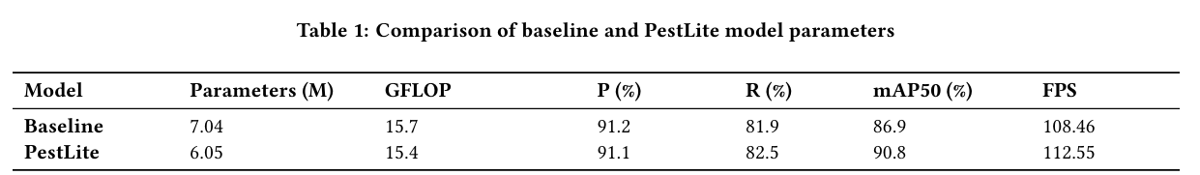
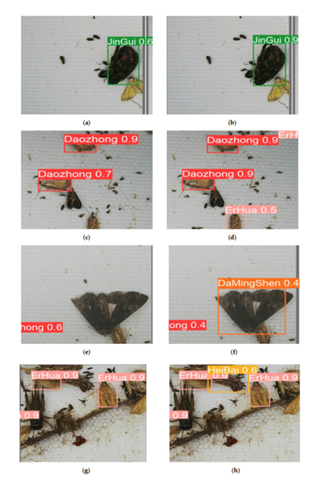
Figure 1 : Visual Pest Detection Results
- Tools/Datasets Used: The primary dataset was Mydataset, focusing on pests in corn and rice, supplemented by images from the "Teddy Cup Pest Dataset" and 600 additional images captured with a Sony Alpha a6400 camera. A total of 1500 images covering nine pest species were used for testing. The implementation utilized Ubuntu 20.04, Python 3.9, PyTorch 1.10.0, and CUDA 11.4 on hardware including an Intel Xeon Gold 6330 CPU and NVIDIA RTX 3090 GPU.
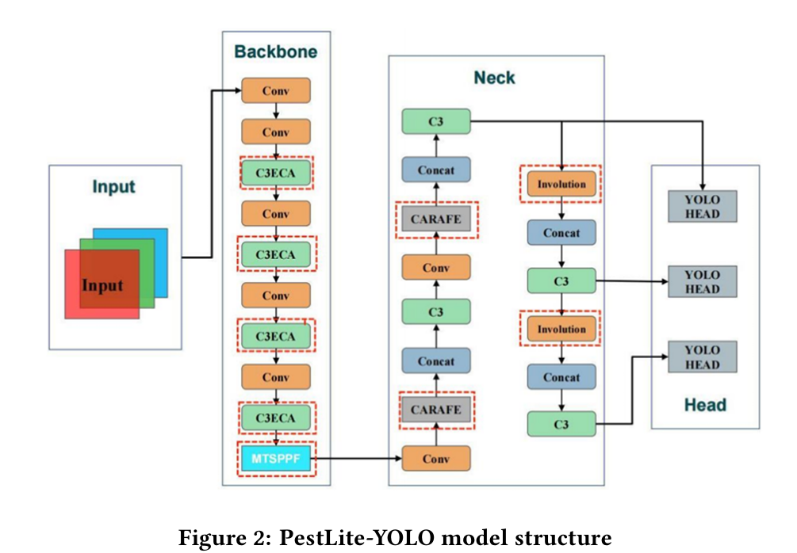

Paper 2: Azad, V., Kumar, S., & Yadav, R. N. (2023). Automated Spray Control using Deep Learning and Image Processing. The 29th Annual International Conference on Mobile Computing and Networking (ACM MobiCom '23).
- Objective: To develop and assess a comprehensive system that integrates deep learning and image processing for automated disease detection and severity assessment in tomato plants. This will allow for targeted spray control, which will lower pesticide and energy usage.

- Methodology: Using a modified Vision Transformer (ViT) model that incorporates ideas from DeiT (Data-efficient image Transformers), such as distillation tokens, the system first detects diseases. If a disease is identified, the damaged area is measured and the degree of severity is estimated using image processing techniques (such as color thresholding, contour extraction, and Canny edge detection for segmentation). The system uses an Arduino Uno and motor driver to control a spray pump based on the severity calculation. It modifies the amount of pesticide by varying the voltage and power supplied to the pump.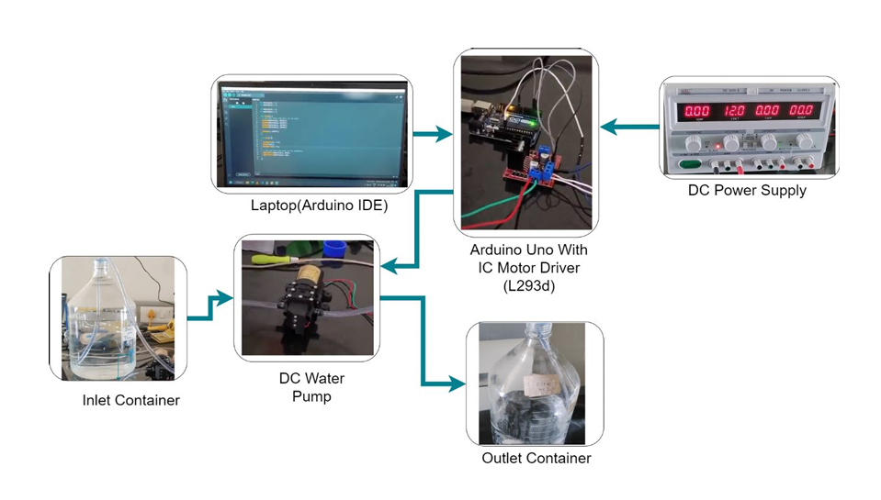
Figure 3: Experimental Setup for Spray System

- Results: The modified ViT model classified tomato diseases with a high degree of accuracy (99.31%). When compared to conventional constant spraying, the end-to-end system showed notable resource savings when tested on a specially constructed testbed. It resulted in a 29.58% reduction in energy use and a 20% decrease in the use of pesticides.

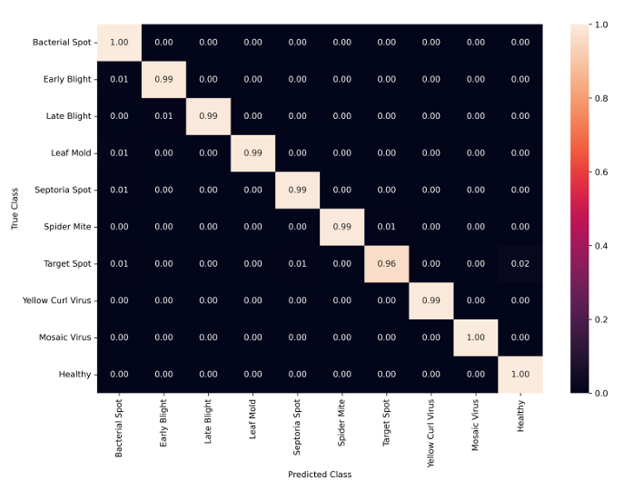
Figure 4: Confusion Matrix for Tomato Disease Detection
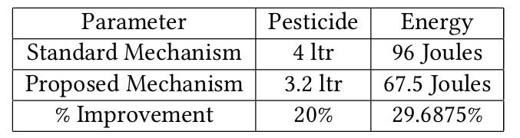
Table 2: Improvement in amount of pest and energy consumption using proposed method
- Tools/Datasets Used: The study utilized the Plant Village dataset, specifically the subset containing 18,162 images of tomato leaves (1 healthy class, 9 unhealthy classes) along with segmented binary mask images. The experimental setup included an Arduino Uno, L293d motor driver, DC water pump, DC power source, containers, and a laptop for control. Deep learning models were likely trained using standard frameworks like PyTorch or TensorFlow.

Paper 3: Konduru, S., Amiruzzaman, M., Avina, V., & Islam, M. R. (2023). Plant Disease Detection and Classification Using Deep Learning Models. Consortium for Computing Sciences in Colleges.
- Objective: utilizing a recently assembled and enhanced dataset to create and assess deep learning models (AlexNet, MobileNet) for identifying and categorizing plant diseases that impact not only leaves but also stems, fruits, roots, and other plant parts.

- Methodology: With a focus on apple, corn, and tomato crops (25 disease classes), a new dataset of more than 50,000 photos was produced by combining photos of diseases on leaves from the Plant Village dataset with photos of diseases on other plant parts (stems, fruits, and roots) that were scraped from Google and other sources. To address class imbalance, data balancing strategies were used, including undersampling and oversampling through data augmentation. Geometric (flipping, cropping, rotating, zooming, scaling) and color (brightness, contrast) transformations were used in data augmentation. This dataset was used to train two CNN architectures, AlexNet and MobileNet, for 100 epochs using pre-trained ImageNet weights (in the case of MobileNet, layers were not retrained). Accuracy, precision, recall, F1-score, and loss were used to assess performance.

- Results: With training accuracy of 99.69% and validation accuracy of 94.37% (95.99% accuracy reported at best validation loss), MobileNet performed better than AlexNet. Additionally, it outperformed AlexNet (0.89 for all metrics) in terms of average precision (0.96), recall (0.96), and F1-score (0.96). MobileNet was quicker because it had fewer parameters and performed better at predicting diseases that affect non-leaf parts. AlexNet obtained 91.58% validation accuracy (88.70% at best validation loss) and 99.19% training accuracy.

- Tools/Datasets Used: A custom dataset of 50,000+ images (40k training, 10k validation) derived from Plant Village and web scraping (Google, etc.) covering 25 classes across apple, corn, and tomato. Deep learning frameworks (likely TensorFlow/Keras or PyTorch) were used for implementing and training AlexNet and MobileNet models. Data augmentation libraries were also employed.

Paper 4: Long, Y., & Liu, C. (2019). Research on Deep Learning Method of Crop Disease Identification. AIIPCC '19.
- Objective: To address the shortcomings of conventional image processing by studying and enhancing the performance of deep learning algorithms (CNNs) for crop disease identification through model structure optimization and training label development.

- Methodology: Several well-known CNN architectures were used in the study, including VGG-16, ResNet-50, InceptionV3, and MobileNetV2. In order to initialize models with parameters pre-trained on ImageNet and modify the final layer for the particular crop disease classes, transfer learning was used. ResNet-50 was the focus of model structure optimization, which suggested two variations (ResNet-A and ResNet-B). To possibly lessen feature loss, ResNet-A adjusted stride values in the convolutional layers of the downsampling block. To increase non-linearity and decrease parameters, ResNet-B substituted three 3x3 convolutions for the original 7x7 convolution. In order to enhance generalization and avoid overconfidence, training label optimization used Label Smoothing rather than conventional one-hot encoding. Image resizing, normalization, and online data augmentation (random flips, rotations) were all examples of data preprocessing. Training was conducted using the Adam optimizer and a binary cross-entropy loss function with L2 regularization.

- Results: ResNet-50 had the best Top-5 accuracy (99.7%), while InceptionV3 had the highest Top-1 accuracy (89.4%) among the baseline models. ResNet-A and ResNet-B, two structural enhancements to ResNet-50, improved Top-1 accuracy by 1.4% and 1.7%, respectively, without appreciably changing the number of parameters. All tested models (VGG-16: +1.1%, ResNet-B: +1.4%, InceptionV3: +1.2%, MobileNetV2: +0.7%) saw an increase in Top-1 accuracy when Label Smoothing was applied. With a Top-1 accuracy of 91.2% and a Top-5 accuracy of 99.8% (or 99.9% as discussed later), the optimized ResNet-B model with Label Smoothing performed the best overall. With its lower parameters (3.4M) and respectable accuracy (87.7% Top-1 with label smoothing), MobileNetV2 provided a good balance.
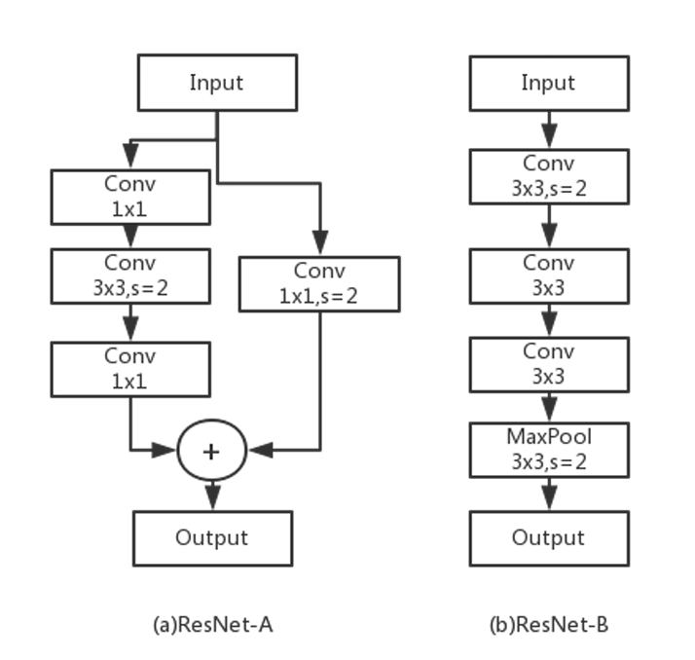
Figure 5 : Architecture of ResNet-50 and improvements
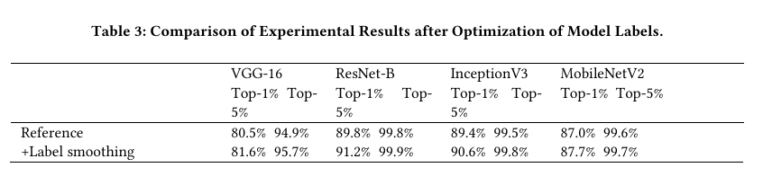
- Tools/Datasets Used: The AI Challenger dataset for crop diseases was used, containing initially 61 categories (10 species, 27 diseases, varying severity levels). After removing two categories, the final dataset comprised 40,772 images across 59 classes (10 crops, 26 diseases, with 23 classified by severity). The data was split into training (70%), validation (15%), and testing (15%) sets. The experimental environment used Python 3.6 and the PyTorch 0.4.1 deep learning framework on a Windows 10 machine with an AMD Ryzen 5 CPU, 16GB RAM, and an Nvidia GeForce GTX 1060Ti GPU.

Scope for Future Work
●Future Research Scope: Beyond Leaf Diseases Diseases can affect the stems, fruits, roots, or entire plant, although most studies concentrate on the symptoms of leaves. As started in Paper 3, future research should keep creating models and datasets that cover diseases affecting every part of plants for a more comprehensive diagnostic approach.
●Better Segmentation and Severity Estimation: Precise severity estimation still depends on accurately separating diseased regions from healthy tissue. In order to improve severity calculations and optimize treatments like spraying, Paper 2 identified improving image segmentation as a future goal, potentially through the use of deep learning-based techniques. Severity levels were already present in Paper 4's dataset, indicating the need for more study on models that specifically predict severity in addition to classification.
● Advanced Imaging Techniques: Combining traditional imaging with cutting-edge methods such as hyper-spectral imaging may yield more detailed information, possibly identifying subtle pre-visual symptoms or distinguishing between diseases or nutritional deficiencies that are visually similar. In order to improve the accuracy of severity estimation, Paper 2 proposes combining computer vision algorithms with hyper-spectral data.

● Dataset Diversity and Expansion: Big, varied, and well-annotated datasets are crucial to deep learning models' performance. Subsequent endeavors ought to concentrate on broadening current datasets, such as Plant Village, or developing new ones that encompass a greater variety of crops, diseases, geographical areas, and environmental circumstances (including uncontrolled, real-world field conditions). Data augmentation and dataset expansion could be accomplished with methods such as Generative Adversarial Networks (GANs), particularly CycleGAN as described in Paper 3, particularly for classes with limited real images.
● Real-time, On-Device Deployment: Although models such as PestLite-YOLO (Paper 1) and MobileNet (Paper 3) show good efficiency, more optimization is required for deployment on devices with limited resources, such as smartphones or drones, for in-field diagnosis and action in real-time. It is still important to conduct research on effective architectures, quantization, and model compression.

●Resolving Data Imbalance: In disease datasets, class imbalance is a frequent problem. Even though over/under-sampling and data augmentation are employed, investigating more sophisticated approaches to deal with imbalance during training could increase the robustness of the model even more, particularly for rare diseases.
● Time Cost of Data Collection: In Paper 4, the necessity of taking into account the time cost of data collection for deep learning model training is briefly mentioned, indicating that this is a topic that should be investigated further. Practical deployment requires effective pipelines for data acquisition and annotation.

conclusion
The reviewed literature identifies a number of directions for further study and advancement while also highlighting notable advancements in the use of deep learning for crop disease detection:
- Beyond Diseases of the Leaf: Diseases can affect the stems, fruits, roots, or entire plant, although most studies concentrate on the symptoms of leaves. As started in Paper 3, future research should keep creating models and datasets that cover diseases affecting every part of plants for a more comprehensive diagnostic approach into models that explicitly predict severity alongside classification.

- Better Segmentation and Severity Estimation: Precise severity estimation still depends on accurately separating diseased regions from healthy tissue. In order to improve severity calculations and optimize treatments like spraying, Paper 2 identified improving image segmentation as a future goal, potentially through the use of deep learning-based techniques. Severity levels were already included in Paper 4's dataset, indicating the need for more study.

- Advanced Imaging Techniques: Combining traditional imaging with cutting-edge methods such as hyper-spectral imaging may yield more detailed information, possibly identifying subtle pre-visual symptoms or distinguishing between diseases or nutritional deficiencies that are visually similar. In order to improve the accuracy of severity estimation, Paper 2 proposes combining computer vision algorithms with hyper-spectral data.

- Dataset Diversity and Expansion: Big, varied, and well-annotated datasets are crucial to the effectiveness of deep learning models. Subsequent endeavors ought to concentrate on broadening current datasets, such as Plant Village, or developing new ones that encompass a greater variety of crops, diseases, geographical areas, and environmental circumstances (including uncontrolled, real-world field conditions). Data augmentation and dataset expansion could be accomplished with methods such as Generative Adversarial Networks (GANs), particularly CycleGAN as described in Paper 3, particularly for classes with limited real images.

- For real-time, on-device diagnosis and action, more optimization is required for deployment on resource-constrained devices like smartphones or drones, even though models like PestLite-YOLO (Paper 1) and MobileNet (Paper 3) show good efficiency. It is still important to conduct research on effective architectures, quantization, and model compression.

- Resolving Data Imbalance: In disease datasets, class imbalance is a frequent problem. Even though over/under-sampling and data augmentation are employed, investigating more sophisticated approaches to deal with imbalance during training could increase the robustness of the model even more, particularly for rare diseases.

- Time Cost of Data Collection: In a brief statement, Paper 4 suggests that future research should focus on the time cost of data collection for deep learning model training. Practical deployment requires effective pipelines for data acquisition and annotation.

References
[1] Gao, J. (2024). Application of YOLO deep algorithm in detection of crop diseases and insect pests. 5th International Conference on Computer Information and Big Data Applications (CIBDA 2024), Wuhan, China. ACM.
[2] Azad, V., Kumar, S., & Yadav, R. N. (2023). Automated Spray Control using Deep Learning and Image Processing. The 29th Annual International Conference on Mobile Computing and Networking (ACM MobiCom '23), Madrid, Spain. ACM.
[3] Konduru, S., Amiruzzaman, M., Avina, V., & Islam, M. R. (2023). Plant Disease Detection and Classification Using Deep Learning Models. Consortium for Computing Sciences in Colleges.
[4] Long, Y., & Liu, C. (2019). Research on Deep Learning Method of Crop Disease Identification. Proceedings of the 2019 International Conference on Artificial Intelligence and Information Processing Technology (AIIPCC '19), Sanya, China. ACM.

List of Figures
Figure 1: Visual Pest Detection Results…………………………………6
Figure 2: PestLite-YOLO Model Structure………………………………7
Figure 3: Experimental Setup for Spray System…………………………8
Figure 4: Confusion Matrix for Tomato Disease Detection……………...9
Figure 5: Architecture of ResNet-50 and improvements……………….12

List of Tables
Table 1 : Comparison of baseline and PestLite Model Parameters …………………6
Table 2: Improvement in amount of pest and energy consumption using proposed method………………………………………………………………………………9
Table 3: Comparison of Experimental Results after Optimization of Model Labels. …..12

