Batch: C3 Roll No.:16010123217

Experiment No. 6

Title: Data Cleaning, Transformation and Feature Engineering Techniques

Aim : Handle missing values, detect outliers, perform one-hot encoding, label encoding, feature scaling (min-max and z-score normalization), and generate polynomial features.

Course Outcome:
CO3 : Learn data cleaning, transformation, and feature engineering techniques.

Books/ Journals/ Websites referred:
- The Comprehensive R Archive Network
- Posit

Resources used:
(Students should write the datasets used)
______________________________________________________________________

Theory:

Implementation:
- Handling Missing Values
In this example we will use the open repository of plants classification Iris.
- Data Loading
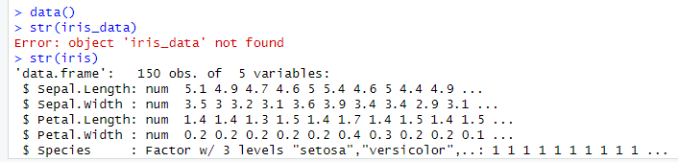
- Introducing missing values in the dataset
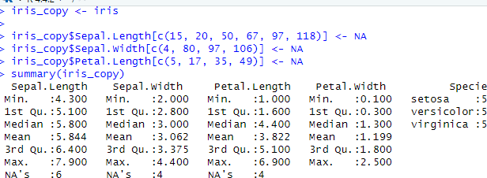

- Find NA’s in dataset
# The first thing we can do is to ask if there is any missing value in our table
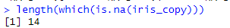
# We can check that we introduced 14 missing values in the table

# There are several ways to identify rows containing NA's.
# First we will use the complete.cases function (check ?complete.cases for information)
# This function returns only rows without NA's. Putting ! in front of it we get only rows with NA's
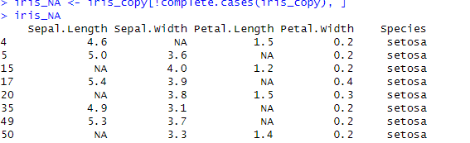
# We see that we have 13 rows with missing values on it
# Another way is to search for TRUE values in the is.na function
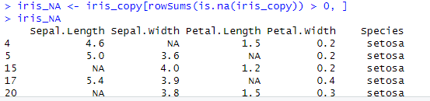
# We obtain the same result.

- Removing rows containing NA’s
# Depending on the case, there are different things we can do with NA's. However there is not a unique and general solution to this issue. If the missing value can be calculated direclty using other columns the problem is solved.
# The first choice can be to just remove the rows containing NA's
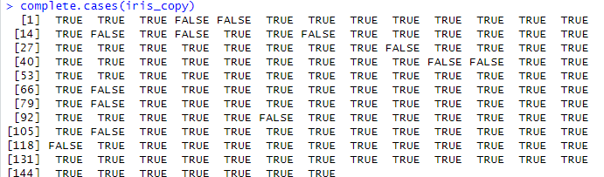
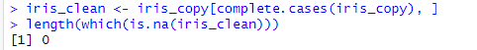
# The number of missing values in this table is 0

- Substituting NA’s with numerical values
# In other cases we don't want to lose the information that we have in one row with missing values
# In this case we will substitute the missing value with a numerical value
# The first thing we can do is to introduce the mean of a column in a missing value
# However it's more safe to use the median because it's not affected by outliers
# However we should be careful as in this case it's more correct to introduce the mean for the proper species
# We should do it column by column
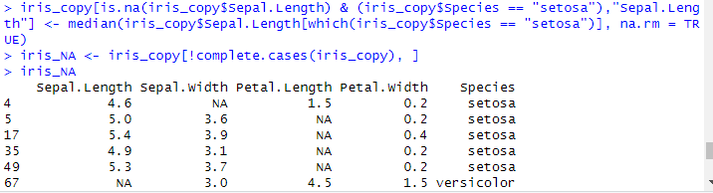
# Now we have removed 3 NA's. Only 11 left
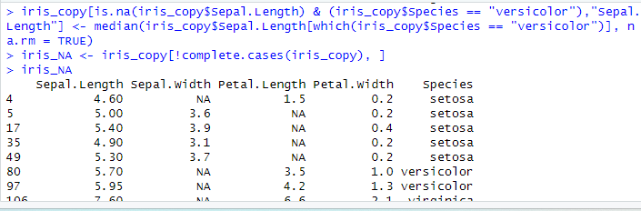
# Now we have removed 1 NA's. Only 8 left
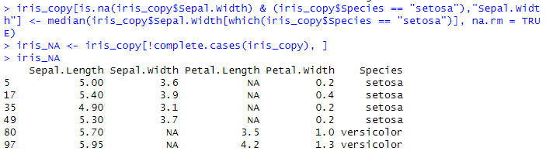
# Now we have removed 1 NA's. Only 7 left
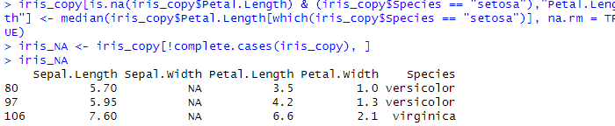

# Now it's your time to finish the logic and remove all the remaining NA's of the table

# We have saved a lot of interesting data. However we must be careful because each case is different and we can affect the result if we introduce the wrong number in the NA position

- Detecting Outliers

Boxplot Method
Boxplots are useful for identifying outliers. In a boxplot, data points that lie beyond 1.5 times the interquartile range (IQR) are considered outliers.

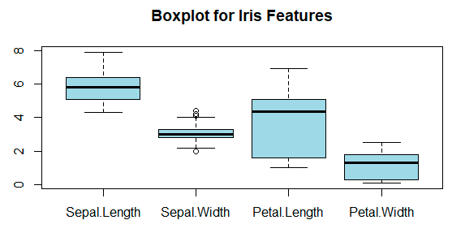

- If any points are plotted outside the whiskers, they are considered outliers.
To find specific outliers:
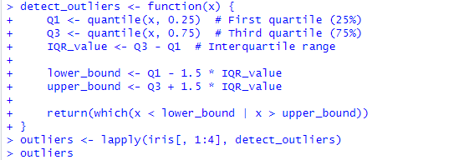
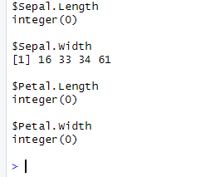

4. Visualization Using Scatterplots
Scatterplots can help visualize potential outliers.
r
CopyEdit
# Scatter plot matrix
pairs(iris[, 1:4], col = ifelse(rownames(iris) %in% unlist(outliers), "red", "black"),
main = "Scatterplot Matrix with Outliers (Red)")

5. Outlier Detection Using outliers Package
You can also use the outliers package:
r
CopyEdit
install.packages("outliers")
library(outliers)

# Identify the most extreme value in Sepal.Length
outlier_value <- scores(iris$Sepal.Length, type = "z")
outliers_sepal <- which(abs(outlier_value) > 3)
outliers_sepal

- Perform One-Hot Encoding
One-hot encoding is used to convert categorical variables into numerical format for machine learning models. In the Iris dataset, the Species column is categorical and can be converted into numerical dummy variables.
Use model.matrix() for One-Hot Encoding
The model.matrix() function in R can be used to perform one-hot encoding:
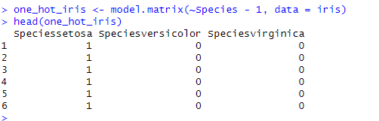
~Species - 1: The -1 removes the intercept term to ensure we get separate columns for each category.
This will create three new columns: Speciessetosa, Speciesversicolor, and Speciesvirginica, each containing 0 or 1.

3. Combine One-Hot Encoding with Original Data
To create a new dataframe with encoded values:

r
Copy
Edit
# Convert to dataframe
one_hot_iris <- as.data.frame(one_hot_iris)

# Combine with original numerical features
iris_encoded <- cbind(iris[, 1:4], one_hot_iris)

# View the updated dataset
head(iris_encoded)
4. Using caret Package for One-Hot Encoding
Alternatively, you can use the caret package:

r
Copy
Edit
install.packages("caret") # Install caret package if not installed
library(caret)

# Apply one-hot encoding
dummy_vars <- dummyVars(~ Species, data = iris)
iris_transformed <- predict(dummy_vars, newdata = iris)

# Convert to dataframe
iris_encoded <- cbind(iris[, 1:4], as.data.frame(iris_transformed))

# View result
head(iris_encoded)

- Feature scaling (min-max and z-score normalization)

Min-Max Scaling
Min-Max Scaling transforms the data to a fixed range, typically [0,1]. The formula is: 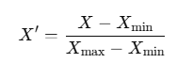
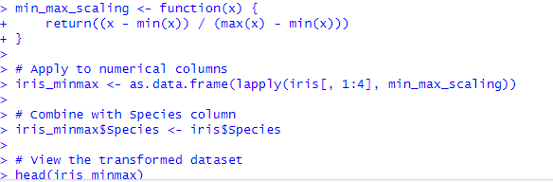

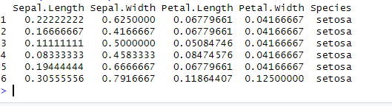

Z-Score Normalization (Standardization)
Z-Score Normalization transforms data to have mean = 0 and standard deviation = 1 using the formula:

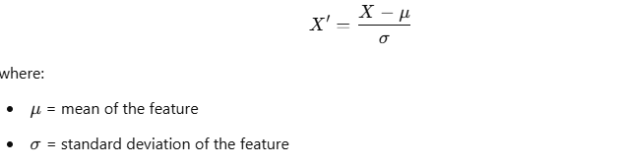
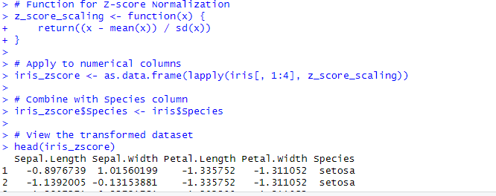

4. Using caret Package for Feature Scaling
You can also use the caret package:
r
CopyEdit
install.packages("caret") # Install caret package if not installed
library(caret)

# Min-Max Scaling
preprocess_minmax <- preProcess(iris[, 1:4], method = "range")
iris_minmax_caret <- predict(preprocess_minmax, iris[, 1:4])

# Z-Score Normalization
preprocess_zscore <- preProcess(iris[, 1:4], method = "center", "scale")
iris_zscore_caret <- predict(preprocess_zscore, iris[, 1:4])

# Add Species column back
iris_minmax_caret$Species <- iris$Species
iris_zscore_caret$Species <- iris$Species

# View results
head(iris_minmax_caret)
head(iris_zscore_caret)

- Generate polynomial features.

Using poly() Function
The poly() function generates orthogonal polynomials of a given degree.
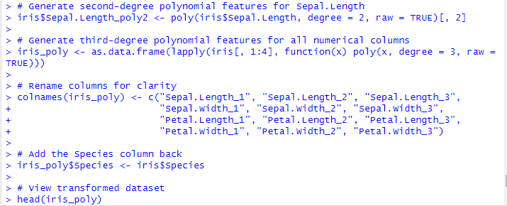
• poly(x, degree = 3, raw = TRUE): Creates polynomial features up to degree 3.
• raw = TRUE: Ensures regular polynomial terms (without orthogonal transformation).
• lapply(): Applies the function to all numeric columns.

Using caret Package
The caret package allows automatic polynomial feature generation.
r
CopyEdit
install.packages("caret") # Install if not installed
library(caret)

# Generate polynomial features up to degree 3
poly_features <- preProcess(iris[, 1:4], method = "poly", degree = 3, raw = TRUE)

# Apply transformation
iris_poly_caret <- predict(poly_features, iris[, 1:4])

# Add Species column back
iris_poly_caret$Species <- iris$Species

# View results
head(iris_poly_caret)

4. Using polyreg Package
The polyreg package provides another way to generate polynomial features.
r
CopyEdit
install.packages("polyreg") # Install package
library(polyreg)

# Generate polynomial features up to degree 3
iris_polyreg <- poly_fit(iris[, 1:4], degree = 3)

# View transformed dataset
head(iris_polyreg)

Students have to explore the datasets within R libraries, Kaggle, UCI or any other freely available data repositories.

Red Colour part (commands) student should try

Code:
> data(women)
> print(women)
height weight
1 58 115
2 59 117
3 60 120
4 61 123
5 62 126
6 63 129
7 64 132
8 65 135
9 66 139
10 67 142
11 68 146
12 69 150
13 70 154
14 71 159
15 72 164
>
> women_with_na <- women
> set.seed(123) # For reproducibility
> women_with_na[sample(1:nrow(women_with_na), 5), "height"] <- NA
> women_with_na[sample(1:nrow(women_with_na), 3), "weight"] <- NA
> print(women_with_na)
height weight
1 58 115
2 NA 117
3 NA 120
4 61 123
5 62 NA
6 63 NA
7 64 132
8 65 135
9 66 139
10 NA 142
11 68 NA
12 69 150
13 70 154
14 NA 159
15 NA 164
> length(which(is.na(women_with_na)))
[1] 8
> missing_rows <- !complete.cases(women_with_na)
> women_with_na[missing_rows, ]
height weight
2 NA 117
3 NA 120
5 62 NA
6 63 NA
10 NA 142
11 68 NA
14 NA 159
15 NA 164
> complete.cases(women_with_na)
[1] TRUE FALSE FALSE TRUE FALSE FALSE TRUE TRUE TRUE FALSE FALSE TRUE TRUE FALSE FALSE
> women_clean <- women_with_na[complete.cases(women_with_na), ]
> print(women_clean)
height weight
1 58 115
4 61 123
7 64 132
8 65 135
9 66 139
12 69 150
13 70 154
> length(which(is.na(women_clean)))
[1] 0
> women_new <- women_with_na
>
> women_new$height[is.na(women_new$height)] <- median(women_new$height, na.rm = TRUE)
>
> women_new$weight[is.na(women_new$weight)] <- mean(women_new$weight, na.rm = TRUE)
>
> length(which(is.na(women_new)))
[1] 0
> print(women_new)
height weight
1 58.0 115.0
2 64.5 117.0
3 64.5 120.0
4 61.0 123.0
5 62.0 137.5
6 63.0 137.5
7 64.0 132.0
8 65.0 135.0
9 66.0 139.0
10 64.5 142.0
11 68.0 137.5
12 69.0 150.0
13 70.0 154.0
14 64.5 159.0
15 64.5 164.0
> boxplot(women$height, main="Boxplot of Height", ylab="Height (in)")
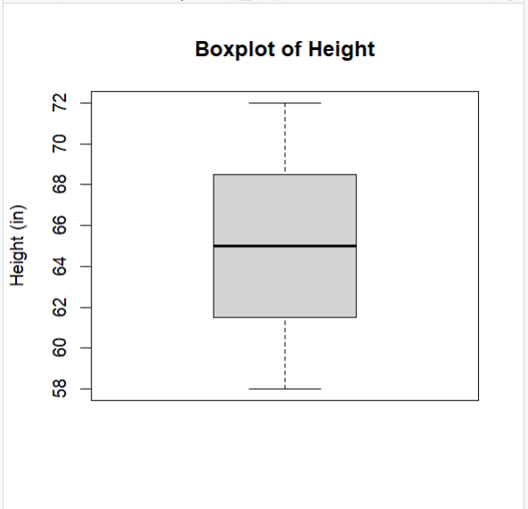
> boxplot(women$weight, main="Boxplot of Weight", ylab="Weight (lbs)")
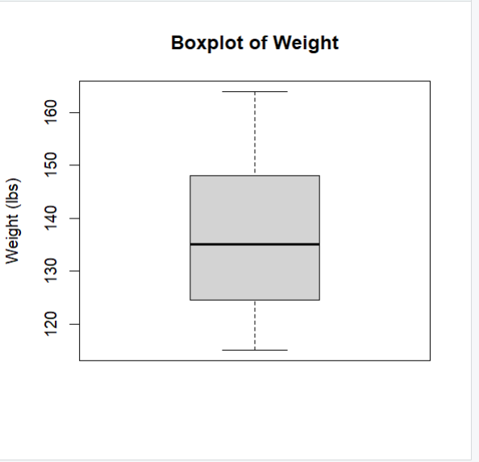
> Q1_h <- quantile(women$height, 0.25)
> Q3_h <- quantile(women$height, 0.75)
> IQR_h <- Q3_h - Q1_h
> min_h <- Q1_h - 1.5 * IQR_h
> max_h <- Q3_h + 1.5 * IQR_h
>
> h_outliers <- which(women$height < min_h | women$height > max_h)
> Q1_w <- quantile(women$weight, 0.25)
> Q3_w <- quantile(women$weight, 0.75)
> IQR_w <- Q3_w - Q1_w
> min_w <- Q1_w - 1.5 * IQR_w
> max_w <- Q3_w + 1.5 * IQR_w
>
> w_outliers <- which(women$weight < min_w | women$weight > max_w)
> plot(women$height, women$weight,
+ main = "Scatter Plot of Height vs Weight",
+ xlab = "Height (in)",
+ ylab = "Weight (lbs)",
+ col = ifelse(1:nrow(women) %in% c(h_outliers, w_outliers), "red", "black"),
+ pch = 16)
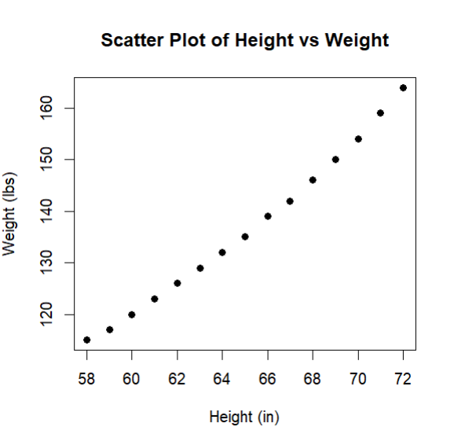
> women_cat <- women
> women_cat$height_category <- cut(women$height,
+ breaks = c(0, 62, 66, 72),
+ labels = c("short", "medium", "tall"))
> women_cat$weight_category <- cut(women$weight,
+ breaks = c(0, 125, 140, 164),
+ labels = c("thin", "medium", "fat"))
> one_hot_women <- model.matrix(~height_category + weight_category -1, data = women_cat)
> one_hot_women
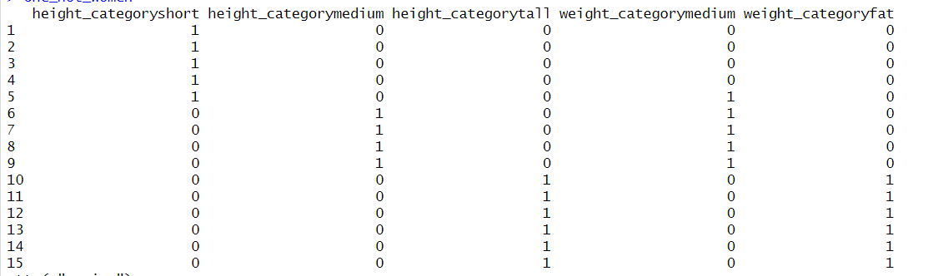
attr(,"assign")
[1] 1 1 1 2 2
attr(,"contrasts")
attr(,"contrasts")$height_category
[1] "contr.treatment"

attr(,"contrasts")$weight_category
[1] "contr.treatment"

> library(caret)
Loading required package: ggplot2
Loading required package: lattice
Warning message:
package ‘caret’ was built under R version 4.4.3
>
> dummy_vars <- dummyVars(~ height_category + weight_category, data = women_cat)
> women_transformed <- predict(dummy_vars, newdata = women_cat)
>
> women_encoded <- cbind(women_cat[, c("height", "weight")], as.data.frame(women_transformed))
>
> print(women_encoded)
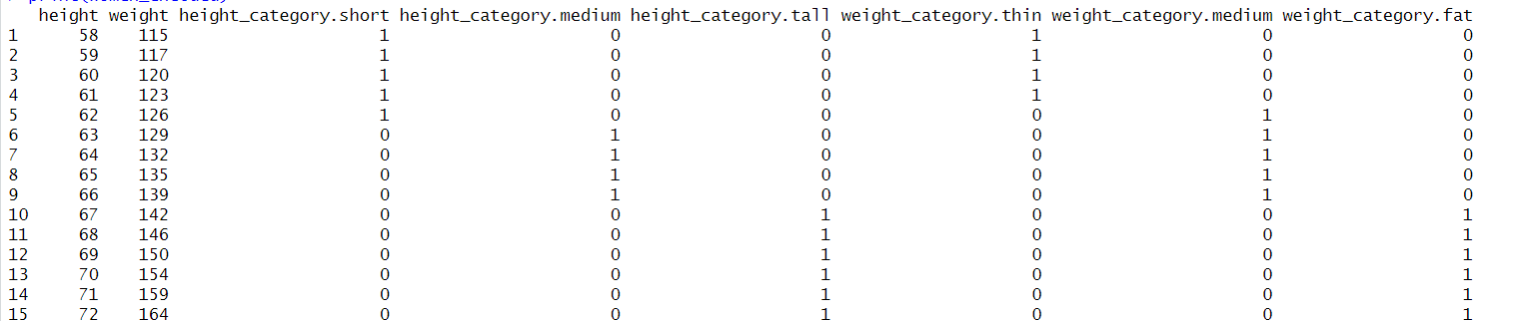
> min_max_scale <- function(x) {
+ (x - min(x)) / (max(x) - min(x))
+ }
> women_minmax <- women
> women_minmax$height <- min_max_scale(women$height)
> women_minmax$weight <- min_max_scale(women$weight)
> print(women_minmax)
height weight
1 0.00000000 0.00000000
2 0.07142857 0.04081633
3 0.14285714 0.10204082
4 0.21428571 0.16326531
5 0.28571429 0.22448980
6 0.35714286 0.28571429
7 0.42857143 0.34693878
8 0.50000000 0.40816327
9 0.57142857 0.48979592
10 0.64285714 0.55102041
11 0.71428571 0.63265306
12 0.78571429 0.71428571
13 0.85714286 0.79591837
14 0.92857143 0.89795918
15 1.00000000 1.00000000

Conclusion:
I handled missing values using different strategies such as removal and imputation, detected outliers using statistical methods like the IQR rule and Z-score, and performed one-hot encoding and label encoding to convert categorical data into numerical form. Additionally, I implemented feature scaling using Min-Max normalization and Z-score standardization to standardize data, making it suitable for machine learning models.

Post Lab Question
`1) Discuss an alternative approach to capturing non-linear relationships in a dataset instead of polynomial feature generation.
An alternative approach is using kernel methods such as the Radial Basis Function (RBF) kernel in Support Vector Machines (SVM) or Gaussian Processes. Neural networks, especially deep learning models, can also capture complex non-linear relationships without manually generating polynomial features.

2) What is the difference between univariate and multivariate outlier detection?
Ans.
Univariate outlier detection analyzes a single variable, identifying extreme values using methods like Z-score, IQR, and box plots. For example, detecting unusually high or low heights in a student dataset is a univariate approach. In contrast, multivariate outlier detection considers relationships between multiple variables to identify anomalies. Techniques like Mahalanobis Distance, PCA, and machine learning models detect outliers that may not be extreme in individual variables but are unusual when analyzed together. For instance, a student with an average height but extremely low weight could be a multivariate outlier. While univariate methods are simpler, multivariate techniques offer deeper insights, making them essential for high-dimensional data analysis.

