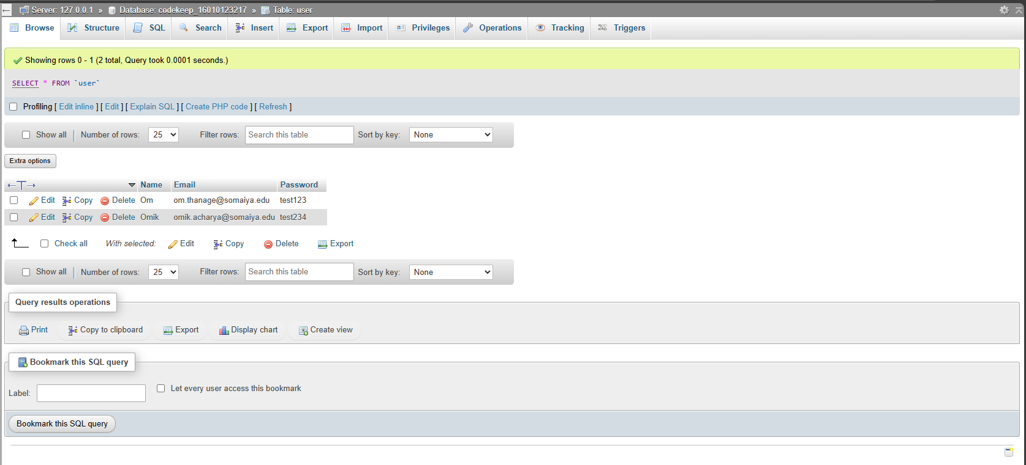

JS implemented
<!DOCTYPE html>
<html lang="en">
<head>
<meta charset="UTF-8">
<meta name="viewport" content="width=device-width, initial-scale=1.0">
<title>Document</title>
</head>
<body>
<h1>Name: Om Thanage</h1>
<h1>Roll No: 16010123217</h1>

<div style="display: flex; gap: 4rem; align-items: center; justify-content: space-between; width: 50vw;">
<h1>A)</h1>
<h1>Display Date</h1>
<p id="date"></p>
<button style="padding: 12px;" onclick="displayDate()">Get Date</button>
</div>

<div style="display: flex; gap: 4rem; align-items: center; justify-content: space-between; width: 50vw;">
<h1>B)</h1>
<h1>Factorial</h1>
<button style="padding: 12px;" onclick="getFactorial()">Get Factorial</button>
</div>

<div style="display: flex; gap: 4rem; align-items: center; justify-content: space-between; width: 50vw;">
<h1>C)</h1>
<h1>Multiplication Table</h1>
<button style="padding: 12px;" onclick="getTable()">Get Table</button>
</div>
<div style="width: 50vw; margin-top: 2rem;" id="table"></div>

</div>

<script>
function displayDate() {
let date = new Date();
document.getElementById("date").innerHTML = date;
}

function getFactorial() {
let num = prompt("Enter a number: ");
let factorial = 1;
for (let i = 1; i <= num; i++) {
factorial *= i;
}
alert(`Factorial of ${num} is ${factorial}`);
}

function getTable() {
let num = prompt("Enter a number: ");
let table = "";
for (let i = 1; i <= 10; i++) {
table += `${num} x ${i} = ${num * i}<br>`;
}
document.getElementById("table").innerHTML = table;
}
</script>
</body>
</html>

Output:
