ACKNOWLEDGEMENT

We consider it a privilege to express our sincere gratitude and respect to all those who have guided and inspired us for this project. We express our heartfelt thanks to our guide Prof. Sumangala N Bhavikatti, Department of Electronics and Communication, SDM College of Engineering and Technology, Dharwad, for the valuable guidance and suggestions.

We are humbly thankful to Dr. Shreedhar.A.Joshi, HOD, Department of Electronics and Communication, SDM College of Engineering and Technology, Dharwad, for providing us with all the facilities that were required in completion of the project work.

We would like to express our immense gratitude to Dr. Ramesh .L. Chakrasali, Principal , SDM College of Engineering and Technology, Dharwad, for providing us with all the necessary infrastructure.

Mr. GURUPRASAD S YADAV-2SD22EC023
Mr. MANOJ HALAPETI-2SD22EC037
Mr. MEENAPPA TARANALLI-2SD22EC038
Mr. OM V HIREMATH -2SD22EC047

CONTENTS

Sl no. | Name | Page no.
1. | Abstract | 3
2. | Problem Statement | 4
3. | Principles of balance | 6
4. | Applications | 8
5. | Benefits | 10
6. | Block Diagram | 11
7. | Circuit Diagram | 12
8. | Testing and Calibration | 14
9. | Conclusion | 19
10. | Reference | 20

1.ABSTRACT

The development of a self-balancing robot has garnered significant attention due to its wide applications in robotics, automation, and real-time control systems. This paper presents a self-balancing robot using the ESP32 microcontroller, which provides efficient computational capabilities and real-time wireless communication. The robot utilizes sensors, such as an accelerometer and gyroscope (e.g., MPU6050), to measure the tilt angle and angular velocity in real-time. The ESP32 processes this sensor data and controls the motor drivers to maintain balance using a feedback control loop, specifically a Proportional-Integral-Derivative (PID) controller. The real-time balancing algorithm constantly adjusts the robot's posture, ensuring stability by making rapid adjustments to the motors based on the input sensor data. The ESP32 enables the integration of wireless communication features such as Bluetooth or Wi-Fi, allowing for remote control or monitoring. The robot's hardware design includes a compact chassis, motors, wheels, and a battery system to provide mobility and energy efficiency. Experimental results demonstrate that the self-balancing robot can remain upright and responsive under various conditions, with the ESP32 proving to be a cost-effective and reliable platform for real-time control applications in robotics. The presented system serves as a foundation for further research in autonomous and adaptive robot design.

INTRODUCTION

A self-balancing robot is a two-wheeled robotic system that uses control algorithms and sensors to maintain its balance. These robots demonstrate principles of robotics, control systems, and dynamic stability, making them an engaging and educational project for engineers and enthusiasts alike.

In this project, the ESP32 microcontroller serves as the central processing unit, providing a powerful and efficient platform for real-time control. The ESP32's dual-core processor, built-in Wi-Fi, and Bluetooth capabilities make it ideal for integrating sensors, actuators, and wireless communication in robotics applications.

The core functionality of the self-balancing robot relies on a combination of sensors and algorithms. The inertial measurement unit (IMU) is used to measure tilt and angular velocity, which are processed using a control algorithm, such as a Proportional-Integral-Derivative (PID) controller. The ESP32 processes this data to calculate necessary motor adjustments, ensuring the robot maintains balance.

This project not only highlights the practical application of microcontroller programming but also provides insights into concepts like feedback control, sensor integration, and system optimization. Whether for educational purposes or as a stepping stone to advanced robotics projects, a self-balancing robot using ESP32 is an excellent demonstration of modern robotics engineering.
2.PROBLEM STATEMENT:
The goal of this project is to design and build a self-balancing robot that uses the ESP32 microcontroller for real-time processing and control. The robot will maintain its upright balance autonomously using feedback from sensors and will be able to adjust its position and orientation to remain balanced in both static and dynamic conditions.

2.1 OBJECTIVES:
Design and Develop a Stable Balancing Mechanism:
- Develop a mechanical platform with two wheels and a robust structure to support the components (motors, ESP32, sensors, etc.).
- Ensure that the robot can maintain its balance and adjust its position autonomously in real-time.

Integrate Sensor System for Orientation Detection:
- Select and integrate suitable sensors such as the MPU6050 (accelerometer and gyroscope) to accurately detect the robot’s orientation, tilt angle, and angular velocity.
- Ensure real-time data collection and filtering from the sensors to avoid noise and errors.

Implement Control Algorithm:
- Develop a control algorithm (such as PID control) to interpret the sensor data and generate appropriate commands to the motors for maintaining balance.
- Tune the algorithm for optimal performance, considering both stability and responsiveness.

Motor Control and Actuation:
- Implement motor drivers (e.g., L298N) to control the DC motors based on the feedback from the ESP32.
- Ensure smooth motor operation and precise control to adjust the robot’s position as required by the control algorithm.

Real-Time Processing Using ESP32:
- Utilize the processing power of the ESP32 to handle sensor data input, perform control algorithm computations, and control the motors in real-time.
- Optimize the ESP32’s code for low latency and efficient performance, ensuring the robot reacts quickly to changes in its orientation.

Power Management and Efficiency:
- Design the robot to be power-efficient, using a rechargeable battery to provide a reasonable runtime for the balancing task.
- Incorporate power management techniques to extend the battery life while maintaining performance.
Prototype Testing and Performance Evaluation:
- Conduct thorough testing to evaluate the robot’s ability to maintain balance in various scenarios (static, dynamic, and external disturbances).
- Evaluate the performance of the PID controller and refine it for optimal stability and response.

Documentation and Reporting:
- Document the design, development process, and results of the project.
- Prepare a report that includes the technical specifications, challenges faced, solutions implemented, and recommendations for future improvements

3. PRINIPLES OF BALANCE

1. Sensor Feedback (Tilt and Rotation)
- Accelerometer: Measures the gravitational force to determine the robot's tilt angle relative to the ground. The accelerometer senses the linear acceleration and gravity, which is used to calculate the robot's inclination.
- Gyroscope: Measures the rate of change in angular velocity. It helps track the robot's rotation and complements the accelerometer by providing dynamic information that corrects for short-term errors in tilt detection.

2. PID (Proportional-Integral-Derivative) Control
- Proportional: The control signal is proportional to the error (the difference between the desired tilt angle and the current tilt angle). The larger the error, the stronger the corrective action.
- Integral: Accounts for accumulated past errors. This helps the system eliminate steady-state error and ensures the robot eventually stabilizes at the correct tilt.
- Derivative: Predicts future errors by calculating the rate of change of the tilt angle. This allows the system to anticipate and respond to changes in tilt more smoothly.
- The combination of these terms allows the robot to adjust its motors and stabilize in real-time by continuously adjusting to small changes in tilt and rotation.
3. Motor Control
- The motors (usually DC motors or brushless motors) control the robot's movement based on the PID output. The robot tilts forward or backward to adjust its center of gravity (CoG) to maintain balance.
- The motor drivers interpret the PID output and adjust the speed and direction of the motors to change the robot's tilt angle and speed of movement.
- The microcontroller, such as a 32-bit STM32, processes these commands rapidly to ensure smooth balancing.

4. Center of Gravity (CoG) Adjustment
- The robot's balance depends on its center of gravity. The robot must constantly adjust its CoG by moving forward, backward, or sideways, using its wheels.
- A well-designed control system ensures the CoG stays over the base (the wheels) to prevent tipping over.

5. Real-Time Processing
- A 32-bit microcontroller like STM32 provides ample processing power to handle the sensor data (accelerometer and gyroscope) in real-time.
- The data from the sensors is processed to compute the robot's tilt angle and angular velocity, and corrective actions are sent to the motor driver instantly.

6. Feedback Loop and Stability
- The entire system works in a closed-loop feedback control system, meaning that the robot continuously adjusts its behavior based on real-time sensor feedback.
- The stability of the robot is determined by the speed and accuracy of the feedback loop. The quicker the system can process data and correct errors, the more stable the robot will be.

4.AREAS OF APPLICATION
1.Robotics and Automation:
- Personal Assistants: Self-balancing robots can be used as personal assistants for tasks like delivery within homes or offices, where the robot autonomously navigates and maintains balance while transporting items.
- Surveillance Robots: These robots can be used in surveillance applications, where their mobility and stability allow them to navigate through environments, providing real-time video feeds for security purposes.
2.Educational Purpose:
- STEM Education: The self-balancing robot can be used in educational settings to teach students about robotics, control systems, and sensor integration. It offers practical exposure to real-time feedback systems, control algorithms (e.g., PID), and robotics design.
- Engineering Projects and Research: Students and researchers can use self-balancing robots for exploring topics in robotics, embedded systems, sensor fusion, and real-time control systems.
3.Industrial Automation:
- Material Handling: Self-balancing robots can be used for transporting materials within warehouses or factories. The robots could maintain balance while moving loads through tight spaces, making them ideal for automated logistics systems.
- Inspection and Maintenance: These robots can be deployed in environments where precise movement is required, such as in factory equipment inspection or maintenance in hard-to-reach locations.
4.Human-Robot Interaction (HRI):
- Assistive Robots: A self-balancing robot can be used as a base for assistive robots that support elderly or disabled individuals. The robot can carry objects, guide people, or provide mobility support.
- Companion Robots: Self-balancing robots could be used in companionship roles, interacting with humans in various settings, such as homes, hospitals, or rehabilitation centers.

5.Entertainment and Consumer Robotics:
- Robot Toys and Gadgets: Self-balancing robots can be developed as entertainment devices, such as robot toys that balance on two wheels and perform various tricks or dances, providing fun for users of all ages.
- Interactive Displays: These robots can be used in exhibitions, trade shows, or marketing campaigns to attract attention with their balancing capabilities and provide interactive experiences to audiences.
6.Transport and Mobility Systems:
- Personal Transport Devices: Self-balancing robots can serve as personal transportation devices, similar to electric scooters or Segways, where users can ride on a two-wheeled, self-balancing platform for easy and efficient transportation over short distances.
- Autonomous Delivery Systems: These robots can be adapted for use in last-mile delivery systems, where the robot autonomously delivers packages to consumers by maintaining balance while navigating urban environments.
7.Search and Rescue Operations:
- Rescue Robots: In disaster-stricken areas or emergency situations, self-balancing robots can be deployed to navigate difficult terrains and assist in search and rescue operations. Their stability and small size make them ideal for navigating through debris or confined spaces.
8.Autonomous Vehicles and Robotics:
- Testing Autonomous Algorithms: A self-balancing robot serves as a low-cost platform for testing and refining autonomous navigation and control algorithms before applying them to larger vehicles or drones.
- Robotics Prototyping: It can act as a testbed for developing and experimenting with new robotics technologies, including AI-driven navigation and real-time decision-making processes.
9.Health and Fitness Applications:
- Physical Therapy and Rehabilitation: Self-balancing robots could be used in physical therapy applications, where patients practice maintaining balance or performing exercises with the robot’s assistance.
- Balance Training Devices: They can be employed in fitness and wellness centers as devices that help individuals improve their balance and coordination.
10.Transportation and Smart Cities:
- Mobility Solutions in Smart Cities: Self-balancing robots could play a role in smart city ecosystems, serving as autonomous transport vehicles or kiosks that interact with pedestrians and provide services such as information, wayfinding, or even food delivery.

5.BENEFITS:
- Autonomous Balance: The primary benefit of a self-balancing robot is its ability to autonomously maintain balance on two wheels, which allows it to operate in dynamic environments with minimal risk of tipping over.

- High-Precision Control: The combination of real-time sensor feedback (accelerometer, gyroscope) and control algorithms (e.g., PID) ensures precise adjustments, providing smooth and stable operation even during sudden movements or external disturbances
- Energy Efficiency: By using two wheels, the robot has a simpler mechanical design that can be more energy-efficient, extending its operational time compared to more complex systems

- Low-Cost Platform for Testing: Using the ESP32 as the core processor makes it affordable for educational purposes and prototype testing. The ESP32 offers great performance at a lower cost, which is ideal for researchers, hobbyists, and engineers looking to explore robotics and control systems.

- Upgradable Software: The ESP32 allows for continuous software upgrades and improvements. New algorithms or sensors can be integrated, and the robot's functionality can be extended over time as the technology advances.

- Remote Operation: The ESP32’s Bluetooth and Wi-Fi capabilities enable remote control and monitoring of the robot, making it possible to adjust settings, track performance, or operate the robot without physical interaction.

- Skill Development: It promotes the development of skills in programming, robotics design, and electronics, which are valuable in various engineering and technology fields.

- Adaptability to Different Surfaces: The robot can handle small obstacles or uneven surfaces while maintaining balance, making it adaptable to various environments such as homes, factories, or outdoor terrain.

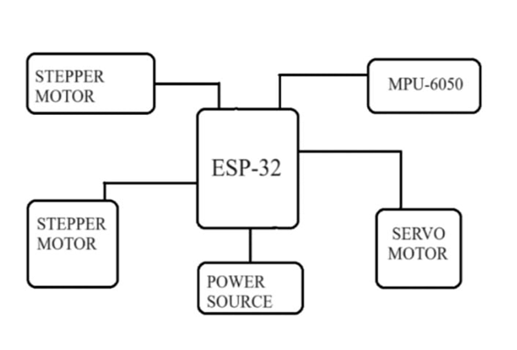
6.BLOCK DIAGRAM

Fig.1 block diagram of our work

In the above block diagram Explains that, the ESP-32 serves as the central controller, receiving instructions and issuing commands to other components. Stepper motors, known for their precise movements are controlled by the ESP-32. The MPU-6050 sensor provides essential motion and orientation data. A power source supplies the necessary energy to operate the entire system. This integrated setup enables controlled and precise movements.

1.Sensors: The accelerometer and gyroscope detect the robot's tilt and rotation in real-time and send this data to the ESP32 for processing. They help the robot understand its orientation and movement.

2.ESP32 Microcontroller: This microcontroller processes the sensor data and runs the control algorithm (e.g., PID control) to determine if the robot is falling or if it's in a balanced state. It sends commands to the motor drivers to correct any imbalance.

3.Control Algorithm: The PID control algorithm computes the robot's current tilt compared to the ideal upright position. It then outputs a correction signal based on the error, which tells the robot how much to adjust its movement.

4.Motor Drivers: The motor driver takes the correction signals from the ESP32 and adjusts the power and direction of the DC motors. The motor driver controls the speed and direction of the wheels, helping the robot lean forward or backward to restore balance.

5.DC Motors: These are the actuators that physically move the robot's wheels. By varying the speed of the motors based on the input from the motor drivers, the robot adjusts its position to remain upright.

6.Power Supply: A battery or power source is used to power all components, including the ESP32, sensors, motor drivers, and motors. It needs to provide adequate voltage and current to ensure stable operation of the robot.

7.CIRCUIT DIAGRAM

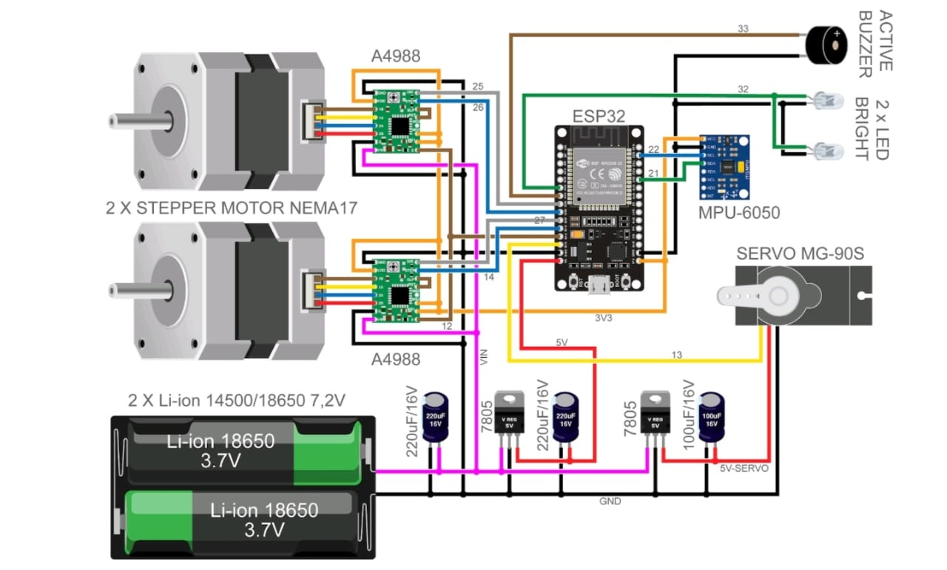

Fig.2 circuit diagram

System Overview

Hardware Components:

ESP32 Microcontroller: The brain of the system, handling computations and control signals.

IMU Sensor (e.g., MPU6050): Provides accelerometer and gyroscope data for tilt and angular velocity.

DC Motors with Encoders: Drive the wheels and provide feedback on position and speed.

Motor Driver (e.g., L298N): Interfaces between the microcontroller and the motors.

Power Supply: Lithium-ion battery pack to power the components.

Chassis: Physical structure housing the components.

7.Hardware design of our project

1. Microcontroller (MCU) Selection

A 32-bit microcontroller is a good choice for handling complex calculations involved in balancing and controlling the motors. You can use the following options:

STM32 series (STMicroelectronics)

ESP32 (Espressif Systems)

2. Power Supply

Battery: A Li-Po (Lithium-Polymer) or Li-Ion battery (7.4V or 11.1V) would be suitable for providing the necessary power.

Voltage regulator: If the microcontroller and motors have different voltage requirements, use a DC-DC buck converter to regulate the voltage from the battery

3. Sensors

Self-balancing robots typically use accelerometers and gyroscopes to measure the tilt and angular velocity to maintain balance.

IMU (Inertial Measurement Unit): You need a sensor module with both accelerometer and gyroscope, such as:

MPU-6050: A common 6-axis IMU (accelerometer + gyroscope)

4.Wheels and Chassis

Wheels: Large wheels are better as they provide stability.

Use high grip rubber wheels for better traction and stability.

Chassis: A lightweight yet rigid chassis made from materials like acrylic, aluminum, or plastic.

Ensure that the center of mass is as low as possible to improve stability.

Place the wheels and motors towards the bottom of the chassis for better balance.

5.Motor Mounting
- Ensure the motors are securely mounted to the chassis and connected to the wheels. The position of the wheels should be set to provide stability, with the center of mass positioned low and centrally.

8.Testing and Calibration of Components
1. Testing and Calibration of Sensors (IMU, Gyroscope, Accelerometer)

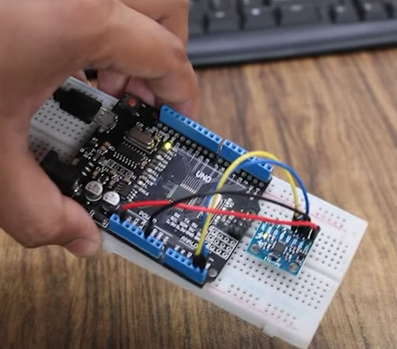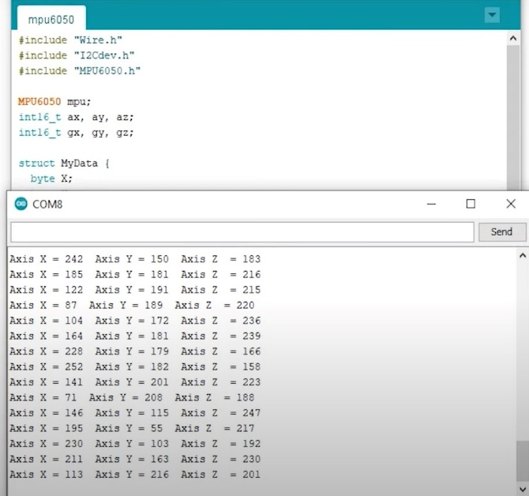
Fig.3 Result of Testing the Gyroscope (MPU6050)
The above fig explains the result of testing MPU6050, that MPU6050 provides raw data from its accelerometer and gyroscope, which requires processing to extract meaningful information. The accelerometer measures linear acceleration in three axes (X, Y, and Z), As we tilt the gyroscope in space it provides the angle in which position it has tilted in three axis.By that we can estimate the device's orientation and motion. Calibrating the sensor is crucial to account for biases and offsets, ensuring accurate readings. This processed data can be used to supply the necessary amount of power supply to motors for rotate and balance itself.
A self-balancing robot typically uses an IMU (Inertial Measurement Unit), which often combines an accelerometer and gyroscope. The ESP32 reads the sensor data to maintain balance.
Steps for Testing:
- Check Power Supply:
  - Ensure the IMU is properly powered. The ESP32 usually provides 3.3V, but the sensor's voltage rating should be checked.
- Check I2C Communication (for I2C IMUs):
  - If using an I2C IMU (e.g., MPU6050, BNO055), confirm that the data lines (SDA, SCL) are properly connected to the ESP32.
  - Use an I2C scanner sketch on the ESP32 to check if the IMU is recognized.
Calibration Steps:
- Accelerometer Calibration:
  - Place the robot on a flat surface and check the accelerometer readings (x, y, z axis).
  - The z-axis should read close to the acceleration due to gravity (9.8 m/s²), and the x and y axes should be close to zero.
  - Adjust the offset values in your code to ensure the accelerometer reads correct values when the robot is stationary.
- Gyroscope Calibration:
  - Place the robot on a stable surface.
  - The gyroscope should output values near zero if the robot is stationary.
  - You may need to subtract the gyroscope's offset from the sensor's readings.
- Magnetometer Calibration (if using one):
  - If the robot uses a magnetometer (e.g., HMC5883L), perform a calibration by rotating the robot in all directions to ensure accurate compass readings
2.Testing and Calibration of the ESP32
The ESP32 is the brain of the robot. You’ll need to verify the following:
Steps for Testing:
- Verify Wi-Fi/Bluetooth Functionality (it used for control):
  - Ensure that the Wi-Fi or Bluetooth functionality of the ESP32 is properly working, especially if the robot is controlled via a mobile app or web interface.
- GPIO Pin Testing:
  - Test the GPIO pins on the ESP32 to ensure they work with the motor driver and sensors (using a simple "high" and "low" test on each pin).
Calibration Steps:
- PWM Calibration:
  - Ensure that the PWM signals output from the ESP32 are correctly controlling the motor driver.
  - Use the ledcWrite function to generate PWM signals with different frequencies and duty cycles to control motor speed.

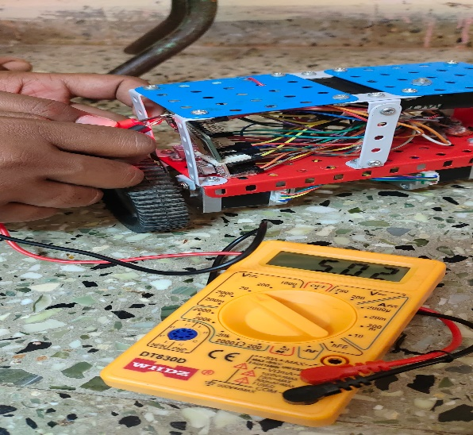

Fig.4: Required power supply given

The image showcases a hands-on approach to verifying the voltage supply to an ESP32 project. The testing is using a multimeter to measure the voltage across the ESP32 board's power pins. The multimeter’s display indicates a reading of 5.02 volts, which is within the acceptable range for ESP32 operation. This step is crucial to ensure that the project receives the correct amount of power to function properly, with the ESP32 board is serving as the brain for controlling its movements and sensors.

3.Testing of the Motor Drivers and Motors:

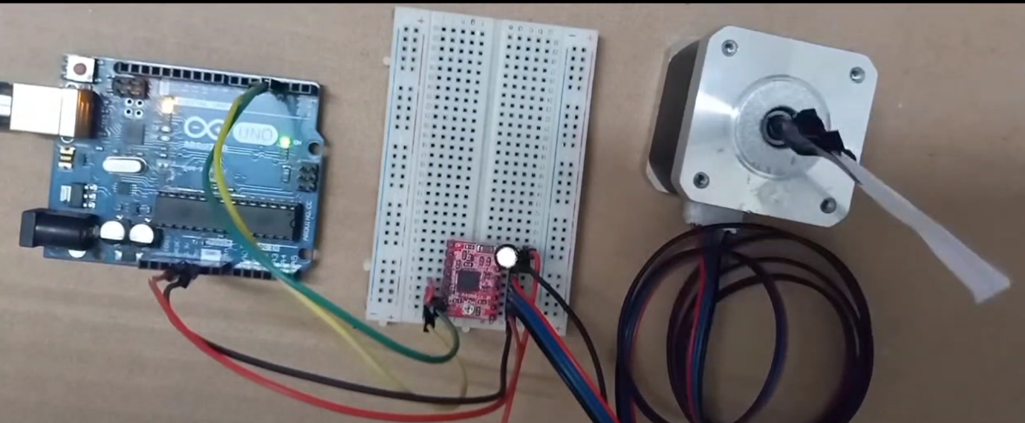
fig.5 Testing of stepper motor by rotating it in clockwise & anticlockwise with some desired angles

The fig .5 depicts a setup for testing a stepper motor's rotational capabilities in both clockwise and anticlockwise directions with precise angular control. a stepper motor's performance, we subject it to a series of precise rotations. A sequence of angles, along with their corresponding rotational directions (clockwise or anticlockwise) is programmed, As the motor executes these commands, we measure its accuracy in reaching target angles, These parameters provide valuable insights into the motor's suitability for specific rotation, Its angular rotation and holding torque are crucial parameters. the motor's ability to maintain its position against external forces, critical for applications requiring load-holding capabilities.
Steps for Testing:
- Verify Motor Connections:
  - Check the wiring between the ESP32, motor driver, and motors.
  - Ensure that the motor driver is receiving the correct PWM signals from the ESP32.

- Test Motor Direction and Speed:
  - Write a simple program to spin the motors at various speeds and directions.
  - Ensure the motors respond correctly to PWM signal changes. The robot should move forward, backward, and turn left/right based on motor control.

4.System Integration Testing
Once individual components are tested and calibrated, you need to test the robot as a whole.
Steps for Integration Testing:
- Basic Balance Test:
  - Place the robot on a flat surface and check if it can balance on its own. Adjust the PID values if necessary to improve balancing performance.
- Movement Testing:
  - Move the robot in different directions (forward, backward, turning) and observe its behavior. The robot should respond quickly and smoothly to input from sensors.
Future Improvements
- Integration of advanced control techniques like adaptive or fuzzy logic controllers.
- Enhanced IoT capabilities for remote monitoring and diagnostics.
- Improved energy efficiency and miniaturization of components.

9.CONCLUSION

This report outlines the development of a self-balancing robot utilizing the ESP32 microcontroller. The robot employs an inverted pendulum principle to maintain balance dynamically, leveraging the dual-core processing and connectivity features of the ESP32. The hardware comprises an IMU sensor for tilt detection, DC motors with encoders for movement, and a motor driver for actuation. The software integrates sensor data processing, PID control algorithms, and real-time motor control, ensuring robust balance and stability.

Key features include precise tilt estimation using complementary or Kalman filters and modular software design enabling efficient performance. Testing demonstrated successful balancing under various conditions, although minor challenges like sensor noise and PID tuning were addressed. Future improvements propose enhanced control techniques, IoT capabilities, and hardware miniaturization.

This project serves as an educational and practical platform for understanding control systems, robotics, and embedded IoT applications.

10.REFERENCE

1)Espressif Systems, "ESP32 Technical Reference Manual," Espressif Systems, 2020.
2)J. Sathish, "PID-Based Self-Balancing Robot Using Arduino and MPU6050," International Journal of Innovative Technology and Exploring Engineering (IJITEE), Vol. 9, Issue 4, 2020.
3)M. Manogaran, R. B. R. Subramanian, and P. G. S. Sundaram, "Development of Self-Balancing Robot using Wireless Technology," Journal of Robotics & Automation, 2018.
And some Online resources

