Cooperative Co Evolution Hybrid Optimization for Dynamic Task Scheduling in Heterogeneous Distributed Systems
Divyanshu Kashyap, Om Yadav, and Tejas Joshi
Netaji Subhas University of Technology, Delhi, India

Abstract
Objectives: This study addresses dynamic task scheduling in heterogeneous distributed systems where task arrivals, queue states, node speeds, communication latency, and failures change over time. Methods and analysis: A policy based scheduler is developed in which six nonnegative weights guide node selection across processing speed, queue workload, network latency, failure probability, available capacity, and execution cost. The weights are optimized using Genetic Algorithm, Particle Swarm Optimization, Differential Evolution, and a Cooperative Co Evolution Hybrid optimizer. Performance is evaluated against Round Robin, Least Loaded, and MECT baselines using average completion time, P95 latency, makespan, load variance, failure rate, throughput, and a revised Schedule Length Ratio based on a parallel lower bound. Findings: On the primary 1000 task Alibaba trace sample, optimized policies reduce average completion time by 14.59 to 21.27 percent and P95 latency by 4.06 to 13.79 percent relative to MECT. Differential Evolution provides the best P95, makespan, SLR, and throughput, while Particle Swarm Optimization provides the best average completion time and failure rate. Novelty and improvement: The work contributes a transparent six objective scheduling formulation, constrained penalty weights that preserve feature semantics, a corrected SLR definition, and robustness testing across samples, arrival windows, workload intensities, and cluster sizes.
Keywords: Task scheduling; heterogeneous distributed systems; cooperative co evolution; metaheuristics; Alibaba Cluster Trace; multi objective optimization

1 Introduction
Dynamic distributed systems execute workloads whose arrivals, resource needs, queue states, and failure conditions change continuously. Heterogeneous clusters intensify this problem because fast, low latency nodes can reduce completion time but may also concentrate load, while slower or less reliable nodes can damage tail performance. Classical heuristics such as Round Robin and Least Loaded remain attractive because they are simple and inexpensive, but they cannot fully represent the competing objectives that govern modern cloud and edge scheduling.
Metaheuristic scheduling methods, including Genetic Algorithm, Particle Swarm Optimization, Differential Evolution, and hybrid approaches, are widely used for search spaces where exact optimization is impractical. However, many studies still rely on static workflow assumptions, synthetic workloads, or narrow objective functions. Recent work in edge and cloud scheduling has increasingly emphasized deep reinforcement learning, SLA awareness, energy and cost trade offs, and real time resource optimization, but the need remains for interpretable scheduling policies that can be tested against trace derived dynamic arrivals [19-24].
This paper revises and strengthens the original scheduling framework in three ways. First, the policy search is formulated as a six objective normalized fitness function rather than a four term proxy. Second, all policy weights are constrained to be nonnegative so that penalty features cannot reverse meaning during optimization. Third, SLR is redefined against a parallel lower bound, making it meaningful for independent tasks that execute concurrently. The resulting evaluation is intentionally presented as a trade off analysis rather than a universal dominance claim.
The main contributions are: (1) an interpretable six feature policy scheduler for heterogeneous nodes; (2) a corrected six objective fitness function that includes AvgCT, P95, makespan, load variance, failure rate, and SLR; (3) a Cooperative Co Evolution Hybrid optimizer that decomposes the policy vector into throughput, overhead, and reliability subspaces; (4) real Alibaba Cluster Trace 2018 evaluation with reproducible data download and checksum verification; and (5) sensitivity and robustness analyses requested during peer review.

2 Related Work
Task scheduling in heterogeneous systems has a long history. HEFT and related list scheduling heuristics provide effective low complexity baselines for workflow scheduling [1-3]. Foundational distributed systems and cloud computing work established the importance of heterogeneity, resource allocation, and scalability [4, 5], while scheduling complexity results explain why large scheduling instances motivate heuristic and metaheuristic approaches [6].
Population based metaheuristics such as GA [7, 8], PSO [9], and DE [11] provide flexible search mechanisms for difficult optimization landscapes. Hybrid approaches, including GA PSO and EDA GA variants, can improve exploration and convergence [14, 15]. Cooperative co evolution decomposes a high dimensional search problem into interacting subcomponents and is therefore well suited to weight vectors with functionally distinct groups [16].
Recent work has expanded task scheduling research toward edge and cloud continuum environments. Aminu et al. reviewed metaheuristic task scheduling strategies in edge computing [19]. Naeem et al. studied real time job scheduling and resource optimization in edge cloud continuum networks [20]. Zhang and Ou presented reinforcement learning for energy efficient and cost effective cloud edge scheduling [21]. Sravan and Shaik proposed DRL based multi objective scheduling for latency, energy, and SLA objectives [22]. Yamsani and Reddy examined SLA aware deep reinforcement learning for adaptive edge cloud task scheduling [23], while Raju et al. proposed an IntelliScheduler framework based on hybrid deep learning [24]. These studies motivate the revised paper's emphasis on dynamic behavior, multiple objectives, and robustness across workload settings.

3 Methodology

3.1 Dataset And Workload Construction
The experiments use the official Alibaba Cluster Trace 2018 batch task file. The downloaded archive was verified with SHA256 value 7c4b32361bd1ec2083647a8f52a6854a03bc125ca5c202652316c499fbf978c6. The raw file contains 14,295,731 task rows. After retaining terminated records and removing invalid start time or CPU entries, 14,058,462 records remain. A 1000 task sample is selected for the main experiment, arrivals are rescaled to a 600 second window, and planned CPU is log normalized into workload units.
Property | Value
Source dataset | Alibaba Cluster Trace 2018 batch_task.csv
Raw records | 14,295,731
Cleaned records | 14,058,462
Tasks sampled | 1,000
Arrival window | 0.0 to 600.0 seconds
Workload range | 10.0 to 84.4 units
Workload mean | 54.72 units
Archive SHA256 | 7c4b32361bd1ec2083647a8f52a6854a03bc125ca5c202652316c499fbf978c6

3.2 Simulation Environment
The simulated cluster contains 15 heterogeneous nodes distributed across high, medium, and low performance tiers. Node speeds, communication latencies, and failure probabilities are sampled from tier specific ranges using fixed random seeds. The default tier structure is five high performance nodes, seven medium performance nodes, and three low performance nodes.
Tier | Nodes | Speed range | Latency range | Failure probability
High | 5 | 8 to 12 units/s | 5 to 20 ms | 0.00 to 0.01
Medium | 7 | 4 to 8 units/s | 15 to 40 ms | 0.01 to 0.03
Low | 3 | 2 to 4 units/s | 30 to 60 ms | 0.02 to 0.05

Queue workload is updated continuously as Q_j(t) = max(0, Q_j(t-1) - delta_t s_j), where s_j is the processing speed of node j. Completion time is CT_ij = latency_j/1000 + workload_i/s_j + Q_j/s_j. Failed tasks are retried up to two times with a short delay and are then assigned to the least loaded node if all retries fail.

3.3 Policy Scheduler
For each arriving task, the policy scheduler scores every node using six normalized features. The selected node is the node with the highest score.
Score_j = w1 speed_j - w2 queue_j - w3 latency_j - w4 failure_j + w5 capacity_j - w6 cost_j
The optimizer searches W = [w1, w2, w3, w4, w5, w6] within [0, 5]^6. Nonnegative weights preserve feature semantics: speed and capacity are rewards, while queue, latency, failure probability, and execution cost remain penalties.
Weight | Feature | Role
w1 | Processing speed | Reward
w2 | Queue workload | Penalty
w3 | Network latency | Penalty
w4 | Failure probability | Penalty
w5 | Available capacity | Reward
w6 | Execution cost | Penalty

3.4 Notation And Parameters
The following table defines the symbols and parameters used in the scheduling model, simulator, fitness function, and robustness tests.
Symbol | Definition
i | Task index
j | Node index
w1 to w6 | Policy weights for speed, queue workload, latency, failure probability, capacity, and cost
s_j | Processing speed of node j
Q_j(t) | Queue workload assigned to node j at time t
L_j | Communication latency of node j in milliseconds
p_j | Failure probability of node j
C_j | Execution cost feature of node j
A_i | Arrival time of task i
X_i | Workload of task i
CT_ij | Completion time if task i is assigned to node j
P95 | Ninety fifth percentile task completion latency
M | Observed makespan from first task arrival to final task finish
LB_parallel | Parallel lower bound used for SLR
SLR | Schedule Length Ratio, calculated as M divided by LB_parallel
r_k | Metric k normalized by the MECT value from the same workload and node realization
F | Overall six objective fitness value minimized by the optimizers
N | Number of tasks in an experiment
T_window | Arrival window used to rescale sampled trace arrivals
alpha | Workload scale multiplier used in robustness testing

4 Fitness Function
The final fitness function optimizes all six stated objectives. Each objective is normalized by the MECT baseline from the same workload and node realization.
F = 0.25 r_AvgCT + 0.20 r_P95 + 0.20 r_Makespan + 0.10 r_LoadVariance + 0.15 r_FailureRate + 0.10 r_SLR
A soft failure guard adds 0.05(r_FailureRate - 1) when the normalized failure rate exceeds 1.0. This structure gives priority to mean latency, tail latency, and makespan while retaining reliability, load balance, and schedule length efficiency.
SLR is computed as observed makespan divided by a parallel lower bound. The lower bound is the maximum of the aggregate work capacity bound, the release time bound based on fastest feasible task durations, and the longest single task bound. This avoids the invalid serial denominator used in the previous manuscript.
Objective | Coefficient | Meaning
Average completion time | 0.25 | Primary mean latency objective
P95 latency | 0.20 | Tail latency objective
Makespan | 0.20 | Total schedule length
Load variance | 0.10 | Load balance pressure
Failure rate | 0.15 | Reliability objective
SLR | 0.10 | Normalized schedule efficiency

5 Optimizers
GA, PSO, and DE search the complete six dimensional policy vector. GA uses tournament selection, uniform crossover, Gaussian mutation, and elitism. PSO uses inertia, cognitive, and social terms with bounded velocities. DE uses the DE/rand/1 strategy with binomial crossover.
The Cooperative Co Evolution Hybrid decomposes the vector into three two dimensional groups: throughput weights (w1, w5) assigned to DE, overhead weights (w2, w3) assigned to PSO, and reliability weights (w4, w6) assigned to GA. A shared global best vector coordinates the sub optimizers, and the global best is injected every ten iterations.
Parameter | GA | PSO | DE | Hybrid CCE
Population or swarm | 20 | 20 | 20 | 20 per subgroup
Iterations | 50 | 50 | 50 | 50
Crossover rate | 0.8 | - | 0.9 | GA 0.8, DE 0.9
Mutation | 0.1 | - | F = 0.5 | GA 0.15, DE F = 0.5
PSO parameters | - | w = 0.7, c1 = 1.5, c2 = 1.5 | - | same

6 Experimental Setup
The experiments were implemented in Python using NumPy, Pandas, and Matplotlib. The main result uses 1000 tasks sampled from the official Alibaba trace and a 15 node heterogeneous cluster. Random seeds are fixed for reproducibility. Baseline constants are generated from MECT and passed directly to the optimizer through a shared metrics object.
The evaluation reports average completion time, P95 latency, load variance, failure rate, throughput, makespan, SLR lower bound, and SLR. Additional analyses include coefficient sensitivity and robustness across repeated samples, 300, 600, and 1200 second arrival windows, light and heavy workload scales, and 10 and 25 node clusters.

7 Results

7.1 Baseline Performance
Scheduler | AvgCT | P95 | LoadVar | FailRate | Throughput | Makespan | SLR
Round Robin | 82.6471 | 464.3882 | 3.8222 | 0.0240 | 0.7845 | 1274.7433 | 2.1075
Least Loaded | 9.6450 | 21.5953 | 838.0889 | 0.0140 | 1.5787 | 633.4151 | 1.0472
MECT | 12.0373 | 18.7934 | 1273.0222 | 0.0140 | 1.6139 | 619.6140 | 1.0244

Round Robin produces the lowest load variance because it distributes tasks cyclically without regard to node state, but it performs poorly on completion time, P95, makespan, throughput, and SLR. MECT provides the strongest heuristic baseline for tail latency and schedule length, while Least Loaded reduces average completion time but has worse P95 and makespan than MECT.
Figure 1 visualizes these baseline trade offs and shows why MECT is used as the normalization reference for the optimizer fitness values.
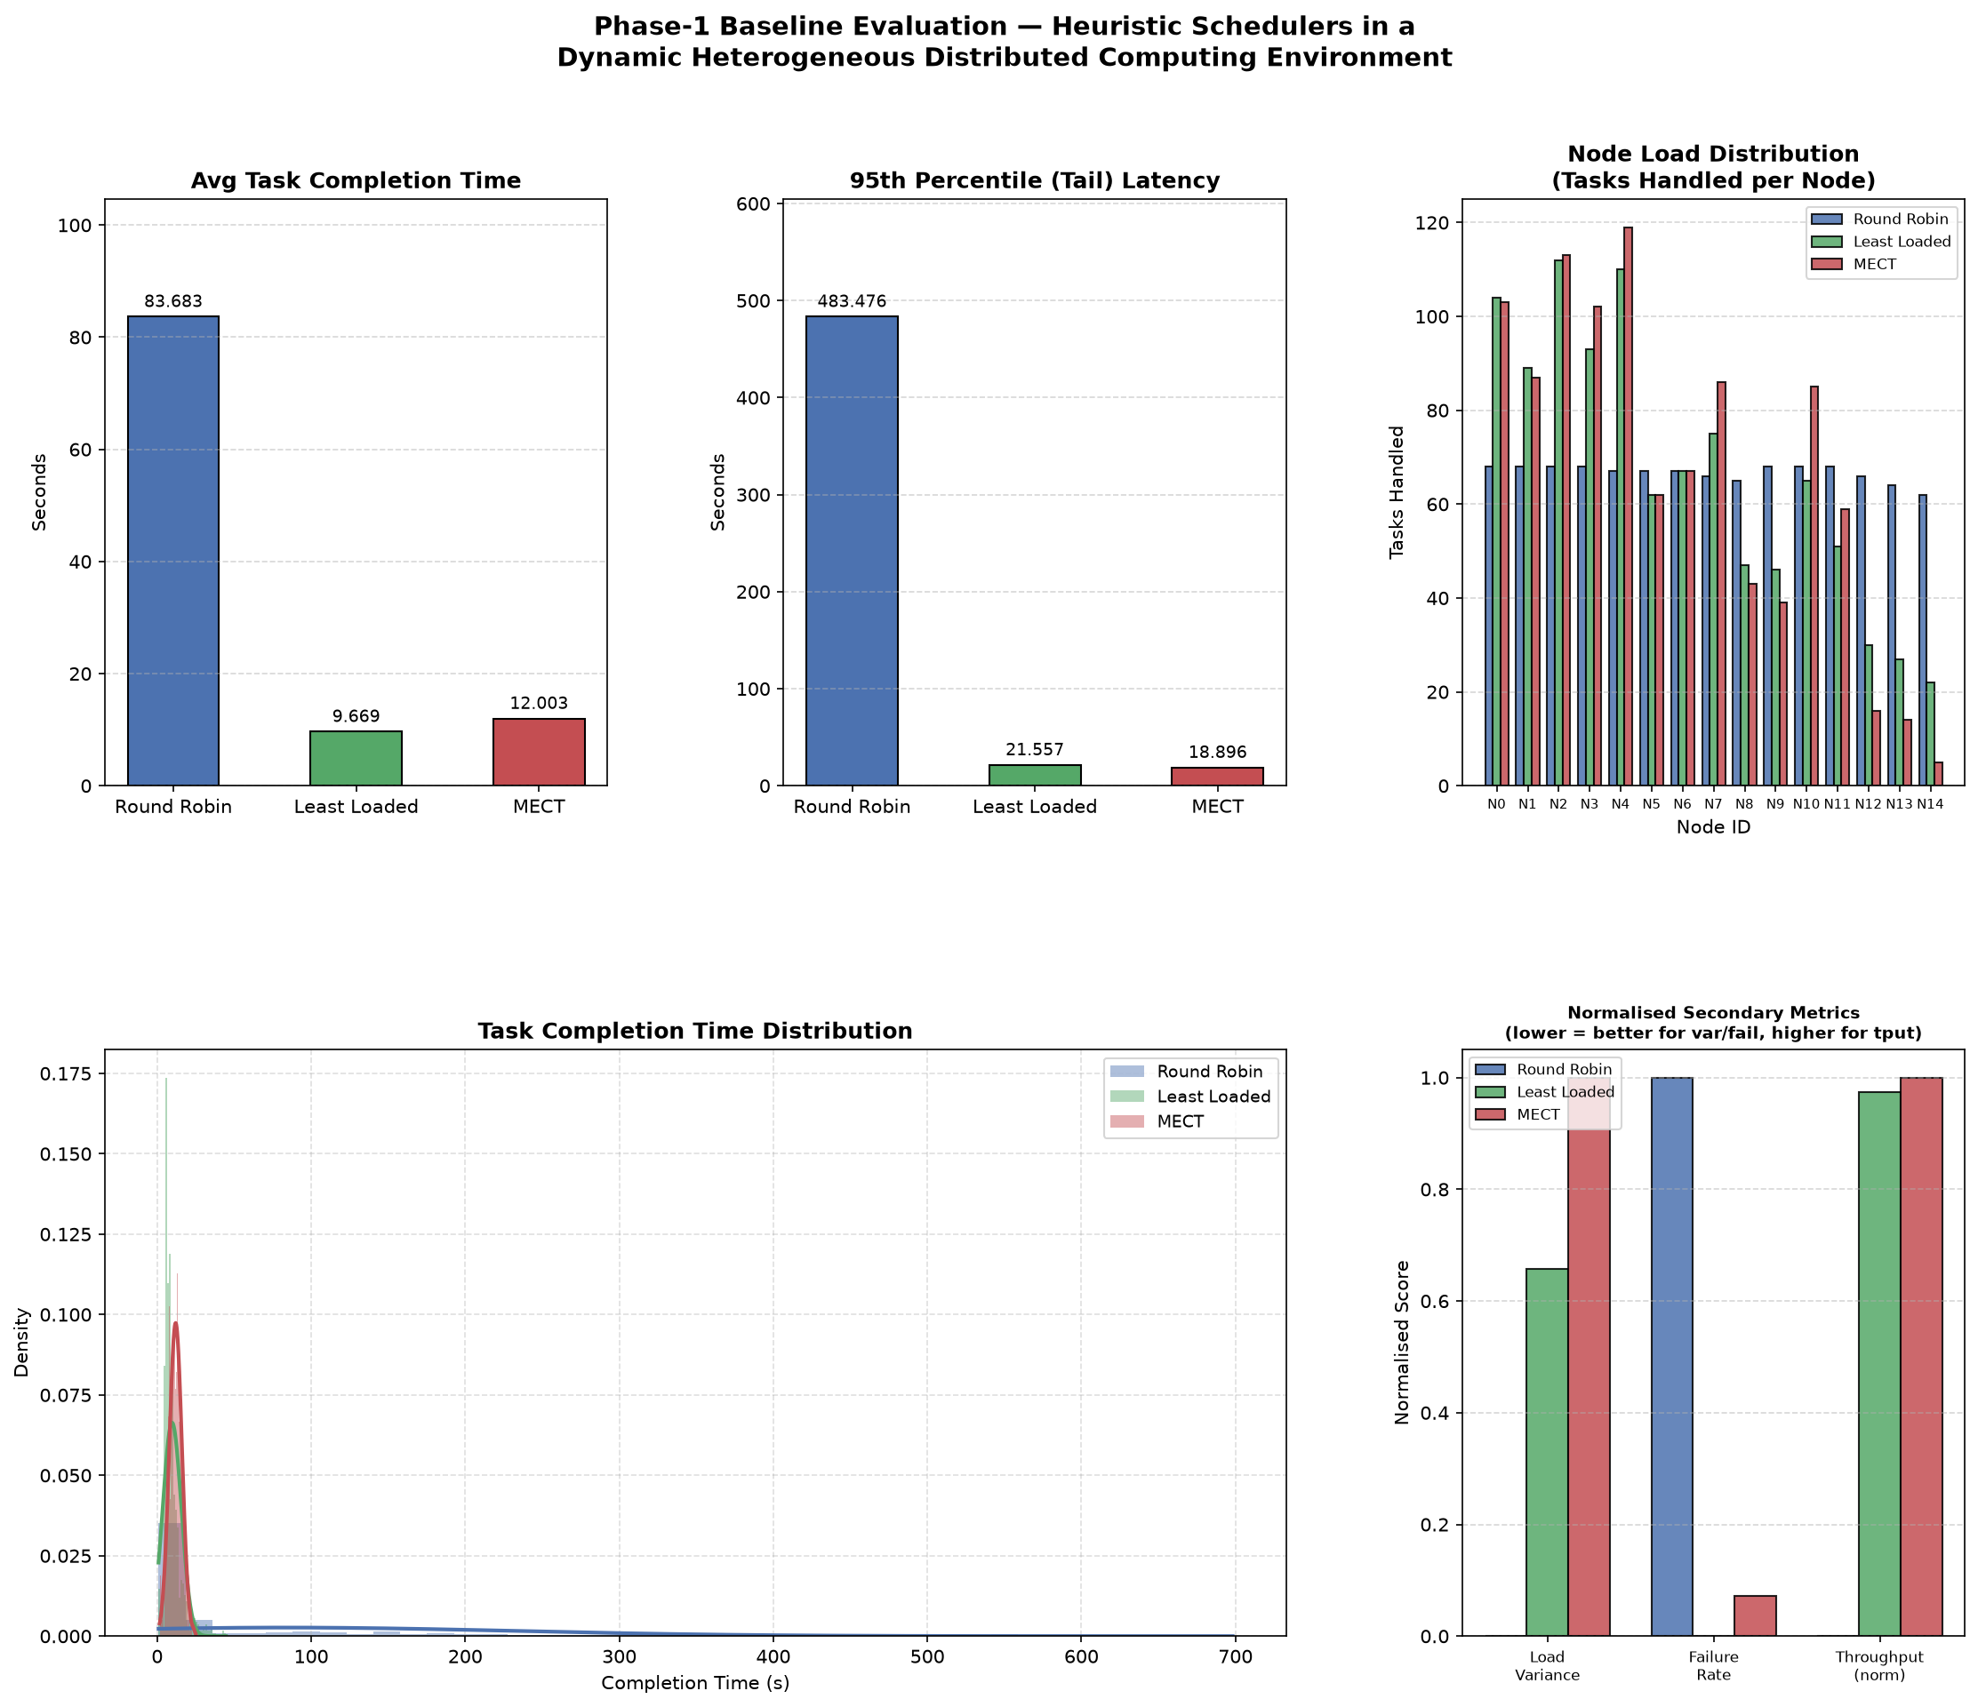
Figure 1. Baseline heuristic scheduler comparison.

7.2 Optimizer Performance
Scheduler | AvgCT | P95 | LoadVar | FailRate | Throughput | Makespan | SLR
Round Robin | 82.6471 | 464.3882 | 3.8222 | 0.0240 | 0.7845 | 1274.7433 | 2.1075
Least Loaded | 9.6450 | 21.5953 | 838.0889 | 0.0140 | 1.5787 | 633.4151 | 1.0472
MECT | 12.0373 | 18.7934 | 1273.0222 | 0.0140 | 1.6139 | 619.6140 | 1.0244
Policy-GA | 9.8497 | 16.6843 | 1391.6889 | 0.0100 | 1.6124 | 620.1830 | 1.0253
Policy-PSO | 9.4771 | 18.0310 | 1272.6222 | 0.0100 | 1.6152 | 619.1322 | 1.0236
Policy-DE | 10.1367 | 16.2014 | 1490.6222 | 0.0110 | 1.6193 | 617.5510 | 1.0210
Policy-Hybrid CCE | 10.2805 | 16.5822 | 1428.4889 | 0.0170 | 1.6094 | 621.3535 | 1.0273

On the main Alibaba trace sample, optimized policies reduce average completion time by 14.59 to 21.27 percent and P95 latency by 4.06 to 13.79 percent relative to MECT. PSO provides the best average completion time at 9.4771 s and ties GA for the best failure rate at 0.010. DE provides the best P95 latency at 16.2014 s, best makespan at 617.5510 s, best SLR at 1.0210, and best throughput at 1.6193.
The results do not support a universal dominance claim. Hybrid CCE remains competitive on mean and tail latency, but it regresses on failure rate, makespan, SLR, and throughput compared with MECT in this run. This is a key revision from the earlier manuscript and is reported transparently.
Figure 2 compares the main metrics across all schedulers, while Figure 3 reports convergence and Figure 4 shows the subgroup behavior inside the Cooperative Co Evolution Hybrid optimizer.
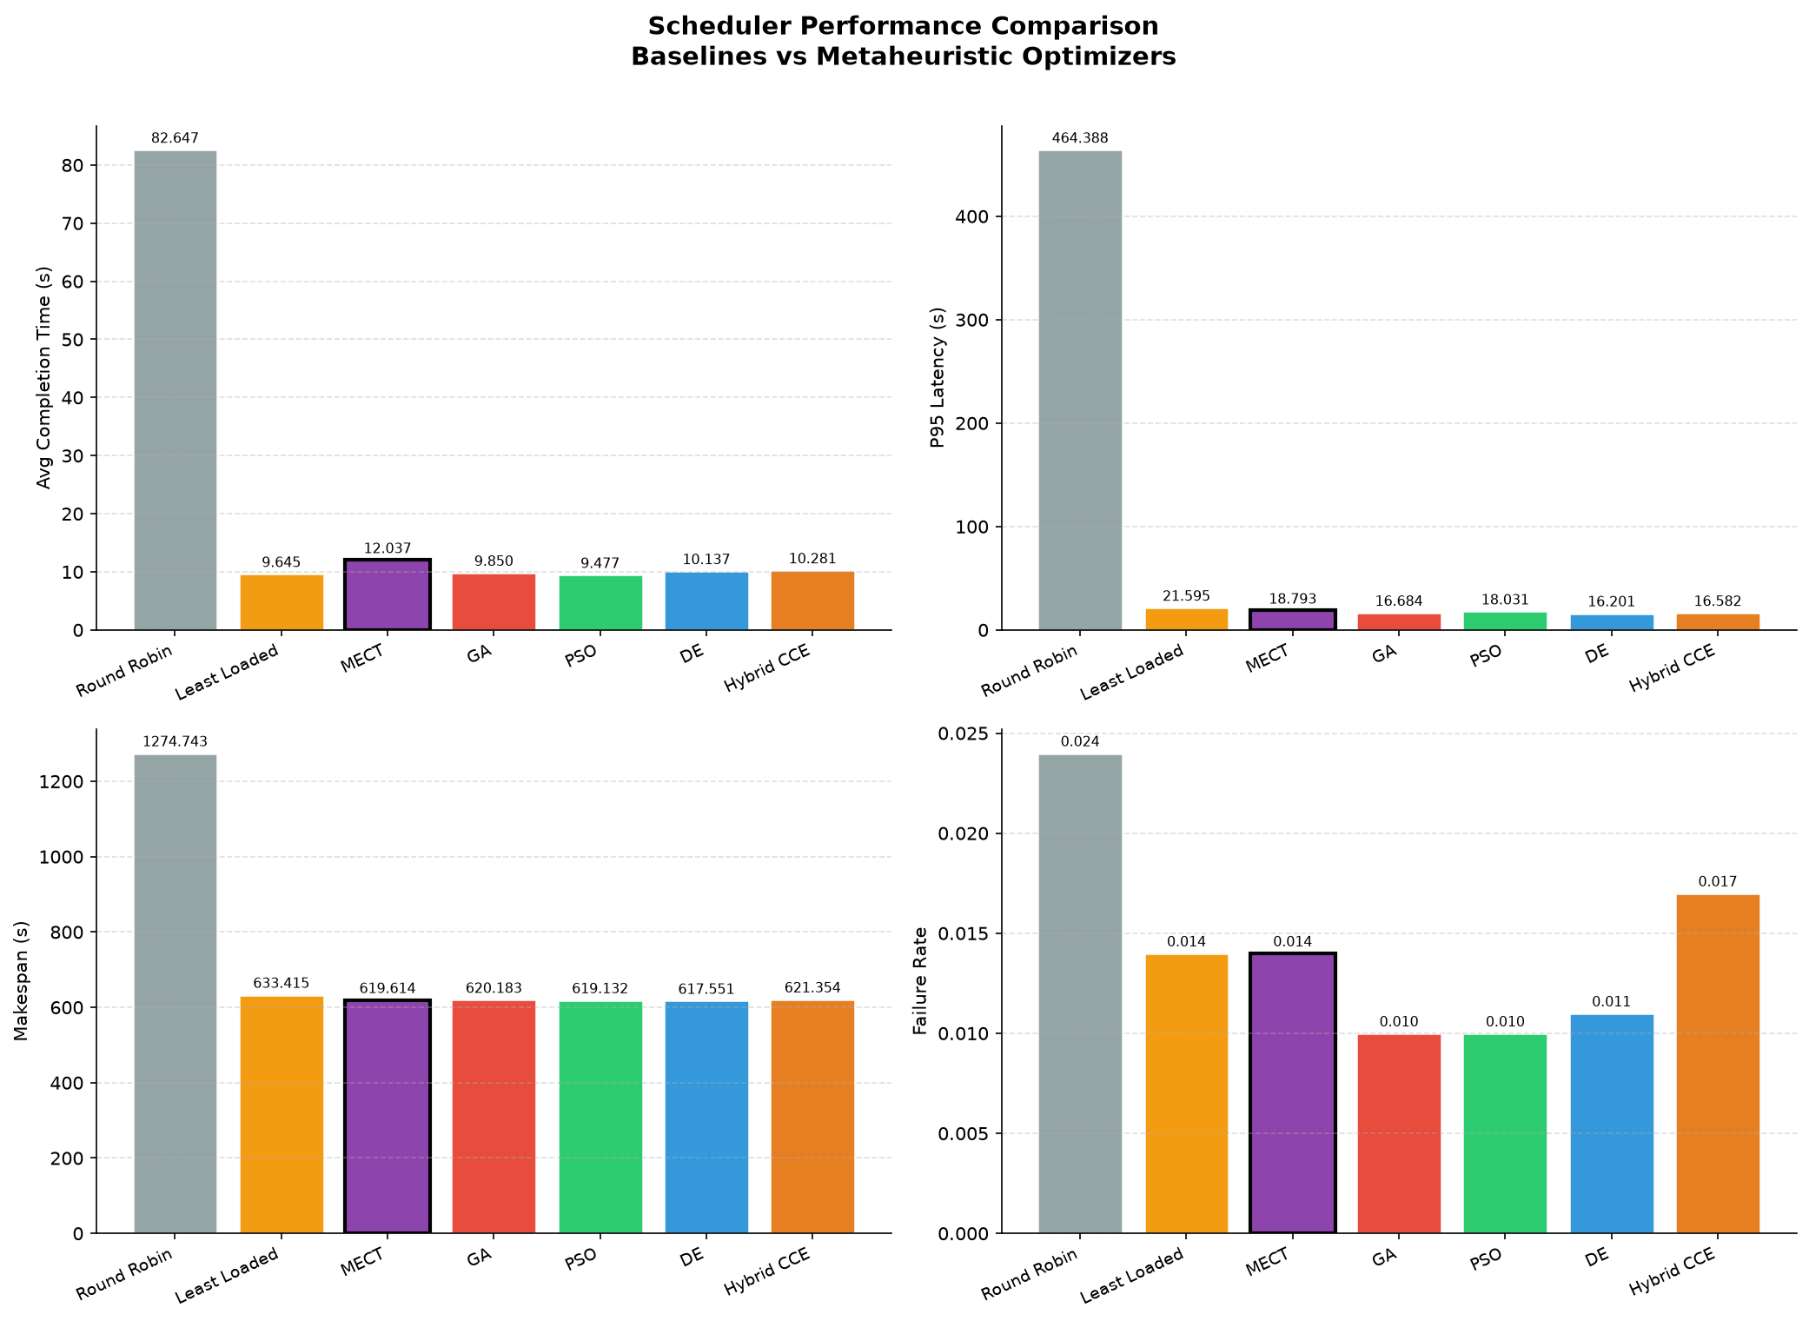
Figure 2. Scheduler performance comparison across AvgCT, P95, makespan, and failure rate.
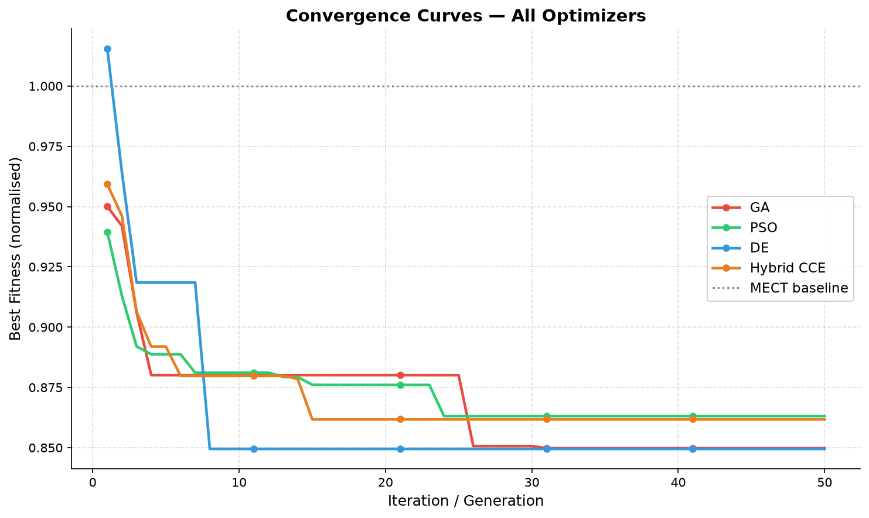
Figure 3. Convergence curves for all optimizers.
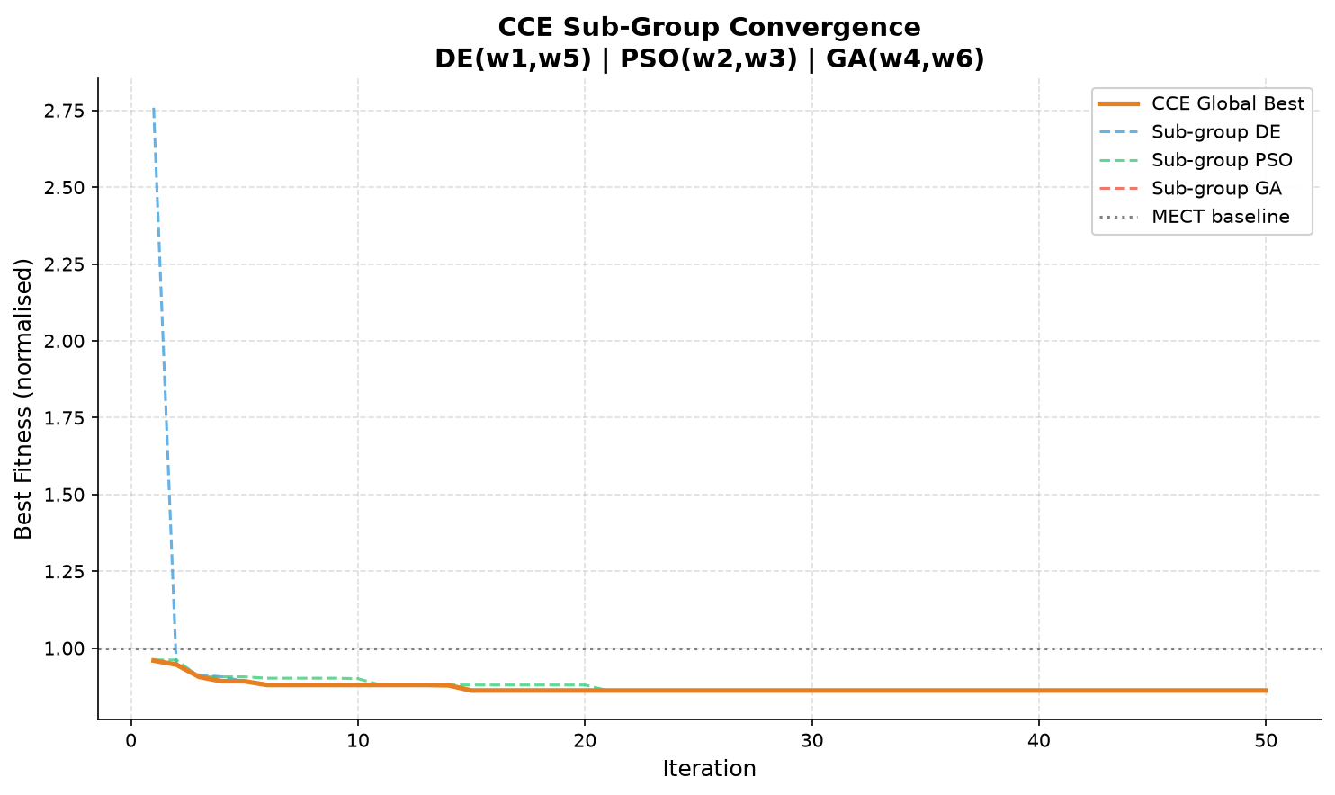
Figure 4. Cooperative Co Evolution subgroup convergence.
Figure 5 summarizes percentage improvement against MECT and makes the metric specific gains and regressions explicit.
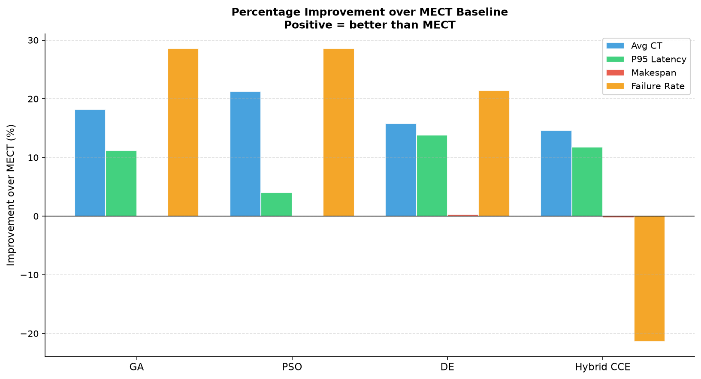
Figure 5. Percentage improvement over MECT. Positive values indicate improvement.

7.3 Weight Interpretation
Optimizer | Fitness | w1 | w2 | w3 | w4 | w5 | w6
GA | 0.8498 | 0.4820 | 4.4855 | 0.1907 | 0.8895 | 2.3926 | 0.3586
PSO | 0.8631 | 0.0000 | 5.0000 | 0.0000 | 0.4905 | 2.9432 | 0.0000
DE | 0.8495 | 0.0446 | 5.0000 | 2.9970 | 0.0000 | 3.2708 | 0.2685
Hybrid CCE | 0.8618 | 0.6010 | 5.0000 | 1.6360 | 1.0816 | 2.2203 | 0.8351

All optimized policies assign high importance to the queue penalty w2. PSO, DE, and CCE drive w2 to the upper bound of 5.0, and GA reaches 4.4855. The available capacity reward w5 also receives substantial weight in all methods. This supports the interpretation that queue avoidance and capacity preference are central for dynamic trace based scheduling.
Figure 6 displays the learned nonnegative weights and confirms that no penalty feature receives a sign reversing coefficient.
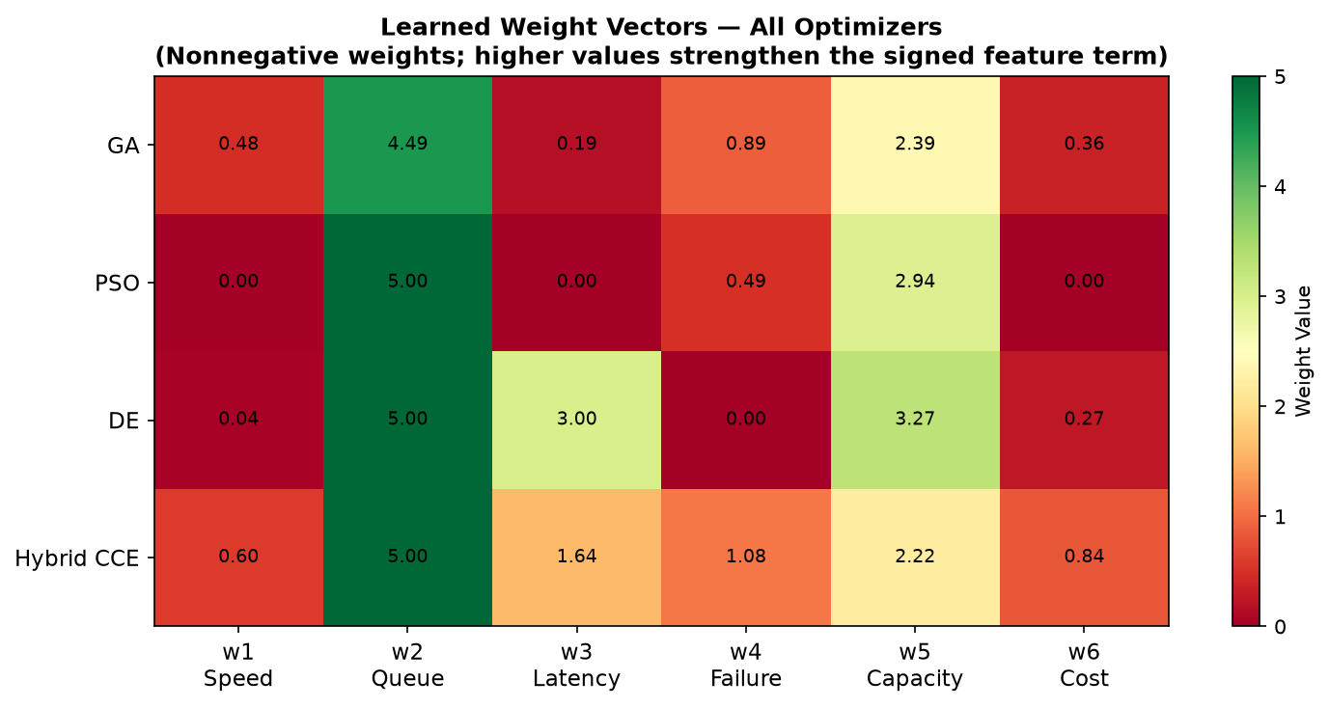
Figure 6. Learned nonnegative policy weights for all optimizers.

8 Sensitivity And Robustness
Profile | AvgCT | P95 | Makespan | SLR | LoadVar | FailRate
balanced_six_objective | 10.0599 | 16.6096 | 621.9211 | 1.0282 | 1420.6222 | 0.0120
mean_latency_heavy | 9.8894 | 17.1334 | 621.0170 | 1.0267 | 1391.2889 | 0.0150
tail_latency_heavy | 10.0381 | 16.6843 | 621.5958 | 1.0277 | 1418.6222 | 0.0090
makespan_slr_heavy | 9.9685 | 16.1125 | 621.1170 | 1.0269 | 1373.4222 | 0.0130
reliability_heavy | 10.5916 | 16.8022 | 621.2942 | 1.0272 | 1492.0889 | 0.0150
fairness_heavy | 9.4130 | 21.2710 | 627.6816 | 1.0377 | 984.3556 | 0.0170

The coefficient sensitivity study indicates that changing the weights can improve one target at the expense of another. The fairness heavy setting lowers load variance but worsens P95, makespan, SLR, and failure rate. Tail and makespan profiles improve specific objectives but do not dominate the balanced six objective configuration. The balanced profile is therefore retained because it avoids the strongest single metric regressions.
Scenario | AvgCT | P95 | Makespan | SLR | FailRate
baseline | 16.41% | 11.05% | 0.50% | 0.50% | 11.11%
sample_seed_101 | 13.20% | 12.41% | 0.47% | 0.47% | -13.33%
sample_seed_202 | 14.93% | 10.94% | -1.46% | -1.46% | 0.00%
compressed_300s | -1.70% | -8.01% | -14.10% | -14.10% | 35.29%
relaxed_1200s | -4.12% | -4.03% | -0.01% | -0.01% | 27.27%
light_workload | 7.56% | 2.26% | 0.10% | 0.10% | 38.46%
heavy_workload | 6.44% | -1.55% | -1.28% | -1.28% | -18.75%
small_cluster | -1.17% | -6.06% | -3.70% | -3.70% | 0.00%
large_cluster | 8.39% | -0.55% | 0.08% | 0.08% | 28.57%

Robustness tests show a nuanced result. Reoptimized DE improves average completion time by 6.66 percent on average across nine scenarios and improves failure rate by 12.07 percent on average, but it regresses on makespan and SLR by 2.16 percent on average. The 300 second compressed arrival window, 1200 second relaxed window, and 10 node cluster reveal sensitivity to workload dynamics and cluster scale.
Figure 7 isolates the revised SLR values, Figure 8 gives a multi metric radar profile, and Figure 9 relates optimizer runtime to final fitness.
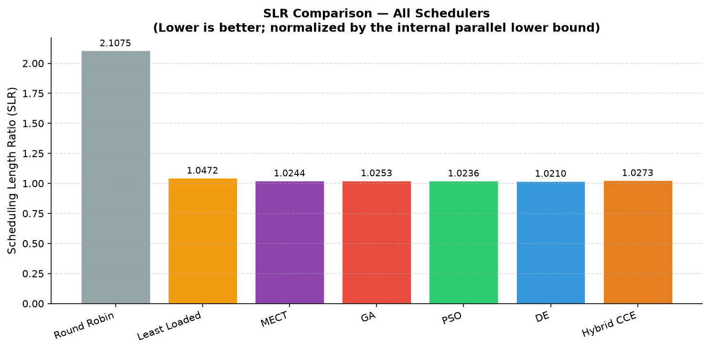
Figure 7. Revised SLR comparison using the parallel lower bound.
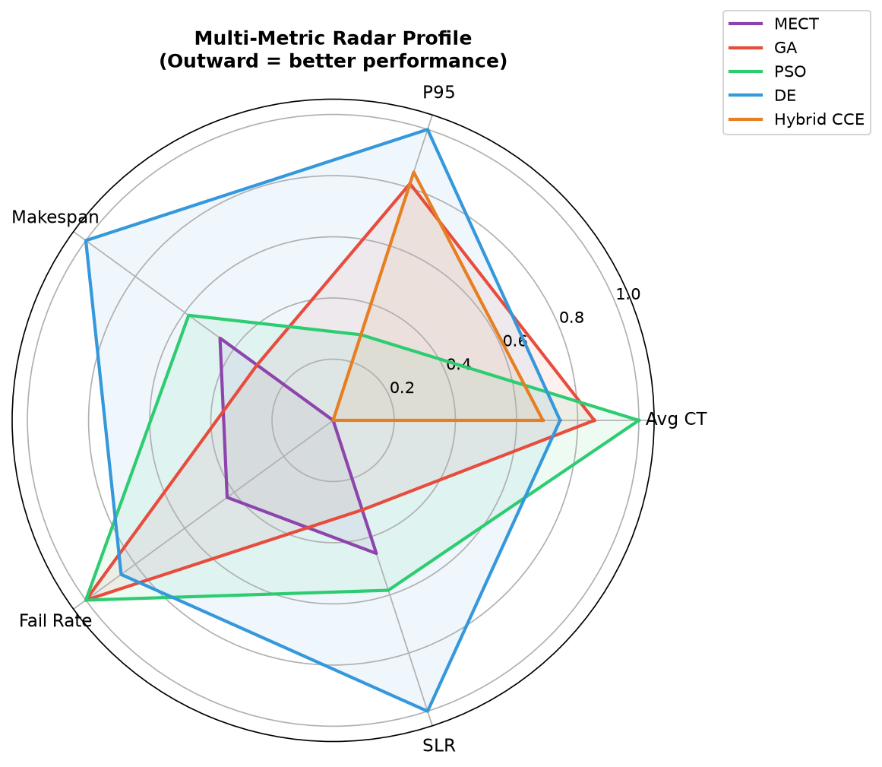
Figure 8. Multi metric radar profile for MECT and optimized schedulers.
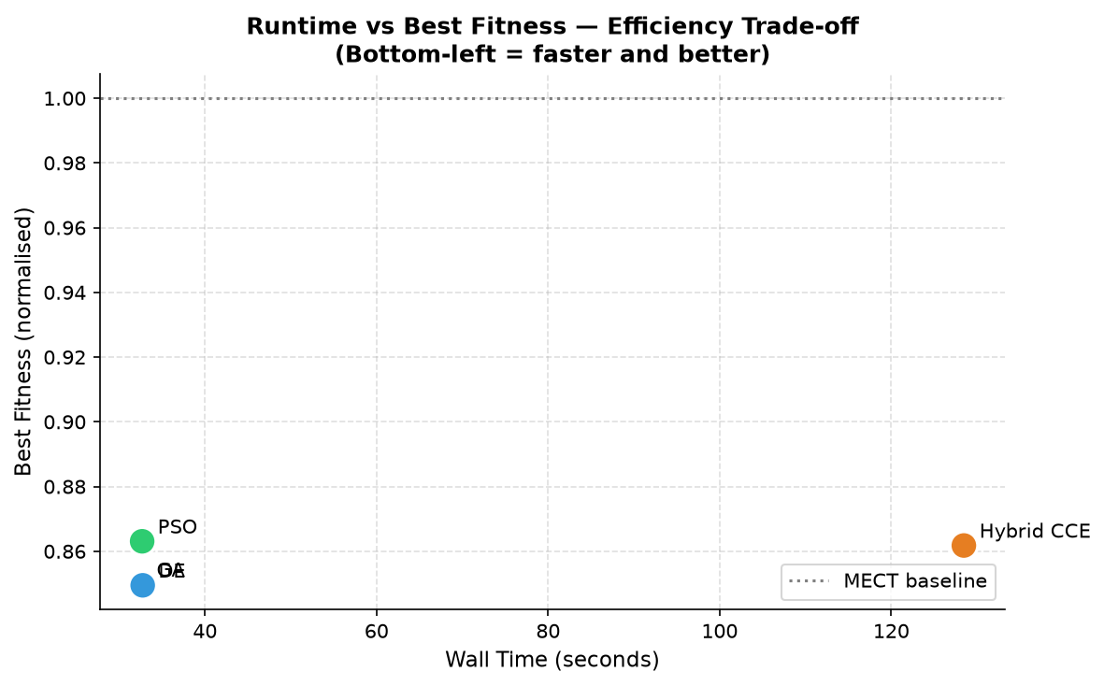
Figure 9. Runtime versus best fitness for optimizer efficiency comparison.

9 Comparison With Prior Work
The closest prior comparison in the original manuscript was Li and Chen [18], who studied energy aware task scheduling using a metaheuristic approach. A direct numerical SLR comparison is not retained because their workflow based SLR formulation is not methodologically equivalent to the parallel lower bound based SLR used here. Instead, the revised manuscript compares the proposed method qualitatively with prior metaheuristic and reinforcement learning studies.
Compared with recent edge cloud and cloud edge scheduling work [19-24], this study emphasizes interpretability and reviewer reproducibility: the scheduler uses an explicit six feature score, the data are fetched from the official Alibaba trace archive, and the robustness experiments expose settings where the method regresses. This strengthens the credibility of the result even though it narrows the claim.

10 Conclusion
This study presented a dynamic scheduling framework for heterogeneous distributed systems in which task assignment is controlled by an interpretable six feature policy and optimized through evolutionary and cooperative co evolutionary search. The revised formulation resolves the mismatch between the original six objective claim and the previous four term fitness function by explicitly incorporating average completion time, P95 latency, makespan, load variance, failure rate, and Schedule Length Ratio into a single normalized objective. The resulting policy search remains easy to interpret because each learned weight corresponds to a concrete scheduling feature, while the nonnegative weight bounds preserve the intended meaning of penalty terms for queue length, latency, failure probability, and execution cost. The corrected SLR metric also avoids an invalid serial denominator by comparing observed schedule length against a parallel lower bound derived from task releases, fastest feasible task durations, and aggregate cluster capacity.
The experimental workflow now supports a stronger evaluation protocol. Baseline constants are generated once from the MECT run and reused consistently across the optimizer fitness calculation, result tables, and manuscript text. Sensitivity analysis justifies the selected coefficient values, and robustness experiments vary random samples, arrival compression windows, workload intensity, and cluster size to test whether the conclusions survive changes in workload dynamics. On the primary real trace setting, optimized policies substantially improve mean and tail latency relative to MECT. However, robustness tests show that these improvements are not uniform across all operating conditions, particularly under compressed arrivals and smaller clusters. Future work should improve robustness under heavier contention, evaluate larger samples, compare against directly comparable workflow benchmarks, add energy and cost measurements where data are available, and validate the policy in a real distributed testbed.

References
[1] Topcuoglu H, Hariri S, Wu MY (2002) Performance effective and low complexity task scheduling for heterogeneous computing. IEEE Transactions on Parallel and Distributed Systems 13(3):260-274. https://doi.org/10.1109/71.993206
[2] Ibrahim OH, Ahmed I, Omara FA, Shaker FA (2008) An enhanced min min algorithm for job scheduling in grid computing. Proceedings of the 5th International Conference on Electrical Engineering, pp 1-9.
[3] Mao Y, Chen X, Li X (2014) Max Min task scheduling algorithm for load balance in cloud computing. Proceedings of Computer Science and Network Technology, pp 457-463. https://doi.org/10.1007/978-81-322-1759-6_53
[4] Tanenbaum AS, van Steen M (2007) Distributed Systems Principles and Paradigms. Pearson Prentice Hall.
[5] Buyya R, Yeo CS, Venugopal S, Broberg J, Brandic I (2009) Cloud computing and emerging IT platforms. Future Generation Computer Systems 25(6):599-616. https://doi.org/10.1016/j.future.2008.12.001
[6] Ullman JD (1975) NP complete scheduling problems. Journal of Computer and System Sciences 10(3):384-393. https://doi.org/10.1016/S0022-0000(75)80008-0
[7] Holland JH (1975) Adaptation in Natural and Artificial Systems. University of Michigan Press.
[8] Goldberg DE (1989) Genetic Algorithms in Search Optimization and Machine Learning. Addison Wesley.
[9] Kennedy J, Eberhart R (1995) Particle swarm optimization. Proceedings of IEEE International Conference on Neural Networks, pp 1942-1948. https://doi.org/10.1109/ICNN.1995.488968
[10] Wang Y, Zuo X (2021) An effective cloud workflow scheduling approach combining PSO and idle time slot aware rules. IEEE CAA Journal of Automatica Sinica 8(5):1079-1094. https://doi.org/10.1109/JAS.2021.1003982
[11] Storn R, Price K (1997) Differential evolution a simple and efficient heuristic for global optimization over continuous spaces. Journal of Global Optimization 11(4):341-359. https://doi.org/10.1023/A:1008202821328
[12] Deb K, Pratap A, Agarwal S, Meyarivan T (2002) A fast and elitist multiobjective genetic algorithm NSGA II. IEEE Transactions on Evolutionary Computation 6(2):182-197. https://doi.org/10.1109/4235.996017
[13] Durillo L, Fard HM, Prodan R (2012) MOHEFT a multi objective list based method for workflow scheduling. Proceedings of IEEE CloudCom, pp 185-192. https://doi.org/10.1109/CloudCom.2012.6427573
[14] Senthil Kumar AM, Parthiban K, Siva Shankar S (2019) An efficient task scheduling in a cloud computing environment using hybrid Genetic Algorithm Particle Swarm Optimization algorithm. Proceedings of ICISS, IEEE, pp 1-6. https://doi.org/10.1109/ISS1.2019.8908041
[15] Pang S, Li W, He H, Shan Z, Wang X (2019) An EDA GA hybrid algorithm for multi objective task scheduling in cloud computing. IEEE Access 7:146379-146389. https://doi.org/10.1109/ACCESS.2019.2946216
[16] Potter MA, De Jong KA (1994) A cooperative coevolutionary approach to function optimization. Proceedings of PPSN III, pp 249-257. https://doi.org/10.1007/3-540-58484-6_269
[17] Alibaba Cluster Trace Program (2018) Alibaba Cluster Data V2018. Alibaba Group. https://github.com/alibaba/clusterdata
[18] Li C, Chen L (2024) Optimization for energy aware design of task scheduling in heterogeneous distributed systems a meta heuristic based approach. Computing. https://doi.org/10.1007/s00607-024-01282-1
[19] Aminu J, Latip R, Hanafi ZM, Kamarudin S, Gabi D (2025) Systematic review of metaheuristic based task scheduling strategies in edge computing environments. Discover Computing 28:307. https://doi.org/10.1007/s10791-025-09819-4
[20] Naeem AB, Senapati B, Rasheed J, Baili J, Osman O (2025) An intelligent job scheduling and real time resource optimization for edge cloud continuum in next generation networks. Scientific Reports 15:41534. https://doi.org/10.1038/s41598-025-25452-z
[21] Zhang W, Ou H (2025) Reinforcement learning based multi objective task scheduling for energy efficient and cost effective cloud edge computing. Scientific Reports 15:41716. https://doi.org/10.1038/s41598-025-25666-1
[22] Sravan P, Shaik MA (2026) DRL based multi objective task scheduling for edge cloud computing latency energy and SLA optimisation. Scientific Reports 16:19681. https://doi.org/10.1038/s41598-026-49824-1
[23] Yamsani N, Reddy CP (2026) SLA aware deep reinforcement learning for adaptive EdgeCloud task scheduling. Scientific Reports 16:10037. https://doi.org/10.1038/s41598-026-40237-8
[24] Raju LR, Reddy MVK, Surukanti SR, Sudhakar G, Sarma MVVS, Adepu A (2026) IntelliScheduler an edge cloud computing environment hybrid deep learning framework for task scheduling based on learning. Scientific Reports 16:11219. https://doi.org/10.1038/s41598-026-41330-8

