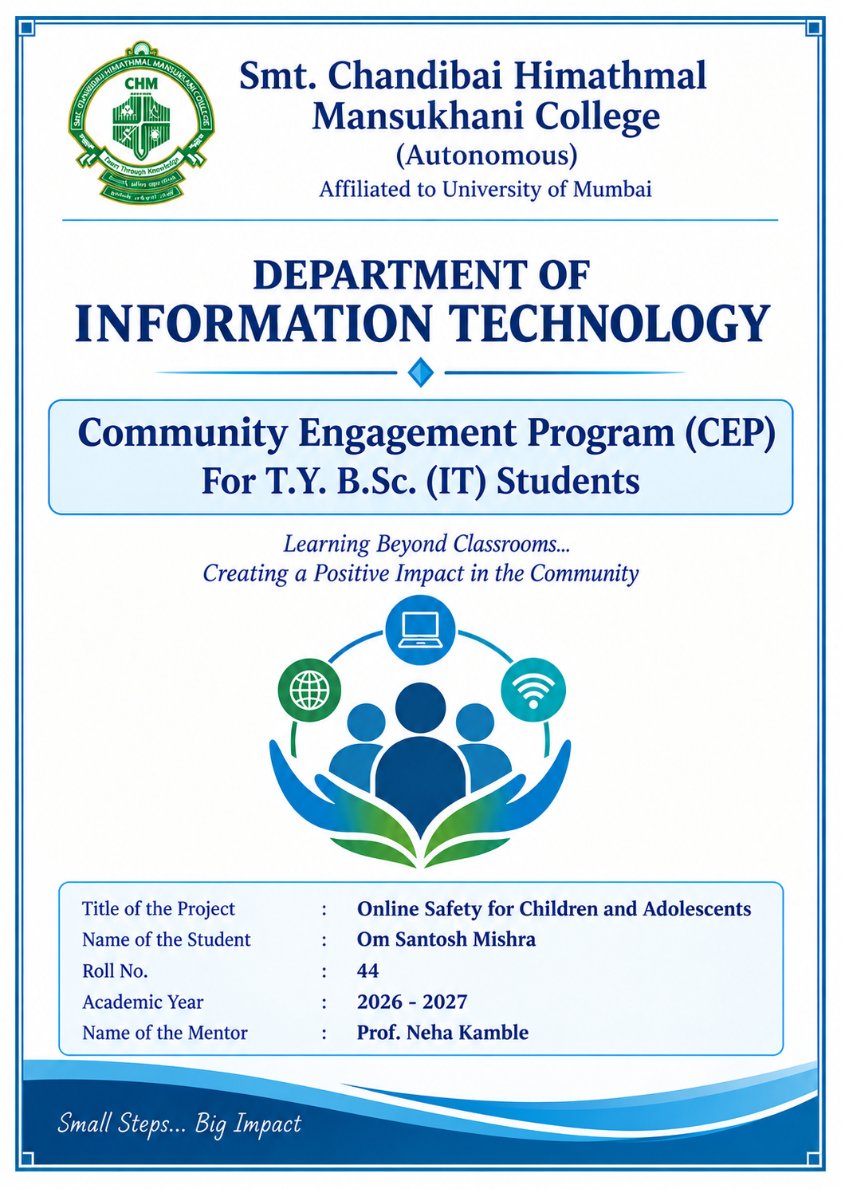

SMT. CHANDIBAI HIMATHMAL MANSUKHANI COLLEGE
(AUTONOMOUS)
Affiliated to the University of Mumbai
DEPARTMENT OF INFORMATION TECHNOLOGY
INSTITUTE CERTIFICATE

This is to certify that Mr./Ms. Om Santosh Mishra , a student of T.Y.
B.Sc. (Information Technology), has completed the Community Engagement Program (CEP) project entitled Online Safety for Children and Adolescents during the academic year
2026 – 2027 , as part of the prescribed academic requirements of the programme.
The project involved engagement with the community through planned activities undertaken by the student. The work included interaction with the target community, implementation of the proposed activities, and documentation of the observations and outcomes as part of the CEP.
This certificate is issued in recognition of the student's completion of the programme in accordance with the requirements of the T.Y. B.Sc. (Information Technology) programme.

Mr. Agi Thomas
Head, B.Sc. (IT)

SMT. CHANDIBAI HIMATHMAL MANSUKHANI COLLEGE
(AUTONOMOUS)
Affiliated to the University of Mumbai
DEPARTMENT OF INFORMATION TECHNOLOGY
MENTOR CERTIFICATE

This is to certify that Mr./Ms. Om Santosh Mishra , a student of T.Y. B.Sc. (Information Technology), has successfully completed the Community Engagement Program (CEP) project entitled Online Safety for Children and Adolescents during the academic year
2026 – 2027 .
The project has been carried out under my guidance as part of the prescribed academic requirements of the T.Y. B.Sc. (Information Technology) programme. The report presents the work undertaken by the student, including community interaction, field activities, data collection, and the observations and findings recorded during the project.
To the best of my knowledge, the student has completed the work sincerely under my supervision, and the report is submitted for academic evaluation.

Date: ___________________________
Signature of the Mentor: ___________________________
Name of the Mentor: Prof. Neha Kamble
Department of Information Technology

SMT. CHANDIBAI HIMATHMAL MANSUKHANI COLLEGE
(AUTONOMOUS)
Affiliated to the University of Mumbai
DEPARTMENT OF INFORMATION TECHNOLOGY
STUDENT DECLARATION

I hereby declare that the report entitled Online Safety for Children and Adolescents has been prepared by me as part of the Community Engagement Program (CEP) undertaken in partial fulfilment of the academic requirements of T.Y. B.Sc. (Information Technology) semester V during the academic year 2026 – 2027 .
The report is based on the activities carried out by me as part of the programme, including community interaction, fieldwork, data collection, and analysis of the information gathered. The observations and findings presented in this report are based on the work undertaken by me.
I further declare that the information presented in this report is true to the best of my knowledge and that all sources referred to in preparing the report have been duly acknowledged.

Date: ____________________
Signature of the Student: ____________________
Name of the Student: Om Santosh Mishra
Roll No.: 44
T.Y. B.Sc. (Information Technology)

ACKNOWLEDGEMENT
We would like to express our sincere gratitude to Dr. Ila Paul, Principal of Anugrah Seva Mandal
Anugrah Children’s Hostel, for her support and for providing the opportunity to carry out our Community Engagement Program (CEP) on “Online Safety for Children and Adolescents.” We are thankful to the hostel staff and the participating students for their time, cooperation and involvement in the baseline survey, learning activities and follow-up survey.
We also express our gratitude to Smt. Chandibai Himathmal Mansukhani College and the Department of Information Technology for providing the academic framework for this community-oriented project. We acknowledge the guidance and feedback of our Faculty Guide Dr.Shiji Johnson & Prof. Neha Kamble.
Finally, we thank all participants whose responses helped us understand existing awareness of online safety and plan learning activities around privacy, account security, online scams and responsible Internet use.
Om Mishra | Shriram Mainal | Muyeed Khan

ABSTRACT
This Community Engagement Program (CEP), titled “Online Safety for Children and
Adolescents,” was conducted at Anugrah Seva Mandal Anugrah Children’s Hostel by students of Smt. Chandibai Himathmal Mansukhani College. The project aimed to assess participants’ existing awareness of online safety and support safer, more responsible use of the Internet and digital technologies.
The project was organized around three components: a baseline survey, interactive technical and IT teaching-learning activities, and a follow-up survey. The learning areas included personal information and privacy, password and OTP safety, online gaming, phishing and online scams, safe online behaviour, cyberbullying, digital footprint, and basic cybercrime awareness and helpseeking practices. The baseline survey was recorded on 28 September 2026, and the learning activities and follow-up survey were recorded for 2 October 2026.
The supplied baseline and follow-up CSV files each contain 70 records, and the participant names appear in the same order in both files. The baseline responses indicate gaps in several areas, including awareness of online frauds and scams, OTPs, cyberbullying and cybercrime reporting. The follow-up file records affirmative responses for most questions. However, Q3 is negatively worded—“Would you open a link sent by an unknown person?”—so a “Yes” response indicates a potentially unsafe choice rather than improved awareness. The follow-up file records “Yes” for 69 participants on Q3, whereas 69 participants answered “No” at baseline. This apparent reversal must be verified against the original response sheets or survey export before drawing a conclusion about change. Accordingly, the report does not treat all affirmative follow-up responses as evidence of improvement; the final impact analysis should interpret each question according to its wording and response direction.
Keywords: Community Engagement Program, online safety, digital literacy, cybersecurity awareness, phishing, cyberbullying, survey analysis

TABLE OF CONTENTS
Section | Page
Institute Certificate | 1
Mentor Certificate | 2
Student Declaration | 3
Acknowledgement | 5
Abstract | 6
Table of Contents | 7
List of Figures and Tables | 8
Chapter 1: Introduction and Objectives | 7
1.1 Introduction | 12
1.2 Host Institution and Target Community | 12
1.3 Problem Statement | 12
1.4 Aim of the Project | 13
1.5 Objectives | 13
1.6 Scope of the Project | 13
Chapter 2: Literature Review and Background | 11
2.1 Introduction | 16
2.2 Online Safety and Digital Literacy | 16
2.3 Personal Information and Online Privacy | 16
2.4 Strong Passwords and Account Security | 17
2.5 OTPs, Online Fraud, and Scams | 17
2.6 Safe Use of Online Games and Digital Accounts | 18
2.7 Cyberbullying and Harmful Online Behaviour | 18
2.8 Responding to Unsafe Online Experiences | 19
2.9 Cybercrime Reporting and the IT & Cyber Cell | 19
2.10 Role of Families, Schools, and Community Awareness | 20
2.11 Relevance of the Literature to the Present Project | 20
Chapter 3: Methodology and Community Interaction / Field Work | 21
3.1 Introduction | 21
3.2 Community and Target Demographic | 21

3.3 Research Design and Methodology | 21
3.4 Stage One: Baseline Survey and Preparation | 22
3.5 Stage Two: Field Execution and Awareness Sessions | 22
3.5.1 Session One: Personal Information, Privacy, and Passwords | 23
3.5.2 Session Two: OTPs, Suspicious Links, Online Scams, and Safe Internet Use | 23
3.5.3 Session Three: Cyberbullying and Cybercrime Reporting | 23
3.6 Community Interaction | 24
3.7 Stage Three: Follow-up Survey | 24
3.8 Tools and Materials Used | 25
3.9 Consent, Documentation, and Participant Privacy | 25
3.10 Hours Reported for Project Activities | 25
3.11 Methodological Limitations | 25
Chapter 4: Data Analysis and Visualizations | 27
4.1 Introduction | 27
4.2 Survey Sample and Participant Profile | 27
4.3 Baseline Survey Findings | 28
4.4 Overall Cybersecurity Metrics: Pre-Session and Post-Session | 28
4.5 Growth in Fraud and Scam Awareness (Q6 and Q11) | 30
4.6 Improvement in Incident Response and Cyber Cell Awareness (Q10 and Q12) | 30
4.7 Improvement in Privacy Protection and OTP Awareness (Q2 and Q7) | 31
4.8 Safe Response to Unknown Links and Online Confidence | 32
4.9 Summary of Key Statistical Findings | 33
4.10 Limitations of the Analysis | 33
4.11 Chapter Conclusion | 34
Chapter 5: Conclusion and Recommendations | 35
5.1 Introduction | 35
5.2 Summary of the Project | 35
5.3 Major Findings | 35
5.4 Conclusion | 36
5.5 Recommendations | 36
5.6 Limitations of the Project | 37
5.7 Scope for Future Work | 38
5.8 Final Conclusion | 38

LIST OF FIGURES AND TABLES
List of Figures
Figure | Title | Page
Figure 3.1 | Awareness Session: Field Execution and Awareness Sessions | 13
Figure 3.2 | Community Interaction | 14
Figure 3.3 | Follow-up Survey | 15
Figure 4.1 | Age Distribution of the 70 Survey Participants | 19
Figure 4.2 | Baseline Responses Highlighting Gaps in Incident Response and  Scam Identification | 20
Figure 4.3 | Comparison of Affirmative Responses Across Six Selected  Online-Safety Indicators | 21
Figure 4.4 | Baseline and Follow-up Affirmative Responses for Fraud/Scam  Awareness and Scam Identification | 22
Figure 4.5 | Reported Knowledge of Responding to Harmful Online  Behaviour and Cybercrime Reporting | 23
Figure 4.6 | Baseline and Follow-up Responses on Personal-Information  Protection and OTP Awareness | 24
List of Tables
Table | Title | Page
Table 3.1 | Summary of Project Activities and Time Estimates | 16
Table 3.2 | Baseline and Follow-up Questionnaire Response Counts | 8
Table 4.1 | Comparison of Selected Cybersecurity Indicators: Baseline and  Follow-up | 20

CHAPTER 1

INTRODUCTION AND OBJECTIVES

1.1 Introduction
The Internet and digital technologies have become part of everyday life for children and adolescents. They use online services for communication, entertainment, learning and gaming. These opportunities also create risks when young users do not recognize unsafe links, fraudulent messages, requests for one-time passwords (OTPs), inappropriate online behaviour or the longterm consequences of sharing personal information.
Online safety education helps young users make informed decisions while using digital platforms. It includes protecting personal information, creating and maintaining secure accounts, identifying suspicious messages, responding safely to cyberbullying, understanding digital footprints and seeking help from a trusted adult or appropriate reporting channel when an incident occurs.
This CEP focused on online safety for children and adolescents at Anugrah Seva Mandal Anugrah Children’s Hostel. The project combined a baseline survey, interactive teachinglearning activities and a follow-up survey. The surveys were intended to identify initial awareness gaps and review participants’ responses after the learning activities.

1.2 Host Institution and Target Community
The community engagement activities were carried out at Anugrah Seva Mandal Anugrah
Children’s Hostel. The project was undertaken by Om Mishra, Shriram Mainal and Muyeed Khan, students of Smt. Chandibai Himathmal Mansukhani College. Dr. Ila Paul was identified as the Principal of the host institution.
The project was designed for children and adolescents, with the intended focus on ages 13–15. The supplied survey files, however, contain participant ages from 13 to 21. This actual recorded range is reported here for transparency; the age entries and the intended target-group description should be reconciled before the final report is submitted.

1.3 Problem Statement
Access to the Internet does not necessarily mean that young users have the knowledge needed to use it safely. The baseline survey recorded widespread Internet access, while responses to several specific online-safety items indicated limited awareness of online frauds and scams, OTPs, cyberbullying and cybercrime reporting. This created a need for practical, age-appropriate learning activities that connect online-safety concepts with realistic situations.

1.4 Aim of the Project
To assess and strengthen awareness of online safety among participants at Anugrah Seva Mandal Anugrah Children’s Hostel through a baseline survey, interactive technical and IT teachinglearning activities, and a follow-up survey.

1.5 Objectives
- To assess participants’ initial awareness of Internet use and online safety through a baseline survey.
- To explain personal information protection, privacy and safe sharing practices.
- To develop awareness of password hygiene, OTP confidentiality and account security.
- To help participants recognize common phishing attempts, fake messages, online scams and suspicious offers.
- To explain online gaming safety, cyberbullying, digital footprints and responsible online behaviour.
- To encourage participants to preserve relevant evidence and seek help from a trusted adult or appropriate reporting channel when facing online harm.
- To conduct a follow-up survey and compare responses with the baseline, subject to validation of the survey questions and recorded entries.

1.6 Scope of the Project
The project scope covers awareness and preventive guidance rather than technical investigation or offensive cybersecurity practice. The learning areas include personal-data protection, password and OTP safety, online gaming, phishing and scams, cyberbullying, digital footprints, safe online decisions and help-seeking or reporting awareness. The project uses survey responses to describe the participants’ reported awareness before and after the intervention. The results are limited by the wording of the survey questions, the accuracy of recorded responses and the extent to which the same participants completed both surveys.

Project timeline (recorded dates)
Activity | Recorded date
Baseline survey | 28 September 2026
Teaching-learning session(s) | 2 October 2026
Follow-up / final survey | 2 October 2026
Note: The detailed activities and duration of each of the three sessions should be described in Chapter 3 using the actual fieldwork logbook. The dates above are based on the project details supplied by the group.

SURVEY INTERPRETATION NOTE
The questionnaire wording supplied by the project group has been used to interpret the survey items. Q3 asks, “Would you open a link sent by an unknown person?” For this item, “No” is the safer response. In the original baseline file, 69 of 70 participants answered “No”; in the updated follow-up file, all 70 participants answered “No”. The updated follow-up file therefore no longer shows the earlier apparent reversal. Both files contain 70 records, and participant names appear in the same order. The responses below are summarized as recorded; any conclusions about learning should be based on the question wording and should not be interpreted as proof of longterm behaviour change.
Questionnaire response counts (as currently recorded):
Question | Baseline (n=70) | Follow-up (n=70)
Q1 Internet access | 68 Yes, 2 No | 70 Yes
Q2 Personal information | 1 Yes, 69 No | 69 Yes, 1 Not Sure
Q3 Unknown-person link | 1 Yes, 69 No | 70 No
Q4 Strong password | 65 Yes, 5 No | 70 Yes
Q5 Confidence online | 59 Yes, 11 No | 70 Yes
Q6 Online fraud/scams | 70 No | 69 Yes, 1 Not Sure
Q7 OTP awareness | 1 Yes, 69 No | 70 Yes
Q8 Online games/accounts | 67 Yes, 3 No | 69 Yes, 1 Not Sure
Q9 Cyberbullying | 1 Yes, 69 No | 69 Yes, 1 Not Sure
Q10 Responding to bad behaviour | 46 No, 24 Not Sure | 70 Yes
Q11 Identifying scams/fake messages | 60 No, 10 Not Sure | 69 Yes, 1 Not Sure
Q12 Cybercrime / IT &  Cyber Cell | 70 No | 70 Yes

CHAPTER 2
LITERATURE REVIEW AND BACKGROUND

2.1 Introduction
Online safety refers to the practices and knowledge that help people use the internet, digital devices, applications, games, and social-media platforms responsibly while reducing the risk of harm. For children and adolescents, online safety is especially important because digital services are used for education, communication, entertainment, and social interaction.
Internet access provides opportunities to learn, create, communicate, and participate in society. However, it can also expose young users to privacy violations, scams, harmful content, cyberbullying, impersonation, and contact from people who may attempt to exploit their trust. UNICEF explains that children’s digital experiences are shaped by platforms and online interactions, and that protection requires support from families, educators, governments, and technology providers (UNICEF, n.d.).
This chapter reviews the main concepts related to the project “Online Safety for Children and Adolescents.” It provides the background for the awareness activities and the survey questions used to understand participants’ knowledge of safe internet practices.

2.2 Online Safety and Digital Literacy
Online safety is not simply avoiding the internet. It means using digital technology in a careful, informed, respectful, and responsible way. Digital literacy includes the ability to understand online information, recognize possible risks, protect personal accounts, make sensible decisions, and ask for help when something feels unsafe.
Children and adolescents may use the internet frequently without knowing how to recognize every risk. A person may be comfortable using a phone, online game, or messaging application but still be unfamiliar with privacy settings, suspicious links, account security, or reporting procedures. Therefore, online-safety education should combine practical guidance with examples that young users can understand and apply.

2.3 Personal Information and Online Privacy
Personal information is information that identifies a person or can be used to contact, locate, impersonate, or learn sensitive details about them. Examples include a home address, phone number, school name and location, passwords, OTPs, identity documents, live location, and private photographs. Some details may appear harmless individually but can create risk when combined.
Users should think carefully before posting photographs, videos, location details, or personal information publicly. Privacy settings can help control who sees a profile or contacts an account, but they do not guarantee that shared material will remain private. Content may be copied, saved, forwarded, or shared beyond the intended audience.
Children should avoid sharing personal details with strangers, review privacy settings with a trusted adult, and ask for guidance before responding to requests for private information. CERTIn’s guidance on children’s online safety also advises young users to be careful with photographs and videos and not to reveal details such as their address, phone number, or school location (CERT-In, 2020).

2.4 Strong Passwords and Account Security
A password helps prevent unauthorized access to an account. A strong password should be difficult for another person to guess and should not be based on obvious information such as a name, date of birth, or a simple number sequence. Where available, users should create long, unique passwords and avoid reusing the same password across important accounts.
Passwords should not be shared with friends or strangers. Users should sign out of shared devices, protect their devices with a screen lock, and enable additional verification such as multifactor authentication when available. If an account behaves unexpectedly or a password may have been exposed, the user should change it and inform a trusted adult or the relevant service provider.
Account security also includes keeping devices and applications updated and downloading apps from trusted sources. CERT-In recommends basic cyber-hygiene practices, including protecting passwords and using genuine, updated software (CERT-In, n.d.).

2.5 OTPs, Online Fraud, and Scams
An OTP, or One-Time Password, is a temporary code used to verify a login, transaction, or other action. An OTP is intended for the person completing that action. It should not be disclosed to another person, even if the person claims to be a bank employee, customer-care representative, delivery agent, game administrator, or government official.
Online scams use misleading messages, calls, websites, offers, or profiles to persuade people to reveal information, send money, install unsafe applications, or open malicious links. Warning signs may include urgent threats, unexpected prizes, requests for secrecy, spelling or address inconsistencies, suspicious links, and requests for passwords, PINs, or OTPs.
Phishing is a form of deception in which an attacker tries to make a message or website appear trustworthy so that the recipient reveals information or performs an unsafe action. Before clicking a link, users should check who sent it, verify the request through an independent official channel, and avoid entering personal or financial information on unfamiliar pages. If a message seems suspicious, it is safer not to open its links or attachments.
Users should not assume that a message is genuine merely because it appears to come from a familiar name or account. Accounts can be impersonated or compromised. CERT-In’s cybersecurity awareness materials discuss phishing, social-media fraud, password safety, and other common cyber risks (CERT-In, n.d.).

2.6 Safe Use of Online Games and Digital Accounts
Online games and gaming platforms can support recreation, collaboration, and social interaction. However, public chats, friend requests, in-game purchases, account trading, and downloadable files may create risks. A person met in a game may not be who they claim to be, and requests for passwords, OTPs, private photographs, money, or personal details should be treated cautiously.
Young users should use privacy and parental-control settings where appropriate, avoid sharing account credentials, and be cautious about unknown links or unofficial game downloads. They should not agree to meet an online contact in person without involving a trusted adult. If a player receives threatening or inappropriate messages, they can block and report the account and tell a trusted adult.

2.7 Cyberbullying and Harmful Online Behaviour
Cyberbullying is bullying carried out through digital technologies, including social media, messaging services, gaming platforms, and mobile phones. It can include repeated hurtful messages, threats, spreading rumours, sharing embarrassing images, excluding someone deliberately, or impersonating another person to cause harm. UNICEF notes that cyberbullying can leave a digital record that may help explain what happened and support reporting (UNICEF, n.d.).
People experiencing cyberbullying should not be expected to handle it alone. Useful steps include not retaliating, saving relevant evidence such as screenshots and message details, blocking or restricting the account, reporting the content through the platform, and telling a trusted adult, teacher, caregiver, or appropriate authority. If there is an immediate threat to safety, urgent help should be sought.
Respectful online behaviour is also part of online safety. Users should consider how their messages may affect others, obtain permission before sharing another person’s photographs or information, and avoid forwarding humiliating content. Bystanders can help by refusing to spread harmful material and by supporting the affected person.

2.8 Responding to Unsafe Online Experiences
If a child receives an uncomfortable message, is pressured to share private material, notices an account has been accessed without permission, or suspects a scam, the first step is to stop interacting with the suspicious person or message. The child should avoid sending more information or money and should tell a trusted adult as soon as possible.
Where safe and appropriate, relevant evidence can be preserved, including screenshots, usernames, profile links, dates, transaction details, and message records. Evidence should not be edited or circulated unnecessarily. The affected person should use the platform’s block and report features and seek help from a parent, caregiver, teacher, or the police, depending on the seriousness of the incident.
Children should understand that asking for help is not a reason to feel ashamed. Prompt reporting can make it easier for trusted adults and relevant authorities to respond. The appropriate response depends on the type and seriousness of the incident.

2.9 Cybercrime Reporting and the IT & Cyber Cell
Cybercrime refers to unlawful activity involving computers, digital devices, networks, online accounts, or digital platforms. Examples include online financial fraud, identity theft, unauthorized access to accounts, certain forms of online harassment, and cyber offences involving children. The correct reporting route depends on the incident and the applicable local procedures.
In India, the National Cyber Crime Reporting Portal (https://www.cybercrime.gov.in) provides a facility for reporting cybercrime complaints. The Government of India’s portal includes reporting options for financial fraud and other cybercrime, including offences involving women and children. For immediate reporting of financial cyber fraud, the portal instructs users to call helpline 1930 (Government of India, n.d.). A trusted adult should help a child decide how to report an incident and provide accurate information.
The term “IT & Cyber Cell” is commonly used for a local or institutional unit that handles information-technology or cyber-related concerns, but its exact responsibilities and contact details can differ by location or organization. Students should therefore learn the verified contact details and procedure relevant to their community rather than assuming that every institution has the same structure. Serious incidents can also be reported through the official national portal or to local police as appropriate.

2.10 Role of Families, Schools, and Community Awareness
Online safety is a shared responsibility. Parents and caregivers can discuss internet use without blame, help young people set privacy controls, and encourage them to report uncomfortable experiences. Teachers and community organizations can explain common risks using ageappropriate examples and demonstrate safe responses.Awareness sessions are most useful when they are practical and interactive. Short scenarios—such as deciding whether to open an unknown link, identifying a request for an OTP, choosing what information should remain private, or responding to cyberbullying—can help participants practise decision-making. Participants should also know where to seek help after the session.Community-based awareness programmes can identify topics that need more explanation and provide a structured opportunity to discuss online risks. However, a short programme can assess immediate understanding or selfreported awareness; it cannot by itself establish that every participant will consistently follow safe practices in the future.

2.11 Relevance of the Literature to the Present Project
The reviewed guidance identifies several connected areas of online safety: privacy and personal information, passwords and account security, suspicious links and scams, OTP protection, safe gaming, cyberbullying, and reporting procedures. These areas align with the themes addressed by the project’s baseline and follow-up questionnaire.The survey provides a structured way to record participants’ responses to these topics. The findings are considered in Chapter 4. Survey responses describe what participants selected at the time of data collection; they should not automatically be treated as proof of practical skill, actual online behaviour, or long-term change.

CHAPTER 3

METHODOLOGY AND COMMUNITY INTERACTION / FIELD WORK

3.1 Introduction
This chapter describes the methodology followed for the Community Engagement Programme (CEP) titled “Online Safety for Children and Adolescents,” conducted at Anugrah Seva Mandal Anugrah Children’s Hostel. It explains the target participants, baseline survey, awareness sessions, follow-up survey, data-collection approach, materials used, community interaction, and time reported for project activities.
The project was planned to improve students’ awareness of online safety. The work involved collecting baseline responses, conducting awareness sessions on selected online-safety topics, and collecting follow-up responses. The chapter records the activities and time estimates supplied by the project team; where durations were given as ranges, they are retained as ranges.

3.2 Community and Target Demographic
The community selected for this project was Anugrah Seva Mandal Anugrah Children’s Hostel. The project focused on students at the hostel and aimed to improve their awareness of safe and responsible internet use.
The baseline survey recorded 70 responses on 28 September 2026. Three awareness sessions and the follow-up survey were conducted on 2 October 2026, with 70 responses recorded for the follow-up survey. The available project information does not specify a complete age or class distribution for this chapter; the detailed demographic profile can be presented in Chapter 4 if required by the survey data.
The selection of this community was based on the objective of improving students’ awareness of online safety. The topics covered were chosen to address practical risks associated with privacy, account security, suspicious links, online scams, cyberbullying, and cybercrime reporting.

3.3 Research Design and Methodology
The project used a baseline-and-follow-up survey approach supported by community-based awareness sessions. The baseline survey was used to record participants’ responses before the awareness activities. The team then explained online-safety topics through presentations, verbal explanations, pictures, questions, and fun games. A follow-up survey was conducted on the same date as the three reported sessions to record participants’ responses after the awareness activities.
The questionnaire questions were asked verbally, and the participants’ responses were recorded. This approach allowed the team to communicate the questions directly and record responses during the survey. The questionnaire covered internet use, personal information, unknown links, strong passwords, confidence in staying safe online, online scams, OTPs, online games and accounts, cyberbullying, responses to harmful online behaviour, recognition of fake messages, and cybercrime reporting.
The project included three main stages: (1) baseline survey and preparation, (2) field action through three awareness sessions, and (3) follow-up survey and review of the collected responses. The follow-up survey records responses after the awareness activities; it does not by itself establish long-term changes in behaviour.

3.4 Stage One: Baseline Survey and Preparation
The baseline survey was conducted on 28 September 2026, and 70 responses were recorded. Before conducting the survey, the team spent approximately 12–15 hours on preparation, study, and research for the first survey. This preparation supported the selection and understanding of the topics and the preparation of the questionnaire.
The baseline survey itself took approximately 4–5 hours. During this activity, the questions were asked verbally and responses were recorded. The team also spent approximately 2–3 hours in meetings with the hostel or ashram head and staff. These meetings formed part of the coordination for the community engagement work.
The baseline responses provided an initial record of participants’ reported awareness of onlinesafety topics. The detailed numerical analysis of the responses is presented separately in Chapter
4.

3.5 Stage Two: Field Execution and Awareness Sessions
The field-action stage began with a meeting with the head of the institution, which took approximately 2 hours. The team then spent approximately 3 hours preparing the presentation and lecture material. The awareness activities were delivered through three sessions on 2 October 2026.
Each session lasted approximately 2–2.5 hours and included presentation, explanation, and interaction with participants. The three sessions are described below according to the topics reported by the team.

3.5.1 Session One: Personal Information, Privacy, and Passwords
The first session explained the importance of protecting personal information, maintaining online privacy, and using strong passwords. The discussion focused on the types of information that should be handled carefully online and the role of passwords in protecting digital accounts.
Participants were given explanations and opportunities to ask questions.

3.5.2 Session Two: OTPs, Suspicious Links, Online Scams, and Safe Internet Use
The second session covered the purpose and safe handling of One-Time Passwords (OTPs), the risks associated with suspicious links, and common online scams. The team also discussed safe internet-use practices. The topics were explained through presentations and verbal explanations, supported by pictures, questions, and fun games as reported by the team.

3.5.3 Session Three: Cyberbullying and Cybercrime Reporting
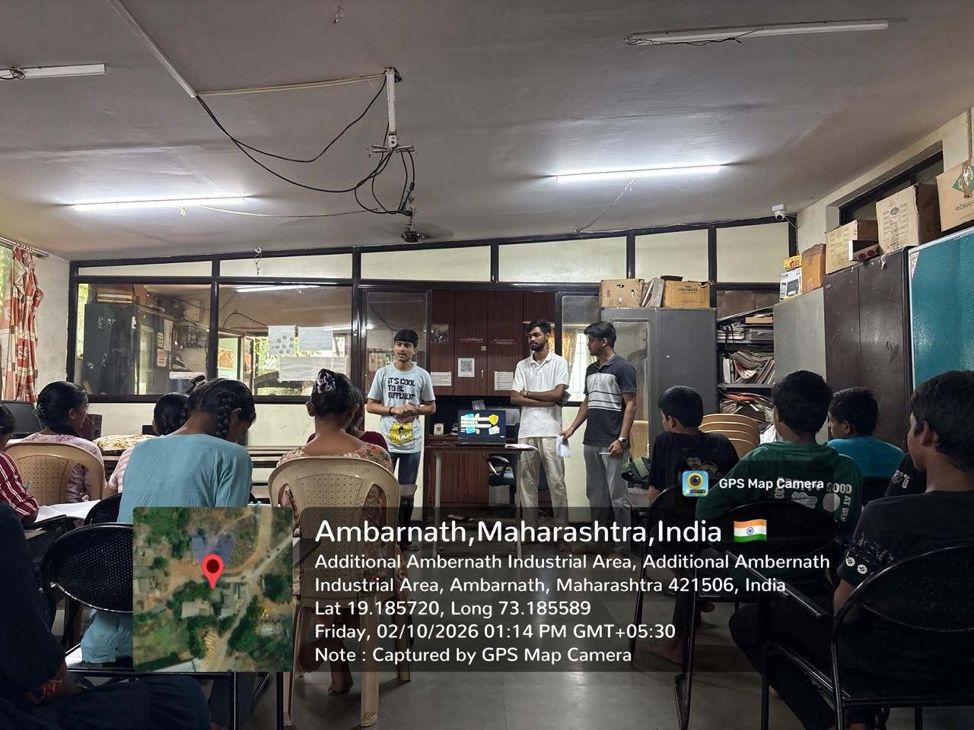
The third session addressed cyberbullying, how to respond to harmful behaviour online, and cybercrime reporting. Participants were encouraged to raise questions and doubts about the topics. The team responded to participants’ queries and explained the importance of seeking appropriate help when facing online-safety concerns.

Figure 3.1 — Awareness Session: Field Execution and Awareness Sessions.

3.6 Community Interaction
Community interaction was part of the awareness sessions. The team explained the selected topics, interacted with students, listened to their questions, and answered their queries and doubts. Presentations, verbal explanations, pictures, questions, and fun games were used to support communication and participation.
This interaction provided an opportunity for participants to ask for clarification about the topics being discussed. This chapter describes the interaction reported by the team; specific attendance figures for each session and a count of questions asked were not provided.
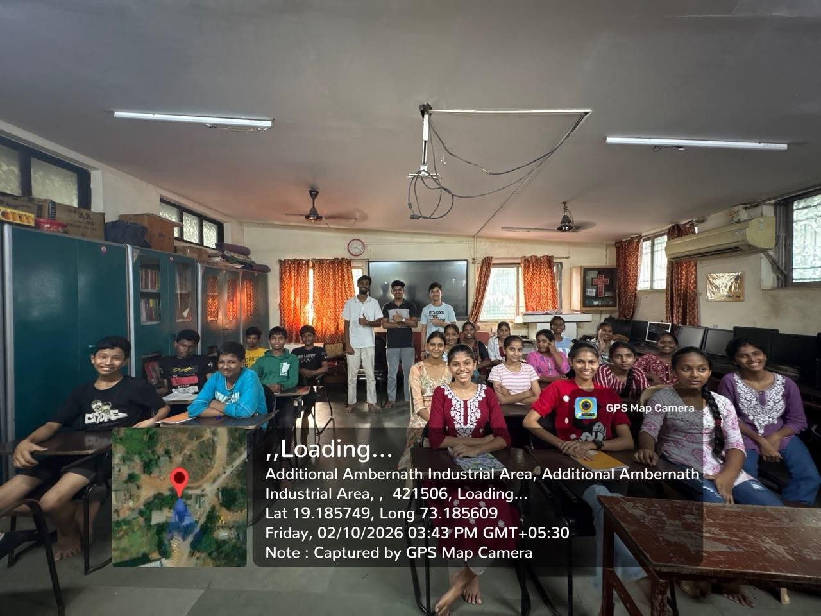
Figure 3.2 — Community Interaction

3.7 Stage Three: Follow-up Survey
The follow-up survey was conducted on 2 October 2026, after the awareness sessions, and 70 responses were recorded. The survey questions were asked verbally, and responses were recorded using the questionnaire approach described for the project.
The purpose of the follow-up survey was to record participants’ responses after the awareness activities and provide information for comparison with the baseline survey. The findings from both survey stages will be presented in Chapter 4 using tables and visualizations. The follow-up survey reflects responses at the time of collection and should not be treated as proof of long-term retention or behaviour change.

3.8 Tools and Materials Used
The tools and materials reported for the project were:
- Questionnaire used to collect baseline and follow-up responses.
- Laptop used to present material and support the awareness activities.
- PowerPoint presentations (PPTs) used during the sessions.
- Pictures shown to participants to support explanations.
- Verbal explanations, questions, and fun games used to encourage interaction.
No additional software, online platform, or technical equipment is included here because it was not specified in the information provided.

3.9 Consent, Documentation, and Participant Privacy
Participant consent was reported as having been obtained. Photographs and other documentation of the fieldwork are available and can be included in the appendices, subject to any applicable institutional requirements and participant privacy considerations.
Because the project involved students, identifying details should be handled carefully in the report. Survey findings should be presented in aggregate form, and participants’ names or other personally identifying details should not be displayed in analytical tables or charts unless there is a clear, approved reason to do so. Photographs should be used only where their inclusion is permitted and appropriate.

3.10 Hours Reported for Project Activities
The following table summarizes the time estimates supplied for the project. Ranges are retained as reported. The session duration is calculated from three sessions of approximately 2–2.5 hours each; the separate estimate of approximately 12 hours for field action is also retained as reported rather than silently reconciled.

3.11 Methodological Limitations
The project used self-reported questionnaire responses collected at two points around the awareness activities. Such responses are useful for describing participants’ stated awareness but do not necessarily demonstrate practical skill or actual behaviour outside the sessions. The follow-up survey was conducted on the same date as the three awareness sessions, so the results primarily describe responses recorded at that time rather than long-term retention.
The supplied time estimates are approximate and include ranges. The total time should be finalized against the team’s actual field logbook before the report is submitted. This chapter does not claim a precise total of completed CEP hours beyond the estimates supplied.

Table 3.1: Summary of Project Activities and Time Estimates
Activity | Reported duration
Preparation, study, and research for baseline survey | 12–15 hours
Baseline survey | 4–5 hours
Meetings with hostel/ashram head and staff | 2–3 hours
Initial field-action meeting with institutional head | 2 hours
Team preparation of presentation and lecture | 3 hours
Three awareness sessions | Approximately 2–2.5 hours per session; approximately  6–7.5 hours when calculated from the session durations
Field action total | Approximately 12 hours, as separately reported by the team
Follow-up survey | 3–4 hours
Total based on individual activity ranges, counting the three sessions separately | Approximately 32–39.5 hours; confirm against the field logbook before submission
Note: The activity estimates overlap in how the team described the field-action total. The team should verify the logbook before declaring a final total. The individual ranges and the separately reported field-action estimate are shown transparently.

CHAPTER 4
DATA ANALYSIS AND VISUALIZATIONS

4.1 Introduction
This chapter presents the analysis of the baseline survey conducted before the online-safety awareness activities and the follow-up survey conducted after the three awareness sessions. Each survey included 70 responses and used the same 12 questions. The analysis compares the response patterns before and after the field action, identifies the main areas of reported improvement, and discusses what the results can and cannot establish.
The findings are descriptive. They are presented mainly as counts out of 70 and percentages. A positive change in self-reported answers is evidence of a change in reported awareness, but it does not by itself prove practical competence or long-term retention.

4.2 Survey Sample and Participant Profile
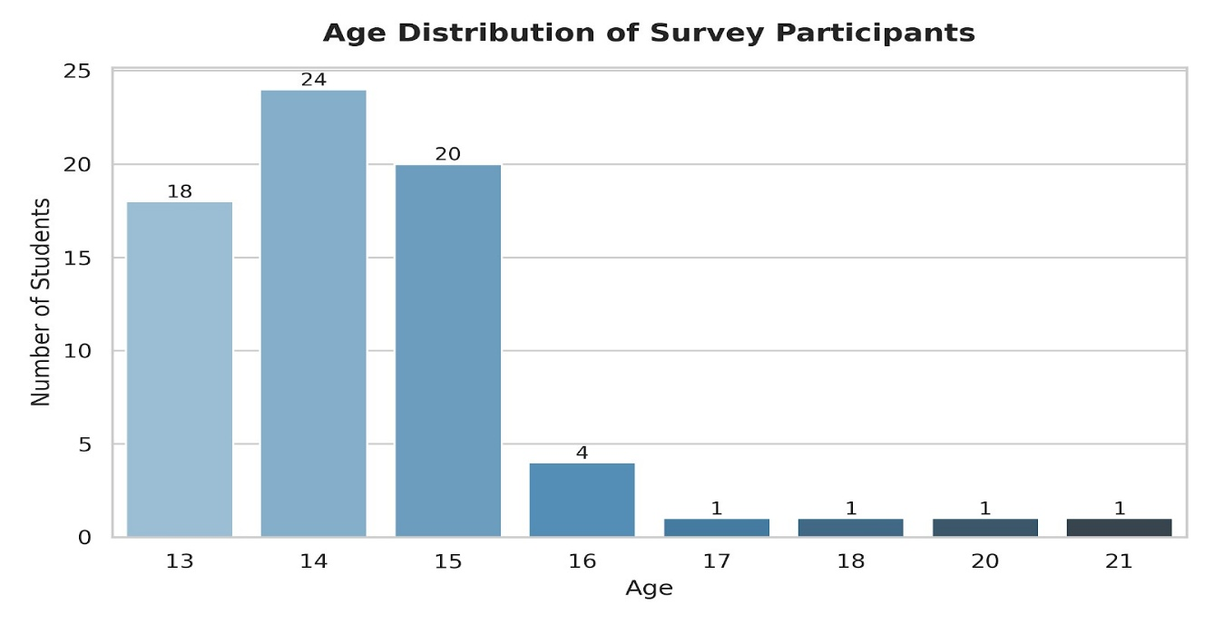
The baseline dataset contained 70 participants. The recorded ages were 13 (18 participants), 14 (24), 15 (20), 16 (4), 17 (1), 18 (1), 20 (1), and 21 (1). The largest group was age 14, followed by ages 15 and 13. Although the project initially focused on adolescents around ages 13–15, the recorded sample included participants aged 16–21 as well; therefore, the sample should not be described as consisting exclusively of 13–15-year-olds.

Figure 4.1: Age distribution of the 70 survey participants.

4.3 Baseline Survey Findings
The baseline survey indicated important gaps in self-reported online-safety awareness. Only 1 of 70 participants (1.4%) answered “Yes” to knowing what personal information should not be shared online, and only 1 of 70 (1.4%) reported knowing what an OTP is. No participants answered “Yes” to knowing about online frauds and scams, cyberbullying, or what to do when a cybercrime occurs. For Q10, 46 participants answered “No” and 24 answered “Not Sure” when asked whether they knew what to do if someone behaved badly toward them online. For Q11, 60 answered “No” and 10 answered “Not Sure” about identifying scams and fake messages.
Some areas showed a different baseline pattern. Sixty-five participants (92.9%) answered “Yes” to knowing what a strong password is, and 59 (84.3%) answered “Yes” to the confidence question. These responses suggest that awareness was not equally low across all topics.
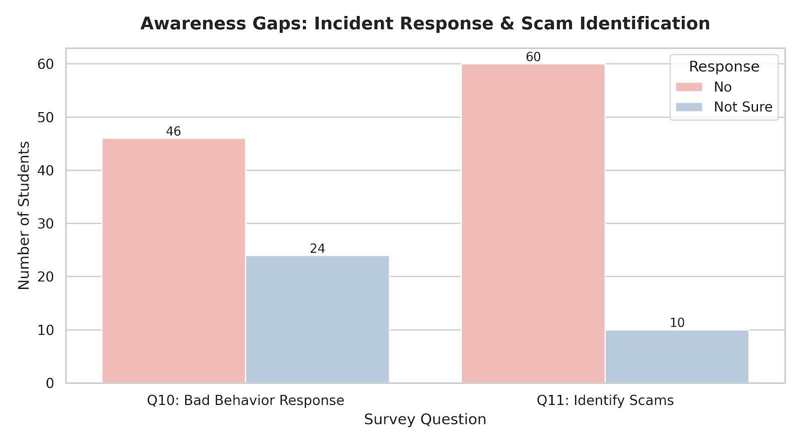

Figure 4.2: Baseline responses highlighting reported gaps in incident response and scam identification.

4.4 Overall Cybersecurity Metrics: Pre-Session and Post-Session
The overall comparison chart covers six indicators: strong-password awareness, confidence in staying safe online, OTP knowledge, knowing how to respond to bad online behaviour, scam identification, and Cyber Cell/reporting awareness. The affirmative responses increased across all six indicators in the follow-up survey.
Indicator | Baseline Yes | Baseline % | Follow-up Yes | Follow-up %
Strong-password awareness (Q4) | 65/70 | 92.9% | 70/70 | 100%
Reported onlinesafety confidence  (Q5) | 59/70 | 84.3% | 70/70 | 100%
OTP awareness (Q7) | 1/70 | 1.4% | 70/70 | 100%
Response to bad online behaviour | 0/70 | 0% | 70/70 | 100%
(Q10)
Scam/fake-message identification (Q11) | 0/70 | 0% | 69/70 | 98.6%
Cybercrime reporting/Cyber Cell awareness (Q12) | 0/70 | 0% | 70/70 | 100%
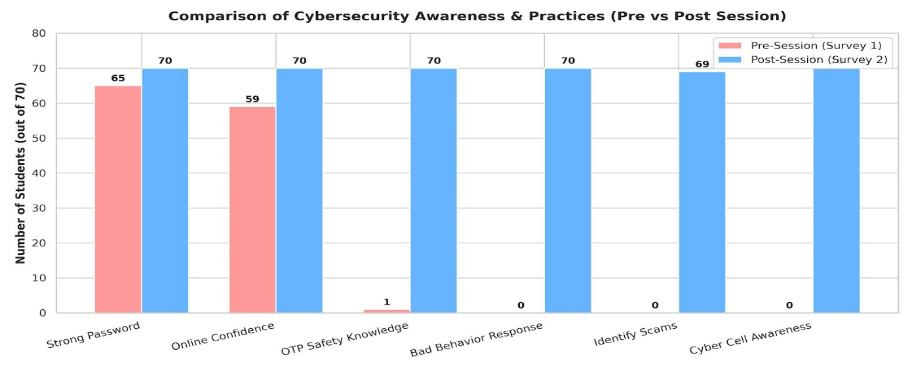
Across these six indicators, the follow-up survey recorded 419 affirmative responses out of 420 possible responses (99.8%), compared with 190 out of 420 (45.2%) at baseline. This aggregate is a simple descriptive summary of these six selected items; it should not be interpreted as a validated cybersecurity score. Q5 measures self-reported confidence rather than objective skill.

Figure 4.3: Comparison of affirmative responses across six selected online-safety indicators before and after the awareness sessions.

4.5 Growth in Fraud and Scam Awareness (Q6 and Q11)
At baseline, 0 of 70 participants (0%) answered “Yes” to knowing about online frauds and scams (Q6). For Q11, 0 of 70 answered “Yes” to being able to identify scams and fake messages; 60 answered “No” and 10 answered “Not Sure”. In the follow-up survey, 69 of 70 participants (98.6%) answered “Yes” to Q6 and 69 of 70 (98.6%) answered “Yes” to Q11.
These results show a large increase in reported fraud/scam awareness and perceived ability to identify scams after the sessions. However, because the questions were self-reported, the results do not demonstrate that each participant can reliably detect a real scam. A practical scenariobased test would be needed to assess that ability directly.
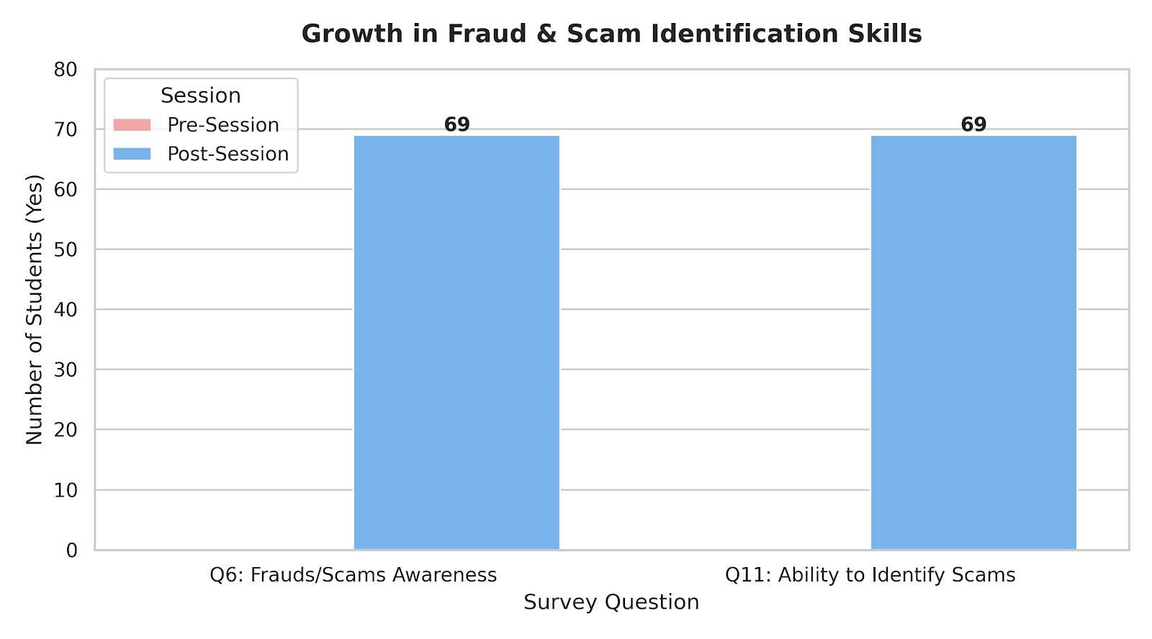
Figure 4.4: Baseline and follow-up affirmative responses for fraud/scam awareness and scam identification.

4.6 Improvement in Incident Response and Cyber Cell Awareness (Q10 and Q12)
For Q10, which asked whether participants knew what to do if someone behaved badly toward them online, the baseline survey recorded 46 “No” responses, 24 “Not Sure” responses, and no “Yes” responses. In the follow-up survey, all 70 participants (100%) answered “Yes”. For Q12, about what to do when a cybercrime occurs and awareness of the IT & Cyber Cell, the baseline survey recorded no “Yes” responses; all 70 participants (100%) answered “Yes” in the followup.
Among the measured topics, these changes were especially pronounced. They suggest that the sessions were associated with a substantial increase in participants’ reported knowledge of how to respond to harmful online behaviour and where cybercrime reporting support may be available. The survey did not independently test whether participants could complete a reporting process.
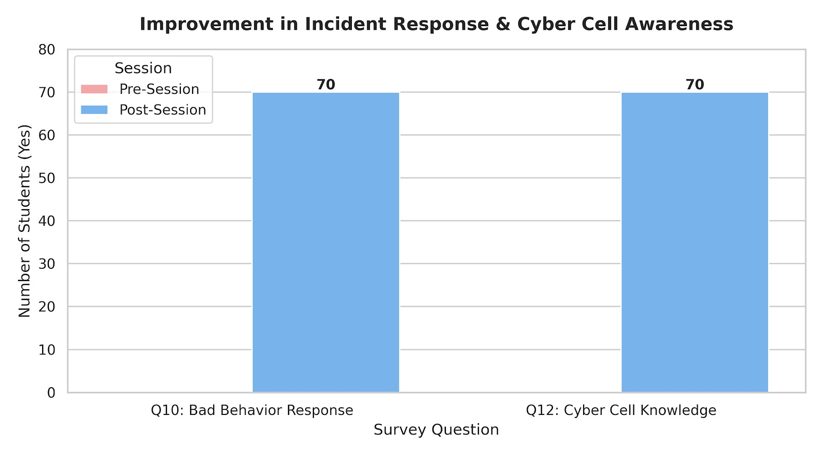
4.5: Reported knowledge of responding to harmful online behaviour and cybercrime reporting before and after the sessions.

4.7 Improvement in Privacy Protection and OTP Awareness (Q2 and Q7)
For Q2, which asked whether participants knew what personal information should not be shared online, 1 participant (1.4%) answered “Yes” at baseline. In the follow-up, 69 participants (98.6%) answered “Yes” and 1 answered “Not Sure”. For Q7, OTP awareness increased from 1 “Yes” response (1.4%) at baseline to 70 “Yes” responses (100%) in the follow-up.
The findings indicate a substantial increase in self-reported awareness of privacy protection and OTPs. Because OTPs can be used to authorize access or transactions, awareness sessions should reinforce that such codes must not be shared with other people. The survey results themselves, however, do not measure how participants would behave when faced with an actual request for an OTP.
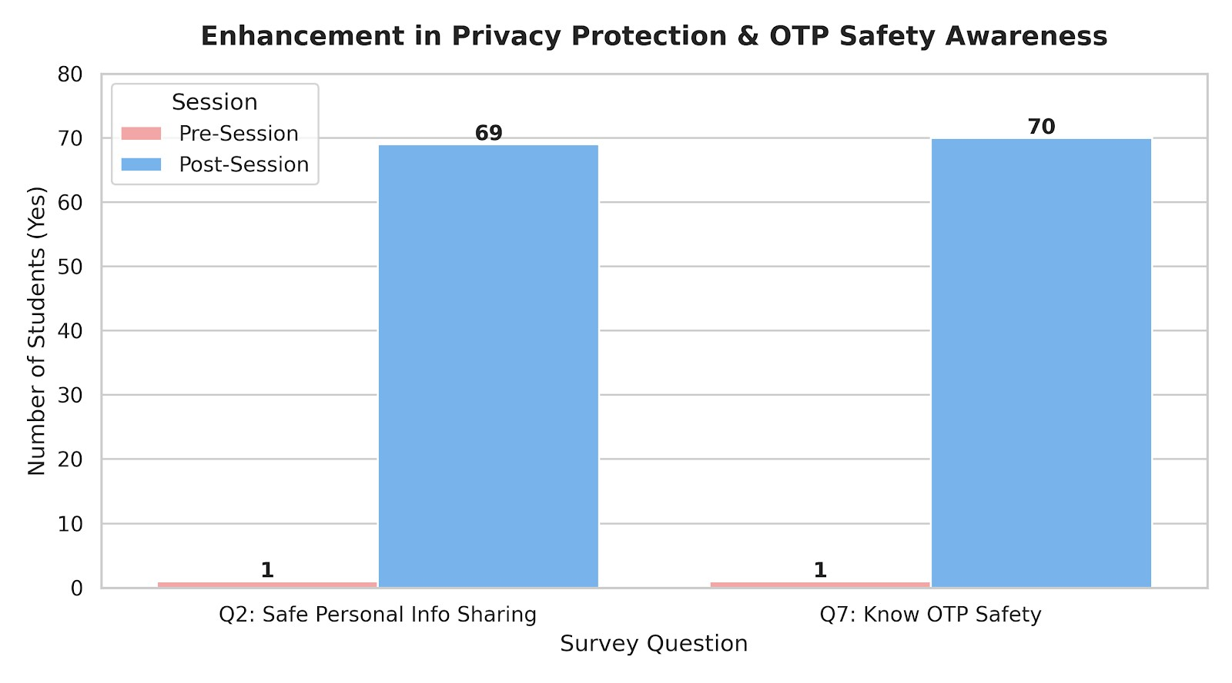
Figure 4.6: Baseline and follow-up responses on personal-information protection and OTP awareness.

4.8 Safe Response to Unknown Links and Online Confidence
For Q3, which asked whether a participant would open a link sent by an unknown person, the safer response is “No”. At baseline, 69 of 70 participants (98.6%) answered “No”; all 70 (100%) answered “No” in the follow-up. This item therefore shows a small improvement in the safe response, not a shift from low to high awareness.
For Q5, the number answering “Yes” to the confidence question increased from 59 (84.3%) at baseline to 70 (100%) in the follow-up. As the response options were “Yes”, “No”, and “Not Sure”, this is a count of affirmative self-reports, not a numerical confidence scale. The results should be described as increased reported confidence rather than proven competence.
If a separate safety-and-confidence graph is included, label the unknown-link item as the percentage selecting the safer answer (“No”) and label Q5 as affirmative self-reported confidence. Do not combine the two as though “Yes” is the desirable answer for both.

4.9 Summary of Key Statistical Findings
- Personal-information awareness (Q2) increased from 1/70 (1.4%) to 69/70 (98.6%) affirmative responses.
- OTP awareness (Q7) increased from 1/70 (1.4%) to 70/70 (100%).
- Fraud/scam awareness (Q6) increased from 0/70 (0%) to 69/70 (98.6%).
- Reported ability to identify scams (Q11) increased from 0/70 (0%) to 69/70 (98.6%).
- Reported knowledge of responding to bad online behaviour (Q10) increased from 0/70 (0%) to 70/70 (100%).
- Cybercrime reporting/Cyber Cell awareness (Q12) increased from 0/70 (0%) to 70/70 (100%).
- The safer response to unknown links (Q3: “No”) was already high at baseline and increased from 69/70 (98.6%) to 70/70 (100%).
Overall, the baseline results identified reported awareness gaps in privacy, OTPs, scams, cyberbullying response, and cybercrime reporting. The follow-up responses showed markedly higher self-reported awareness across these topics, with affirmative responses reaching 98.6%– 100% on the indicators highlighted above. These results are consistent with a positive immediate learning response to the awareness sessions, while not establishing long-term retention or independently verified practical competence.

4.10 Limitations of the Analysis
- The analysis is based on 70 baseline and 70 follow-up responses. Although the sample sizes match, aggregate comparisons alone do not confirm that every response can be paired reliably at individual level.
- The follow-up survey was conducted on the same date as the awareness sessions, so the analysis measures immediate self-reported change rather than retention over time.
- Most questions rely on self-report and do not directly test practical cybersecurity skills.
- Q5 is a categorical confidence question, not a validated numerical scale.
- Q3 must be interpreted in reverse relative to most questions: “No” is the safer answer when asked about opening a link from an unknown person.
- The sample includes participants aged 13–21, not only ages 13–15.

4.11 Chapter Conclusion
The descriptive comparison indicates a substantial increase in reported online-safety awareness following the three awareness sessions. The largest changes were observed in reported knowledge of OTPs, fraud/scam awareness, incident response, and cybercrime reporting. The unknown-link item was already strong at baseline and remained strong in the follow-up. The project therefore provides encouraging evidence of immediate self-reported learning, but a later follow-up and practical scenario-based assessment would be needed to evaluate retention and application.

CHAPTER 5
CONCLUSION AND RECOMMENDATIONS

5.1 Introduction
This chapter presents the overall conclusion of the Community Engagement Programme (CEP) titled “Online Safety for Children and Adolescents,” conducted at Anugrah Seva Mandal Anugrah Children’s Hostel. It summarizes the project activities, interprets the baseline and follow-up survey findings, identifies limitations, and provides recommendations for sustaining and strengthening online-safety awareness.

5.2 Summary of the Project
The project aimed to improve participants’ awareness of online safety and responsible internet use. A baseline survey was conducted on 28 September 2026 with 70 responses to identify areas where participants reported limited awareness. Based on the initial findings, the team conducted three awareness sessions on 2 October 2026 and collected 70 follow-up survey responses.
The sessions covered three broad areas: (1) personal information, privacy, and strong passwords;
(2) OTPs, suspicious links, online scams, and safe internet use; and (3) cyberbullying, responding to harmful online behaviour, and cybercrime reporting. The team used verbal explanations, PowerPoint presentations, pictures, questions, and interactive games. Participants were given opportunities to ask questions and clarify doubts.

5.3 Major Findings
The baseline survey showed that reported awareness was low in several important areas. Only 1 of 70 participants (1.4%) initially answered “Yes” to knowing what personal information should not be shared online, and only 1 of 70 (1.4%) reported knowing what an OTP is. No participants answered “Yes” to the baseline questions on awareness of online frauds and scams, cyberbullying, or knowledge of what to do when cybercrime occurs.
The follow-up survey recorded substantially higher affirmative responses in these areas. Personal-information awareness increased from 1 of 70 to 69 of 70 participants (98.6%); OTP awareness increased from 1 of 70 to 70 of 70 (100%); and fraud/scam awareness increased from 0 of 70 to 69 of 70 (98.6%). Reported knowledge of responding to harmful online behaviour and cybercrime reporting increased from no affirmative baseline responses to 70 of 70 (100%) in the follow-up.
The response to the unknown-link question requires separate interpretation. For this question,
“No” is the safer answer. Sixty-nine participants (98.6%) selected “No” at baseline, and all 70 (100%) selected “No” in the follow-up. This suggests that the safer response was already widely reported before the sessions and remained high afterward.
Taken together, the survey results show a marked increase in self-reported online-safety awareness immediately after the educational activities. The findings are consistent with a positive immediate learning response, particularly for privacy, OTPs, scam awareness, incident response, and cybercrime reporting.

5.4 Conclusion
The CEP provided an opportunity to engage with the community and address practical onlinesafety topics relevant to children and adolescents. The baseline survey helped identify areas requiring attention, while the three awareness sessions provided focused explanations and interactive learning activities. The follow-up responses showed considerably higher reported awareness across several of the topics discussed.
The project therefore met its immediate awareness-raising purpose as reflected in participants’ post-session responses. It also highlighted the value of explaining online risks in simple language and giving participants opportunities to ask questions. However, the findings should be interpreted as changes in self-reported answers rather than proof that every participant can consistently recognize scams, respond to cyberbullying, or complete a cybercrime report independently.
A future assessment after several weeks, together with short scenario-based exercises, would provide stronger evidence of whether the knowledge is retained and applied in real situations.

5.5 Recommendations
- Conduct periodic refresher sessions. The hostel or institution can arrange short follow-up discussions to revisit privacy, passwords, OTPs, suspicious links, scams, cyberbullying, and reporting procedures.
- Use practical examples and scenario-based activities. Participants can be shown sample suspicious messages, fake offers, unknown links, and requests for OTPs and asked to explain the safest response. Examples should be fictional or safely anonymized.
- Reinforce personal-information protection. Explain which details should not be shared publicly, including passwords, OTPs, account credentials, and sensitive personal or family information.
- Teach clear steps for responding to cyberbullying or harmful online behaviour. Participants should be encouraged to avoid retaliating, preserve relevant evidence where safe, block or report abusive accounts, and seek help from a trusted adult or responsible staff member.
- Explain verified cybercrime reporting channels. Provide participants and staff with current, official information about cybercrime reporting in India. Verify contact details from official sources before printing them in any handout.
- Involve hostel staff and caregivers. Staff and caregivers can reinforce the lessons, encourage participants to report uncomfortable online experiences, and help them access support without blame or embarrassment.
- Assess retention and practical understanding. Repeat a short survey after a few weeks and include simple scenario questions. Compare the results with the immediate follow-up to assess whether awareness is retained.
- Protect participants’ privacy in project documentation. Keep survey data aggregated in the report, store records securely, and use photographs only with appropriate permission and consent. Avoid publishing identifiable personal information.

5.6 Limitations of the Project
- The project involved 70 baseline responses and 70 follow-up responses at one community location; findings may not represent all children or adolescents.
- The follow-up survey was conducted on the same date as the awareness sessions, so it measures immediate self-reported responses rather than long-term retention.
- The questions relied mainly on participants’ own reports and did not independently test practical skills in identifying scams or completing reporting steps.
- The age records ranged from 13 to 21, so the participant group was broader than the intended focus on ages 13–15.
- Matching sample sizes do not by themselves prove that every baseline response can be paired with the same participant’s follow-up response for individual-level analysis.

5.7 Scope for Future Work
Future CEP activities could include a follow-up survey after four to six weeks, practical identification exercises using sample messages, a short safety checklist displayed in the hostel, and a simple guide for seeking help when online harm occurs. If the institution agrees, the project could also be repeated with another group and the results compared using the same questions and consistent data-collection procedures.

5.8 Final Conclusion
The project addressed relevant online-safety concerns through a baseline survey, three focused awareness sessions, and a follow-up survey. The post-session responses showed substantial increases in reported awareness of privacy, OTPs, scams, responding to harmful online behaviour, and cybercrime reporting. These findings indicate encouraging immediate results from the community awareness activity. Continued reinforcement, practical assessment, and a later follow-up are recommended to determine whether participants retain and apply the information over time.

Note on Fieldwork Photographs
Fieldwork photographs belong primarily in Chapter 3, where project activities and community interaction are described, rather than in Chapter 5. Place Figure 3.2 (Community Interaction) in Section 3.6, immediately after the paragraph describing the team’s interaction with participants, answering questions, or conducting the survey. Use only an authentic project photograph with appropriate permission and consent.

APPENDICES
Appendix A — DAILY FIELDWORK LOGBOOK
1. Student Details
Student Name: Om Santosh Mishra | Roll No : 44
Project Title: ONLINE SAFETY FOR CHILDREN  AND ADOLESCENTS | Target Location: Anugrah Seva Mandal, Phansiphada, MIDC, Ambernath, Mahrashtra
2. Attendance & Activity Log (Target: 30 Fieldwork Hours | Fill entries on the day of field visit)
Entry | Date & Time | Hours | Brief Description of Activity & Technical Work | Participants | Student Sign
01 | 28th September  10:00 AM | 11 | Day 1: Baseline Survey Meetings,Preparation & Survey Conduct | 70 Students
02 | 02nd October  7:00 AM | 4 | Day 2: Session 1 | 70 Students
03 | 02nd October  12:00 PM | 4 | Day 2: Session 2 | 70 Students
04 | 02nd October  4:30 PM | 4 | Day 2: Session 3 | 70 Students
05 | 03rd October  11:00 AM | 7 | Day 3: Follow-up After-Session Survey | 70 Students
3. Declaration & Guide Evaluation
Student Declaration & Verification:  • Total Field Hours Completed: _______ / 30 Hours  • Total Participants Reached: _______  Student Sign: __________________ Date: ________ | Faculty Guide Evaluation (Internal Marks: 10):  • Attendance & Log Verified: [ ] Yes [ ] No  • Approved Field Hours: _______ / 30 Hours  • Guide Sign: ____________________ Date: ________

Appendix B — Survey Questionnaire and Sample Survey Forms
Include a blank copy of the questionnaire used for both the baseline and follow-up surveys. If completed sample forms are included, remove names and other information that could identify individual participants.
Survey questions used in the project:
Q1. Do you have access to the internet?
Q2. Do you know which personal information should not be shared online?
Q3. Would you open a link sent by an unknown person?
Q4. Do you know how to create a strong password?
Q5. Do you feel confident about staying safe online?
Q6. Do you know about online fraud and scams?
Q7. Do you know what an OTP is and how to keep it safe?
Q8. Do you use online games or digital accounts?
Q9. Do you know what cyberbullying is?
Q10. Do you know what to do if someone behaves badly toward you online?
Q11. Can you identify suspicious messages or online scams?
Q12. Do you know how to report cybercrime or what the IT & Cyber Cell does?
Response options: Yes / No / Not Sure.

Baseline Survey Data
Student Name | Age | Q1 (Internet Access) | Q2 (Personal Info) | Q3 (Unknown Link) | Q4 (Strong Password) | Q5 (Confidence) | Q6 (Frauds/Scams) | Q7 (Know OTP) | Q8 (Online Games) | Q9 (Cyberbullying) | Q10 (Bad Behavior Response) | Q11 (Identify Scams) | Q12 (Cyber Cell)
Roshni | 14 | Yes | No | No | Yes | Yes | No | No | Yes | No | No | No | No
Deepali Waghe | 15 | Yes | No | No | Yes | Yes | No | No | Yes | No | Not Sure | No | No
Hirkani Athawale | 13 | Yes | No | No | Yes | Yes | No | No | Yes | No | No | No | No
Sania Sheikh | 14 | Yes | No | No | Yes | Yes | No | No | Yes | No | Not Sure | Not Sure | No
Gracy Torne | 15 | Yes | No | No | Yes | No | No | No | Yes | No | No | No | No
Naomi Poojari | 13 | Yes | No | No | Yes | Yes | No | No | Yes | No | No | No | No
Ruth Kujur | 14 | Yes | No | No | Yes | Yes | No | No | Yes | No | Not Sure | No | No
Abraham Kami | 15 | Yes | No | No | Yes | Yes | No | No | Yes | No | No | No | No
Stavan Bhalerao | 14 | Yes | Yes | No | Yes | Yes | No | No | Yes | Yes | Not Sure | No | No
Aarav Patel | 13 | Yes | No | No | Yes | Yes | No | No | Yes | No | No | Not Sure | No
Vihaan Sharma | 14 | Yes | No | No | Yes | No | No | No | Yes | No | No | No | No
Vivaan Singh | 15 | Yes | No | Yes | Yes | Yes | No | No | Yes | No | Not Sure | No | No
Ananya Gupta | 13 | Yes | No | No | Yes | Yes | No | No | Yes | No | No | No | No
Diya Das | 14 | Yes | No | No | No | Yes | No | No | Yes | No | No | No | No
Advik Kumar | 15 | Yes | No | No | Yes | Yes | No | No | Yes | No | Not Sure | No | No
Myra Desai | 14 | Yes | No | No | Yes | Yes | No | No | Yes | No | No | Not Sure | No
Arjun Malhotra | 13 | Yes | No | No | Yes | No | No | No | Yes | No | No | No | No
Sai Joshi | 15 | Yes | No | No | Yes | Yes | No | No | Yes | No | Not Sure | No | No
Yash Verma | 14 | Yes | No | No | Yes | Yes | No | No | Yes | No | No | No | No
Riya Mishra | 16 | Yes | No | No | Yes | Yes | No | Yes | Yes | No | No | No | No
Aahil Khan | 15 | Yes | No | No | Yes | Yes | No | No | Yes | No | Not Sure | No | No
Ishaan Reddy | 14 | Yes | No | No | Yes | Yes | No | No | Yes | No | No | No | No
Kavya Nair | 13 | Yes | No | No | Yes | Yes | No | No | Yes | No | No | Not Sure | No
Aditya Iyer | 14 | Yes | No | No | No | Yes | No | No | Yes | No | Not Sure | No | No
Kabir Kapoor | 15 | Yes | No | No | Yes | No | No | No | Yes | No | No | No | No
Shaurya Menon | 13 | Yes | No | No | Yes | Yes | No | No | Yes | No | No | No | No
Aadhya Bose | 14 | Yes | No | No | Yes | Yes | No | No | Yes | No | Not Sure | No | No
Dhruv Chatterjee | 15 | No | No | No | Yes | Yes | No | No | Yes | No | No | No | No
Kiara Sen | 13 | Yes | No | No | Yes | Yes | No | No | Yes | No | No | No | No
Prisha Rao | 14 | Yes | No | No | Yes | Yes | No | No | Yes | No | Not Sure | Not Sure | No
Aryan Bhat | 15 | Yes | No | No | Yes | Yes | No | No | Yes | No | No | No | No
Atharv Kadam | 13 | Yes | No | No | Yes | No | No | No | Yes | No | No | No | No
Rudra Patil | 14 | Yes | No | No | Yes | Yes | No | No | Yes | No | Not Sure | No | No
Ira Deshmukh | 15 | Yes | No | No | Yes | Yes | No | No | Yes | No | No | No | No
Reyansh Joshi | 13 | Yes | No | No | No | Yes | No | No | Yes | No | No | No | No
Rohan Kulkarni | 14 | Yes | No | No | Yes | Yes | No | No | No | No | Not Sure | No | No
Kritika Sharma | 15 | Yes | No | No | Yes | Yes | No | No | Yes | No | No | No | No
Anika Yadav | 13 | Yes | No | No | Yes | Yes | No | No | Yes | No | No | Not Sure | No
Vedant Rane | 14 | Yes | No | No | Yes | No | No | No | Yes | No | Not Sure | No | No
Aarohi Chalke | 15 | Yes | No | No | Yes | Yes | No | No | Yes | No | No | No | No
Siddharth More | 16 | Yes | No | No | Yes | Yes | No | No | Yes | No | No | No | No
Neha Tambe | 14 | Yes | No | No | Yes | Yes | No | No | Yes | No | Not Sure | No | No
Sneha Kande | 15 | Yes | No | No | Yes | Yes | No | No | Yes | No | No | No | No
Rahul Pawar | 13 | Yes | No | No | Yes | Yes | No | No | Yes | No | No | No | No
Karan Jadhav | 14 | Yes | No | No | Yes | No | No | No | Yes | No | Not Sure | No | No
Pooja Shinde | 15 | Yes | No | No | Yes | Yes | No | No | Yes | No | No | Not Sure | No
Manav Munde | 13 | Yes | No | No | Yes | Yes | No | No | Yes | No | No | No | No
Shweta Bhosale | 14 | Yes | No | No | No | Yes | No | No | Yes | No | Not Sure | No | No
Tarun Gokhale | 15 | Yes | No | No | Yes | Yes | No | No | No | No | No | No | No
Divya Apte | 15 | Yes | No | No | Yes | Yes | No | No | Yes | No | No | No | No
Kunal Pandit | 14 | Yes | No | No | Yes | Yes | No | No | Yes | No | Not Sure | No | No
Aarti Dalvi | 15 | Yes | No | No | Yes | No | No | No | Yes | No | No | No | No
Prateek Mane | 13 | Yes | No | No | Yes | Yes | No | No | Yes | No | No | No | No
Nidhi Shirke | 14 | No | No | No | Yes | Yes | No | No | Yes | No | Not Sure | Not Sure | No
Sameer Kale | 20 | Yes | No | No | Yes | Yes | No | No | Yes | No | No | No | No
Tanvi Thakur | 13 | Yes | No | No | Yes | Yes | No | No | Yes | No | No | No | No
Ishita Sawant | 14 | Yes | No | No | Yes | No | No | No | Yes | No | Not Sure | No | No
Vishal Wagh | 15 | Yes | No | No | Yes | Yes | No | No | Yes | No | No | No | No
Ritu Mahajan | 13 | Yes | No | No | Yes | Yes | No | No | Yes | No | No | No | No
Virat Sharma | 14 | Yes | No | No | No | Yes | No | No | Yes | No | Not Sure | No | No
Disha Naik | 17 | Yes | No | No | Yes | Yes | No | No | Yes | No | No | No | No
Ruth Kujur | 13 | Yes | No | No | Yes | Yes | No | No | Yes | No | No | Not Sure | No
Rohit Mainal | 14 | Yes | No | No | Yes | No | No | No | Yes | No | Not Sure | No | No
Malvinda Samsa | 16 | Yes | No | No | Yes | Yes | No | No | Yes | No | No | No | No
Yohan Jhadav | 13 | Yes | No | No | Yes | Yes | No | No | Yes | No | No | No | No
Siddharth Mastipuram | 14 | Yes | No | No | Yes | Yes | No | No | Yes | No | Not Sure | No | No
Aron Fernandes | 15 | Yes | No | No | Yes | Yes | No | No | Yes | No | No | No | No
Rajeev Shetty | 16 | Yes | No | No | Yes | No | No | No | Yes | No | No | Not Sure | No
Sujata Shelar | 18 | Yes | No | No | Yes | Yes | No | No | Yes | No | Not Sure | No | No
Babli Warne | 21 | Yes | No | No | Yes | Yes | No | No | No | No | No | No | No

Follow-up Survey Data
Student Name | Age | Q1 (Internet Access) | Q2 (Personal Info) | Q3 (Unknown Link) | Q4 (Strong Password) | Q5 (Confidence) | Q6 (Frauds/Scams) | Q7 (Know OTP) | Q8 (Online Games) | Q9 (Cyberbullying) | Q10 (Bad Behavior Response) | Q11 (Identify Scams) | Q12 (Cyber Cell)
Roshni | 14 | Yes | Yes | No | Yes | Yes | Yes | Yes | Yes | Yes | Yes | Yes | Yes
Deepali Waghe | 15 | Yes | Yes | No | Yes | Yes | Yes | Yes | Yes | Yes | Yes | Yes | Yes
Hirkani Athawale | 13 | Yes | Yes | No | Yes | Yes | Yes | Yes | Yes | Yes | Yes | Yes | Yes
Sania Sheikh | 14 | Yes | Yes | No | Yes | Yes | Yes | Yes | Yes | Yes | Yes | Yes | Yes
Gracy Torne | 15 | Yes | Yes | No | Yes | Yes | Yes | Yes | Yes | Yes | Yes | Yes | Yes
Naomi Poojari | 13 | Yes | Yes | No | Yes | Yes | Yes | Yes | Yes | Yes | Yes | Yes | Yes
Ruth Kujur | 14 | Yes | Yes | No | Yes | Yes | Yes | Yes | Yes | Yes | Yes | Yes | Yes
Abraham Kami | 15 | Yes | Yes | No | Yes | Yes | Yes | Yes | Yes | Yes | Yes | Yes | Yes
Stavan Bhalerao | 14 | Yes | Yes | No | Yes | Yes | Yes | Yes | Yes | Yes | Yes | Yes | Yes
Aarav Patel | 13 | Yes | Yes | No | Yes | Yes | Yes | Yes | Yes | Yes | Yes | Yes | Yes
Vihaan Sharma | 14 | Yes | Yes | No | Yes | Yes | Yes | Yes | Yes | Yes | Yes | Yes | Yes
Vivaan Singh | 15 | Yes | Yes | No | Yes | Yes | Yes | Yes | Yes | Yes | Yes | Yes | Yes
Ananya Gupta | 13 | Yes | Yes | No | Yes | Yes | Yes | Yes | Yes | Yes | Yes | Yes | Yes
Diya Das | 14 | Yes | Yes | No | Yes | Yes | Yes | Yes | Yes | Yes | Yes | Yes | Yes
Advik Kumar | 15 | Yes | Yes | No | Yes | Yes | Yes | Yes | Yes | Yes | Yes | Yes | Yes
Myra Desai | 14 | Yes | Yes | No | Yes | Yes | Yes | Yes | Yes | Yes | Yes | Yes | Yes
Arjun Malhotra | 13 | Yes | Yes | No | Yes | Yes | Yes | Yes | Yes | Yes | Yes | Yes | Yes
Sai Joshi | 15 | Yes | Yes | No | Yes | Yes | Yes | Yes | Yes | Yes | Yes | Yes | Yes
Yash Verma | 14 | Yes | Yes | No | Yes | Yes | Yes | Yes | Yes | Yes | Yes | Yes | Yes
Riya Mishra | 16 | Yes | Yes | No | Yes | Yes | Yes | Yes | Yes | Yes | Yes | Yes | Yes
Aahil Khan | 15 | Yes | Yes | No | Yes | Yes | Yes | Yes | Yes | Yes | Yes | Yes | Yes
Ishaan Reddy | 14 | Yes | Yes | No | Yes | Yes | Yes | Yes | Yes | Yes | Yes | Yes | Yes
Kavya Nair | 13 | Yes | Yes | No | Yes | Yes | Yes | Yes | Yes | Yes | Yes | Yes | Yes
Aditya Iyer | 14 | Yes | Yes | No | Yes | Yes | Yes | Yes | Yes | Yes | Yes | Yes | Yes
Kabir Kapoor | 15 | Yes | Yes | No | Yes | Yes | Yes | Yes | Yes | Yes | Yes | Yes | Yes
Shaurya Menon | 13 | Yes | Yes | No | Yes | Yes | Yes | Yes | Yes | Yes | Yes | Yes | Yes
Aadhya Bose | 14 | Yes | Yes | No | Yes | Yes | Yes | Yes | Yes | Yes | Yes | Yes | Yes
Dhruv Chatterjee | 15 | Yes | Yes | No | Yes | Yes | Yes | Yes | Yes | Yes | Yes | Yes | Yes
Kiara Sen | 13 | Yes | Yes | No | Yes | Yes | Yes | Yes | Yes | Not Sure | Yes | Yes | Yes
Prisha Rao | 14 | Yes | Yes | No | Yes | Yes | Yes | Yes | Yes | Yes | Yes | Yes | Yes
Aryan Bhat | 15 | Yes | Yes | No | Yes | Yes | Yes | Yes | Yes | Yes | Yes | Yes | Yes
Atharv Kadam | 13 | Yes | Yes | No | Yes | Yes | Yes | Yes | Yes | Yes | Yes | Yes | Yes
Rudra Patil | 14 | Yes | Yes | No | Yes | Yes | Yes | Yes | Yes | Yes | Yes | Yes | Yes
Ira Deshmukh | 15 | Yes | Yes | No | Yes | Yes | Yes | Yes | Yes | Yes | Yes | Yes | Yes
Reyansh Joshi | 13 | Yes | Yes | No | Yes | Yes | Yes | Yes | Yes | Yes | Yes | Yes | Yes
Rohan Kulkarni | 14 | Yes | Yes | No | Yes | Yes | Yes | Yes | Yes | Yes | Yes | Yes | Yes
Kritika Sharma | 15 | Yes | Yes | No | Yes | Yes | Yes | Yes | Yes | Yes | Yes | Yes | Yes
Anika Yadav | 13 | Yes | Yes | No | Yes | Yes | Yes | Yes | Yes | Yes | Yes | Yes | Yes
Vedant Rane | 14 | Yes | Yes | No | Yes | Yes | Yes | Yes | Yes | Yes | Yes | Yes | Yes
Aarohi Chalke | 15 | Yes | Yes | No | Yes | Yes | Yes | Yes | Yes | Yes | Yes | Yes | Yes
Siddharth More | 16 | Yes | Yes | No | Yes | Yes | Yes | Yes | Yes | Yes | Yes | Yes | Yes
Neha Tambe | 14 | Yes | Yes | No | Yes | Yes | Yes | Yes | Yes | Yes | Yes | Yes | Yes
Sneha Kande | 15 | Yes | Yes | No | Yes | Yes | Not Sure | Yes | Yes | Yes | Yes | Yes | Yes
Rahul Pawar | 13 | Yes | Yes | No | Yes | Yes | Yes | Yes | Yes | Yes | Yes | Yes | Yes
Karan Jadhav | 14 | Yes | Yes | No | Yes | Yes | Yes | Yes | Yes | Yes | Yes | Yes | Yes
Pooja Shinde | 15 | Yes | Yes | No | Yes | Yes | Yes | Yes | Not Sure | Yes | Yes | Yes | Yes
Manav Munde | 13 | Yes | Yes | No | Yes | Yes | Yes | Yes | Yes | Yes | Yes | Yes | Yes
Shweta Bhosale | 14 | Yes | Yes | No | Yes | Yes | Yes | Yes | Yes | Yes | Yes | Yes | Yes
Tarun Gokhale | 15 | Yes | Yes | No | Yes | Yes | Yes | Yes | Yes | Yes | Yes | Yes | Yes
Divya Apte | 15 | Yes | Yes | No | Yes | Yes | Yes | Yes | Yes | Yes | Yes | Yes | Yes
Kunal Pandit | 14 | Yes | Yes | No | Yes | Yes | Yes | Yes | Yes | Yes | Yes | Yes | Yes
Aarti Dalvi | 15 | Yes | Yes | No | Yes | Yes | Yes | Yes | Yes | Yes | Yes | Yes | Yes
Prateek Mane | 13 | Yes | Yes | No | Yes | Yes | Yes | Yes | Yes | Yes | Yes | Yes | Yes
Nidhi Shirke | 14 | Yes | Yes | No | Yes | Yes | Yes | Yes | Yes | Yes | Yes | Yes | Yes
Sameer Kale | 20 | Yes | Yes | No | Yes | Yes | Yes | Yes | Yes | Yes | Yes | Yes | Yes
Tanvi Thakur | 13 | Yes | Yes | No | Yes | Yes | Yes | Yes | Yes | Yes | Yes | Yes | Yes
Ishita Sawant | 14 | Yes | Yes | No | Yes | Yes | Yes | Yes | Yes | Yes | Yes | Yes | Yes
Vishal Wagh | 15 | Yes | Yes | No | Yes | Yes | Yes | Yes | Yes | Yes | Yes | Yes | Yes
Ritu Mahajan | 13 | Yes | Yes | No | Yes | Yes | Yes | Yes | Yes | Yes | Yes | Not Sure | Yes
Virat Sharma | 14 | Yes | Yes | No | Yes | Yes | Yes | Yes | Yes | Yes | Yes | Yes | Yes
Disha Naik | 17 | Yes | Yes | No | Yes | Yes | Yes | Yes | Yes | Yes | Yes | Yes | Yes
Ruth Kujur | 13 | Yes | Yes | No | Yes | Yes | Yes | Yes | Yes | Yes | Yes | Yes | Yes
Rohit Mainal | 14 | Yes | Yes | No | Yes | Yes | Yes | Yes | Yes | Yes | Yes | Yes | Yes
Malvinda Samsa | 16 | Yes | Not Sure | No | Yes | Yes | Yes | Yes | Yes | Yes | Yes | Yes | Yes
Yohan Jhadav | 13 | Yes | Yes | No | Yes | Yes | Yes | Yes | Yes | Yes | Yes | Yes | Yes
Siddharth Mastipuram | 14 | Yes | Yes | No | Yes | Yes | Yes | Yes | Yes | Yes | Yes | Yes | Yes
Aron Fernandes | 15 | Yes | Yes | No | Yes | Yes | Yes | Yes | Yes | Yes | Yes | Yes | Yes
Rajeev Shetty | 16 | Yes | Yes | No | Yes | Yes | Yes | Yes | Yes | Yes | Yes | Yes | Yes
Sujata Shelar | 18 | Yes | Yes | No | Yes | Yes | Yes | Yes | Yes | Yes | Yes | Yes | Yes
Babli Warne | 21 | Yes | Yes | No | Yes | Yes | Yes | Yes | Yes | Yes | Yes | Yes | Yes

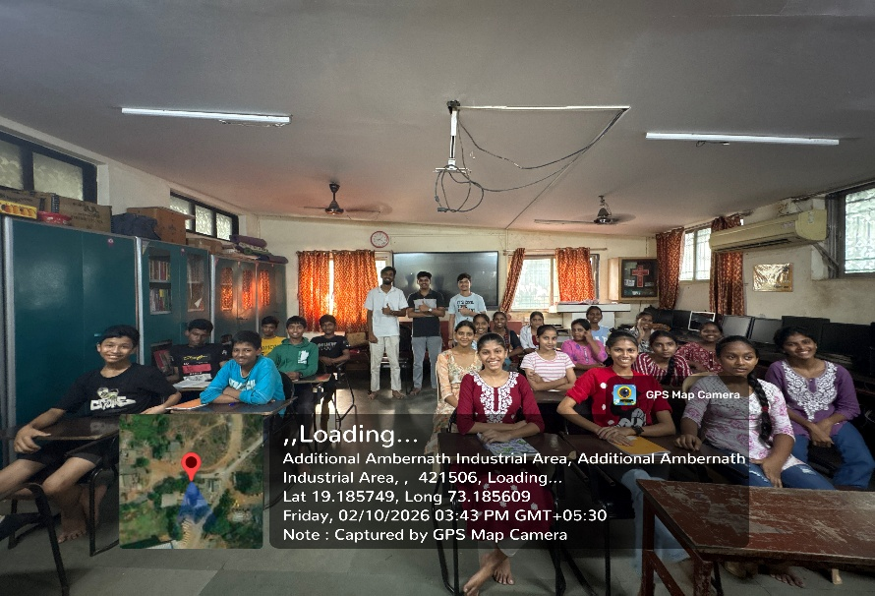
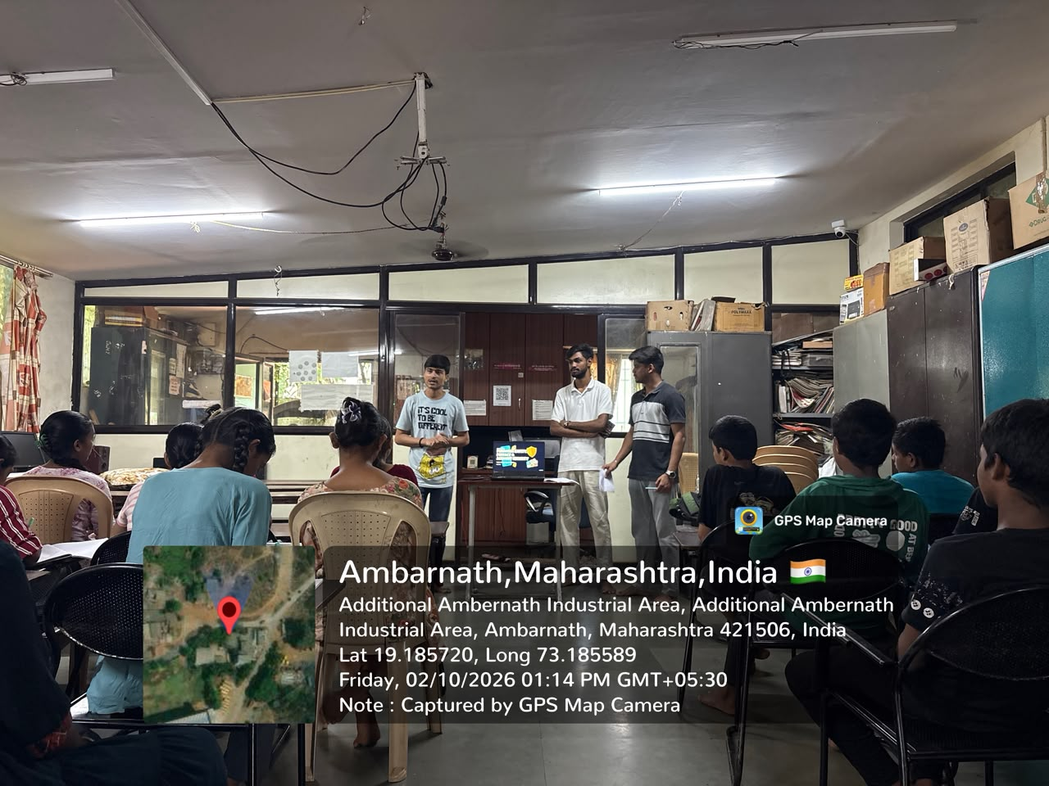
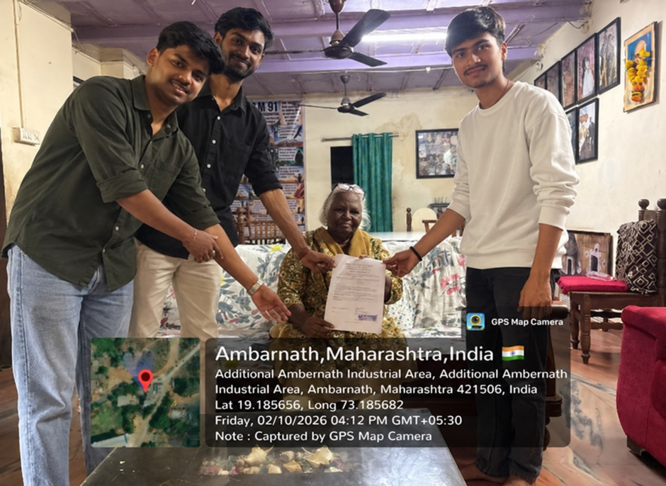
Appendix C — Fieldwork Photographs


