Experiment 1
Implement and demonstrate the FIND-S algorithm for finding the mostspecific hypothesis based on a given set of training data samples.

Aim
To implement the Find-S algorithm in Python to determine the maximally specific hypothesis from the given EnjoySport training dataset.

Program
import csv
a = []
with open('enjoysport.csv', 'r') as csvfile:
for row in csv.reader(csvfile):
a.append(row)
print(a)
print("\n The total number of training instances are : ",len(a))
num_attribute = len(a[0])-1
print("\n The initial hypothesis is : ")
hypothesis = ['0']*num_attribute
print(hypothesis)
for i in range(0, len(a)):
if a[i][num_attribute] == 'yes':
for j in range(0, num_attribute):
if hypothesis[j] == '0' or hypothesis[j] == a[i][j]:
hypothesis[j] = a[i][j]
else:
hypothesis[j] = '?'
print("\n The hypothesis for the training instance {} is :\n" .format(i+1),hypothesis)
print("\n The Maximally specific hypothesis for the training instance is ")
print(hypothesis)

Output
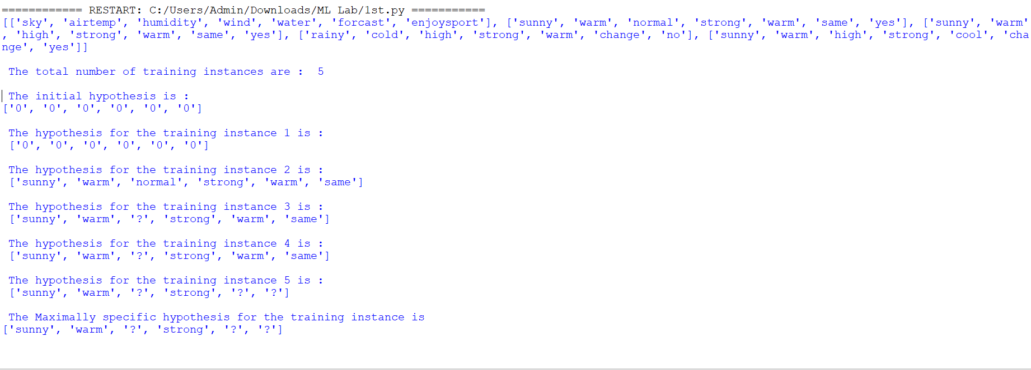

Result
The maximally specific hypothesis obtained after applying the Find-S algorithm is:
['sunny', 'warm', '?', 'strong', '?', '?']

