Experiment 2
For a given set of training data examples stored in a .CSV file, implement and demonstrate the Candidate-Elimination algorithm in python to output a description of the set of all hypotheses consistent with the training examples

Aim
To implement the Candidate Elimination Algorithm in Python and determine the version space (S and G boundaries) consistent with the given training examples.

Program
import csv
import copy
# Load dataset
data = []
with open('enjoysport.csv', 'r') as file:
reader = csv.reader(file)
for row in reader:
data.append(row)

# Remove header
header = data[0]
data = data[1:]
num_attr = len(header) - 1
# Initialize S and G
S = ['0'] * num_attr
G = [['?'] * num_attr]
print("Initial S:", S)
print("Initial G:", G)
for instance in data:
if instance[-1] == 'yes': # Positive example
# Remove inconsistent hypotheses from G
G = [g for g in G if all(g[i] == '?' or g[i] == instance[i] for i in range(num_attr))
# Generalize S if needed
for i in range(num_attr):
if S[i] == '0':
S[i] = instance[i]
elif S[i] != instance[i]:
S[i] = '?'

else: # Negative example
new_G = []
for g in G:
if all(g[i] == '?' or g[i] == instance[i] for i in range(num_attr)):
for i in range(num_attr):
if g[i] == '?':
if S[i] != instance[i]:
new_hypothesis = copy.deepcopy(g)
new_hypothesis[i] = S[i]
new_G.append(new_hypothesis)

else:
new_G.append(g)
G = new_G
print("\nAfter instance:", instance)
print("S:", S)
print("G:", G)
print("\nFinal Specific Boundary S:", S)
print("Final General Boundary G:", G)

Output

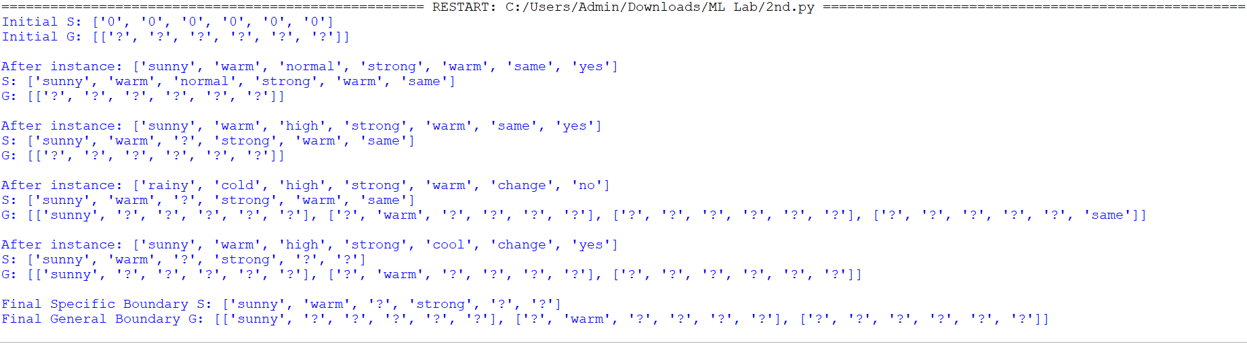
Result
The Candidate Elimination algorithm successfully computed the version space boundaries (S and G) that represent all hypotheses consistent with the given training examples.
The final S boundary is ['sunny', 'warm', '?', 'strong', '?', '?'] and G boundary contains the most general consistent hypotheses.

