Experiment 3
Demonstrate the working of the decision tree based ID3 algorithm. Use an appropriate data set for building the decision tree and apply this knowledge to classify a new sample.
Aim
To implement the ID3 decision tree algorithm and construct a decision tree using the given dataset to classify a new sample.

Program
import math
data = [
['Sunny','Hot','High','Weak','No'],
['Sunny','Hot','High','Strong','No'],
['Overcast','Hot','High','Weak','Yes'],
['Rain','Mild','High','Weak','Yes'],
['Rain','Cool','Normal','Weak','Yes'],
['Rain','Cool','Normal','Strong','No'],
['Overcast','Cool','Normal','Strong','Yes'],
['Sunny','Mild','High','Weak','No'],
['Sunny','Cool','Normal','Weak','Yes'],
['Rain','Mild','Normal','Weak','Yes'],
['Sunny','Mild','Normal','Strong','Yes'],
['Overcast','Mild','High','Strong','Yes'],
['Overcast','Hot','Normal','Weak','Yes'],
['Rain','Mild','High','Strong','No']
]

attributes = ['Outlook','Temperature','Humidity','Wind']

# -----------------------------
# Step 2: Entropy Function
# -----------------------------
def entropy(rows):
total = len(rows)
yes = sum(1 for row in rows if row[-1] == 'Yes')
no = sum(1 for row in rows if row[-1] == 'No')
if yes == 0 or no == 0:
return 0

p_yes = yes / total
p_no = no / total
return -p_yes * math.log2(p_yes) - p_no * math.log2(p_no)
def info_gain(rows, col):
total_entropy = entropy(rows)
values = set(row[col] for row in rows)
weighted_entropy = 0
for val in values:
subset = [row for row in rows if row[col] == val]
weighted_entropy += (len(subset) / len(rows)) * entropy(subset)
return total_entropy - weighted_entropy
def id3(rows, cols):
labels = [row[-1] for row in rows]
# If all labels same → return label
if labels.count(labels[0]) == len(labels):
return labels[0]
# If no attributes left → return majority class
if not cols:
return max(set(labels), key=labels.count)
# Calculate best attribute using Information Gain
gains = [info_gain(rows, col) for col in cols]
best_col = cols[gains.index(max(gains))]
best_attr = attributes[best_col]
tree = {best_attr: {}}
values = set(row[best_col] for row in rows)
for val in values:
subset = [row for row in rows if row[best_col] == val]
new_cols = [c for c in cols if c != best_col]
tree[best_attr][val] = id3(subset, new_cols)
return tree

tree = id3(data, [0,1,2,3])
print("Decision Tree:\n")
print(tree)
def predict(sample, tree):
for attr in tree:
value = sample[attr]
result = tree[attr][value]
if isinstance(result, dict):
return predict(sample, result)
else:
return result

new_sample = {
'Outlook': 'Sunny',
'Temperature': 'Cool',
'Humidity': 'High',
'Wind': 'Strong'
}
print("\nNew Sample:", new_sample)
print("Prediction:", predict(new_sample, tree))

Output
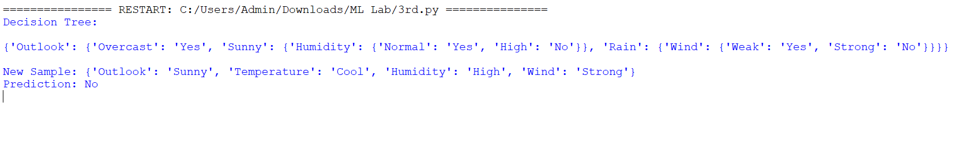

Result
The decision tree was successfully constructed using the ID3 algorithm, and the new sample was classified correctly as “No”.

