Experiment 4
Build an Artificial Neural Network by implementing the Backpropagation algorithm and test the same using appropriate data sets.
Aim
To build an Artificial Neural Network and implement the Backpropagation algorithm for training the network using a suitable dataset.

Program
import random
import math
dataset = [
([0,0], [0]),
([0,1], [1]),
([1,0], [1]),
([1,1], [0])
]
def sigmoid(x):
return 1 / (1 + math.exp(-x))

def sigmoid_derivative(x):
return x * (1 - x)

input_neurons = 2
hidden_neurons = 2
output_neurons = 1
learning_rate = 0.5
epochs = 5000
# Random weights
wh = [[random.uniform(-1,1) for _ in range(hidden_neurons)] for _ in range(input_neurons)]
bh = [random.uniform(-1,1) for _ in range(hidden_neurons)]

wo = [[random.uniform(-1,1) for _ in range(output_neurons)] for _ in range(hidden_neurons)]
bo = [random.uniform(-1,1) for _ in range(output_neurons)]
for epoch in range(epochs):
for inputs, target in dataset:
# ---- Forward Propagation ----
hidden_input = []
for j in range(hidden_neurons):
total = sum(inputs[i] * wh[i][j] for i in range(input_neurons)) + bh[j]
hidden_input.append(sigmoid(total))
output_input = []
for j in range(output_neurons):
total = sum(hidden_input[i] * wo[i][j] for i in range(hidden_neurons)) + bo[j]
output_input.append(sigmoid(total))
# ---- Backward Propagation ----
output_error = [target[i] - output_input[i] for i in range(output_neurons)]
output_delta = [output_error[i] * sigmoid_derivative(output_input[i]) for i in range(output_neurons)]
hidden_error = []
for i in range(hidden_neurons):
error = sum(output_delta[j] * wo[i][j] for j in range(output_neurons))
hidden_error.append(error)
hidden_delta = [hidden_error[i] * sigmoid_derivative(hidden_input[i]) for i in range(hidden_neurons)]
# ---- Update Weights ----
for i in range(hidden_neurons):
for j in range(output_neurons):
wo[i][j] += learning_rate * output_delta[j] * hidden_input[i]

for j in range(output_neurons):
bo[j] += learning_rate * output_delta[j]
for i in range(input_neurons):
for j in range(hidden_neurons):
wh[i][j] += learning_rate * hidden_delta[j] * inputs[i]
for j in range(hidden_neurons):
bh[j] += learning_rate * hidden_delta[j]
# -----------------------------
print("Testing Neural Network:\n")
for inputs, target in dataset:
# Forward pass
hidden_input = []
for j in range(hidden_neurons):
total = sum(inputs[i] * wh[i][j] for i in range(input_neurons)) + bh[j]
hidden_input.append(sigmoid(total))
output_input = []
for j in range(output_neurons):
total = sum(hidden_input[i] * wo[i][j] for i in range(hidden_neurons)) + bo[j]
output_input.append(sigmoid(total))
print("Input:", inputs, "Expected:", target, "Predicted:", round(output_input[0]))

Output
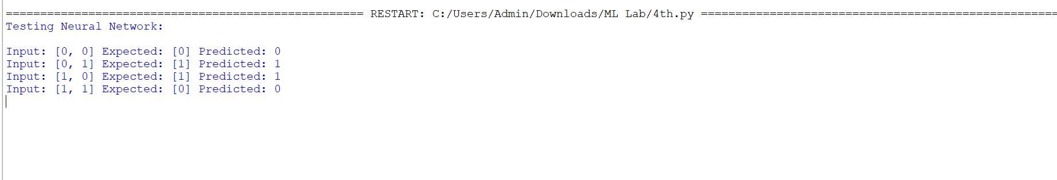

Result
The neural network was successfully trained using the Backpropagation algorithm and correctly classified the XOR dataset outputs.

