Experiment 01

# **Aim:** Create web page to implement Elements, Attributes, Head, Body, Hyperlink, Formatting

# **Requirements:** Chrome, VsCode

## **Theory:**

Html Elements:

The HTML element is everything from the start tag to the end tag:

<tagname>Content goes here...</tagname>

Examples of some HTML elements:

<h1>My First Heading</h1>

<p>My first paragraph. </p>

Attributes:   
 HTML attributes provide additional information about HTML elements

All HTML elements can have attributes

Attributes provide additional information about elements

Attributes are always specified in the start tag

Attributes usually come in name/value pairs like: name="value"

The href Attribute - The <a> tag defines a hyperlink. The href attribute specifies the URL of the page the link goes to.

Head:

The HTML <head> element is a container for the following elements: <title>, <style>, <meta>, <link>, <script>, and <base>

Body:

The <body> tag defines the document's body.

The <body> element contains all the contents of an HTML document, such as headings, paragraphs, images, hyperlinks, tables, lists, etc.

Hyperlinks:

HTML links are hyperlinks.

You can click on a link and jump to another document.

When you move the mouse over a link, the mouse arrow will turn into a little hand.

Formatting:

Formatting elements were designed to display special types of text:

* <b> - Bold text
* <strong> - Important text
* <i> - Italic text
* <em> - Emphasized text
* <mark> - Marked text
* <small> - Smaller text
* <del> - Deleted text
* <ins> - Inserted text
* <sub> - Subscript text
* <sup> - Superscript text

# **Output:**

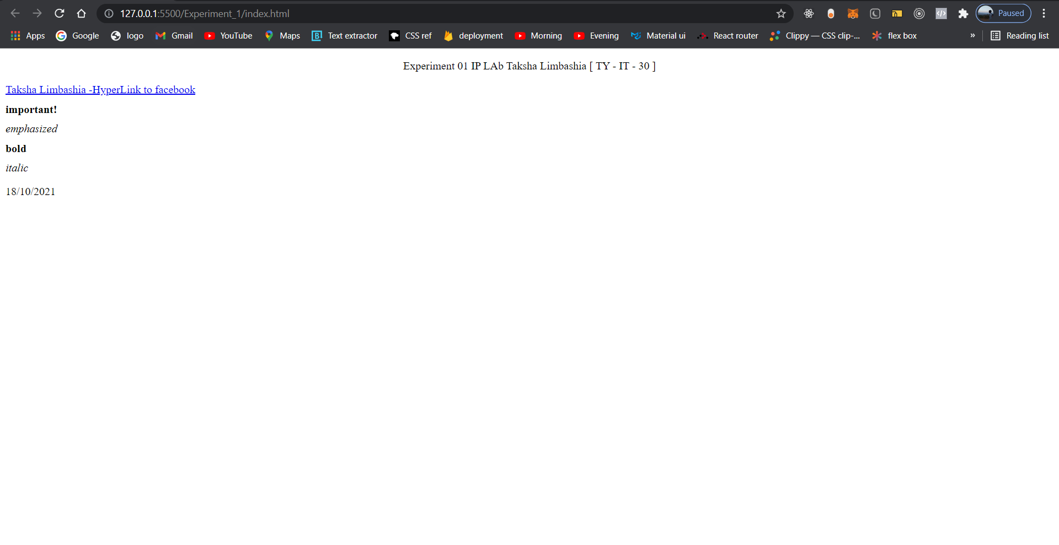

# **Conclusion:** In Html we can include Elements, Attributes, Head, Body, Hyperlink, Formatting very easily. These features allow us to make simple html template

**References**: <https://www.w3schools.com>