Experiment 02

# **Aim:** Create web page to implement Images, Tables, List, Frames, Forms, Multimedia

# **Requirements:** Chrome, VsCode

**Theory:**

Image:

The <img> tag is used to embed an image in an HTML page.

Images are not technically inserted into a web page; images are linked to web pages. The <img> tag creates a holding space for the referenced image.

The <img> tag has two required attributes:

src - Specifies the path to the image

alt - Specifies an alternate text for the image, if the image for some reason cannot be displayed

Tables:

A table in HTML consists of table cells inside rows and columns. Each table cell is defined by a <td> and a </td> tag. td stands for table data. Everything between <td> and </td> are the content of the table cell. Each table row starts with a <tr> and end with a </tr> tag. tr stands for table row. Sometimes you want your cells to be headers, in those cases use the <th> tag instead of the <td> tag

List:  
 HTML lists allow web developers to group a set of related items in lists. An unordered list starts with the <ul> tag. Each list item starts with the <li> tag. The list items will be marked with bullets (small black circles) by default

Forms:  
 An HTML form is used to collect user input. The user input is most often sent to a server for processing. The HTML <form> element is used to create an HTML form for user input. The <form> element is a container for different types of input elements, such as: text fields, checkboxes, radio buttons, submit buttons, etc.

Multimedia:   
 Multimedia comes in many different formats. It can be almost anything you can hear or see, like images, music, sound, videos, records, films, animations, and more.Web pages often contain multimedia elements of different types and formats

# **Output:**

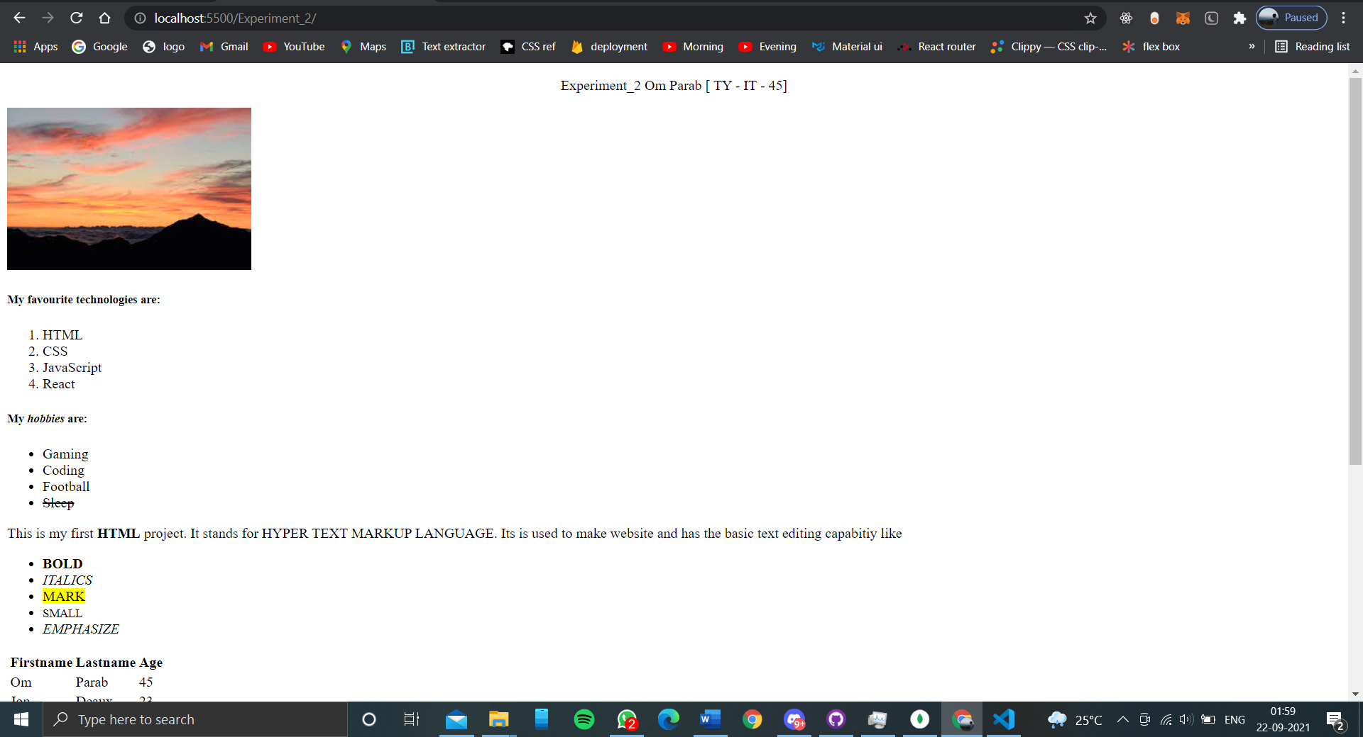

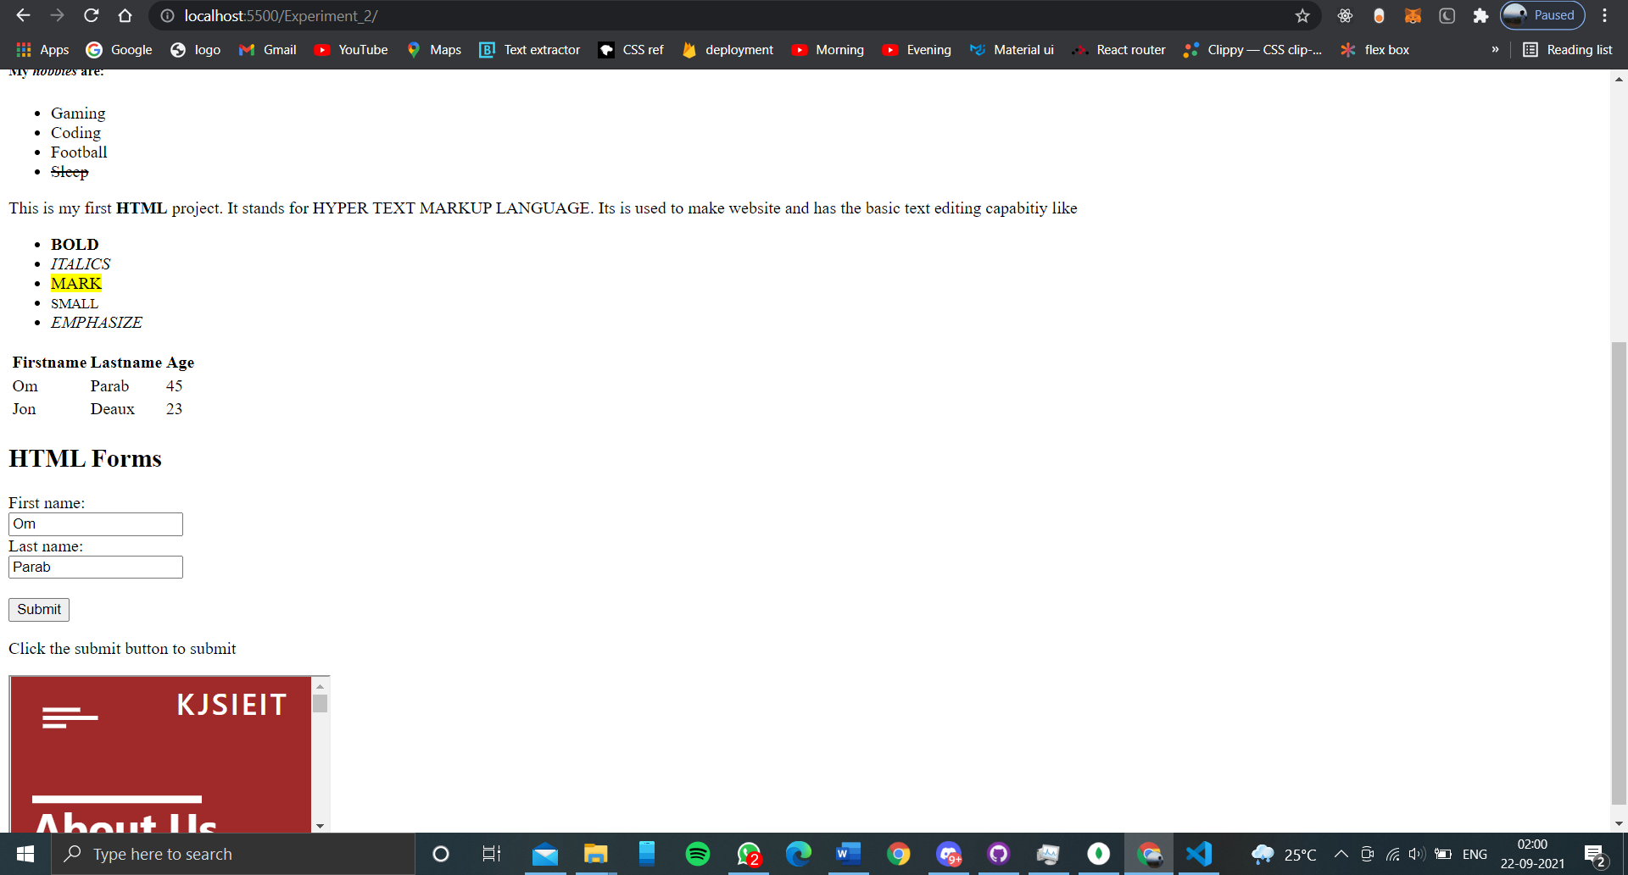

# **Conclusion:** Html forms are very useful in takin inputs from user for any real time application like login page application. The tables can be used visualizing data better in webpage. And iframes are image can be embedded very easily in html.

**References**: <https://www.w3schools.com>