Experiment 03

# **Aim:** Create webpage to implement CSS Syntax and different properties (Inclusion, Color, Background, Fonts, Tables, lists, etc.)

# **Requirements:** Chrome, VsCode

# **Theory:**

# What is CSS?

* CSS stands for Cascading Style Sheets
* CSS describes how HTML elements are to be displayed on screen, paper, or in other media
* CSS saves a lot of work. It can control the layout of multiple web pages all at once
* External stylesheets are stored in CSS files.

Inclusion:

There are four ways to associate styles with your HTML document. Most commonly used methods are inline CSS and External CSS. You can use style attribute of any HTML element to define style rules. These rules will be applied to that element only. Here is the generic syntax −

<element style = "...style rules....">

Colour:   
 Colors are specified using predefined color names, or RGB, HEX, HSL, RGBA, HSLA values.

# background-color: This gives background color to element to which it is given to.

Font:   
 The <font> tag was used in HTML 4 to specify the font face, font size, and color of text.

Tables:

A table in HTML consists of table cells inside rows and columns. Each table cell is defined by a <td> and a </td> tag. td stands for table data. Everything between <td> and </td> are the content of the table cell. Each table row starts with a <tr> and end with a </tr> tag. tr stands for table row. Sometimes you want your cells to be headers, in those cases use the <th> tag instead of the <td> tag

List:  
 HTML lists allow web developers to group a set of related items in lists. An unordered list starts with the <ul> tag. Each list item starts with the <li> tag.  The list items will be marked with bullets (small black circles) by default

Margin:  
 The CSS margin properties are used to create space around elements, outside of any defined borders.

With CSS, you have full control over the margins. There are properties for setting the margin for each side of an element (top, right, bottom, and left).

# **Output:**

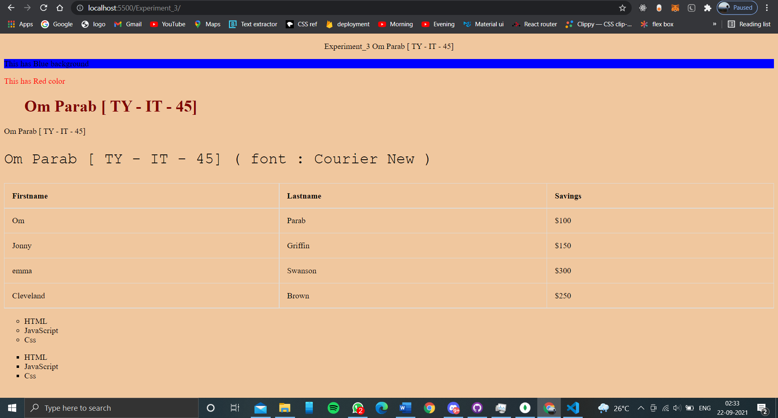

# **Conclusion:** With CSS we can beautify our webpages to make our site more attractive rather than just html which is markup language.

**References**: <https://www.w3schools.com>