Experiment 04

# **Aim:** Create webpage to implement CSS3 selectors, Pseudo classes, Pseudo elements.

# **Requirements:** Chrome, VSCode

# **Theory:**

CSS selectors are used to "find" (or select) the HTML elements you want to style.We can divide CSS selectors into five categories:

* Simple selectors (select elements based on name, id, class)
* [Combinator selectors](https://www.w3schools.com/css/css_combinators.asp) (select elements based on a specific relationship between them)
* [Pseudo-class selectors](https://www.w3schools.com/css/css_pseudo_classes.asp) (select elements based on a certain state)
* [Pseudo-elements selectors](https://www.w3schools.com/css/css_pseudo_elements.asp) (select and style a part of an element)
* [Attribute selectors](https://www.w3schools.com/css/css_attribute_selectors.asp) (select elements based on an attribute or attribute value)

A pseudo-class is used to define a special state of an element.

For example, it can be used to:

* Style an element when a user mouses over it
* Style visited and unvisited links differently
* Style an element when it gets focus

A CSS pseudo-element is used to style specified parts of an element.

For example, it can be used to:

* Style the first letter, or line, of an element
* Insert content before, or after, the content of an element

# **Output:**

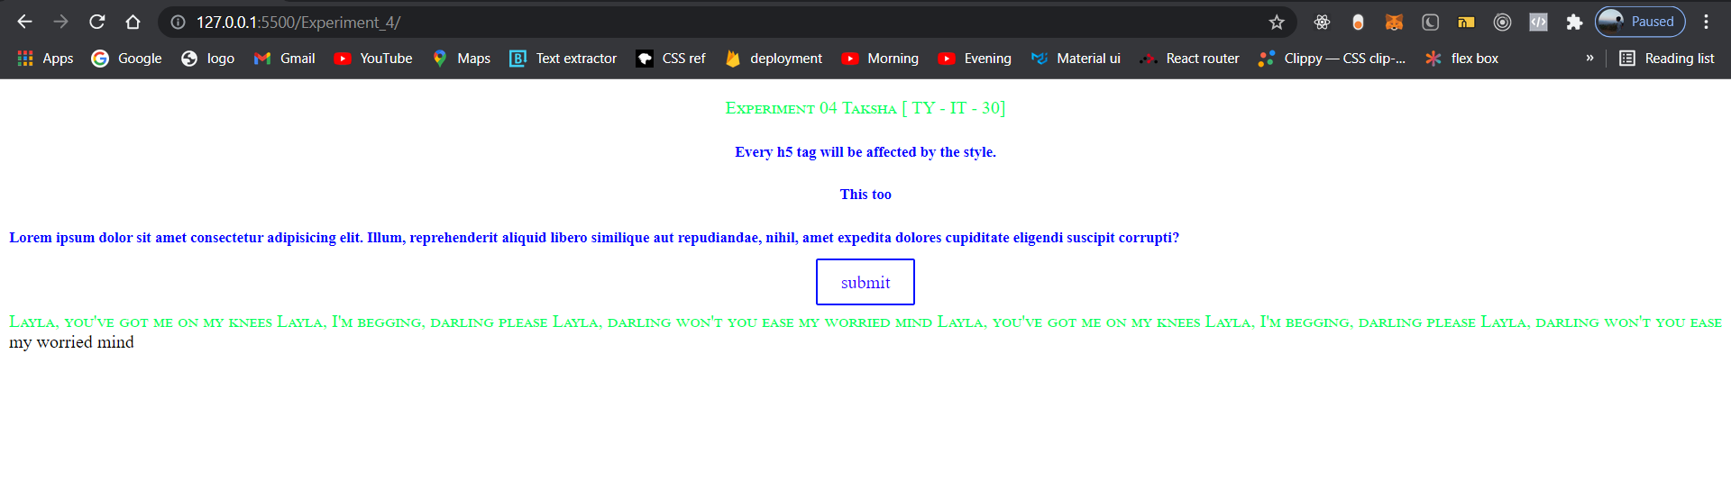

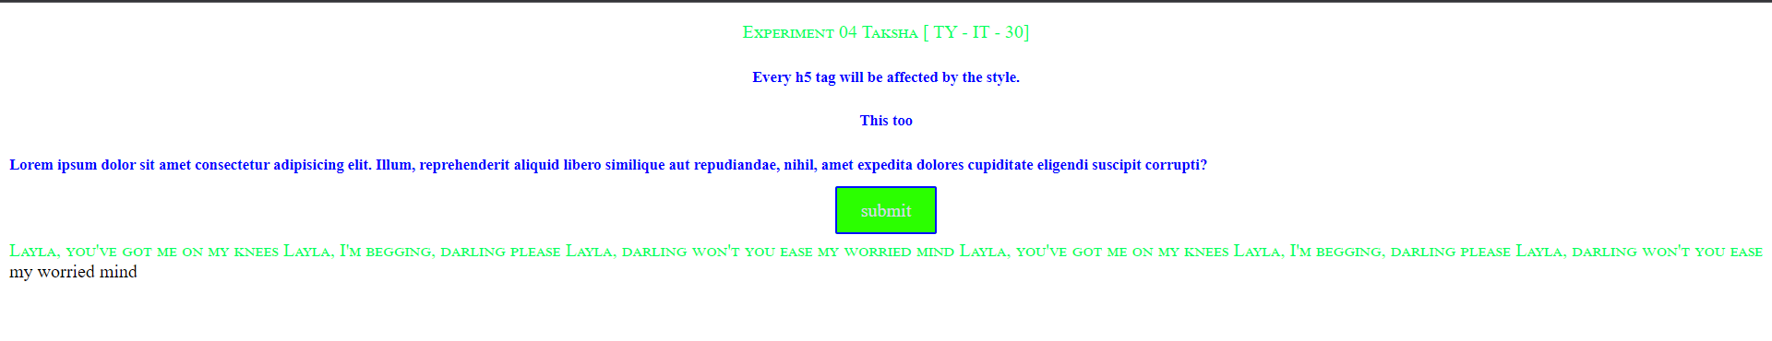

[On Hover]

# **Conclusion:** By using Pseudo elements and classes we can make user friendly and beautiful websites. CSS selectors help in selecting element from html and give styling to the same.

**References:** <https://www.w3schools.com>