Experiment 05

# **Aim:** Create responsive webpage to implement Grid system, Forms, Button, Navbar, Breadcrumb, Jumbotron using bootstrap

# **Requirements:** Chrome, VsCode

# **Theory:**

Bootstrap is a [free and open-source](https://en.wikipedia.org/wiki/Free_and_open-source) [CSS framework](https://en.wikipedia.org/wiki/CSS_framework) directed at responsive, [mobile-first](https://en.wikipedia.org/wiki/Responsive_web_design#Mobile_first,_unobtrusive_JavaScript,_and_progressive_enhancement) [front-end web development](https://en.wikipedia.org/wiki/Front-end_web_development). It contains [CSS](https://en.wikipedia.org/wiki/CSS)- and (optionally) [JavaScript](https://en.wikipedia.org/wiki/JavaScript)-based design templates for [typography](https://en.wikipedia.org/wiki/Web_design#Typography), [forms](https://en.wikipedia.org/wiki/Form_(HTML)), [buttons](https://en.wikipedia.org/wiki/Button_(computing)#HTML), [navigation](https://en.wikipedia.org/wiki/Web_navigation#Local_website_navigation), and other interface components.

Bootstrap’s grid system uses a series of containers, rows, and columns to layout and align content. It’s built with [flexbox](https://developer.mozilla.org/en-US/docs/Web/CSS/CSS_Flexible_Box_Layout/Using_CSS_flexible_boxes) and is fully responsive.

The Bootstrap grid system has four classes:

* xs (for phones - screens less than 768px wide)
* sm (for tablets - screens equal to or greater than 768px wide)
* md (for small laptops - screens equal to or greater than 992px wide)
* lg (for laptops and desktops - screens equal to or greater than 1200px wide)

The classes above can be combined to create more dynamic and flexible layouts.

* Some Bootstrap grid system rules:
* Rows must be placed within a .container (fixed-width) or .container-fluid (full-width) for proper alignment and padding
* Use rows to create horizontal groups of columns
* Content should be placed within columns, and only columns may be immediate children of rows
* Predefined classes like. row and. col-sm-4 are available for quickly making grid layouts
* Columns create gutters (gaps between column content) via padding. That padding is offset in rows for the first and last column via negative margin on. rows
* Grid columns are created by specifying the number of 12 available columns you wish to span. For example, three equal columns would use three. col-sm-4
* Column widths are in percentage, so they are always fluid and sized relative to their parent element

Bootstrap provides three types of form layouts:

* Vertical form (this is default)
* Horizontal form
* Inline form

Standard rules for all three form layouts:

* Wrap labels and form controls in <div class="form-group"> (needed for optimum spacing)
* Add class. form-control to all textual <input>, <textarea>, and <select> elements

Bootstrap provides different styles of buttons: Basic Default Primary Success Info Warning Danger Link

To achieve the button styles above, Bootstrap has the following classes:

* .btn
* .btn-default
* .btn-primary
* .btn-success
* .btn-info
* .btn-warning
* .btn-danger
* .btn-link

A navigation bar is a navigation header that is placed at the top of the page:

[**WebSiteName**](javascript:void(0);)[**Home**](javascript:void(0);)[**Page 1**](javascript:void(0);)[**Page 2**](javascript:void(0);)

With Bootstrap, a navigation bar can extend or collapse, depending on the screen size.

A standard navigation bar is created with <nav class="navbar navbar-default">.

A breadcrumb navigation provide links back to each previous page the user navigated through, and shows the user's current location in a website.

[Home](javascript:void(0)) / [Pictures](javascript:void(0)) / [Summer 15](javascript:void(0)) / Italy

A jumbotron indicates a big grey box for calling extra attention to some special content or information.

# **Output:**

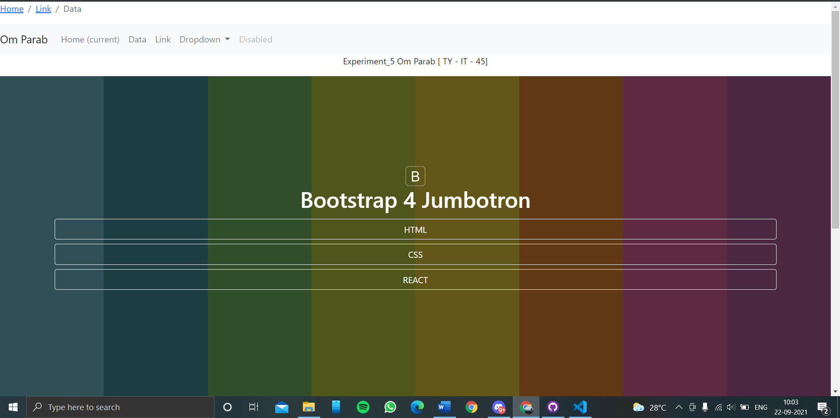

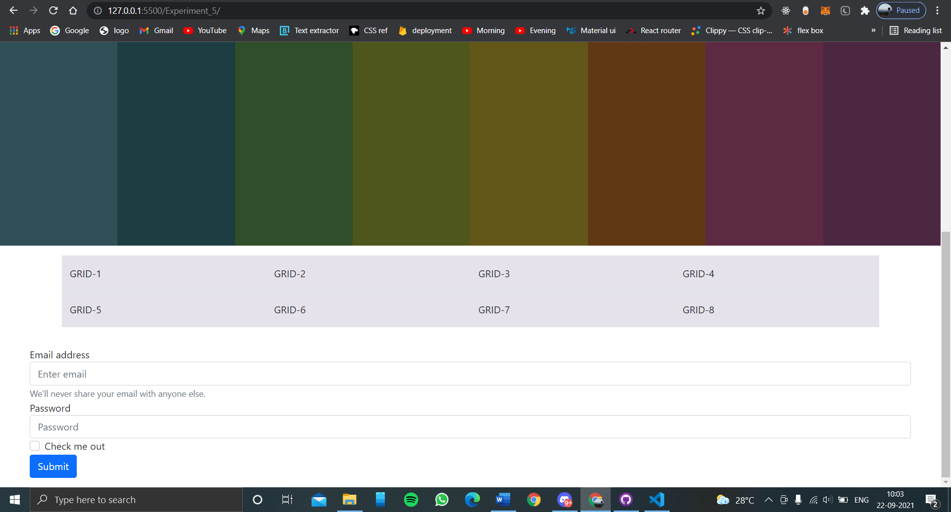

# **Conclusion:** With bootstrap 5 we can make user Friendly and responsive UI of webpages which adjust itself in all devices in beautiful way.

**References**: <https://www.w3schools.com>