Experiment 06

# **Aim:** Perform from the following to develop interactive web pages using JavaScript: a. Variables, Operators, Conditions, Loops, b. Functions, Events, Classes and Objects

# **Requirements:** Chrome, VsCode

## **Theory:**

**1) Variables**

Variables are containers for storing data (values).

In this example, x, y, and z, are variables, declared with the var keyword:

### Example

var x = 5;  
var y = 6;  
var z = x + y;

From the example above, you can expect:

* x stores the value 5
* y stores the value 6
* z stores the value 11

**2) Operators**

JavaScript operators are symbols that are used to perform operations on operands. For example:

1. var sum=10+20;

Here, + is the arithmetic operator and = is the assignment operator.

There are following types of operators in JavaScript.

1. Arithmetic Operators
2. Comparison (Relational) Operators
3. Bitwise Operators
4. Logical Operators
5. Assignment Operators
6. Special Operators

# 

# **3) Conditions**

Very often when you write code, you want to perform different actions for different decisions.

You can use conditional statements in your code to do this.

In JavaScript we have the following conditional statements:

* Use if to specify a block of code to be executed, if a specified condition is true
* Use else to specify a block of code to be executed, if the same condition is false
* Use else if to specify a new condition to test, if the first condition is false
* Use switch to specify many alternative blocks of code to be executed

# **4) Loops**

Loops are handy, if you want to run the same code over and over again, each time with a different value. There are different kinds of loops

JavaScript supports different kinds of loops:

* for - loops through a block of code a number of times
* for/in - loops through the properties of an object
* for/of - loops through the values of an iterable object
* while - loops through a block of code while a specified condition is true
* do/while - also loops through a block of code while a specified condition is true

# **5) Functions**

A JavaScript function is defined with the function keyword, followed by a name, followed by parentheses ().

Function names can contain letters, digits, underscores, and dollar signs (same rules as variables).

The parentheses may include parameter names separated by commas:  
(parameter1, parameter2, ...)

The code to be executed, by the function, is placed inside curly brackets: {}

function name(parameter1, parameter2, parameter3) {  
  // code to be executed  
}

# **6) Events**

The change in the state of an object is known as an Event. In html, there are various events which represents that some activity is performed by the user or by the browser. When [JavaScript](https://www.javatpoint.com/javascript-tutorial) code is included in [HTML](https://www.javatpoint.com/html-tutorial), js react over these events and allow the execution. This process of reacting over the events is called Event Handling. Thus, js handles the HTML events via Event Handlers.

For example, when a user clicks over the browser, add js code, which will execute the task to be performed on the event.

# **7) Classes**

Classes are in fact "special [functions](https://developer.mozilla.org/en-US/docs/Web/JavaScript/Reference/Functions)", and just as you can define [function expressions](https://developer.mozilla.org/en-US/docs/Web/JavaScript/Reference/Operators/function) and [function declarations](https://developer.mozilla.org/en-US/docs/Web/JavaScript/Reference/Statements/function), the class syntax has two components: [class expressions](https://developer.mozilla.org/en-US/docs/Web/JavaScript/Reference/Operators/class) and [class declarations](https://developer.mozilla.org/en-US/docs/Web/JavaScript/Reference/Statements/class). One way to define a class is using a class declaration. To declare a class, you use the class keyword with the name of the class

class Rectangle {

constructor(height, width) {

this.height = height;

this.width = width;

}

}

# **8) Objects**

A JavaScript object is an entity having state and behaviour (properties and method). For example: car, pen, bike, chair, glass, keyboard, monitor etc.

JavaScript is an object-based language. Everything is an object in JavaScript.

JavaScript is template based not class based. Here, we don't create class to get the object. But, we direct create objects.

## Creating Objects in JavaScript

There are 3 ways to create objects.

1. By object literal
2. By creating instance of Object directly (using new keyword)
3. By using an object constructor (using new keyword)

# **Output:**

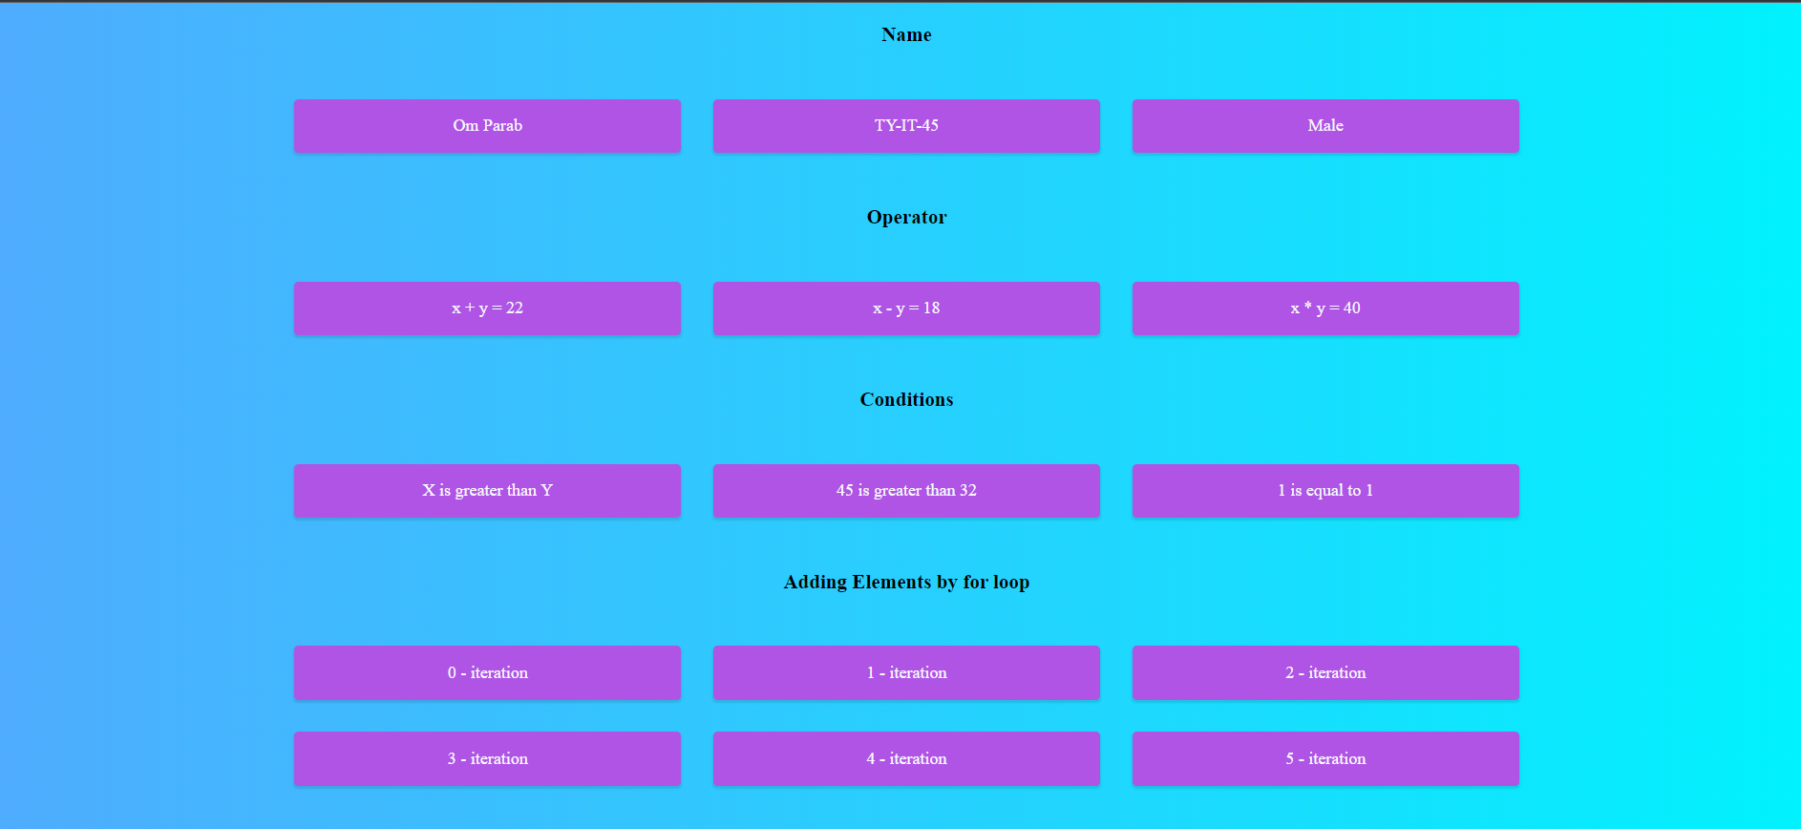

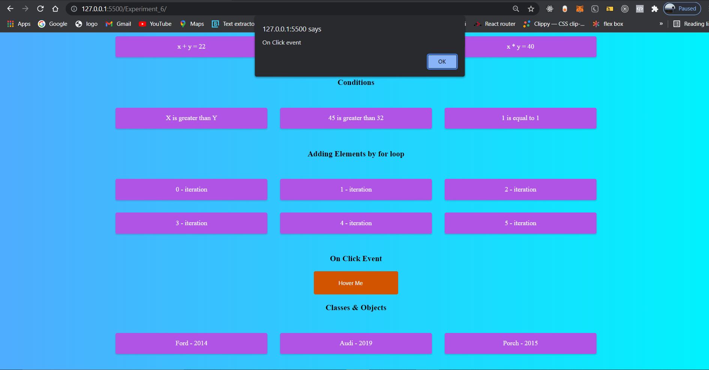

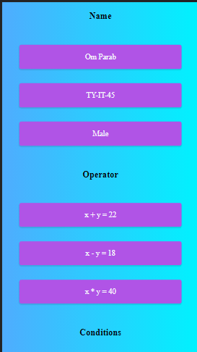

[ Responsive ]

# **Conclusion:** In JavaScript we can use Variables, Operators, Conditions, Loops, Functions, Events, Classes and Objects for doing logic of how the interactions of user will work.

**References**: <https://www.w3schools.com>