Q-1:
CREATE TABLE Customer (
customer_id INT PRIMARY KEY,
customer_name VARCHAR(50),
city VARCHAR(50)
);
CREATE TABLE Orders (
order_id INT PRIMARY KEY,
customer_id INT REFERENCES Customer(customer_id),
amount INT
);
INSERT INTO Customer (customer_id, customer_name, city)
VALUES
(1, 'Amn', 'Delhi'),
(2, 'Neha', 'Delhi'),
(3, 'Raj', 'Mumbai'),
(4, 'Priya', 'Mumbai'),
(5, 'Karan', 'Pune');
INSERT INTO Orders (order_id, customer_id,amount)
VALUES
(101, 1, 4000),
(102, 1, 3000),
(103, 2, 5000),
(104, 3, 6000),
(105, 3, 2000),
(106, 4, 8000),
(107, 5, 4500);
SELECT
c.customer_name,
c.city,
SUM(o.amount) AS total_purchase
FROM Customer c
JOIN Orders o
ON c.customer_id = o.customer_id
GROUP BY
c.customer_id,
c.customer_name,
c.city
HAVING SUM(o.amount) >= ALL (
SELECT SUM(d.amount)
FROM Customer c2
JOIN Orders d
ON c2.customer_id = d.customer_id
WHERE c2.city = c.city
AND c2.customer_id <> c.customer_id
GROUP BY c2.customer_id
);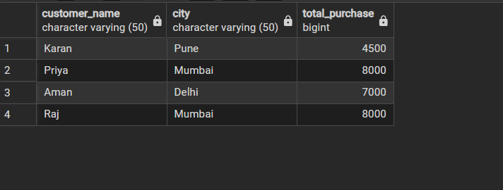

Q-2:
CREATE TABLE product_inventory (
product_id INT PRIMARY KEY,
product_name VARCHAR(50),
price INT
);
create trigger trg_product_audit
on product_inventory
after insert, delete
as
begin
insert into product_audit
(product_id, product_name, action, action_timestamp)
select
product_id,
product_name,
'Product Added',
getdate()
from inserted;

insert into product_audit
(product_id, product_name, action, action_timestamp)
select
product_id,
product_name,
'Product Removed',
getdate()
from deleted;
end;
