**Assignment Subjective Question Answers**

1. Which are the top three variables in your model which contribute most towards the probability of a lead getting converted?

TOP variables that contribute for lead getting converted in the model are:

* Tags_Lost to EINS
* Tags_Closed by Horizzon
* Lead Quality_Worst

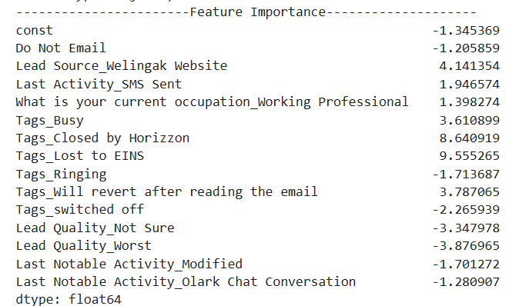

1. What are the top 3 categorical/dummy variables in the model which should be focused the most on to increase the probability of lead conversion?

TOP variables that contribute for lead getting converted in the model are:

* Tags_Lost to EINS
* Tags_Closed by Horizzon
* Lead Quality_Worst



1. X Education has a period of 2 months every year during which they hire some interns. The sales team has around 10 interns allotted to them. So, during this phase, they wish to make the lead conversion more aggressive. So, they want almost all the potential leads (i.e., the customers who have been predicted as 1 by the model) to be converted and hence, want to make phone calls to as much of such people as possible. Suggest a good strategy they should employ at this stage.

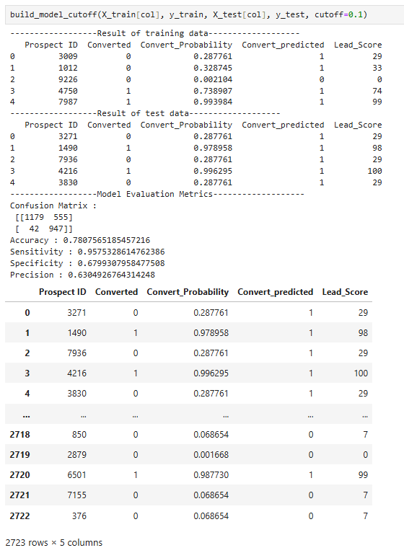

1. Similarly, at times, the company reaches its target for a quarter before the deadline. During this time, the company wants the sales team to focus on some new work as well. So, during this time, the company’s aim is to not make phone calls unless it’s extremely necessary, i.e., they want to minimize the rate of useless phone calls. Suggest a strategy they should employ at this stage.

