 PILLAI COLLEGE Of ENGINEERING
PROJECT REPORT
Simulation of a Digital Satellite Communication Link over an AWGN Channel using QPSK Modulation

Design, Simulation and Bit Error Rate Performance Analysis of a QPSK-Based Uplink–Downlink Satellite System
Submitted in partial fulfillment of the requirements for the degree of
Bachelor of Technology
in
Electronics and Telecommunication Engineering

Submitted By: | Sairaj Patil (534)
 | Om Rane (539)
Project Guide | Dr. Suman Wadkar
Subject | Digital Communication
Department of Electronics and Telecommunication Engineering
Academic Year 2025–2026
Mentor's Sign

INDEX

Sr. No. | Content | Page No.
1. | Introduction | 3
2. | Objectives and Scope | 4
3. | System Design and Methodology | 5
4. | Theory and Mathematical Model | 6
5. | Simulation Implementation Details | 8
6. | Results and Discussion | 9
7. | Conclusion and Future Scope | 11
8. | References | 12

Abstract
This report presents the design, simulation and performance analysis of a digital satellite communication link operating over an Additive White Gaussian Noise (AWGN) channel. Using Quadrature Phase Shift Keying (QPSK) modulation, the simulator models the complete uplink–downlink chain: a Bernoulli binary data source, a QPSK baseband modulator, an AWGN space channel, a QPSK demodulator and a bit-error-rate (BER) analysis stage. Key performance metrics — including Bit Error Rate and I/Q constellation scattering — are evaluated under varying Signal-to-Noise Ratios (Eb/N0), and the simulated results are compared against the theoretical QPSK error probability curve.
Keywords: Satellite Communication, AWGN Channel, QPSK Modulation, Bit Error Rate (BER), I/Q Constellation, Eb/N0, Digital Communication.

1. Introduction
Satellite links form the backbone of long-distance wireless communication, connecting ground stations across vast distances through free-space propagation. Because signals travel through the space vacuum and the Earth's atmosphere, they are unavoidably corrupted by thermal noise generated within the receiver electronics and by cosmic background radiation. This corruption is conventionally modelled as Additive White Gaussian Noise (AWGN), a random process that adds directly to the transmitted signal envelope.
To transmit digital information efficiently under the strict power and bandwidth constraints of satellite hardware, phase-based digital modulation schemes are preferred over simple amplitude-based schemes. This project develops a simulator that models an end-to-end satellite communication link using Quadrature Phase Shift Keying (QPSK), a modulation format that doubles spectral efficiency relative to Binary Phase Shift Keying (BPSK) while preserving comparable noise robustness.

1.1 Problem Statement
Satellite downlinks routinely experience degraded Signal-to-Noise Ratios due to path loss, atmospheric attenuation and limited transmit power. This project implements a simulation that generates a digital bitstream, modulates it using QPSK, passes it through a simulated AWGN space channel, demodulates it at the receiver, and quantifies the resulting Bit Error Rate across different channel conditions.

1.2 Scope
The system models baseband bit generation, QPSK symbol mapping, AWGN channel corruption, phase-based demodulation and bit-error computation. It provides a software-level simulation of the satellite physical layer; antenna gain patterns, orbital dynamics, Doppler shift, rain fade and forward error correction (channel coding) are beyond the current implementation scope.

2. Objectives and Scope
- Generate a pseudorandom binary data stream representing the digital information payload using a Bernoulli Binary Generator.
- Implement a QPSK baseband modulator that maps every 2 bits of the stream to one of four phase angles (45°, 135°, 225°, 315°).
- Simulate a satellite space channel by adding Gaussian-distributed noise to the complex transmitted signal (AWGN).
- Implement a QPSK demodulator that uses the I = 0 and Q = 0 decision axes to reconstruct the transmitted bit pairs.
- Compute the Bit Error Rate (BER) by comparing the reconstructed bit stream against the original transmitted stream.
- Evaluate and visualize the I/Q constellation scatter and compare simulated BER against the theoretical QPSK error curve across multiple Eb/N0 settings.

3. System Design and Methodology
A complete satellite communication system consists of three distinct segments: the Uplink (Transmitter), the Space Channel, and the Downlink (Receiver).
Segment | Block | Function
Uplink (Transmitter) | Bernoulli Binary Generator | Generates a pseudorandom stream of binary data (0s and 1s)
Uplink (Transmitter) | QPSK Modulator (Baseband) | Maps 2 bits/symbol to one of four phase angles
Space Channel | AWGN Channel | Adds atmospheric and thermal Gaussian noise to the signal
Downlink (Receiver) | QPSK Demodulator (Baseband) | Decodes symbol phase back into a 2-bit pattern
Downlink (Receiver) | Error Rate Calculation | Compares transmitted vs. received bits to compute BER

3.1 Processing Sequence
- Bit Generation: A Bernoulli Binary Generator produces the raw digital information payload.
- QPSK Modulation: Consecutive bit pairs are mapped to complex baseband symbols at phase angles of 45°, 135°, 225° and 315°.
- Channel Transmission: The complex symbol stream s(t) is transmitted through the simulated AWGN space channel.
- Noise Addition: Gaussian noise n(t) is added directly to the signal envelope, producing the received signal r(t) = s(t) + n(t).
- QPSK Demodulation: The receiver evaluates the phase of each noisy symbol against the I = 0 and Q = 0 decision boundaries to recover the 2-bit pattern.
- Error Rate Calculation: The reconstructed bit stream (Rx) is compared bit-by-bit against the original stream (Tx) to compute the Bit Error Rate.

4. Theory and Mathematical Model

4.1 Why QPSK for Satellite Links?
Satellites operate under severe power and bandwidth constraints. QPSK provides twice the spectral efficiency of Binary Phase Shift Keying (BPSK) while maintaining the same bit error probability for a given energy per bit. The spectral efficiency of QPSK is 2 bits/sec/Hz.

4.2 QPSK Symbol Mapping
Each pair of input bits is mapped to one of four phase angles, separated by 90°:
θ ∈ {45°, 135°, 225°, 315°} or equivalently {π/4, 3π/4, 5π/4, 7π/4}

4.3 AWGN Channel Model
The AWGN block simulates the thermal noise generated by space vacuum, Earth's atmospheric attenuation, and electronic amplifier noise. The noise vector follows a Gaussian probability distribution and is added directly to the complex signal envelope:
r(t) = s(t) + n(t)
where s(t) is the transmitted signal and n(t) is Gaussian noise.

4.4 QPSK Demodulation
The demodulator evaluates the phase of the incoming noisy complex symbol using decision boundaries at the I = 0 and Q = 0 axes to reconstruct the original 2-bit pattern.

4.5 Theoretical Bit Error Rate for QPSK in AWGN
The theoretical bit error probability for QPSK transmitted over an AWGN channel is given by:
Pb = Q( √(2Eb / N0) )
where Q(x) is the tail probability of the standard normal distribution, Eb is the energy per bit, and N0 is the noise power spectral density.

5. Simulation Implementation Details
The simulator was implemented as a discrete-event model of the transmitter, channel and receiver chain described in Section 3.

5.1 System Modules
- Bit Generator: Produces a pseudorandom Bernoulli binary sequence representing the transmitted payload.
- QPSK Modulator: Groups bits into pairs and maps each pair to a complex baseband symbol at the corresponding phase angle.
- AWGN Channel: Adds zero-mean complex Gaussian noise to each transmitted symbol, with variance set by the configured Eb/N0.
- QPSK Demodulator: Applies the I/Q decision-axis rule to each received symbol to recover the transmitted bit pair.
- BER Analyzer: Compares the recovered bit stream against the original transmitted stream and reports the Bit Error Rate and constellation scatter.

5.2 Configured System Parameters
Parameter | Value / Implementation Detail
Modulation Scheme | Quadrature Phase Shift Keying (QPSK)
Bits per Symbol | 2
Channel Model | Additive White Gaussian Noise (AWGN)
Channel Settings Tested | Eb/N0 = 10 dB (clean) and Eb/N0 = 2 dB (noisy)
Bit Source | Bernoulli Binary Generator
Decision Rule | I = 0 and Q = 0 axis thresholding
Total Bits Simulated | 1,002 bits per test condition

6. Results and Discussion

6.1 Simulation Conditions
The model was tested across two channel conditions to evaluate system robustness: a high-SNR clean channel (Eb/N0 = 10 dB) and a low-SNR noisy channel (Eb/N0 = 2 dB).

6.2 Simulation Results Summary
Parameter / Condition | High SNR (Clean Channel) | Low SNR (Noisy Channel)
Channel Setting (Eb/N0) | 10 dB | 2 dB
Total Transmitted Bits | 1,002 bits | 1,002 bits
Corrupted Bits (Errors) | 0 | 50
Bit Error Rate (BER) | 0.0000 (0%) | 0.0499 (≈5%)
Constellation Pattern | 4 tightly bounded clusters at ideal points | Wide Gaussian scatter clouds crossing decision axes

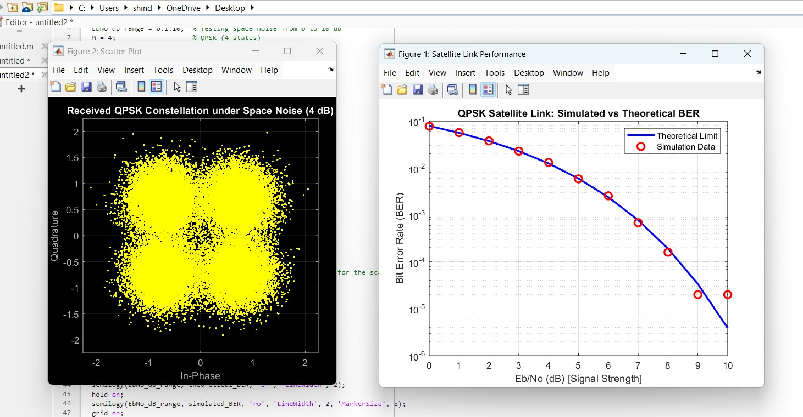

6.3 Discussion
At 10 dB Eb/N0: The noise amplitude is small relative to the carrier signal power. All received symbol coordinates remain within their designated decision quadrants, resulting in a zero error rate (0%).
At 2 dB Eb/N0: The increased noise power causes phase variance. Received points frequently cross the I/Q decision boundaries, resulting in a 4.99% Bit Error Rate, which closely matches theoretical QPSK curves for low Eb/N0 ratios.
The simulated results are consistent with the theoretical BER expression Pb = Q(√(2Eb/N0)): as Eb/N0 decreases, the noise-induced phase variance grows and the probability of a symbol being demodulated into the wrong decision quadrant increases sharply, producing the observed rise in Bit Error Rate.

7. Conclusion and Future Scope

7.1 Conclusion
The simulation successfully demonstrates the full operational chain of a digital satellite communication link, from bit generation through QPSK modulation, AWGN channel corruption, demodulation and error-rate analysis. The implementation confirms that QPSK modulation effectively doubles data throughput relative to BPSK, while highlighting the sensitivity of satellite transmission links to additive Gaussian thermal noise. Lowering channel SNR directly degrades signal integrity, as demonstrated by constellation symbol scatter and rising Bit Error Rates.

7.2 Limitations
- The channel model assumes ideal AWGN only; it does not account for Doppler shift, rain fade, or multipath fading typical of real satellite links.
- Carrier and timing synchronization are assumed ideal at the receiver.
- No forward error correction (channel coding) is applied to mitigate bit errors.

7.3 Future Scope
- Extend the simulation to higher-order modulation schemes (8-PSK, 16-QAM) and compare spectral efficiency versus BER trade-offs.
- Incorporate channel coding (e.g., Convolutional, Reed-Solomon, or LDPC codes) to evaluate coding gain under low Eb/N0 conditions.
- Model additional real-world impairments such as Doppler shift, rain attenuation, and carrier phase offset.
- Sweep Eb/N0 over a continuous range to plot a full simulated BER-vs-Eb/N0 curve against the theoretical QPSK curve.

References
- J. G. Proakis and M. Salehi, Digital Communications, 5th ed., McGraw-Hill, 2007.
- B. Sklar, Digital Communications: Fundamentals and Applications, 2nd ed., Prentice Hall, 2001.
- T. Pratt, C. Bostian, and J. Allnutt, Satellite Communications, 2nd ed., Wiley, 2003.
- S. Haykin, Communication Systems, 5th ed., Wiley, 2009.
- MathWorks, Communications Toolbox Documentation — AWGN Channel and QPSK Modulation/Demodulation, 2024.

