Fair Trade Coffee Verifier
Hackathon-Ready AI Agent Documentation
Offline Streamlit application for verifying whether a coffee product claim maps to a certified Fair Trade farm registry.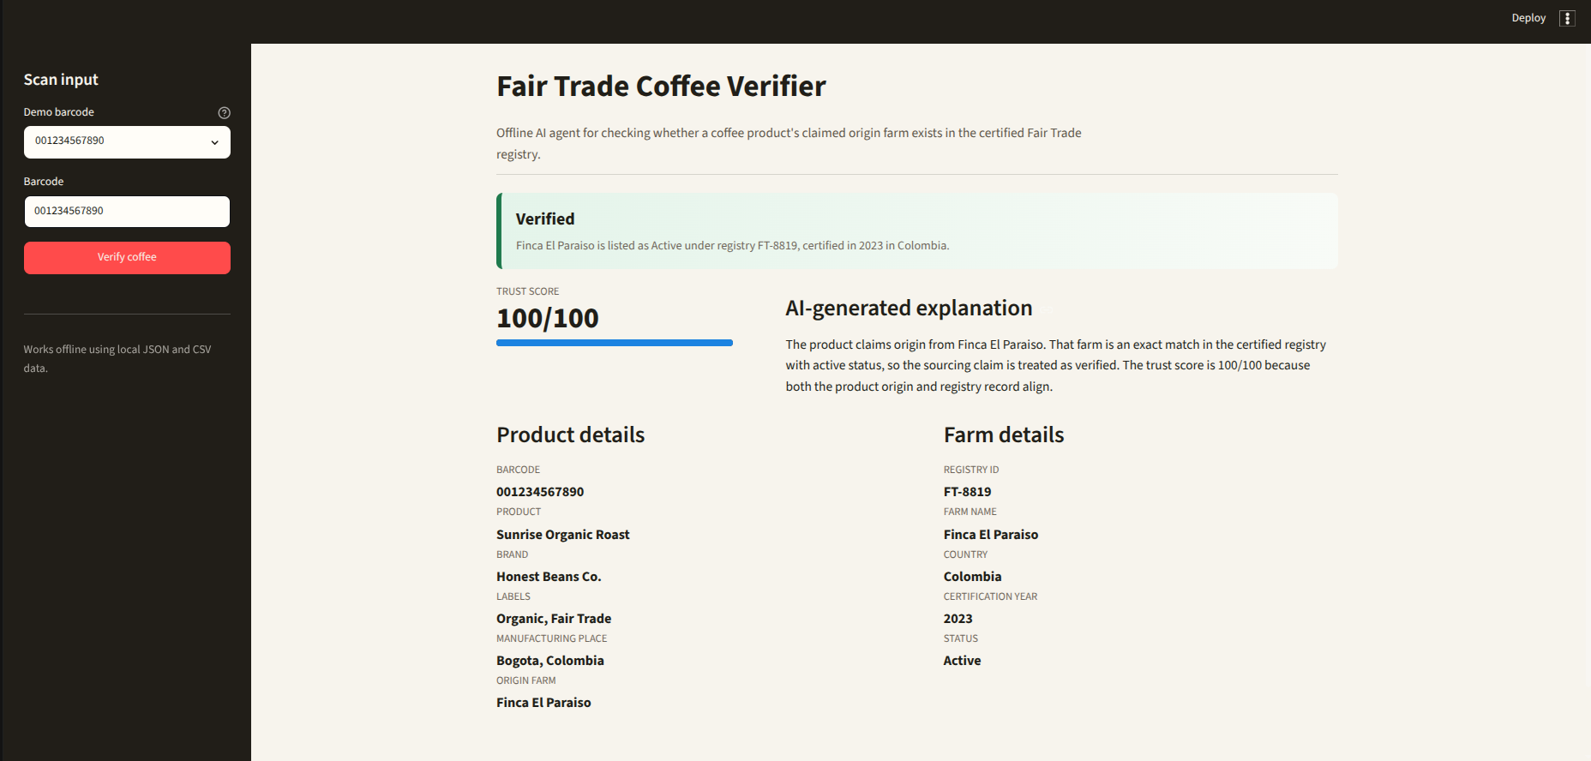

1. Project Overview
Fair Trade Coffee Verifier is an offline AI agent that simulates barcode-based product lookup and validates coffee origin claims against a certified Fair Trade farm registry. The agent helps users identify whether a product is likely authentic or potentially greenwashed.
- User enters or scans a barcode in the Streamlit sidebar.
- The app retrieves product details from bundled mock JSON data.
- The origin_farm_name field is extracted from the product payload.
- The farm is checked against the bundled certified Fair Trade farms CSV.
- The UI displays product details, farm details, verification status, certification information, trust score, and a local AI-generated explanation.

2. Problem Statement
Consumers often rely on labels such as Fair Trade, Sustainable, Eco-Friendly, or Organic when buying coffee. Some brands may use these claims without verifiable sourcing evidence. This project provides a simple supply-chain audit agent that checks whether the claimed origin farm appears in a certified registry.

3. Data Sources
Source | File | Purpose
Mock barcode API responses | data/mock_products.json | Offline product lookup source simulating Open Food Facts API payloads
Certified farms registry | data/certified_fair_trade_farms.csv | Local registry used to verify farm certification

The application works entirely offline after dependencies are installed. No external barcode API or AI API is called at runtime.

4. Demo Barcode Test Cases
Barcode | Product | Expected Result
001234567890 | Sunrise Organic Roast by Honest Beans Co. | Verified. Origin farm Finca El Paraiso exists in the CSV registry.
009876543210 | Eco-Friendly Earth Blend by Global MegaCorp Coffee | Possible Greenwashing. Origin farm Mass Harvest Plantations Ltd. is not found in the registry.
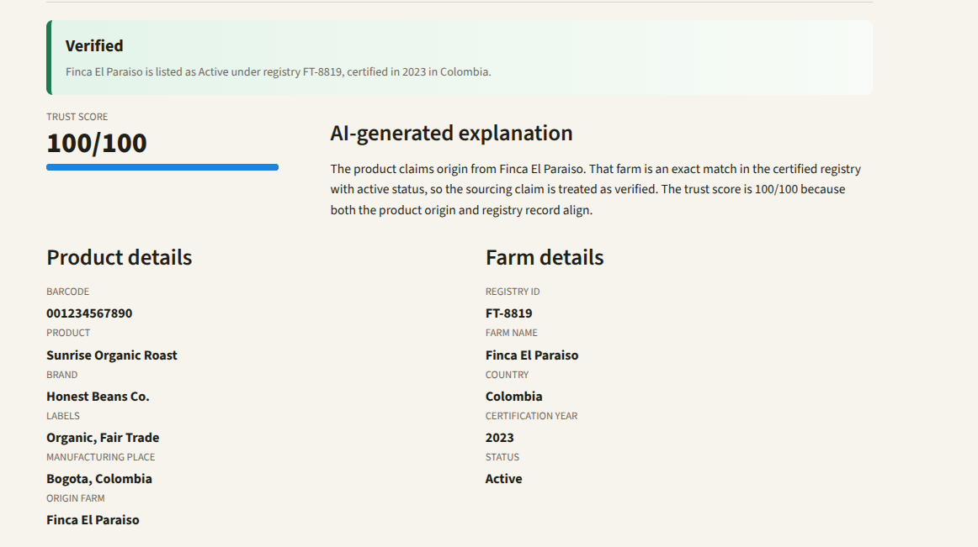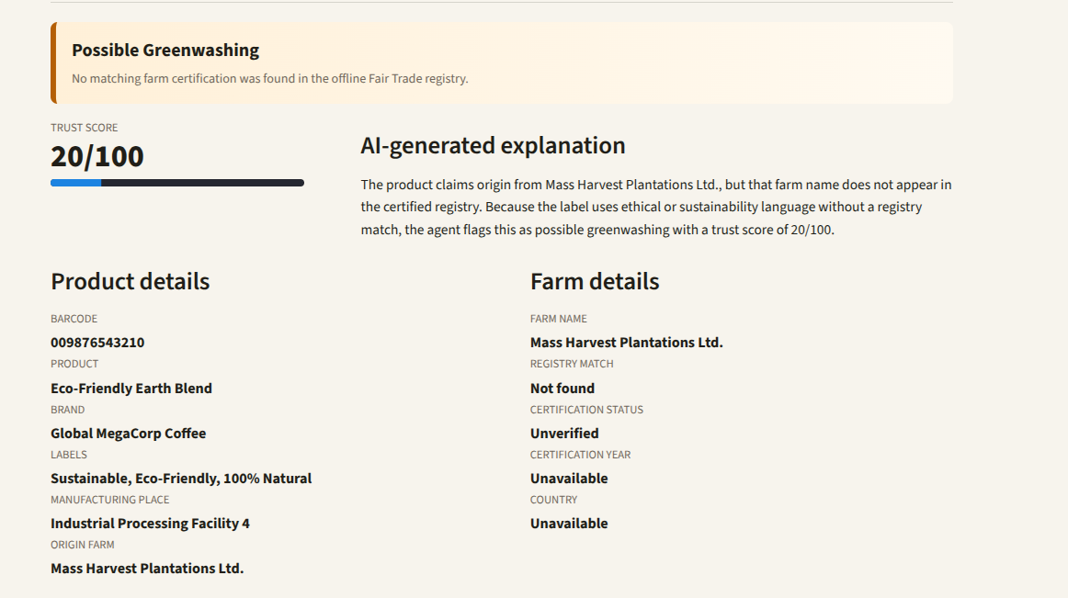

5. Architecture
The app uses a clean modular architecture so the UI, data lookup, registry loading, verification logic, and logging are separated.
Module | Responsibility
app.py | Streamlit user interface and result rendering
src/agent.py | Coordinates lookup, registry, and verification
src/product_lookup.py | Loads mock barcode JSON and returns normalized Product objects
src/registry.py | Loads certified Fair Trade CSV and performs farm matching
src/verifier.py | Calculates status, trust score, certification information, and explanation
src/models.py | Dataclasses for Product, Farm, and VerificationResult
src/logging_config.py | Rotating file logger configuration

6. Verification Workflow
- Step 1: User enters a barcode.
- Step 2: MockBarcodeLookup normalizes the barcode and loads the matching JSON payload.
- Step 3: The agent extracts product_name, brands, labels, manufacturing_places, and origin_farm_name.
- Step 4: FairTradeRegistry loads certified_fair_trade_farms.csv.
- Step 5: CoffeeVerifier performs an exact normalized match against Farm_Name.
- Step 6: The app displays the result and generated explanation.

7. Verification Logic
A product is marked Verified only when the extracted origin_farm_name matches a farm in the CSV registry and that farm has Active status. If the farm is missing from the registry, the product is flagged as Possible Greenwashing.
Trust score behavior:
- Verified products start at 82 points, receive additional credit for Fair Trade labels and Active registry status, and cap at 100.
- Unregistered farms start at 28 points and lose points when sustainability or ethical claims are present without registry evidence.
- The greenwashing example receives 20/100 because it uses sustainability language but lacks a registry match.

8. User Interface
- Sidebar includes demo barcode selection, manual barcode input, and a Verify coffee button.
- Main page includes a verdict banner, trust score, AI-generated explanation, product details, and farm details.
- The design uses a restrained coffee-inspired palette and avoids network-dependent assets.
- Sidebar input styling was adjusted so barcode text remains readable in both light and dark modes.

9. Error Handling and Logging
- Missing barcode: ProductLookupError explains that the barcode is not available in the offline lookup source.
- Invalid mock JSON: ProductLookupError identifies invalid or unusable product payloads.
- Missing CSV: RegistryError reports the missing registry path.
- Unexpected runtime errors are logged to logs/app.log and shown as a concise Streamlit error message.
- Logging uses a rotating file handler to keep runtime logs bounded.

10. How to Run
From the project directory, run:
cd /home/omkar/Desktop/CODE/fair_trade_coffee_verifier
python3 -m streamlit run app.py
Then open http://127.0.0.1:8501 in a browser.

11. Automated Testing
Run the test suite with:
PYTHONDONTWRITEBYTECODE=1 python3 -m pytest -p no:cacheprovider
Current tests cover the verified barcode path and the possible greenwashing barcode path.

12. Project File Structure
fair_trade_coffee_verifier/
app.py
data/certified_fair_trade_farms.csv
data/mock_products.json
src/agent.py
src/product_lookup.py
src/registry.py
src/verifier.py
src/models.py
tests/test_verifier.py
README.md

13. Future Improvements
- Add real camera barcode scanning through a browser-compatible component.
- Support fuzzy farm matching with transparent confidence explanations.
- Add downloadable verification reports for consumers or auditors.
- Connect to live Open Food Facts and official certification registries when internet access is allowed.
- Add image-based package label analysis for products without origin_farm_name metadata.

