# BUSA8090 Data and Visualisation for Business

Assignment 2

Contents

BUSA8090 Data and Visualisation for Business 1

Data Analytics Process for Data Governance: 1

Data Collection 1

Data Storage and Management 1

Data Processing and Analysis 2

Data Monitoring and Compliance 2

Features of Tableau for Visualization according to Data Governance Principles: 2

Data Security 2

Data Governance Integration 2

Data Connectivity 2

Customizable Dashboards 2

Ethics in Data Visualization: 2

Accuracy and Truthfulness 2

Data Privacy and Anonymity: 2

Transparency and Clarity 2

Visualisations 3

1) Attribute analysis of top streaming songs 3

2) Top streaming songs’s analysis on different charts 3

3) Artist collab analysis 4

4) Sentiment analysis of top streaming songs 5

5) Relevance of older artists 5

Data Analytics Process for Data Governance:

Data Collection: Involves gathering relevant data from various sources, ensuring its accuracy, completeness, and timeliness.

Data Storage and Management: Organizing and storing data securely, maintaining data quality, and ensuring data accessibility for authorized users.

Data Processing and Analysis: Utilizing tools and techniques to process and analyze data, identify patterns, trends, and insights for informed decision-making.

Data Monitoring and Compliance: Regularly monitoring data usage, enforcing data governance policies, and ensuring compliance with data regulations and standards.

# Features of Tableau for Visualization according to Data Governance Principles:

Data Security: Tableau offers data security features such as encryption, user authentication, and permission controls to ensure secure data visualization and access.

Data Governance Integration: Tableau allows integration with data governance tools to maintain data quality, standardization, and compliance with data policies.

Data Connectivity: Tableau provides connectivity to various data sources, enabling the visualization of data from multiple platforms while ensuring data accuracy and integrity.

Customizable Dashboards: Tableau's customizable dashboards and interactive visualizations allow users to create tailored views of data, supporting better decision-making while adhering to data governance principles.

# Ethics in Data Visualization:

Ethics in data visualization are essential for ensuring the responsible and ethical use of data. Some key ethics values to maintain include:

Accuracy and Truthfulness: Ensure that data representations are accurate and truthful, avoiding any misrepresentation or manipulation that could lead to false interpretations or misunderstandings.

Data Privacy and Anonymity: Safeguard sensitive information and respect individual privacy by anonymizing personal data whenever possible, and by adhering to relevant data protection laws and regulations.

Transparency and Clarity: Provide clear explanations of the data sources, methodologies, and any assumptions made during the visualization process. I have tried to uphold ethics by using the above points. Additionally, I have added references of my dataset in the story mode and maintained transparency and accuracy throughout the visualization process.

By upholding these ethics values, data visualization practitioners can maintain the integrity of their work and foster trust among their audience, ensuring that data is used in a responsible and ethical manner.

Visualisations

1. Attribute analysis of top streaming songs  
   A screenshot of a computer

   Description automatically generated

The visualization can be used by a CMO of Sony Music to solve problems by analyzing the track attributes of different songs. The CMO can use this plot to understand which attributes are more popular among the listeners and which attributes are not. For example, if the CMO finds that songs with high energy levels are more popular among listeners, they can focus on producing and promoting such songs.

## Top streaming songs’s analysis on different charts

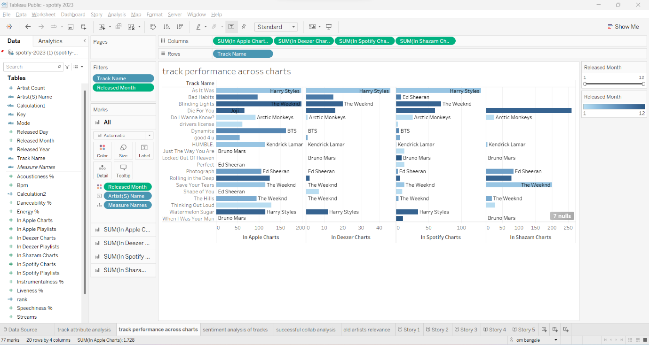

A CMO of Sony could use this dashboard to understand how their artists are performing on different charts, which could help them make informed decisions about marketing and promotion strategies. For example, if an artist is performing well on the “Artist Monthly Listeners” chart but not on the “Artist Streams” chart, the CMO could consider promoting the artist on platforms that are more conducive to streaming, such as Spotify or Apple Music.

## Artist collab analysis

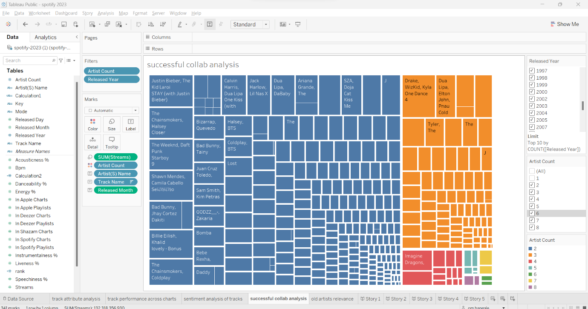

A CMO could use this treemap chart to visualize the success of their collaborations. The size of the rectangles represents the success of the collaboration, and the color of the rectangles represents the type of collaboration. The chart is divided into number of singers, and they are colour coded. Subsequently we can see that duets are the most successful and as you add more artists the songs keep doing worse.

## Sentiment analysis of top streaming songs

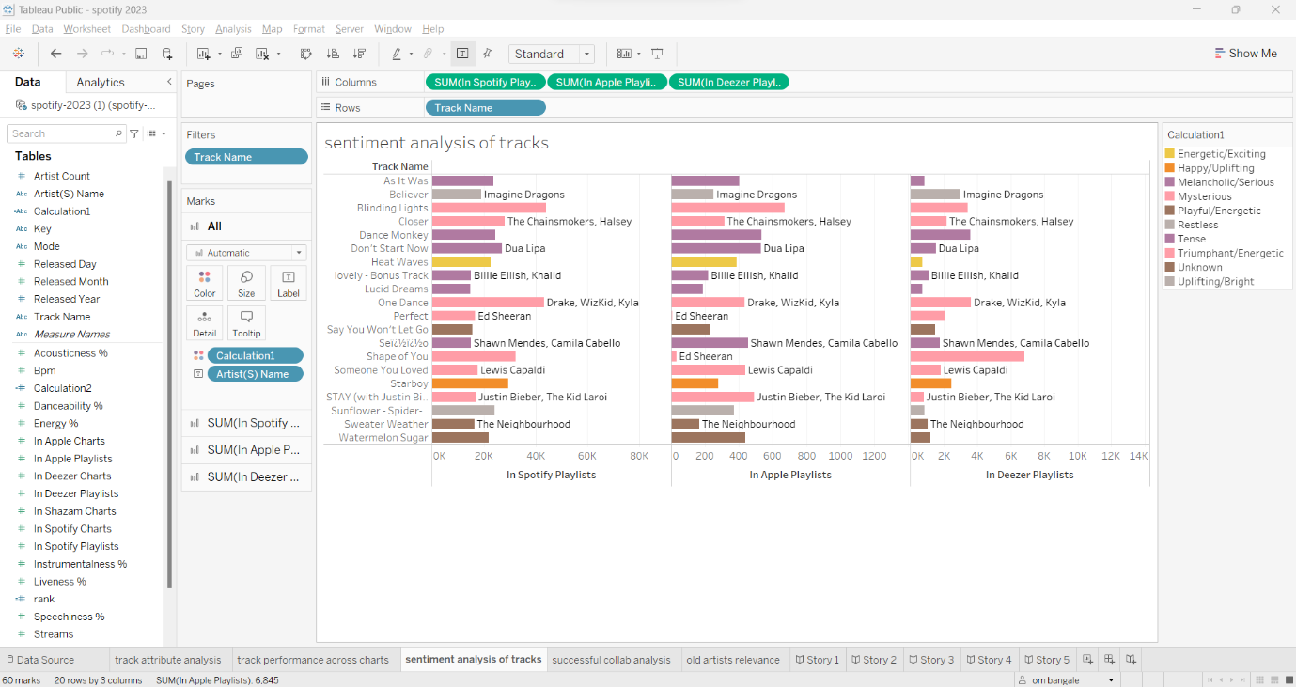

This plot is a sentiment analysis of tracks. It shows the percentage of positive, negative, and neutral sentiment for each track. The plot shows that for eg **The Chainsmokers - Closer** has the highest percentage of positive sentiment, while **The Chainsmokers - Don’t Let Me Down** has the highest percentage of negative sentiment. Based on this information, the CMO of Sony could make decisions about which tracks to promote more .For example, they could focus on promoting **The Chainsmokers - Closer** more heavily since it has a higher percentage of positive sentiment.

## Relevance of older artists

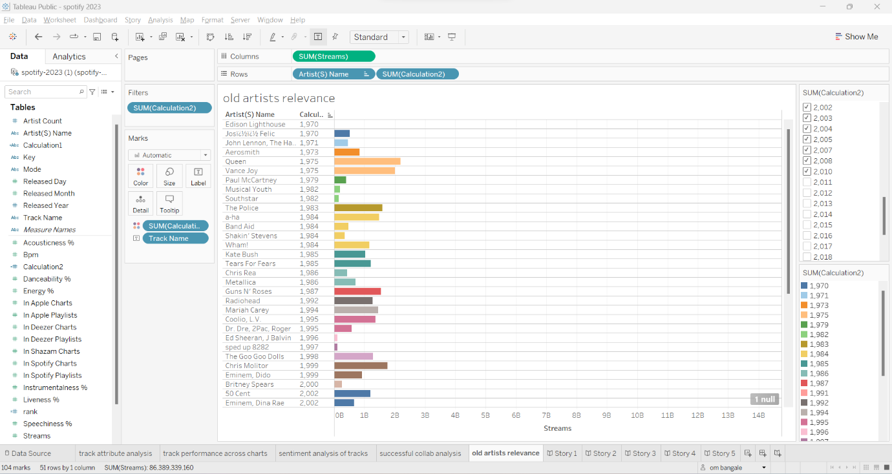

The chart is titled “Old artists relevance” and is sorted in descending order of relevance.

A CMO of Sony can use this chart to understand which artists are more relevant in the industry and which are less relevant. This can help them make better decisions about which artists to invest in and which artists to let go. For example, if an artist is not very relevant, Sony could choose not to renew their contract or invest less in their music. On the other hand, if an artist is very relevant, Sony could invest more in their music or try to sign them to a contract.