Personal Website Development Report
Website created using HTML, CSS, JavaScript, and a personal photograph

Student Name: Om Agrawal
Course: B.E. / B.Tech
Institute: Bangalore Institute of Technology
Academic Year: 2026 - Present

This report documents the design, structure, screenshots, source code, and technologies used in the responsive personal portfolio website.

1. Introduction and Objective
The objective of this project is to create a personal website that presents basic personal information, education, skills, achievements, hobbies, blog content, photographs, and contact details in a clean and professional format. The website acts as a digital portfolio for Om Agrawal and demonstrates the use of HTML, CSS, and JavaScript for front-end web development.
The website is designed as a single-page responsive portfolio so that visitors can quickly move between sections using the navigation menu. It uses a professional visual style, a real profile photograph adjusted with CSS cropping, card layouts, and section-based content organization.

2. Description of Website Sections
Home: Introduces Om Agrawal with a short profile summary, call-to-action buttons, and a personal photograph cropped inside the hero profile panel.
Education: Shows the academic timeline: B.E. / B.Tech at Bangalore Institute of Technology, PUC at Swami Atmanand English Medium School, and 10th Grade at Gyandeep Vidya Mandir, Mandhar.
Skills: Lists technical skills such as C, Python, C++ basics, HTML, CSS, and JavaScript basics, along with non-technical skills such as problem-solving, time management, and critical thinking.
Achievements: Highlights completed work and accomplishments including a personal website, hackathon participation, an online programming basics course, small projects, and a small-scale game using C# and Python.
Hobbies and Interests: Presents interests such as exploring AI tools, gym and games, and exploring new places.
Blog: Includes the blog post ?Why I Started Learning Programming,? explaining the motivation for learning programming and building projects.
Contact: Provides Gmail contact information for academic and project-related communication.

3. Screenshots of the Website Pages
The screenshots below show the main parts of the single-page personal website on desktop and mobile screen sizes.
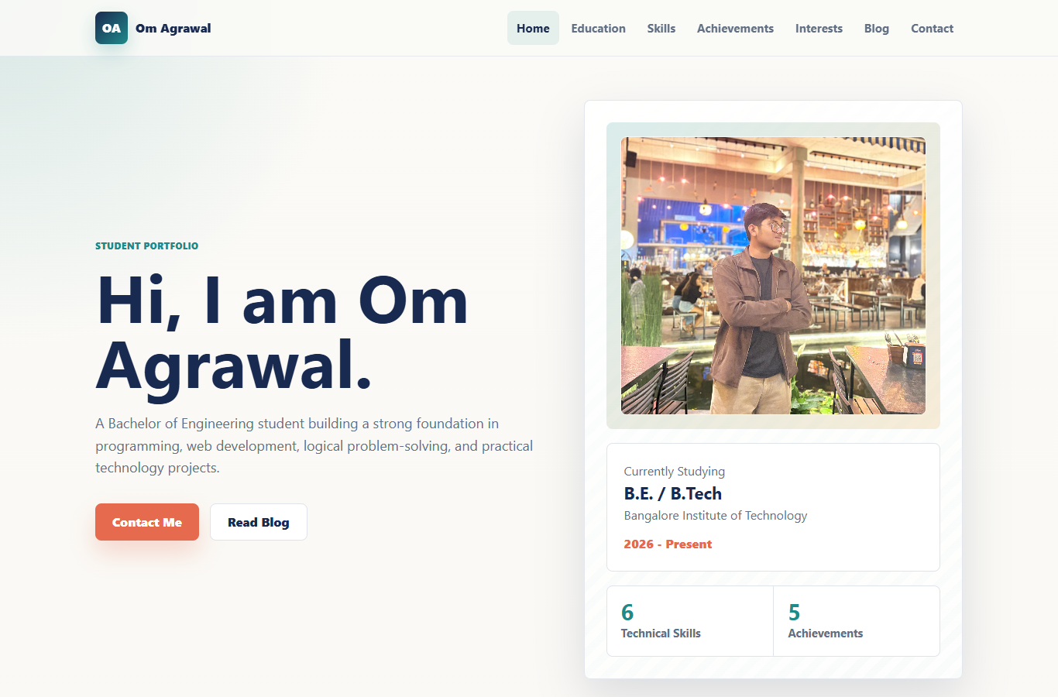
Figure 1: Home section with profile summary and cropped photograph.
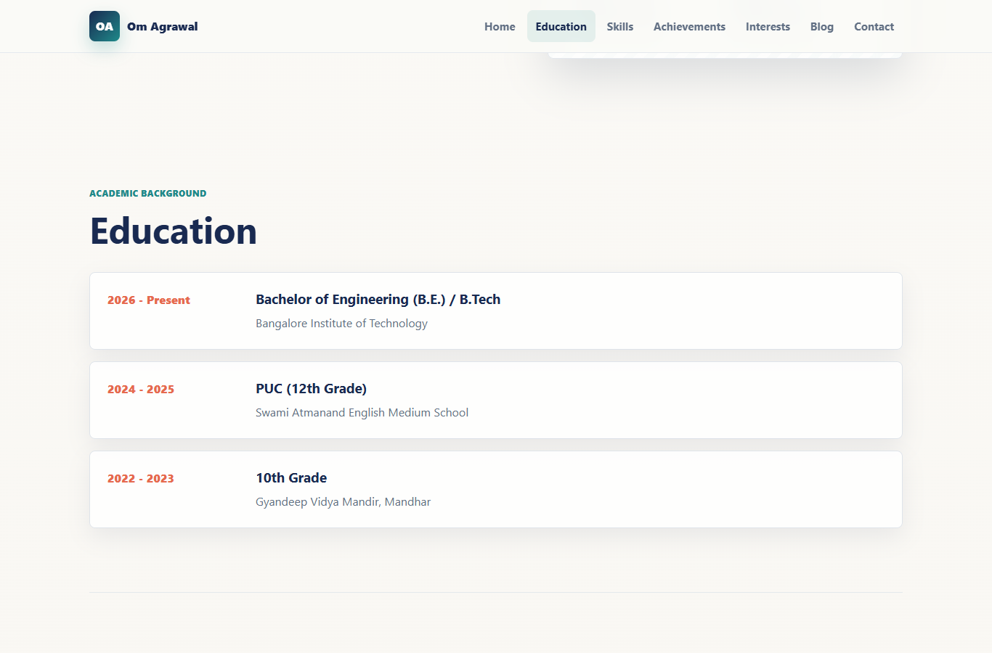
Figure 2: Education section and navigation behavior.
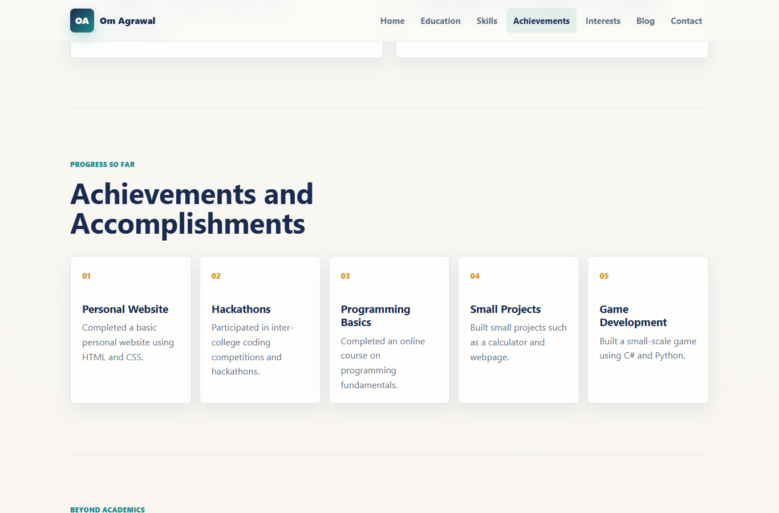
Figure 3: Achievements and hobbies/interests sections.
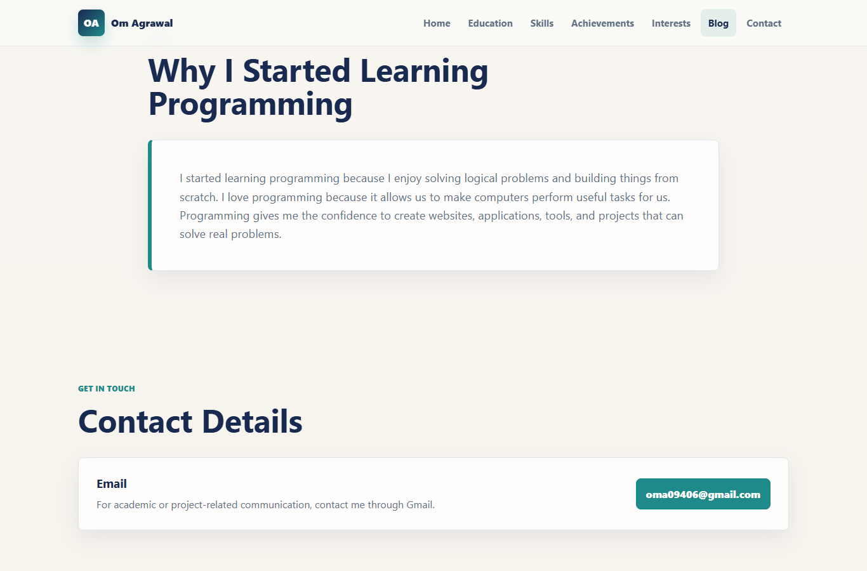
Figure 4: Blog and contact details section.
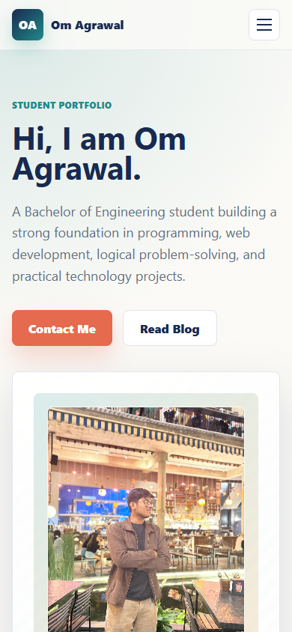
Figure 5: Mobile responsive view with the photograph adjusted for smaller screens.

4. Tools and Technologies Used
- HTML was used to create the structure and content of the website.
- CSS was used for responsive layout, typography, colors, cards, spacing, image cropping, and visual styling.
- JavaScript was used for the mobile navigation menu, active navigation highlighting, and reveal animation behavior.
- A personal photograph was added as a website asset and adjusted using CSS object-fit and object-position.
- A web browser was used to test the layout and capture screenshots.
- A DOCX report was prepared to document the website objective, sections, screenshots, source code, technologies, and conclusion.

5. Conclusion
The personal website successfully presents Om Agrawal?s education, skills, achievements, interests, blog content, photograph, and contact information in a professional and responsive format. The project demonstrates basic front-end development skills and provides a useful digital portfolio that can be expanded in the future with more projects, certifications, and blog posts.

6. Source Code Used
The source code files used for the website are included below.

index.html
<!DOCTYPE html>
<html lang="en">
<head>
<meta charset="UTF-8">
<meta name="viewport" content="width=device-width, initial-scale=1.0">
<title>Om Agrawal | Personal Portfolio</title>
<meta name="description" content="Personal portfolio website of Om Agrawal, a B.E./B.Tech student interested in programming, AI tools, and technology.">
<link rel="stylesheet" href="style.css">
</head>
<body>
<header class="site-header">
<nav class="navbar" aria-label="Main navigation">
<a class="brand" href="#home" aria-label="Om Agrawal home">
<span class="brand-mark">OA</span>
<span>Om Agrawal</span>
</a>
<button class="menu-toggle" type="button" aria-label="Open navigation menu" aria-expanded="false">
<span></span>
<span></span>
<span></span>
</button>
<div class="nav-links">
<a href="#home">Home</a>
<a href="#education">Education</a>
<a href="#skills">Skills</a>
<a href="#achievements">Achievements</a>
<a href="#interests">Interests</a>
<a href="#blog">Blog</a>
<a href="#contact">Contact</a>
</div>
</nav>
</header>

<main>
<section class="hero section" id="home">
<div class="hero-content reveal">
<p class="eyebrow">Student Portfolio</p>
<h1>Hi, I am Om Agrawal.</h1>
<p class="hero-text">
A Bachelor of Engineering student building a strong foundation in programming,
web development, logical problem-solving, and practical technology projects.
</p>
<div class="hero-actions">
<a class="primary-button" href="#contact">Contact Me</a>
<a class="secondary-button" href="#blog">Read Blog</a>
</div>
</div>
<div class="profile-panel reveal" aria-label="Profile summary">
<div class="avatar-wrap">
<img class="profile-photo" src="assets/om-agrawal-photo.jpeg" alt="Portrait photograph of Om Agrawal">
</div>
<div class="profile-card">
<p class="profile-label">Currently Studying</p>
<h2>B.E. / B.Tech</h2>
<p>Bangalore Institute of Technology</p>
<span>2026 - Present</span>
</div>
<div class="quick-stats" aria-label="Quick highlights">
<div>
<strong>6</strong>
<span>Technical Skills</span>
</div>
<div>
<strong>5</strong>
<span>Achievements</span>
</div>
</div>
</div>
</section>

<section class="section" id="education">
<div class="section-heading reveal">
<p class="eyebrow">Academic Background</p>
<h2>Education</h2>
</div>
<div class="timeline reveal">
<article class="timeline-item">
<span class="year">2026 - Present</span>
<div>
<h3>Bachelor of Engineering (B.E.) / B.Tech</h3>
<p>Bangalore Institute of Technology</p>
</div>
</article>
<article class="timeline-item">
<span class="year">2024 - 2025</span>
<div>
<h3>PUC (12th Grade)</h3>
<p>Swami Atmanand English Medium School</p>
</div>
</article>
<article class="timeline-item">
<span class="year">2022 - 2023</span>
<div>
<h3>10th Grade</h3>
<p>Gyandeep Vidya Mandir, Mandhar</p>
</div>
</article>
</div>
</section>

<section class="section split-section" id="skills">
<div class="section-heading reveal">
<p class="eyebrow">What I Am Learning</p>
<h2>Skills</h2>
</div>
<div class="skill-groups">
<article class="feature-card reveal">
<div class="card-icon" aria-hidden="true">
<svg viewBox="0 0 24 24" role="img">
<path d="M8 18 2 12l6-6M16 6l6 6-6 6M14 4l-4 16"/>
</svg>
</div>
<h3>Technical Skills</h3>
<div class="tags">
<span>C</span>
<span>Python</span>
<span>C++ Basics</span>
<span>HTML</span>
<span>CSS</span>
<span>JavaScript Basics</span>
</div>
</article>
<article class="feature-card reveal">
<div class="card-icon" aria-hidden="true">
<svg viewBox="0 0 24 24" role="img">
<path d="M9 12l2 2 4-4M21 12a9 9 0 1 1-18 0 9 9 0 0 1 18 0Z"/>
</svg>
</div>
<h3>Non-Technical Skills</h3>
<div class="tags">
<span>Problem-solving</span>
<span>Time management</span>
<span>Critical thinking</span>
</div>
</article>
</div>
</section>

<section class="section" id="achievements">
<div class="section-heading reveal">
<p class="eyebrow">Progress So Far</p>
<h2>Achievements and Accomplishments</h2>
</div>
<div class="achievement-grid reveal">
<article>
<span>01</span>
<h3>Personal Website</h3>
<p>Completed a basic personal website using HTML and CSS.</p>
</article>
<article>
<span>02</span>
<h3>Hackathons</h3>
<p>Participated in inter-college coding competitions and hackathons.</p>
</article>
<article>
<span>03</span>
<h3>Programming Basics</h3>
<p>Completed an online course on programming fundamentals.</p>
</article>
<article>
<span>04</span>
<h3>Small Projects</h3>
<p>Built small projects such as a calculator and webpage.</p>
</article>
<article>
<span>05</span>
<h3>Game Development</h3>
<p>Built a small-scale game using C# and Python.</p>
</article>
</div>
</section>

<section class="section split-section" id="interests">
<div class="section-heading reveal">
<p class="eyebrow">Beyond Academics</p>
<h2>Hobbies and Interests</h2>
</div>
<div class="interest-list reveal">
<article>
<h3>Exploring AI Tools</h3>
<p>I enjoy discovering new AI tools and learning how they can improve creativity, productivity, and problem-solving.</p>
</article>
<article>
<h3>Gym and Games</h3>
<p>Fitness and games help me stay energetic, focused, and balanced.</p>
</article>
<article>
<h3>Exploring New Places</h3>
<p>I like visiting new places because it helps me learn, observe, and experience different environments.</p>
</article>
</div>
</section>

<section class="section blog-section" id="blog">
<div class="section-heading reveal">
<p class="eyebrow">Blog</p>
<h2>Why I Started Learning Programming</h2>
</div>
<article class="blog-card reveal">
<p>
I started learning programming because I enjoy solving logical problems and
building things from scratch. I love programming because it allows us to make
computers perform useful tasks for us. Programming gives me the confidence to
create websites, applications, tools, and projects that can solve real problems.
</p>
</article>
</section>

<section class="section contact-section" id="contact">
<div class="section-heading reveal">
<p class="eyebrow">Get In Touch</p>
<h2>Contact Details</h2>
</div>
<div class="contact-card reveal">
<div>
<h3>Email</h3>
<p>For academic or project-related communication, contact me through Gmail.</p>
</div>
<a href="mailto:oma09406@gmail.com">oma09406@gmail.com</a>
</div>
</section>
</main>

<footer class="site-footer">
<p>&copy; 2026 Om Agrawal. Personal Portfolio Website.</p>
</footer>

<script src="script.js"></script>
</body>
</html>

style.css
:root {
--ink: #162033;
--muted: #627084;
--paper: #f7f4ee;
--surface: #ffffff;
--line: #dfe4ea;
--teal: #1f8a8a;
--coral: #e66a4e;
--gold: #d99a2b;
--navy: #192a51;
--shadow: 0 24px 60px rgba(24, 42, 81, 0.14);
}

* {
box-sizing: border-box;
}

html {
scroll-behavior: smooth;
}

body {
margin: 0;
font-family: "Segoe UI", Arial, sans-serif;
color: var(--ink);
background:
radial-gradient(circle at top left, rgba(31, 138, 138, 0.16), transparent 28rem),
linear-gradient(180deg, #fbfaf7 0%, var(--paper) 100%);
line-height: 1.6;
}

a {
color: inherit;
text-decoration: none;
}

.site-header {
position: sticky;
top: 0;
z-index: 20;
border-bottom: 1px solid rgba(223, 228, 234, 0.78);
background: rgba(251, 250, 247, 0.88);
backdrop-filter: blur(18px);
}

.navbar {
width: min(1120px, calc(100% - 32px));
min-height: 72px;
margin: 0 auto;
display: flex;
align-items: center;
justify-content: space-between;
gap: 24px;
}

.brand,
.nav-links {
display: flex;
align-items: center;
}

.brand {
gap: 10px;
font-weight: 800;
color: var(--navy);
}

.brand-mark {
display: grid;
place-items: center;
width: 42px;
aspect-ratio: 1;
border-radius: 8px;
color: #ffffff;
background: linear-gradient(135deg, var(--navy), var(--teal));
box-shadow: 0 10px 24px rgba(31, 138, 138, 0.25);
}

.nav-links {
gap: 4px;
}

.nav-links a {
padding: 10px 12px;
border-radius: 8px;
color: var(--muted);
font-size: 0.94rem;
font-weight: 700;
transition: color 0.2s ease, background 0.2s ease;
}

.nav-links a:hover,
.nav-links a.active {
color: var(--navy);
background: rgba(31, 138, 138, 0.1);
}

.menu-toggle {
display: none;
width: 42px;
aspect-ratio: 1;
border: 1px solid var(--line);
border-radius: 8px;
background: var(--surface);
cursor: pointer;
}

.menu-toggle span {
display: block;
width: 20px;
height: 2px;
margin: 5px auto;
background: var(--navy);
}

.section {
width: min(1120px, calc(100% - 32px));
margin: 0 auto;
padding: 88px 0;
scroll-margin-top: 86px;
}

.hero {
min-height: calc(100vh - 72px);
display: grid;
grid-template-columns: minmax(0, 1.08fr) minmax(320px, 0.92fr);
align-items: center;
gap: 56px;
padding-top: 56px;
}

.eyebrow {
margin: 0 0 12px;
color: var(--teal);
font-size: 0.78rem;
font-weight: 800;
letter-spacing: 0;
text-transform: uppercase;
}

h1,
h2,
h3,
p {
overflow-wrap: break-word;
}

h1 {
max-width: 760px;
margin: 0;
font-size: clamp(2.6rem, 7vw, 5.4rem);
line-height: 0.97;
letter-spacing: 0;
color: var(--navy);
}

h2 {
margin: 0;
font-size: clamp(2rem, 4vw, 3.1rem);
line-height: 1.05;
letter-spacing: 0;
color: var(--navy);
}

h3 {
margin: 0 0 8px;
line-height: 1.25;
color: var(--navy);
}

.hero-text {
max-width: 620px;
margin: 24px 0 0;
color: var(--muted);
font-size: 1.12rem;
}

.hero-actions {
display: flex;
flex-wrap: wrap;
gap: 14px;
margin-top: 32px;
}

.primary-button,
.secondary-button {
display: inline-flex;
align-items: center;
justify-content: center;
min-height: 48px;
padding: 0 22px;
border-radius: 8px;
font-weight: 800;
}

.primary-button {
color: #ffffff;
background: var(--coral);
box-shadow: 0 16px 32px rgba(230, 106, 78, 0.25);
}

.secondary-button {
border: 1px solid var(--line);
color: var(--navy);
background: var(--surface);
}

.profile-panel {
position: relative;
padding: 28px;
border: 1px solid rgba(223, 228, 234, 0.88);
border-radius: 8px;
background:
linear-gradient(160deg, rgba(255, 255, 255, 0.94), rgba(255, 255, 255, 0.76)),
repeating-linear-gradient(135deg, rgba(31, 138, 138, 0.08) 0 10px, transparent 10px 20px);
box-shadow: var(--shadow);
}

.avatar-wrap {
padding: 18px;
border-radius: 8px;
background: linear-gradient(135deg, rgba(31, 138, 138, 0.16), rgba(217, 154, 43, 0.18));
}

.profile-photo {
display: block;
width: 100%;
height: 360px;
object-fit: cover;
object-position: 50% 63%;
min-height: 260px;
border: 1px solid rgba(255, 255, 255, 0.68);
border-radius: 8px;
box-shadow: inset 0 -80px 120px rgba(25, 42, 81, 0.18);
}

.profile-card,
.quick-stats {
margin-top: 18px;
border-radius: 8px;
background: var(--surface);
border: 1px solid var(--line);
}

.profile-card {
padding: 22px;
}

.profile-label,
.profile-card p {
margin: 0;
color: var(--muted);
}

.profile-card h2 {
margin: 4px 0;
font-size: 1.38rem;
}

.profile-card span {
display: inline-flex;
margin-top: 12px;
color: var(--coral);
font-weight: 800;
}

.quick-stats {
display: grid;
grid-template-columns: repeat(2, 1fr);
}

.quick-stats div {
padding: 18px;
}

.quick-stats div + div {
border-left: 1px solid var(--line);
}

.quick-stats strong {
display: block;
color: var(--teal);
font-size: 1.8rem;
line-height: 1;
}

.quick-stats span {
color: var(--muted);
font-size: 0.92rem;
font-weight: 700;
}

.section-heading {
max-width: 760px;
margin-bottom: 34px;
}

.timeline {
display: grid;
gap: 16px;
}

.timeline-item,
.feature-card,
.achievement-grid article,
.interest-list article,
.blog-card,
.contact-card {
border: 1px solid var(--line);
border-radius: 8px;
background: rgba(255, 255, 255, 0.84);
box-shadow: 0 12px 32px rgba(24, 42, 81, 0.08);
}

.timeline-item {
display: grid;
grid-template-columns: 180px minmax(0, 1fr);
gap: 24px;
padding: 24px;
}

.timeline-item p {
margin: 0;
color: var(--muted);
}

.year {
color: var(--coral);
font-weight: 800;
}

.split-section {
border-top: 1px solid rgba(223, 228, 234, 0.8);
border-bottom: 1px solid rgba(223, 228, 234, 0.8);
}

.skill-groups {
display: grid;
grid-template-columns: repeat(2, minmax(0, 1fr));
gap: 22px;
}

.feature-card {
padding: 28px;
}

.card-icon {
display: grid;
place-items: center;
width: 52px;
aspect-ratio: 1;
margin-bottom: 20px;
border-radius: 8px;
color: #ffffff;
background: var(--navy);
}

.card-icon svg {
width: 27px;
height: 27px;
fill: none;
stroke: currentColor;
stroke-width: 2;
stroke-linecap: round;
stroke-linejoin: round;
}

.tags {
display: flex;
flex-wrap: wrap;
gap: 10px;
margin-top: 18px;
}

.tags span {
padding: 8px 11px;
border-radius: 8px;
color: var(--navy);
background: rgba(31, 138, 138, 0.1);
font-size: 0.92rem;
font-weight: 700;
}

.achievement-grid {
display: grid;
grid-template-columns: repeat(5, minmax(0, 1fr));
gap: 14px;
}

.achievement-grid article {
min-height: 238px;
padding: 20px;
}

.achievement-grid span {
display: inline-flex;
margin-bottom: 36px;
color: var(--gold);
font-size: 0.86rem;
font-weight: 800;
}

.achievement-grid p,
.interest-list p,
.blog-card p,
.contact-card p {
margin: 0;
color: var(--muted);
}

.interest-list {
display: grid;
grid-template-columns: repeat(3, minmax(0, 1fr));
gap: 18px;
}

.interest-list article {
padding: 24px;
}

.blog-section {
max-width: 900px;
}

.blog-card {
padding: clamp(24px, 5vw, 44px);
border-left: 6px solid var(--teal);
}

.blog-card p {
font-size: 1.14rem;
}

.contact-section {
padding-bottom: 64px;
}

.contact-card {
display: flex;
align-items: center;
justify-content: space-between;
gap: 24px;
padding: 28px;
}

.contact-card a {
flex: 0 1 auto;
padding: 12px 16px;
border-radius: 8px;
color: #ffffff;
background: var(--teal);
font-weight: 800;
overflow-wrap: anywhere;
}

.site-footer {
padding: 28px 16px;
color: var(--muted);
text-align: center;
border-top: 1px solid var(--line);
background: rgba(255, 255, 255, 0.62);
}

.site-footer p {
margin: 0;
}

html.js-enabled .reveal {
opacity: 0;
transform: translateY(18px);
transition: opacity 0.7s ease, transform 0.7s ease;
}

html.js-enabled .reveal.is-visible {
opacity: 1;
transform: translateY(0);
}

@media (max-width: 980px) {
.hero {
grid-template-columns: 1fr;
min-height: auto;
padding-top: 64px;
}

.achievement-grid {
grid-template-columns: repeat(2, minmax(0, 1fr));
}

.interest-list {
grid-template-columns: 1fr;
}
}

@media (max-width: 760px) {
.navbar {
min-height: 66px;
}

.menu-toggle {
display: block;
}

.nav-links {
position: absolute;
inset: 66px 16px auto 16px;
display: none;
flex-direction: column;
align-items: stretch;
padding: 10px;
border: 1px solid var(--line);
border-radius: 8px;
background: var(--surface);
box-shadow: var(--shadow);
}

.nav-links.open {
display: flex;
}

.nav-links a {
padding: 12px;
}

.section {
padding: 64px 0;
}

.hero {
gap: 34px;
}

.profile-photo {
height: 320px;
min-height: 210px;
object-position: 50% 61%;
}

.timeline-item {
grid-template-columns: 1fr;
gap: 8px;
}

.skill-groups,
.achievement-grid {
grid-template-columns: 1fr;
}

.achievement-grid article {
min-height: auto;
}

.achievement-grid span {
margin-bottom: 18px;
}

.contact-card {
align-items: stretch;
flex-direction: column;
}
}

@media (prefers-reduced-motion: reduce) {
html {
scroll-behavior: auto;
}

html.js-enabled .reveal {
opacity: 1;
transform: none;
transition: none;
}
}

script.js
document.documentElement.classList.add("js-enabled");

const menuToggle = document.querySelector(".menu-toggle");
const navLinks = document.querySelector(".nav-links");
const navAnchors = document.querySelectorAll(".nav-links a");
const sections = document.querySelectorAll("main section[id]");
const revealItems = document.querySelectorAll(".reveal");

menuToggle.addEventListener("click", () => {
const isOpen = navLinks.classList.toggle("open");
menuToggle.setAttribute("aria-expanded", String(isOpen));
});

navAnchors.forEach((anchor) => {
anchor.addEventListener("click", () => {
navLinks.classList.remove("open");
menuToggle.setAttribute("aria-expanded", "false");
});
});

const revealObserver = new IntersectionObserver(
(entries) => {
entries.forEach((entry) => {
if (entry.isIntersecting) {
entry.target.classList.add("is-visible");
revealObserver.unobserve(entry.target);
}
});
},
{ threshold: 0.14 }
);

revealItems.forEach((item) => revealObserver.observe(item));

window.addEventListener("load", () => {
setTimeout(() => {
revealItems.forEach((item) => item.classList.add("is-visible"));
}, 1200);
});

const activeObserver = new IntersectionObserver(
(entries) => {
entries.forEach((entry) => {
if (!entry.isIntersecting) return;

navAnchors.forEach((anchor) => {
anchor.classList.toggle("active", anchor.getAttribute("href") === `#${entry.target.id}`);
});
});
},
{ rootMargin: "-38% 0px -55% 0px" }
);

sections.forEach((section) => activeObserver.observe(section));

