REMOTE FILE MANAGEMENT SYSTEM
Using Microsoft .NET Remoting

Course: Distributed Computing Systems
Technology: C# · .NET Framework 4.8 · TCP Remoting
IDE: Visual Studio 2022
Academic Year: 2026

Submitted by
Ashish Pakhale | Om Amar | Tanay Umre | Prathamesh D.
BT23CSE107 | BT23CSE106 | BT23CSE109 | BT23CSE096

1. Abstract
In this project, an example of a complete and working Remote File Management System based on Microsoft .NET Remoting was designed. This is a traditional object-oriented RPC framework within the .NET platform.
The client connects with the server using a TCP channel which uses binary serialization. Using this connection, the client performs all possible manipulations related to files and directories stored in the server – creation, reading, updating, appending, deleting, renaming, copying, moving, uploading, downloading, and searching, while never possessing any direct access to the physical disk of the server.
All file manipulations take place inside a separate ServerStorage folder and are protected from any path traversal attacks.
2. Objectives
- Implement pure .NET Remoting using System.Runtime.Remoting, MarshalByRefObject, and TcpChannel.
- Provide complete file operations: CRUD (Create, Read, Update, Append, Delete), Rename, Copy, Move.
- Support binary file transfer: Upload any file from client to server and Download server files to client.
- Implement recursive file Search across server storage
- Deliver a clean, intuitive Windows Forms GUI (TreeView + ListView explorer interface).
- Log all server operations with timestamps and color-coded category tags on the server console.
3. System Architecture
The system follows a three-tier distributed architecture:
Tier | Responsibility
Client Tier | Windows Forms desktop GUI. Obtains a Transparent Proxy to IRemoteFileManager via Activator.GetObject(). All user actions are dispatched as remote method calls.
Network Layer | TCP Channel on port 9000. Calls are serialized using Binary Formatter and transmitted over the TCP socket.
Server Tier | Console application host. RemoteFileManager inherits MarshalByRefObject and implements IRemoteFileManager. Executes physical file I/O inside ServerStorage.
Storage Tier | Dedicated ServerStorage directory on the server machine. Supports all file types — text, binary, images, documents.

Communication Flow:Client GUI → Transparent Proxy →TCP Port 9000 (Binary Serialized) → RemoteFileManager (MarshalByRefObject) → ServerStorage (Physical Disk)
4. Technologies & Tools
Technology | Details
Programming Language | C# (Version 7.3+)
Runtime / Framework | .NET Framework 4.8
Remoting Core | System.Runtime.Remoting, System.Runtime.Remoting.Channels.Tcp
Serialization | Binary Formatter (TypeFilterLevel.Full)
Communication Protocol | TCP Channel, Port 9000
User Interface | Windows Forms (System.Windows.Forms, System.Drawing)
IDE / Build Tools | Visual Studio 2022, MSBuild
Operating System | Windows 10 / 11 (x64)

The Remote Service Contract (IRemoteFileManager)
IRemoteFileManager is defined in the Shared assembly and referenced by both projects. It declares every operation the client can invoke on the server. This interface is the only API surface visible to the client — it never gets a direct reference to the server class.
Server — MarshalByRefObject & Infinite Lifetime
RemoteFileManager inherits from MarshalByRefObject so that the .NET Remoting infrastructure dispatches calls to the actual server instance rather than serializing and copying the object to the client. The lifetime lease is overridden to null (infinite) so the singleton instance never expires during a session.
Client — Transparent Proxy Connection
The client obtains a Transparent Proxy via Activator.GetObject(). From this point, calling any method on _server behaves exactly like a local method call in code, while the runtime transparently serializes the call, transmits it over TCP, and deserializes the response.

5. Practical Screenshots
Server Startup
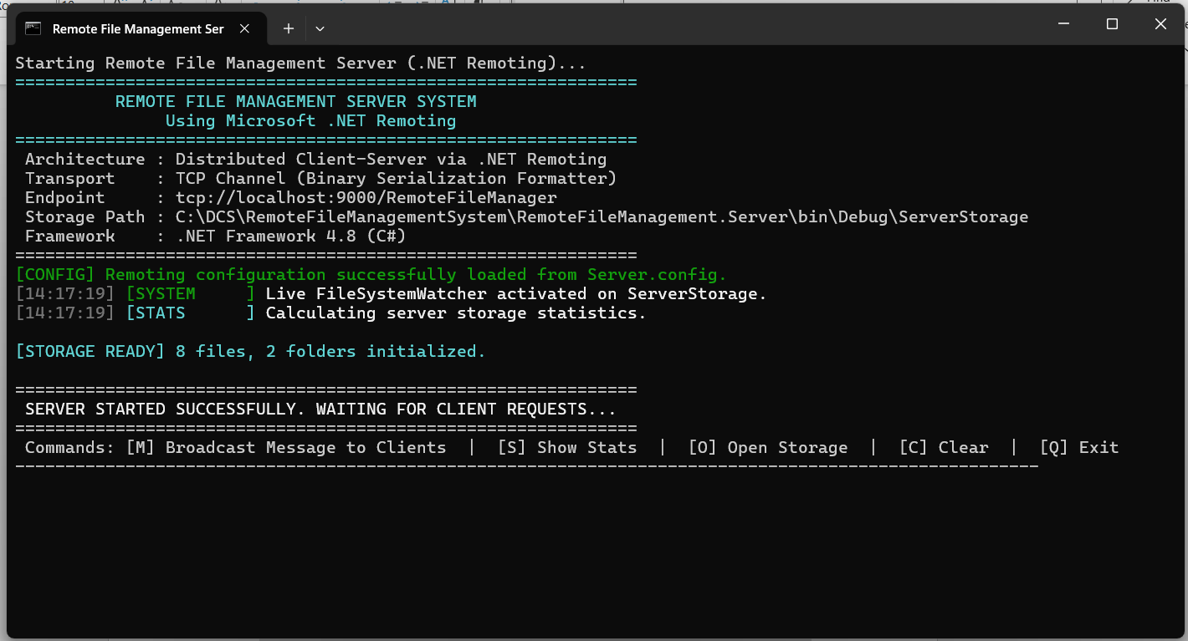

Client: Disconnected State
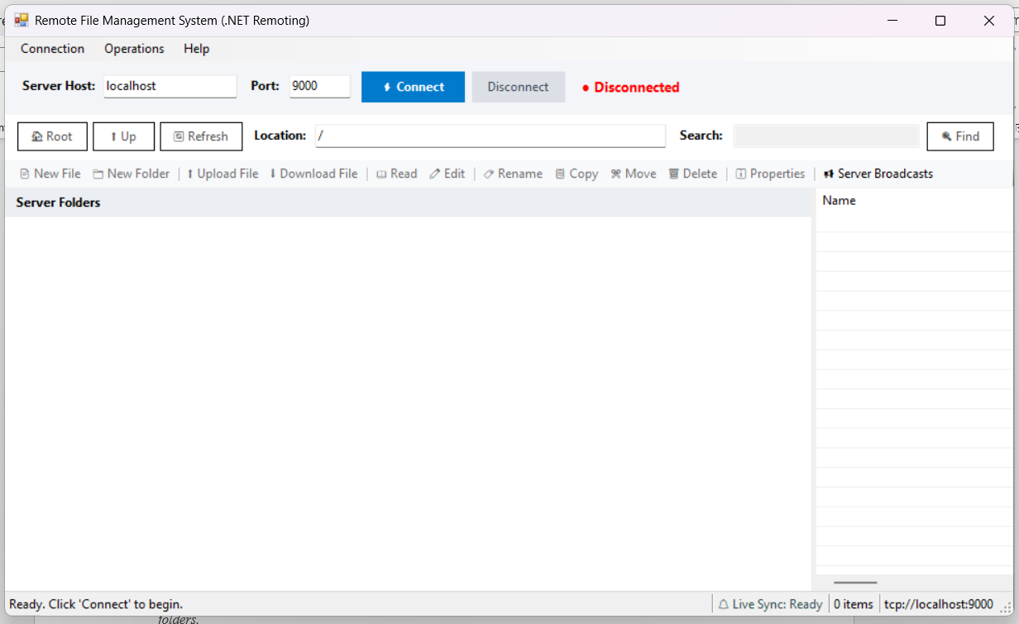

Client: Connected State
After clicking Connect — status bar shows '● Connected ✓' in green. TreeView populated with server folders.
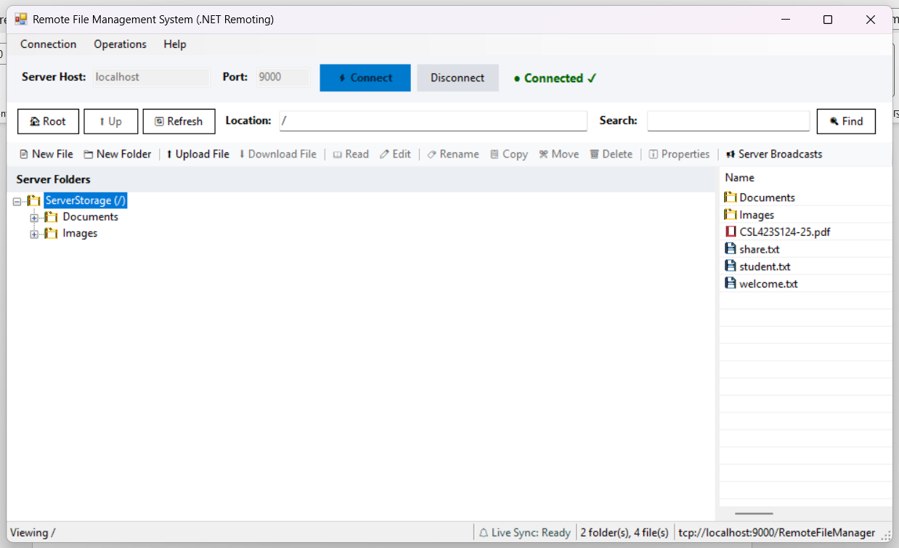

Server Ping Log - Server console printing the [CONNECT]
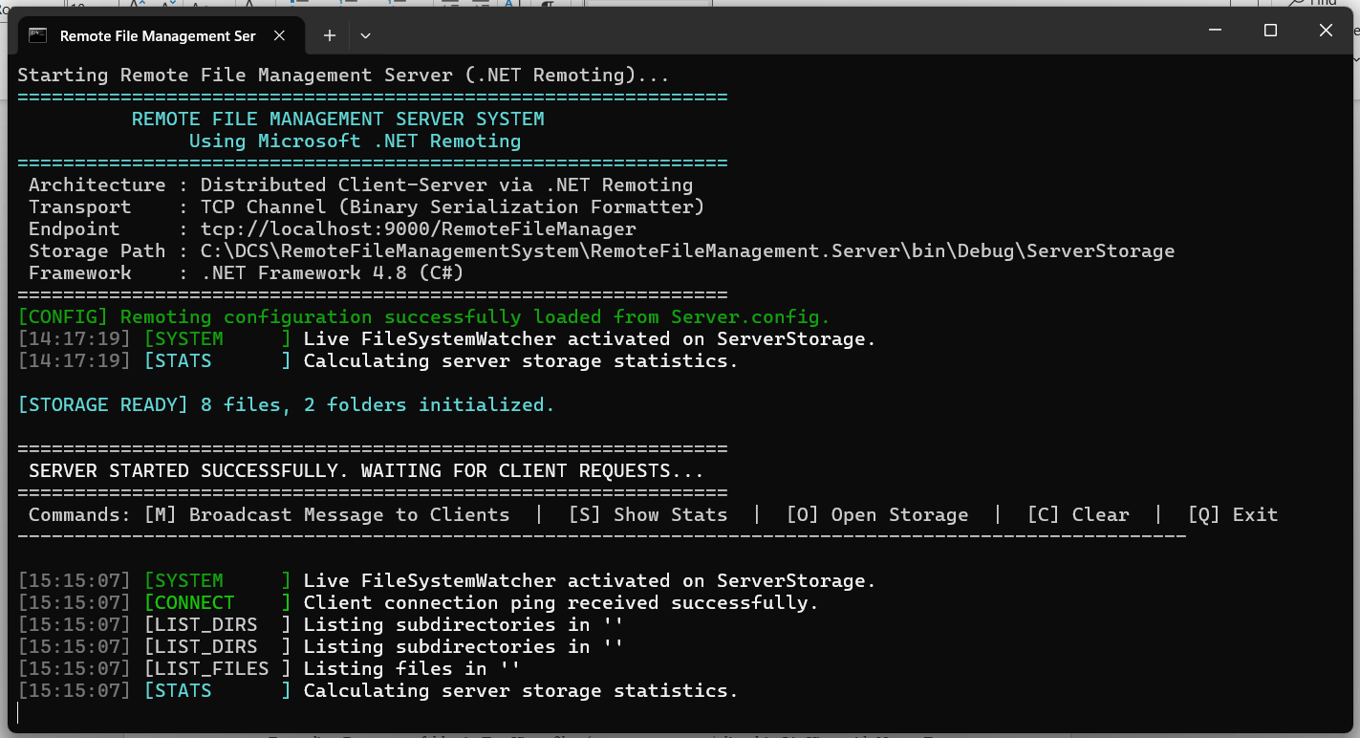

Directory Navigation (TreeView + ListView)
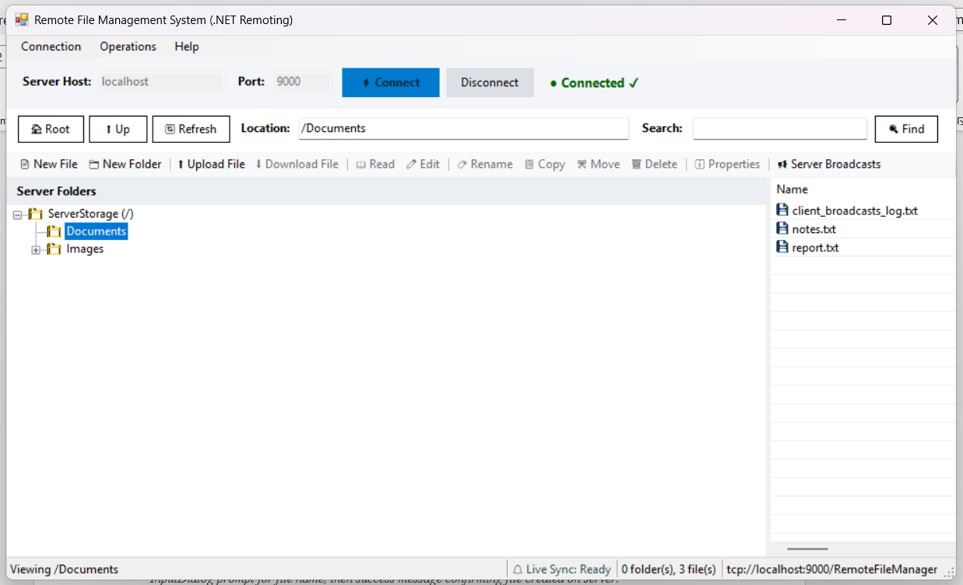

Create New File
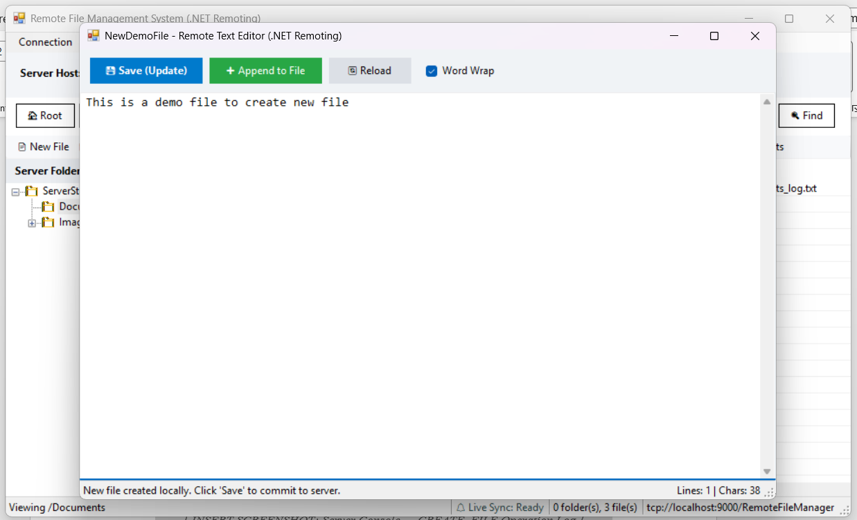

Server Console: File Create Log
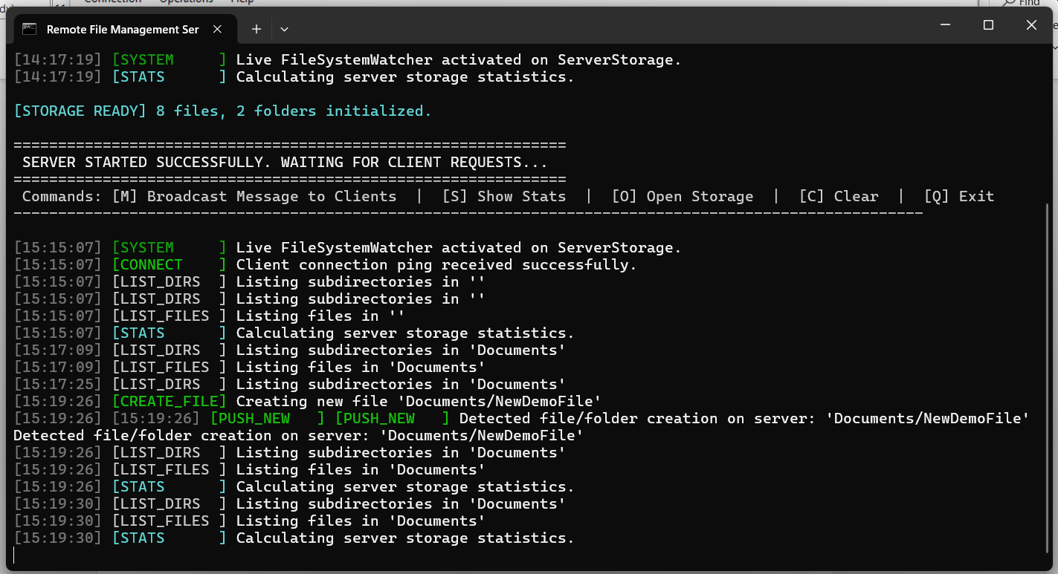

File Editor: Read Text File
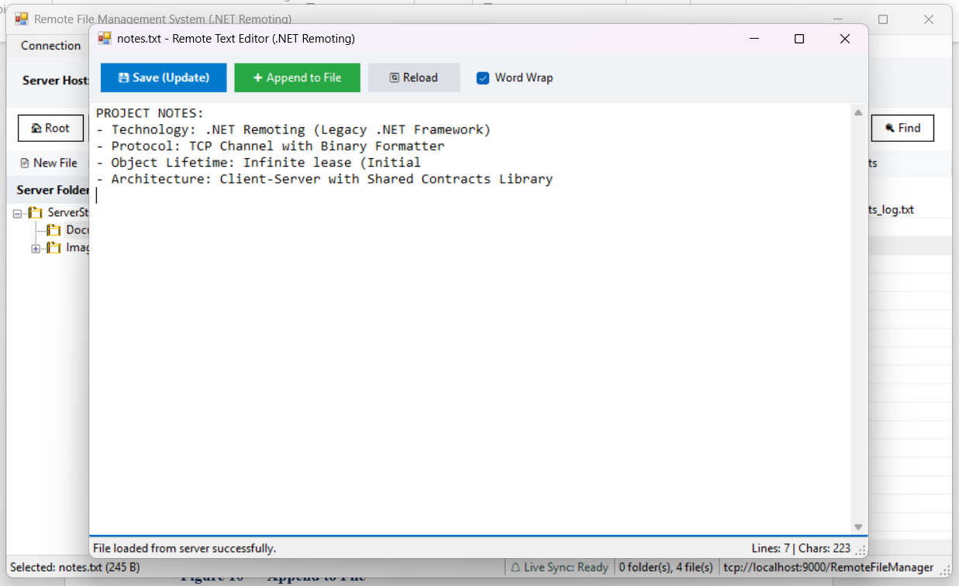

Append to File
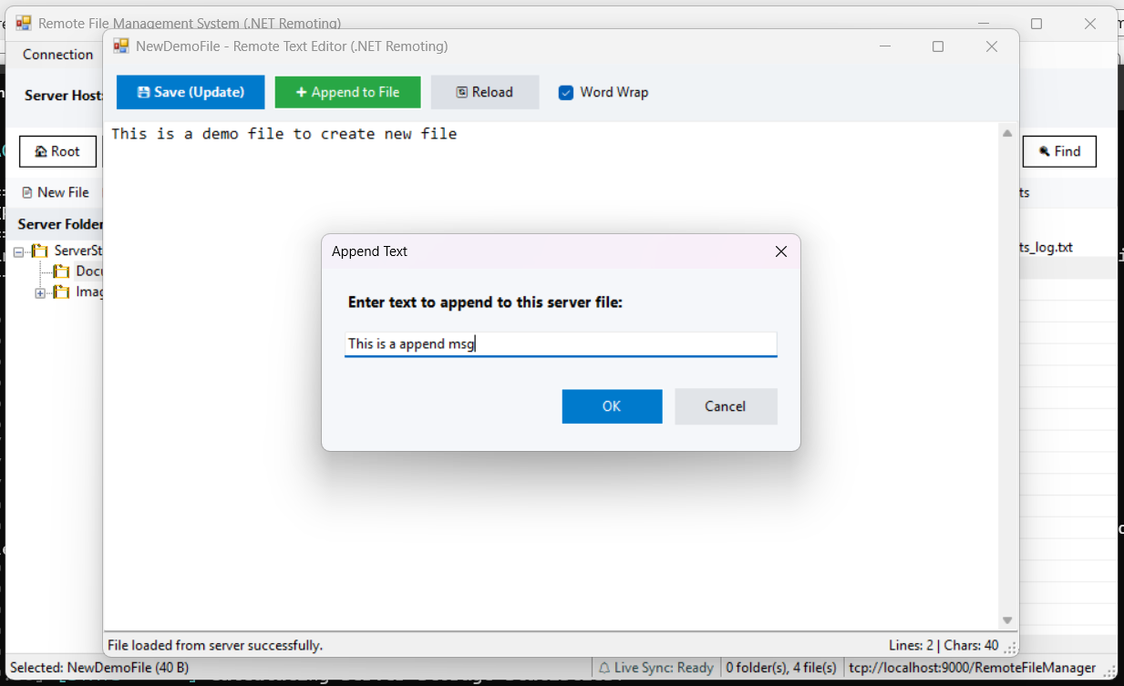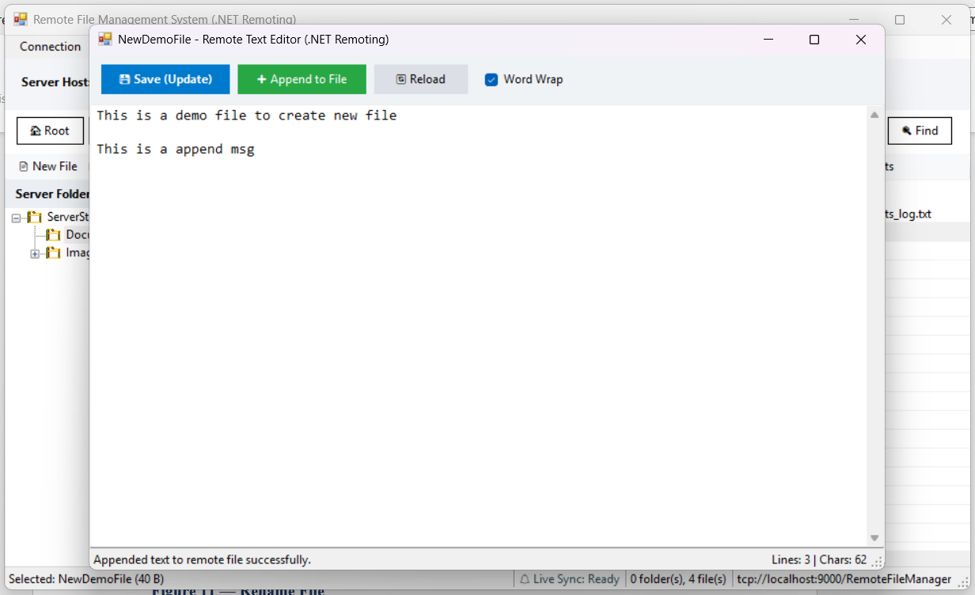

Rename File
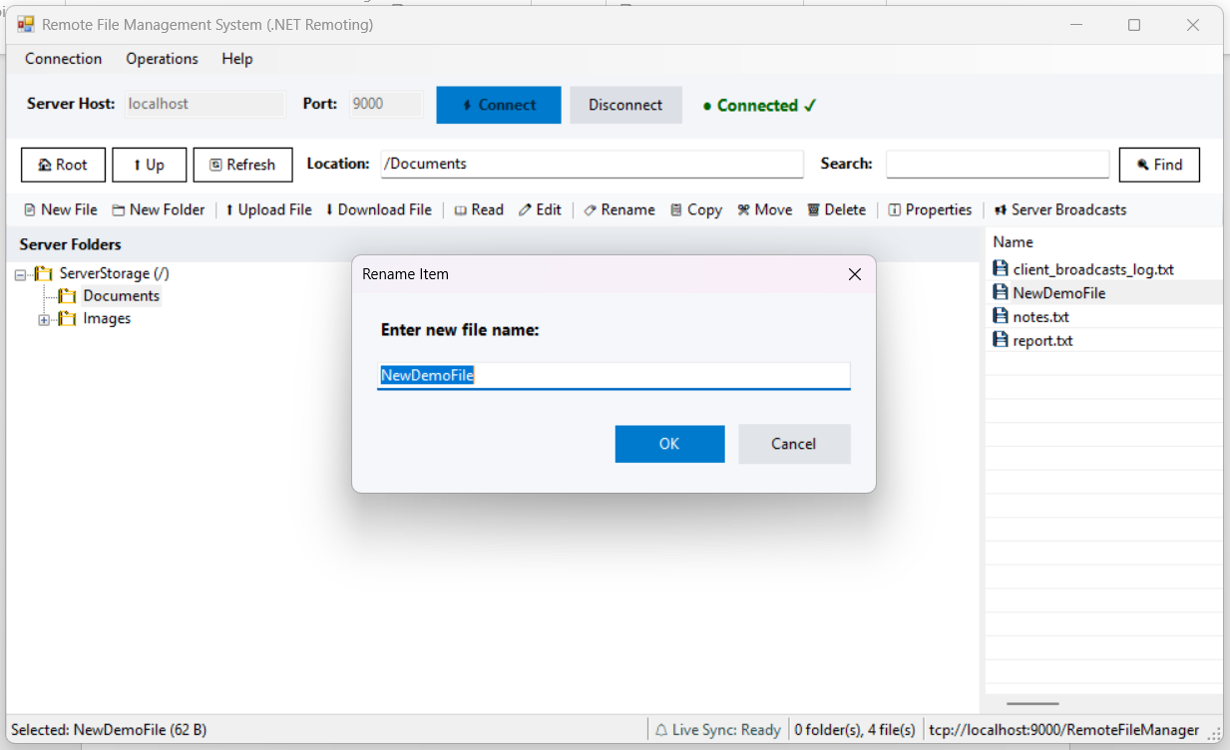

Copy File
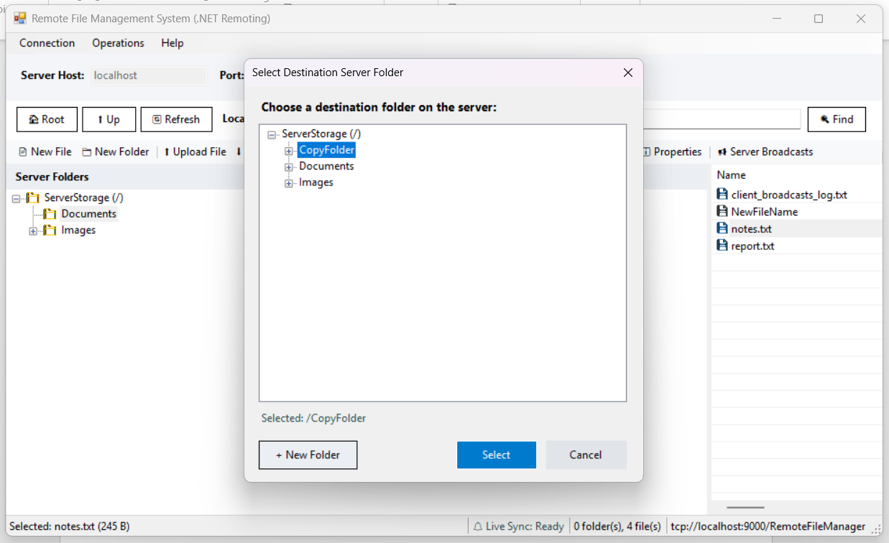

Upload File (Client → Server)
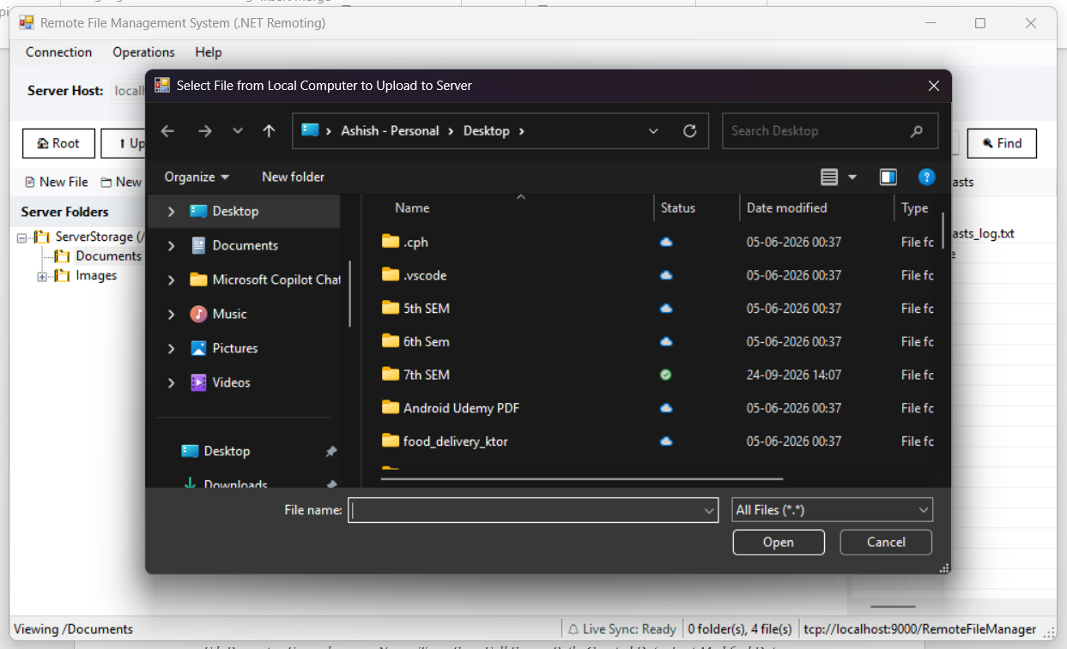
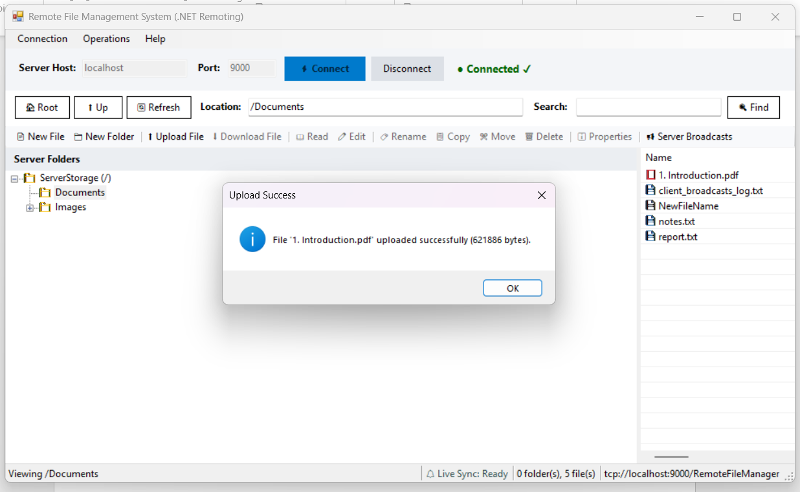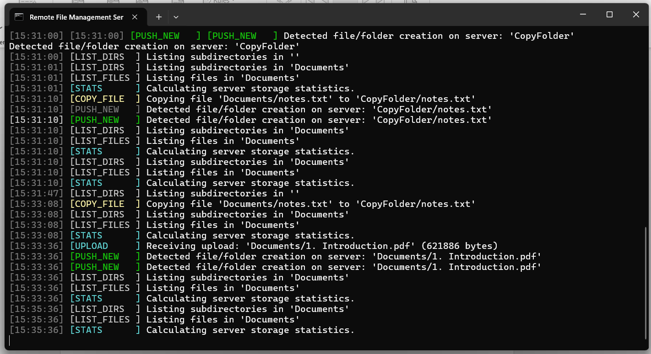

Download File (Server → Client)
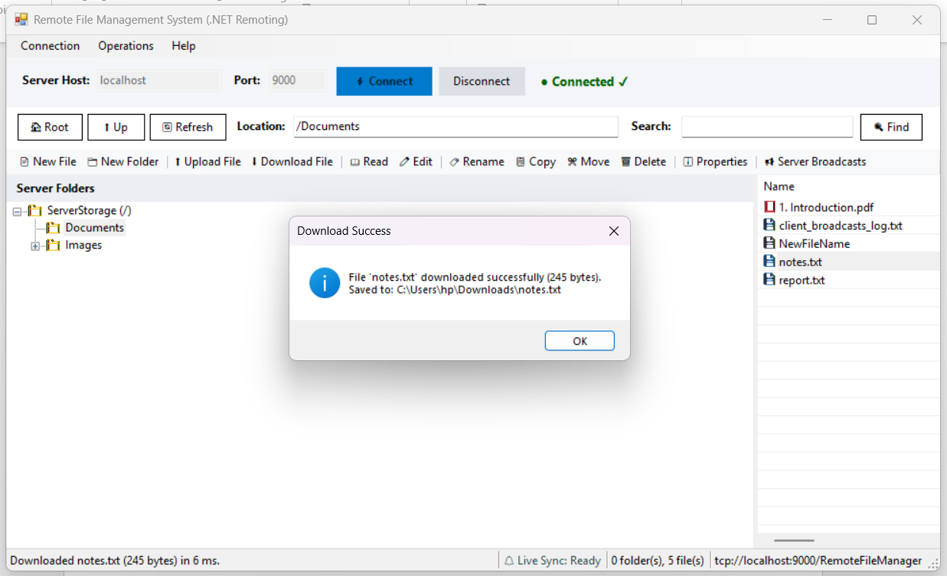

Search Results
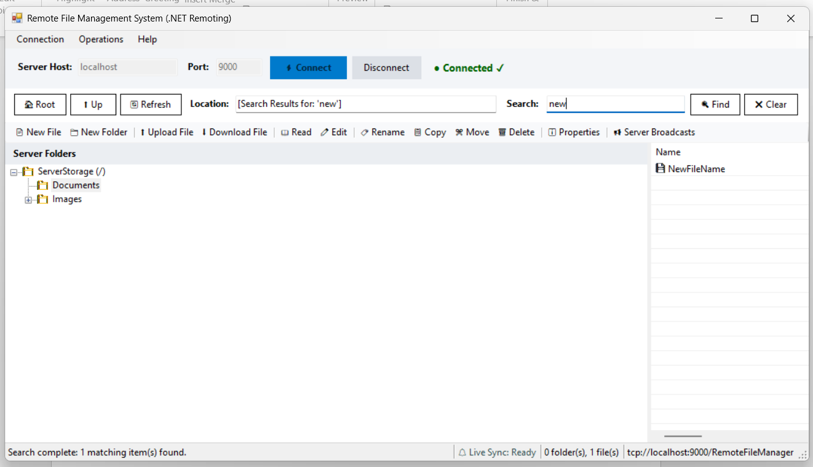

Delete Confirmation
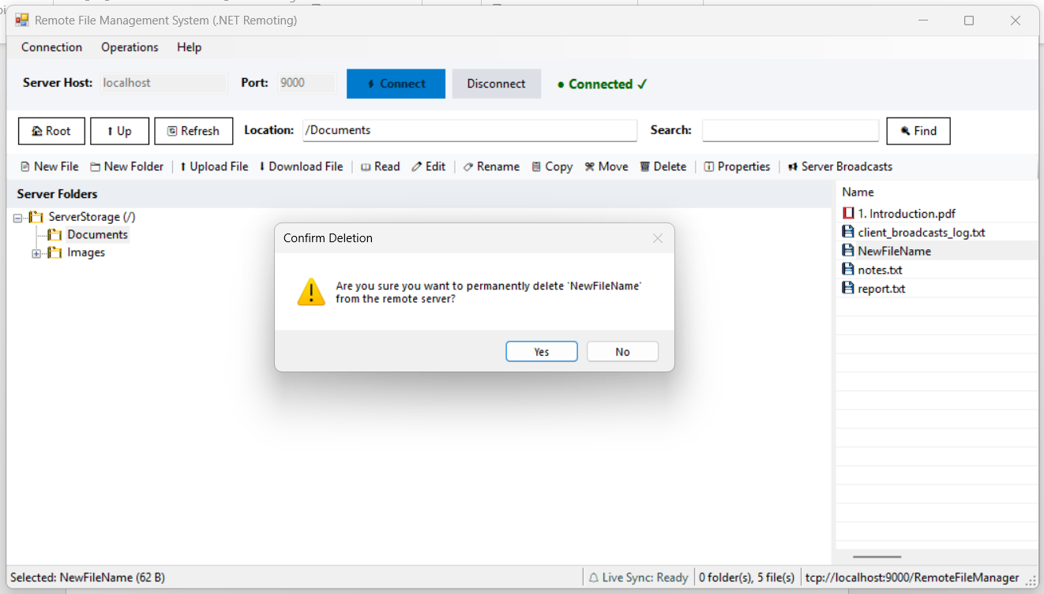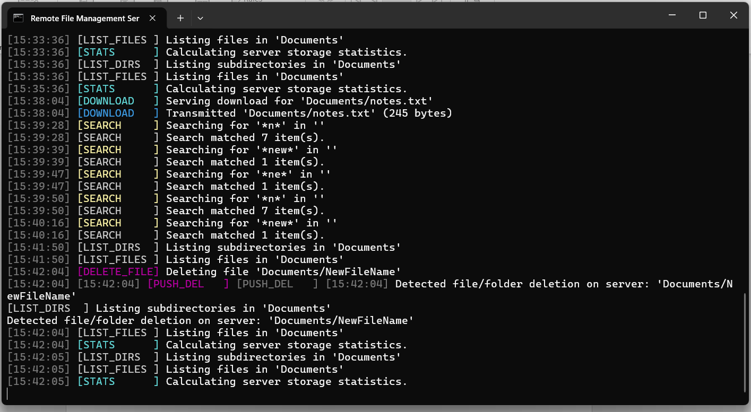

Storage Statistics
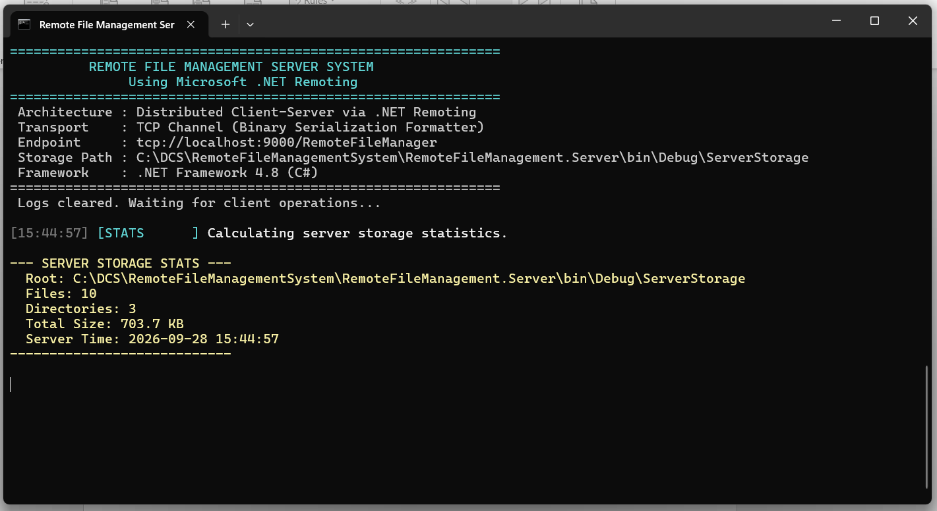

Broadcast Message to all clients
