Machine Learning Lab Assignment

Decision Tree

Name: Faraz Ahmad

Reg. No.: 16BCE0920

Slot: F2

The Dataset:

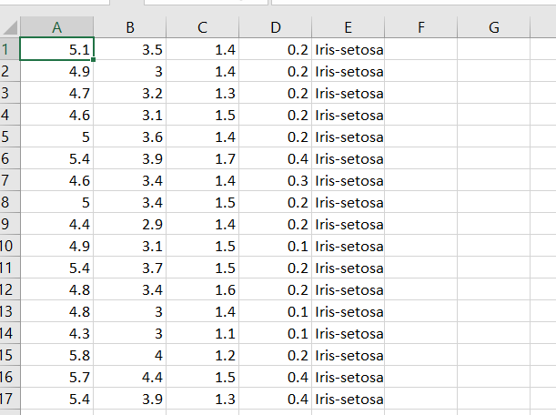

The Code:

# Importing the libraries

import numpy as np

import matplotlib.pyplot as plt

import pandas as pd

# Importing the dataset

dataset = pd.read_csv('data.csv')

X = dataset.iloc[:, [2, 3]].values

y = dataset.iloc[:, 4].values

#Converting String to Charaterized data

from sklearn.preprocessing import LabelEncoder, OneHotEncoder

# Encoding the Dependent Variable

labelencoder_y = LabelEncoder()

y = labelencoder_y.fit_transform(y)

# Splitting the dataset into the Training set and Test set

from sklearn.model_selection import train_test_split

X_train, X_test, y_train, y_test = train_test_split(X, y, test_size = 0.25, random_state = 0)

# Feature Scaling

from sklearn.preprocessing import StandardScaler

sc = StandardScaler()

X_train = sc.fit_transform(X_train)

X_test = sc.transform(X_test)

# Fitting Decision Tree Classification to the Training set

from sklearn.tree import DecisionTreeClassifier

classifier = DecisionTreeClassifier(criterion = 'entropy', random_state = 0)

classifier.fit(X_train, y_train)

# Predicting the Test set results

y_pred = classifier.predict(X_test)

# Making the Confusion Matrix

from sklearn.metrics import confusion_matrix

cm = confusion_matrix(y_test, y_pred)

# Visualising the Training set results

from matplotlib.colors import ListedColormap

X_set, y_set = X_train, y_train

X1, X2 = np.meshgrid(np.arange(start = X_set[:, 0].min() - 1, stop = X_set[:, 0].max() + 1, step = 0.01),

np.arange(start = X_set[:, 1].min() - 1, stop = X_set[:, 1].max() + 1, step = 0.01))

plt.contourf(X1, X2, classifier.predict(np.array([X1.ravel(), X2.ravel()]).T).reshape(X1.shape),

alpha = 0.75, cmap = ListedColormap(('red', 'green','orange')))

plt.xlim(X1.min(), X1.max())

plt.ylim(X2.min(), X2.max())

for i, j in enumerate(np.unique(y_set)):

plt.scatter(X_set[y_set == j, 0], X_set[y_set == j, 1],

c = ListedColormap(('red', 'green','orange'))(i), label = j)

plt.title('Decision Tree Classification (Training set)')

plt.xlabel('Petal Length')

plt.ylabel('Petal Width')

plt.legend()

plt.show()

# Visualising the Test set results

from matplotlib.colors import ListedColormap

X_set, y_set = X_test, y_test

X1, X2 = np.meshgrid(np.arange(start = X_set[:, 0].min() - 1, stop = X_set[:, 0].max() + 1, step = 0.01),

np.arange(start = X_set[:, 1].min() - 1, stop = X_set[:, 1].max() + 1, step = 0.01))

plt.contourf(X1, X2, classifier.predict(np.array([X1.ravel(), X2.ravel()]).T).reshape(X1.shape),

alpha = 0.75, cmap = ListedColormap(('red', 'green','orange')))

plt.xlim(X1.min(), X1.max())

plt.ylim(X2.min(), X2.max())

for i, j in enumerate(np.unique(y_set)):

plt.scatter(X_set[y_set == j, 0], X_set[y_set == j, 1],

c = ListedColormap(('red', 'green','orange'))(i), label = j)

plt.title('Decision Tree Classification (Test set)')

plt.xlabel('Petal Length')

plt.ylabel('Petal Width')

plt.legend()

plt.show()

from sklearn.metrics import classification_report

print(classification_report(y_test,y_pred))

The Output:

