Microprocessor and Interfacing Lab Experiment

Masm

Opening of MASM

<ftp://10.10.151.151/lab>

copy and paste the MASM.ZIP file on your Desktop

Extract the file on the Desktop

Open DOS Box emulator:- it is the DOS virtual drive

Z:\>mount c ~ /desktop

Z:\>c:

C:\>cd MASM

MASM:\>edit one.asm

Coding:

Multiplication of two numbers:-

.MODEL SMALL

.DATA

; No data defined

.CODE

start:

MOV AX,@DATA  
MOV DS, AX  
  
MOV AL, 09h  
MOV BL, 04H  
ADD AL,BL

MOV AH, 4Ch ;terminate the process and returning to DOS or parent process

INT 21h

END start

End

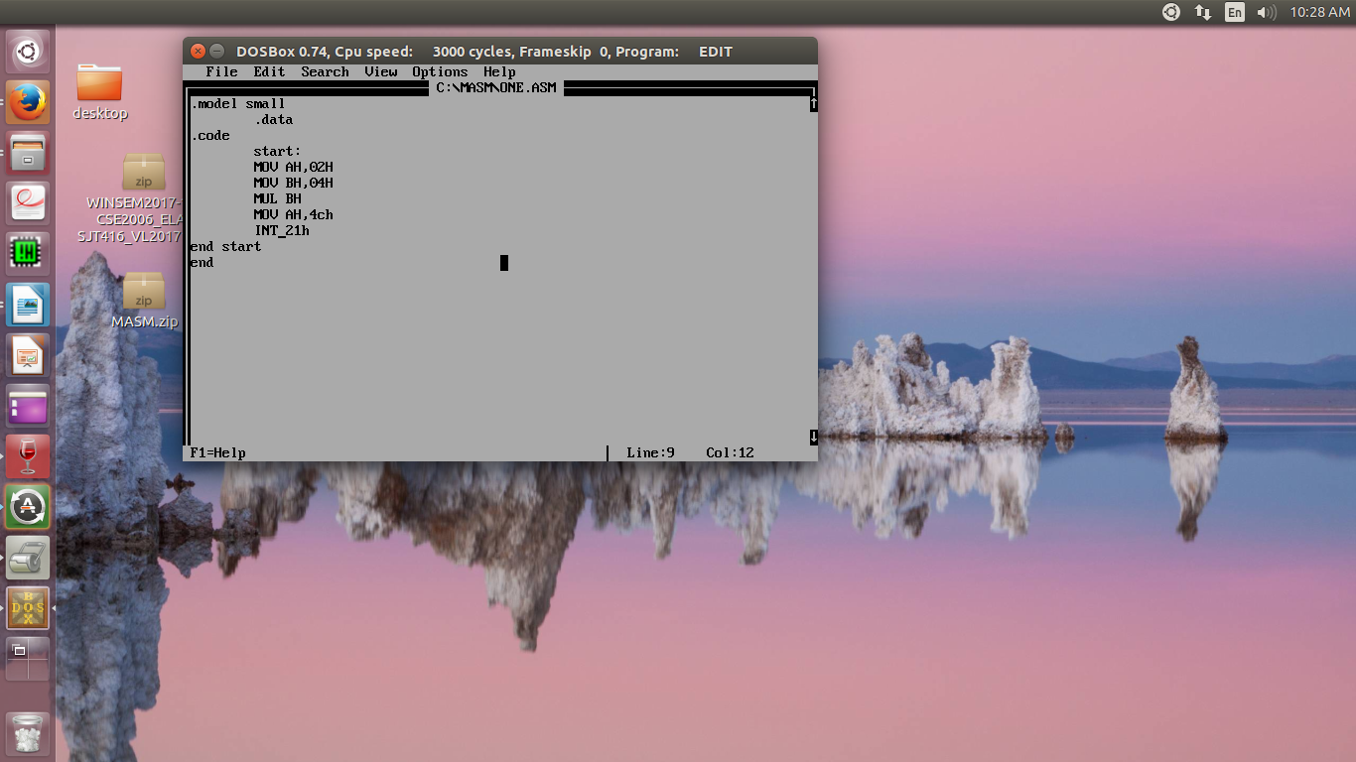

Then we save the program and run the code

Save the file.

MASM:\>Masm one.asm

Press ‘enter’ three times

MASM:\>Link one.obj

Press ‘enter’ three times

Debug one.exe

-t for line by line execution

-q for quit

-d ds:2000 to display memory content

-e ds:2000 to enter the data in memory

The output

