Operating System

Lab Experiment 3

Name : Om Ashish Mishra

Reg. No.: 16BCE0789

Slot: A1+TA1

**PROCESS CREATION**

The child-parent process

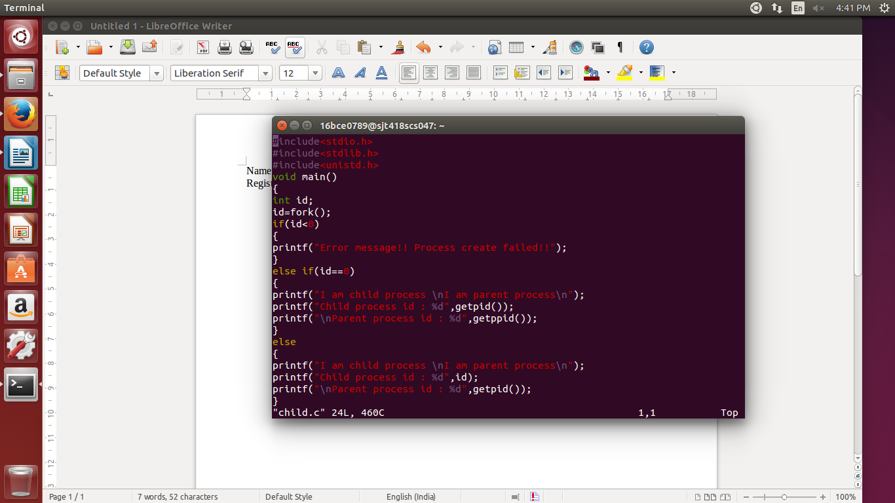

The output:

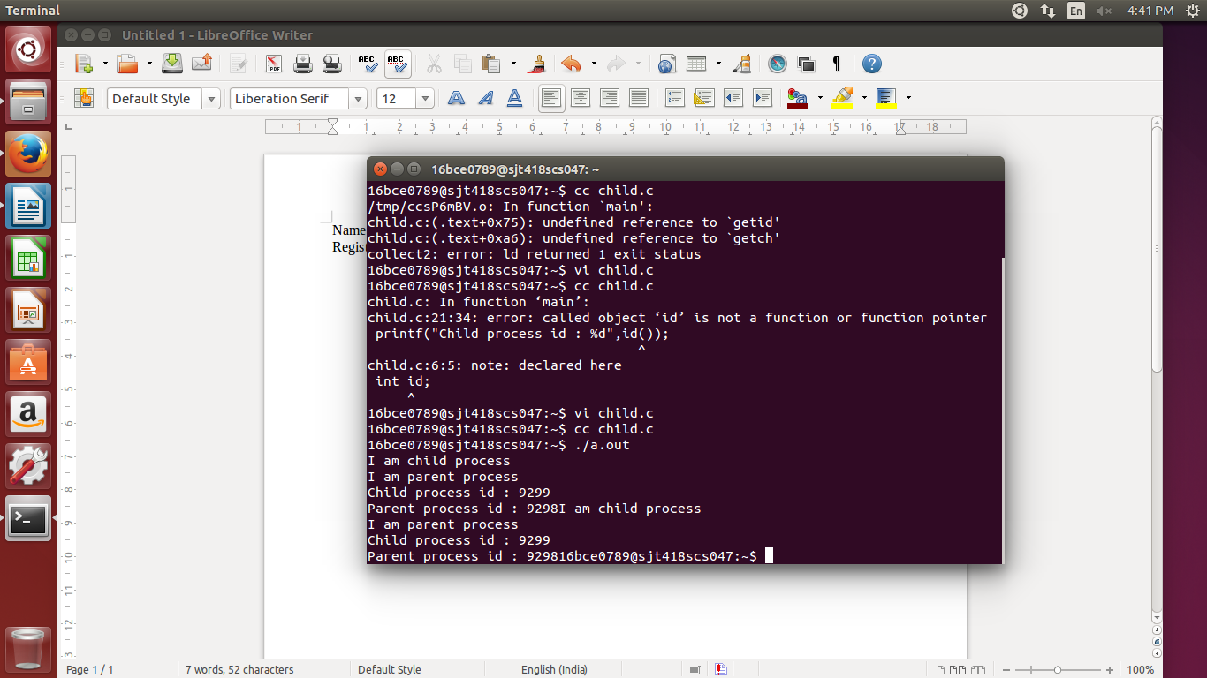

**ZOMBIE PROCESS**

The child-parent process:

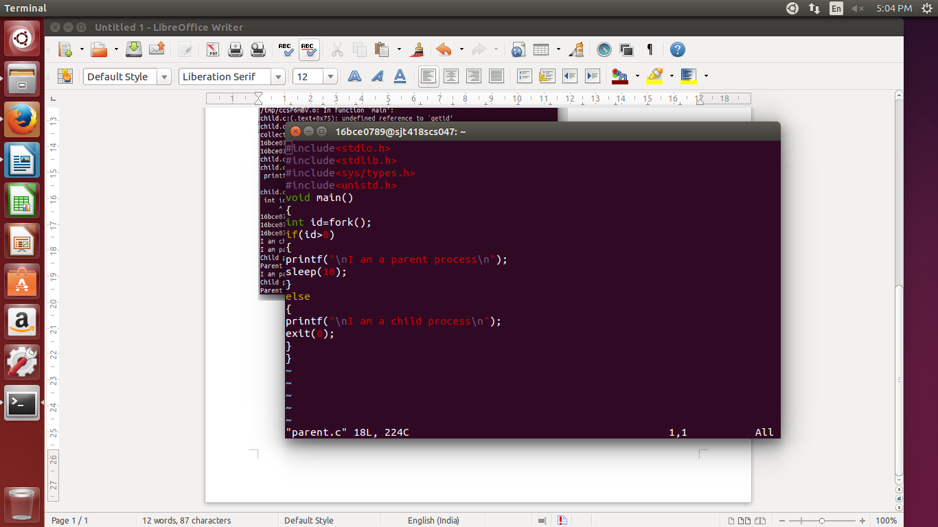

The Output:

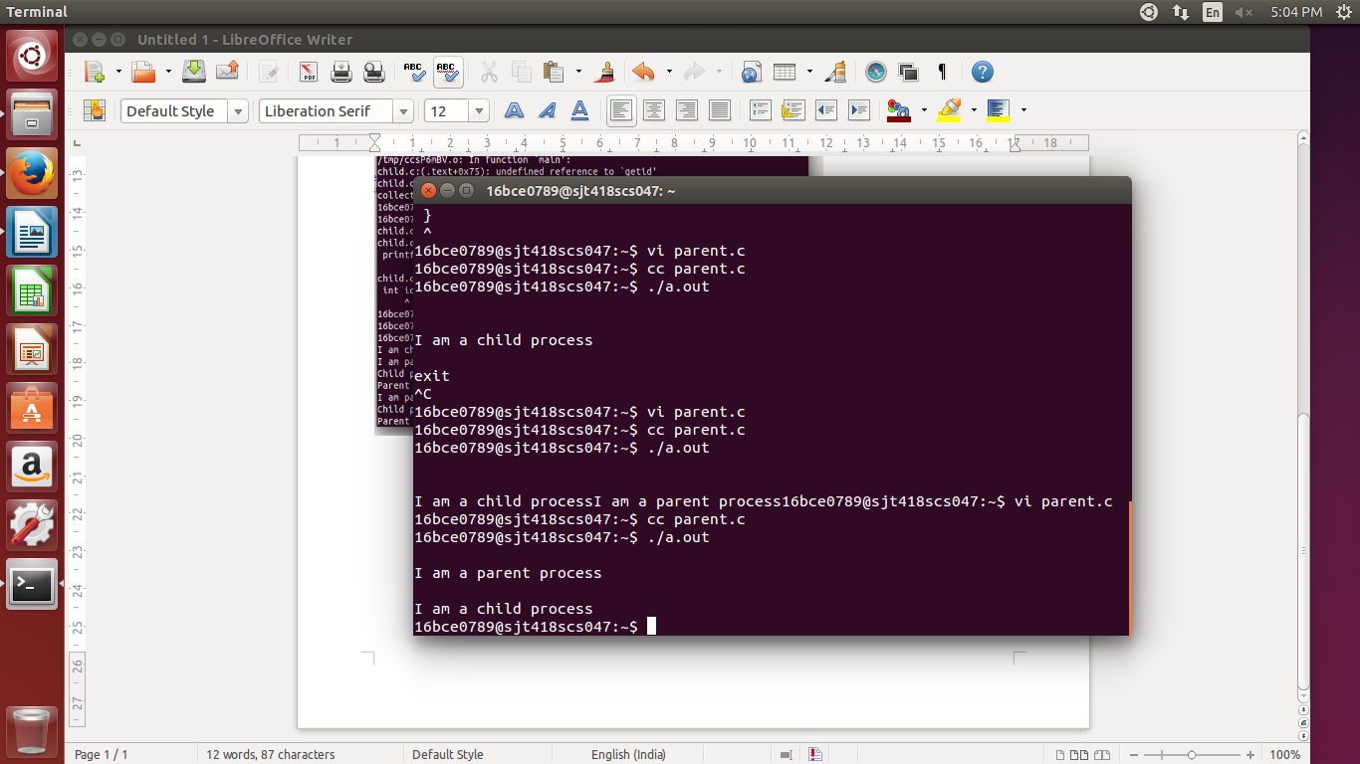

**THE ORPHAN PROCESS**

The child-parent process:

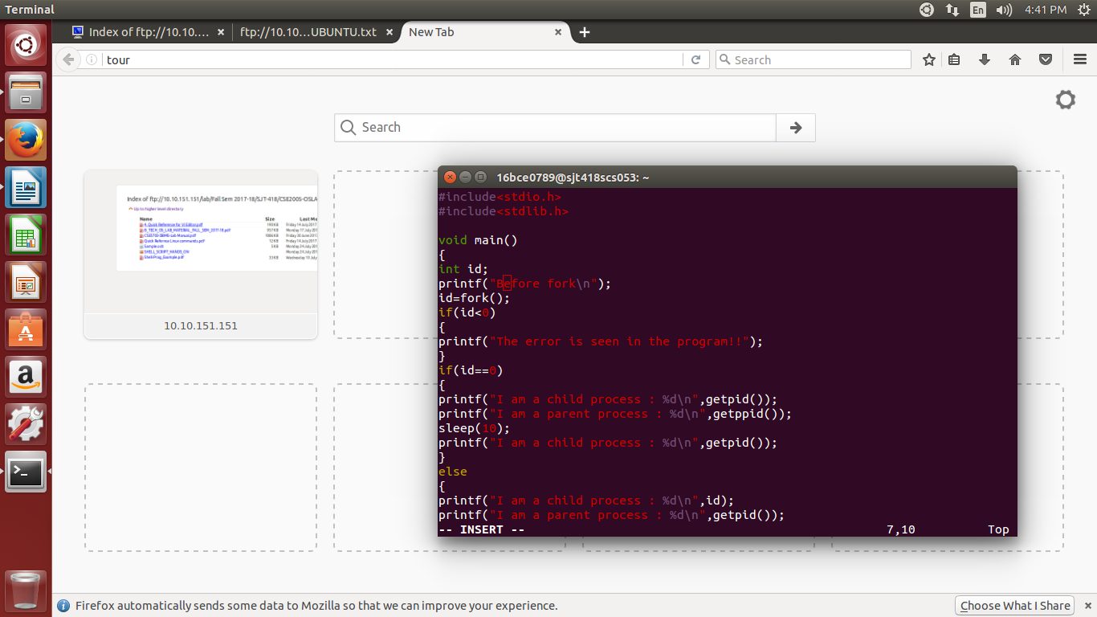

The Output:

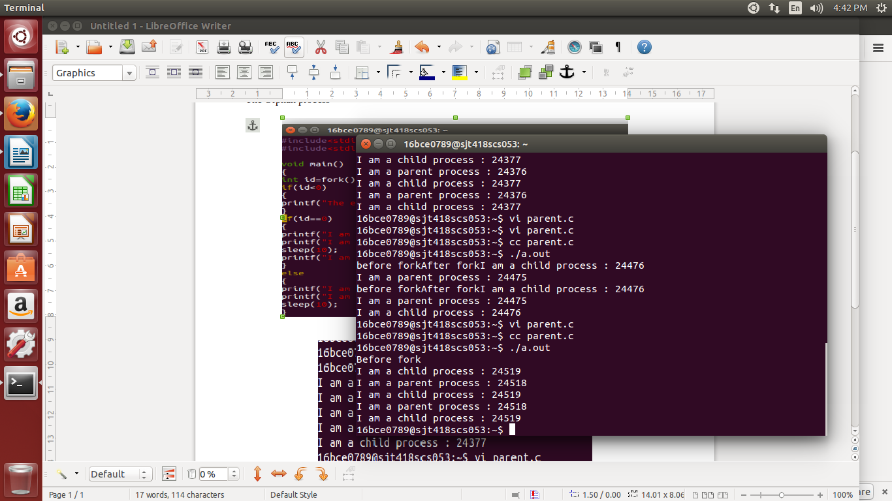

**THANK YOU**